Supporting Information

Electronic structure, stability, and cooperativity of chalcogen bonding in sulfur dioxide and hydrated sulfur dioxide clusters: a DFT study and wave funtional analysis

Natarajan Sathiyamoorthy Venkataramanan,^{a *}

ªSHARP Substratum
Adavathur East,
Trichy – 620 102
India
Email: nsvenkataramanan@gmail.com
http://orcid.org/0000-0001-6228-0894

Fig. S1 Optimized low-lying isomers for SO₂ dimer
Fig. S2 Optimized low-lying isomers for SO₂ timer
Fig. S3 Optimized low-lying isomers for SO₂ tetramer
Fig. S4 Optimized low-lying isomers for SO₂ pentamer
Fig. S5 Optimized low-lying isomers for SO₂ hexamer
Fig. S6 Optimized low-lying isomers for SO₂ heptamer
Fig. S7 Optimized low-lying isomers for heterodimer and heterotrimer hydrated SO₂ clusters
Fig. S8 Optimized low-lying isomers for heterotetramer hydrated SO₂ clusters
Fig. S9 Optimized low-lying isomers for heteropentamer hydrated SO₂ clusters
Fig. S10 Optimized low-lying isomers for heterohexamer hydrated SO₂ clusters
Fig. S11 Optimized low-lying isomers for heteroheptamer hydrated SO₂ clusters
Fig. S12 Electron density difference isosurfaces (±0.001 au) of the SO2 dimer, SO2 trimer, heterodimer, hetrotrimer and hetrotetramer clusters
Fig. S13 Plots of the reduced density gradient (s) versus sign(λ₂)ρ, and NCI isosurfaces at the right corner of each image (s = 0.50) for PGM hydrated sulfur dioxide clusters.

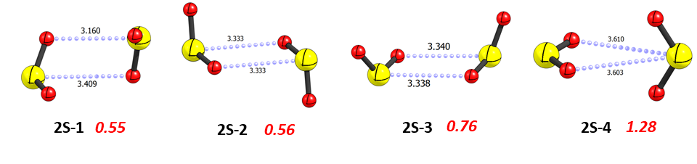
Fig. S1

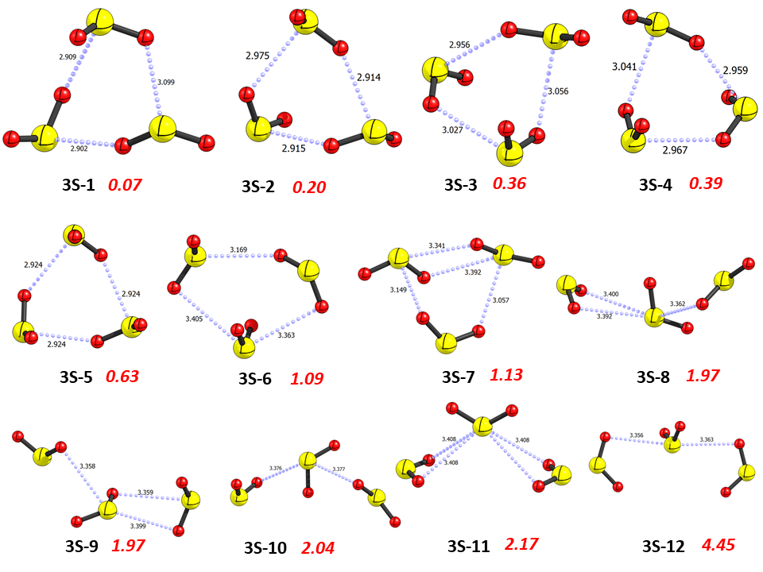
Fig. S2

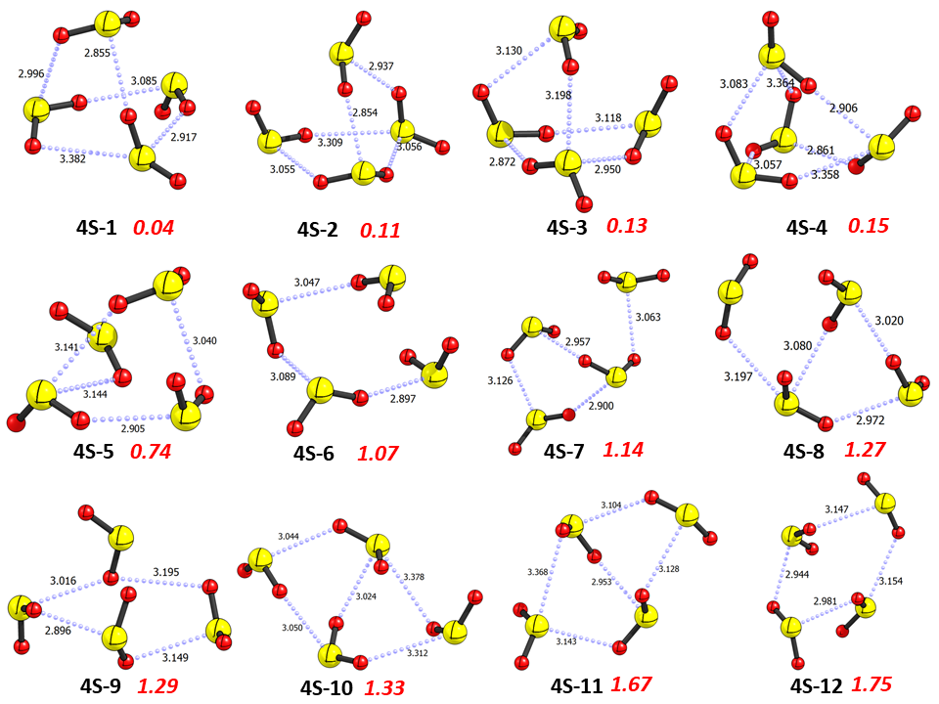
Fig. S3

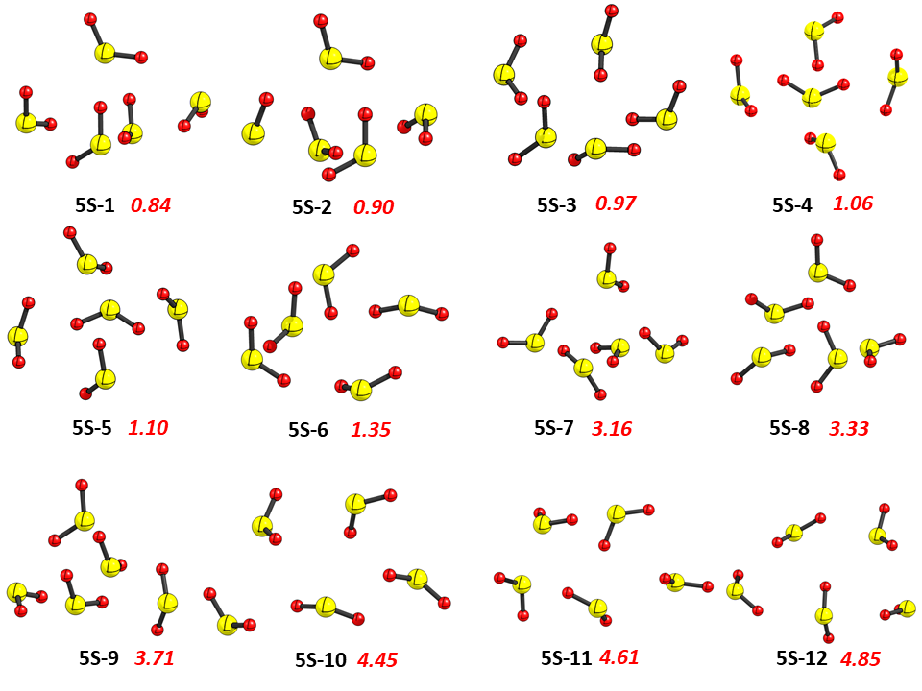

Fig. S4

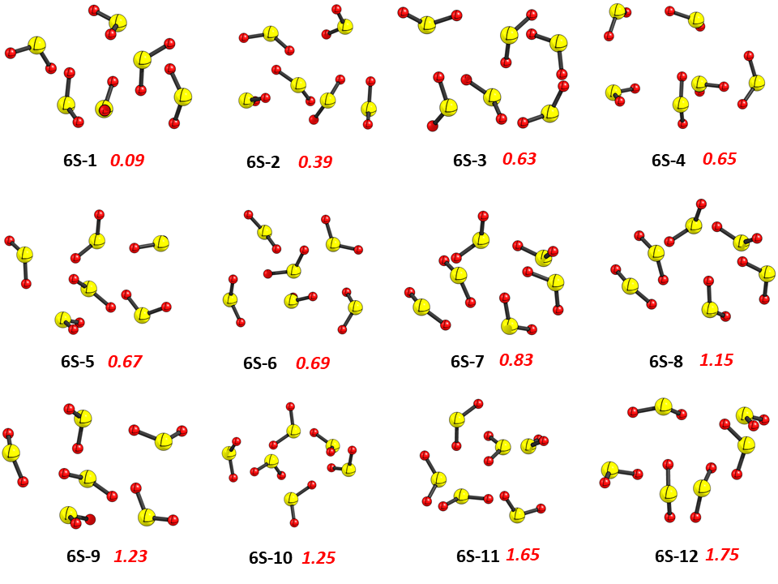
Fig. S5

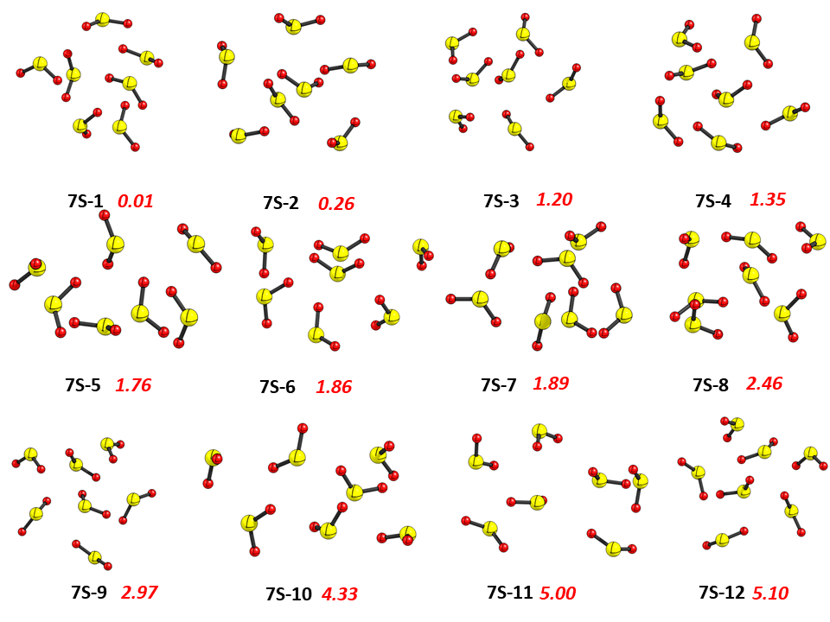
Fig. S6

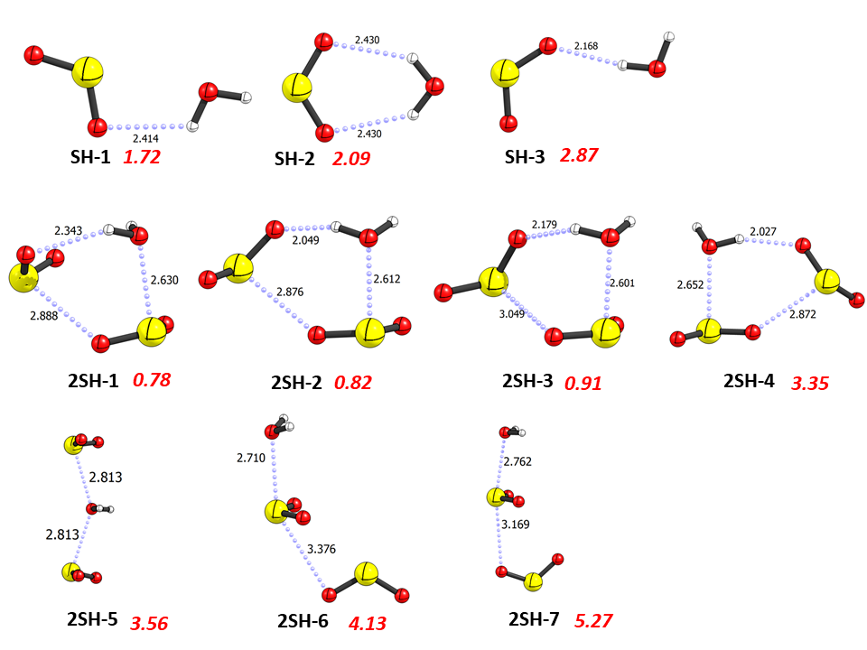

Fig. S7

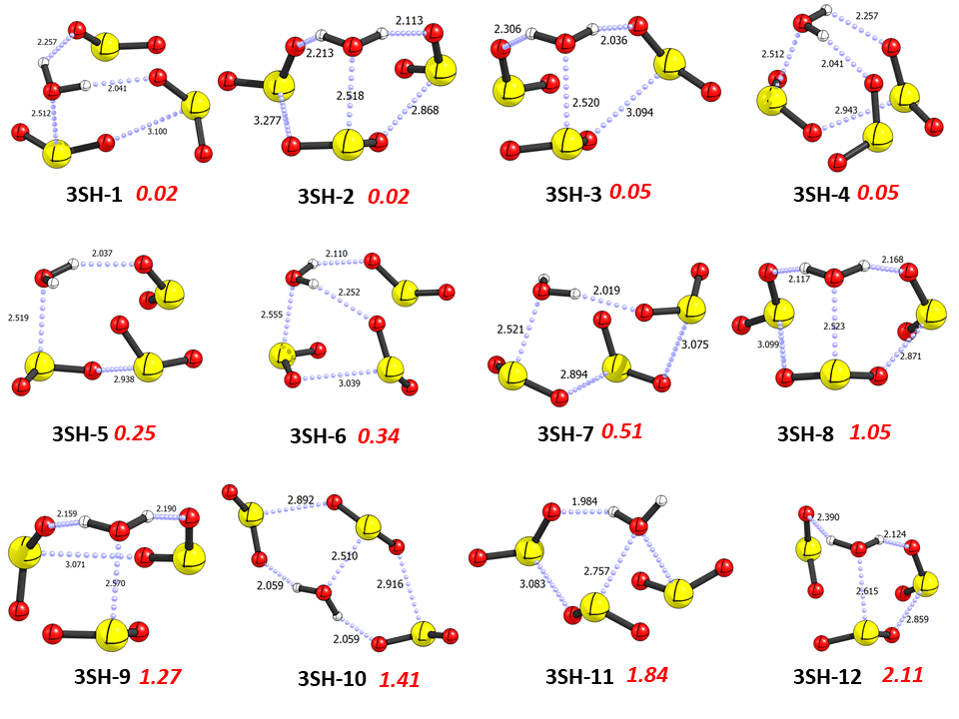
Fig. S8

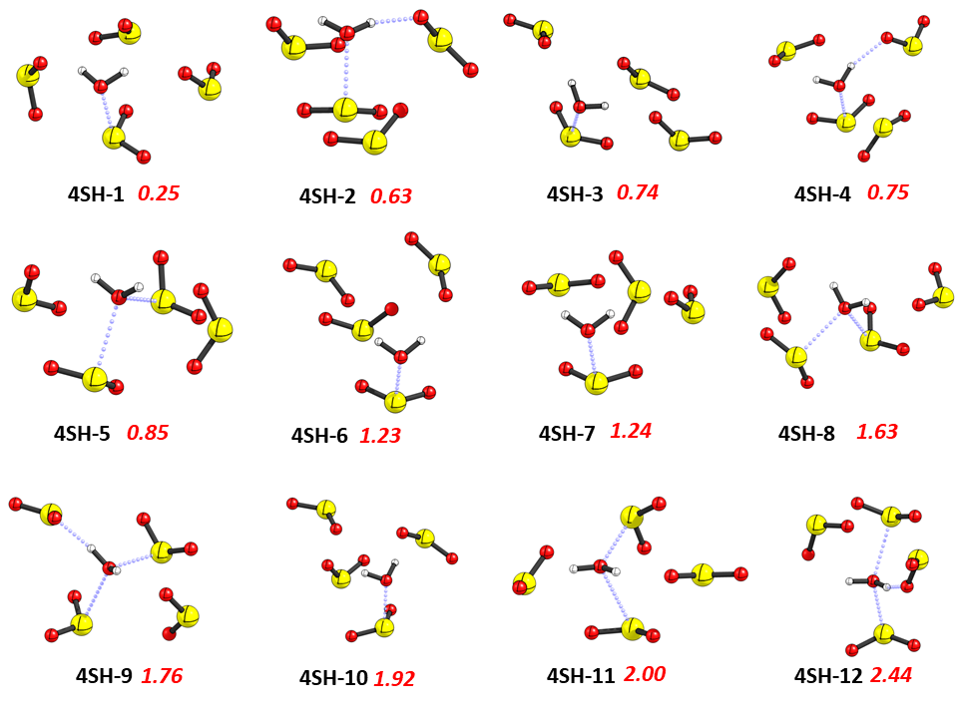
Fig. S9

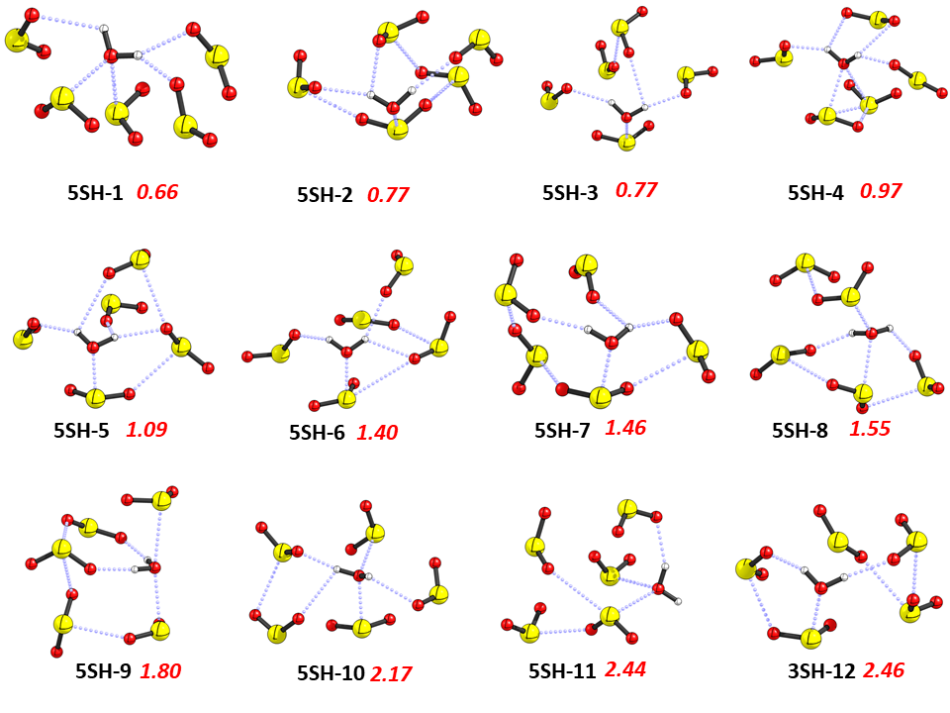
Fig. S10

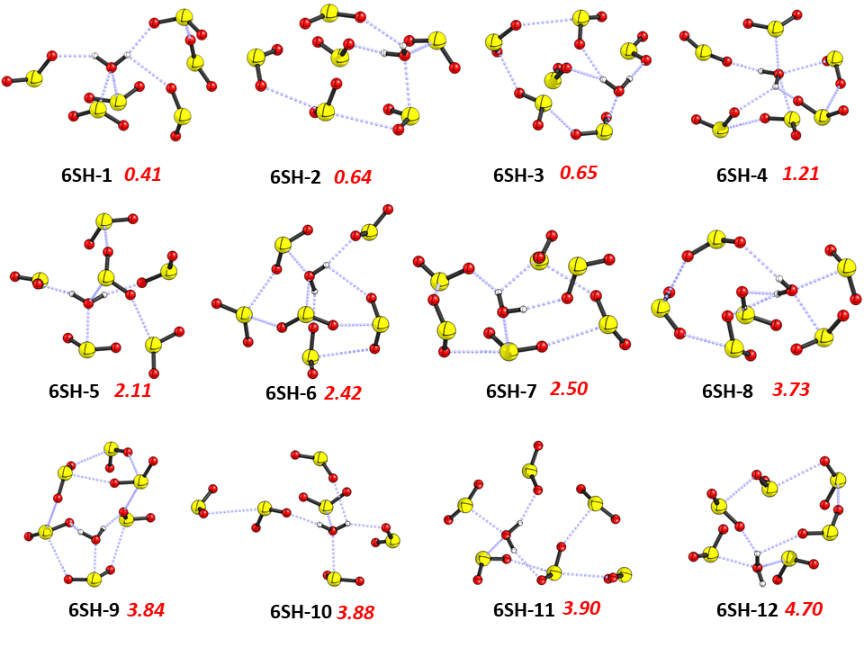
Fig. S11

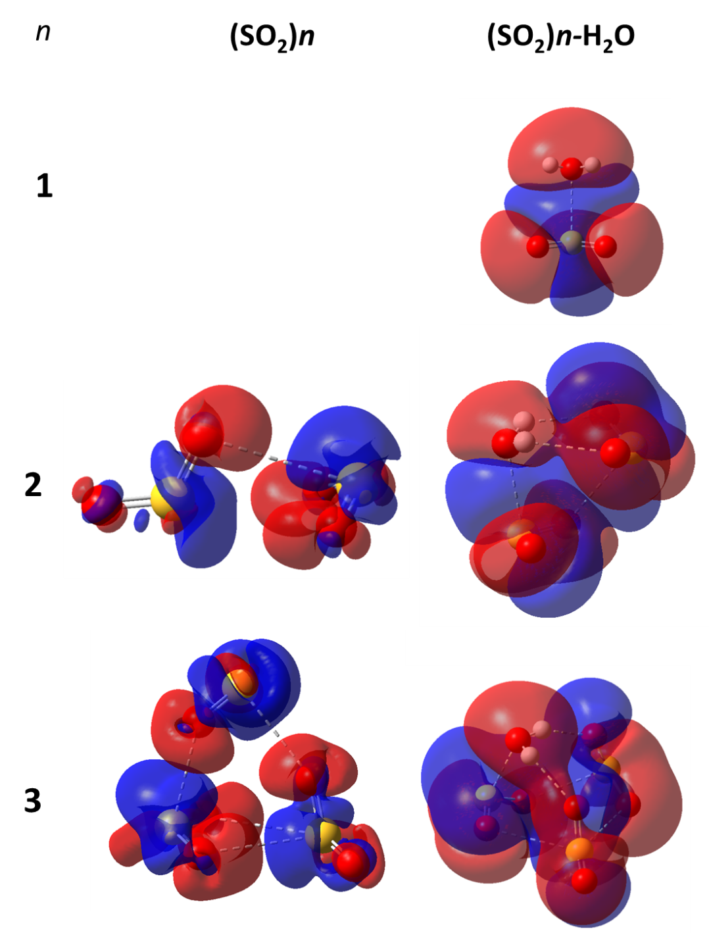
Fig. S12

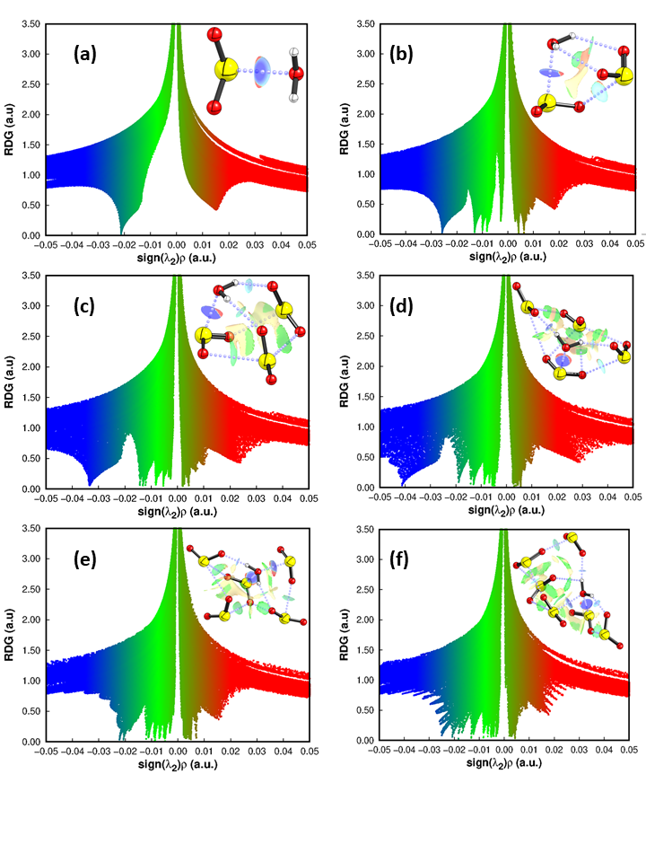
Fig. S13

Table S1. The QTAIM parameters corresponding to intermolecular bonding between the SO₂ molecules in SO₂ cluster.
Atoms | ρ(r) | ∇²ρ(r) | λ₁ | λ₂ | λ₃ | V(r) | G(r) | H(r) | ε
Dimer
S1 - O5 | 0.005801 | 0.024560 | -0.00284 | -0.00094 | 0.028335 | -0.003202 | 0.004671 | -0.00147 | 2.034408
Timer
S1 - O9 | 0.012157 | 0.044476 | -0.00972 | -0.00963 | 0.063818 | -0.007484 | 0.009302 | -0.00182 | 0.009522
O5 - S7 | 0.011795 | 0.046518 | -0.00928 | -0.00892 | 0.064709 | -0.007687 | 0.009658 | -0.00197 | 0.040622
O3 - S4 | 0.005068 | 0.020805 | -0.00256 | -0.00142 | 0.024787 | -0.002617 | 0.003909 | -0.00129 | 0.798779
O2 - S4 | 0.008316 | 0.031139 | -0.00619 | -0.00588 | 0.043206 | -0.004489 | 0.006137 | -0.00165 | 0.053930
Tetramer
O6 - S7 | 0.005234 | 0.021478 | -0.00314 | -0.00158 | 0.026198 | -0.002785 | 0.004077 | -0.00129 | 0.984562
O5 - O8 | 0.005234 | 0.023106 | -0.00280 | -0.00112 | 0.027023 | -0.002776 | 0.004276 | -0.00150 | 1.512681
O2 - S4 | 0.010708 | 0.039783 | -0.00876 | -0.00774 | 0.056280 | -0.006373 | 0.008159 | -0.00179 | 0.131505
O3 - O5 | 0.004294 | 0.019136 | -0.00296 | -0.00171 | 0.023797 | -0.002204 | 0.003494 | -0.00129 | 0.732703
O5 - S10 | 0.007792 | 0.032322 | -0.00563 | -0.00465 | 0.042600 | -0.004781 | 0.006431 | -0.00165 | 0.210950
S1 - O8 | 0.013224 | 0.051303 | -0.01080 | -0.01012 | 0.072222 | -0.008789 | 0.010808 | -0.00202 | 0.067183
O5 - S10 | 0.007792 | 0.032322 | -0.00563 | -0.00465 | 0.042600 | -0.004781 | 0.006431 | -0.00165 | 0.210950
O3 - S10 | 0.004969 | 0.020731 | -0.00357 | -0.00282 | 0.027120 | -0.002667 | 0.003925 | -0.00126 | 0.264558
S7 - O12 | 0.011737 | 0.044625 | -0.00995 | -0.00894 | 0.063510 | -0.007372 | 0.009264 | -0.00189 | 0.112866
Pentamer
S4 - O14 | 0.007523 | 0.029721 | -0.0056 | -0.00327 | 0.038583 | -0.004195 | 0.005812 | -0.00162 | 0.713749
O5 - O15 | 0.004764 | 0.021804 | -0.00267 | -0.00115 | 0.025622 | -0.002528 | 0.00399 | -0.00146 | 1.328361
S7 - O15 | 0.006349 | 0.025182 | -0.00512 | -0.00487 | 0.035178 | -0.003419 | 0.004857 | -0.00144 | 0.050746
O11 - S13 | 0.008992 | 0.033805 | -0.00712 | -0.00657 | 0.047491 | -0.005131 | 0.006791 | -0.00166 | 0.082749
O6 - S7 | 0.005104 | 0.020439 | -0.0033 | -0.00287 | 0.026613 | -0.002621 | 0.003865 | -0.00125 | 0.150243
O5 - S10 | 0.011358 | 0.046124 | -0.00864 | -0.00744 | 0.062200 | -0.007581 | 0.009556 | -0.00198 | 0.161380
O5 - O8 | 0.004771 | 0.020403 | -0.00272 | -0.00057 | 0.023694 | -0.002477 | 0.003789 | -0.00131 | 3.808566
S1 - O8 | 0.013316 | 0.051441 | -0.01104 | -0.01044 | 0.072930 | -0.008818 | 0.010839 | -0.00202 | 0.057487
O3 - S10 | 0.004652 | 0.019188 | -0.00327 | -0.00287 | 0.025330 | -0.002408 | 0.003603 | -0.00119 | 0.138403
O3 - O5 | 0.004683 | 0.021097 | -0.00329 | -0.00179 | 0.026167 | -0.002508 | 0.003891 | -0.00138 | 0.839949
O2 - S4 | 0.008377 | 0.032550 | -0.00652 | -0.00441 | 0.043475 | -0.004810 | 0.006474 | -0.00166 | 0.479713
Hexamer
S13 - O17 | 0.005051 | 0.021472 | -0.00339 | -0.00087 | 0.025738 | -0.002685 | 0.004027 | -0.00134 | 2.886162
O14 - O17 | 0.005163 | 0.021710 | -0.00343 | -0.00060 | 0.025744 | -0.002618 | 0.004023 | -0.00141 | 4.687836
O2 - S16 | 0.005185 | 0.020836 | -0.00375 | -0.00293 | 0.027522 | -0.002711 | 0.00396 | -0.00125 | 0.278780
O12 - S16 | 0.005508 | 0.022198 | -0.00395 | -0.00129 | 0.027442 | -0.002816 | 0.004183 | -0.00137 | 2.061297
O2 - S13 | 0.007282 | 0.028471 | -0.00525 | -0.00324 | 0.036963 | -0.003976 | 0.005547 | -0.00157 | 0.617914
O12 - O14 | 0.005158 | 0.023000 | -0.00369 | -0.00204 | 0.028730 | -0.002802 | 0.004276 | -0.00147 | 0.804232
S1 - O12 | 0.012768 | 0.049654 | -0.01002 | -0.00969 | 0.069362 | -0.008461 | 0.010438 | -0.00198 | 0.033306
S1 - O6 | 0.005008 | 0.021180 | -0.00342 | -0.00114 | 0.025732 | -0.002702 | 0.003998 | -0.00130 | 2.010738
O6 - O12 | 0.004151 | 0.017743 | -0.00287 | -0.00237 | 0.022975 | -0.002047 | 0.003241 | -0.00119 | 0.211202
O8 - S10 | 0.012254 | 0.047248 | -0.00963 | -0.00915 | 0.066023 | -0.008000 | 0.009906 | -0.00191 | 0.052123
S4 - O11 | 0.004605 | 0.018602 | -0.00303 | -0.00253 | 0.024155 | -0.002275 | 0.003462 | -0.00119 | 0.196422
S4 - O8 | 0.008385 | 0.032446 | -0.00657 | -0.00464 | 0.043654 | -0.004780 | 0.006446 | -0.00167 | 0.418082
O3 - S7 | 0.008138 | 0.034009 | -0.00636 | -0.00434 | 0.044704 | -0.005024 | 0.006763 | -0.00174 | 0.464829
O3 - O14 | 0.004815 | 0.021872 | -0.00204 | -0.00131 | 0.025217 | -0.002541 | 0.004005 | -0.00146 | 0.559443
S7 - O14 | 0.005274 | 0.021737 | -0.00342 | -0.00107 | 0.026229 | -0.002827 | 0.004131 | -0.00130 | 2.191487
O3 - O15 | 0.004937 | 0.021894 | -0.00341 | -0.00176 | 0.02706 | -0.002573 | 0.004023 | -0.00145 | 0.934761
O9 - O15 | 0.004881 | 0.020003 | -0.00283 | -0.00146 | 0.024297 | -0.002344 | 0.003672 | -0.00133 | 0.938684
Heptamer
O6 - S7 | 0.008772 | 0.032422 | -0.00671 | -0.00647 | 0.045597 | -0.004764 | 0.006435 | -0.00167 | 0.037364
S4 - O14 | 0.009433 | 0.035048 | -0.00698 | -0.00690 | 0.048931 | -0.005378 | 0.007070 | -0.00169 | 0.011712
O5 - O15 | 0.004606 | 0.020809 | -0.00251 | -0.00158 | 0.024905 | -0.002352 | 0.003777 | -0.00143 | 0.585157
S7 - O15 | 0.006714 | 0.026590 | -0.00555 | -0.00517 | 0.037309 | -0.003655 | 0.005151 | -0.00150 | 0.072461
O12 - O15 | 0.003501 | 0.015891 | -0.00255 | -0.00236 | 0.020796 | -0.001841 | 0.002907 | -0.00107 | 0.081420
S13 - O17 | 0.013543 | 0.050689 | -0.01162 | -0.01063 | 0.072938 | -0.008804 | 0.010738 | -0.00193 | 0.093144
O5 - O17 | 0.003841 | 0.016692 | -0.00269 | -0.00257 | 0.021949 | -0.001987 | 0.003080 | -0.00109 | 0.045257
S7 - O12 | 0.004688 | 0.019475 | -0.00316 | -0.00117 | 0.023809 | -0.002425 | 0.003647 | -0.00122 | 1.697157
O11 - S16 | 0.010121 | 0.037555 | -0.00796 | -0.00757 | 0.053075 | -0.005910 | 0.007649 | -0.00174 | 0.051508
S16 - O20 | 0.006116 | 0.025394 | -0.00454 | -0.00401 | 0.033949 | -0.003423 | 0.004886 | -0.00146 | 0.132216
O5 - S10 | 0.008055 | 0.033718 | -0.00572 | -0.00380 | 0.043240 | -0.005066 | 0.006748 | -0.00168 | 0.505025
O8 - S10 | 0.005656 | 0.022198 | -0.00404 | -0.00265 | 0.028885 | -0.002904 | 0.004227 | -0.00132 | 0.528239
O5 - O8 | 0.005325 | 0.022484 | -0.00339 | -0.00139 | 0.027262 | -0.002727 | 0.004174 | -0.00145 | 1.443071
O2 - S4 | 0.009298 | 0.035907 | -0.00683 | -0.00562 | 0.048358 | -0.005612 | 0.007294 | -0.00168 | 0.215189
S1 - O8 | 0.012292 | 0.047391 | -0.00965 | -0.00913 | 0.066164 | -0.008026 | 0.009937 | -0.00191 | 0.057284
O2 - O21 | 0.002574 | 0.010769 | -0.00146 | -0.00073 | 0.012956 | -0.001191 | 0.001941 | -0.00075 | 1.013270
O3 - O5 | 0.004458 | 0.019402 | -0.00295 | -0.00204 | 0.024389 | -0.002309 | 0.003580 | -0.00127 | 0.444222
O5 - O21 | 0.005536 | 0.023057 | -0.00384 | -0.00104 | 0.027937 | -0.002861 | 0.004312 | -0.00145 | 2.677272
O3 - S10 | 0.007233 | 0.029445 | -0.00565 | -0.00471 | 0.039802 | -0.004169 | 0.005765 | -0.00160 | 0.201369
O2 - O21 | 0.002574 | 0.010769 | -0.00146 | -0.00073 | 0.012956 | -0.001191 | 0.001941 | -0.00075 | 1.013270
O11 - S16 | 0.010121 | 0.037555 | -0.00796 | -0.00757 | 0.053075 | -0.005910 | 0.007649 | -0.00174 | 0.051508
S16 - O20 | 0.006116 | 0.025394 | -0.00454 | -0.00401 | 0.033949 | -0.003423 | 0.004886 | -0.00146 | 0.132216
O11 - S19 | 0.006995 | 0.028531 | -0.00544 | -0.00385 | 0.037828 | -0.004028 | 0.005581 | -0.00155 | 0.412533
O3 - S19 | 0.005043 | 0.020118 | -0.00365 | -0.00243 | 0.026193 | -0.002627 | 0.003828 | -0.0012 | 0.502434
O5 - O21 | 0.005536 | 0.023057 | -0.00384 | -0.00104 | 0.027937 | -0.002861 | 0.004312 | -0.00145 | 2.677272

Table S2: The QTAIM parameters corresponding to intermolecular bonding between the SO₂ molecules and water and SO₂ molecules in (SO₂)n-H₂O cluster.
Atoms | ρ(r) | ∇²ρ(r) | λ₁ | λ₂ | λ₃ | V(r) | G(r) | H(r) | ε | E_{HB}
 | hetrodimer
S2 - O5 | 0.021179 | 0.065943 | -0.01894 | -0.01808 | 0.102966 | -0.01420 | 0.015342 | 0.00114 | 0.04756
 | hetrotrimer
O2 - S5 | 0.025796 | 0.075238 | -0.02475 | -0.02328 | 0.123266 | -0.01768 | 0.018244 | 0.00057 | 0.063075
O4 - S8 | 0.013075 | 0.047335 | -0.01041 | -0.00991 | 0.067659 | -0.00820 | 0.010015 | 0.00182 | 0.050861
H3 - O9 | 0.010006 | 0.042569 | -0.01057 | -0.00862 | 0.061755 | -0.00574 | 0.008193 | 0.00245 | 0.225520 | -1.80
O2 - O7 | 0.008228 | 0.036034 | -0.00761 | -0.00499 | 0.048633 | -0.00475 | 0.006879 | 0.00213 | 0.527501
 | hetrotetramer
H1 - O10 | 0.014358 | 0.063024 | -0.01766 | -0.01714 | 0.097825 | -0.00951 | 0.012632 | 0.00312 | 0.030552 | -2.98
H3 - O6 | 0.012211 | 0.055088 | -0.01388 | -0.01175 | 0.080713 | -0.00796 | 0.010868 | 0.00290 | 0.181109 | -2.49
O2 - S8 | 0.033547 | 0.087964 | -0.03525 | -0.03267 | 0.155884 | -0.02382 | 0.022906 | 0.00091 | 0.079249
S5 - O7 | 0.008283 | 0.031813 | -0.00642 | -0.00450 | 0.042730 | -0.00465 | 0.006299 | 0.00165 | 0.427369
O6 - O10 | 0.002628 | 0.010733 | -0.00153 | -0.00020 | 0.012462 | -0.00123 | 0.001954 | 0.00073 | 6.798235
O9 - S11 | 0.013209 | 0.050243 | -0.01059 | -0.00991 | 0.070744 | -0.00868 | 0.010622 | 0.00194 | 0.069287
S5 - O12 | 0.005403 | 0.021761 | -0.00393 | -0.00287 | 0.028564 | -0.00288 | 0.004162 | 0.00128 | 0.371806
 | hetropentamer
H3 - O6 | 0.019013 | 0.080439 | -0.02653 | -0.02560 | 0.132569 | -0.01397 | 0.017041 | 0.00307 | 0.035996 | -4.38
O2 - S11 | 0.041270 | 0.099299 | -0.04636 | -0.04233 | 0.187989 | -0.03061 | 0.027717 | 0.00289 | 0.095058
H1 - O13 | 0.014213 | 0.064116 | -0.01755 | -0.01735 | 0.099007 | -0.00945 | 0.012738 | 0.00329 | 0.011560 | -2.96
O2 - O7 | 0.006855 | 0.031601 | -0.00502 | -0.00355 | 0.040168 | -0.00417 | 0.006036 | 0.00187 | 0.415269
O7 - O13 | 0.004691 | 0.020422 | -0.00331 | -0.00219 | 0.025921 | -0.00244 | 0.003772 | 0.00133 | 0.515084
O12 - S14 | 0.013032 | 0.049662 | -0.01034 | -0.00980 | 0.069797 | -0.00856 | 0.010486 | 0.00193 | 0.055477
S8 - O10 | 0.008790 | 0.033556 | -0.00634 | -0.00430 | 0.044195 | -0.00498 | 0.006682 | 0.00171 | 0.473110
S5 - O9 | 0.005477 | 0.021048 | -0.00397 | -0.00330 | 0.028317 | -0.00258 | 0.003921 | 0.00134 | 0.203183
S8 - O15 | 0.005666 | 0.023438 | -0.00395 | -0.00208 | 0.029467 | -0.00314 | 0.004499 | 0.00136 | 0.898255
S5 - O10 | 0.005003 | 0.020604 | -0.00342 | -0.00279 | 0.026818 | -0.00274 | 0.003945 | 0.00121 | 0.225949
hetrohexamer
O2 - S5 | 0.020668 | 0.070040 | -0.01831 | -0.01656 | 0.104907 | -0.01448 | 0.015995 | 0.00151 | 0.105870
H1 - O18 | 0.012063 | 0.056150 | -0.01373 | -0.01323 | 0.083109 | -0.00776 | 0.010897 | 0.00314 | 0.038315 | -2.43
O2 - O9 | 0.008658 | 0.039671 | -0.00794 | -0.00538 | 0.052994 | -0.00539 | 0.007654 | 0.00226 | 0.475640
H3 - O13 | 0.018558 | 0.079137 | -0.02533 | -0.02465 | 0.129111 | -0.01357 | 0.016677 | 0.00311 | 0.027511 | -4.26
O2 - S11 | 0.022195 | 0.065935 | -0.02046 | -0.01935 | 0.105741 | -0.01459 | 0.015535 | 0.00095 | 0.057659
O4 - S11 | 0.004964 | 0.020350 | -0.00316 | -0.00167 | 0.025182 | -0.00244 | 0.003763 | 0.00132 | 0.890336
O6 - S11 | 0.005044 | 0.021492 | -0.00242 | -0.00143 | 0.025349 | -0.00269 | 0.004031 | 0.00134 | 0.689251
O6 - S17 | 0.011161 | 0.043516 | -0.00882 | -0.00842 | 0.060761 | -0.00705 | 0.008965 | 0.00191 | 0.047567
O12 - S17 | 0.007143 | 0.030630 | -0.00527 | -0.00236 | 0.038257 | -0.0044 | 0.006030 | 0.00163 | 1.236871
O9 - O18 | 0.004895 | 0.021282 | -0.00338 | -0.00105 | 0.025711 | -0.00258 | 0.003949 | 0.00137 | 2.237464
S8 - O12 | 0.009082 | 0.033605 | -0.00706 | -0.00666 | 0.047317 | -0.00506 | 0.006730 | 0.00167 | 0.059638
O9 - S14 | 0.005385 | 0.021491 | -0.00387 | -0.00269 | 0.028051 | -0.00291 | 0.004140 | 0.00123 | 0.442694
O10 - S14 | 0.008845 | 0.035040 | -0.00715 | -0.00569 | 0.047883 | -0.00532 | 0.007039 | 0.00172 | 0.256681
 | hetroheptamer
H1 - O15 | 0.018381 | 0.077925 | -0.02527 | -0.02470 | 0.127903 | -0.01337 | 0.016426 | 0.00306 | 0.023076 | -4.19
H3 - O21 | 0.016873 | 0.076377 | -0.02144 | -0.02121 | 0.119032 | -0.01222 | 0.015656 | 0.00344 | 0.010996 | -3.83
O2 - O12 | 0.006557 | 0.034391 | -0.00522 | -0.00316 | 0.042770 | -0.00445 | 0.006522 | 0.00208 | 0.653267
O2 - S17 | 0.020795 | 0.065815 | -0.01939 | -0.01798 | 0.103185 | -0.01386 | 0.015157 | 0.00130 | 0.078447
O2 - S5 | 0.025021 | 0.076327 | -0.02422 | -0.02210 | 0.122646 | -0.01735 | 0.018217 | 0.00087 | 0.096371
O18 - S19 | 0.006682 | 0.027518 | -0.00499 | -0.00471 | 0.037215 | -0.00385 | 0.005363 | 0.00152 | 0.059144
O6 - S19 | 0.008362 | 0.033173 | -0.00655 | -0.00553 | 0.045248 | -0.00490 | 0.006596 | 0.00170 | 0.185348
O12 - O15 | 0.004416 | 0.020569 | -0.00310 | -0.00118 | 0.024844 | -0.00241 | 0.003773 | 0.00137 | 1.624277
O12 - O13 | 0.004601 | 0.021035 | -0.00338 | -0.00174 | 0.026146 | -0.00244 | 0.003851 | 0.00141 | 0.946264
O9 - S14 | 0.012419 | 0.047094 | -0.01060 | -0.01011 | 0.067802 | -0.00790 | 0.009837 | 0.00194 | 0.049234
O4 - S11 | 0.008323 | 0.033979 | -0.00608 | -0.00447 | 0.044525 | -0.00509 | 0.006792 | 0.00170 | 0.362173
O7 - O12 | 0.005270 | 0.022752 | -0.00356 | -0.00070 | 0.027010 | -0.00279 | 0.004239 | 0.00145 | 4.055657
O9 - O12 | 0.004232 | 0.018967 | -0.00270 | -0.00029 | 0.021947 | -0.00225 | 0.003495 | 0.00125 | 8.463749
S8 - O16 | 0.013209 | 0.050915 | -0.01141 | -0.01078 | 0.073108 | -0.00860 | 0.010665 | 0.00206 | 0.058502
O12 - S17 | 0.005198 | 0.021895 | -0.00295 | -0.00061 | 0.025455 | -0.00281 | 0.004141 | 0.00133 | 3.870598
O10 - S17 | 0.005387 | 0.021413 | -0.00348 | -0.00329 | 0.028181 | -0.00278 | 0.004066 | 0.00129 | 0.057859
hetrooctamer
O2 - S17 | 0.022799 | 0.067490 | -0.02186 | -0.02052 | 0.109868 | -0.01499 | 0.015931 | 0.00094 | 0.065275
O2 - S5 | 0.023466 | 0.075615 | -0.02217 | -0.02028 | 0.118071 | -0.01643 | 0.017669 | 0.00124 | 0.093179
H3 - O21 | 0.010203 | 0.050243 | -0.01063 | -0.00885 | 0.069721 | -0.00669 | 0.009627 | 0.00293 | 0.201449 | -2.10
H3 - O15 | 0.013143 | 0.061555 | -0.01502 | -0.01251 | 0.089081 | -0.00903 | 0.012207 | 0.00318 | 0.201258 | -2.83
H1 - O23 | 0.005824 | 0.026333 | -0.00435 | -0.00380 | 0.034486 | -0.00318 | 0.004883 | 0.00170 | 0.143490 | -0.99
O2 - O24 | 0.005346 | 0.025999 | -0.00323 | -0.00205 | 0.031277 | -0.00317 | 0.004837 | 0.00166 | 0.573981
H1 - O7 | 0.014391 | 0.064602 | -0.01734 | -0.01648 | 0.098418 | -0.00977 | 0.012959 | 0.00319 | 0.052046 | -3.06
O4 - S22 | 0.011609 | 0.044327 | -0.00918 | -0.00851 | 0.062018 | -0.00736 | 0.009222 | 0.00186 | 0.079171
O6 - S17 | 0.004698 | 0.020116 | -0.00249 | -0.00167 | 0.024278 | -0.00255 | 0.003787 | 0.00124 | 0.489222
O6 - O21 | 0.005002 | 0.021822 | -0.00356 | -0.00171 | 0.027085 | -0.00251 | 0.003980 | 0.00148 | 1.080900
O15 - O21 | 0.004594 | 0.019954 | -0.00307 | -0.00162 | 0.024643 | -0.00240 | 0.003693 | 0.00130 | 0.901226
O18 - S19 | 0.012606 | 0.048667 | -0.01010 | -0.00940 | 0.068164 | -0.00826 | 0.010214 | 0.00195 | 0.074604
S14 - O20 | 0.005169 | 0.020567 | -0.00366 | -0.00206 | 0.026287 | -0.00261 | 0.003875 | 0.00127 | 0.772026
O15 - O18 | 0.005538 | 0.024627 | -0.00293 | -0.00165 | 0.029206 | -0.00298 | 0.004569 | 0.00159 | 0.770309
O9 - S14 | 0.007545 | 0.029765 | -0.00574 | -0.00410 | 0.039605 | -0.00425 | 0.005848 | 0.00159 | 0.399571
O7 - O15 | 0.003771 | 0.016260 | -0.00242 | -0.00138 | 0.020059 | -0.00190 | 0.002980 | 0.00109 | 0.748370
O15 - O16 | 0.005418 | 0.024108 | -0.00283 | -0.00086 | 0.027801 | -0.00292 | 0.004472 | 0.00156 | 2.289350
S8 - O16 | 0.012486 | 0.048450 | -0.00977 | -0.00893 | 0.067145 | -0.00823 | 0.010171 | 0.00194 | 0.094643
S17 - O24 | 0.007232 | 0.030962 | -0.00529 | -0.00425 | 0.040499 | -0.00444 | 0.006092 | 0.00165 | 0.243766
O7 - S11 | 0.005449 | 0.023400 | -0.00244 | -0.00057 | 0.026414 | -0.00299 | 0.004418 | 0.00143 | 3.292098
O12 - S22 | 0.007379 | 0.030370 | -0.00518 | -0.00250 | 0.038046 | -0.00430 | 0.005946 | 0.00165 | 1.073045
O7 - O24 | 0.004421 | 0.018599 | -0.00290 | -0.00231 | 0.023816 | -0.00218 | 0.003417 | 0.00123 | 0.255389
O7 - O23 | 0.004415 | 0.019075 | -0.00268 | -0.00257 | 0.024322 | -0.00228 | 0.003526 | 0.00124 | 0.045345

XXXX

