Supplementary information
Figure S1. Maximum absolute SF change rate for each participant in the single condition. Participant 9 was excluded from the analysis because it deviated from the mean by > 3 SD.
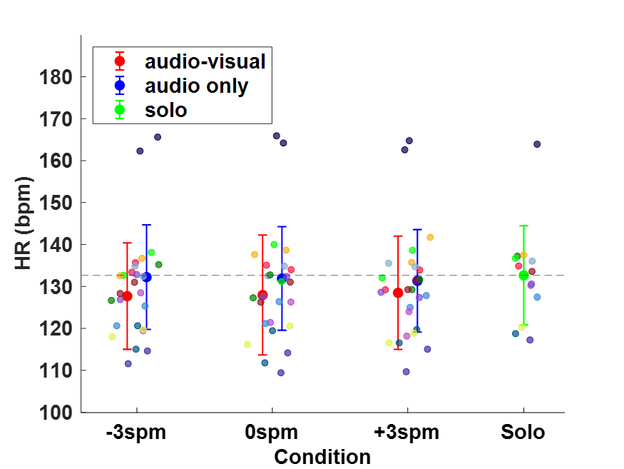
Figure S2. HR for the single and other conditions. The horizontal dashed line is the mean value in solo condition. The audio-only condition did not have a higher HR than solo condition, and the gaze from the backward runner in audio-only condition did not increase the HR.

