Supplementary Tables

Supplementary Table S1. Proportion of test set samples with high enzyme similarity (99–100%) to those in the training set for the first category of methods, which utilize only enzyme and single-substrate information.
Methods | Total number of samples | Number of high-similarity samples (99-100%) | Proportion
DLKcat | 1684 | 1536 | 91.2%
UniKP | 1684 | 1536 | 91.2%
DLTKcat | 2164 | 2014 | 93.1%
DeepEnzyme | 1193 | 1114 | 93.4%

Supplementary Figures
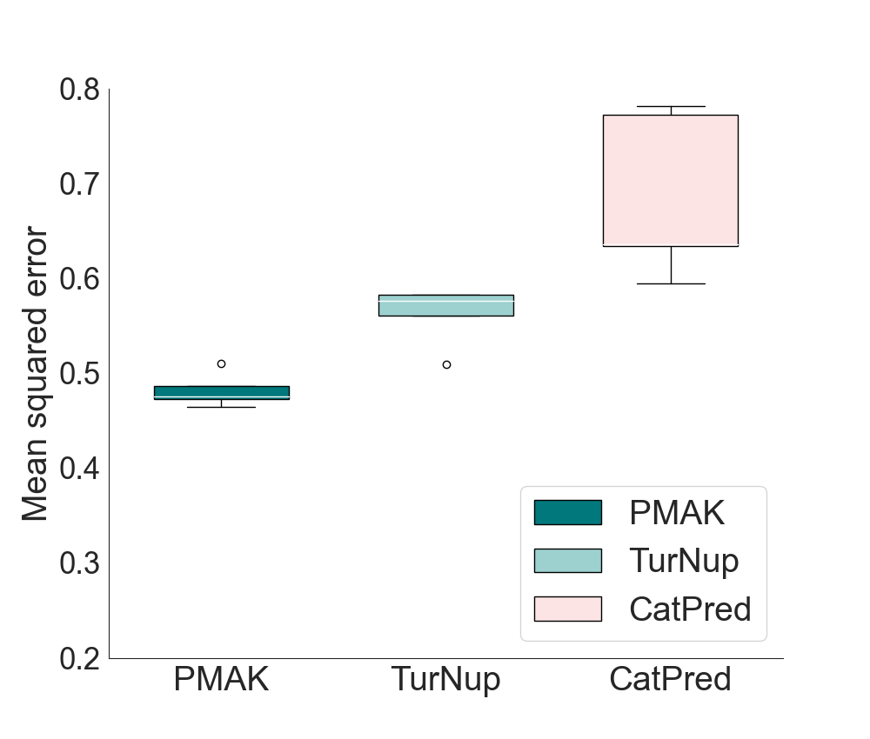
Supplementary Figure S1. Comparison of MSE between PMAK, TurNup and CatPred on the test sets, generated through five random splits under warm-start conditions.

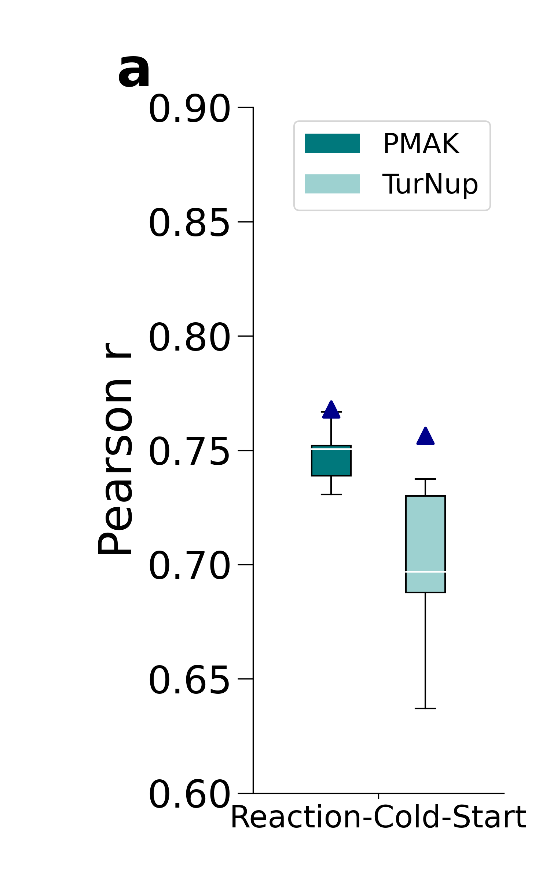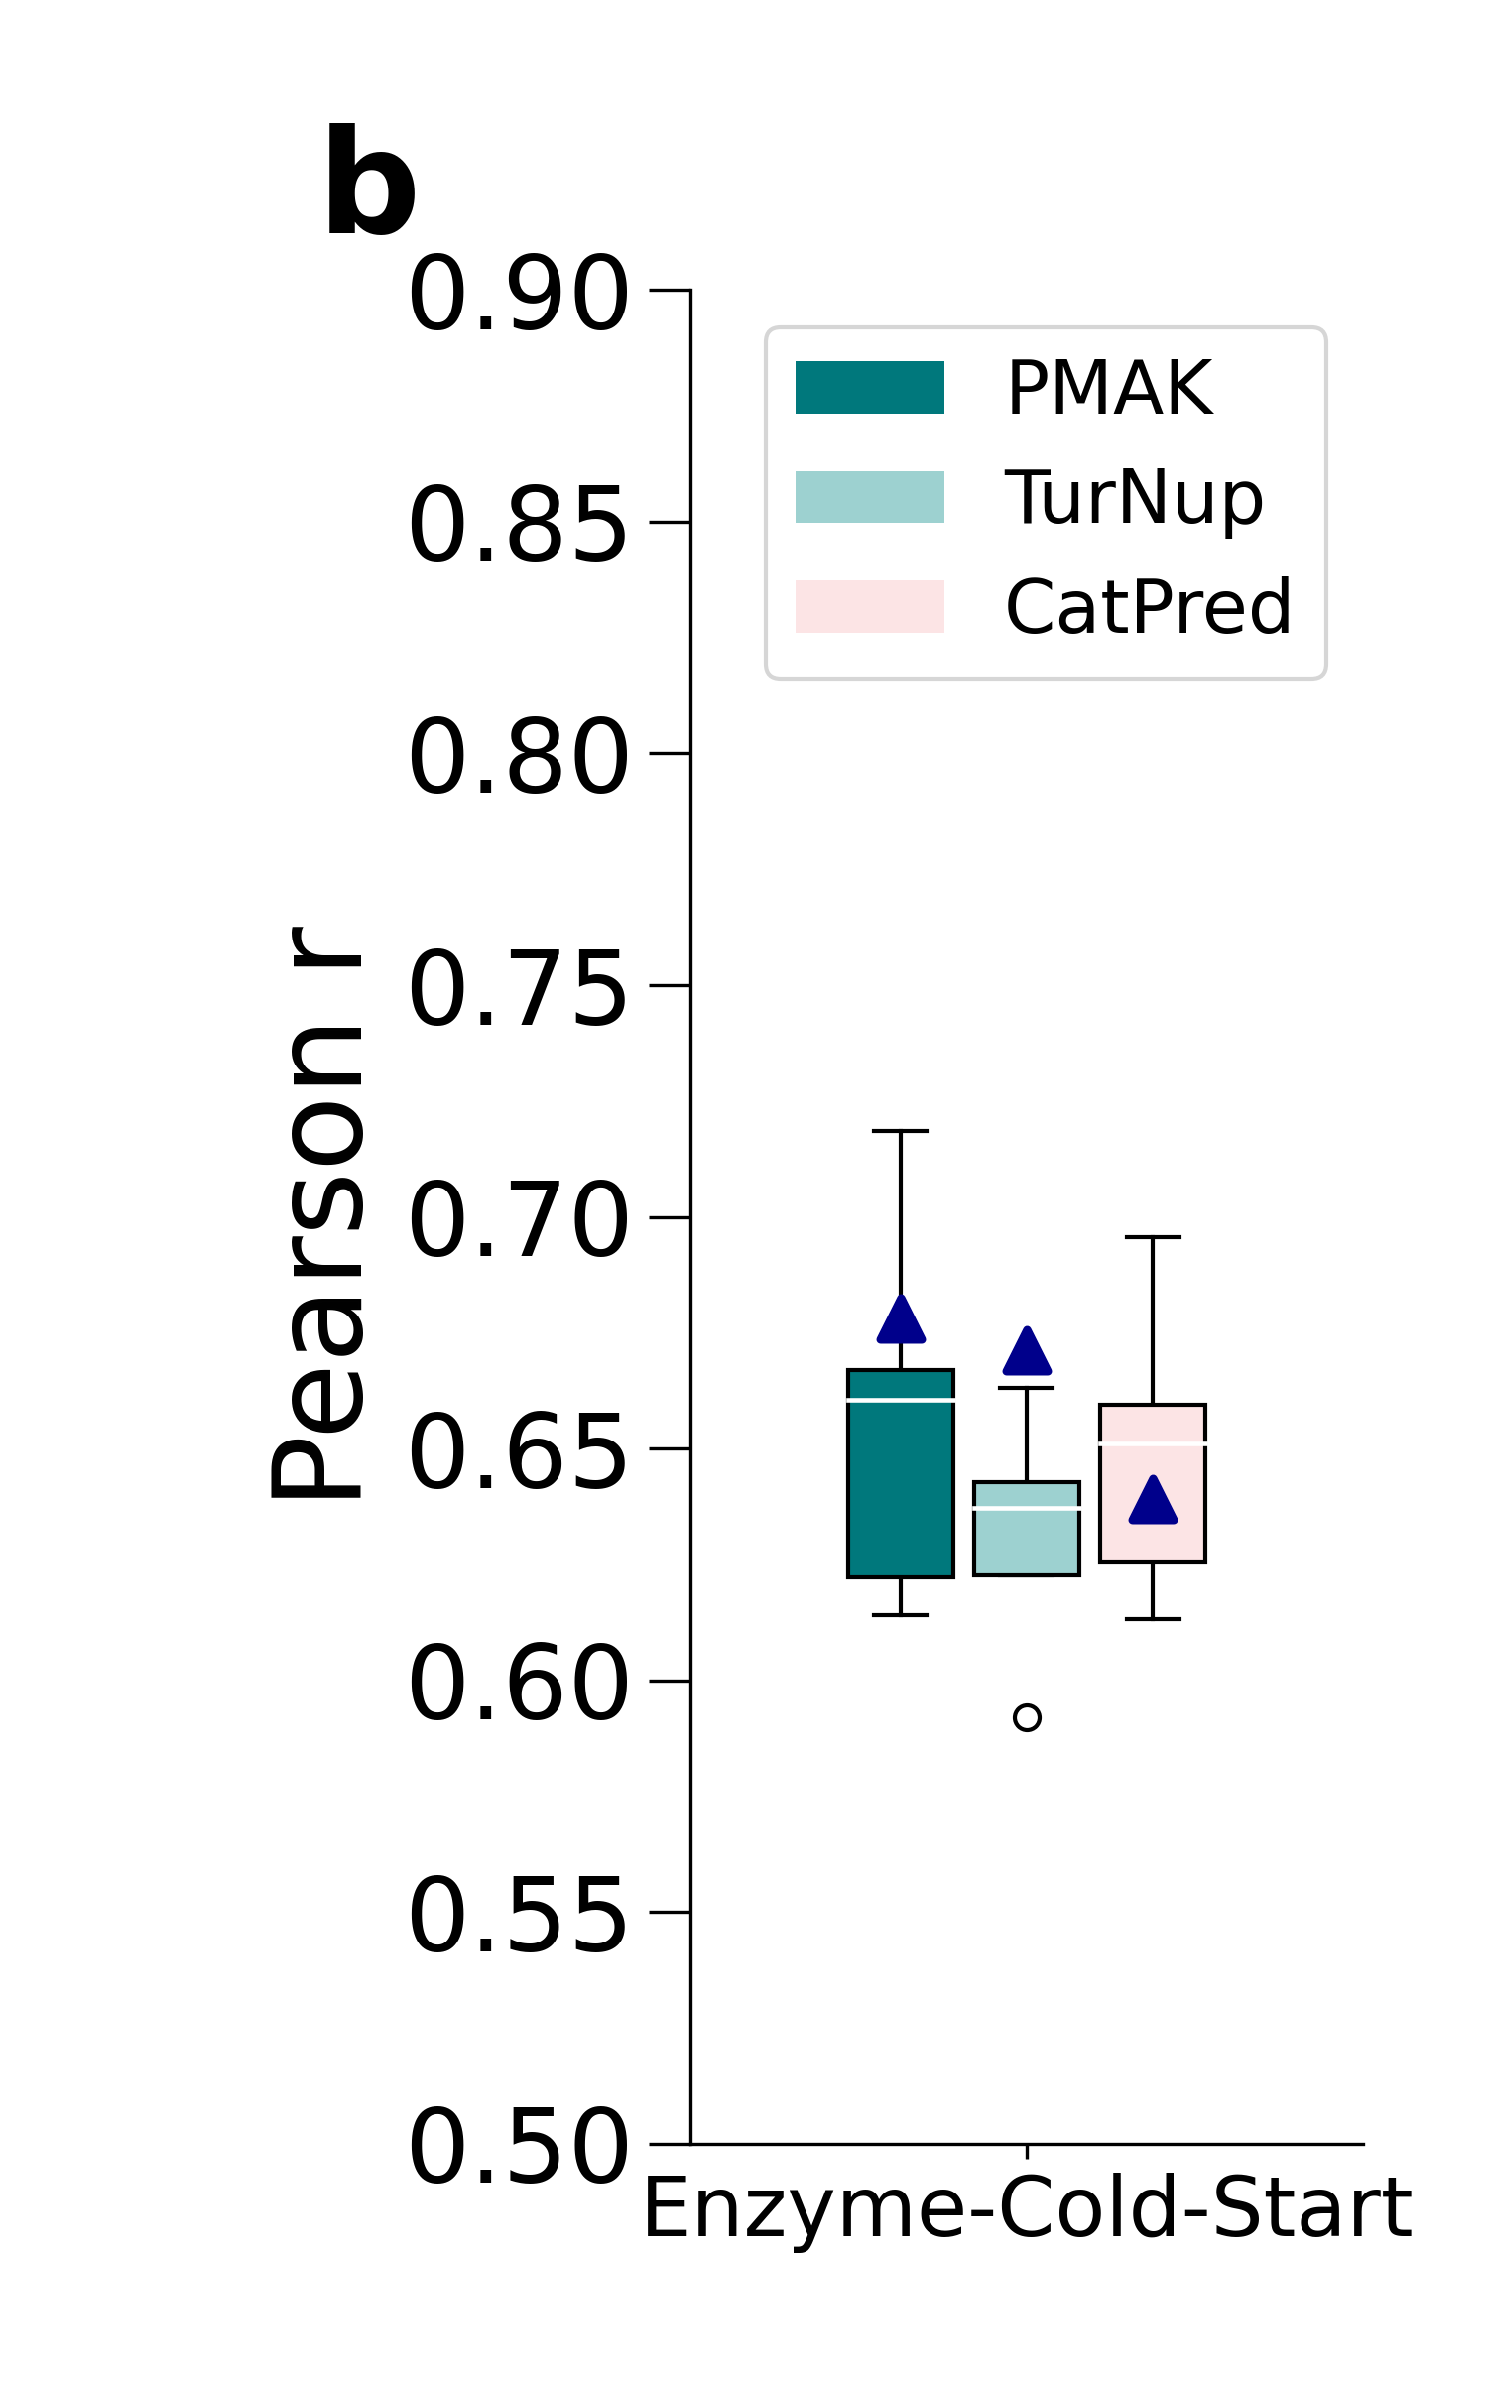
Supplementary Figure S2. a. Comparison of Pearson Correlation Coefficient (PCC) for PMAK and TurNup on the test set under the cold-start experiments for reactions. b. Comparison of Pearson Correlation Coefficient (PCC) for PMAK, TurNup and CatPred on the test set under the cold-start experiments for enzymes.

