APPENDIX

Table A1. Unadjusted association between characteristics and mental health (continuous outcomes)

Variables | GAD-7 score |  | PHQ-9 score
Variables | Beta [95%CI] | p | Beta [95%CI] | p
Demographic/academic characteristics
Age group (n = 624)
<25-34 | reference |  | reference
35-59 | 0.46 [-1.03, 1.96] | 0.5430 | 0.25 [-1.28,1.77] | 0.7510
60-65+ | -0.80 [-2.74, 1.13] | 0.4140 | -1.17 [-3.14,0.80] | 0.2440
Gender (n = 624)
Male | reference |  | reference
Female | 0.30 [-0.71, 1.30] | 0.5600 | 0.30 [-0.72, 1.32] | 0.5680
Non-binary / third gender | -0.06 [-3.99, 3.87] | 0.9750 | 1.10 [-2.90, 5.10] | 0.5900
Prefer not to say | -0.42 [-3.51, 2.67] | 0.7910 | -0.97 [-4.11, 2.18] | 0.5470
Academic Level (n = 624)
Sessional/Casual/Adjunct | reference |  | reference
Lecturer/Level A | 0.39 [-1.88, 2.65] | 0.7390 | 0.53 [-1.79, 2.84] | 0.6540
Lecturer/Level B | 0.56 [-1.25, 2.38] | 0.5400 | 0.21 [-1.64, 2.06] | 0.8230
Senior Lecturer/Level C | 1.18 [-0.65, 3.01] | 0.2060 | 0.93 [-0.94, 2.80] | 0.3290
Associate Professor/Level D | 2.11 [0.12, 4.10] | 0.0370 | 1.45 [-0.58, 3.47] | 0.1610
Professor/Level E | -0.96 [-3.32, 1.41] | 0.4270 | -1.65 [-4.06, 0.77] | 0.1810
Type of employment (n = 624)
Full Time | reference |  | reference
Part Time | -0.03 [-1.51, 1.44] | 0.9640 | -0.46 [-1.97, 1.05] | 0.5480
Sessional/Casual/Adjunct Academic | -1.05 [-2.74, 0.65] | 0.2250 | -0.96 [-2.68, 0.76] | 0.2750
Number of academic working years (n = 624)
1-9 years | reference |  | reference
10-14 years | -0.05 [-1.25, 1.14] | 0.9280 | -0.34 [-1.55, 0.88] | 0.5830
15 years or more | 0.34 [-0.72, 1.40] | 0.5260 | 0.28 [-0.80, 1.36] | 0.6160
Workload
Total teaching & HDR hours (n = 405) | 0.001 [0.0009, 0.0019] | <0.0001 | 0.001 [0.0007, 0.0018] | <0.0001
Total research hours (n = 335) | 0.0001 [-0.0004, 0.0007] | 0.6530 | -0.0003 [-0.0009, 0.0002] | 0.2330
Total service hours (n = 406) | 0.0019 [0.0005, 0.0034] | 0.0070 | 0.0018 [0.0003, 0.0033] | 0.0180
Adjusted total hours (n = 406) | 0.0006 [0.0004, 0.0009] | <0.0001 | 0.0005 [0.0002, 0.0008] | <0.0001

Table A2. Unadjusted association between characteristics and mental health (binomial outcomes)

Variables | Binomial GAD-7 |  | Binomial PHQ-9
Variables | OR [95%CI] | p | OR [95%CI] | p
Demographic/academic characteristics
Age group (n = 624)
<25-34 | reference |  | reference
35-59 | 1.29 [0.70, 2.38] | 0.4070 | 0.71 [0.41, 1.23] | 0.2190
60-65+ | 0.60 [0.25, 1.41] | 0.2380 | 0.28 [0.12, 0.66] | 0.0040
Gender (n = 624)
Male | reference |  | reference
Female | 1.10 [0.74, 1.63] | 0.6410 | 1.01 [0.68, 1.51] | 0.9440
Non-binary / third gender | 1.59 [0.38, 6.59] | 0.5260 | 2.47 [0.64, 9.56] | 0.1910
Prefer not to say | 0.79 [0.21, 2.93] | 0.7270 | 0.77 [0.21, 2.85] | 0.6960
Academic Level (n = 624)
Sessional/Casual/Adjunct | reference |  | reference
Lecturer/Level A | 1.33 [0.52, 3.40] | 0.5460 | 1.18 [0.47, 2.96] | 0.7210
Lecturer/Level B | 1.26 [0.59, 2.71] | 0.5500 | 0.94 [0.44, 2.00] | 0.8770
Senior Lecturer/Level C | 1.38 [0.64, 2.99] | 0.4090 | 1.41 [0.67, 2.97] | 0.3630
Associate Professor/Level D | 1.91 [0.85, 4.30] | 0.1180 | 1.62 [0.73, 3.57] | 0.2350
Professor/Level E | 0.89 [0.32, 2.50] | 0.8230 | 0.67 [0.23, 1.91] | 0.4560
Type of employment
Full Time (n = 624) | reference |  | reference
Part Time | 1.02 [0.57, 1.80] | 0.9580 | 0.96 [0.54, 1.72] | 0.8920
Sessional/Casual/Adjunct Academic | 0.62 [0.29, 1.30] | 0.2040 | 0.72 [0.35, 1.47] | 0.3640
Number of academic working years
(n = 624)
1-9 years | reference |  | reference
10-14 years | 0.82 [0.51, 1.33] | 0.4290 | 0.79 [0.49, 1.29] | 0.3450
15 years or more | 1.07 [0.71, 1.62] | 0.7350 | 1.05 [0.70, 1.58] | 0.8180
Workload
Total teaching & HDR hours (n = 405) | 1.0004 [1.0002, 1.0006] | <0.0001 | 1.0003 [1.0001, 1.0005] | 0.0050
Total research hours (n = 335) | 0.99 [0.99, 1.0002] | 0.6890 | 1.00 [0.99, 1.0002] | 0.9860
Total service hours (n = 406) | 1.00 [0.99, 1.001] | 0.0780 | 1.00 [0.99, 1.001] | 0.1120
Adjusted total hours (n = 406) | 1.0001 [1.00003, 1,0002] | 0.0110 | 1.0001 [1.00003, 1.0002] | 0.0090

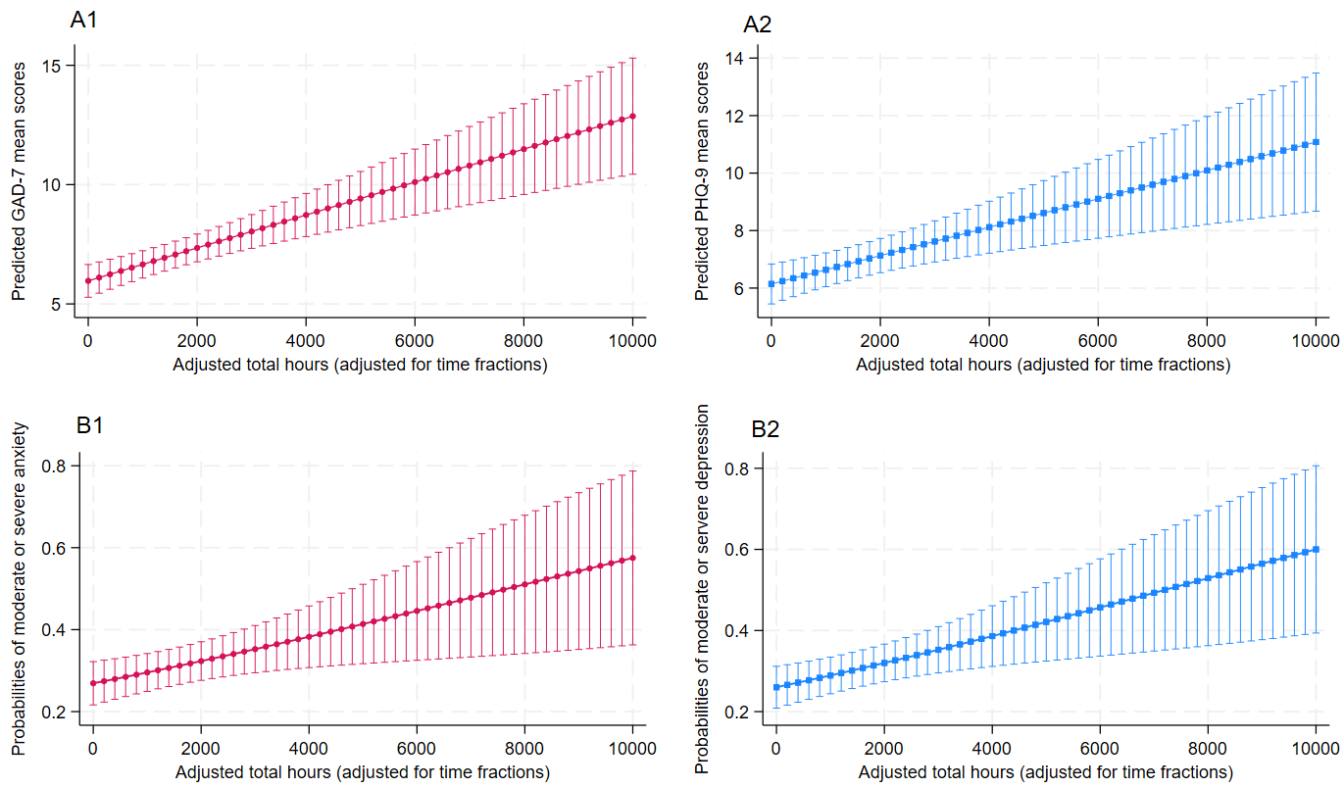

Figure A1. Adjusted association between workload (total working hours) and mental health outcomes as per standard regression approach

