Supporting information for:
Revealing More with Less: Dose Efficiency in Electron Imaging
Anastasios Pateras,^{1, *} Luc J. Bourhis,² Roger Durst, ³ Niels de Jonge,³ and Henry N. Chapman,^{1, 4 ,5}
¹Center for Free-Electron Laser Science CFEL, Deutsches Elektronen-Synchrotron DESY, Notkestrasse 85, 22607 Hamburg, Germany
²Bruker AXS–SAS, 4 Allée Lorentz, 77447 Marne-la-Vallée cedex 2, France
³Bruker AXS GmbH, Östliche Rheinbrückenstrasse 49, 76187 Karlsruhe, Germany
⁴Department of Physics, Universität Hamburg, Luruper Chaussee 149, 22761 Hamburg, Germany
⁵The Hamburg Centre for Ultrafast Imaging, Luruper Chaussee 149, 22761 Hamburg, Germany
KEYWORDS: electron dose, coherent electron diffractive imaging, electron ptychography, phase-retrieval, high-resolution transmission electron microscopy.

- Dose considerations due to overlapping
In this section we will estimate how scanning the sample over overlapping areas with a focused nanobeam affects the total number of electrons scattered by the sample and contributing to its gradual degradation due to the radiation damage phenomena discussed in the main text of this manuscript. The work of Vijayakumar et al. has already provided a quantitative answer assuming the beam shape is a disk with the intensity distribution fully homogenous over its entire area [1]. Using simple geometric considerations, they showed that the total deposited dose with respect to a single illumination as a function of the beam overlap can be calculated with the use of a finite series over all the ptychography scan positions.
We show below that by considering a square beam surface and the ratio of the area of the disk over the area of its corresponding enclosing square we obtain identical results with the use of the simple Eq. (S6) instead of calculating a finite series.
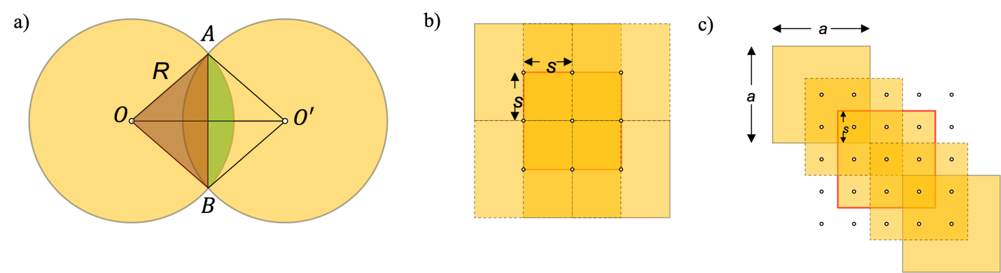

Figure S1. a) Schematic of two overlapping disks of radius R. The area between the two intersecting circles is colored green and corresponds to the areas that are illuminated more than once during a ptychography scan. b) Scanning with a square beam and an overlap of 50% over a 33 grid. c) Scanning with a square beam and an overlap of 2/3 $≈$ 67%.

Generally, the area of two intersecting disks of the same radius $R$ can be calculated with the use of Euclidean geometry, by subtracting the area of one of the triangles formed by one disk center and the points where the disks are intersecting (e. g. $⊿OAB$), from the area of the corresponding circular sector (e. g. $⌔OAB$), as shown in Fig. S1a). The result should then be multiplied by two to obtain the total area of overlap [2]. Thus,
$$S=2\left(S_{⌔OAB}-S_{⊿OAB}\right)=2R^{2}\cos^{-1}\left[\frac{\left(OO'\right)}{2R}\right]-\frac{\left(OO^{'}\right)}{2}\sqrt{4R^{2}-{\left(OO^{'}\right)}^{2}} (S1)$$
To calculate the total deposited dose, one has to know the centers of each disk illumination and sum the area of overlap for each pair of illuminations who are intersecting with each other. This translates to calculating a finite mathematical series. We show below that we can obtain the same result with excellent accuracy deriving a simple formula for an illumination of square shape and correcting with respect to a disk area.
For the calculation we assume a square shape beam with side $a$, which we are going to scan with a step $s$, where $a=2s$, for an overlap of 50%, thus, we will have three steps in each direction until our beam stops illuminating the central square, as illustrated in Fig. S1b). If we calculate the total area of overlap for the central square in this configuration we have
$$A_{2s}=s^{2}+2s^{2}+s^{2}+2s^{2}+4s^{2}+2s^{2}+s^{2}+2s^{2}+s^{2}=16s^{2}=2^{2}{\left(2s\right)}^{2} (S2)$$
For $a=3s$, we need to take five steps in each direction until the central square stops getting any deposited electrons, shown in Fig. S1c). Thus,
$$A_{3s}=s^{2}+2s^{2}+3s^{2}+2s^{2}+s^{2}+2s^{2}+4s^{2}+6s^{2}+4s^{2}+2s^{2}+3s^{2}+6s^{2}+9s^{2}+6s^{2}+3s^{2}+2s^{2}+4s^{2}+6s^{2}+4s^{2}+2s^{2}+s^{2}+2s^{2}+3s^{2}+2s^{2}+s^{2}=81s^{2}=3^{2}{\left(3s\right)}^{2} (S3)$$
Similarly, for $a=4s$, we can show that
$$A_{4s}=256s^{2}=4^{2}{\left(4s\right)}^{2} (S4)$$
and ultimately, for $a=ms, ∀ m∈N$, we obtain the formula
$$A_{ms}=m^{2}{\left(ms\right)}^{2} (S5).$$
We can directly write the above result with respect to the value of overlap by substitution in the definition of the overlap, given by Eq. (2) from the main text
$$O=1-\frac{s}{a}=\frac{ms-s}{m\text{s}}⇒O=\frac{m-1}{m} (S6)$$
To account for the disk-shaped beam employed in our simulations and most likely used in reality, we multiply our result with the ratio of the area of a disk of radius $R$ to the area of a square of side $a=2R$, which is $a_{ratio}=\frac{πR^{2}}{{\left(2R\right)}^{2}}=\frac{π}{4}=$ 0.786. We compare the result obtained from our simple approach to the calculation of the series in Fig. S2. Each transparent blue disk-shaped marker plotted in Fig. S2a) was calculated using Eq. (S6) for each integer value of $m≤10$ and the result was multiplied with the $a_{ratio}$. Similarly, the blue disk markers were calculated with the use of Eq. (S1), after iteratively summing each area of overlapping beam-disks. This means that for each pair of disks, the distance of their centers is calculated and compared with the disk diameter, so that for every pair the distance is smaller than the beam diameter, $\left(OO^{'}\right)<2R$, the overlapping area is added to the total area.
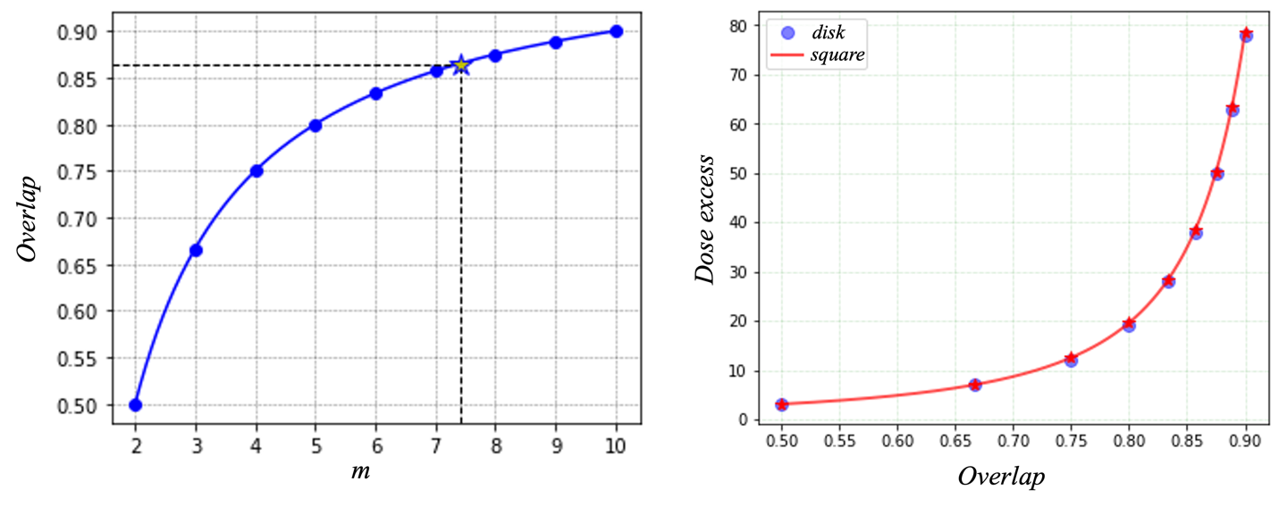
Figure S2. a) Value of overlap as a function of the ratio of the beam size over the step size. Smaller step sizes mean that a larger number of steps $m$ is needed for the illumination to exit the central area shown in Fig. S1b)-c). b) Dose excess as a function of beam overlap. In both figures, the markers correspond to values calculated for integer values of $m$ ($m∈N$).

The red curve including the star markers were obtained using Eq. (S5) for the case of a square-shaped illumination and multiplied with 0.786 as explained previously. The result is a direct comparison between the typical scanning mode of SEM where there is no overlap for adjacent illuminated regions of the specimen and ptychography scans with different values of overlap between adjacent beams. Thus, a ptychography scan will deposit total doses multiple times larger than those in SEM for the same levels of exposure per illumination, so in order to keep the value of the total deposited dose equal, the exposure for each ptychography diffraction pattern should be reduced.

- Aberrated and aberration-corrected HRTEM

Figure S3. a) Contrast transfer function for a lens with (C_{s}=7×10⁻³ mm) and without (C_{s}=1 mm) aberration correction at the Scherzer defocus. The calculations correspond to a value of 50 Å of focal spread. b) Simulated transmission electron microscopy images for electron doses of 20 e⁻/Å² and 100 e⁻/Å², with (AC) and without aberration correction (NAC).

- Estimation of the resolution
To estimate the resolution of our images for each of the three employed imaging methods, we calculated the cross-section of the ½-bit and 1-bit criterion with the Fourier shell correlation (FSC). [3]

Figure S4. CDI reconstructed images as a function of dose from two independent noisy datasets and their calculated power spectra.

Figure S5. Ptychography reconstructed images as a function of dose from two independent noisy datasets and their calculated power spectra.

Figure S6. HRTEM images without aberration correction as a function of dose and their calculated power spectra.

References
[1] J. Vijayakumar, H. Yuan, N. Mille, S. Stanescu, S. Swaraj, V. Favre-Nicolin, E. Najafi, A. P. Hitchcock, and R. Belkhou, Soft X-Ray Spectro-Ptychography of Boron Nitride Nanobamboos, Carbon Nanotubes and Permalloy Nanorods, J Synchrotron Rad 30, (2023).
[2] R. Kürsten, S. Stroteich, M. Z. Hernández, and T. Ihle, Multiple Particle Correlation Analysis of Many-Particle Systems: Formalism and Application to Active Matter, Phys. Rev. Lett. 124, 088002 (2020).
[3] M. van Heel and M. Schatz, Fourier Shell Correlation Threshold Criteria, Journal of Structural Biology 151, 250 (2005).
[4] H. Y. Liao and J. Frank, Definition and Estimation of Resolution in Single-Particle Reconstructions, Structure 18, 768 (2010).

