Supplementary figures
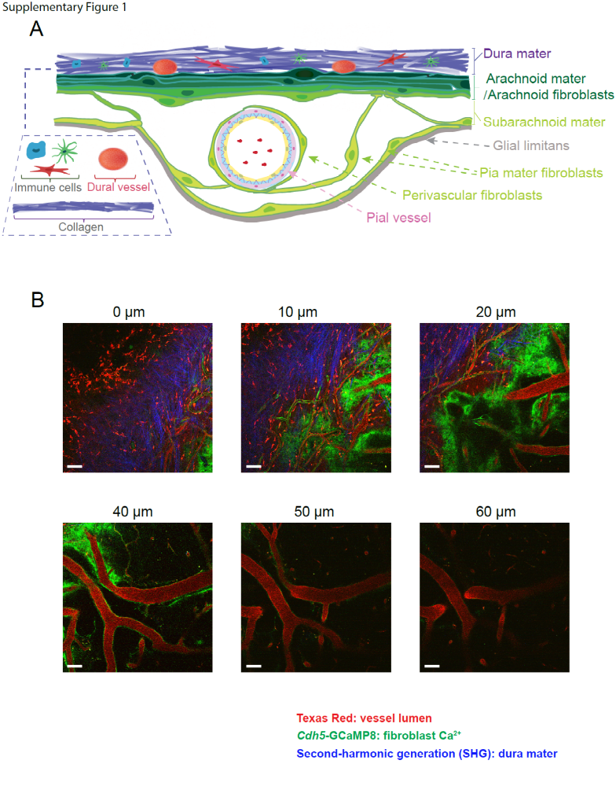
Supplementary Figure 1. Diagram and two-photon microscopy of leptomeningeal fibroblasts. (A) Diagram of locations and morphologies of each leptomeningeal FB subgroups. (B) x-y plane TPM images at different cortical depths. Red: i.v. injection of Texas Red for vessel lumen. Green: Cdh5-GCaMP8. Blue: second harmonic generation (SHG) for collagen. Scale bar: 50 μm.

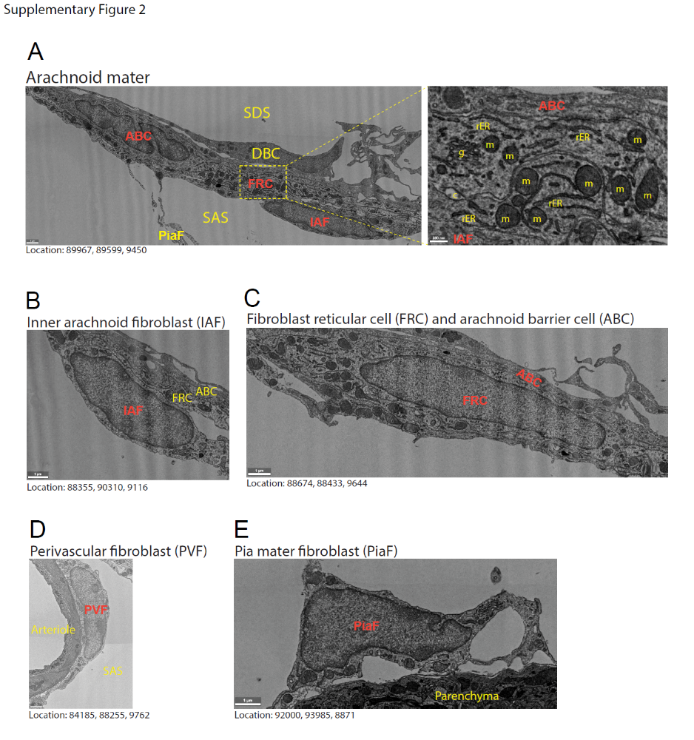
Supplementary Figure 2. Ultrastructures of leptomeningeal FB subgroups based on EM data. (A) Showing the ultrastructure of cells forming the arachnoid mater separating the subarachnoid space (SAS) from the subdural space (SDS). Processes of pia mater FBs (PiaF) or inner arachnoid FBs (IAF) form trabeculae that cross the SAS. The IAFs form the inner lining of the arachnoid mater, adhering to the FB reticular cells (FRC). Morphologically, it is difficult to distinguish PiaFs, IAFs and perivascular FBs (PVFs), so their identities are based on the location of their nuclei. FRCs are distinguishable by their high content of rough endoplasmic reticulum (rER) and a large mitochondrial (m) network. Collagen (c) strands form a matrix of intercellular channels in the FRC layer that is connected with the subpial collagen matrix via larger collagen fibers. Arachnoid barrier cells (ABCs) cover a large area and often have more than one nucleus (this ABC has 2 nuclei). They have thin processes that overlap other ABC processes tightly and have no collagen strands or channels crossing them, forming a diffusion barrier. The FRCs adhere to ABCs. In some places, remnants of the removed dura in the form of dural border cells (DBC) loosely attach to the ABCs. Golgi apparatus (g). Scale bar: 1 μm. Inset: 300 nm. (B-E) Showing close-up examples of the different cell types of the leptomeninges. Scale bar: 1 μm. Notice how PVF, PiaF, and IAF which line the SAS have a similar morphology, while FRCs have more rER and mitochondria. Locations indicate coordinates in the dataset accessible at www.microns-explorer.org

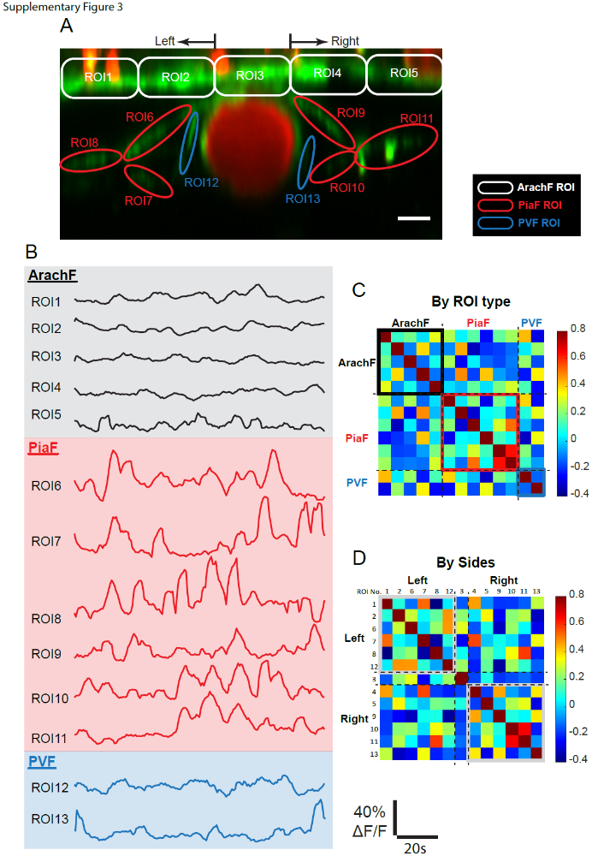
Supplementary Figure 3. Uncorrelated fibroblast Ca²⁺ activities in a representative two-photon recording. (A) x-z plane TPM image. Red channel: Texas Red for vessel lumen. Green channel: Cadherin5-GCaMP8. ROIs at each fibroblast (FB) subgroup are marked with different colors and sequential numbers. Scale bar: 10 μm. (B) Measured Ca²⁺ activities at each ROI. (C) Heat map of correlation coefficient sorted by FB subgroups. (D) Heat map of correlation coefficient sorted by ROI spatial proximity.

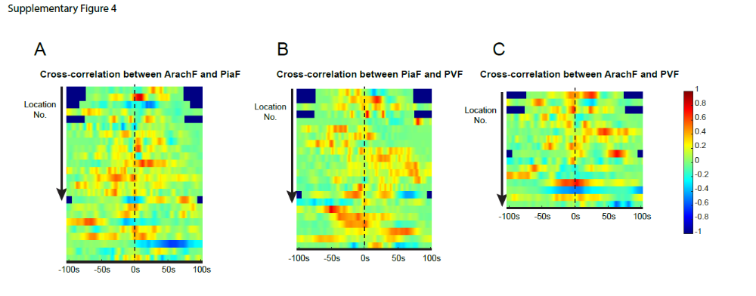
Supplementary Figure 4. Uncorrelated fibroblast Ca²⁺ activities by paired fibroblast subgroups. (A) Heat map of cross-correlation between ArachF and PiaF. The X-axis represents the time delay of the cross-correlation of each pair of traces. The y-axis represents location number. (B) Heat map of cross-correlation between PiaF and PVF. (C) Heat map of cross-correlation between ArachF and PVF.

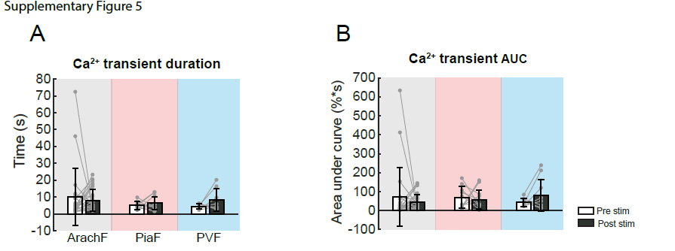

Supplementary Figure 5. Comparison of fibroblast Ca²⁺ transients before and after whisker air puff. (A) Comparison of Ca²⁺ transient duration before and after air-puff stimulation. (B) Comparison of Ca²⁺ transient area under the curve (AUC) before and after air-puff stimulation. (ArachF: N = 4 mice, n = 9 locations, n′ = 29 trials; PiaF: N = 3 mice, n = 8 locations, n′ = 13 trials; PVF: N = 4 mice, n = 7 locations, n′ = 8 trials.) Bar plots are presented as the mean ± s.t.d. Linear mixed-effect models were used, followed by Tukey post hoc tests for pairwise comparisons. * p < 0.05, ** p < 0.01, *** p < 0.001.

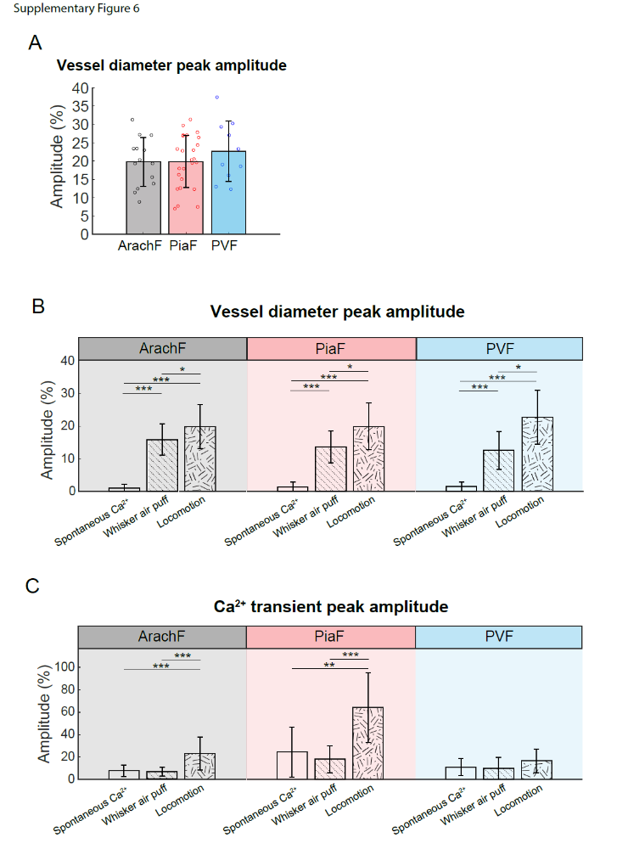
Supplementary Figure 6. Summary of the Ca²⁺ profiles and co-localized vessel diameter change at three fibroblast subgroups. (A) Comparison of locomotion-induced vessel diameter change at each fibroblast (FB) subgroup, focusing on peak amplitude. (ArachF: N = 5 mice, n = 7 locations, n′ = 35 trials; PiaF: N = 6 mice, n = 9 locations, n′ = 25 trials; PVF: N = 4 mice, n = 8 locations, n′ = 10 trials.) (B-C) Comparison across three scenarios: spontaneous Ca²⁺, whisker air puff, and locomotion. Peak amplitude of vessel diameter (B) and Ca²⁺ transients at each FB subgroups are compared. Bar plots are presented as the mean ± s.t.d. Linear mixed-effect models were used, followed by Tukey post hoc tests for pairwise comparisons. * p < 0.05, ** p < 0.01, *** p < 0.001.

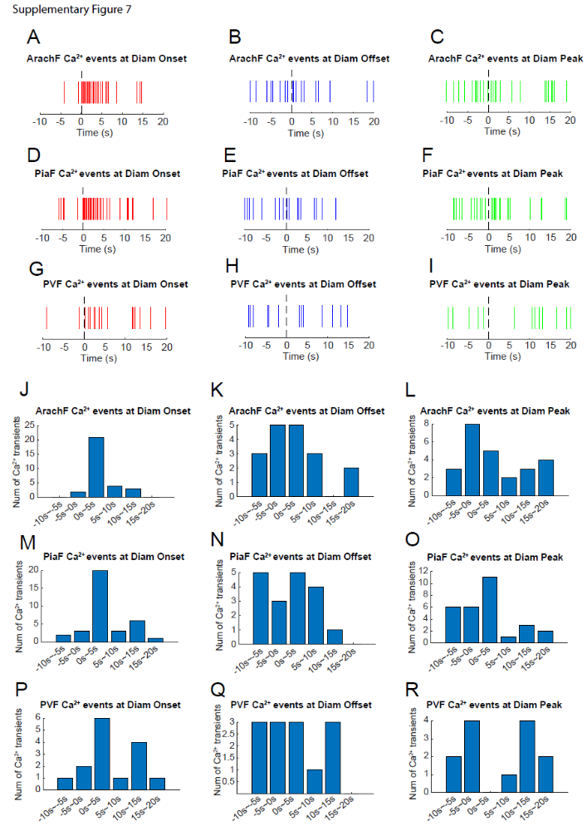
Supplementary Figure 7. Locomotion-induced fibroblast Ca²⁺ transients occur predominantly with vessel diameter onset. (A-I) The onset of each Ca²⁺ transient is digitized as a vertical line, and overlaid at different time points of vessel diameter change, i.e. vasodilataion onset, peak and offset time. Each row represents each FB subgroup, with ArachF, PiaF and PVF respectively. Each column represents different time points of vasodilation, with onset, peak time and offset respectively. (J-R) are summarized bar plots based on (A-I). The height of bars represent the number of Ca²⁺ transients, x-axis represents the multiple 5-second-width windows before and after each vasodilation time point. 0s are the moment of occurrence of onset, peak, and offset of vasodilation, respectively. (ArachF: N = 5 mice, n = 7 locations, n′ = 35 trials; PiaF: N = 6 mice, n = 9 locations, n′ = 25 trials; PVF: N = 4 mice, n = 8 locations, n′ = 10 trials.)
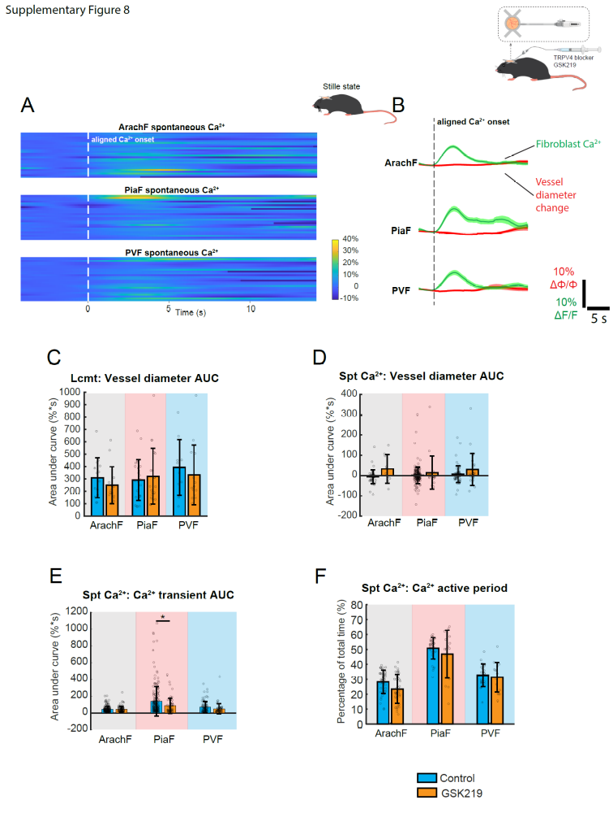
Supplementary Figure 8. TRPV4 channel blocker GSK219 alters fibroblast Ca²⁺ profiles. (A) After administration of GSK219, heat maps of spontaneous Ca²⁺ transients at each FB subgroup, by aligning Ca²⁺ onsets. x-axis: time. Y-axis: trace number. (B) Overlaid Ca²⁺ and vessel diameter traces for each FB subgroups after GSK219. The shadow represents s.e.m. of all traces. (C) Comparison of locomotion-induced Ca²⁺ responses without or with intracortical infusion of GSK219, focusing on the area under the curve of vessel diameter change. (D-F) Comparison of spontaneous Ca²⁺ transients without or with intracortical infusion of GSK219, focusing on (D) area under the curve of vessel diameter change, (E) area under the curve of Ca²⁺ transients, and (F) Ca²⁺ transient active period. (GSK219 spontaneous Ca²⁺ -ArachF: N = 5 mice, n = 11 locations, n′ = 93 events; PiaF: N = 5 mice, n = 11 locations, n′ = 63 events; PVF: N = 5 mice, n = 11 locations, n′ = 61 events.) (GSK219 locomotion - ArachF: N = 4 mice, n = 11 locations, n′ = 38 trials; PiaF: N = 3 mice, n = 9 locations, n′ = 21 trials; PVF: N = 3 mice, n = 10 locations, n′ = 14 trials.) Linear mixed-effect models were used, followed by Tukey post hoc tests for pairwise comparisons. * p < 0.05, ** p < 0.01, *** p < 0.001.
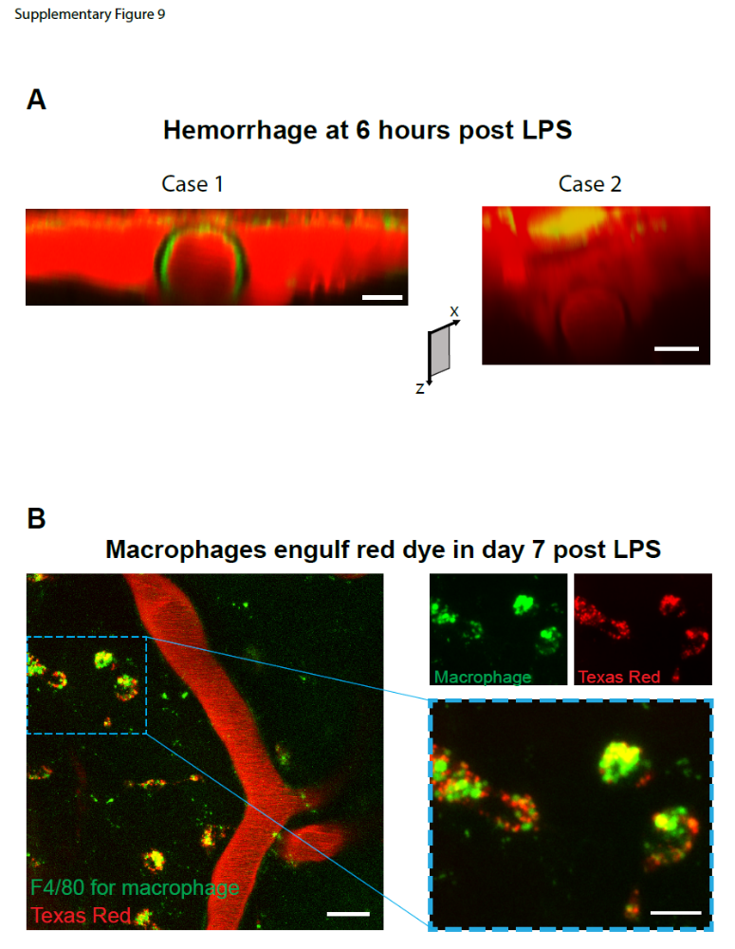
Supplementary Figure 9. LPS-associated systemic inflammation leads to disruption of the blood-brain barrier in the leptomeninges. (A) Six hours after i.p. injection of LPS, almost all the examined mice experienced dye leakage (red cloud) in the leptomeninges, likely due to the disrupted blood-brain barrier by systemic inflammation. This situation severely affects the imaging quality of FB Ca²⁺ signals. x-z plane two-photon image. Scale bar: 20 μm. (B) The leaked red dye is taken up by leptomeningeal macrophages. Green: F4/80-Alexa488 antibody to stain macrophages. Texas red: red vessel lumen dye. Left panel: large-scale x-y TPM image. Scale bar: 25 μm. Right panel: zoomed-in image of a local region. Red and green channels are co-localized but not overlaid. Scale bar: 10 μm.
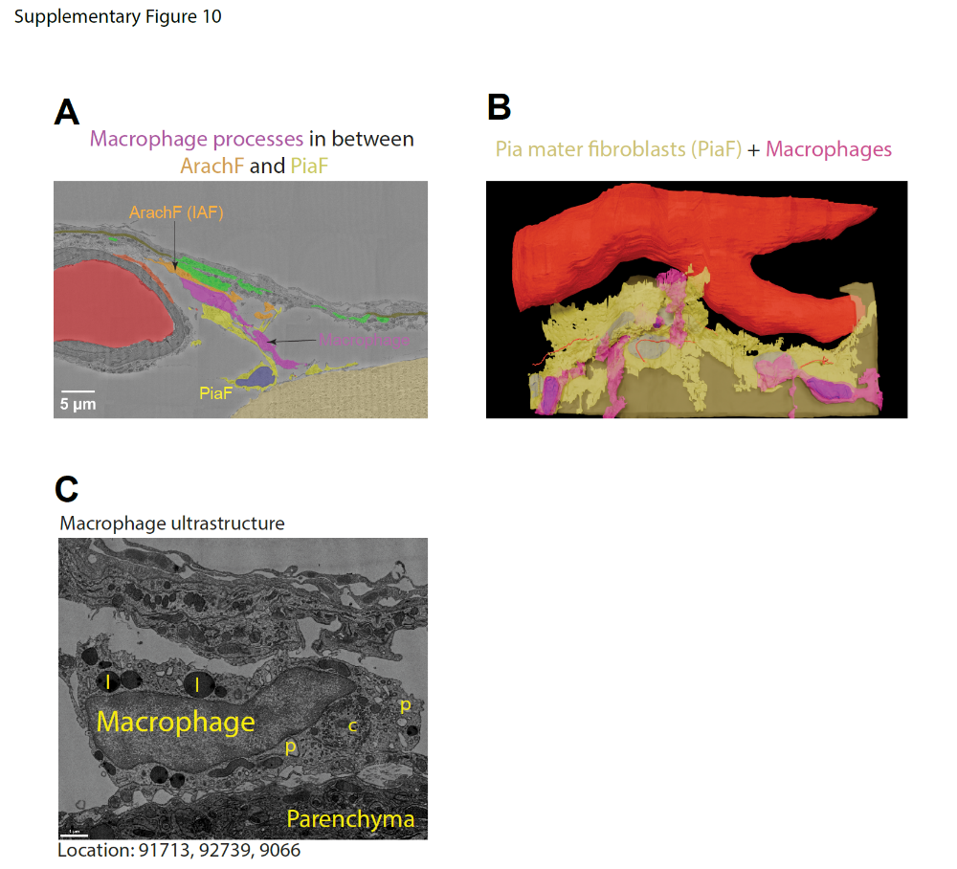
Supplementary Figure 10. Ultrastructure of leptomeningeal fibroblasts and macrophages. (A) The ultrastructure data shows how macrophage processes can be localized between the ArachF and PiaF processes. (B) 3D segmentation shows 3 macrophages that are either on top of the PiaFs or in between them. (C) Macrophages are recognized by their many lysosomes (l) and phagosomes (p), but also by the absence of primary cilia and the centrioles (c) located in the center of the Golgi apparatus. Location indicates coordinates in the dataset accessible at www.microns-explorer.org.
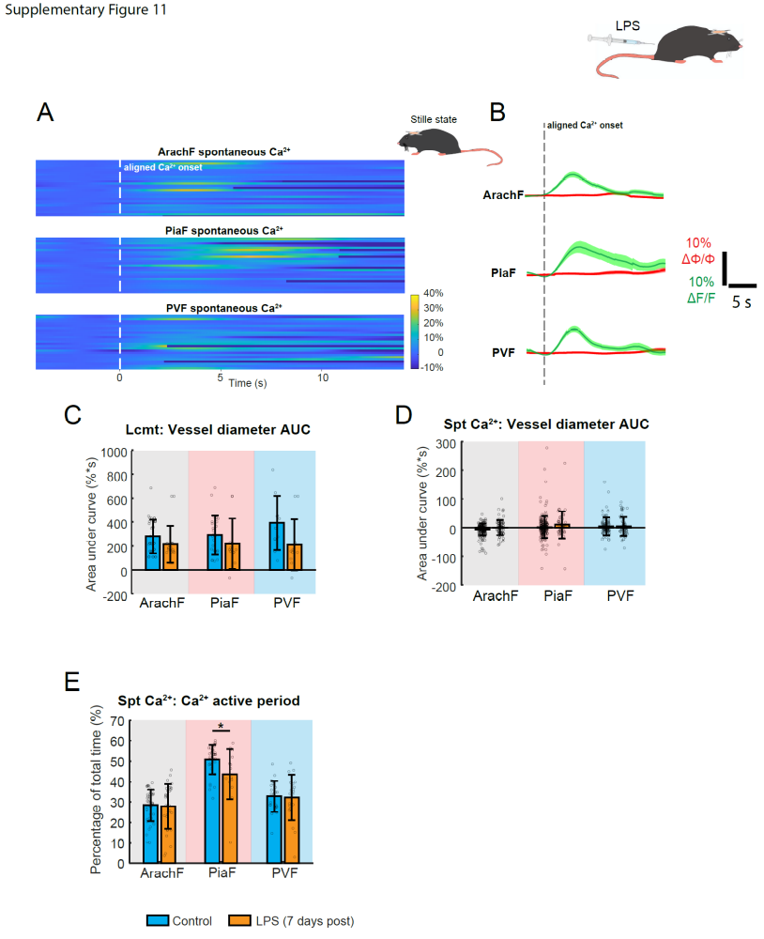
Supplementary Figure 11. LPS-associated systematic inflammation alters fibroblast Ca²⁺ profiles. (A) Seven days after administration of LPS, heat maps of spontaneous Ca²⁺ transients at each FB subgroup were aligned by Ca²⁺ onsets. x-axis: time. Y-axis: trace number. (B) Overlaid Ca²⁺ and vessel diameter traces for each FB subgroups after LPS. The shadow represents s.e.m. of all traces. (C) Comparison of locomotion-induced Ca²⁺ responses without or with LPS, focusing on the area under the curve of vessel diameter change. (D-E) Comparison of spontaneous Ca²⁺ transients without or with LPS, focusing on (D) area under the curve of vessel diameter change and (E) Ca²⁺ transient active period. (LPS spontaneous Ca²⁺ -ArachF: N = 3 mice, n = 9 locations, n′ = 80 events; PiaF: N = 3 mice, n = 8 locations, n′ = 46 events; PVF: N = 3 mice, n = 11 locations, n′ = 62 events.) (LPS locomotion - ArachF: N = 3 mice, n = 7 locations, n′ = 18 trials; PiaF: N = 3 mice, n = 7 locations, n′ = 11 trials; PVF: N = 3 mice, n = 8 locations, n′ = 11 trials.) Linear mixed-effect models were used, followed by Tukey post hoc tests for pairwise comparisons. * p < 0.05, ** p < 0.01, *** p < 0.001.

Videos and video legends
Supplementary Video 1. Cascade of 2D ultrastructures of ArachF, PiaF and PVF using the MICrONS dataset of high-resolution electron microscopy.
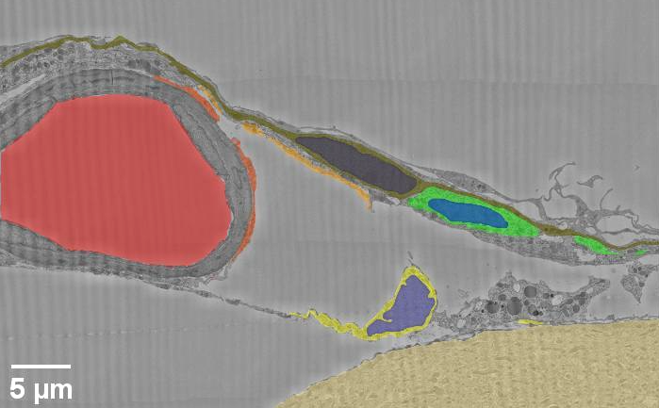

Supplementary Video 2. 3D reconstruction of a local leptomeningeal fibroblast ultrastructure from MICrONS dataset. Each subgroup of fibroblasts is added sequentially.
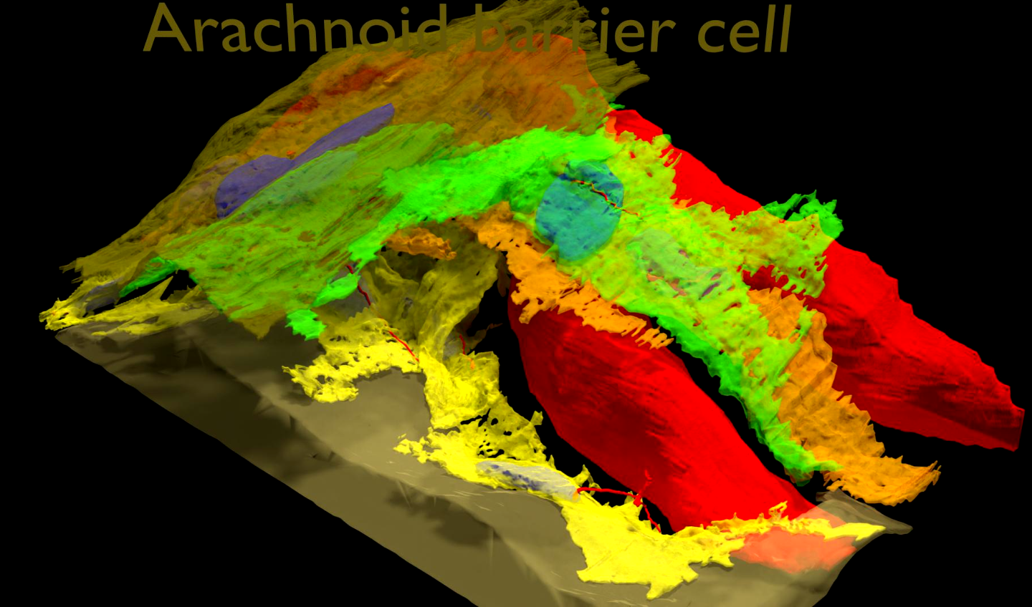

Supplementary Video 3. Time-series movie of leptomeningeal fibroblast Ca²⁺ at x-z plane. The awake mouse is in a stilled state.
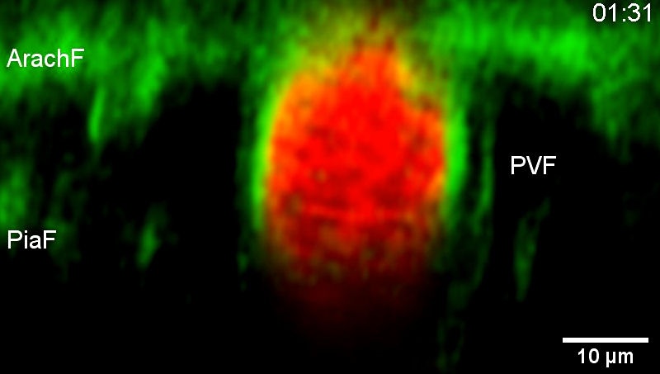

Supplementary Video 4. Time-series movie of leptomeningeal fibroblast Ca²⁺ at x-z plane. The awake mouse has spontaneous locomotion.
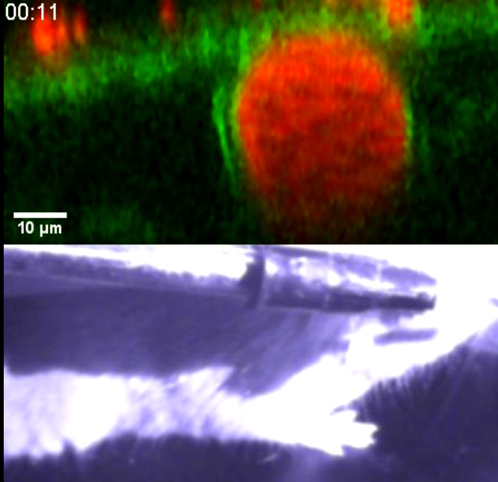

Supplementary Video 5. 3D video of macrophage infiltration.
