Biological complexity in rapid biostimulant screening across multiple seasons
Iida-Maria Rantanen¹, Janne Isojärvi², Erik Chovancek¹, Martina Jokel¹, Sema Sirin¹, Yagut Allahverdiyeva¹
⁽¹⁾ Molecular Plant Biology, Department of Life Technologies, University of Turku, 20014, Turku, Finland
⁽²⁾ Turku PET Centre, Turku University Hospital and University of Turku, 20521, Turku, Finland
Corresponding authors: Sema Sirin (sesiri@utu.fi); Yagut Allahverdiyeva (allahve@utu.fi)
Supplementary Material
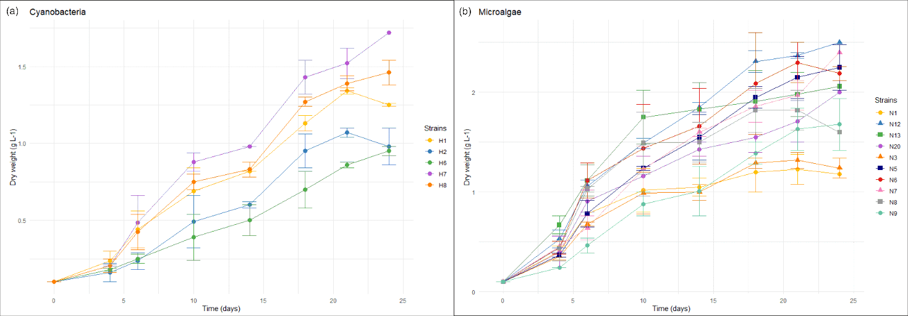
Supplemental figure S1. Growth curves of 15 cyanobacteria (a) and microalgae (b) strains used in this study. The curves represent the average values from two biomass batches and the error bars indicate standard error (n = 2).

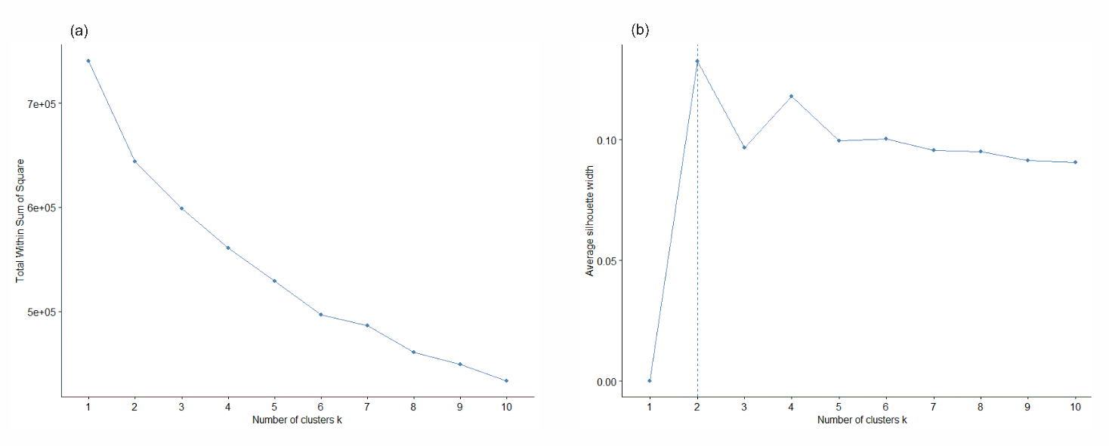
Supplemental figure S2. The elbow method (a) and the silhouette method (b) both indicated that the optimal number of clusters for the MDS analysis is two.

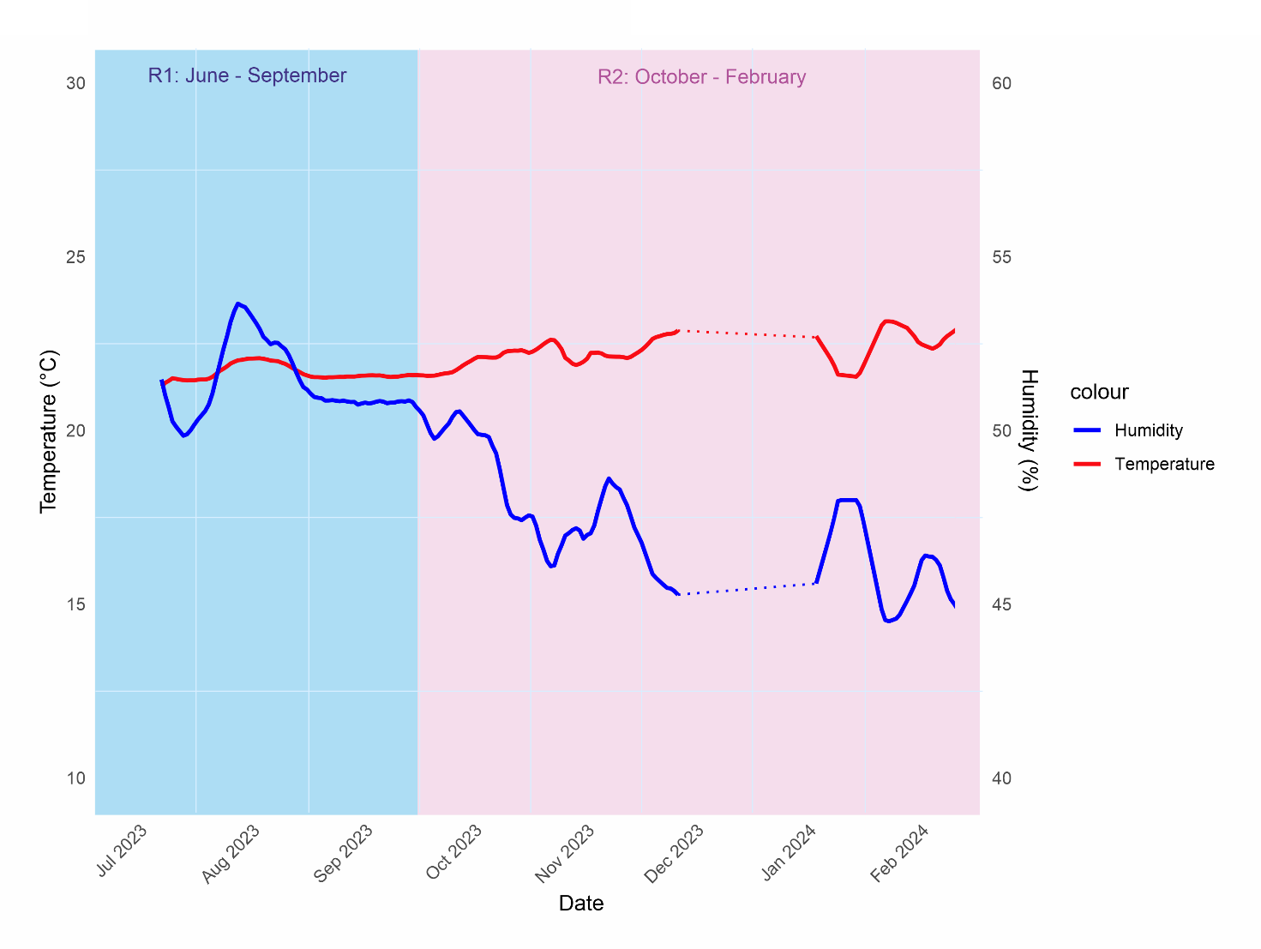
Supplemental figure S3. The temperature (red line, left y-axis) and humidity (blue line, right y-axis) inside the A. thaliana growth chamber during the experimental period. The dotted lines represent the time when there were no experiments running. The vertical shaded areas indicate the two replicates (R1 with blue and R2 with pink).
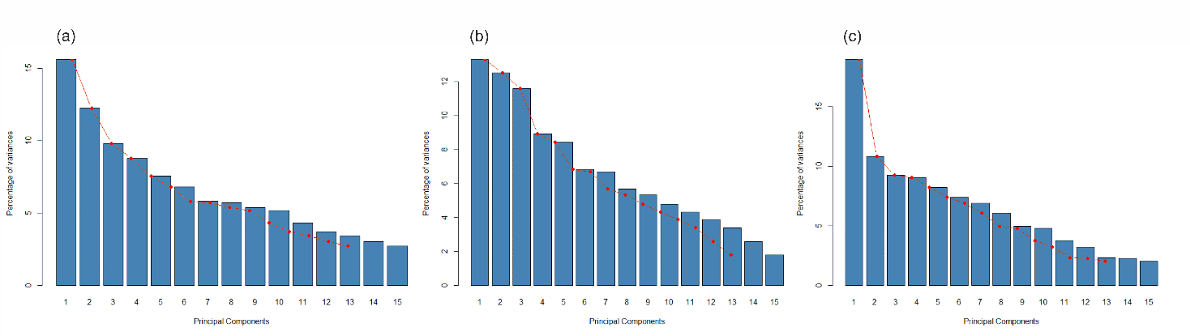
Supplemental figure S4. Eigenvalues of PCA performed for (a) combined data of R1 and R2. Eigenvalues represent the variance each principal component (PC) explains in the data. The first two components explain 28% of all variance. Eigenvalues start to flatten out after PC2. (b) Eigenvalues of separate PCAs performed for R1, where the first two components explain 26% of all variance and the eigenvalues start gradually to flatten out after PC2. (c) In R2, the first two components explain 30% of all variance and the eigenvalues start to flatten out after PC1.

