Peripheral inflammation is associated with reduced influx of TSPO PET tracers into the brain: insights from a non-invasive mapping methodology

Supplementary Materials

S.1 Image-derived input function (IDIF) computation

A semi-automated pipeline was utilized to extract the IDIF for each dynamic PET scan, adapting the procedure described in (Maccioni et al., 2024). For each dataset, a preliminary crop mask was defined to delineate an anatomical area including the siphons. Then, a carotid siphons mask was derived via intensity thresholding of early dynamic PET frames. Blood voxels segmentation was further refined by correlation analysis of preselected voxels TACs and by selection of a subset of voxels (50% of total number for Dataset 1, 70% for Datasets 2, and Dataset 3) with the highest between-voxels correlation of TACs. Additionally, in the case of Dataset 1 and Dataset 2, 50 and 100 voxels with the highest peak amplitudes were selected respectively. At this point, IDIF was computed as the average TAC across selected voxels and fitted using a tri-exponential model - with linear regression applied to the ascending part of the curve and the descending part fitted with a sum of three exponential functions (Parsey et al., 2000) – to address the compartmental modelling assumption of a noise-free input function.

S.2 1T1K-IDIF model linearization

The assumptions on tracer kinetics lead to the derivation of the 1T1K-IDIF model, which is mathematically represented by the following system of equations:

$$\left\{\begin{aligned}{\dot{C}}_{1}\left(t\right)=K_{1}⋅IDIF\left(t\right), { C}_{1}\left(0\right)=0 \\ C\left(t\right)=C_{1}\left(t\right) \end{aligned}\right.$$

where $C_{1}\left(t\right)$ represents tracer activity in the irreversible compartment and $C\left(t\right)$the regional tracer activity in the brain tissues as measured by the PET scanner.

An advantage of the one-tissue model is the possibility of model linearization (Carson, 1993). The differential equation describing the tracer dynamics can be integrated on both sides, resulting in the following expression:
$$C\left(t\right)=K_{1}⋅\int_{0}^{t_{fit}\left(end\right)}{IDIF\left(τ\right)dτ}$$
This approach avoids the need for iterative non-linear methods to estimate K₁, allowing for the use of a linear estimator.

S.3 Fitting time window optimization

The 1T1K-IDIF methodological framework adopted in this study requires the definition of a restricted time interval after tracer injection for kinetic model fitting. While in the case of Dataset 3, the optimal time window was already selected in the previous study by (Maccioni et al, 2024), the choice of the optimal fitting time window was required for Dataset 1 and Dataset 2. Insights from scientific literature, combined with visual inspection of model fit and assessment of model fitting performance metrics, were crucial for optimizing the fitting window. Estimates and precision of estimates (coefficient of variation (CV)) of the K₁ parameter obtained with different fitting intervals are reported in Supplementary Figure 1 for Dataset 1 and Dataset 2.

For Dataset 1, the suitable time interval for model fitting was determined to be 0-5 minutes. Early studies indicated that more than 90% of [¹¹C]-PK11195 tracer remains intact after 5 minutes post-injection (Souza et al., 2021), which aligns with the kinetic modelling assumptions. Furthermore, selecting this window ensured that the mean absolute value of the rate constant was consistent with physiological values extrapolated from previous investigations with this first-generation tracer (Jučaite et al., 2012). Additionally, this interval ensures accurate parameter estimates, as assessed by the CV.

Regarding Dataset 2, the optimal window was determined to be 0-5 minutes. The selected interval meets modelling assumptions, as [¹⁸F]-DPA714 retains over 90% of its integrity within the first 10 minutes after tracer injection (Peyronneau et al., 2023). Additionally, the chosen window ensured physiologically coherent estimates compared to previous studies (Golla et al., 2015), with good precision of the K₁ estimates. In the original study (Maccioni et al., 2024), the methodology was applied to a different [¹⁸F]-DPA714 dataset with available individual plasma-parent fraction curves, which allowed for determining an optimal time window of 8 minutes. However, for Dataset 2, a 5-minute window was better suited to the available data and yielded a comparable CV to that of an 8-minute interval. Importantly, extending the window further would have not only undermined the initial assumptions but also led to unacceptable model residuals and an unacceptable weighted residual sum of squares, due to the inherent challenge of a simple mono-compartmental dynamic in accurately representing the experimental data.

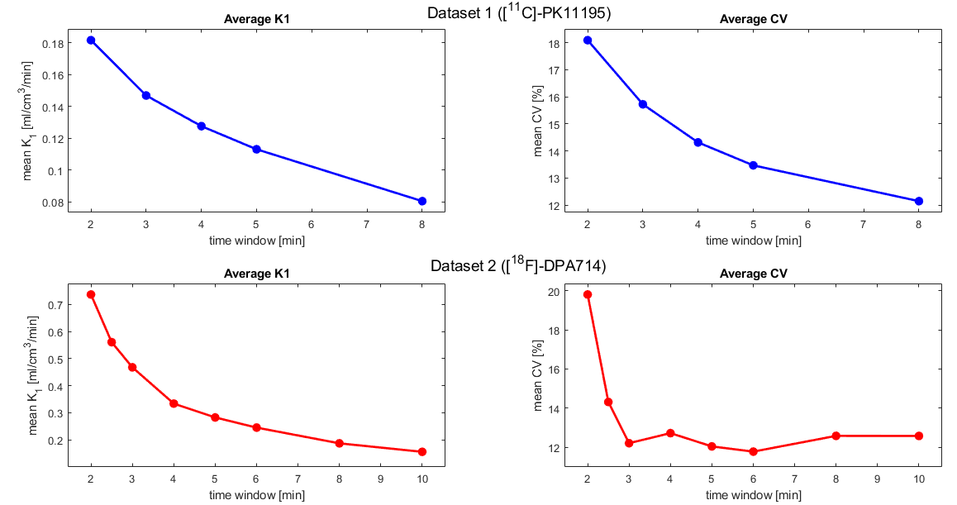

Figure 1. Sensitivity analysis to fitting time window
The figure shows mean estimates and coefficients of variation (CV) of the K₁ parameter, computed across subjects and regions, for Dataset 1 (upper panel) and Dataset 2 (lower panel).

S.4 Imaging transcriptomics analyses

Imaging transcriptomics analysis was conducted using the Imaging Transcriptomics toolbox (Giacomel et al., 2022), which enables the identification of gene expression patterns correlated with the specific neuroimaging phenotype of interest and performs a gene set enrichment analysis (GSEA) (Subramanian et al., 2005) to provide further biological insights into the identified genes. The software utilizes gene expression data from the Allen Human Brain Atlas (AHBA, http://human.brain-map.org/) and maps genetic and neuroimaging data into the same space using the Desikan-Killiany parcellation. A mass-univariate Spearman’s correlation analysis was selected to quantify the association between each gene’s expression and the neuroimaging phenotype. Permutation testing was employed to calculate statistical significance. Additionally, GSEA was implemented to identify specific categories of genes significantly related to the imaging phenotype. The first gene set investigated was the “Lake” gene set, which includes genes expressed in 30 brain cell types (Lake et al., 2018). Other gene sets used for GSEA included “GO Biological Processes”, “GO Cellular Components”, and “GO Molecular Functions”. For each term of the gene sets, the enrichment score (ES), uncorrected p-value, and False Discovery Rate (FDR)-corrected p-value were obtained. Specifically, the ES reflects the extent to which a gene set is overrepresented at the top (positive score) or bottom (negative score) of the ranked gene list from the correlation analysis.

S.5 K₁ maps of representative healthy and pathological individuals

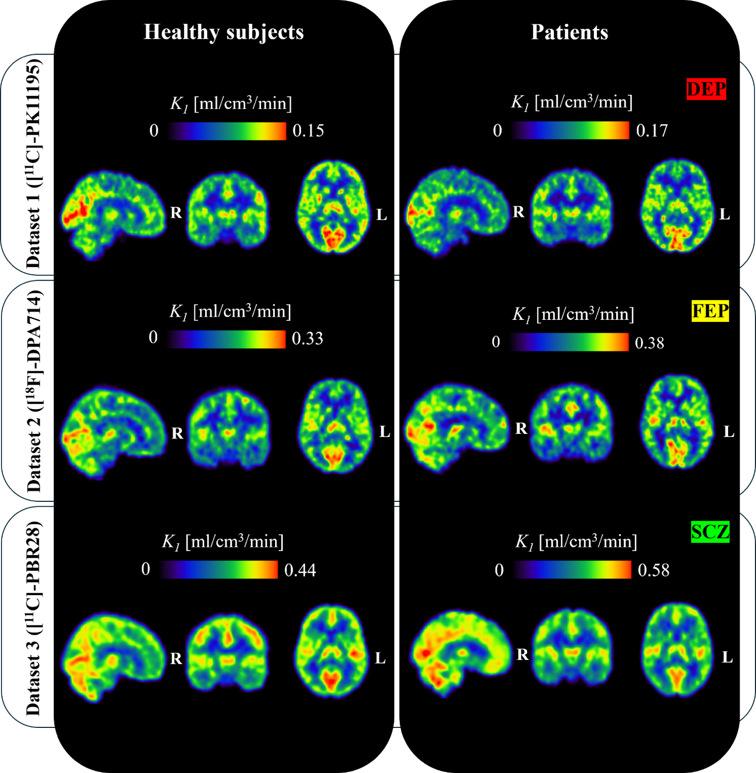

Figure 2. K₁ parametric maps [ml/cm³/min] of representative healthy and pathological subjects from the three datasets.
Panels show representative healthy and pathological subjects’ K₁ parametric maps from Dataset 1 ([¹¹C]-PK11195), Dataset 2 ([¹⁸F]-DPA714), and Dataset 3 ([¹¹C]-PBR28), respectively. Maps are in MNI space, and Gaussian filter (FWHM = 5 mm) smoothing was applied. HC: healthy control; DEP: mild to moderate depression; FEP: first-episode psychosis; SCZ: schizophrenia.

S.6 Positive association between lateral ventricle TSPO PET signal and K₁

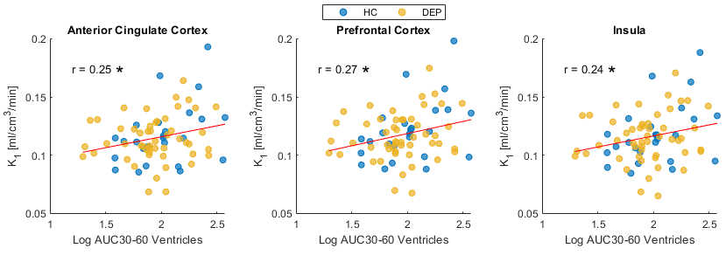

Figure 3. Relationship between TSPO PET signal in the lateral ventricle and tracer delivery
The scatter plot shows the positive linear association between the area under the curve from 30 to 60 min (AUC30-60) of the lateral ventricle TSPO activity and K₁ for the anterior cingulate cortex (r = 0.25, P = 0.03), prefrontal cortex (r = 0.27, P = 0.02), and insula (r = 0.24, P = 0.03). AUC30-60 was available from previous studies by (Turkheimer et al., 2021), and computed using the activity of the lateral ventricle as the target region alongside a supervised reference region (Turkheimer et al., 2007). Pearson’s correlation coefficient r is reported (* indicates P < 0.05). HC: healthy control; DEP: mild to moderate depression.

References

Carson, R. E. (1993). PET parameter estimation using linear integration methods: bias and variability considerations. Quantification of Brain Function: Tracer Kinetics and Image Analysis in Brain PET, 499–507.
de Souza, A., Pitombeira, M., de Souza, L., Marques, F. N., Buchpiguel, C., Real, C., & de Paula Faria, D. (2021). ¹¹ C-PK11195 plasma metabolization has the same rate in multiple sclerosis patients and healthy controls: a cross-sectional study. Neural Regeneration Research, 16(12), 2494. https://doi.org/10.4103/1673-5374.313062
Giacomel, A., Martins, D., Frigo, M., Turkheimer, F., Williams, S. C. R., Dipasquale, O., & Veronese, M. (2022). Integrating neuroimaging and gene expression data using the imaging transcriptomics toolbox. STAR Protocols, 3(2). https://doi.org/10.1016/j.xpro.2022.101315
Golla, S. S., Boellaard, R., Oikonen, V., Hoffmann, A., van Berckel, B. N., Windhorst, A. D., Virta, J., Haaparanta-Solin, M., Luoto, P., Savisto, N., Solin, O., Valencia, R., Thiele, A., Eriksson, J., Schuit, R. C., Lammertsma, A. A., & Rinne, J. O. (2015). Quantification of [ ¹⁸ F]DPA-714 Binding in the Human Brain: Initial Studies in Healthy Controls and Alzheimer’S Disease Patients. Journal of Cerebral Blood Flow & Metabolism, 35(5), 766–772. https://doi.org/10.1038/jcbfm.2014.261
Jučaite, A., Cselényi, Z., Arvidsson, A., Åhlberg, G., Julin, P., Varnäs, K., Stenkrona, P., Andersson, J., Halldin, C., & Farde, L. (2012). Kinetic analysis and test-retest variability of the radioligand [11C](R)-PK11195 binding to TSPO in the human brain - a PET study in control subjects. EJNMMI Research, 2(1), 15. https://doi.org/10.1186/2191-219X-2-15
Lake, B. B., Chen, S., Sos, B. C., Fan, J., Kaeser, G. E., Yung, Y. C., Duong, T. E., Gao, D., Chun, J., Kharchenko, P. V., & Zhang, K. (2018). Integrative single-cell analysis of transcriptional and epigenetic states in the human adult brain. Nature Biotechnology, 36(1). https://doi.org/10.1038/nbt.4038
Maccioni, L., Michelle, C. M., Brusaferri, L., Silvestri, E., Bertoldo, A., Schubert, J. J., Nettis, M. A., Mondelli, V., Howes, O., Turkheimer, F. E., Bottlaender, M., Bodini, B., Stankoff, B., Loggia, M. L., & Veronese, M. (2024). A blood-free modeling approach for the quantification of the blood-to-brain tracer exchange in TSPO PET imaging. Frontiers in Neuroscience, 18. https://doi.org/10.3389/FNINS.2024.1395769
Parsey, R. V., Slifstein, M., Hwang, D. R., Abi-Dargham, A., Simpson, N., Mawlawi, O., Guo, N. N., Van Heertum, R., John Mann, J., & Laruelle, M. (2000). Validation and reproducibility of measurement of 5-HT(1A) receptor parameters with [carbonyl-11 C]WAY-100635 in humans: Comparison of arterial and reference tissue input functions. Journal of Cerebral Blood Flow and Metabolism, 20(7). https://doi.org/10.1097/00004647-200007000-00011
Peyronneau, M., Kuhnast, B., Nguyen, D.-L., Jego, B., Sayet, G., Caillé, F., Lavisse, S., Gervais, P., Stankoff, B., Sarazin, M., Remy, P., Bouilleret, V., Leroy, C., & Bottlaender, M. (2023). [18F]DPA-714: Effect of co-medications, age, sex, BMI and TSPO polymorphism on the human plasma input function. European Journal of Nuclear Medicine and Molecular Imaging, 50(11), 3251–3264. https://doi.org/10.1007/s00259-023-06286-1
Subramanian, A., Tamayo, P., Mootha, V. K., Mukherjee, S., Ebert, B. L., Gillette, M. A., Paulovich, A., Pomeroy, S. L., Golub, T. R., Lander, E. S., & Mesirov, J. P. (2005). Gene set enrichment analysis: A knowledge-based approach for interpreting genome-wide expression profiles. Proceedings of the National Academy of Sciences of the United States of America, 102(43). https://doi.org/10.1073/pnas.0506580102
Turkheimer, F. E., Althubaity, N., Schubert, J., Nettis, M. A., Cousins, O., Dima, D., Mondelli, V., Bullmore, E. T., Pariante, C., & Veronese, M. (2021). Increased serum peripheral C-reactive protein is associated with reduced brain barriers permeability of TSPO radioligands in healthy volunteers and depressed patients: implications for inflammation and depression. Brain, Behavior, and Immunity, 91, 487–497. https://doi.org/10.1016/j.bbi.2020.10.025
Turkheimer, F. E., Edison, P., Pavese, N., Roncaroli, F., Anderson, A. N., Hammers, A., Gerhard, A., Hinz, R., Tai, Y. F., & Brooks, D. J. (2007). Reference and target region modeling of [11C]-(R)-PK11195 brain studies. Journal of Nuclear Medicine, 48(1).

