Geomorphological and sedimentological traces of the 365 AD and 1303 AD tsunami impacts on the Korission Lagoon (Corfu Island, Greece), compared with tsunami simulation scenarios
Tina Georg^{1,2*}, Björn R. Röbke³, Peter Fischer¹, Peter Frenzel⁴, Kalliopi Baika⁵, Timo Willershäuser¹, Andreas Vött¹
¹Institute of Geography, Johannes Gutenberg-Universität Mainz, Johann-Joachim-Becher-Weg 21, 55099, Mainz, Germany
²Institute of Neotectonics and Natural Hazards, RWTH Aachen University, Lochnerstrasse 4–20, 52056 Aachen, Germany
³Department for Applied Morphodynamics, Deltares, Boussinesqweg 1, 2629 HV Delft, The Netherlands
⁴Institute of Geosciences, Friedrich Schiller University, Burgweg 11, 07749 Jena, Germany
⁵Centre Camille-Jullian, CNRS, Aix-Marseille Université, Maison Méditerranéenne des Sciences de l'Homme, 5 Rue Château de l'Horloge, 13090 Aix-en-Provence, France
Correspondence to: Tina Georg (tina.georg@uni-mainz.de)

1 Sensistivity analyses of the numerical simulation
For our sensitivity analyses, we tested the different seismic scenarios, the effects of different modelling parameters and the influence of different morphological features within the Korission Lagoon. For the 365 AD tsunami, we used four published scenarios, namely by Lorito et al. (2008), Papadimitriou and Karakostas (2008), Shaw et al. (2008), and Stiros (2010). In the first run of each scenario, standardized values were used for all model parameters uniformly throughout the whole model domain (i.e. a Manning friction coefficient of 0.023 was assumed for the sea bottom and land surface) along with the current topography of the Korission Lagoon to observe the inundation of the tsunami wave caused by each seismic scenario. The results show that under current conditions, the Korission Lagoon would be inundated by tsunami waves in all selected seismic scenarios (Fig. S.1). The inundation, however, only occurs in the northwestern part of the lagoon and on a small scale. Neither the location of the washover fan where KOR 19 was retrieved nor any other part of the beach ridge where clear washover fans can be observed are inundated. The maximum wave height and the flow velocity at the location of sediment core KOR 19 is not sufficient to relocate the amount of sediment detected for the AD365 tsunami event in the analysed of KOR 19 (Fig. S.2, left). In fact, water levels at the location of LIN 1A are higher than at KOR 19 and the flow velocity is similar due to the funneling effect (Röbke and Vött, 2017) which becomes apparent especially in the maximum wave heights of the tsunami triggered by the seismic scenarios of Lorito et al. (2008) and Shaw et al. (2008, Fig. S.2, left). The water level at selected observation points at the seaward side of the lagoon (location see Fig. S.1) shows wave heights of up to 1 m (Obs.W) and up to 2 m (Obs.S, Fig. S.3). This implies that the southern part of the lagoon is protected by the Holocene and Pleistocene dunes, while the spit at the northwestern part is prone to tsunami inundations. Since the inundation modelled for the scenarios is greatest for the one by Lorito et al. (2008) and Shaw et al. (2008), further adaptations have been restricted to these scenarios.
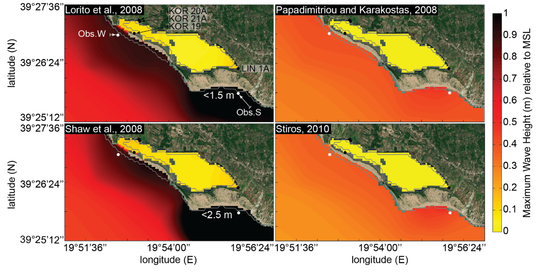
Figure S.1: Inundation scenarios for the Korission Lagoon for 4 selected seismic scenarios of the 365 AD earthquake and the resulting tsunami (Map: ©Microsoft, 2024).
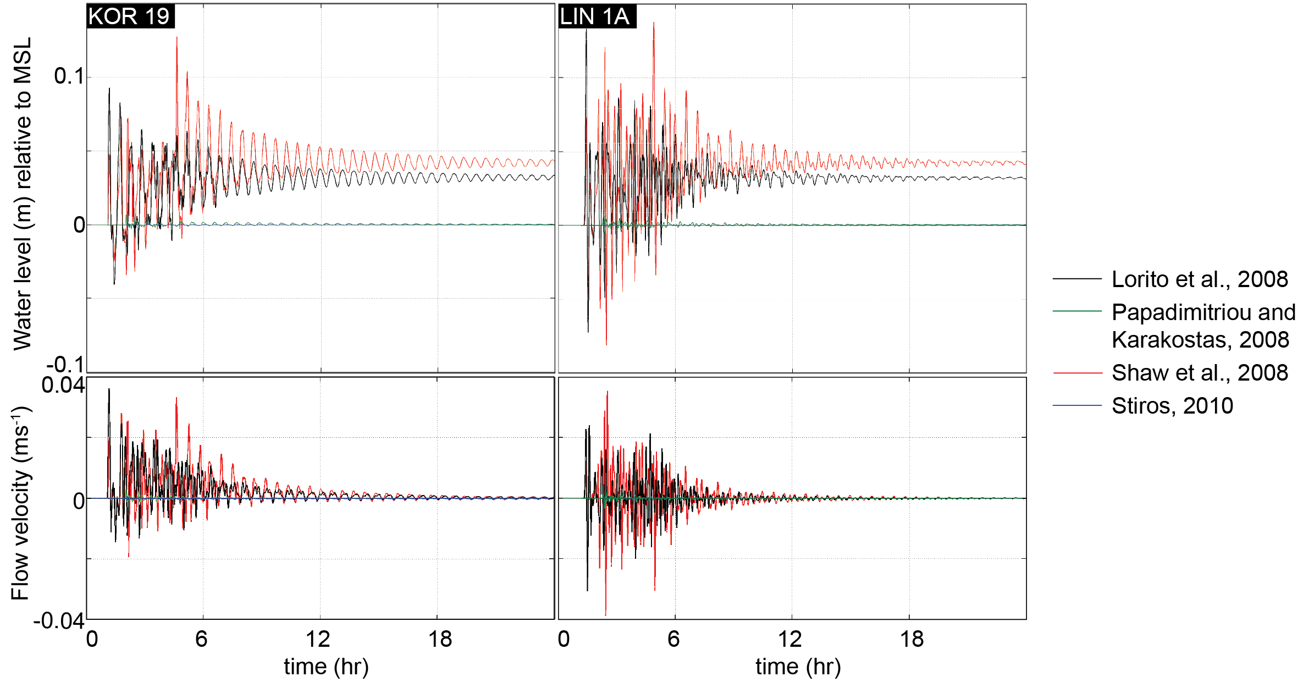
Figure S.2: Modelled water level (m) relative to Mean Sea Level (MSL, top) and flow velocity (ms⁻¹, bottom) for KOR 19 (left) and LIN 1A (right).
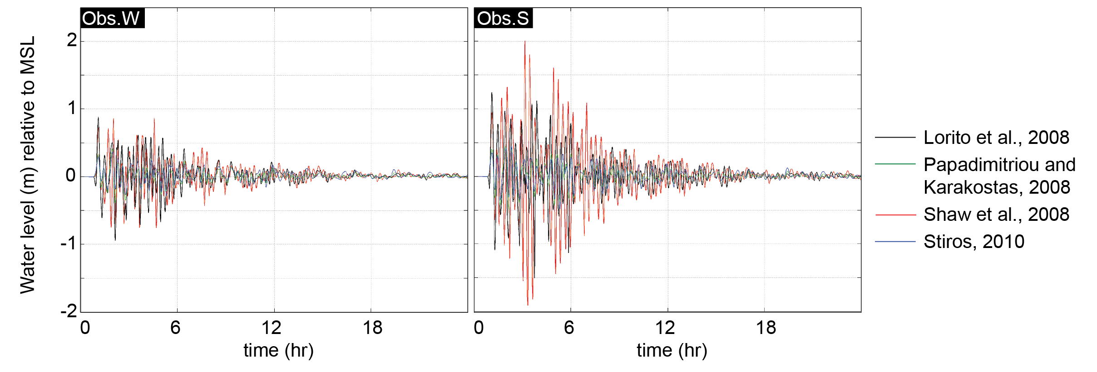
Figure S.3: Water level (m) relative to the MSL of two observation points at the seaward side of KOR 19 (Obs.W) and LIN 1A (Obs.S).
In the next runs, we adapted the friction coefficients (0.02 for sea bottom and within the lagoon, 0.032 for the land surface), implemented a hydrodynamic model to observe the sediment flow during the inundation of the spit and within the lagoon, and tested different types of transport formulas (i.e., van Rijn, 1993). For the hydrodynamic model, we added sand with a diameter of 200 µm and a thickness of 5 m to the western spit. We did not adapt the morphological features of the lagoon and the beach barrier for this run; hence, it functions as reference for further adaptations (Run08L/Reference, see Fig. 10 of the main article for results). In the following runs, we removed the washover fans since they are potentially created by the AD365 event. Additionally, we tested different heights of the beach barrier: (i) 0.5 m (Run09 and Run10), (ii) the recent one obtained from the digital elevation model (DEM, Run11), and (iii) 1 m (Run13, Run14) and different depths of the lagoon (Figd. S.4 and S.5). For the latter, we tested a shallower lagoon with a depth of 0.5 m (Run09, Run11) and a deeper bottom level of -4 m (Run10, Run14, Run17, Run18) to test for the effects of a potential subsidence or stable tectonic conditions of the area. The chosen maximum depth was based on the stratigraphy of the sediment core KOR 19 where the base of the corresponding high-energy event layer was observed at 4.47 m. The results of these adaptations show a clear formation of washover fans in all runs, however, an increased sedimentation into the lagoon can be observed with a deeper bottom level (Fig. S.4 A₂ and B₂). Since an increase of the height of the beach ridge did not lead to increased erosion and sedimentation (Fig. S.5 A₁ and B₁), we considered the recent height (DEM) as the best fit for the simulation runs. Using this height also ensures a more natural setting of the beach ridge in contrast to a uniform height throughout the whole western part of the ridge.
In a last step, we tested the impact of slip rate and dip angle on the erosion and sedimentation (Run15, Run16, Run17, Run18). The results of these runs show that an increase of the slip rate increases the velocity and, therefore, the erosion and sedimentation (Figs. 10 and S.5). An increase in the dip angle does, however, not impact the result on a noticeable scale. Still, sedimentation and erosion at or near all locations of the shown sediment cores occurs in this scenario (Fig. S.5 D).
For the best-fit runs, we compared the results based on the seismic scenarios by Lorito et al. (2008) and Shaw et al. (2008) for the whole Korission Lagoon (Figs. S.6-S.8) and selected observation points near the sediment cores (Figs. S.9-S.11). The scenario based on Lorito et al. (2008) leads to higher water levels on the seawards side of the beach ridge and in the lagoon (Fig. S.6), to increased velocity magnitudes (Fig. S.7), and enhanced erosion and sedimentation (Fig. S.8). Here, the washover fans built up farther into the lagoon. Differences in the distribution of highest observed waves, highest flow velocities, and sedimentation/erosion rates between both scenarios also become visible in the point data of the observation points (Figs. S.9-S.11). In general, the results show that the highest wave is not always the first one, however, it is within the first 10 waves of the wave train. Additionally, the highest wave does not always correspond to the highest flow velocities and erosion rates. Differences in the sedimentation and erosion rates of both scenarios are depicted in Tab. S.1.
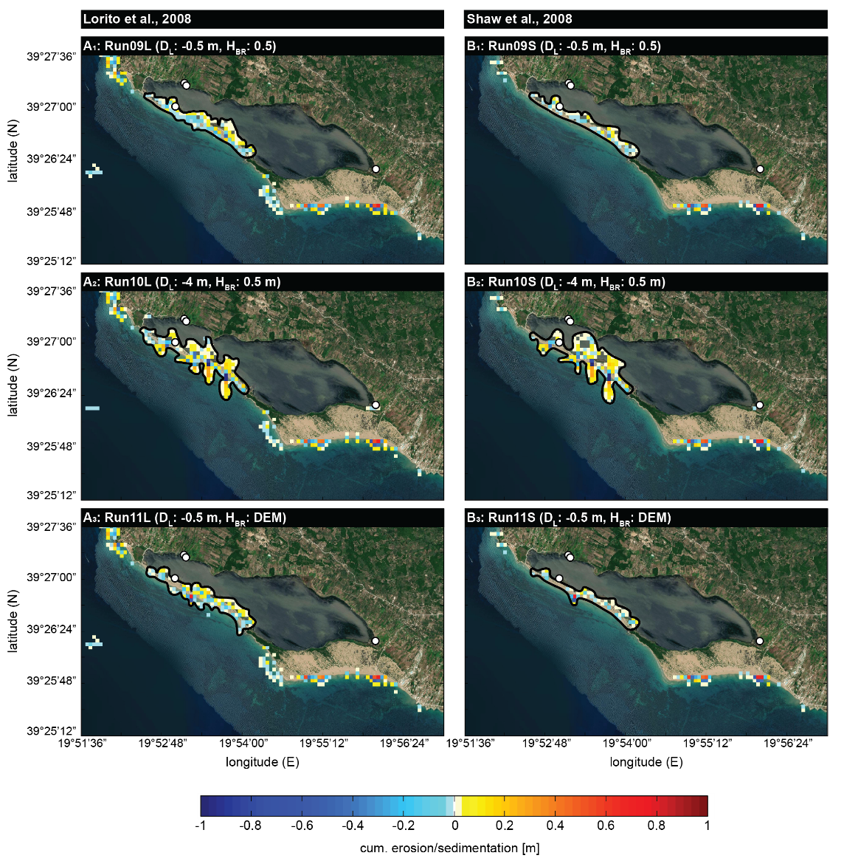
Figure S.4: Cumulative erosion (blues) and sedimentation (yellow-red) for adapted morphological features for Lorito et al. (2008, A) and Shaw et al. (2008, B, Map: ©Microsoft, 2024).
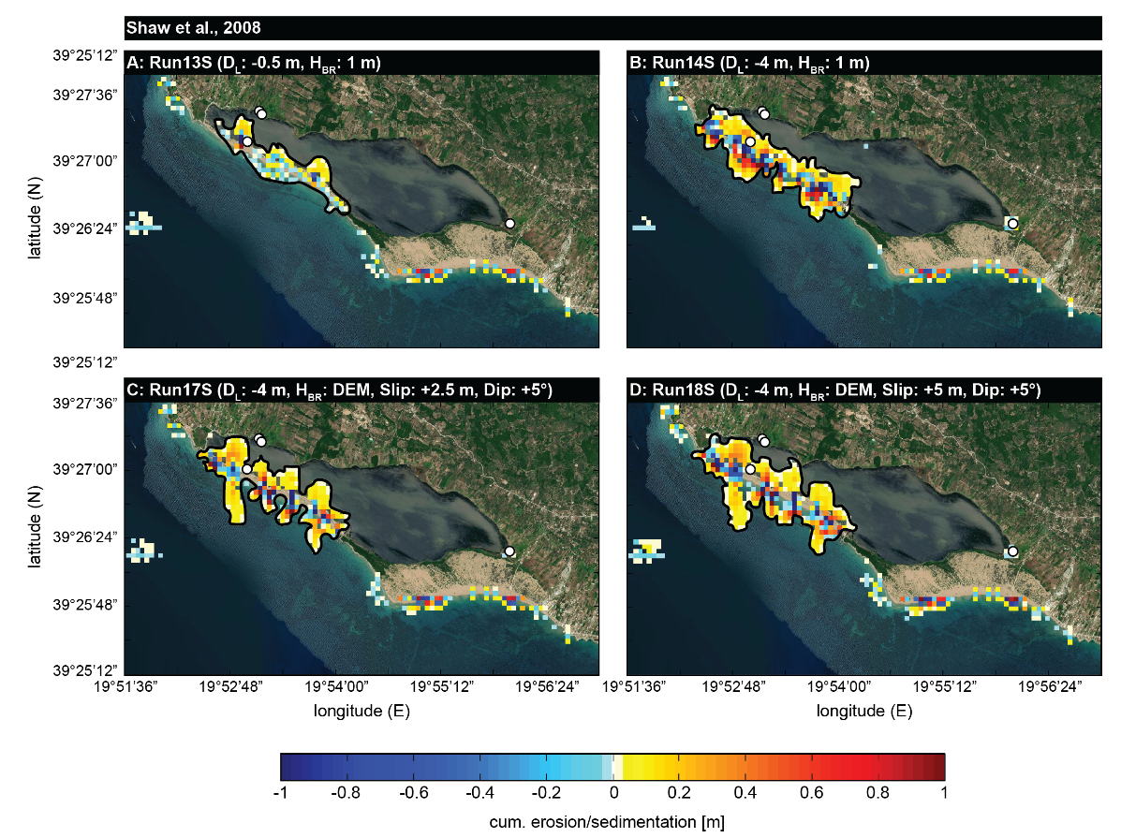
Figure S.5: Cumulative erosion (blues) and sedimentation (yellow-red) for adapted morphological features and earthquake parameters for (Lorito et al., 2008, Map: ©Microsoft, 2024).

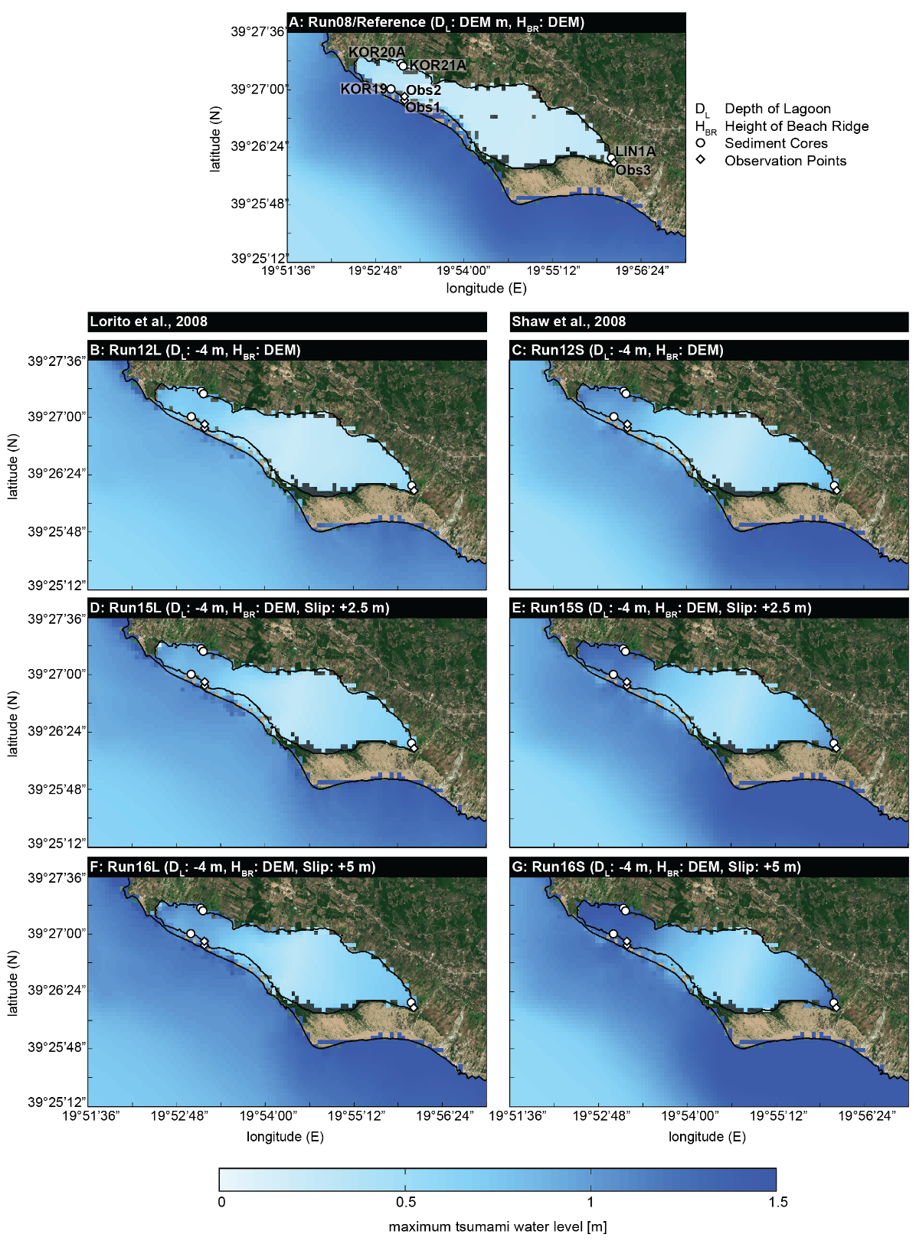
Figure S.6: Maximum tsunami water level for selected scenarios of the 365 AD tsunami simulated based on Lorito et al. (2008, B) and Shaw et al. (2008, C). Reference Run (Run08, A) refers to the published seismic scenario of Shaw et al. (2008) and the recent topography. Modifications of Runs 12, 15, and 16 are stated in the headers of each subfigure. Please see supplementary files for results of further runs (Map: ©Microsoft, 2024).
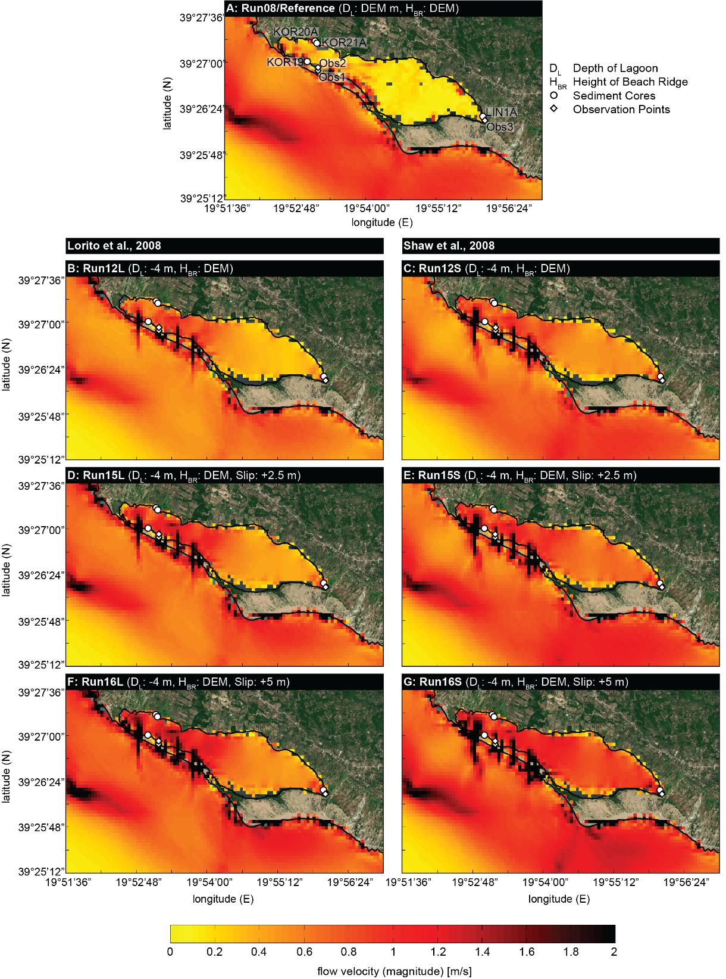
Figure S.7: Velocity magnitude for selected scenarios of the 365 AD tsunami simulated based on Lorito et al. (2008, B) and Shaw et al. (2008, C). Please see Fig. MWL and supplementary files for results of further runs (Map: ©Microsoft, 2024).
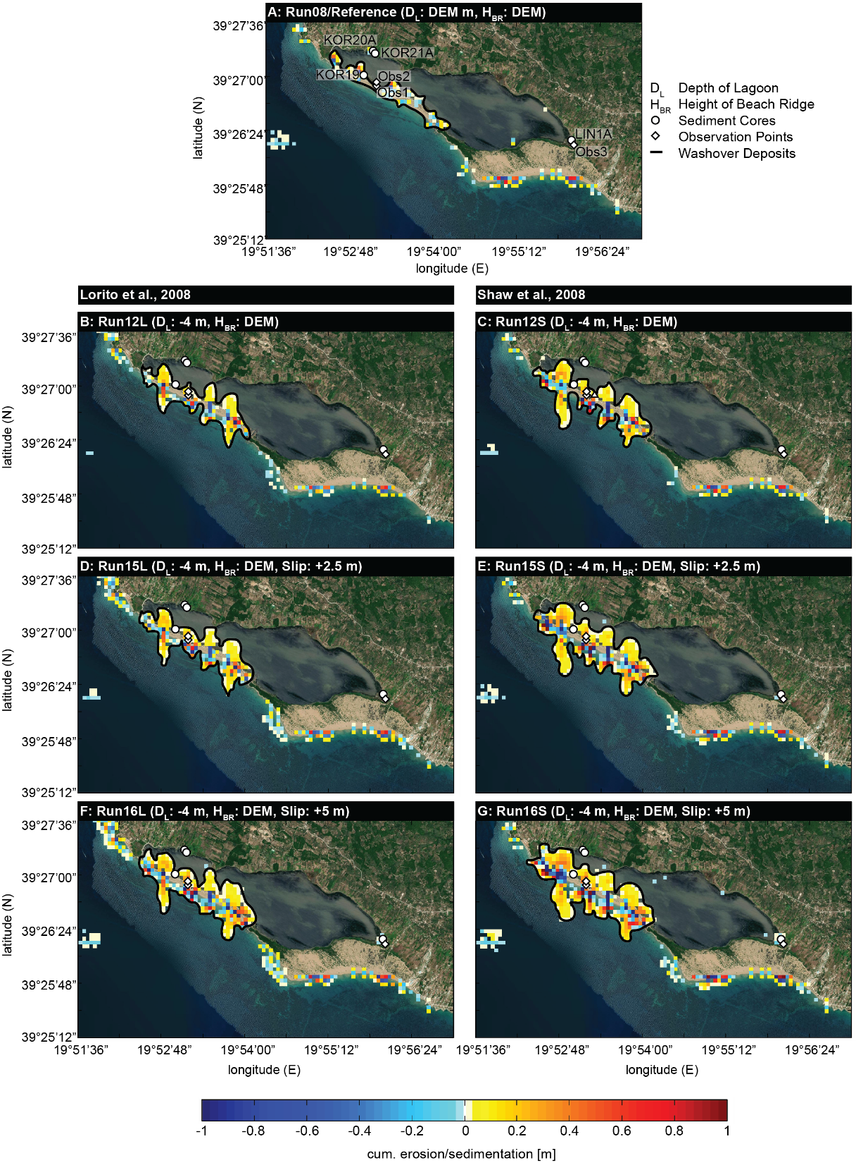
Figure S.8: Cumulative erosion (blues) and sedimentation (yellow-red) for selected scenarios of the 365 AD tsunami simulated based on Lorito et al. (2008, B) and Shaw et al. (2008, C). Please see Fig. MWL and the supplementary files for further information and results (Map: ©Microsoft, 2024).
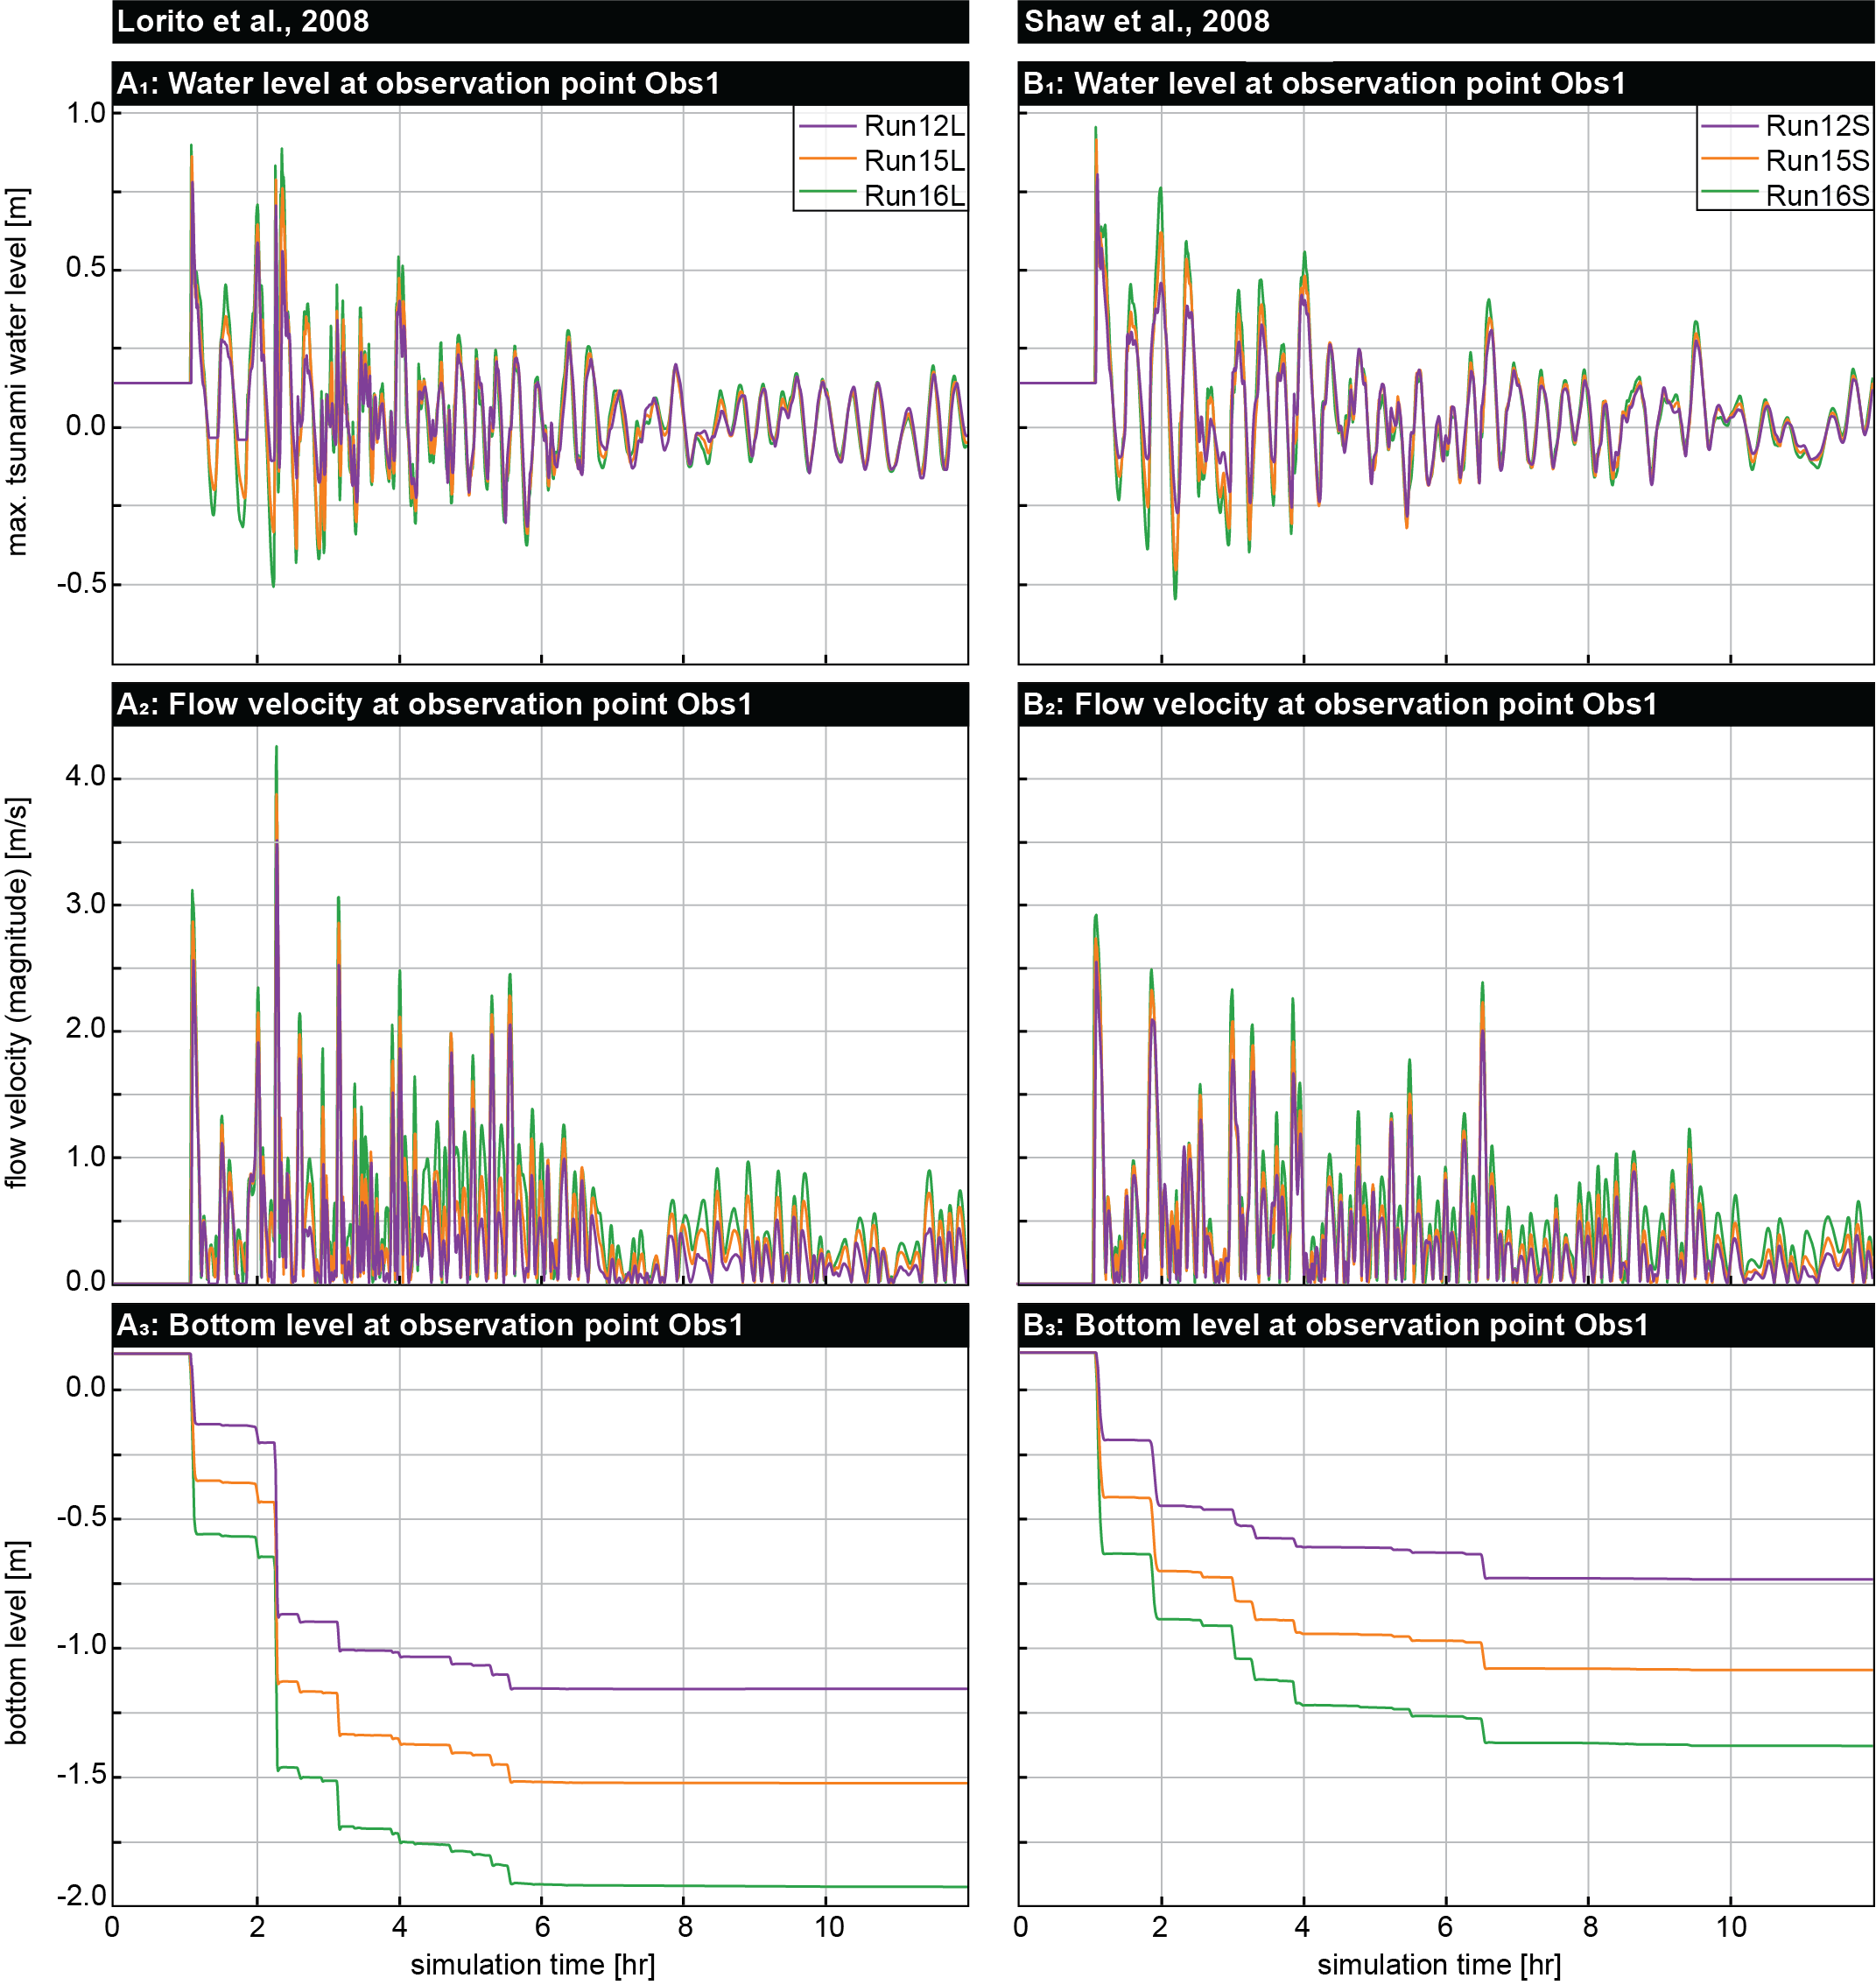
Figure S.9: Water level (1), flow velocity (2), and bottom level (3) modelled for the 365 AD tsunami at observation point Obs1 on the beach ridge near coring site KOR 19 (location see Fig. MWL A) for two different tsunamigenic scenarios based on Lorito et al. (2008, A) and Shaw et al. (2008, B).
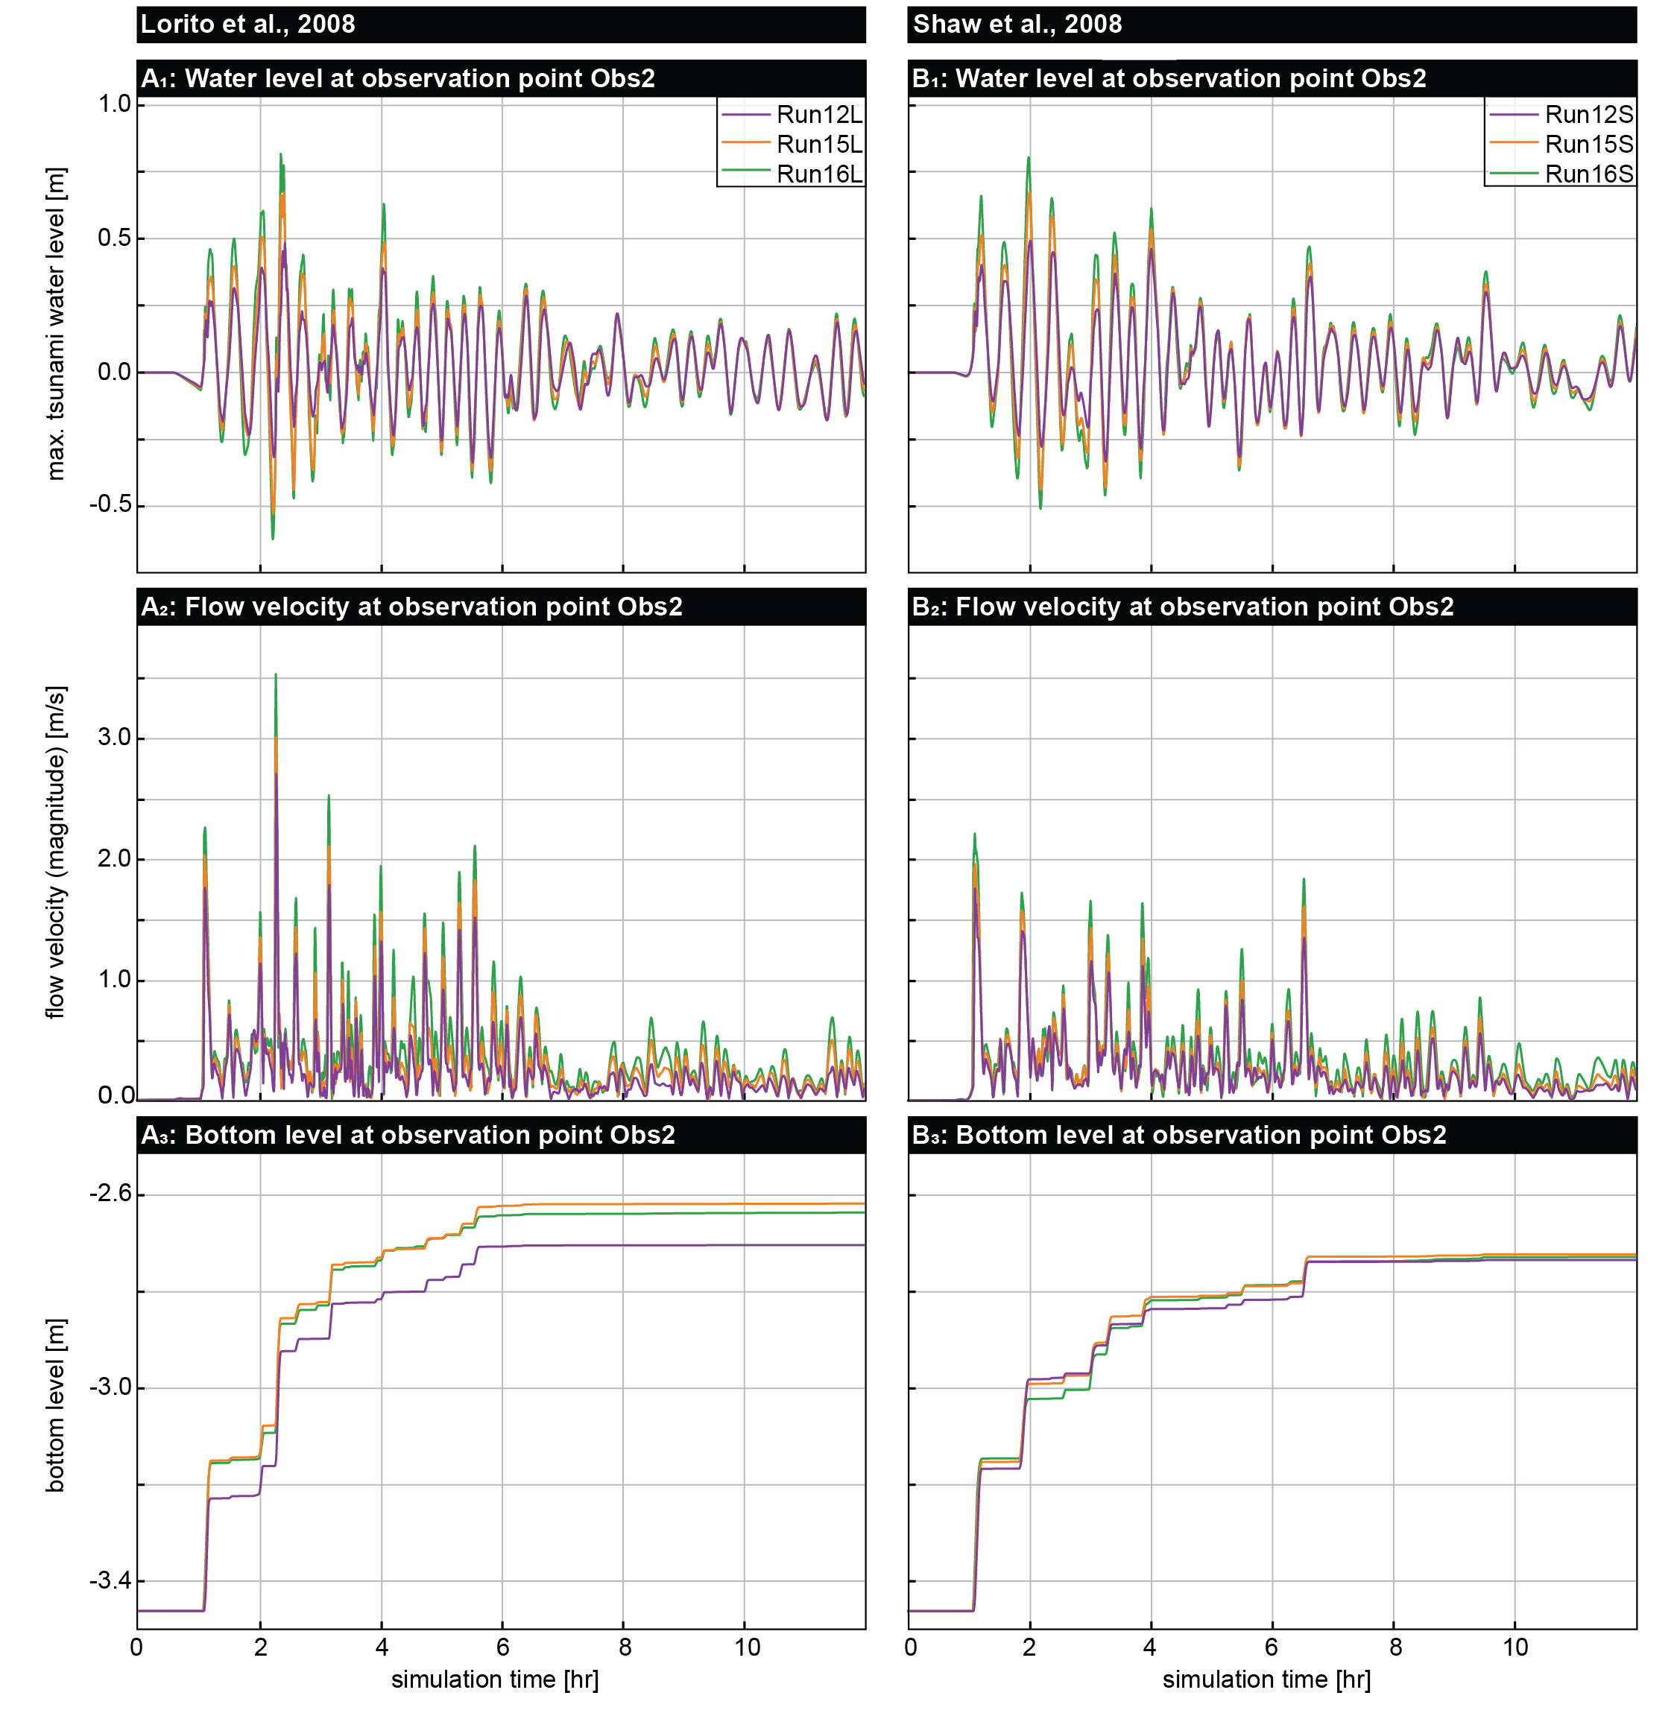
Figure S.10: Water level (1), flow velocity (2), and bottom level (3) modelled for the 365 AD tsunami at observation point Obs2 on a simulated washover fan near coring site KOR 19 (location see Fig. MWL A) for two different tsunamigenic scenarios based on Lorito et al. (2008, A) and Shaw et al. (2008, B).
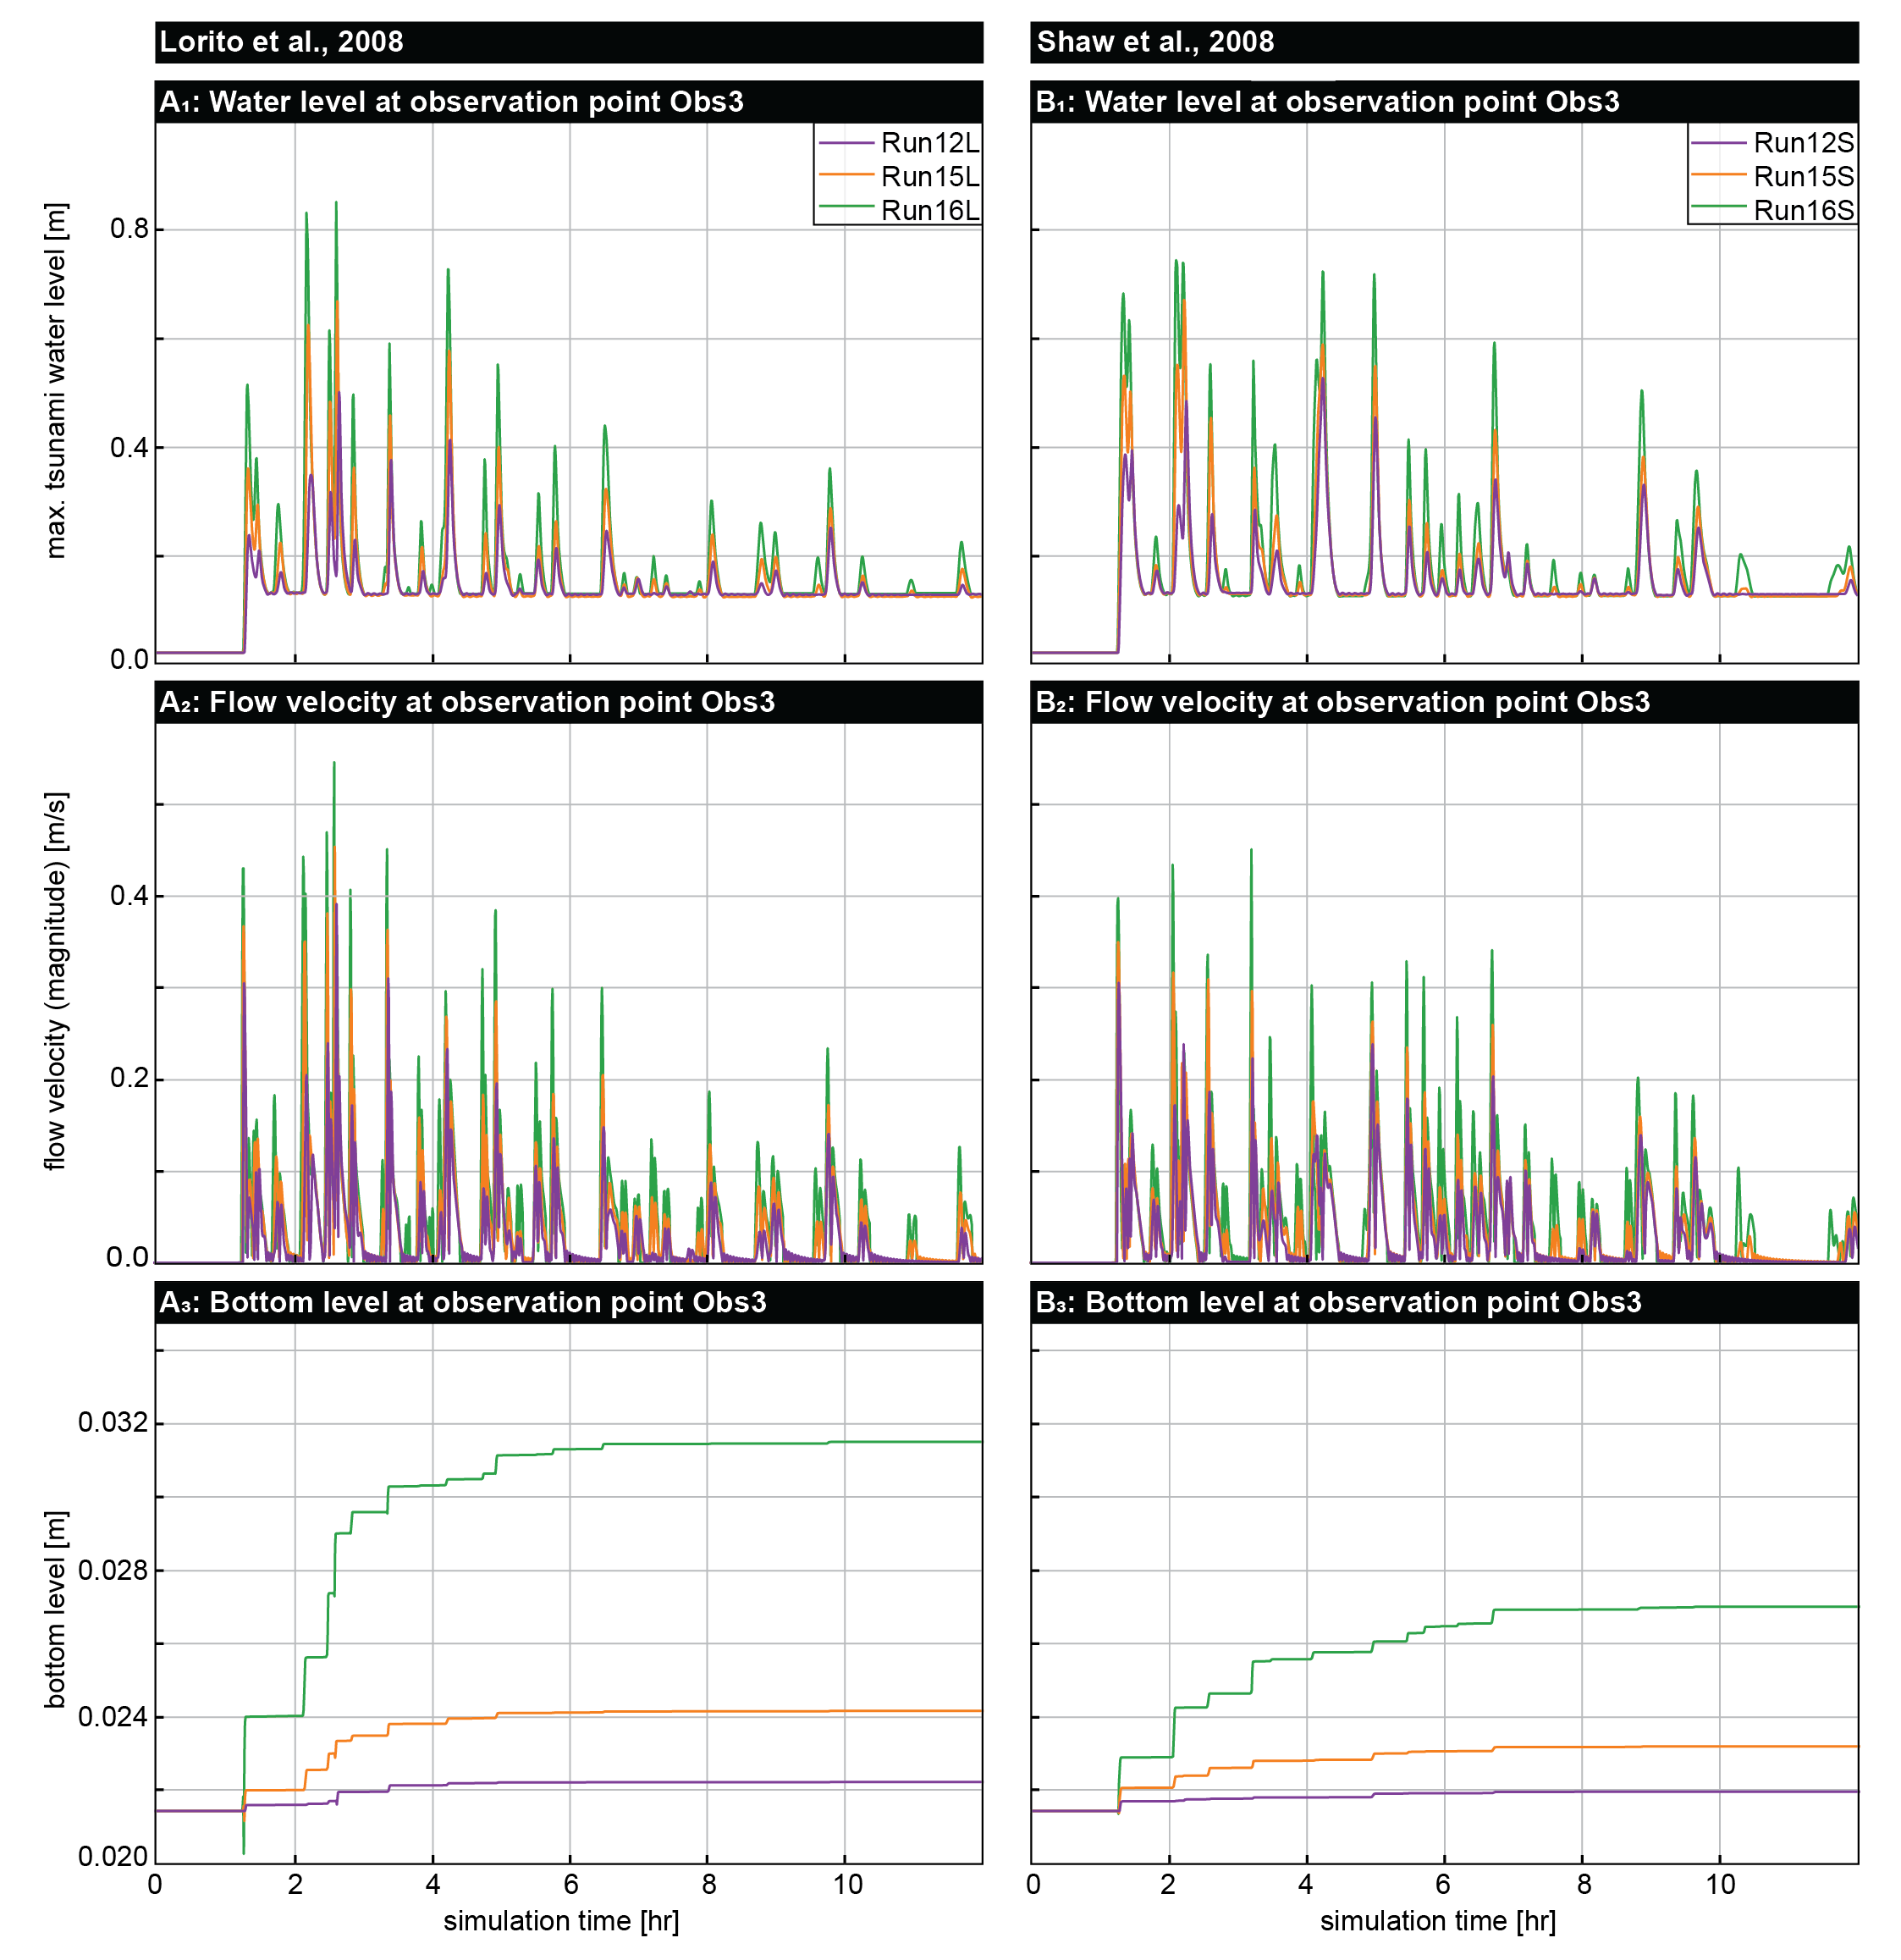
Figure S.11: Water level (1), flow velocity (2), and bottom level (3) modelled for the 365 AD tsunami at observation point Obs3 near LIN 1A (location see Fig. MWL A) for the two different tsunamigenic scenarios based on Lorito et al. (2008, A) and Shaw et al. (2008, B).

 | RunRef | 12L | 12S | 15L | 15S | 16L | 16S | Field traces
Obs.1 | 0 | -1.3 | -0.878 | -1.664 | -1.23 | -2.065 | -1.523 | -
Obs.2 (KOR 19) | 0 | +0.757 | +0.726 | +0.843 | +0.738 | +0.825 | +0.735 | +1.47
Obs.3  (LIN 1A) | 0 | +0.0007 | +0.0005 | +0.003 | +0.002 | +0.011 | +0.005 | +0.02
Tab. S.1: Modelled erosion and sedimentation for three observation points (Obs.1 and Obs.2 near KOR 19, Obs.3 near LIN 1A) from selected model runs and the observed thickness of deposits found in-situ.

References
Lorito, S., Tiberti, M. M., Basili, R., Piatanesi, A., and Valensise, G.: Earthquake-generated tsunamis in the Mediterranean Sea: Scenarios of potential threats to Southern Italy, Journal of Geophysical Research, 113, B01301, https://doi.org/10.1029/2007JB004943, 2008.
Papadimitriou, E. E. and Karakostas, V. G.: Rupture model of the great AD 365 Crete earthquake in the southwestern part of the Hellenic Arc, Acta Geophysica, 56, 293–312, https://doi.org/10.2478/s11600-008-0001-6, 2008.
van Rijn, L. C.: Principles of sediment transport in rivers, estuaries and coastal seas, Aqua Publications, Amsterdam, 675 pp., 1993.
Röbke, B. R. and Vött, A.: The tsunami phenomenon, Progress in Oceanography, 159, 296–322, https://doi.org/10.1016/j.pocean.2017.09.003, 2017.
Shaw, B., Ambraseys, N. N., England, P. C., Floyd, M. A., Gorman, G. J., Higham, T. F. G., Jackson, J. A., Nocquet, J.-M., Pain, C. C., and Piggott, M. D.: Eastern Mediterranean tectonics and tsunami hazard inferred from the AD 365 earthquake, Nature Geoscience, 1, 268–276, https://doi.org/10.1038/ngeo151, 2008.
Stiros, S. C.: The 8.5+ magnitude, AD365 earthquake in Crete: Coastal uplift, topography changes, archaeological and historical signature, Quaternary International, 216, 54–63, https://doi.org/10.1016/j.quaint.2009.05.005, 2010.

