Digitally Immune-Optimised Next-Generation Influenza Vaccine Provides Cross-Clade Protection Against Emerging H5Nx Viruses

Supplementary File

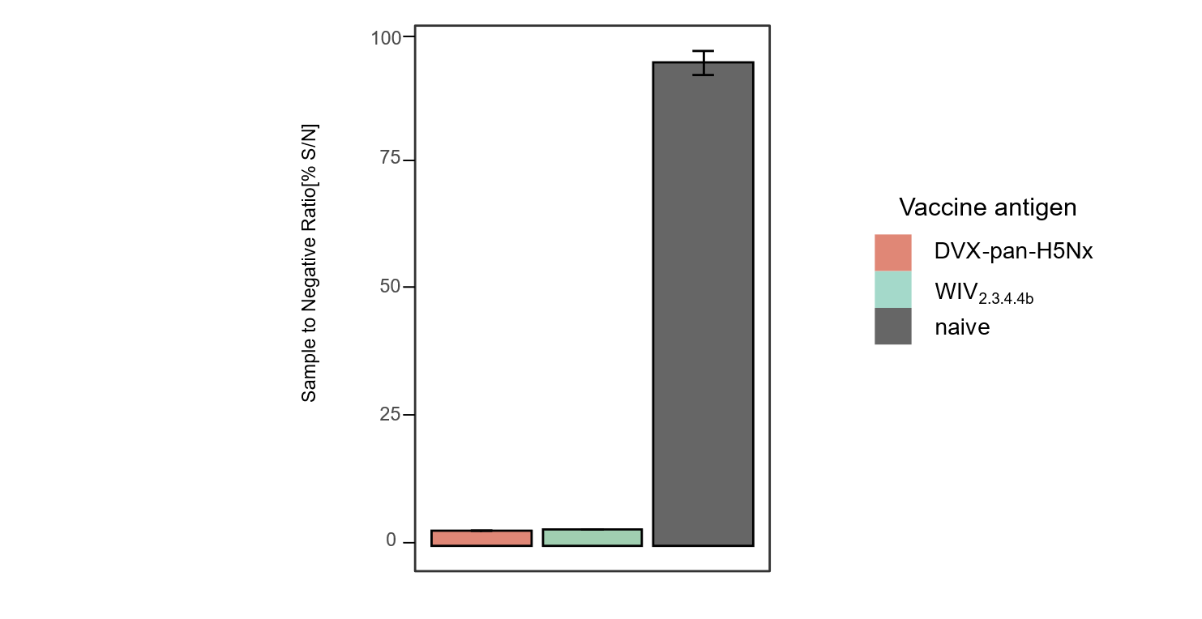

Supplementary Figure 1. Competition ELISA to detect binding antibodies in ferret serum samples on day 42.
Ferret serum samples were assessed by an ID Screen® Influenza H5 Antibody Competition ELISA. Competition is indicated by percent Sample to Negative Ratio (S/N %). Results over the 50% threshold are considered negative.

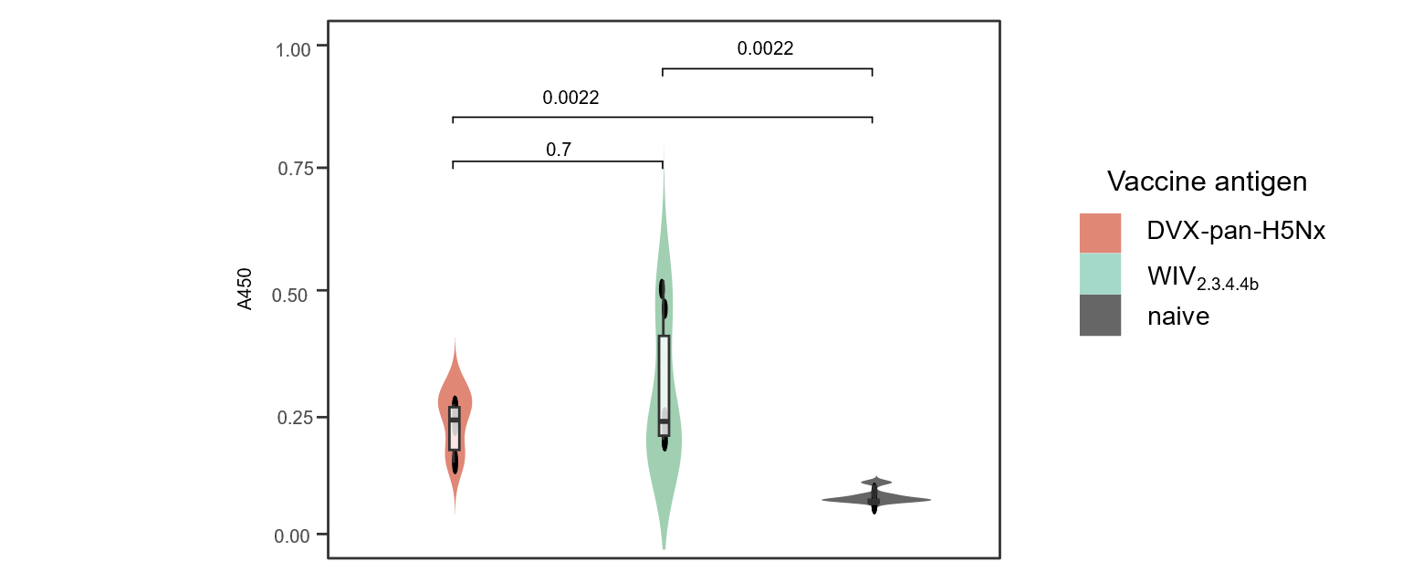

Supplementary Figure 2. Indirect ELISA to detect binding antibodies in ferret serum samples on day 42.
Ferret serum samples used to detect binding antibodies as shown by Absorbance at 450 nm (y axis) against avian H5 from all vaccine groups were detected via an ID Screen® Influenza H5 Indirect ELISA. Statistical significance shown by the indicated p values was determined via two-way Wilcoxon rank test with Benjamini-Hochberg correction.

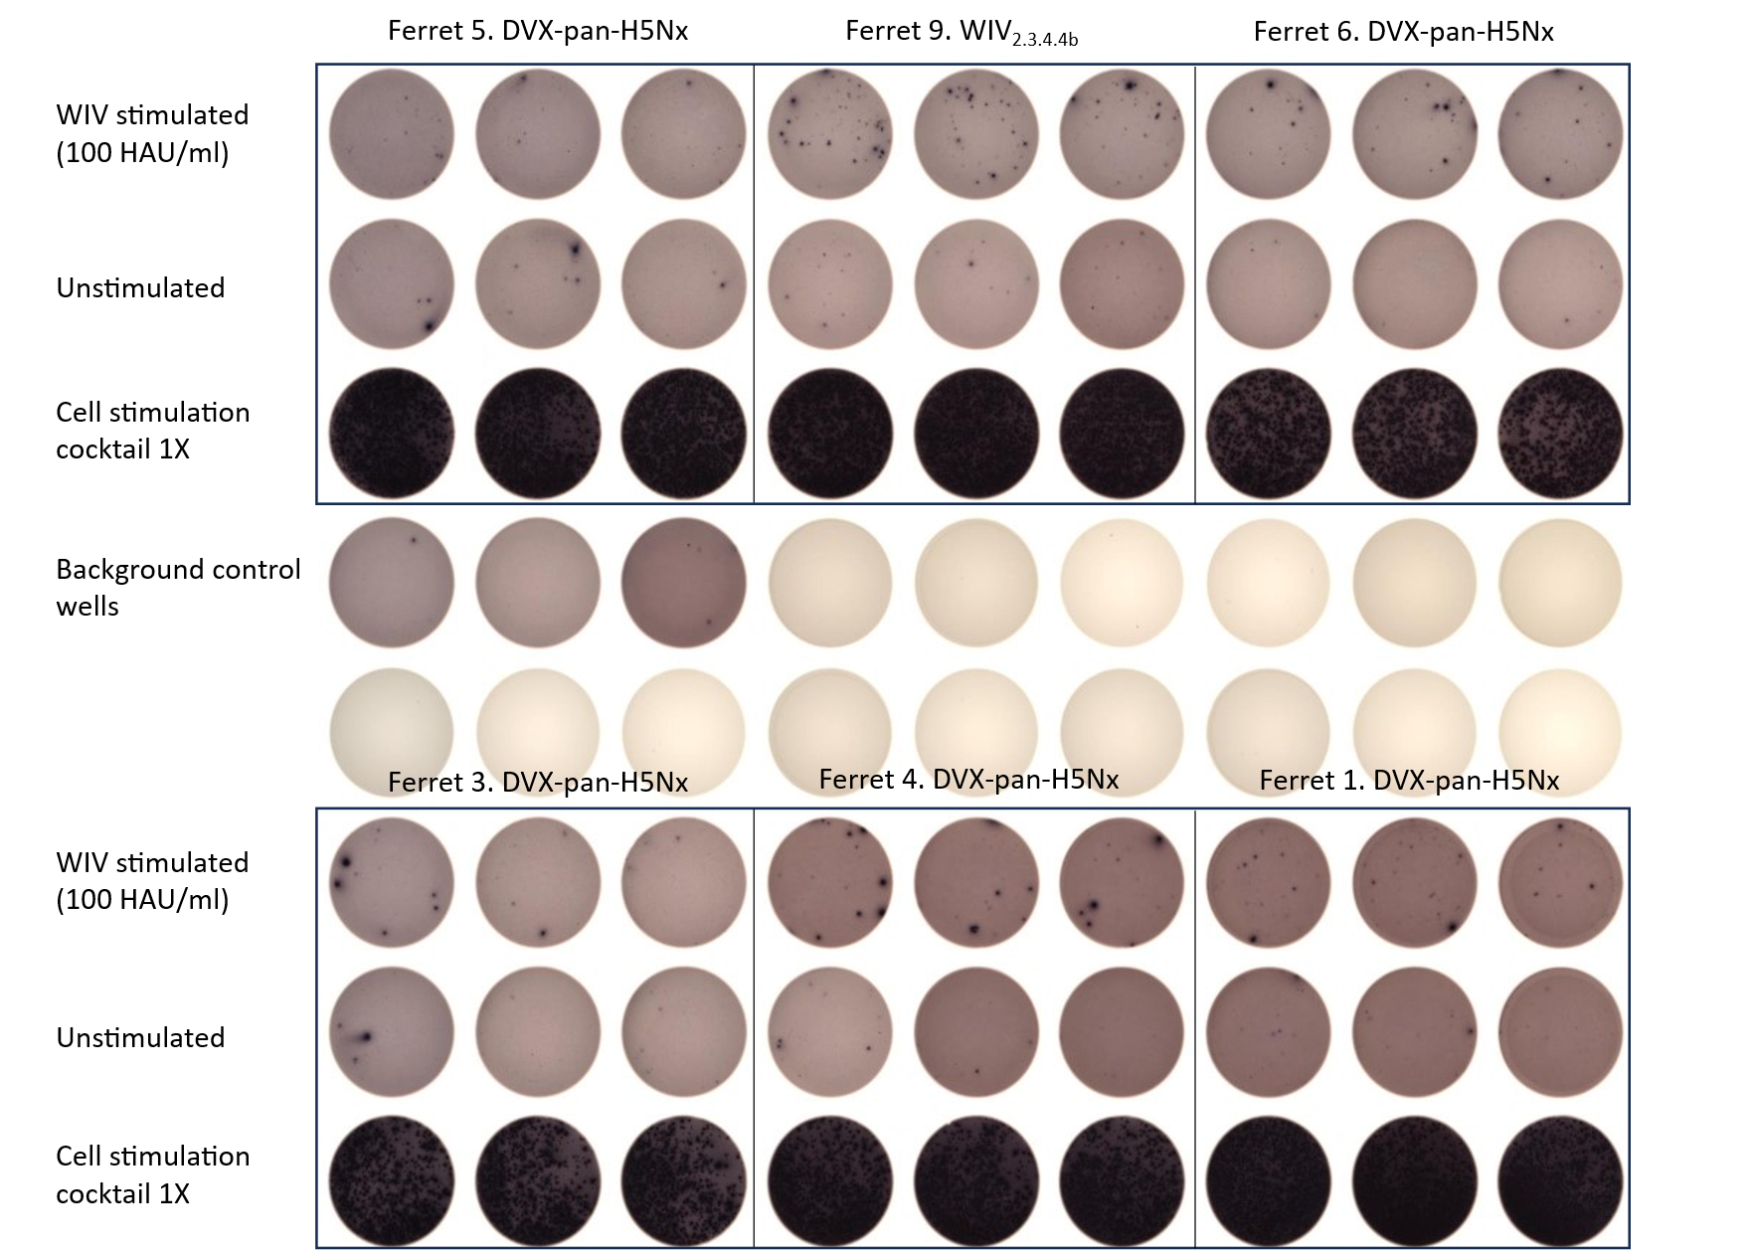

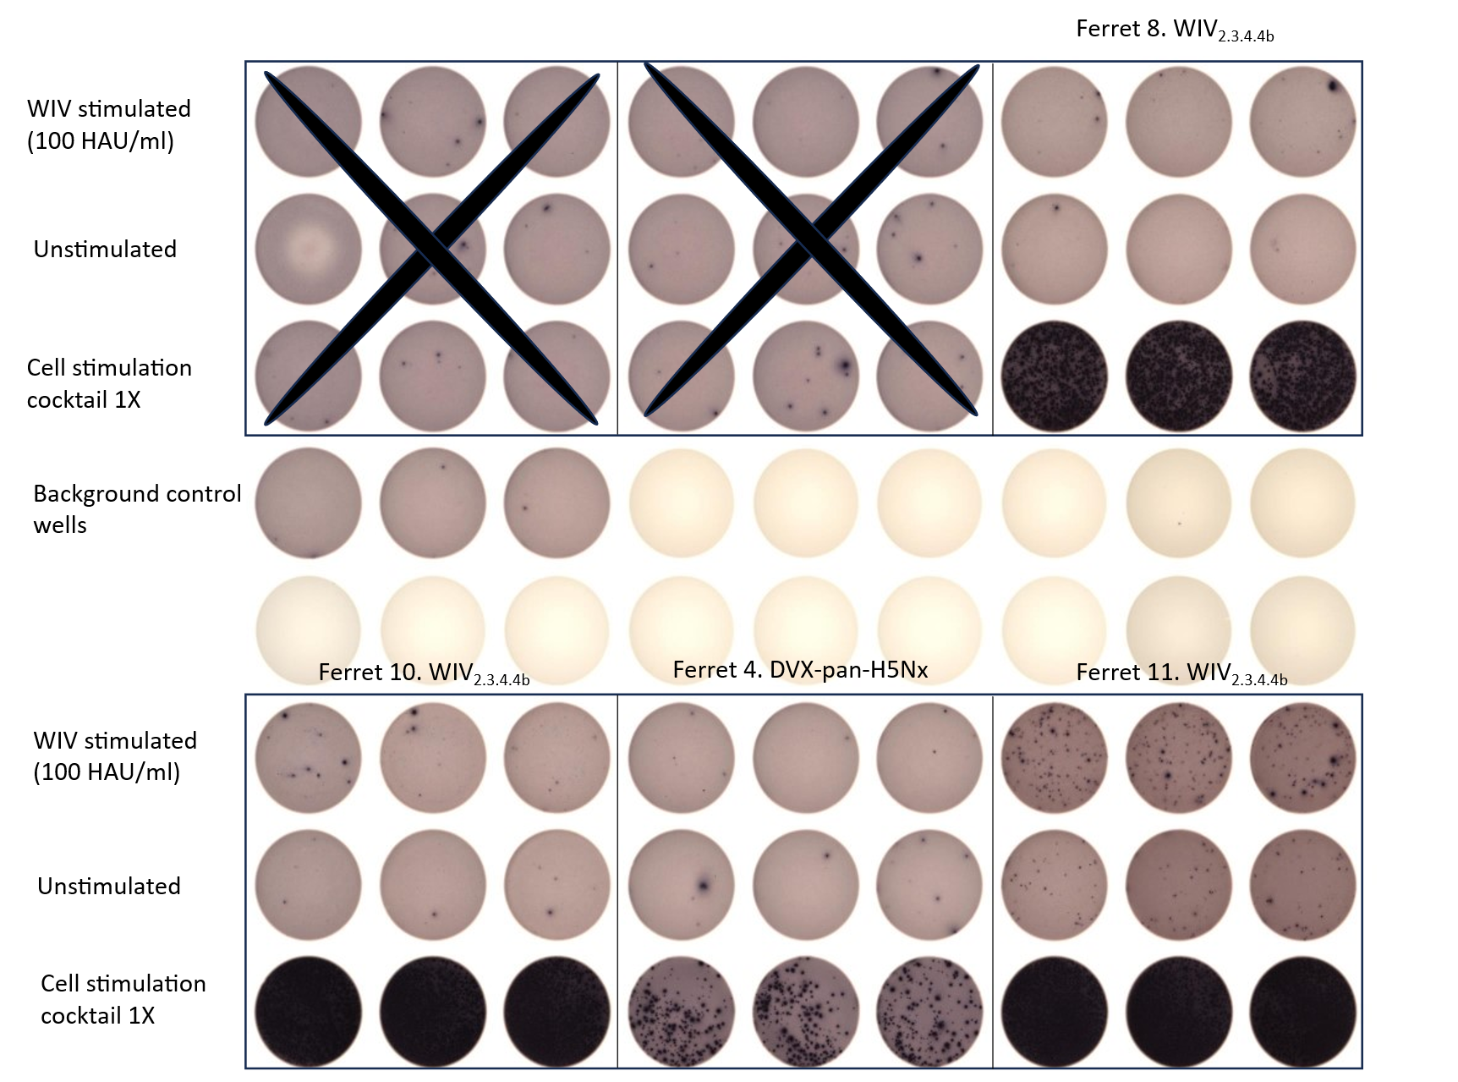

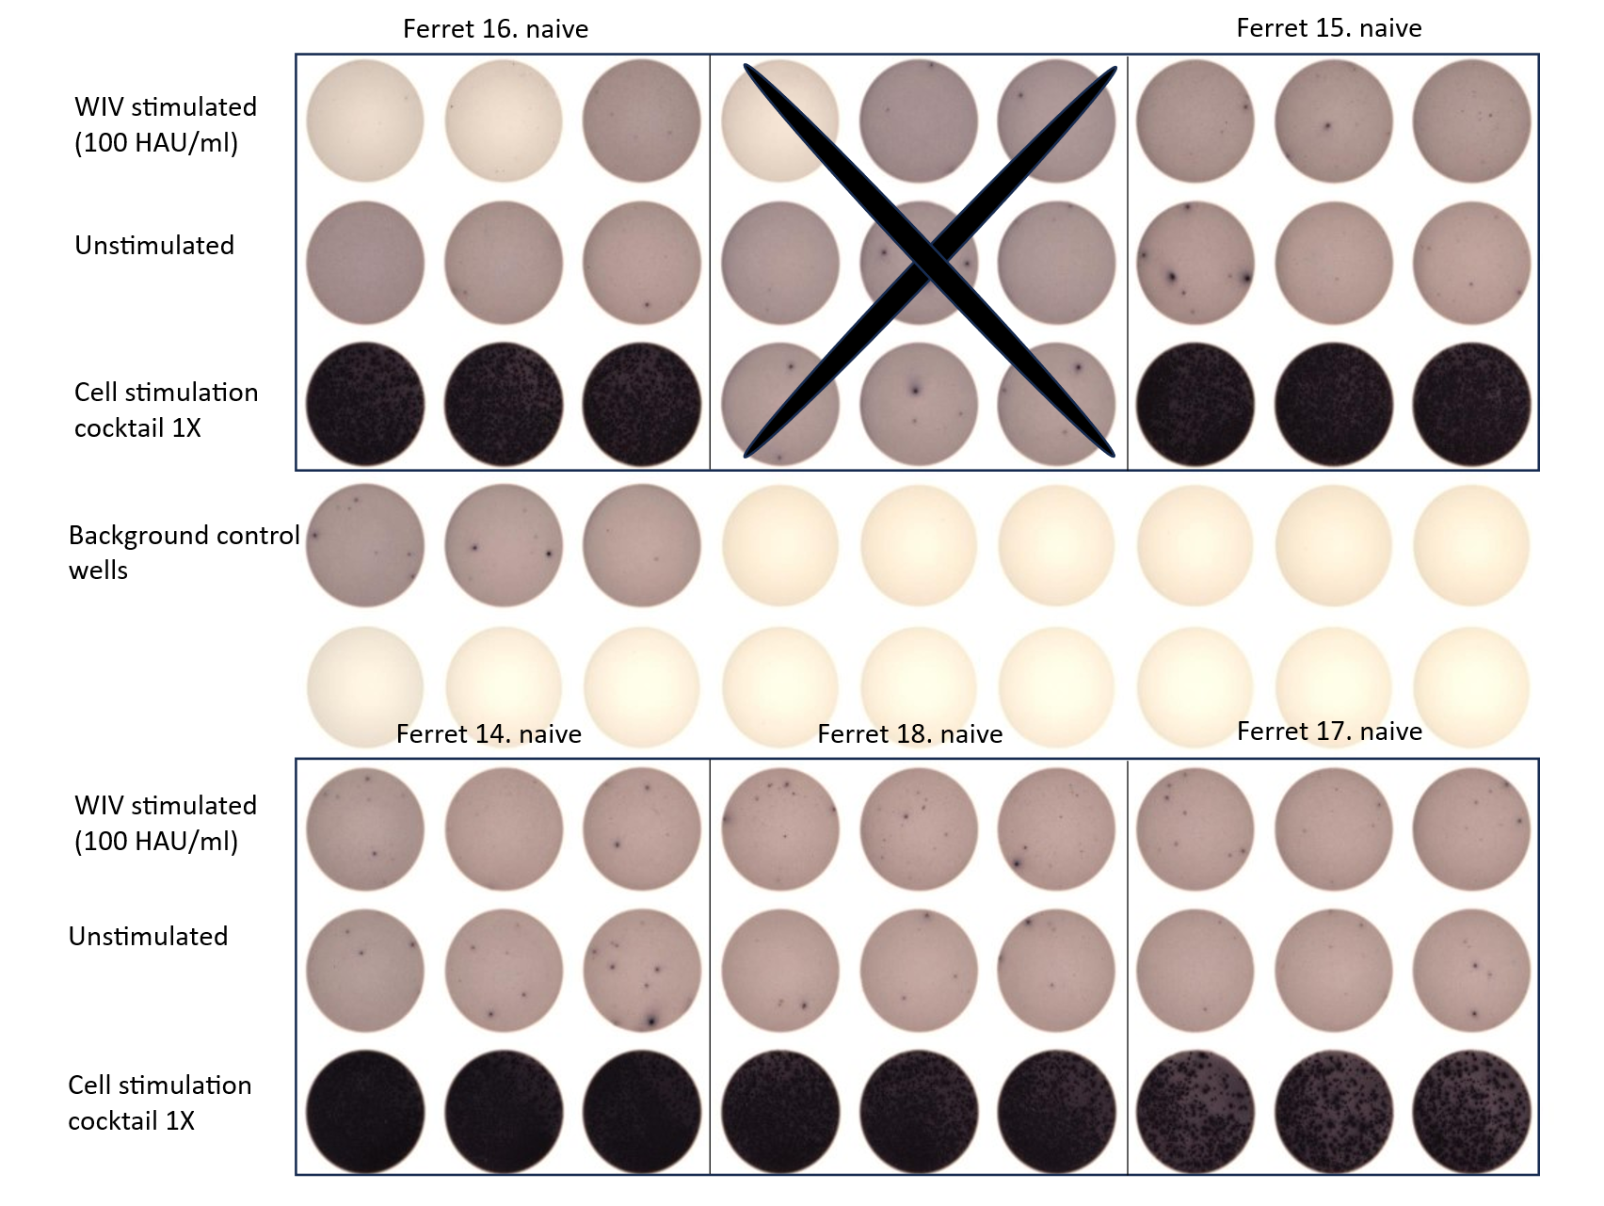

Supplementary Figure 3. Determination of T cell response in ferrets on day 42 by ELISpot. Representative wells showing the absence or presence of spot-forming units (SFU) are presented here to evaluate the induction of T-cell responses due to stimulation with whole inactivated challenge virus (WIV_{stimulated}), A/chicken/Italy/23VIR3799-1/2023 (H5N1). Wells marked with cross could not be read due to technical error
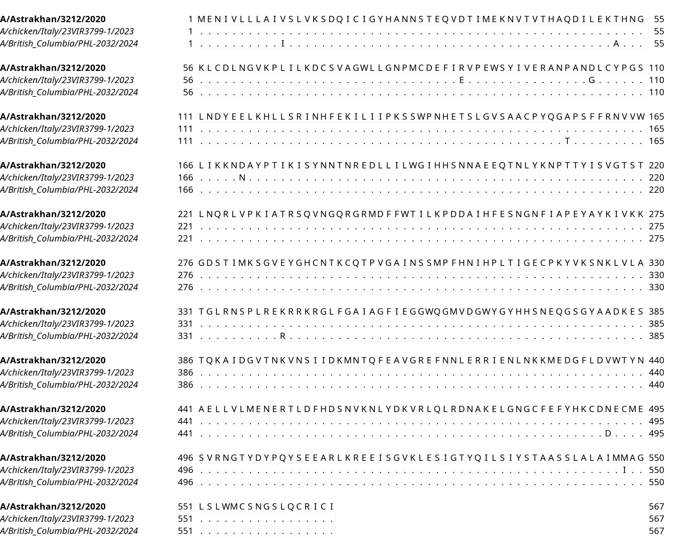
Supplementary Figure 4. Multiple Sequence alignment of selected relevant H5 2.3.4.4b HA sequences.
Multiple sequence alignment of HA sequences from strains A/Astrakhan/3212/2020 (H5N8) (clade 2.3.4.4b), A/chicken/Italy/23VIR3799-1/2023 (H5N1) (clade 2.3.4.4b), and A/British Columbia/PHL-2032/2024 (H5N1) (clade 2.3.4.4b) are shown. The top sequence is used as reference and the conserved amino acids in the rest of the sequences are represented as dots. The alignment was generated using Mafft.

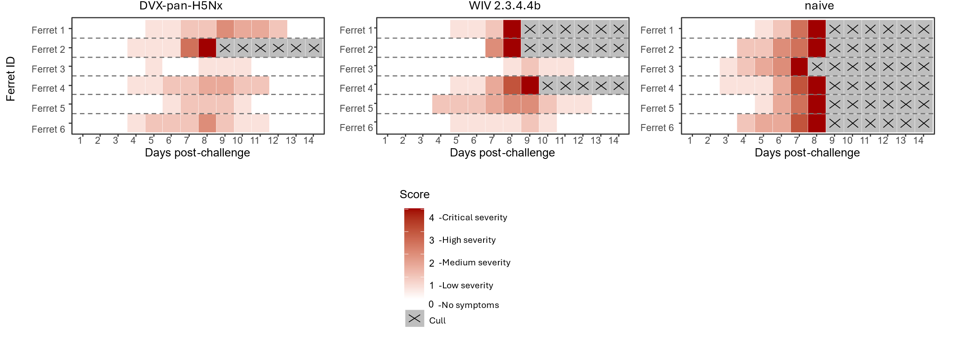

Supplementary Figure 5. Heatmap representation of clinical scoring of ferrets during challenge window.
Clinical signs of infection in ferrets were recorded twice daily during the challenge window. Parameters such as i) Alertness, ii) Breathing, iii) Ocular and Nasal discharge, and iv) Appetite were observed, with a Clinical Score of 0 given to ferrets with no symptoms, and 4 to ferrets with severe symptoms resulting in culling (indicated by X) as humane endpoints were reached.

Supplementary Figure 6. Determination of T cell response in ferrets post-challenge (on the day of culling) by ELISpot.
Representative wells showing the absence or presence of spot-forming units (SFU) are presented here to evaluate the induction of T-cell responses due to stimulation with whole inactivated challenge virus (WIV_{stimulated}), A/chicken/Italy/23VIR3799-1/2023 (H5N1). The T cell responses were evaluated at different time points (dpc) during the challenge window as indicated.

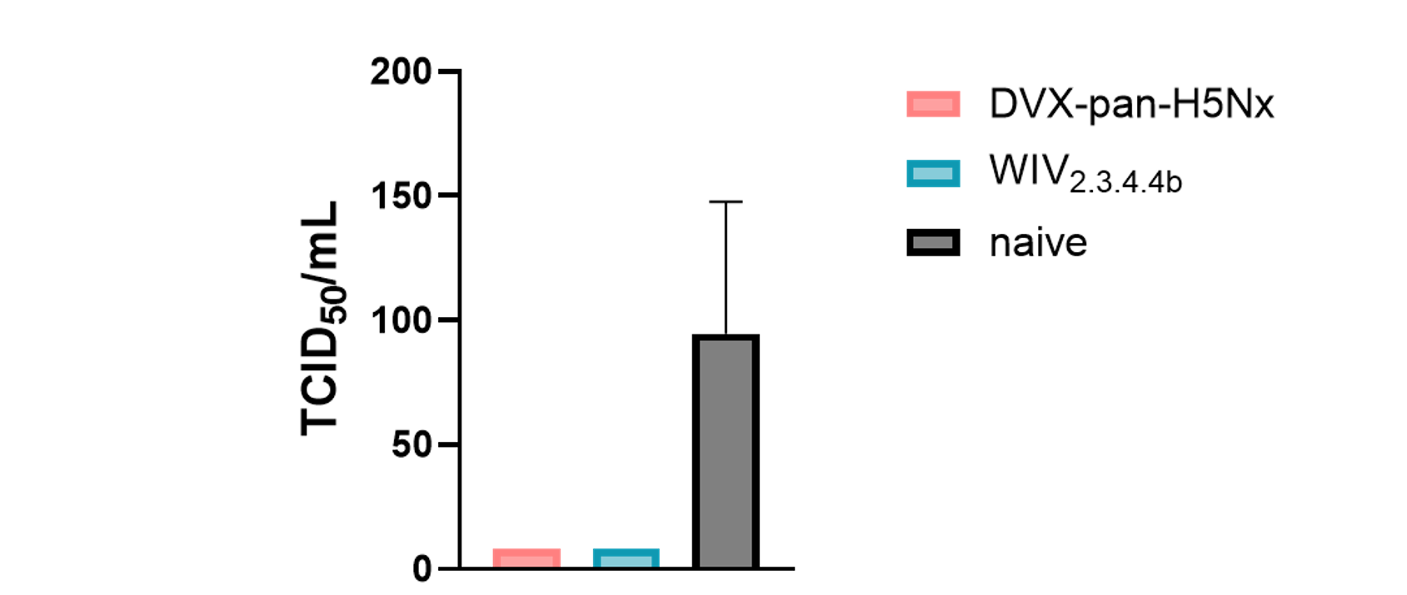
Supplementary Figure 7. Evaluation of viral titres via 50% tissue culture infectious dose (TCID₅₀) obtained from harvested ferret lung tissues post challenge.
Viral titres determined from homogenised lung tissues post challenge with A/chicken/Italy/23VIR3799-1/2023 (H5N1) (clade 2.3.4.4b). Representative viral titres indicated as TCID₅₀/mL on y axis and vaccinated groups on x axis. The plot shows median with interquartile range of individual ferret samples (n=6 per vaccination group). No statistical significance was observed in the recovered viral titres between vaccinated groups and naive groups as determined by Wilcoxon rank test with Benjamini-Hochberg correction (p>0.05).

Supplementary Table 1. Accession id of the HA sequences used to generate Fig 1.

Strain | Subtype | Clade | Accession ID
A/swine/Mexico/GtoDMZC02/2014 | H5N2 | AM non-Gs/GD | EPI837661
A/HongKong/483/1997 | H5N1 | 0 | EPI4349
A/HongKong/481/1997 | H5N1 | 0 | EPI4347
A/HongKong/156/1997 | H5N1 | 0 | EPI4186
A/HongKong/4847232/1997 | H5N1 | 0 | EPI1328385
A/HongKong/97/1998 | H5N1 | 0 | EPI5495
A/swine/Shandong/2/2003 | H5N1 | 0 | EPI22691
A/HongKong/213/2003 | H5N1 | 1 | EPI1161
A/Thailand/16/2004 | H5N1 | 1 | EPI152380
A/Thailand/5(KK-494)/2004 | H5N1 | 1 | EPI21925
A/Vietnam/CL02/2004 | H5N1 | 1 | EPI228832
A/Thailand/NKNPHA/2005 | H5N1 | 1 | EPI226841
A/Cambodia/JP52a/2005 | H5N1 | 1 | EPI115185
A/Cambodia/S1211394/2008 | H5N1 | 1.1.1 | EPI284001
A/Cambodia/V0606311/2011 | H5N1 | 1.1.1 | EPI341364
A/Cambodia/U0417030/2010 | H5N1 | 1.1.2 | EPI341369
A/Cambodia/V0203306/2011 | H5N1 | 1.1.2 | EPI341368
A/Cambodia/W0329318/2012 | H5N1 | 1.1.2 | EPI542914
A/Cambodia/W0526301/2012 | H5N1 | 1.1.2 | EPI542922
A/Cambodia/X0502302/2013 | H5N1 | 1.1.2 | EPI542964
A/Cambodia/X0628313/2013 | H5N1 | 1.1.2 | EPI531266
A/Cambodia/Y0304301/2014 | H5N1 | 1.1.2 | EPI956090
A/Cambodia/Y0314301/2014 | H5N1 | 1.1.2 | EPI957382
A/Cambodia/Y0305306/2014 | H5N1 | 1.1.2 | EPI956098
A/swine/Banten/UT3062/2005 | H5N1 | 2.1.1 | EPI271674
A/swine/EastJava/UT6003/2006 | H5N1 | 2.1.3 | EPI271706
A/Indonesia/CDC624E/2006 | H5N1 | 2.1.3.2 | EPI41668
A/Indonesia/CDC739/2006 | H5N1 | 2.1.3.2 | EPI41915
A/Indonesia/CDC610/2006 | H5N1 | 2.1.3.2 | EPI41592
A/Indonesia/NIHRD10459/2010 | H5N1 | 2.1.3.2 | EPI1377636
A/Indonesia/NIHRD14122/2014 | H5N1 | 2.1.3.2a | EPI531959
A/Indonesia/NIHRD9160/2009 | H5N1 | 2.1.3.2b | EPI1377772
A/Indonesia/NIHRD11931/2012 | H5N1 | 2.1.3.2b | EPI356472
A/cat/Dagestan/87/2006 | H5N1 | 2.2 | EPI106416
A/Azerbaijan/2-115/2006 | H5N1 | 2.2 | EPI124626
A/Azerbaijan/6-207/2006 | H5N1 | 2.2 | EPI124618
A/Azerbaijan/11-162/2006 | H5N1 | 2.2 | EPI124622
A/Azerbaijan/1-161/2006 | H5N1 | 2.2 | EPI124624
A/domesticcat/Iraq/820/2006 | H5N1 | 2.2 | EPI102988
A/Iraq/207-NAMRU3/2006 | H5N1 | 2.2 | EPI102992
A/Iraq/756/2006 | H5N1 | 2.2 | EPI124632
A/Iraq/1/2006 | H5N1 | 2.2 | EPI124616
A/cat/Romania/TL/2007 | H5N1 | 2.2 | EPI221713
A/Egypt/902782/2006 | H5N1 | 2.2.1 | EPI124610
A/Egypt/7021-NAMRU3/2006 | H5N1 | 2.2.1 | EPI255357
A/Egypt/2991-NAMRU3/2006 | H5N1 | 2.2.1 | EPI122749
A/Egypt/2630-NAMRU3/2007 | H5N1 | 2.2.1 | EPI255357
A/Egypt/2331-NAMRU3/2007 | H5N1 | 2.2.1 | EPI116464
A/Egypt/N6774/2011 | H5N1 | 2.2.1.2 | EPI372883
A/Egypt/N01400/2012 | H5N1 | 2.2.1.2 | EPI460365
A/India/SARI4571/2021 | H5N1 | 2.3.2.1a | EPI2116742
A/Nepal/19FL1997/2019 | H5N1 | 2.3.2.1a | EPI1435662
A/Victoria/149/2024 | H5N1 | 2.3.2.1a | EPI3317786
A/HongKong/5923/2012 | H5N1 | 2.3.2.1b | EPI375432
A/Alberta/1/2014 | H5N1 | 2.3.2.1c | EPI500771
A/Cambodia/Y0219302/2014 | H5N1 | 2.3.2.1c | EPI954450
A/lion/Hubei/1-2/2016 | H5N1 | 2.3.2.1c | EPI896339
A/tiger/China/HDHZ03/2016 | H5N1 | 2.3.2.1c | EPI2258325
A/mink/China/CY/2017 | H5N1 | 2.3.2.1c | EPI1536858
A/Indonesia/NIHRD17109/2017 | H5N1 | 2.3.2.1c | EPI1079019
A/Cambodia/2311257/2023 | H5N1 | 2.3.2.1c | EPI2804266
A/Cambodia/KSH230332/2023 | H5N1 | 2.3.2.1c | EPI2804247
A/Cambodia/NPH230032/2023 | H5N1 | 2.3.2.1c | EPI2419700
A/Vietnam/KhanhhoaRV1005/2024 | H5N1 | 2.3.2.1c | EPI3181128
A/tiger/Vietnam/24AS1667/2024 | H5N1 | 2.3.2.1c | EPI3624844
A/tiger/Vietnam/24AS1668/2024 | H5N1 | 2.3.2.1c | EPI3624854
A/tiger/Vietnam/24AS1716/2024 | H5N1 | 2.3.2.1c | EPI3624878
A/Cambodia/KSH250004/2025 | H5N1 | 2.3.2.1c | EPI3785019
A/Fujian/1/2005 | H5N1 | 2.3.4 | EPI181299
A/Anhui/33162/2016 | H5N6 | 2.3.4.4 | EPI1098355
A/greyseal/361-10/BalticPL/2016 | H5N8 | 2.3.4.4b | EPI1297287
A/Guangdong/lgf/2021 | H5N6 | 2.3.4.4b | EPI2255267
A/Hunan/9285/2021 | H5N6 | 2.3.4.4b | EPI1918708
A/GXguilin/11151/2021 | H5N6 | 2.3.4.4b | EPI1887789
A/fox/Finland/284421VIR96191/2021 | H5N1 | 2.3.4.4b | EPI2197216
A/England/215201407/2021 | H5N1 | 2.3.4.4b | EPI1958565
A/redfox/Netherlands/21040099006/2021 | H5N1 | 2.3.4.4b | EPI1988009
A/redfox/Norway/20220717682T/2022 | H5N1 | 2.3.4.4b | EPI2782179
A/fox/Ireland/386622VIR20641/2022 | H5N1 | 2.3.4.4b | EPI1998138
A/polecat/Netherlands/22000516003/2022 | H5N1 | 2.3.4.4b | EPI1958457
A/vulpesvulpes/Belgium/147750001/2022 | H5N1 | 2.3.4.4b | EPI2297256
A/mink/Spain/3691222VIR105868/2022 | H5N1 | 2.3.4.4b | EPI2220613
A/mink/Spain/3691322VIR105869/2022 | H5N1 | 2.3.4.4b | EPI2220621
A/mink/Spain/22VIR127741338692/2022 | H5N1 | 2.3.4.4b | EPI2291510
A/mink/Spain/22VIR127741438693/2022 | H5N1 | 2.3.4.4b | EPI2291518
A/mink/Spain/36911022VIR1058611/2022 | H5N1 | 2.3.4.4b | EPI2220605
A/mink/Spain/3691822VIR1058610/2022 | H5N1 | 2.3.4.4b | EPI2220597
A/lynx/Finland/Vi2092222VIR31272/2022 | H5N1 | 2.3.4.4b | EPI2197224
A/Colorado/18/2022 | H5N1 | 2.3.4.4b | EPI2042405
A/canine/China/GX30/2023 | H5N6 | 2.3.4.4b | EPI2676672
A/walrus/Norway/1/2023 | H5N5 | 2.3.4.4b | EPI3598353
A/SouthAmericanseaLion/Peru/LIMSER036/2023 | H5N1 | 2.3.4.4b | EPI2745234
A/lion/Peru/AIS0554/2023 | H5N1 | 2.3.4.4b | EPI2597244
A/sealion/Brazil/KU3584/2023 | H5N1 | 2.3.4.4b | EPI2919521
A/sealion/Brazil/KU3594/2023 | H5N1 | 2.3.4.4b | EPI2919538
A/sealion/LosLagos/247932/2023 | H5N1 | 2.3.4.4b | EPI3550220
A/Jiangsu/NJ210/2023 | H5N1 | 2.3.4.4b | EPI2455058
A/feline/SouthKorea/SNU01/2023 | H5N1 | 2.3.4.4b | EPI2780151
A/feline/SouthKorea/SNU02/2023 | H5N1 | 2.3.4.4b | EPI2780162
A/vulpesvulpes/Belgium/017840010/2023 | H5N1 | 2.3.4.4b | EPI2468396
A/fox/France/23P002844/2023 | H5N1 | 2.3.4.4b | EPI2467145
A/mink/Finland/735/2023 | H5N1 | 2.3.4.4b | EPI2755659
A/arcticfox/Finland/678/2023 | H5N1 | 2.3.4.4b | EPI2755643
A/arcticfox/Finland/574/2023 | H5N1 | 2.3.4.4b | EPI2697385
A/arcticfox/Finland/HVVI5032323VIR68036/2023 | H5N1 | 2.3.4.4b | EPI2760286
A/rat/Egypt/STK003/2023 | H5N1 | 2.3.4.4b | EPI3276057
A/rat/Egypt/STK001/2023 | H5N1 | 2.3.4.4b | EPI3276049
A/domesticcat/Poland/H253/2023 | H5N1 | 2.3.4.4b | EPI2610789
A/domesticcat/Poland/H249/2023 | H5N1 | 2.3.4.4b | EPI2610773
A/domesticcat/Poland/H248/2023 | H5N1 | 2.3.4.4b | EPI2610805
A/domesticcat/Poland/Kot1/2023 | H5N1 | 2.3.4.4b | EPI2610821
A/domesticcat/Poland/H247/2023 | H5N1 | 2.3.4.4b | EPI2610813
A/domesticcat/Poland/H252/2023 | H5N1 | 2.3.4.4b | EPI2610781
A/domesticcat/Poland/H254/2023 | H5N1 | 2.3.4.4b | EPI2610797
A/pinemarten/Netherlands/1/2024 | H5N5 | 2.3.4.4b | EPI3522541
A/lynx/Norway/20240436256/2024 | H5N5 | 2.3.4.4b | EPI3786642
A/otter/Norway/202480165/2024 | H5N5 | 2.3.4.4b | EPI3873519
A/goat/Minnesota/24007234003original/2024 | H5N1 | 2.3.4.4b | EPI3162317
A/goat/Minnesota/24007234006original/2024 | H5N1 | 2.3.4.4b | EPI3162325
A/goat/Minnesota/24007234009original/2024 | H5N1 | 2.3.4.4b | EPI3162333
A/Texas/37/2024 | H5N1 | 2.3.4.4b | EPI3171488
A/cat/Minnesota/24-018452-002/2024 | H5N1 | 2.3.4.4b | EPI3433955
A/Missouri/121/2024 | H5N1 | 2.3.4.4b | EPI3556416
A/California/150/2024 | H5N1 | 2.3.4.4b | EPI3641366
A/HeFei/4171/2024 | H5N6 | 2.3.4.4b | EPI3520918
A/Washington/240/2024 | H5N1 | 2.3.4.4b | EPI3630049
A/Washington/239/2024 | H5N1 | 2.3.4.4b | EPI3630041
A/domesticcat/Italy/25VIR3921/2025 | H5N1 | 2.3.4.4b | EPI3849410
A/redfox/Netherlands/25000776001/2025 | H5N1 | 2.3.4.4b | EPI3864052
A/fox/USA/000628001/2025 | H5N1 | 2.3.4.4b | EPI3885597
A/England/480160/2025 | H5N1 | 2.3.4.4b | EPI3863023
A/Quanzhou/1/2024 | H5N6 | 2.3.4.4h | EPI3786561

Supplementary Table 2. Immunisation schedule of designed antigens and control “wild-type” antigens as DNA immunogens in BALB/c mice.

Antigen | Legend in Fig. 2b | Dose/  animal (µg) | Days of Immunisation (D)
DVX-H5-1 | DVX-H5-1 | 50 | D0, D28
DVX-H5-2 | DVX-H5-2 | 50 | D0, D28
A/Sichuan/26221/2014 | 2.3.4.4a | 50 | D0, D28
A/gyrfalcon/Washington/41088-6/2014 | 2.3.4.4c | 50 | D0, D28
A/Anhui/2021-00011/2020 | 2.3.4.4h | 50 | D0, D28
DVX-N1 | DVX-N1 | 50 | D0, D14, D28, D42
A/Brisbane/02/2018 | BNE/2018 | 50 | D0, D14, D28, D42
DVX-N6 | DVX-N6 | 50 | D0, D14, D28, D42
A/yellow-billed teal/Chile/8/2013 | ye/CHL/2013 | 50 | D0, D14, D28, D42
DVX-M2 | DVX-M2 | 50 | D0, D21, D42, D63
A/Brisbane/2/2018 | BNE/2018 | 50 | D0, D21, D42, D63
A/Kansas/14/2017 | KS/2017 | 50 | D0, D21, D42, D63
PBS | PBS | - | Same as respective antigens in the study group

Supplementary Table 3. Accession id of the HA protein of the virus strains used for generating the H5 pseudotype virus (PV) panel.

Strain | Clade | Abbreviation used in text | Accession
A/chicken/Mexico/07/2007 | AM non-GS/GD | ch/MX/2007 | KJ729343
A/mallard/Netherlands/41/2015 | EU non-GS/GD | ma/NLD/2015 | MF694083
A/Vietnam/1203/2004 | 1 | VNM/2004 | ABP51977.1
A/Indonesia/5/2005 | 2.1.3.2 | IDN/2005 | ABW06108.1
A/whooper swan/Mongolia/244/2005 | 2.2 | wh/MNG/2005 | GU186700.1
A/turkey/Turkey/1/2005 | 2.2.1 | tu/TUR/2005 | ABD73284.1
A/Egypt/3300-NAMRU3/2008 | 2.2.1.1 | EGY/2008 | FJ226061.1
A/Hubei/1/2010 | 2.3.2.1a | HUB/2010 | CY098758.1
A/Cambodia/NPH230032/2023 | 2.3.2.1c | KHM/2023 | EPI2419700
A/Anhui/1/2005 | 2.3.4 | AN/2005 | ABD28180.1
A/Sichuan/26221/2014 | 2.3.4.4a | SC/2014 | EPI533583
A/muteswan/England/053054/2021 | 2.3.4.4b | mu/ENG/2021 | EPI1924123
A/Hangzhou/01/2021 | 2.3.4.4b | HGH/2021 | EPI1946730
A/Colorado/109/2024 | 2.3.4.4b | CO/2024 | EPI3437006
A/BritishColumbia/PHL-2032/2024 | 2.3.4.4b | BC/2024 | EPI3650014
A/gyrfalcon/Washington/41088-6/2014 | 2.3.4.4c | gy/WA/2014 | EPI569390
A/Guangdong/18SF020/2018 | 2.3.4.4h | GD/2018 | EPI1352813
A/Anhui/2021-00011/2020 | 2.3.4.4h | AN/2020 | EPI1848299
A/chicken/Vietnam/NCVD-016/2008 | 7.1 | ch/VNM/2008 | FJ842476.1

Supplementary Table 4. Accession id of the NA proteins of the virus strains used for generating the pseudotype virus panel for pseudotype enzyme-linked lectin assay (pELLA).

Strain | Subtype | Abbreviation | Accession
A/California/7/2009 | N1 | CA/2009 | NC_026434.1
A/England/195/2009 | N1 | ENG/2009 | EPI178509
A/swine/England/1353/2009 | N1 | sw/ENG/2009 | EPI640886
A/mink/China/CY/2017 | N1 | mi/CHN/2017 | MH127651.1
A/Brisbane/02/2018 | N1 | BNE/2018 | EPI1312565
A/Victoria/2454/2019 | N1 | VIC/2019 | EPI1701883
A/swine/NorthCarolina/A02478985/2020 | N1 | sw/NC/2020 | EPI1785488
A/muteswan/England/053054/2021 | N1 | mu/ENG/2021 | EPI1924125
A/MecklenburgVorpommern/1A/2021 | N1 | MV/2021 | EPI1868544
A/harbor seal/Maine/22-020983-007-original/2022 | N1 | ha/ME/2022 | EPI2110524
A/Victoria/4897/2022 | N1 | VIC/2022 | EPI2447515
A/British_Columbia/PHL-2032/2024 | N1 | BC/2024 | EPI3650016
A/yellow-billed teal/Chile/8/2013 | N6 | ye/CHL/2013 | EPI775314
A/Sichuan/26221/2014 | N6 | SC/2014 | EPI533584
A/duck/NgheAn/5382VTC/2019 | N6 | du/NgheAn/2019 | EPI1665322
A/Anhui/2021-00011/2020 | N6 | AN/2020 | EPI1848297
A/gyrfalcon/Washington/41088-6/2014 | N8 | gy/WA/2014 | EPI569390

Supplementary Table 5. Immunisation schedule of the VAP as mRNA immunogen and the control antigens as whole inactivated vaccines (WIV) in BALB/c mice.

Antigen | Test/Control | Dose/  animal | Days of Immunisation
DVX-pan-H5Nx | pan-H5Nx vaccine candidate | 10 µg | D0, D21
A/Vietnam/1194/2004 (H5N1) (NIBRG-14) | WIV₁ | 1.5 µg | D0
A/Astrakhan/3212/2020 (H5N8) (CBER-RG8A) | WIV_{2.3.4.4b} | 1.5 µg | D0
naive | mRNA diluent | - | D0, D21

Supplementary Table 6. Immunisation and challenge schedule for the vaccine candidate and control WIV in mice against multiple H5N1 viruses.

Vaccine | Test/Control | Dose/  animal (µg) | Day of Immunisation
DVX-pan-H5Nx | pan-H5Nx vaccine candidate | 10 | D0, D21
A/Astrakhan/3212/2020 (H5N8) (NIBSC-CBER-RG8A) | WIV_{2.3.4.4b} control | 0.15 | D0, D21
mRNA diluent | naive control | - | D0, D21
CHALLENGE VIRUS |  | Dose for 10LD50  (plaque-forming units [PFU]) | Day of Challenge
A/British Columbia/PHL-2032/2024 (H5N1) (clade 2.3.4.4b) |  | 10 PFU | D49
A/Cambodia/NPH230032/2023 (H5N1) (clade 2.3.2.1c) [KHM/2023HN] |  | 316 PFU | D49
A/Vietnam/1203/2004 (H5N1) (clade 1) |  | 10 PFU | D49

Supplementary Table 7. p values as calculated using unpaired t-tests with Benjamini Hochberg correction between groups of mice immunised with DVX-pan-H5Nx vs WIV_{2.3.4.4b} (ab), DVX-pan-H5Nx vs naive (ac), and WIV_{2.3.4.4b} vs naïve (bc), on the indicated day post challenge (dpc) with specific challenge viruses. p values indicated in Fig. 4d-f 2nd panel show statistically significant differences in weights between immunisation groups during specified days in the challenge window.
Days post challenge (dpc) | DVX-pan-H5Nx vs WIV_{2.3.4.4b}  [ab] | DVX-pan-H5Nx vs naïve  [ac] | WIV_{2.3.4.4b} vs naive  [bc]
Challenge with A/British Columbia/PHL-2032/2024 (H5N1) Clade 2.3.4.4b
1 | ns | 0.0285 | ns
2 | ns | ns | ns
3 | ns | p<0.0001 | p<0.0001
4 | ns | p<0.0001 | p<0.0001
5 | 0.0285 | p<0.0001 | p<0.0001
Challenge with A/Cambodia/NPH230032/2023 (H5N1) Clade 2.3.2.1c [KHM/2023]
1 | 0.0445 | ns | 0.0445
2 | ns | ns | 0.0482
3 | ns | ns | ns
4 | ns | 0.0328 | ns
5 | 0.0445 | 0.0019 | ns
6 | 0.0387 | p<0.0001 | ns
7 | 0.0445 | ns | ns
8 | ns | 0.0387 | ns
9 | ns | 0.0482 | ns
10 | ns | ns | ns
11 | ns | ns | ns
12 | ns | ns | ns
13 | ns | 0.0445 | ns
Challenge with A/Vietnam/1203/2004 (H5N1) Clade 1
1 | ns | 0.0421 | ns
2 | 0.0109 | ns | ns
3 | ns | ns | ns
4 | 0.0059 | 0.0335 | ns
5 | 0.0057 | 0.0074 | ns
6 | p<0.0001 | 0.0335 | ns
7 | 0.0002 | ns | ns
8 | 0.0005 | ns | ns

Supplementary Table 8. Immunisation and challenge schedule for the vaccine candidate and control WIV in ferrets.

Vaccine | Test/Control | Dose/  animal (µg) | Day of Immunisation /Challenge
DVX-pan-H5Nx | pan-H5Nx vaccine candidate | 100 | D0, D21
A/Astrakhan/3212/2020 (H5N8) (NIBSC-CBER-RG8A), adjuvanted 1:1 with MF59 | WIV_{2.3.4.4b} control | 3.8 | D0, D21
mRNA diluent | Naïve control | - | D0, D21
CHALLENGE
A/chicken/Italy/23VIR3799-1/2023 (H5N1) |  | 1E+05 TCID₅₀/mL | D49

Supplementary Table 9. Isolate id of the viruses used for hemagglutination inhibition (HAI) panel.

Strain | Isolate id | Abbreviation | Clade
A/Vietnam/1194/2004 (H5N1) (NIBRG-14) | EPI_ISL_30632 | VNM/2004 | 1
A/turkey/Turkey/2005 (H5N1) (NIBRG-23) | EPI_ISL_19530537 | tu/TUR/2005 | 2.2.1
A/duck/Bangladesh/17D1012/2018 (H5N1) | EPI_ISL_331119 | du/BGD/2018 | 2.3.2.1a
A/Astrakhan/3212/2020 (H5N8) (CBER-RG8A) | EPI_ISL_13655139 | AST/2020 | 2.3.4.4b
A/duck/Vietnam/NCVD-1584/2012 (H5N1) (NIBRG-301) | EPI_ISL_136169 | du/VNM/2012 | 2.3.2.1c
A/Anhui/1/2005 (H5N1) | EPI_ISL_24603 | AN/2005 | 2.3.4
A/chicken/Italy/23VIR3799-1/2023 (H5N1) | EPI_ISL_19767156 | ch/ITA/2023 | 2.3.4.4b
A/gyrfalcon/Washington/41088-6/2014 (H5N1) | EPI_ISL_173878 | gy/WA/2014 | 2.3.4.4c

Supplementary Table 10. NIBSC ID of the HA antigens used for ELISA in animal immunogenicity studies

Strain | NIBSC ID | Clade
A/Vietnam/1194/2004 (H5N1) (NIBRG-14) | 09/184 | 1
A/duck/Vietnam/NCVD-1584/2012 (H5N1) (NIBRG-301) | 17/142 | 2.3.2.1c
A/Astrakhan/3212/2020 (H5N8) (CBER-RG8A) (H5N8) | 23/178 | 2.3.4.4b

Supplementary Table 11. Main findings on histopathological evaluation of the cranial lung lobe and brain in all experimental groups (number and percentage of animals affected in each experimental group).
Main histopathology findings |  | Experimental groups
 |  | DVX-pan-H5Nx  n=6 | WIV 2.3.4.4b  n=6 | Vehicle  n=6
Cranial lung lobe | Alveolar inflammation  Mild  Moderate  Marked | 6/6 (100%)  1/6 (16.7%)  3/6 (50%)  2/6 (33.3%) | 6/6 (100%)  1/6 (16.7%)  2/6 (33.3%)  3/6 (50%) | 6/6 (100%)  1/6 (16.7%)  2/6 (33.3%)  3/6 (50%)
Cranial lung lobe | Intrabronchial inflammation  Mild  Moderate  Marked | 0/6 (0%)  0/6 (0%)  0/6 (0%)  0/6 (0%) | 3/6 (50%)  2/3 (66.7%)  1/3 (33.3%)  0/3 (0%) | 0/6 (0%)  0/6 (0%)  0/6 (0%)  0/6 (0%)
Cranial lung lobe | Intrabronchiolar inflammation  Mild  Moderate  Marked | 2/6 (33.3%)  2/2 (100%)  0/2 (0%)  0/2 (0%) | 4/6 (66.7%)  3/4 (75%)  1/4 (25%)  0/4 (0%) | 3/6 (50%)  3/3 (100%)  0/3 (0%)  0/3 (0%)
Cranial lung lobe | Bronchial epithelial cell necrosis  Mild  Moderate  Marked | 0/6 (0%)  0/6 (0%)  0/6 (0%)  0/6 (0%) | 2/6 (33.3%)  2/2 (100%)  0/2 (0%)  0/2 (0%) | 1/6 (16.7%)  1/1 (100%)  0/1 (0%)  0/1 (0%)
Cranial lung lobe | Bronchiolar epithelial cell necrosis  Mild  Moderate  Marked | 0/6 (0%)  0/6 (0%)  0/6 (0%)  0/6 (0%) | 2/6 (33.3%)  1/2 (50%)  1/2 (50%)  0/2 (0%) | 2/6 (33.3%)  2/2 (100%)  0/2 (0%)  0/2 (0%)
Brain- rostral cerebral cortex | Inflammatory infiltrate in the leptomeninges  Mild  Moderate  Marked | 6/6 (100%)  2/6 (33.3%)  2/6 (33.3%)  2/6 (33.3%) | 6/6 (100%)  2/6 (33.3%)  4/6 (66.7%)  0/6 (0%) | 6/6 (100%)  3/6 (50%)  3/6 (50%)  0/6 (100%)
Brain- rostral cerebral cortex | Inflammatory infiltrate in the neuroparenchyma  Mild  Moderate  Marked | 5/6 (83.3%)  2/5 (40%)  1/5 (20%)  2/5(40%) | 4/6 (66.7%)  1/4 (25%)  2/4 (50%)  1/4 (25%) | 6/6 (100%)  3/6 (50%)  3/6 (50%)  0/6 (0%)
Brain- rostral cerebral cortex | Perivascular infiltration of lymphocytes  Mild  Moderate  Marked  Lymphocytic infiltrate in the choroid plexus  Mild  Moderate  Marked | 6/6 (100%)  2/6 (33.3%)  3/6 (50%)  1/6 (16.7)  5/6 (83.3%)  4/5 (80%)  1/5 (20%)  0/5 (0%) | 4/6 (36.4%)  0/4 (0%)  4/4 (100%)  0/4 (0%)  3/6 (50%)  2/3(66.75)  1/3 (33.3%)  0/3 (0%) | 6/6 (100%)  4/6 (66.7%)  2/6 (33.3 %)  0/6 (0%)  4/6 (66.7%)  3/4 (75%)  1/4 (25%)  0/4 (0%)

Supplementary Table 12. p values as calculated using unpaired t-tests with Benjamini Hochberg correction between groups of ferrets immunised with DVX-pan-H5Nx vs WIV_{2.3.4.4b} (ab), DVX-pan-H5Nx vs naive (ac), and WIV_{2.3.4.4b} vs naive (bc), on the indicated day post challenge (dpc) with A/chicken/Italy/23VIR3799-1/2023 (H5N1). p values indicated in Fig. 6b show statistically significant differences in weights between immunisation groups during specified days in the challenge window.
Days post challenge (dpc) | DVX-pan-H5Nx vs WIV_{2.3.4.4b}  [ab] | DVX-pan-H5Nx vs naïve  [ac] | WIV_{2.3.4.4b} vs naive  [bc]
Challenge with A/chicken/Italy/23VIR3799-1/2023 (H5N1) Clade 2.3.4.4b
0 | NS | NS | NS
2 | NS | NS | NS
3 | 0.0304 | NS | NS
4 | 0.0115 | NS | NS
6 | 0.0452 | 0.01 | 0.0335
8 | 0.0304 | 0.0241 | NS
10 | NS | - | -
12 | NS | - | -

Supplementary Table 13. p values as calculated using unpaired t-tests with Benjamini Hochberg correction between groups of ferrets immunised with DVX-pan-H5Nx vs WIV_{2.3.4.4b} (ab), DVX-pan-H5Nx vs naive (ac), and WIV_{2.3.4.4b} vs naive (bc), on the indicated day post challenge (dpc) with A/chicken/Italy/23VIR3799-1/2023 (H5N1). p values indicated in Fig. 6c show statistically significant differences in rectal temperatures between immunisation groups during specified days in the challenge window.
Days post challenge (dpc) | DVX-pan-H5Nx vs WIV_{2.3.4.4b}  [ab] | DVX-pan-H5Nx vs naïve  [ac] | WIV_{2.3.4.4b} vs naive  [bc]
Challenge with A/chicken/Italy/23VIR3799-1/2023 (H5N1) Clade 2.3.4.4b
0 | ns | ns | ns
1 | ns | ns | ns
2 | ns | ns | 0.0425
3 | ns | 0.0425 | 0.0146
4 | 0.0425 | ns | 0.0331
5 | ns | 0.02 | 0.006
6 | 0.0425 | ns | ns
7 | 0.0425 | ns | ns
10 | 0.0146 | ns | ns

