Engineered Microenvironment of Imidazolium Salts by Multi-scale Modeling and Machine Learning Algorithms for Enhanced Electrocatalytic CO₂ Reduction to Ethylene and Acetamide via Targeted Delivery of CuAg Alloy Tandem Catalyst Based on Cu(111) Facet
Yunhua Xu^{1￥}; Yingchun Ding^{,2￥}; Haiqiang Bai¹; Yi Xiao^{3*}.
¹College of New Energy, Yulin University, Yulin 719000, China.
²Department of Material and Chemical Engineering, Yibin University, Yibin Sichuan, 644000, China.
³State Key Laboratory of Structural Chemistry, Fujian Institute of Research on the Structure of Matter Chinese Academy of Sciences, Fujian, Fuzhou 350002 (P. R. China).
Email addresses: xiaoyi@fjirsm.ac.cn (Y. Xiao).
￥Contributed equally to this paper
Graphical abstract
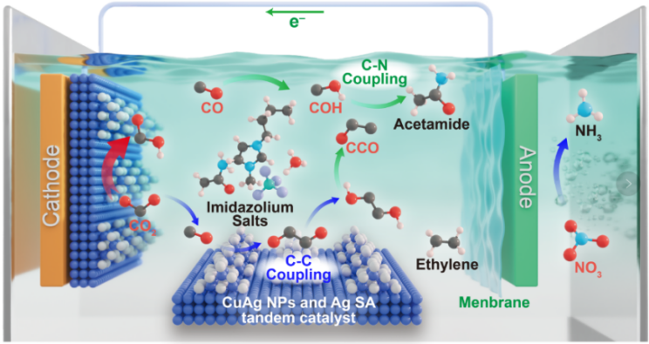

k-point convergence.
The number of k-points Monkhorst−Pack mesh sampling convergence test was performed on adsorption energy of all intermediates in vacuum and solvent models. The adsorption energies were calculated at k-points of 5  5  1. The 11  11  1 k-point was selected for the calculations performed in this work both in vacuum and explicit solvent models because the adsorption energies obtained from the calculations at 5  5  1 k-point are different with less than 0.02 eV/Å.
Section 1. Fitting the dielectric constant () inside Helmholtz layer For a given solid-liquid interfaces model, theis mainly dependent on the specific electrochemical environments at the interface of the electrode. Different values ofwere adopted in different works, ranging from 2.0 to 6.0 V. In this study, for the used CuAg NPs and Ag SA tandem catalyst on Cu(111) facet -water- imidazolium salts model, thewas determined by a fitting method using Volmer reaction as a model reaction. We first set theto different values (2.0, 3.0, 4.0, 5.0 and 6.0) to calculate the reaction barrier (energy difference between initial and final state) of Volmer reaction. And for each, four different electrode potential (), namely 0.0, -0.5, -1.0, and -1.5 V vs. potential of zero charge (), were considered. In this case, we can fit a linear relationship between ΔE andat each .
Section 2. Correspondence between and total electric field
The Stern electric double layer model was used to determine the one-to-one correspondence betweenand, which is described by the Bikerman-Poisson-Boltzmann (BPB) equation. was defined as the distance between the electrode surface and the water layer, and can be directly determined by the explicit solvent model. The induced electric field is related to the electrochemical interfacial environment and was determined by the fitting method as introduced in Section 1.
We first set theto different values (2.0, 3.0, 4.0, 5.0 and 6.0) to calculate the reaction energy ΔG (energy difference between final and initial state) of Volmer reaction. And for each, four different electrode potential (), namely 0.0, -0.5, -1.0, and -1.5 V vs. potential of zero charge () were considered. In this case, we can fit a linear relationship between ΔE and at each as follow:
where the slope a and intercept b are related to the specific value of . The slope will be equal to the charge transfer (Δq) between initial and final states of the reaction if the Helmholtz model is assumed. However, in the calculation of ΔG using the Cu(111) facet-water-ionic liquid model, the charge of H₃O^{+δ} at initial state is uncertain because the H₃O^{+δ} is at the interfaces, not in the bulk solution.
Section 3. Calculation of adsorption and reaction free energies
The items of total Gibss free energy for each adsorbate have been listed in Table S2. In structural relaxations, the σ will fluctuate with the structural perturbation of the water layer and electronic redistribution, resulting in varying .
C-C/N coupling mechanisms on CuAg NPs and Ag SA tandem catalyst. The coupling barriers Ecplg were calculated and listed in Table S3.
Section 4. Machine learning workflow Dataset construction.
We evaluated the NORR performance over 16 catalyst surfaces. four potential reaction pathways for CO₂-to-CH₂CH₂ conversion for each catalyst are considered, generating 64 data points (64 U_{L}(η) values) used in the machine- learning models. As the sure independence screening and sparsifying operator (SISSO) method is effective for relatively small training data sets, only 16 U_{max}(η) values determined along the optimal reaction pathway among the four possible eCO₂R paths for 16 imidazolium salts are selected as the target value. Data cleansing algorithms and feature engineering. As illustrated in Fig. S33-37, the process commences with generating labelled data derived from GC-DFT calculations. We calculated the statistical properties of the data, including the mean and standard deviation (σ), and applied the formula
(6) to standardize the dataset. Feature engineering was undertaken to refine the data. After selecting the initial features, we applied the Pearson coefficient’s correlation analysis. This helped remove highly correlated features (Pearson correlation coefficient |p|≥0.8) to prevent overfitting.
- Machine Learning algorithm selection.
Machine learning algorithms, including polynomial regression (PR), support vector regressor (SVR), and extreme gradient boosting regressor (XGBR), were employed to explore the underlying correlation between the catalytic performance and the intrinsic properties of catalysts. The data sets were randomly divided into training and test sets with a 9:1 data split ratio. The SISSO method was further adopted to identify a mathematical and physically intuitive formula between important features and U_{max}(η). This formula gives a rational design guidance for screening highly active NORR to NH3 SAA catalysts.
CO₂Reduction Reaction Pathway
- *+CO₂→*CO₂
- *+CO₂+(H⁺+e-)→*COOH
- *+CO₂+2(H⁺+e-)→*CO+H₂O
- *+2CO₂+2(H⁺+e-)→*CO+*CO₂+H₂O
- *+2CO₂+3(H⁺+e-)→*CO+*COOH+H₂O
- *+2CO₂+4(H⁺+e-)→*CO*CO+2H₂O
- *+2CO₂+5(H⁺+e-)→*COCOH+2H₂O
- *+2CO₂+6(H⁺+e-)→*COHCOH+2H₂O
- *+2CO₂+6(H⁺+e-)→*CCO+3H₂O
2. Amination Reaction Pathway
1. *+2CO₂+NH₃+6(H⁺+e-)→*CCOH(NH₂)+3H₂O
2. *+2CO₂+NH₃+6(H⁺+e-)→*CHCO(NH₂)+3H₂O
3. *+2CO₂+NH₃+7(H⁺+e-)→*CH₂CO(NH₂)+3H₂O
4. *+2CO₂+NH₃+8(H⁺+e-)→*CH₃CO(NH₂)+3H₂O
5. *+2CO₂+NH₃+12(H⁺+e-)→*CH₃CH₂NH₂+4H₂O
3. Secondary Reaction
(COCO Path)
- *+CO₂+2(H⁺+e-)→*CO+H₂O
- *+2CO₂+3(H⁺+e-)→*COCOOH+H₂O
- *+2CO2+4(H⁺+e-)→*CO*CO+2H₂O
(COCOH Path)
- *+CO₂+3(H⁺+e-)→*COH+H₂O
- *+2CO₂+4(H++e-)→*COHCOOH+H₂O
- *+2CO₂+5(H++e-)→*COHCO+2H₂O
(CHOCO Path)
- *+CO₂+3(H⁺+e⁻)→*CHO+H₂O
- *+2CO₂+4(H⁺+e⁻)→*CHOCOOH+H₂O
- *+2CO₂+5(H⁺+e⁻)→*CHOCO+2H₂O
- *+2CO₂+6(H⁺+e⁻)→*CH(OH)CO+2H₂O
Computational hydrogen electrode model.
The energy of electron and proton pair is calculated as 1/2H₂ according to calculated hydrogen electrode (CHE) by Nørskov, which corresponds to reverse hydrogen electrode (RHE). Therefore, in the RHE, the chemical potential of a proton−electron pair was defined as 1/2H₂. Therefore, in the RHE, the chemical potential of a proton-electron pair was defined as:
Figures:
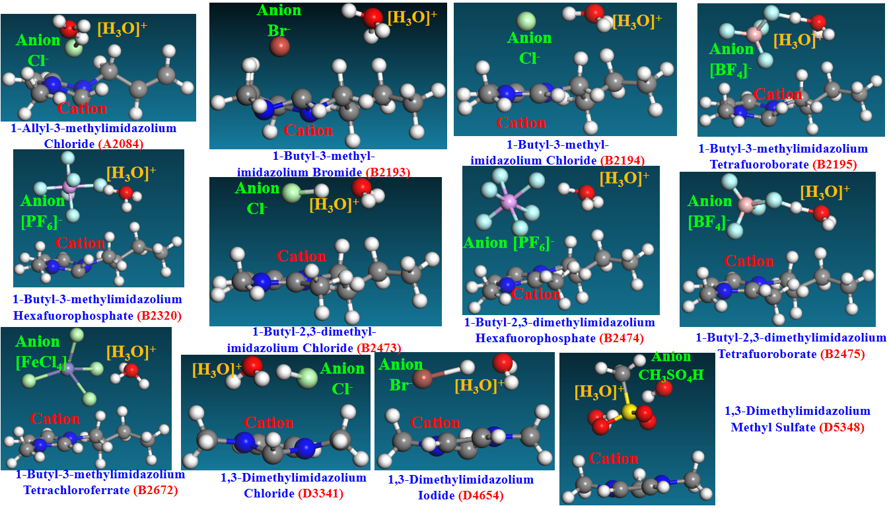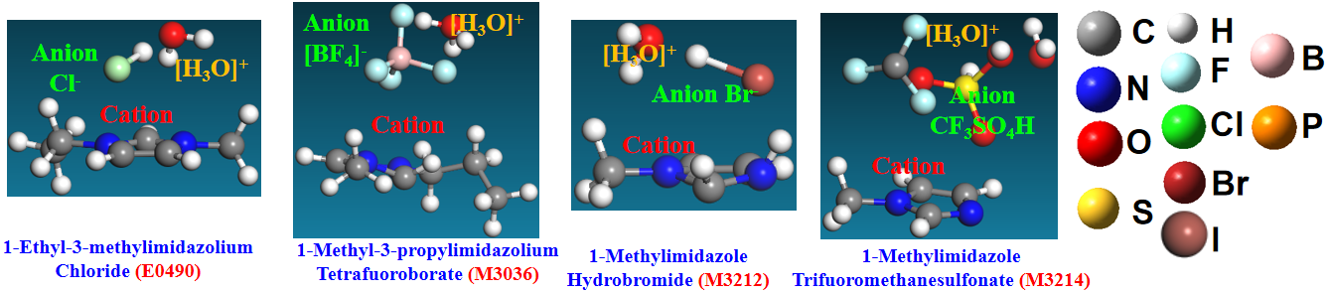
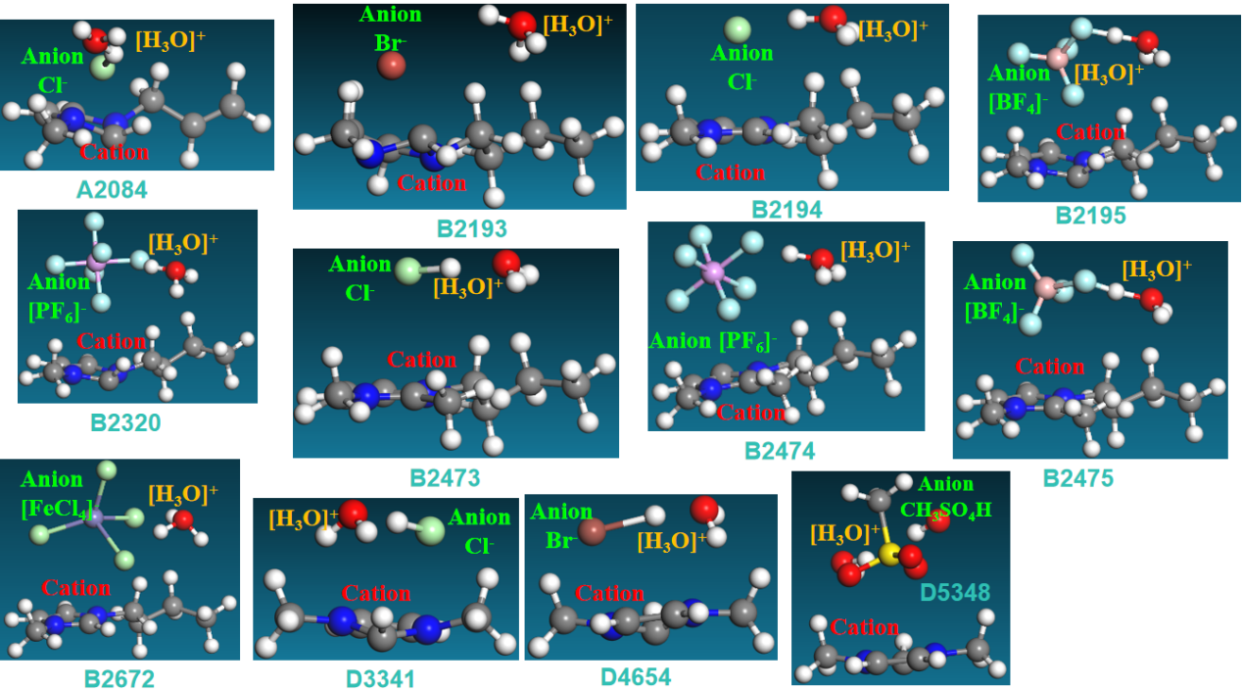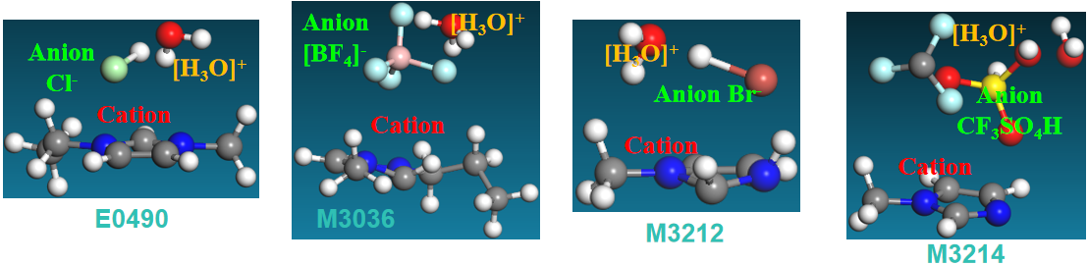Figure S1. Local atomic configurations of reaction microenvironment with imidazolium salts, including cations, anions and a hydronium [H₃O]^{+δ}.
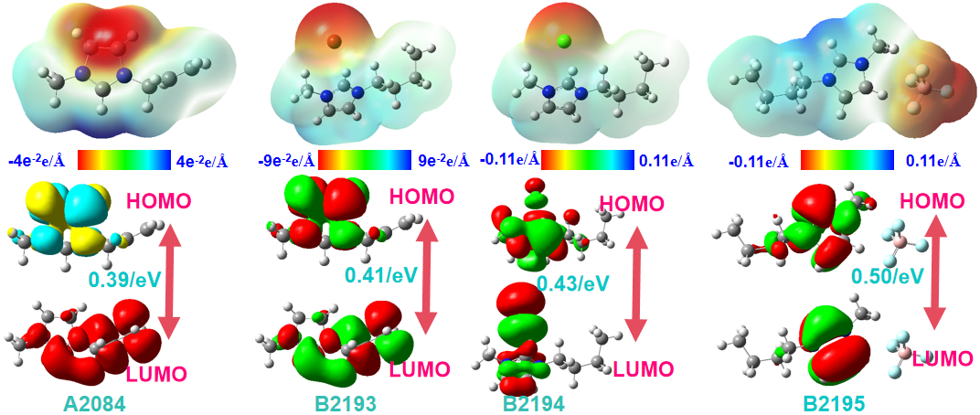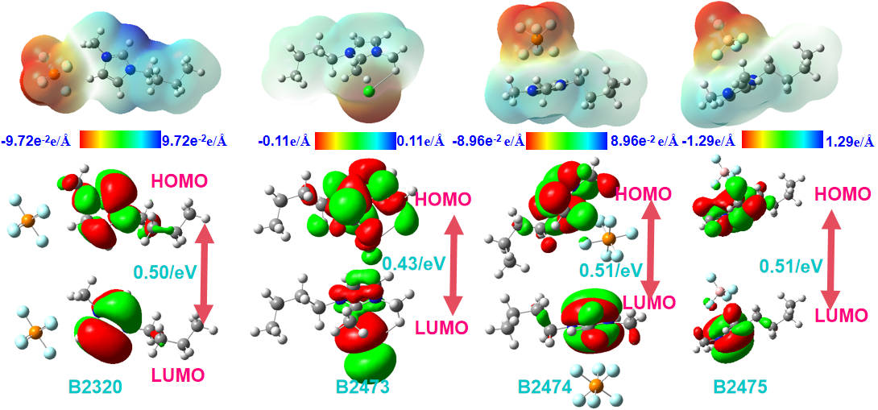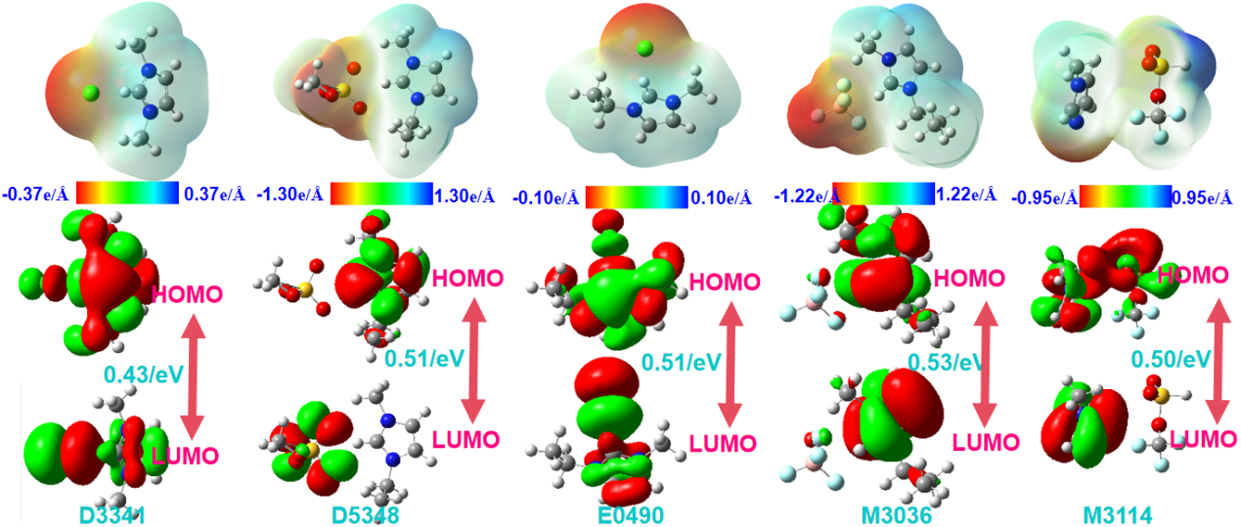Figure S2. Molecular electrostatic potential map (MEP) and frontier molecular orbitals of ionic liquid.

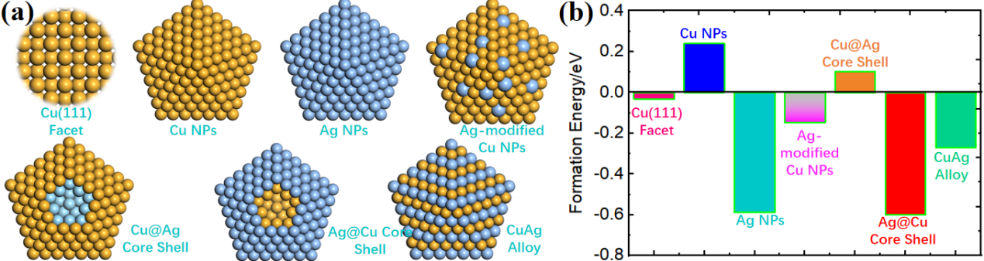
Figure S3. (a) Schematic illustration of diversified morphology Ag SAC and CuAg NPs; (b) The formation energies of each morphology of AgCu NPs structures loaded on Cu(111) facet.
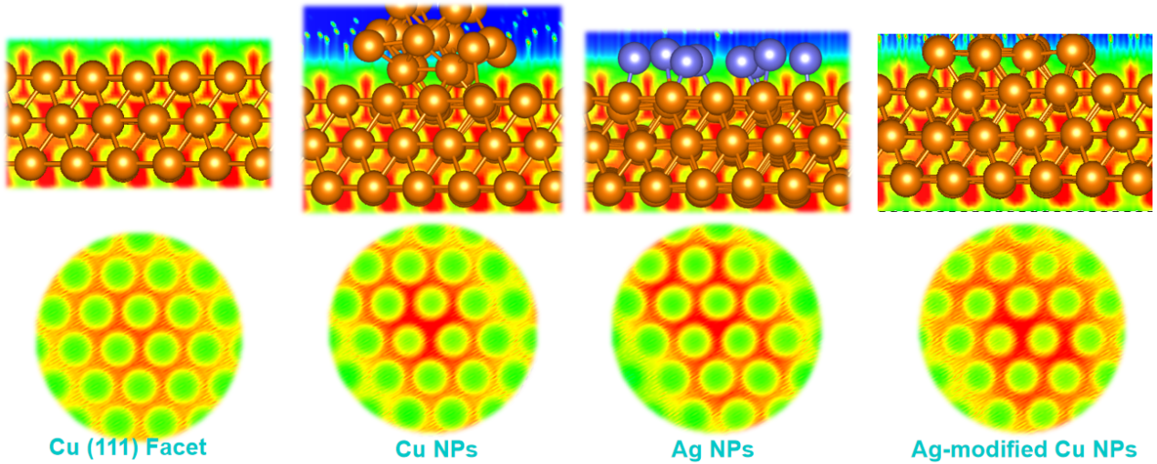
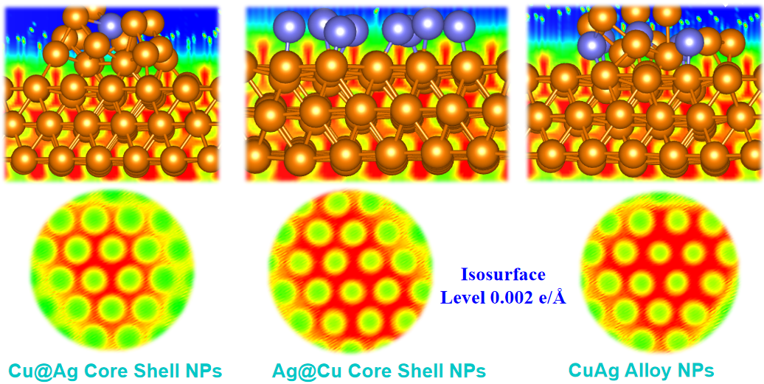
Figure S4. The electronic localization function (ELF) of each morphology of AgCu NPs structures loaded on Cu(111) facet..
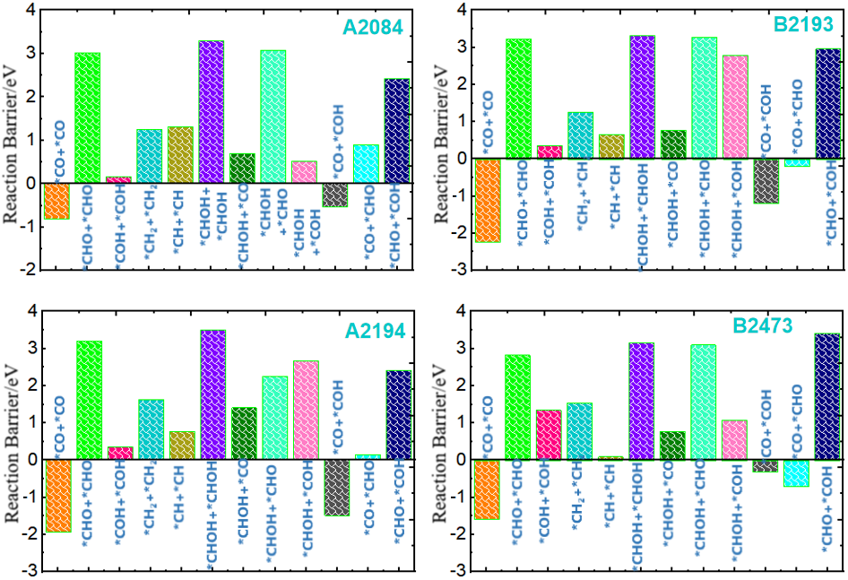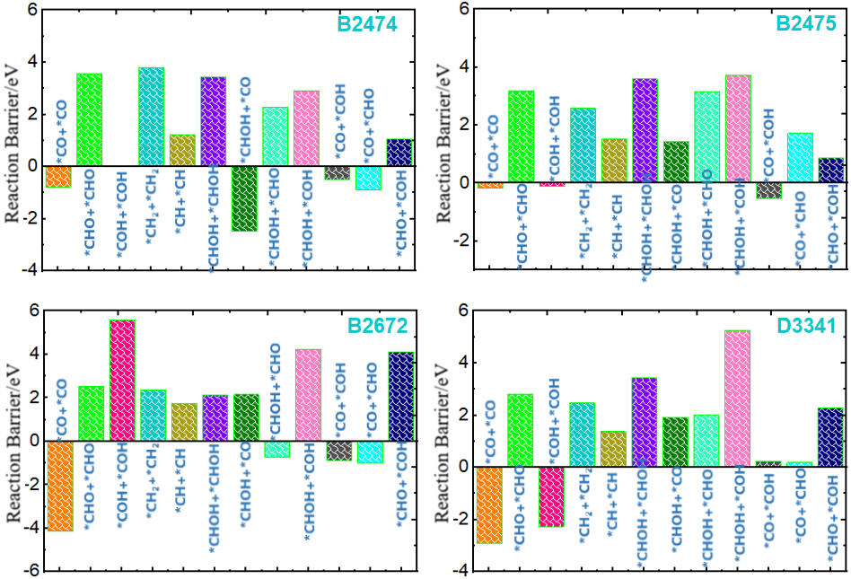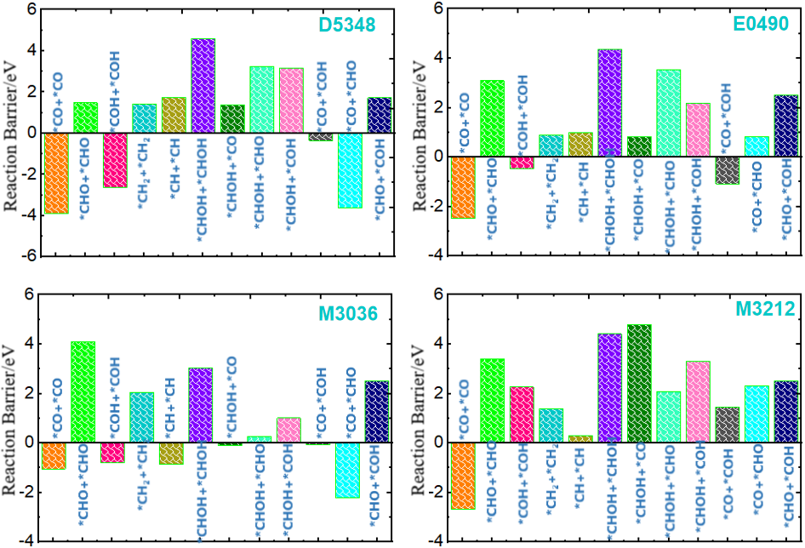
Figure S5. The reaction barrier values for all potential C–C coupling in different C1 precursors in all ionic liquid systems.
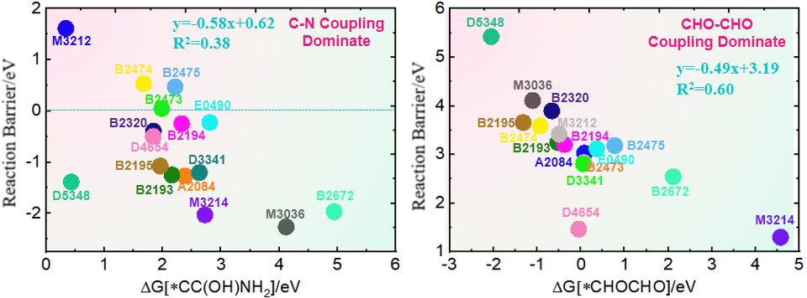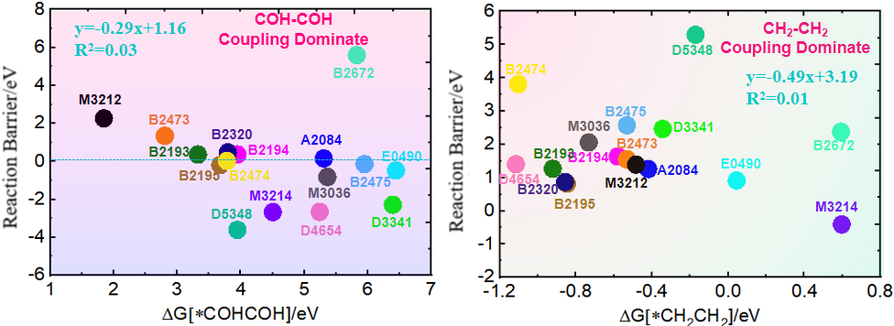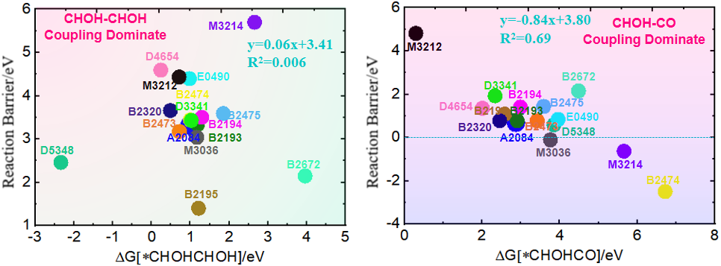
Figure S6. Linear relationship for reaction barrier of following C–C coupling as a function of binding energies; Coefficient of linear relationship (R²) and linear fitting equation were also labeled in the Figures.
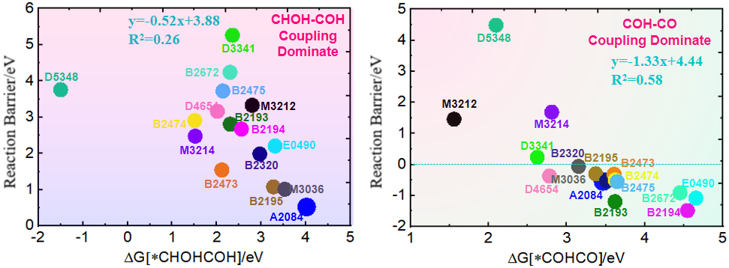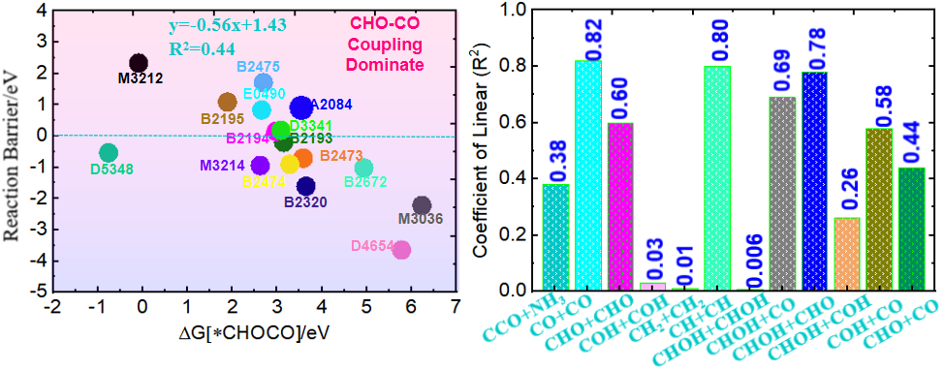
Figure S7. Linear relationship for reaction barrier of following C–C coupling as a function of binding energies; Coefficient of linear relationship (R²) and linear fitting equation were also labeled in the Figures.
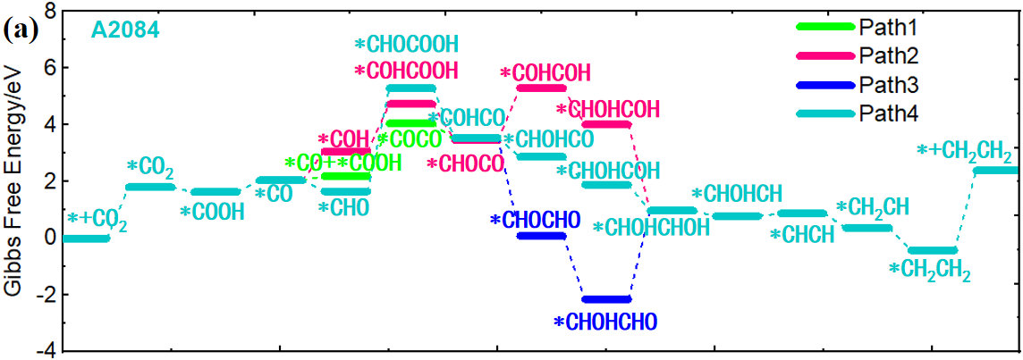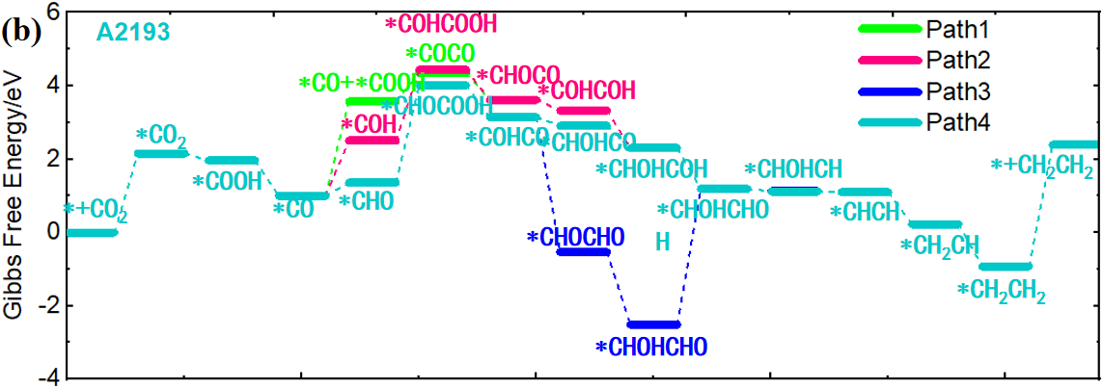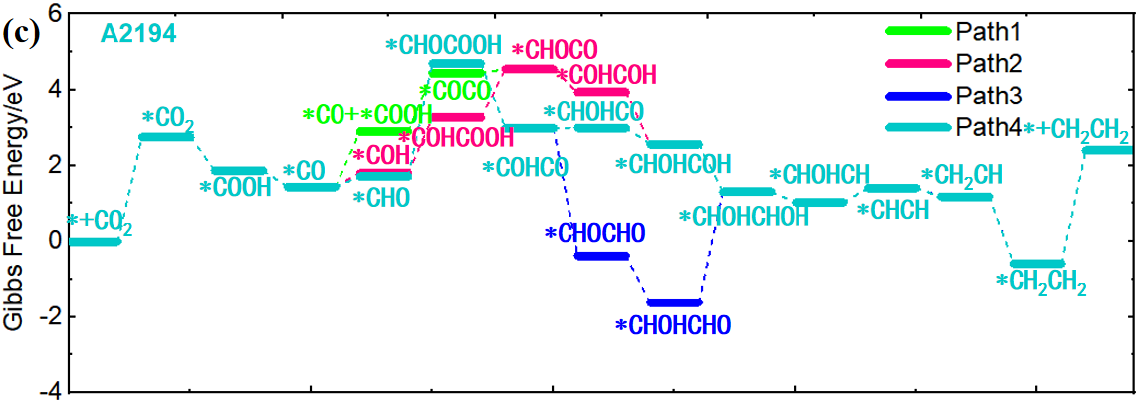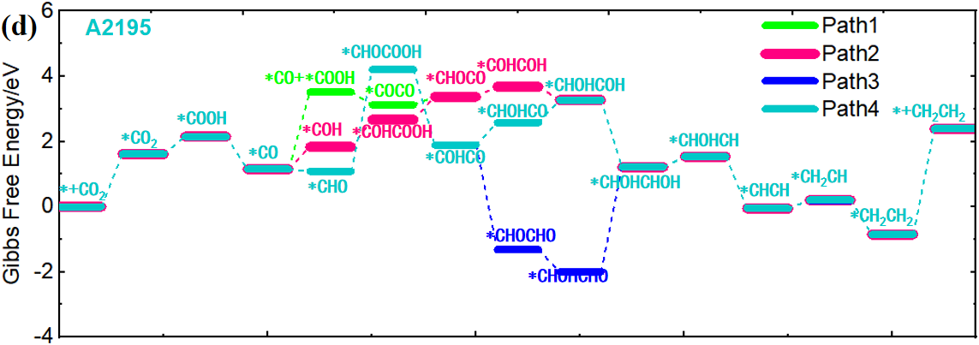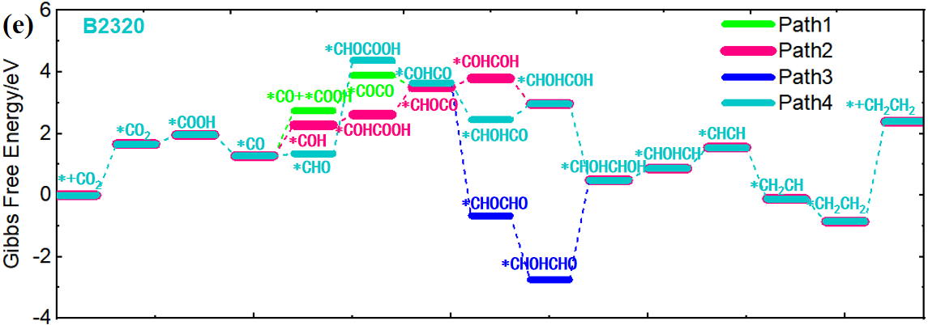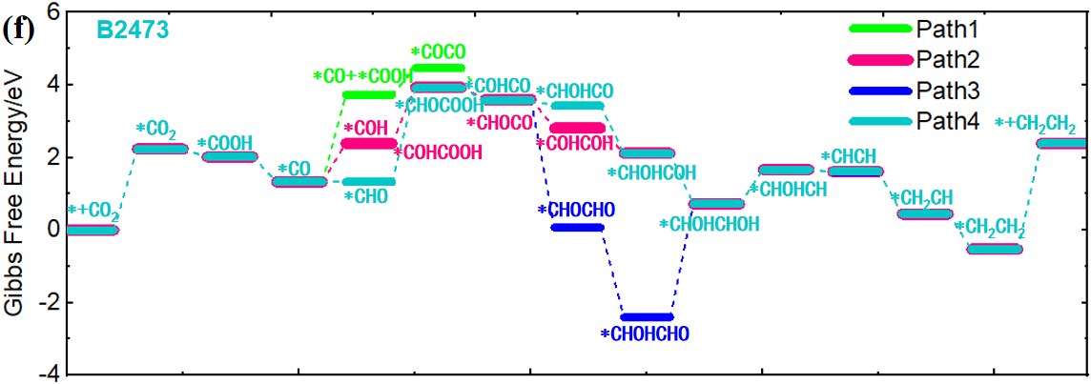
Figure S8. Gibbs free energy profile of A2084, B2193, B2194, B2195, B2320, and B2474 ionic liquids on CuAg NPs/Ag SA tandem catalyst for producing ethylene.
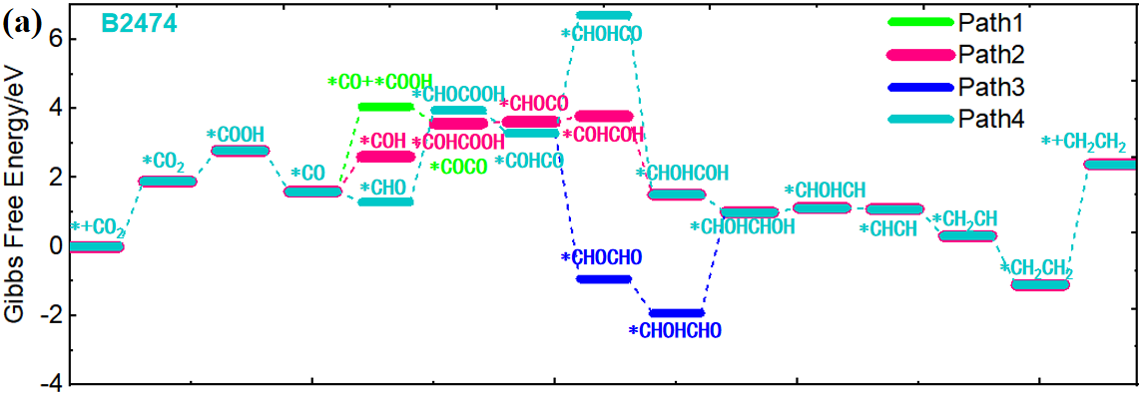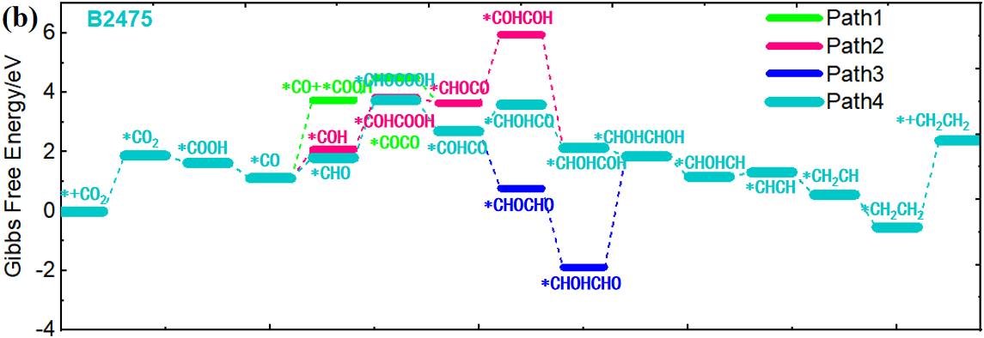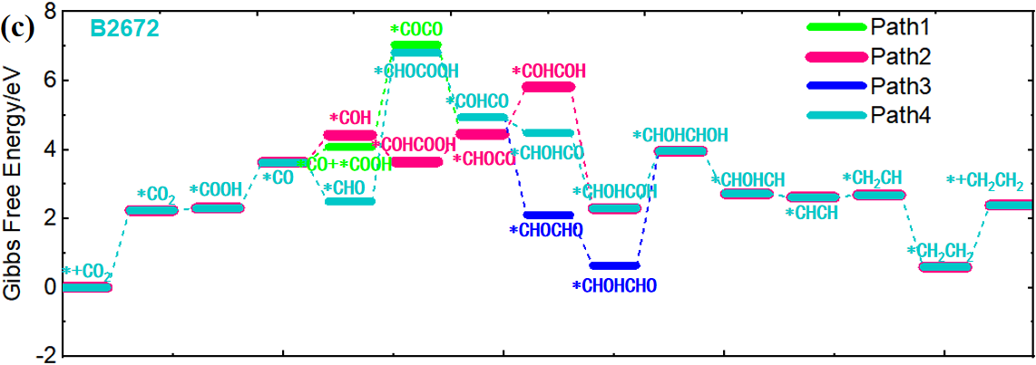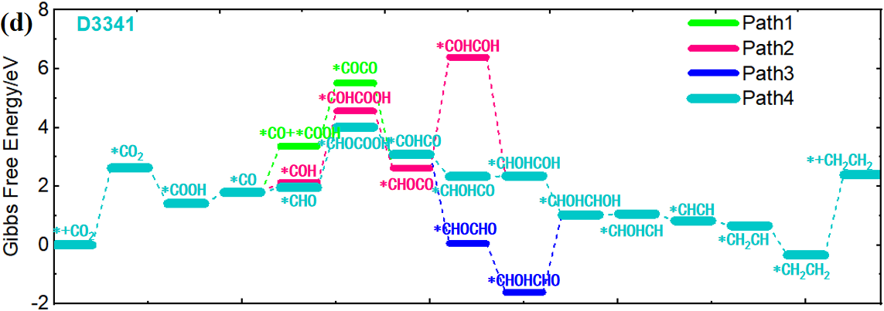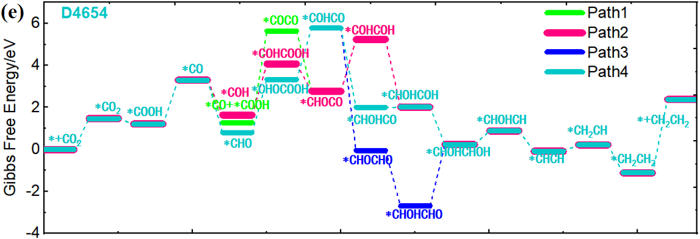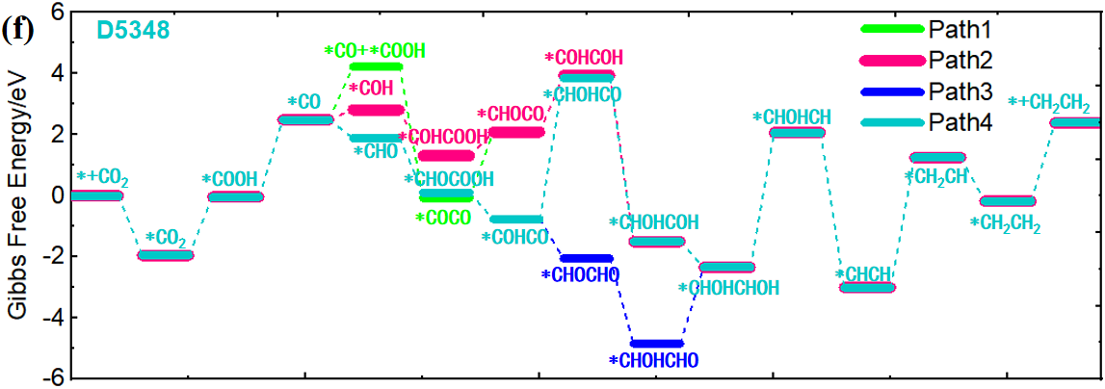
Figure S9. Gibbs free energy profile of B2474, B2475, B2672, D3341, D4654 and D5348 ionic liquids on CuAg NPs/Ag SA tandem catalyst for producing ethylene.
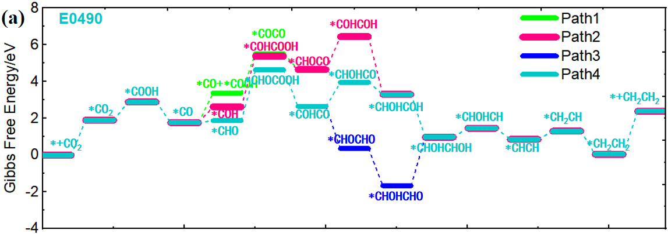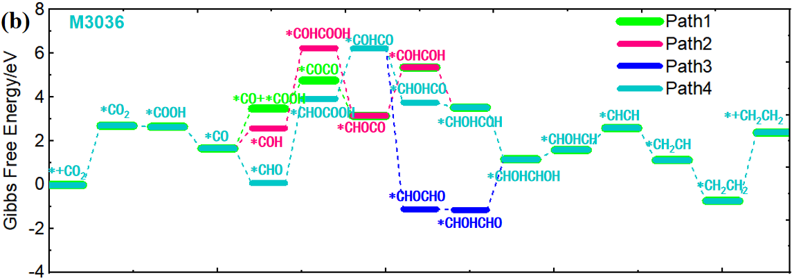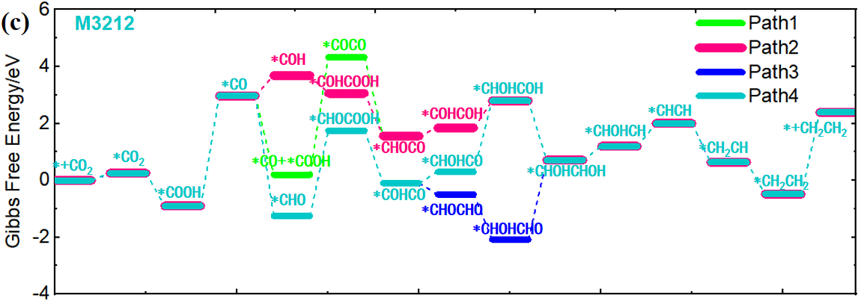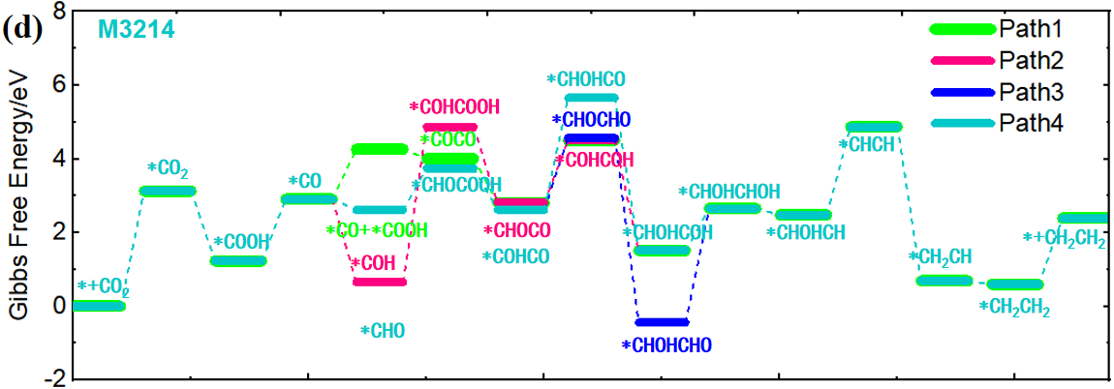
Figure S10. Gibbs free energy profile of E0490, M3036, M3212 and M3214 ionic liquids on CuAg NPs/Ag SA tandem catalyst for producing ethylene.
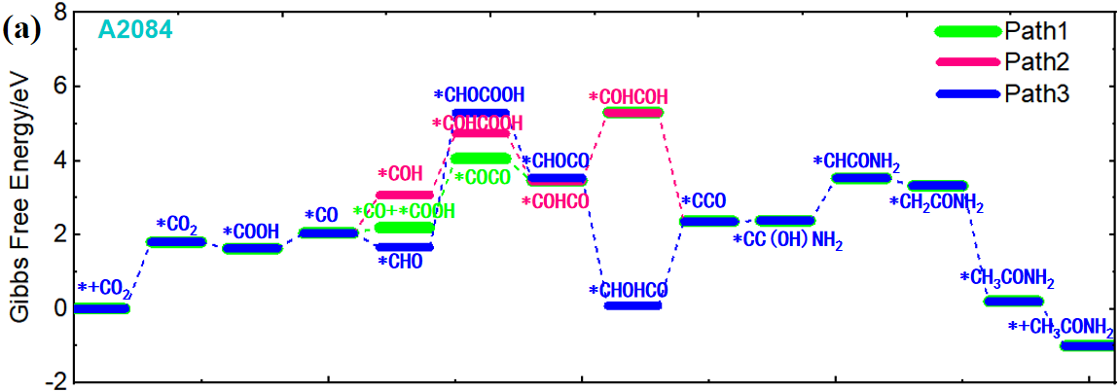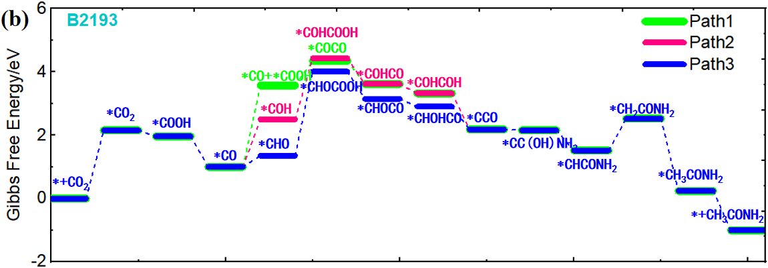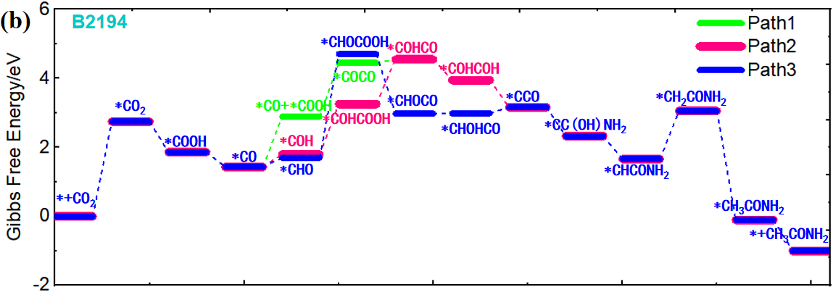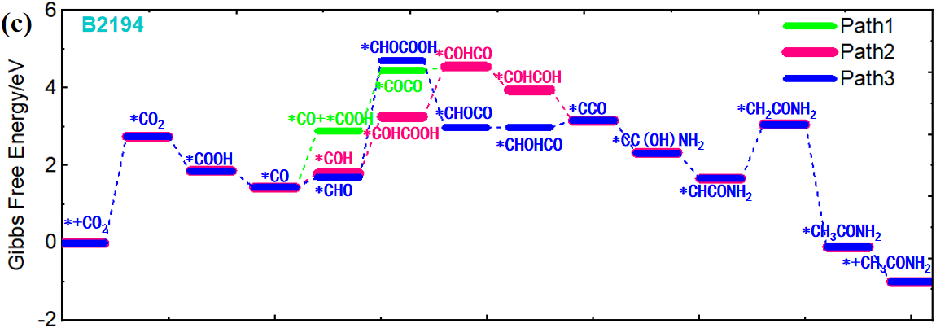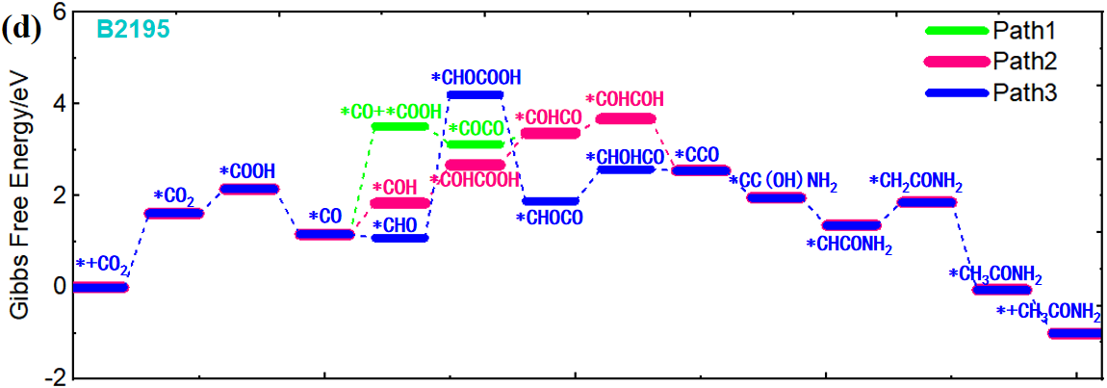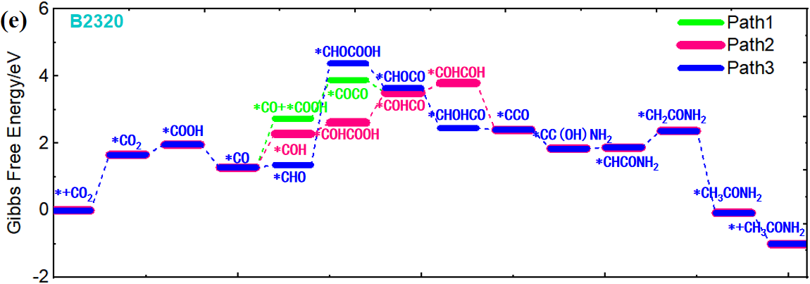
Figure S11. Gibbs free energy profile of A2084, B2193, B2194, B2195, and B2320 ionic liquids on CuAg NPs/Ag SA tandem catalyst for producing acetamide.
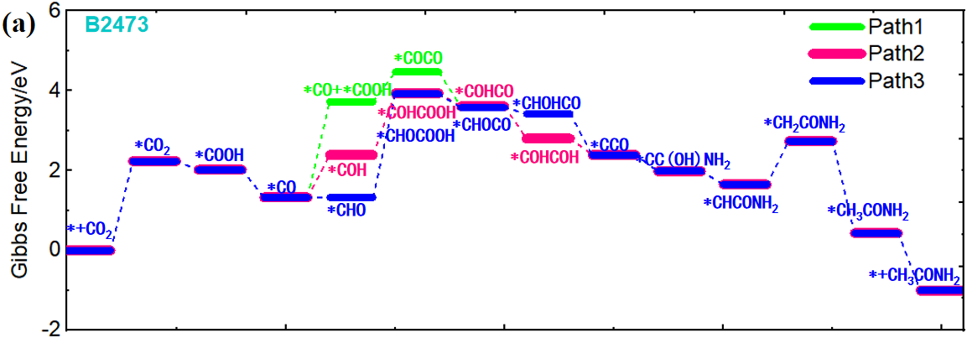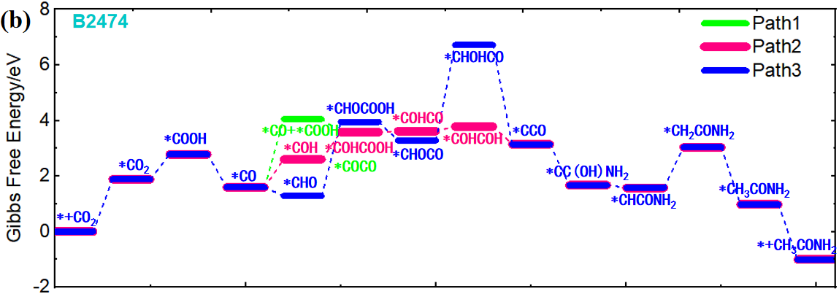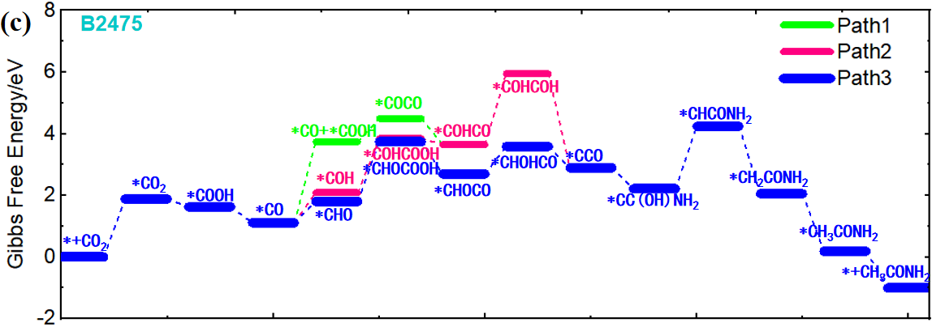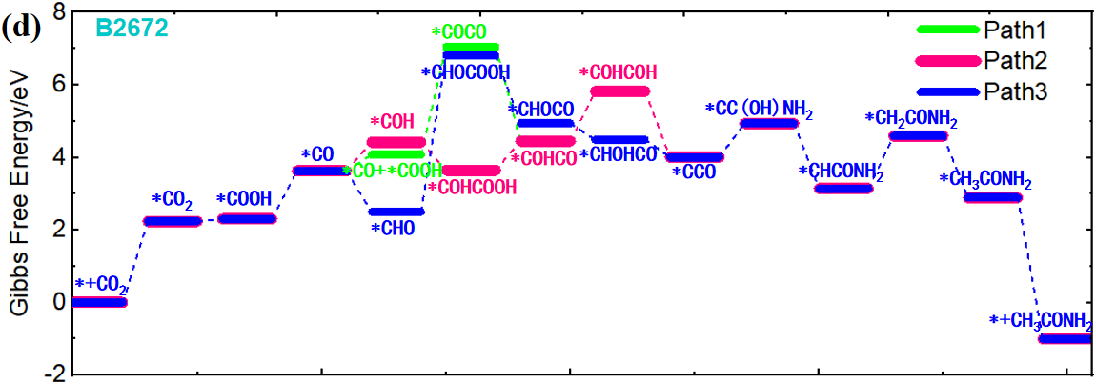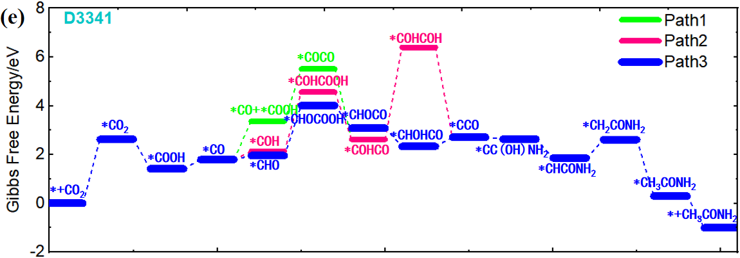
Figure S12. Gibbs free energy profile of B2473, B2474, B2475, B2672 and D3341 ionic liquids on CuAg NPs/Ag SA tandem catalyst for producing acetamide.
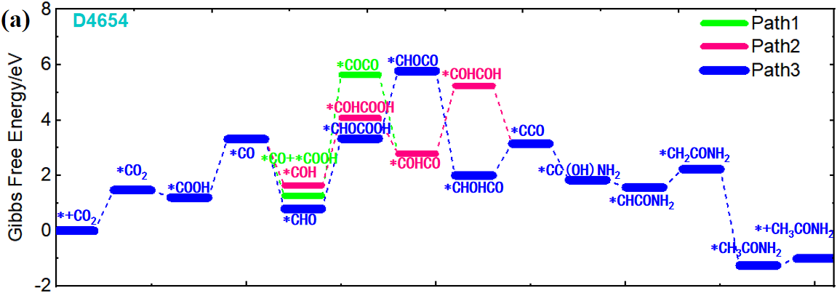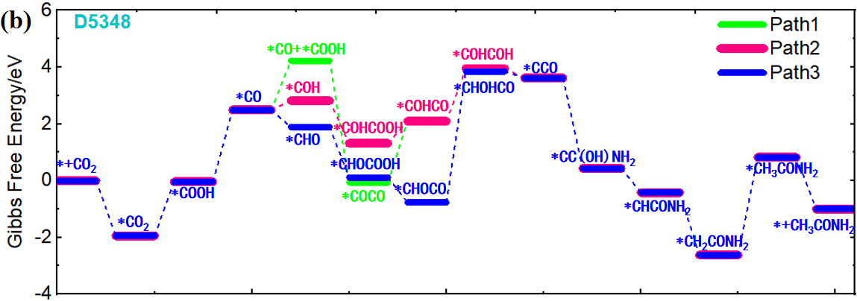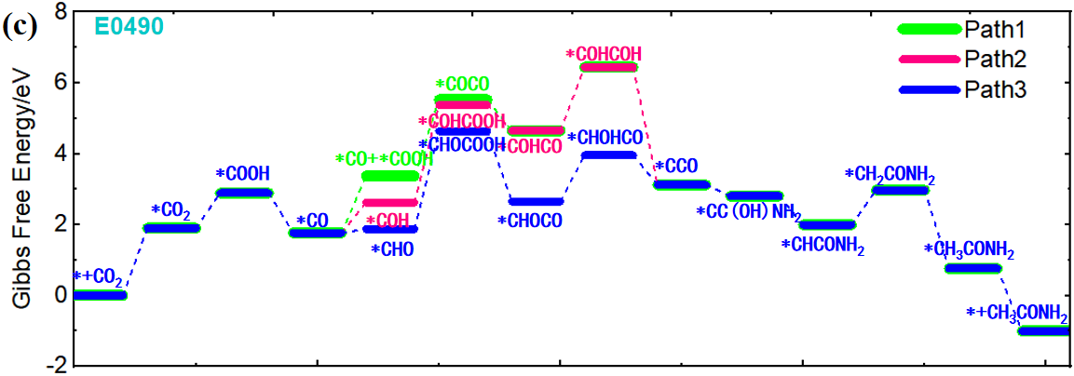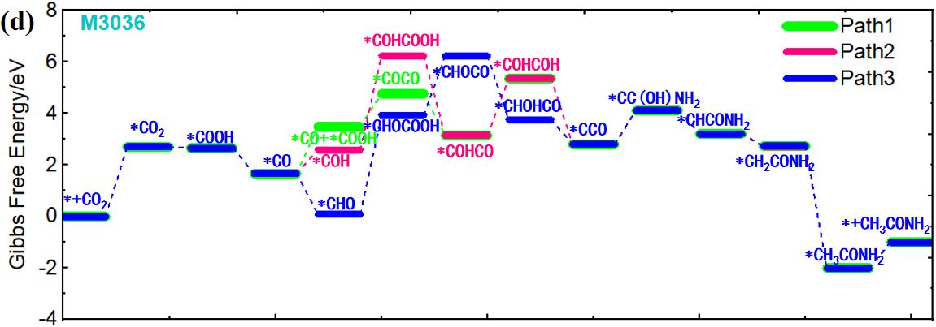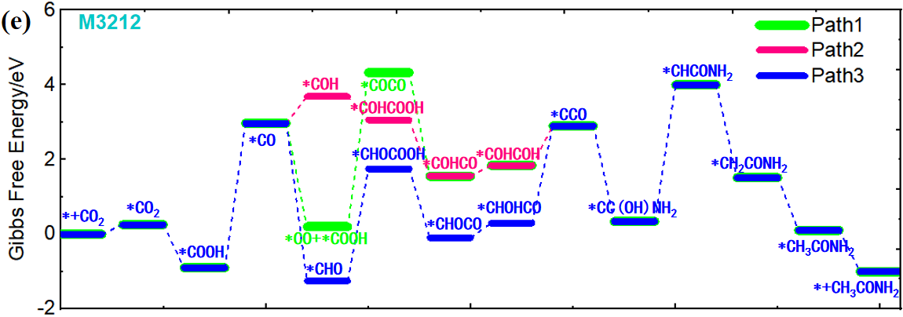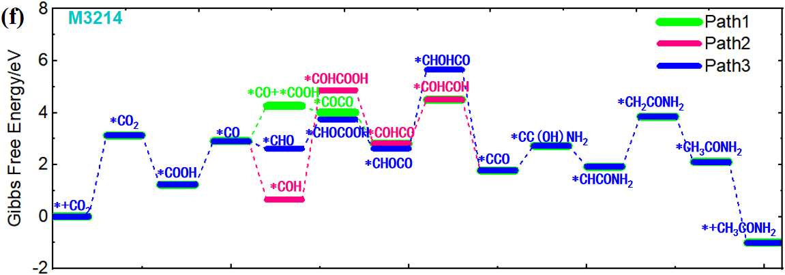Figure S13. Gibbs free energy profile of D4654, E0490, M3036, M3212 and M3214 ionic liquids on CuAg NPs/Ag SA tandem catalyst for producing ethylene.
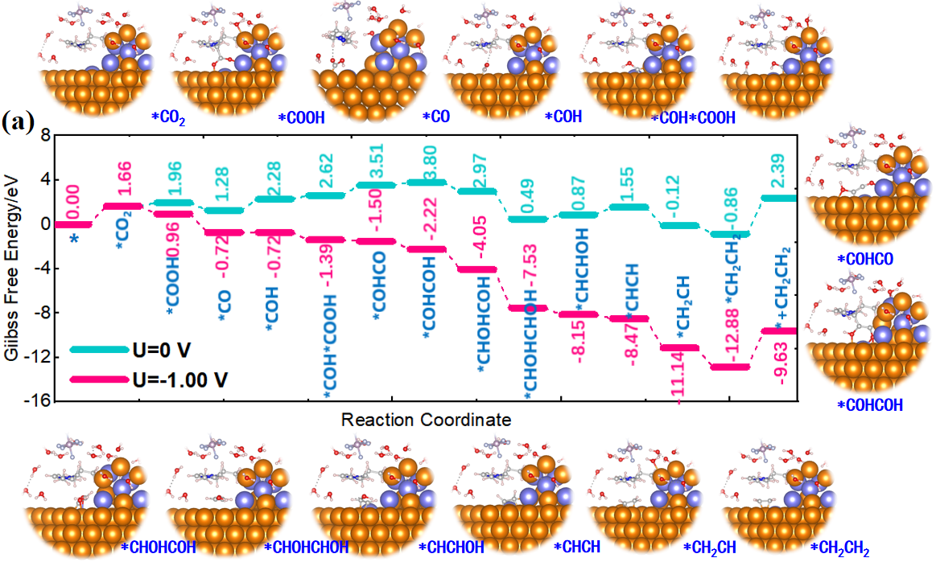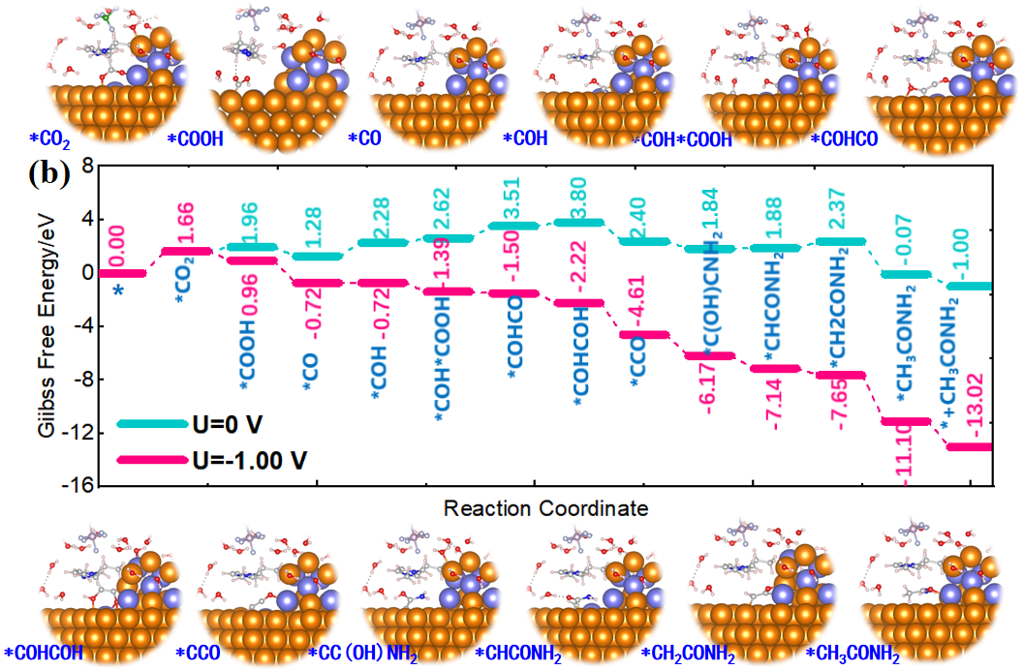
Figure S14. Gibbs free energy profile of B2320 induced ionic liquid under different applied electrode potentials on CuAg NPs/Ag SA tandem catalyst for producing (a) C₂H₄ and CH₃CONH₂ from eCO₂R via the most preferable pathway, respectively..
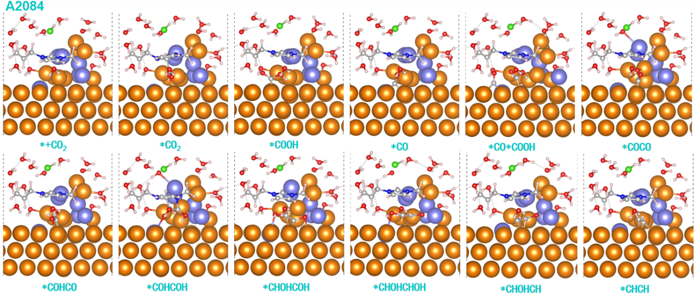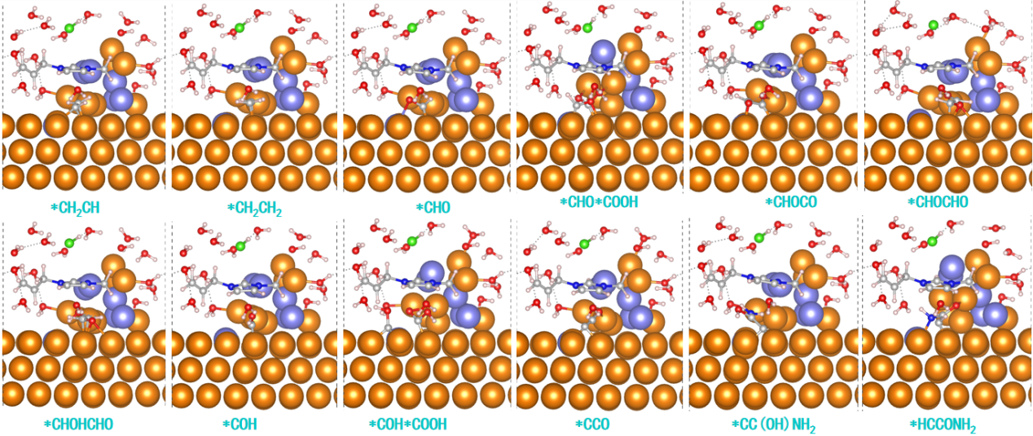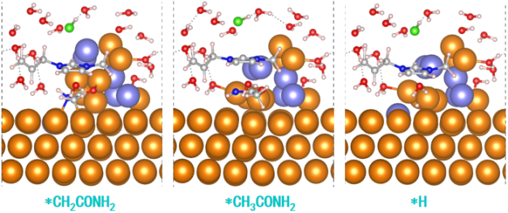
Figure S15. Structures of each reaction intermediate for producing ethylene and acetamide with the A2084 ionic liquid−water interfaces.
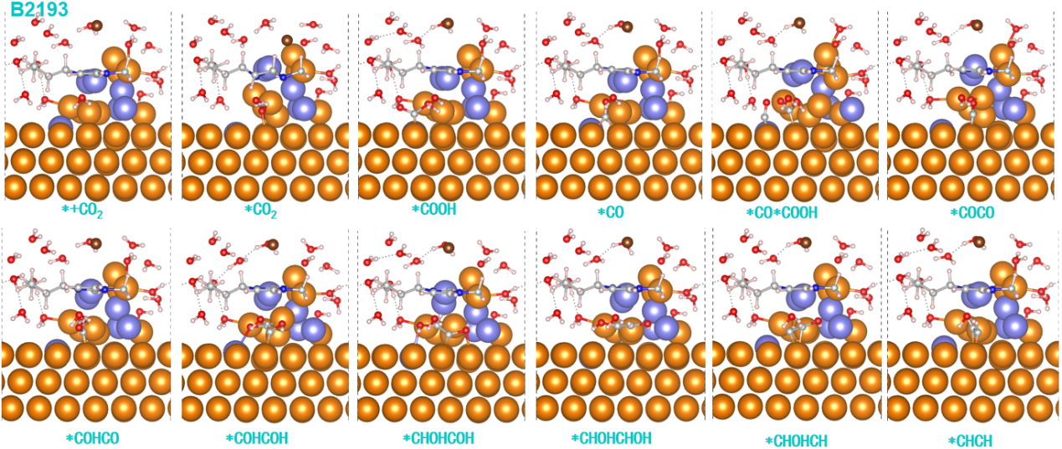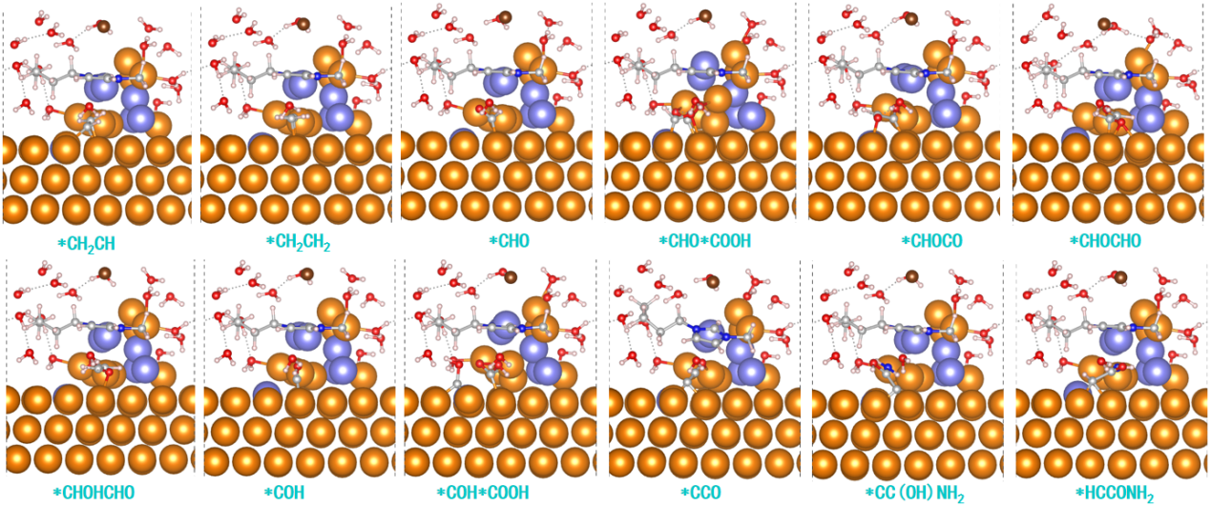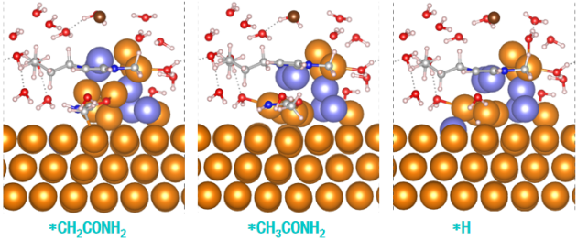
Figure S16. Structures of each reaction intermediate for producing ethylene and acetamide with the B2193 ionic liquid−water interfaces.
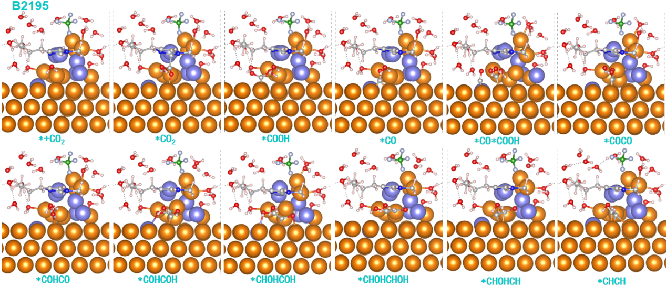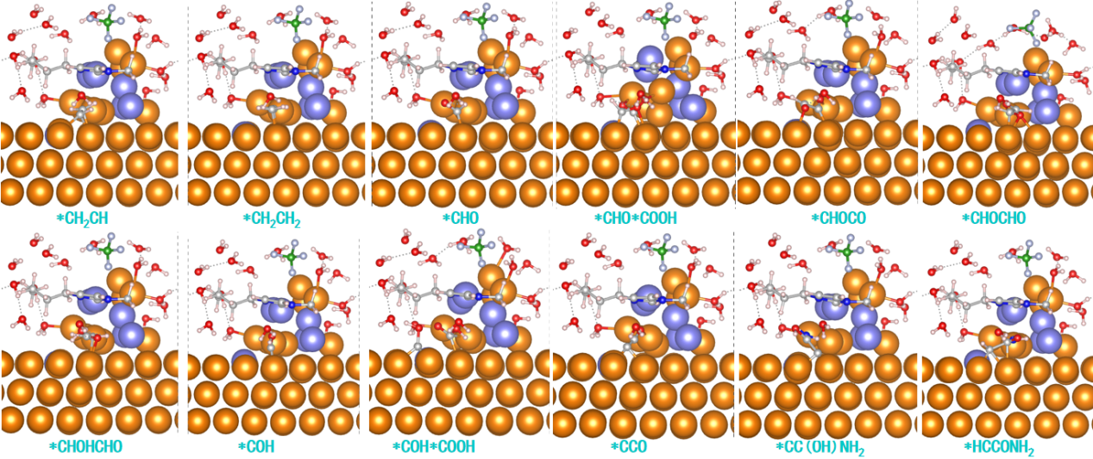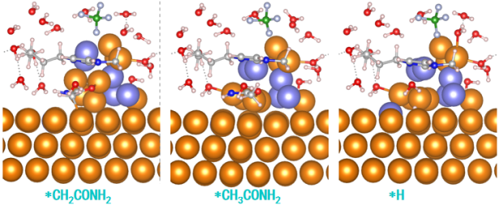
Figure S17. Structures of each reaction intermediate for producing ethylene and acetamide with the B2195 ionic liquid−water interfaces..
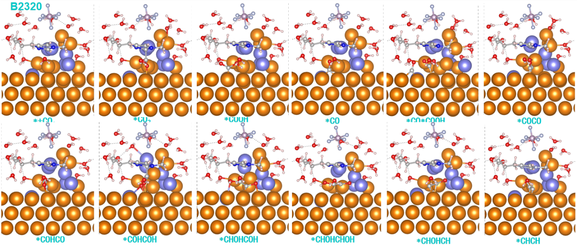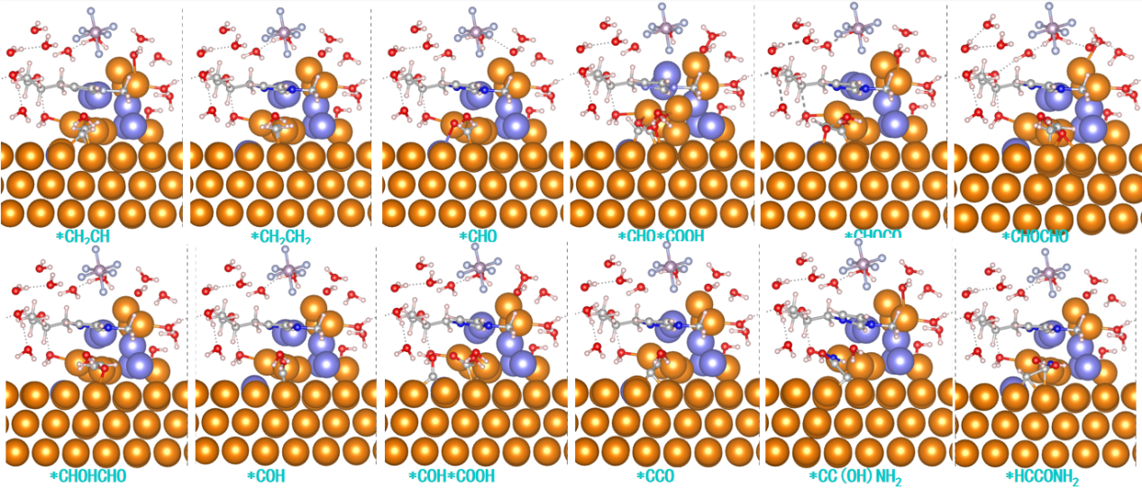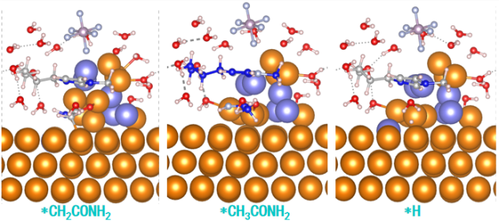
Figure S18. Structures of each reaction intermediate for producing ethylene and acetamide with the B2320 ionic liquid−water interfaces.
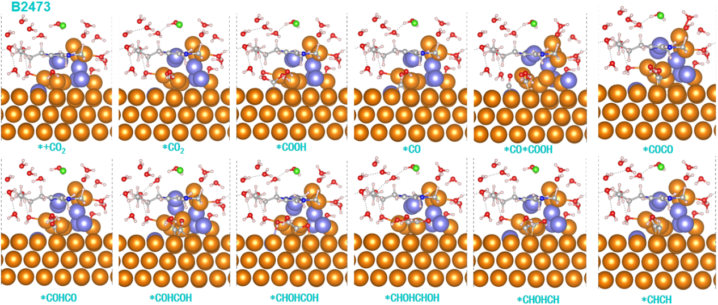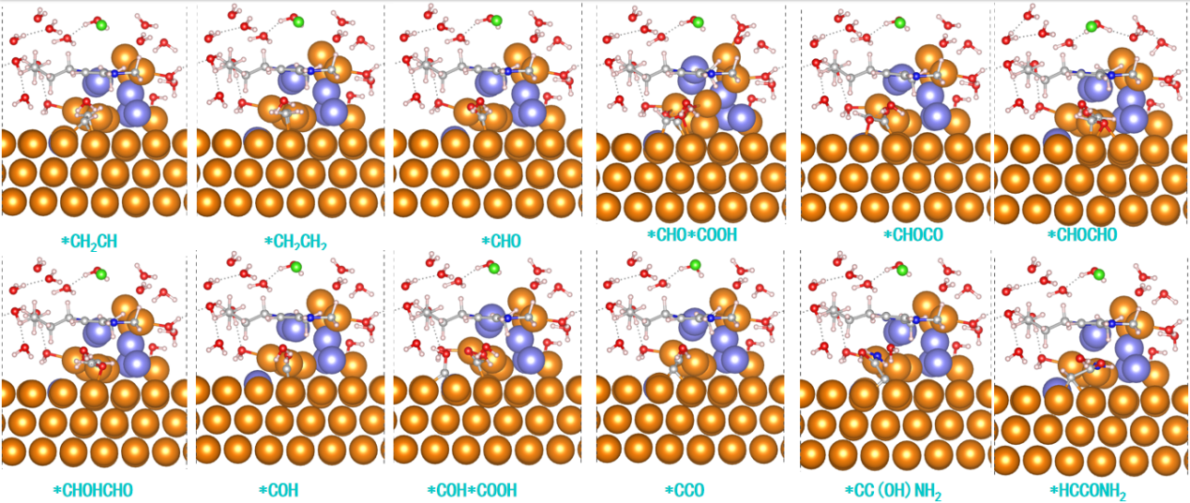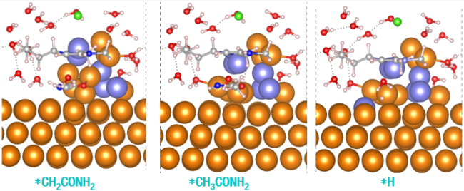
Figure S19. Structures of each reaction intermediate for producing ethylene and acetamide with the B2473 ionic liquid−water interfaces.
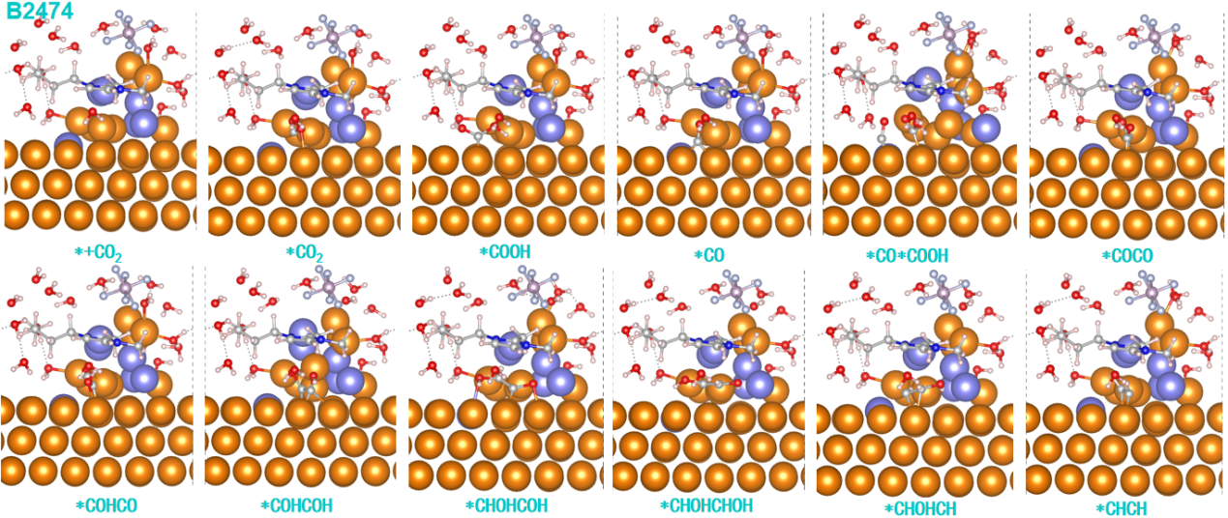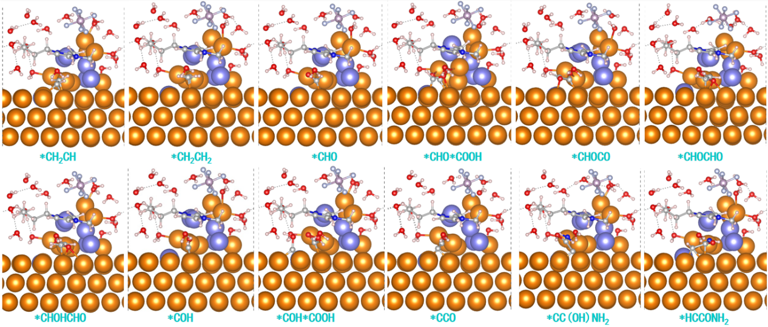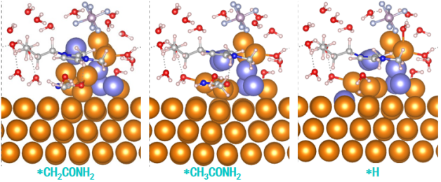
Figure S20. Structures of each reaction intermediate for producing ethylene and acetamide with the B2474 ionic liquid−water interfaces.
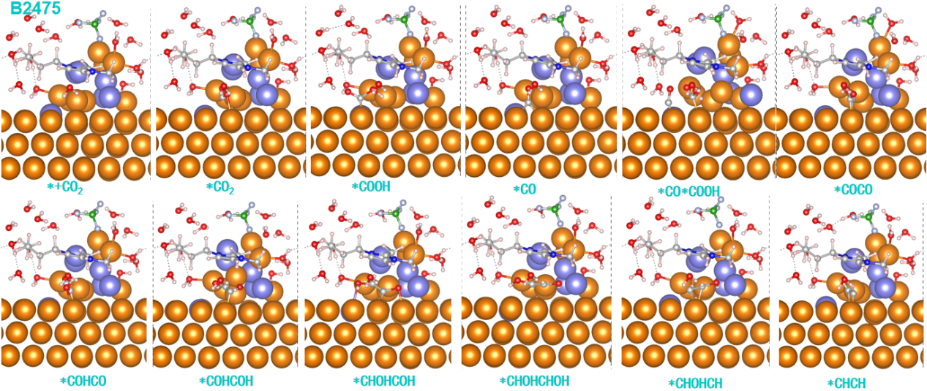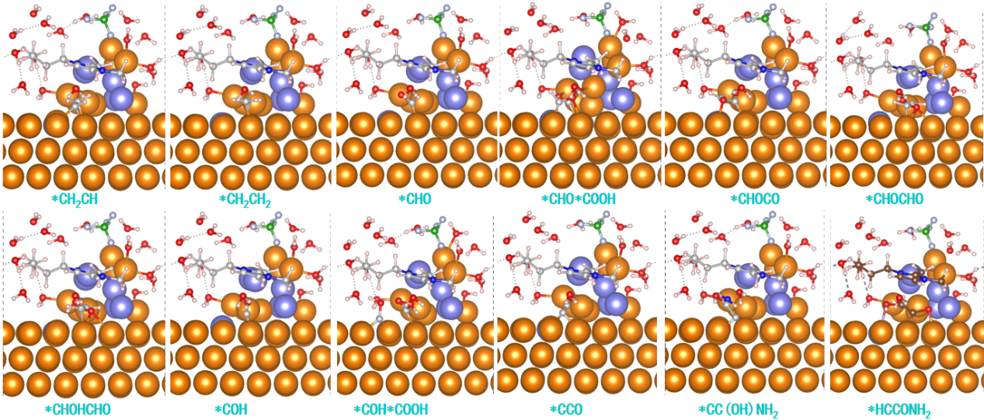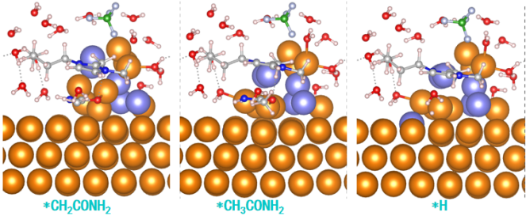
Figure S21.Structures of each reaction intermediate for producing ethylene and acetamide with the B2475 ionic liquid−water interfaces.
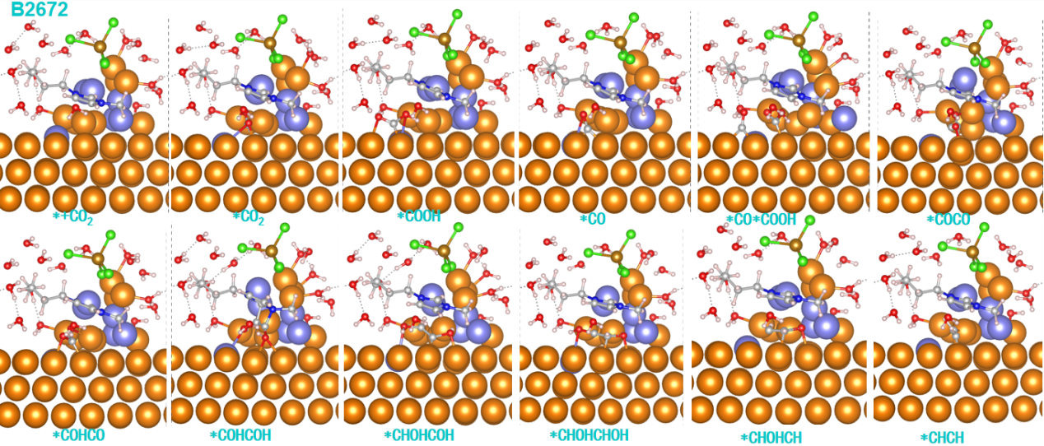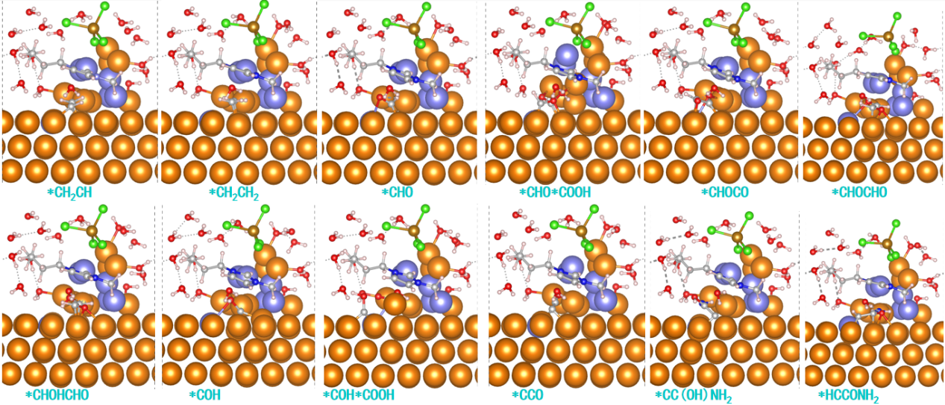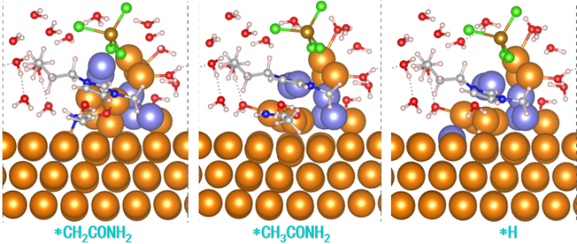
Figure S22.Structures of each reaction intermediate for producing ethylene and acetamide with the B2672 ionic liquid−water interfaces.
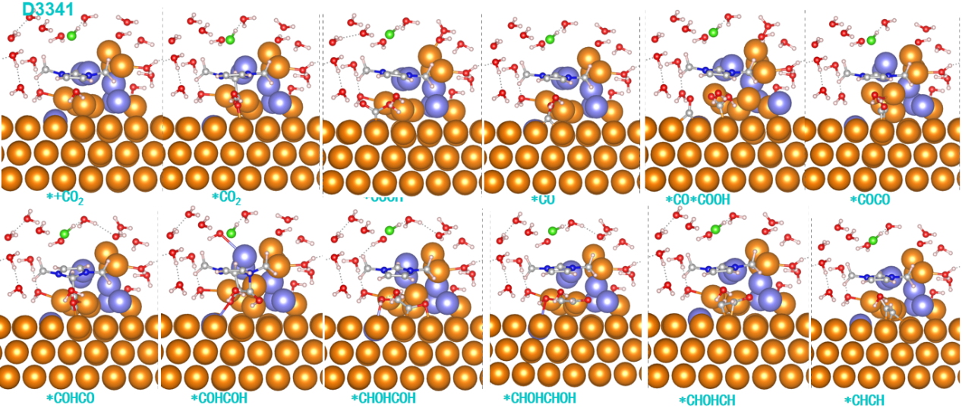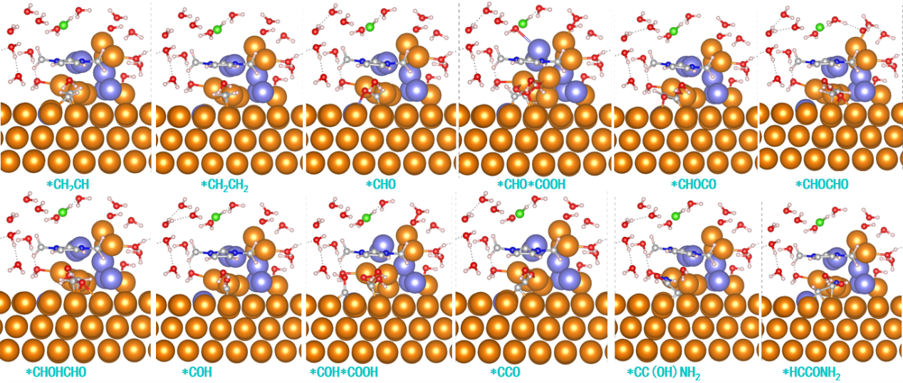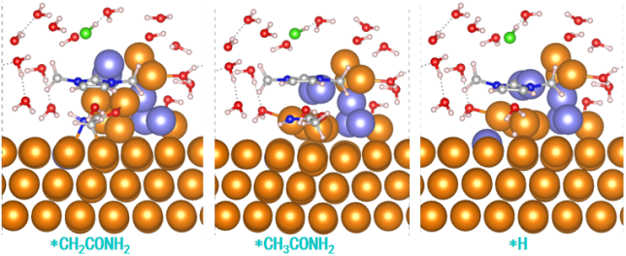
Figure S23. Structures of each reaction intermediate for producing ethylene and acetamide with the D3341 ionic liquid−water interfaces.
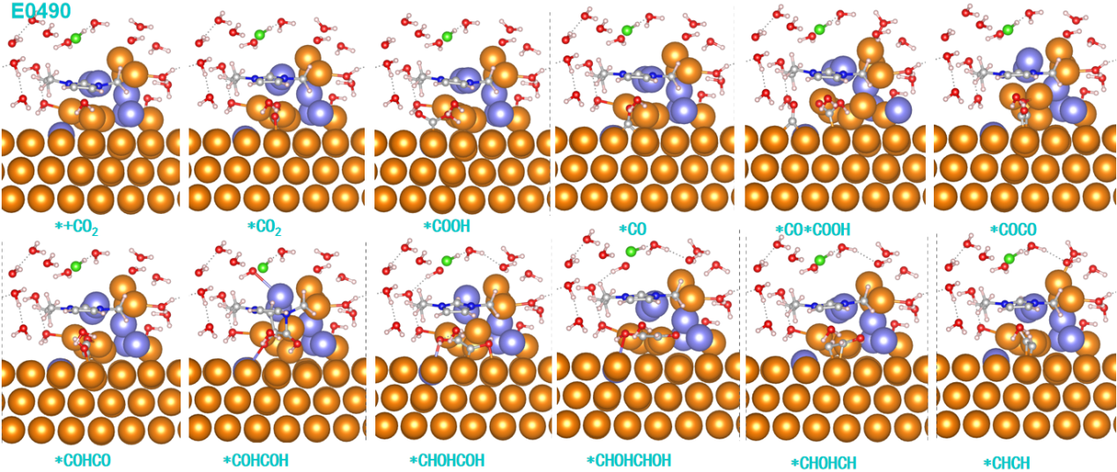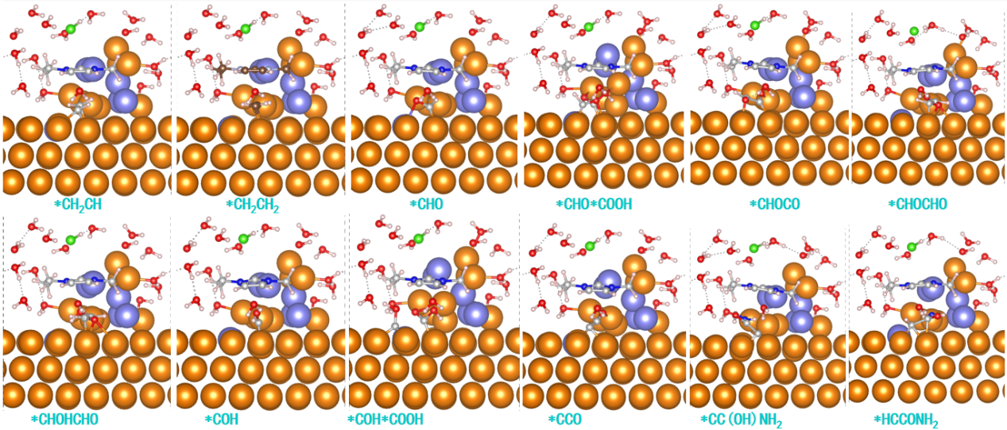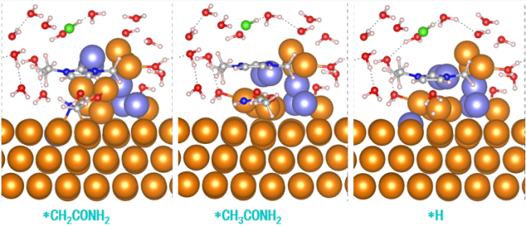
Figure S24. Structures of each reaction intermediate for producing ethylene and acetamide with the E0490 ionic liquid−water interfaces.
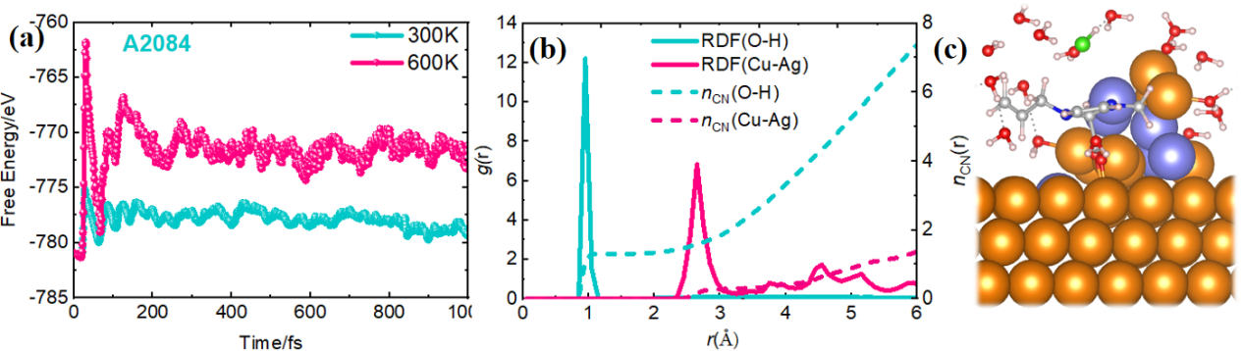
Figure S25. The total energy variations profiles of A2084 imidazolium salts interfacial EDL versus simulation time during AIMD simulation process under 300K and 600K temperatures; (b) The radial distribution function g_{O-H}(r) and g_{Cu-Ag}(r), corresponding coordination number (n_{CN}) are also plotted by the solid and dashed lines in A2084 ionic liquid system, respectively; and (c) computational model of A2084 interfacial EDL microenvironment.
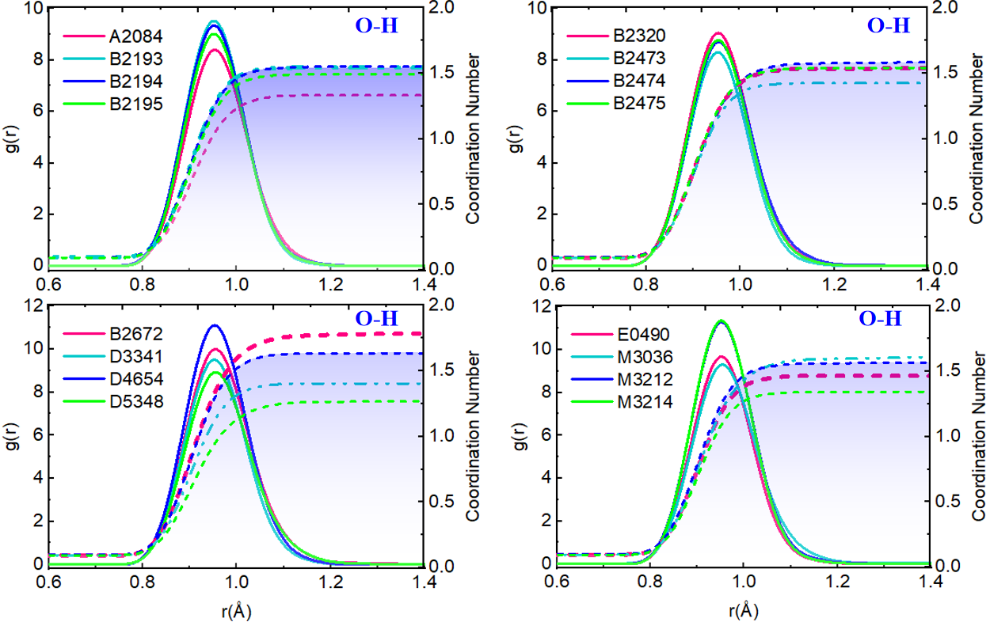Figure S26. The radial distribution function of g_{O-H}(r) for all considered ionic liquid systems and corresponding coordination number (n_{CN}) are plotted by the solid and dashed lines of various imidazolium salts, respectively.
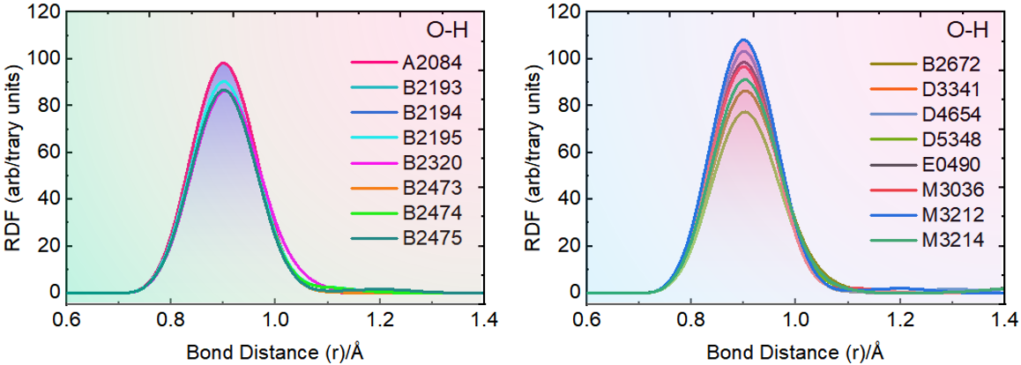Figure S27. The radial distribution function of g_{O-H}(r) for all considered ionic liquid systems are plotted..
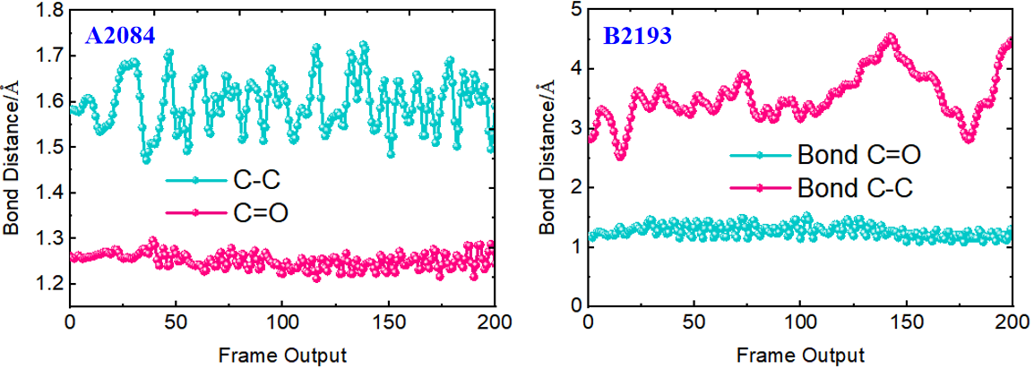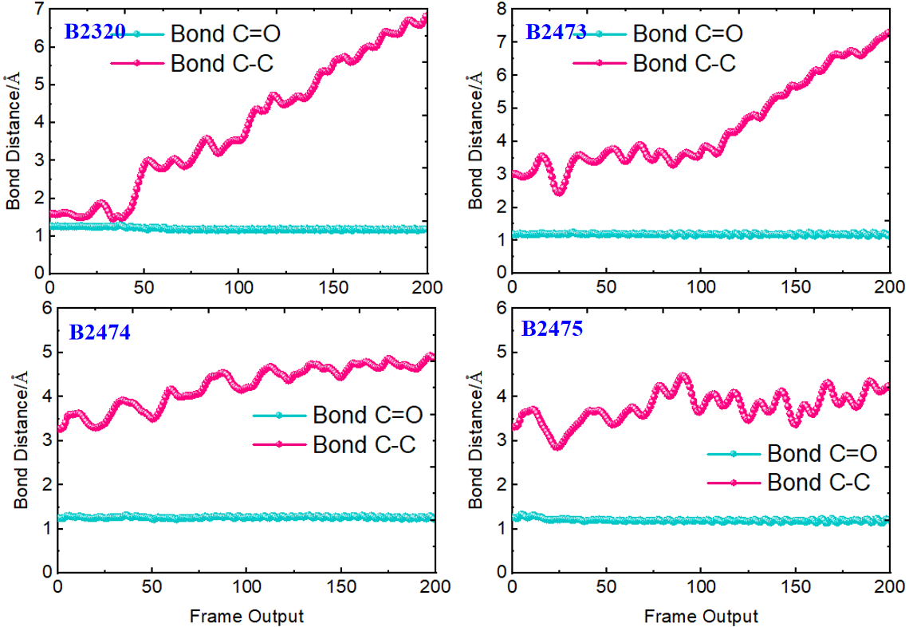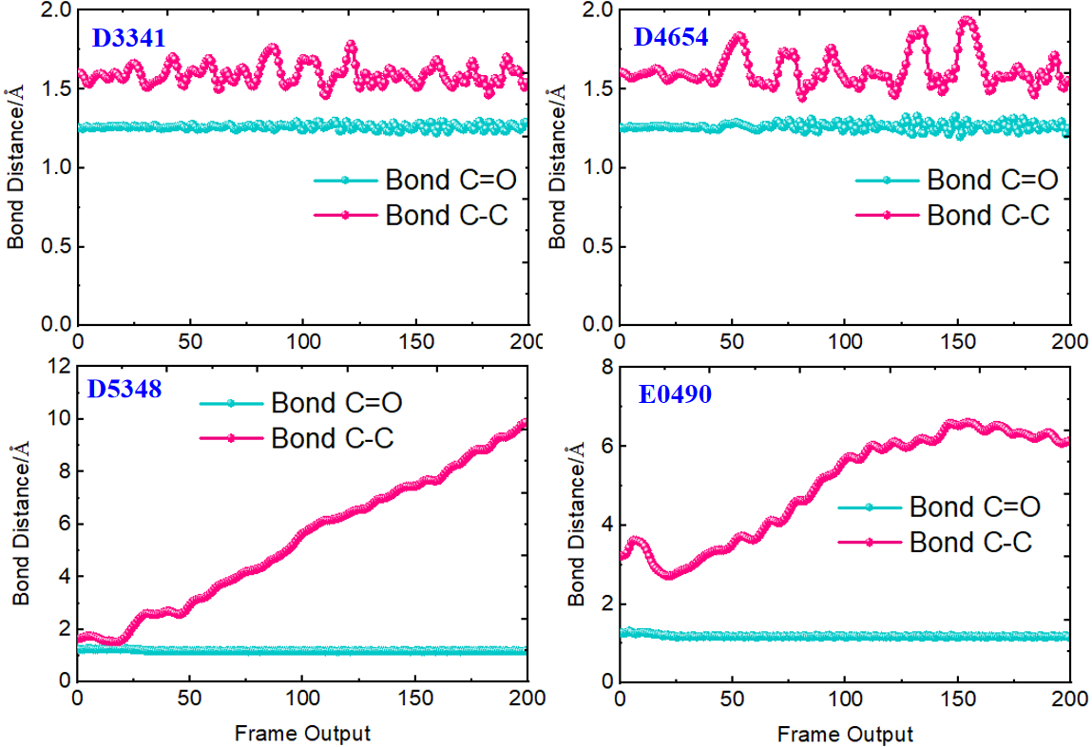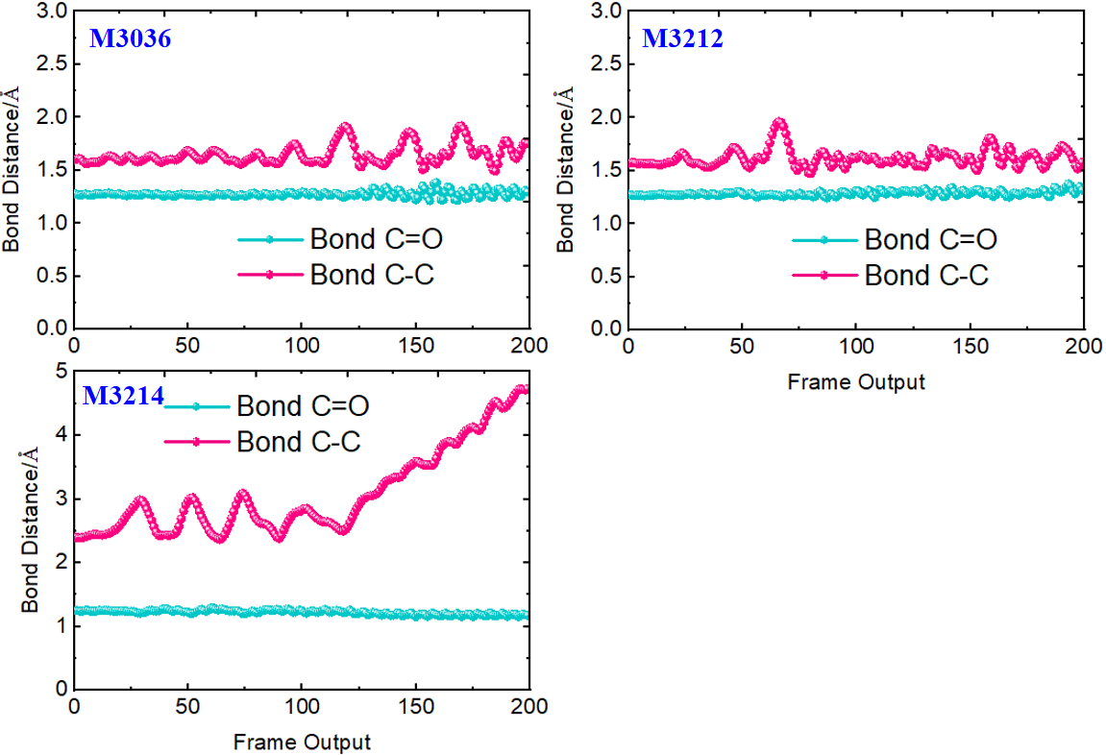Figure S28. The C−C and C=O bonds distance profile of between imidazolium ring and adsorbed CO₂ versus simulation time on CuAg NPs and Ag SA tandem catalyst for all imidazolium salts systems.
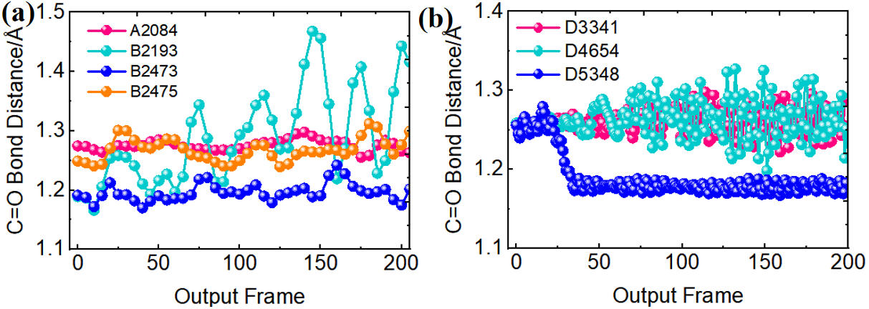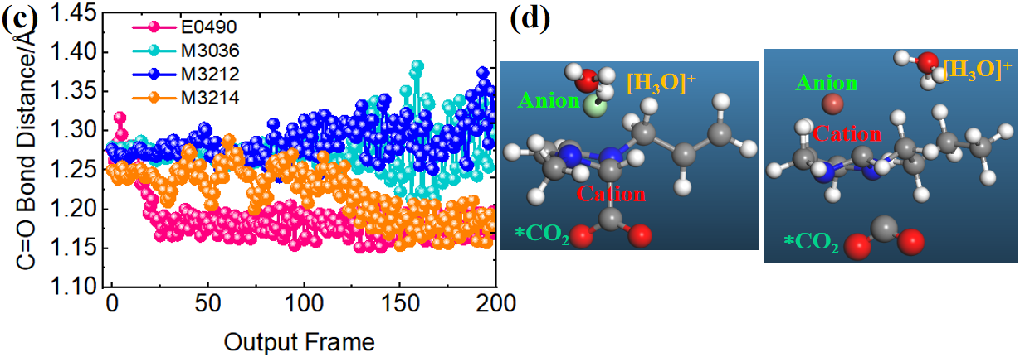
Figure S29. (a-c) The AIMD results of the C=O bond distances variations at 300K for all imidazolium salts, (d) The atomic model of interaction mechanism of between the imidazolium salts and adsorbed CO₂ for B2195 and B2320 imidazolium salts.
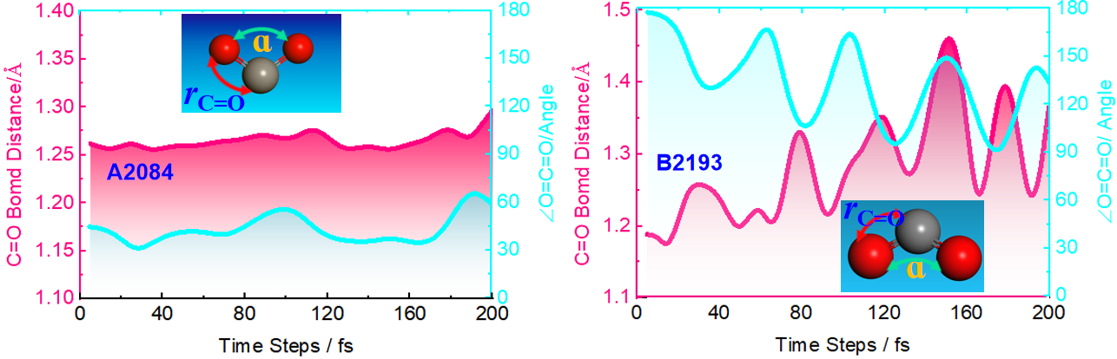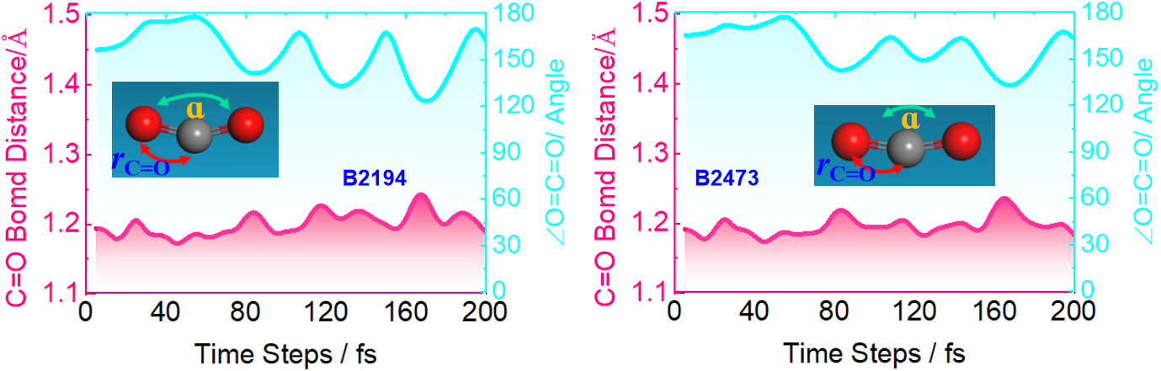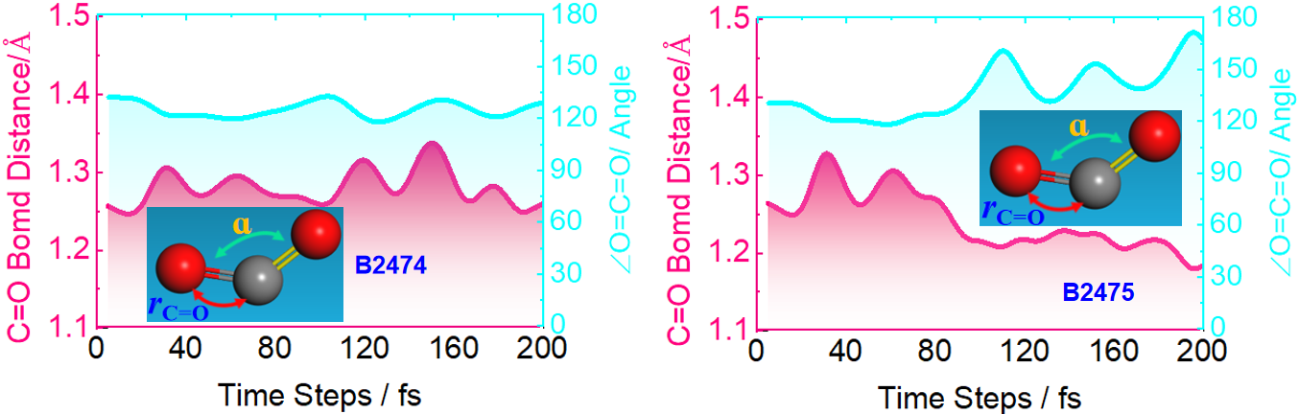
Figure S3 Simulated C=O bond distance and O=C=O bond angle profile in adsorbed CO₂ versus simulation time for different ionic liquid on CuAg NPs and Ag SA tandem catalyst, respectively.
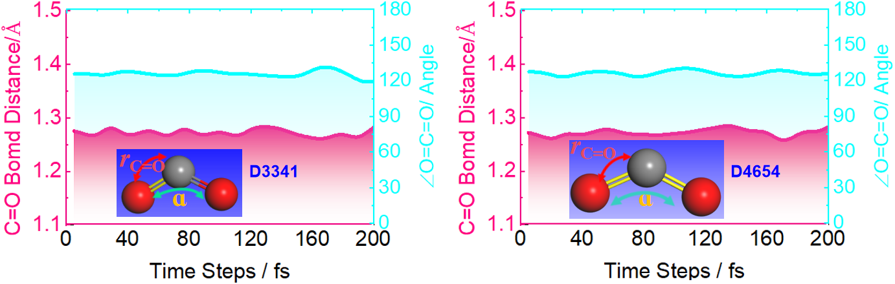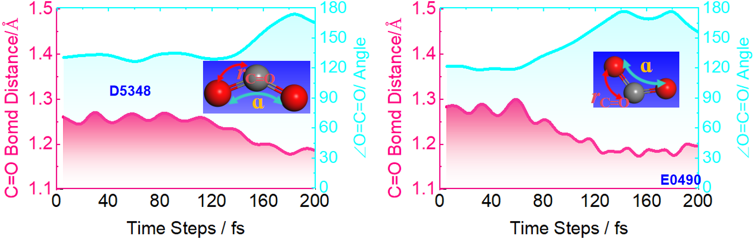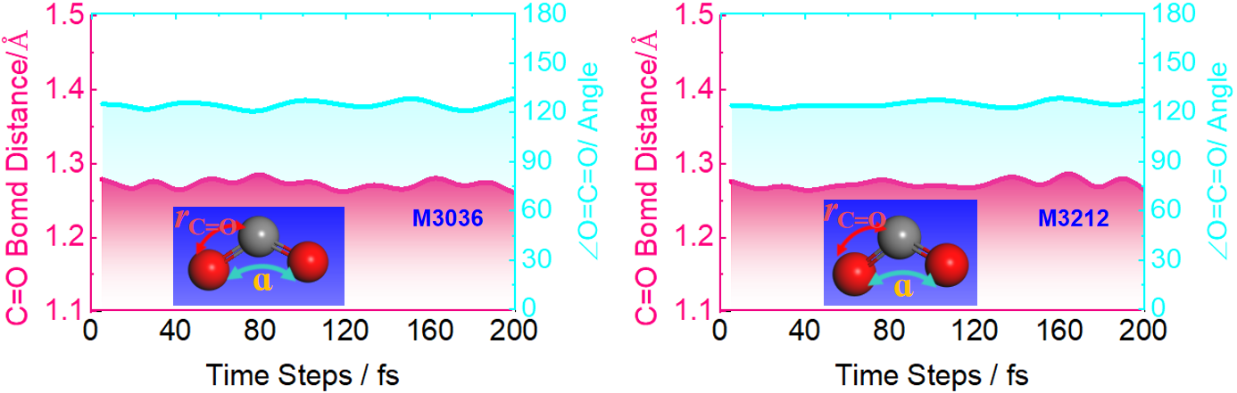
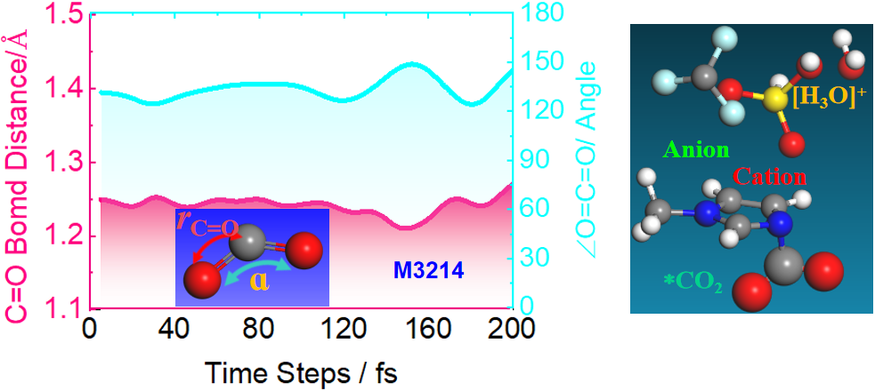
Figure S31.Simulated C=O bond distance and O=C=O bond angle profile in adsorbed CO₂ versus simulation time for different ionic liquid on CuAg NPs and Ag SA tandem catalyst, respectively.
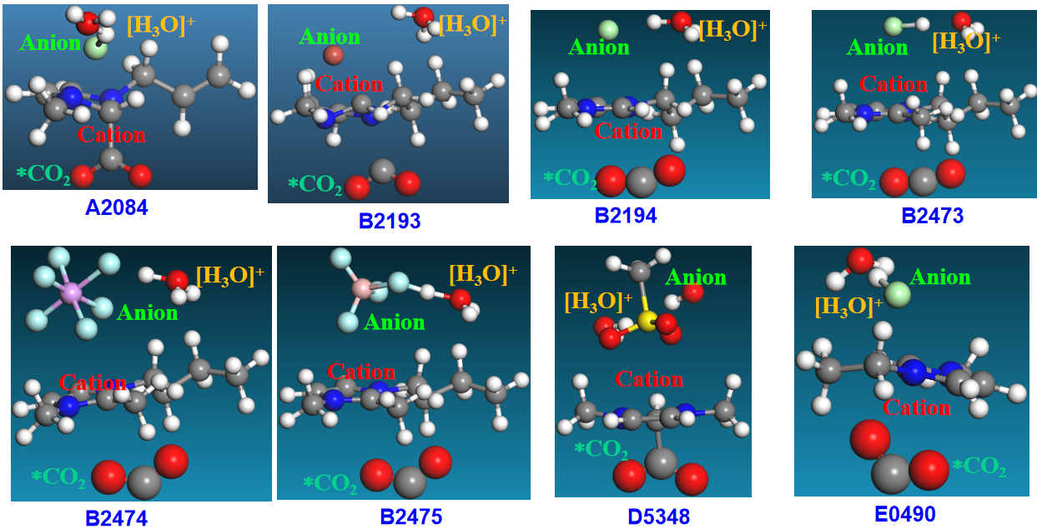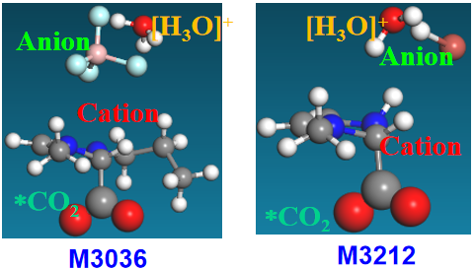
Figure S32. The atomic model of interaction mechanism of between the imidazolium salts and CO₂, including cations and anions.
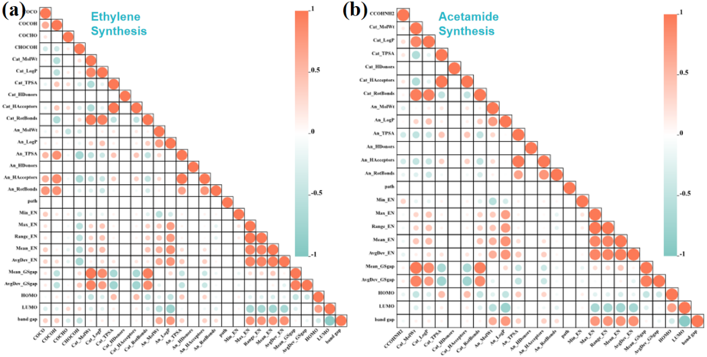
Figure S33.Correlation heatmap were plotted based on Pearson’s correlation for relationship between binding energy of before and after C–C/N bonds coupling of each eCO₂R C1 intermediate for (a) ethylene synthesis, and (b) acetamide synthesis, respectively.
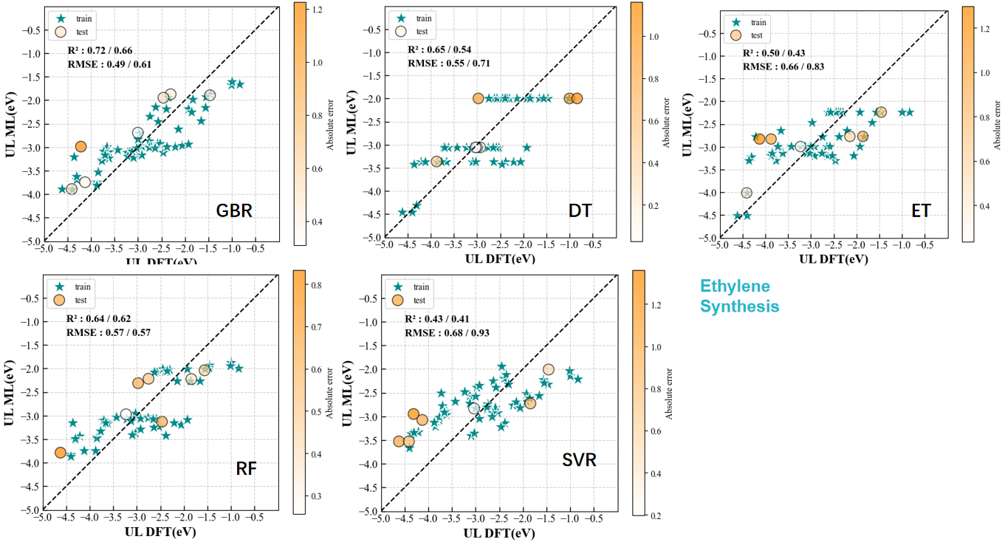Figure S34. Comparison of UL prediction results from other regression models, including (a) GBR, (b) DT, (c) ET, (d) RF, and (e) SVR.
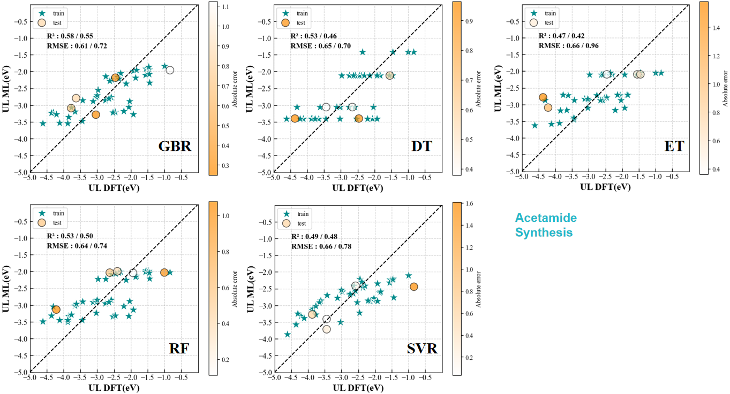
Figure S35. Comparison of U_{L} prediction results from other regression models, including (a) GBR, (b) DT, (c) ET, (d) RF, and (e) SVR.
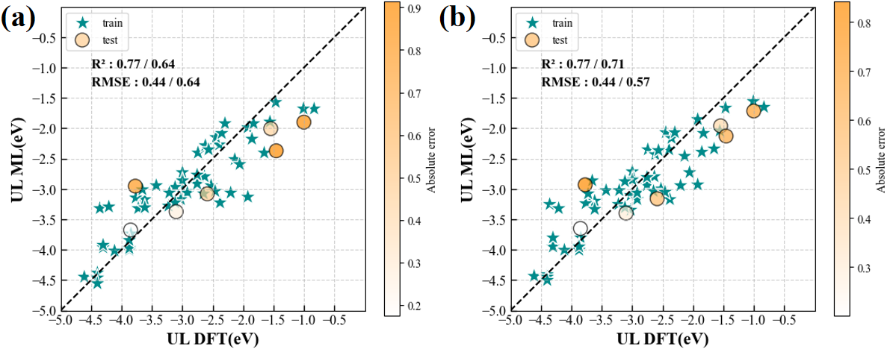
Figure S36. (a). Prediction performance of the initial XGB model prior to descriptor selection. (b) Prediction performance of the refined XGB model after eliminating zero-importance descriptors and retraining during for ethylene synthesis.
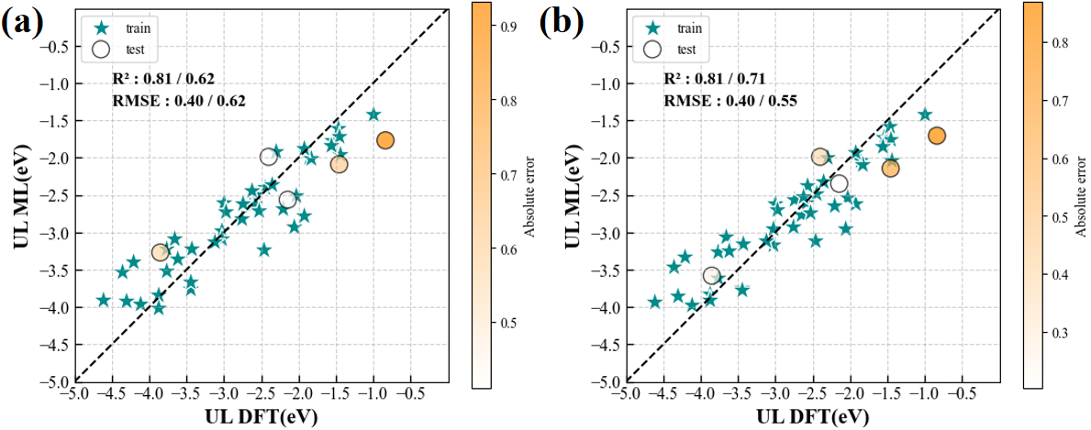
Figure S37. (a). Prediction performance of the final XGB model prior to descriptor selection. (b) Prediction performance of the refined XGB model after eliminating zero-importance descriptors and retraining during for acetamide synthesis.

Tables.
Table S1 the Gibbs free energy of the gas molecular from the DFT calculation at 298.15 K (T).
CO₂ | -23.36583388 | H₂ | -6.87426486 | CH₂CH₂ | -28.72437708
CH₃CONH₂ | -52.10930419 | H₂O | -14.21570483

Table S2 the total Gibbs free energy of each carbon-based intermediate from the DFT calculation at 298.15 K (T).
Systems | A2084 | B2193 | B2194 | B2195 | B2320 | B2473 | B2474 | B2475
Intermediate | -768.61 | -793.06 | -793.98 | -818.05 | -824.73 | -810.50 | -841.18 | -835.04
*CO₂ | -790.17 | -814.27 | -814.60 | -839.80 | -846.44 | -831.63 | -862.65 | -856.52
*COOH | -793.77 | -817.90 | -818.93 | -842.70 | -849.57 | -835.29 | -865.20 | -860.21
*CO | -782.59 | -808.08 | -808.57 | -832.91 | -839.48 | -825.20 | -855.60 | -849.95
*CO+*COOH | -809.24 | -832.31 | -833.92 | -857.35 | -864.82 | -849.60 | -879.95 | -874.13
*COCO | -796.60 | -820.76 | -821.58 | -846.97 | -852.89 | -838.08 | -869.64 | -862.59
*COCOH | -800.63 | -824.92 | -824.92 | -850.16 | -856.71 | -842.38 | -873.04 | -866.87
*COHCOH | -802.22 | -828.66 | -828.96 | -853.29 | -859.86 | -846.62 | -876.32 | -868.01
*CHOHCOH | -806.95 | -833.12 | -833.79 | -857.13 | -864.12 | -850.75 | -882.03 | -875.26
*CHOHCHOH | -813.43 | -837.67 | -838.48 | -862.63 | -870.04 | -855.58 | -885.97 | -878.98
*CHCHOH | -802.84 | -826.95 | -827.98 | -851.53 | -858.88 | -843.85 | -875.07 | -868.89
*CHCH | -791.97 | -816.20 | -816.82 | -842.34 | -847.42 | -833.13 | -864.33 | -857.96
*CH₂CH | -795.91 | -820.51 | -820.49 | -845.52 | -852.52 | -837.73 | -868.54 | -862.16
*CH₂CH₂ | -800.14 | -825.09 | -825.68 | -850.01 | -856.70 | -842.15 | -873.40 | -866.68
*H | -771.69 | -796.62 | -797.08 | -822.31 | -828.75 | -814.47 | -844.39 | -838.40
*COH | -785.00 | -810.02 | -811.65 | -835.67 | -841.91 | -827.57 | -858.03 | -852.41
*COH+*COOH | -810.14 | -834.89 | -836.99 | -861.64 | -868.38 | -852.83 | -883.86 | -877.46
*CHO | -786.41 | -811.16 | -811.74 | -836.42 | -842.84 | -828.64 | -859.35 | -852.69
*CHO*COOH | -809.58 | -835.31 | -835.54 | -860.10 | -866.61 | -852.85 | -883.49 | -877.56
*CHOCO | -800.55 | -825.40 | -826.49 | -851.64 | -856.57 | -842.41 | -873.38 | -867.83
*CHOCHO | -807.45 | -832.51 | -833.28 | -858.29 | -864.32 | -849.35 | -881.03 | -873.18
*CHOHCHO | -809.68 | -834.49 | -834.52 | -858.97 | -866.40 | -851.83 | -882.03 | -875.84
*CHOCOH | -805.24 | -829.61 | -829.97 | -855.70 | -861.04 | -847.37 | -878.29 | -871.10
*CHOHCOH | -806.95 | -833.12 | -833.79 | -857.13 | -864.12 | -850.75 | -882.03 | -875.26
*CHOHCO | -804.66 | -829.07 | -829.92 | -854.39 | -861.20 | -846.00 | -873.38 | -870.37
Systems | B2672 | D3341 | D4654 | D5348 | E0490 | M3036 | M3212 | M3214
*CO₂ | -812.15 | -744.19 | -742.57 | -789.34 | -761.19 | -800.50 | -725.55 | -769.30
*COOH | -833.28 | -764.93 | -764.46 | -814.65 | -782.65 | -821.17 | -748.66 | -789.54
*CO | -836.65 | -769.58 | -768.16 | -816.19 | -785.09 | -824.65 | -753.26 | -794.87
*CO+*COOH | -824.55 | -758.42 | -755.28 | -802.88 | -775.44 | -814.86 | -738.60 | -782.42
*COCO | -850.90 | -783.66 | -784.12 | -827.94 | -800.63 | -839.84 | -768.18 | -807.87
*COCOH | -837.15 | -770.73 | -768.98 | -821.46 | -787.71 | -827.78 | -753.27 | -797.34
*COHCOH | -843.19 | -777.05 | -775.28 | -822.73 | -792.01 | -832.83 | -759.48 | -801.98
*CHOHCOH | -845.25 | -776.72 | -776.25 | -824.32 | -793.66 | -834.06 | -762.63 | -803.72
*CHOHCHOH | -852.21 | -784.20 | -782.91 | -833.20 | -800.24 | -839.33 | -765.11 | -810.14
*CHCHOH | -853.99 | -788.96 | -788.13 | -837.48 | -806.00 | -845.13 | -770.64 | -812.44
*CHCH | -844.45 | -778.15 | -776.70 | -822.29 | -794.73 | -833.92 | -759.37 | -801.84
*CH₂CH | -833.77 | -767.61 | -766.90 | -816.58 | -784.57 | -822.14 | -747.79 | -788.67
*CH₂CH₂ | -837.14 | -771.21 | -770.03 | -815.76 | -787.56 | -827.04 | -752.59 | -796.28
*H | -842.67 | -775.65 | -774.80 | -820.63 | -792.26 | -832.35 | -757.15 | -799.82
*COH | -814.68 | -747.75 | -746.40 | -793.27 | -764.99 | -806.02 | -728.03 | -770.39
*COH+*COOH | -827.19 | -761.52 | -760.38 | -805.99 | -778.02 | -817.37 | -741.33 | -788.10
*CHO | -854.77 | -785.90 | -784.75 | -834.29 | -802.07 | -840.52 | -768.75 | -810.69
*CHO*COOH | -829.11 | -761.70 | -761.23 | -806.91 | -778.77 | -819.88 | -746.26 | -786.14
*CHOCO | -851.60 | -786.44 | -785.50 | -835.50 | -802.81 | -842.83 | -770.06 | -811.81
*CHOCHO | -842.70 | -776.59 | -772.28 | -825.59 | -794.01 | -829.75 | -761.13 | -802.16
*CHOHCHO | -848.96 | -783.06 | -781.54 | -830.32 | -799.74 | -840.52 | -764.97 | -803.65
*CHOCOH | -850.43 | -784.72 | -784.18 | -833.10 | -801.77 | -840.56 | -766.56 | -808.66
*CHOHCOH | -847.01 | -780.80 | -779.16 | -829.79 | -797.22 | -838.19 | -763.48 | -801.43
*CHOHCO | -852.21 | -784.20 | -782.91 | -833.20 | -800.24 | -839.33 | -765.11 | -810.14
*CO₂ | -846.59 | -780.78 | -779.48 | -824.41 | -796.15 | -835.66 | -764.18 | -802.56

Table S3 The coupling energy of both C–C and C–N coupling during ethylene and acetamide synthesis.
Systems | Bmim |  |  | M3212 |  |  | M3214 |  |  | A2084
Species | Before | After | ΔE_{Coup} | Before | After | ΔE_{Coup} | Before | After | ΔE_{Coup} | Before | After | ΔE_{Coup}
CCONH₂ | -842.88 | -840.61 | -2.26 | -767.83 | -769.44 | 1.61 | -808.69 | -806.66 | -2.03 | -811.73 | -810.46 | -1.27
COCO | -828.82 | -827.78 | -1.04 | -755.97 | -753.27 | -2.70 | -799.44 | -797.34 | -2.10 | -797.42 | -796.60 | -0.82
CHOCHO | -836.41 | -840.52 | 4.11 | -761.55 | -764.97 | 3.42 | -802.35 | -803.65 | 1.30 | -804.42 | -807.45 | 3.03
COHCOH | -834.87 | -834.06 | -0.81 | -760.36 | -762.63 | 2.27 | -806.38 | -803.72 | -2.66 | -802.07 | -802.22 | 0.16
CH₂CH₂ | -830.29 | -832.35 | 2.06 | -755.76 | -757.15 | 1.39 | -800.23 | -799.82 | -0.41 | -798.88 | -800.14 | 1.26
CHCH | -823.00 | -822.14 | -0.85 | -747.49 | -747.79 | 0.31 | -790.17 | -788.67 | -1.50 | -790.65 | -791.97 | 1.31
CHOHCHOH | -842.09 | -845.13 | 3.04 | -766.20 | -770.64 | 4.43 | -806.74 | -812.44 | 5.70 | -810.12 | -813.43 | 3.31
CHOHCO | -835.76 | -835.66 | -0.10 | -759.36 | -764.18 | 4.81 | -803.19 | -802.56 | -0.63 | -803.97 | -804.66 | 0.69
CHOHCHO | -840.29 | -840.56 | 0.27 | -764.46 | -766.56 | 2.10 | -806.71 | -808.66 | 1.95 | -806.59 | -809.68 | 3.09
CHOHCOH | -838.32 | -839.33 | 1.01 | -761.78 | -765.11 | 3.33 | -807.67 | -810.14 | 2.48 | -806.42 | -806.95 | 0.52
COCOH | -832.89 | -832.83 | -0.06 | -758.01 | -759.48 | 1.46 | -800.29 | -801.98 | 1.69 | -801.17 | -800.63 | -0.54
COCHO | -831.97 | -829.75 | -2.22 | -758.80 | -761.13 | 2.33 | -803.11 | -802.16 | -0.95 | -799.65 | -800.55 | 0.90
CHOCOH | -837.58 | -840.61 | 3.04 | -759.41 | -763.48 | 4.07 | -804.03 | -801.43 | -2.60 | -802.80 | -805.24 | 2.44
Systems | D3341 |  |  | E0490 |  |  | D5348 |  |  | D4654
 | Before | After | ΔE_{Coup} | Before | After | ΔE_{Coup} | Before | After | ΔE_{Coup} | Before | After | ΔE_{Coup}
CCONH₃ | -787.00 | -785.80 | -1.20 | -802.83 | -802.61 | -0.22 | -834.53 | -833.15 | -1.39 | -785.46 | -784.97 | -0.50
COCO | -773.65 | -770.73 | -2.92 | -790.21 | -787.71 | -2.50 | -817.85 | -821.46 | 3.60 | -772.90 | -768.98 | -3.93
CHOCHO | -780.25 | -783.06 | 2.81 | -796.63 | -799.74 | 3.12 | -824.89 | -830.32 | 5.43 | -780.07 | -781.54 | 1.47
COHCOH | -779.00 | -776.72 | -2.28 | -794.14 | -793.66 | -0.48 | -827.92 | -824.32 | -3.60 | -778.91 | -776.25 | -2.66
CH₂CH₂ | -773.19 | -775.65 | 2.46 | -791.34 | -792.26 | 0.91 | -815.33 | -820.63 | 5.30 | -773.40 | -774.80 | 1.40
CHCH | -766.24 | -767.61 | 1.37 | -783.57 | -784.57 | 1.00 | -811.22 | -816.58 | 5.36 | -765.18 | -766.90 | 1.72
CHOHCHOH | -785.53 | -788.96 | 3.43 | -801.61 | -806.00 | 4.39 | -835.01 | -837.48 | 2.46 | -783.54 | -788.13 | 4.59
CHOHCO | -778.85 | -780.78 | 1.93 | -795.31 | -796.15 | 0.84 | -823.82 | -824.41 | 0.59 | -778.13 | -779.48 | 1.35
CHOHCHO | -782.70 | -784.72 | 2.03 | -798.20 | -801.77 | 3.57 | -827.51 | -833.10 | 5.60 | -780.93 | -784.18 | 3.25
CHOHCOH | -778.94 | -784.20 | 5.26 | -798.03 | -800.24 | 2.21 | -829.44 | -833.20 | 3.76 | -779.75 | -782.91 | 3.16
COCOH | -776.81 | -777.05 | 0.24 | -793.10 | -792.01 | -1.08 | -818.25 | -822.73 | 4.49 | -775.64 | -775.28 | -0.37
COCHO | -776.41 | -776.59 | 0.18 | -793.18 | -794.01 | 0.83 | -826.13 | -825.59 | -0.54 | -775.92 | -772.28 | -3.64
CHOCOH | -778.51 | -780.80 | 2.29 | -794.70 | -797.22 | 2.52 | -829.30 | -829.79 | 0.50 | -777.45 | -779.16 | 1.71
Systems | B2193 |  |  | B2194 |  |  | B2195 |  |  | B2320
Species | Before | After | ΔE_{Coup} | Before | After | ΔE_{Coup} | Before | After | ΔE_{Coup} | Before | After | ΔE_{Coup}
CCONH₃ | -836.38 | -835.13 | -1.25 | -836.14 | -835.89 | -0.25 | -861.40 | -860.32 | -1.07 | -867.52 | -867.12 | -0.39
COCO | -823.00 | -820.76 | -2.24 | -823.51 | -821.58 | -1.94 | -847.87 | -846.97 | -0.90 | -854.99 | -852.89 | -2.10
CHOCHO | -829.26 | -832.51 | 3.25 | -830.07 | -833.28 | 3.20 | -854.63 | -858.29 | 3.66 | -860.42 | -864.32 | 3.90
COHCOH | -828.29 | -828.66 | 0.36 | -828.59 | -828.96 | 0.36 | -853.47 | -853.29 | -0.18 | -859.38 | -859.86 | 0.48
CH₂CH₂ | -823.83 | -825.09 | 1.27 | -824.04 | -825.68 | 1.64 | -849.19 | -850.01 | 0.81 | -855.84 | -856.70 | 0.86
CHCH | -815.54 | -816.20 | 0.67 | -816.04 | -816.82 | 0.77 | -840.87 | -842.34 | 1.47 | -846.69 | -847.42 | 0.73
CHOHCHOH | -834.33 | -837.67 | 3.34 | -834.98 | -838.48 | 3.50 | -861.23 | -862.63 | 1.40 | -866.38 | -870.04 | 3.66
CHOHCO | -828.29 | -829.07 | 0.78 | -828.51 | -829.92 | 1.41 | -853.31 | -854.39 | 1.08 | -860.41 | -861.20 | 0.79
CHOHCHO | -831.20 | -834.49 | 3.29 | -832.26 | -834.52 | 2.26 | -856.82 | -858.97 | 2.15 | -863.40 | -866.40 | 2.99
CHOHCOH | -830.31 | -833.12 | 2.81 | -831.11 | -833.79 | 2.67 | -856.06 | -857.13 | 1.08 | -862.14 | -864.12 | 1.99
COCOH | -826.12 | -824.92 | -1.19 | -826.40 | -824.92 | -1.48 | -850.46 | -850.16 | -0.30 | -857.24 | -856.71 | -0.53
COCHO | -825.60 | -825.40 | -0.20 | -826.34 | -826.49 | 0.15 | -850.55 | -851.64 | 1.09 | -858.17 | -856.57 | -1.61
CHOCOH | -826.63 | -829.61 | 2.98 | -827.56 | -829.97 | 2.41 | -854.39 | -855.70 | 1.31 | -859.78 | -861.04 | 1.26
Systems | B2473 |  |  | B2474 |  |  | B2475 |  |  | B2672
Species | Before | After | ΔE_{Coup} | Before | After |  | Before | After | ΔE_{Coup} | Before | After | ΔE_{Coup}
CCONH₃ | -852.71 | -852.75 | 0.05 | -883.20 | -883.74 | 0.53 | -876.58 | -877.06 | 0.47 | -853.41 | -851.44 | -1.96
COCO | -839.67 | -838.08 | -1.59 | -870.43 | -869.64 | -0.79 | -862.77 | -862.59 | -0.18 | -841.32 | -837.15 | -4.16
CHOCHO | -846.52 | -849.35 | 2.84 | -877.44 | -881.03 | 3.59 | -870.00 | -873.18 | 3.18 | -846.42 | -848.96 | 2.54
COHCOH | -845.27 | -846.62 | 1.35 | -876.29 | -876.32 | 0.03 | -868.14 | -868.01 | -0.14 | -843.36 | -848.96 | 5.60
CH₂CH₂ | -840.60 | -842.15 | 1.55 | -869.59 | -873.40 | 3.81 | -864.11 | -866.68 | 2.57 | -840.30 | -842.67 | 2.38
CHCH | -833.04 | -833.13 | 0.09 | -863.09 | -864.33 | 1.23 | -856.45 | -857.96 | 1.52 | -832.04 | -833.77 | 1.72
CHOHCHOH | -852.41 | -855.58 | 3.17 | -882.53 | -885.97 | 3.44 | -875.39 | -878.98 | 3.59 | -851.84 | -853.99 | 2.15
CHOHCO | -845.23 | -846.00 | 0.78 | -875.88 | -873.38 | -2.49 | -868.94 | -870.37 | 1.43 | -844.44 | -846.59 | 2.15
CHOHCHO | -848.72 | -851.83 | 3.12 | -879.74 | -882.03 | 2.29 | -872.68 | -875.84 | 3.16 | -851.16 | -850.43 | -0.73
CHOHCOH | -849.20 | -850.75 | 1.54 | -879.12 | -882.03 | 2.91 | -871.53 | -875.26 | 3.72 | -847.97 | -852.21 | 4.24
COCOH | -842.70 | -842.38 | -0.31 | -873.54 | -873.04 | -0.50 | -867.43 | -866.87 | -0.55 | -844.10 | -843.19 | -0.91
COCHO | -843.12 | -842.41 | -0.71 | -874.28 | -873.38 | -0.90 | -866.12 | -867.83 | 1.71 | -843.72 | -842.70 | -1.02
CHOCOH | -843.94 | -847.37 | 3.43 | -877.23 | -878.29 | 1.06 | -870.24 | -871.10 | 0.85 | -842.89 | -847.01 | 4.12

Table S4 the Gibbs free energy of the gas molecular from the DFT calculation at 298.15 K (T).
System | A2084 | B2193 | B2194 | B2195 | B2320 | B2473 | B2474 | B2475
* | 0.00 | 0.00 | 0.00 | 0.00 | 0.00 | 0.00 | 0.00 | 0.00
*CO₂ | 1.81 | 2.16 | 2.74 | 1.61 | 1.66 | 2.24 | 1.89 | 1.88
*COOH | 1.64 | 1.97 | 1.86 | 2.15 | 1.96 | 2.02 | 2.79 | 1.63
*CO | 2.04 | 1.00 | 1.43 | 1.16 | 1.28 | 1.33 | 1.60 | 1.11
*CO+*COOH | 2.20 | 3.58 | 2.89 | 3.52 | 2.74 | 3.73 | 4.06 | 3.74
*COCO | 4.06 | 4.35 | 4.45 | 3.12 | 3.89 | 4.47 | 3.59 | 4.49
*COCOH | 3.47 | 3.62 | 4.55 | 3.37 | 3.51 | 3.61 | 3.62 | 3.65
*COHCOH | 5.31 | 3.33 | 3.95 | 3.68 | 3.80 | 2.81 | 3.79 | 5.95
*CHOHCOH | 4.02 | 2.30 | 2.56 | 3.27 | 2.97 | 2.12 | 1.51 | 2.14
*CHOHCHOH | 0.97 | 1.19 | 1.30 | 1.21 | 0.49 | 0.72 | 1.00 | 1.85
*CHCHOH | 0.79 | 1.12 | 1.02 | 1.54 | 0.87 | 1.67 | 1.13 | 1.17
*CHCH | 0.88 | 1.09 | 1.41 | -0.05 | 1.55 | 1.61 | 1.09 | 1.32
*CH₂CH | 0.37 | 0.23 | 1.17 | 0.20 | -0.12 | 0.45 | 0.31 | 0.56
*CH₂CH₂ | -0.42 | -0.92 | -0.58 | -0.85 | -0.86 | -0.53 | -1.10 | -0.53
*H | 0.36 | -0.12 | 0.34 | -0.83 | -0.59 | -0.53 | 0.22 | 0.07
*COH | 3.07 | 2.50 | 1.79 | 1.84 | 2.28 | 2.39 | 2.61 | 2.09
*COH*COOH | 4.73 | 4.44 | 3.26 | 2.67 | 2.62 | 3.94 | 3.58 | 3.84
*CHO | 1.66 | 1.36 | 1.70 | 1.08 | 1.35 | 1.33 | 1.29 | 1.81
*CHO*COOH | 5.29 | 4.02 | 4.71 | 4.21 | 4.38 | 3.92 | 3.96 | 3.74
*CHOCO | 3.54 | 3.15 | 2.98 | 1.89 | 3.65 | 3.58 | 3.28 | 2.70
*CHOCHO | 0.08 | -0.53 | -0.37 | -1.32 | -0.66 | 0.07 | -0.93 | 0.78
*CHOHCHO | -2.15 | -2.51 | -1.61 | -2.00 | -2.74 | -2.41 | -1.93 | -1.88
*CHOCOH | 5.73 | 5.81 | 6.37 | 4.70 | 6.05 | 5.50 | 5.25 | 6.30
*CHOHCOH | 4.02 | 2.30 | 2.56 | 3.27 | 2.97 | 2.12 | 1.51 | 2.14
*CHOHCO | 2.87 | 2.91 | 2.99 | 2.58 | 2.45 | 3.42 | 6.72 | 3.59
System | B2672 | D3341 | D4654 | D5348 | E0490 | M3036 | M3212 | M3214
* | 0.00 | 0.00 | 0.00 | 0.00 | 0.00 | 0.00 | 0.00 | 0.00
*CO₂ | 2.24 | 2.63 | 1.47 | -1.94 | 1.90 | 2.70 | 0.25 | 3.13
*COOH | 2.31 | 1.42 | 1.21 | -0.04 | 2.89 | 2.65 | -0.90 | 1.23
*CO | 3.63 | 1.80 | 3.31 | 2.49 | 1.77 | 1.66 | 2.97 | 2.91
*CO+*COOH | 4.08 | 3.36 | 1.28 | 4.23 | 3.38 | 3.48 | 0.20 | 4.26
*COCO | 7.05 | 5.51 | 5.64 | -0.06 | 5.52 | 4.77 | 4.33 | 4.01
*COCOH | 4.45 | 2.62 | 2.78 | 2.10 | 4.66 | 3.15 | 1.56 | 2.81
*COHCOH | 5.83 | 6.40 | 5.24 | 3.95 | 6.45 | 5.36 | 1.84 | 4.51
*CHOHCOH | 2.30 | 2.35 | 2.02 | -1.50 | 3.31 | 3.53 | 2.80 | 1.52
*CHOHCHOH | 3.96 | 1.03 | 0.24 | -2.34 | 0.98 | 1.17 | 0.71 | 2.66
*CHCHOH | 2.72 | 1.06 | 0.89 | 2.07 | 1.48 | 1.60 | 1.20 | 2.48
*CHCH | 2.62 | 0.83 | -0.09 | -3.00 | 0.86 | 2.60 | 2.00 | 4.87
*CH₂CH | 2.69 | 0.66 | 0.22 | 1.26 | 1.30 | 1.14 | 0.64 | 0.70
*CH₂CH₂ | 0.59 | -0.34 | -1.12 | -0.17 | 0.04 | -0.73 | -0.48 | 0.60
CH₂CH₂ | 2.39 | 2.39 | 2.39 | 2.39 | 2.39 | 2.39 | 2.39 | 2.39
*H | 0.91 | -0.12 | -0.40 | -0.49 | -0.37 | -2.08 | 0.96 | 2.35
*COH | 4.43 | 2.13 | 1.65 | 2.82 | 2.63 | 2.59 | 3.69 | 0.66
*COH*COOH | 3.65 | 4.56 | 4.09 | 1.32 | 5.38 | 6.25 | 3.06 | 4.87
*CHO | 2.50 | 1.96 | 0.80 | 1.89 | 1.88 | 0.09 | -1.25 | 2.62
*CHO*COOH | 6.81 | 4.02 | 3.34 | 0.11 | 4.64 | 3.94 | 1.75 | 3.75
*CHOCO | 4.94 | 3.08 | 5.78 | -0.77 | 2.66 | 6.23 | -0.09 | 2.62
*CHOCHO | 2.12 | 0.06 | -0.05 | -2.05 | 0.36 | -1.10 | -0.50 | 4.57
*CHOHCHO | 0.65 | -1.61 | -2.69 | -4.84 | -1.66 | -1.14 | -2.08 | -0.44
*CHOCOH | 7.50 | 5.75 | 5.77 | 1.91 | 6.33 | 4.67 | 4.43 | 6.80
*CHOHCOH | 2.30 | 2.35 | 2.02 | -1.50 | 3.31 | 3.53 | 2.80 | 1.52
*CHOHCO | 4.49 | 2.34 | 2.01 | 3.85 | 3.96 | 3.76 | 0.29 | 5.66

Table S5 the Gibbs free energy of the gas molecular from the DFT calculation at 298.15 K (T).
U_{L} | COCO | COCOH | COCHO | CHOCOH | Cat_LogP | Cat_TPSA | An_MolWt | An_LogP
-1.86 | -0.82 | -0.54 | 0.90 | 2.44 | 0.41 | 8.81 | 35.45 | -3.00
-2.58 | -2.24 | -1.19 | -0.20 | 2.98 | 1.11 | 8.81 | 79.90 | -3.00
-1.56 | -1.94 | -1.48 | 0.15 | 2.41 | 1.11 | 8.81 | 35.45 | -3.00
-2.36 | -0.90 | -0.30 | 1.09 | 1.31 | 1.11 | 8.81 | 86.80 | 1.30
-1.46 | -2.10 | -0.53 | -1.61 | 1.26 | 1.11 | 8.81 | 144.96 | 3.38
-2.40 | -1.59 | -0.31 | -0.71 | 3.43 | 1.42 | 8.81 | 35.45 | -3.00
-2.46 | -0.79 | -0.50 | -0.90 | 1.06 | 1.42 | 8.81 | 144.96 | 3.38
-2.62 | -0.18 | -0.55 | 1.71 | 0.85 | 1.42 | 8.81 | 86.80 | 1.30
-2.97 | -4.16 | -0.91 | -1.02 | 4.12 | 1.11 | 8.81 | 197.66 | 2.76
-3.77 | -2.92 | 0.24 | 0.18 | 2.29 | -0.15 | 8.81 | 35.45 | -3.00
-4.37 | -3.93 | -0.37 | -3.64 | 1.71 | -0.15 | 8.81 | 126.90 | -3.00
-4.41 | 3.60 | 4.49 | -0.54 | 0.50 | -0.15 | 8.81 | 111.10 | -0.64
-2.14 | -2.50 | -1.08 | 0.83 | 2.52 | 0.33 | 8.81 | 35.45 | -3.00
-2.21 | -1.04 | -0.06 | -2.22 | 3.04 | 0.72 | 8.81 | 86.80 | 1.30
-4.13 | -2.70 | 1.46 | 2.33 | 4.07 | 0.42 | 17.82 | 80.91 | 0.58
-2.39 | -2.10 | 1.69 | -0.95 | -2.60 | 0.42 | 17.82 | 149.07 | 0.05
-1.84 | -0.82 | -0.54 | 0.90 | 2.44 | 0.41 | 8.81 | 35.45 | -3.00
-1.93 | -2.24 | -1.19 | -0.20 | 2.98 | 1.11 | 8.81 | 79.90 | -3.00
-1.47 | -1.94 | -1.48 | 0.15 | 2.41 | 1.11 | 8.81 | 35.45 | -3.00
-0.84 | -0.90 | -0.30 | 1.09 | 1.31 | 1.11 | 8.81 | 86.80 | 1.30
-1.00 | -2.10 | -0.53 | -1.61 | 1.26 | 1.11 | 8.81 | 144.96 | 3.38
-1.55 | -1.59 | -0.31 | -0.71 | 3.43 | 1.42 | 8.81 | 35.45 | -3.00
-1.01 | -0.79 | -0.50 | -0.90 | 1.06 | 1.42 | 8.81 | 144.96 | 3.38
-2.30 | -0.18 | -0.55 | 1.71 | 0.85 | 1.42 | 8.81 | 86.80 | 1.30
-1.66 | -4.16 | -0.91 | -1.02 | 4.12 | 1.11 | 8.81 | 197.66 | 2.76
-3.77 | -2.92 | 0.24 | 0.18 | 2.29 | -0.15 | 8.81 | 35.45 | -3.00
-2.46 | -3.93 | -0.37 | -3.64 | 1.71 | -0.15 | 8.81 | 126.90 | -3.00
-4.41 | 3.60 | 4.49 | -0.54 | 0.50 | -0.15 | 8.81 | 111.10 | -0.64
-2.75 | -2.50 | -1.08 | 0.83 | 2.52 | 0.33 | 8.81 | 35.45 | -3.00
-3.66 | -1.04 | -0.06 | -2.22 | 3.04 | 0.72 | 8.81 | 86.80 | 1.30
-3.87 | -2.70 | 1.46 | 2.33 | 4.07 | 0.42 | 17.82 | 80.91 | 0.58
-4.21 | -2.10 | 1.69 | -0.95 | -2.60 | 0.42 | 17.82 | 149.07 | 0.05
-3.63 | -0.82 | -0.54 | 0.90 | 2.44 | 0.41 | 8.81 | 35.45 | -3.00
-3.70 | -2.24 | -1.19 | -0.20 | 2.98 | 1.11 | 8.81 | 79.90 | -3.00
-3.00 | -1.94 | -1.48 | 0.15 | 2.41 | 1.11 | 8.81 | 35.45 | -3.00
-3.21 | -0.90 | -0.30 | 1.09 | 1.31 | 1.11 | 8.81 | 86.80 | 1.30
-3.23 | -2.10 | -0.53 | -1.61 | 1.26 | 1.11 | 8.81 | 144.96 | 3.38
-3.13 | -1.59 | -0.31 | -0.71 | 3.43 | 1.42 | 8.81 | 35.45 | -3.00
-2.93 | -0.79 | -0.50 | -0.90 | 1.06 | 1.42 | 8.81 | 144.96 | 3.38
-3.73 | -0.18 | -0.55 | 1.71 | 0.85 | 1.42 | 8.81 | 86.80 | 1.30
-4.31 | -4.16 | -0.91 | -1.02 | 4.12 | 1.11 | 8.81 | 197.66 | 2.76
-2.64 | -2.92 | 0.24 | 0.18 | 2.29 | -0.15 | 8.81 | 35.45 | -3.00
-2.93 | -3.93 | -0.37 | -3.64 | 1.71 | -0.15 | 8.81 | 126.90 | -3.00
-4.41 | 3.60 | 4.49 | -0.54 | 0.50 | -0.15 | 8.81 | 111.10 | -0.64
-2.76 | -2.50 | -1.08 | 0.83 | 2.52 | 0.33 | 8.81 | 35.45 | -3.00
-3.85 | -1.04 | -0.06 | -2.22 | 3.04 | 0.72 | 8.81 | 86.80 | 1.30
-3.87 | -2.70 | 1.46 | 2.33 | 4.07 | 0.42 | 17.82 | 80.91 | 0.58
-3.10 | -2.10 | 1.69 | -0.95 | -2.60 | 0.42 | 17.82 | 149.07 | 0.05
-3.63 | -0.82 | -0.54 | 0.90 | 2.44 | 0.41 | 8.81 | 35.45 | -3.00
-2.66 | -2.24 | -1.19 | -0.20 | 2.98 | 1.11 | 8.81 | 79.90 | -3.00
-3.00 | -1.94 | -1.48 | 0.15 | 2.41 | 1.11 | 8.81 | 35.45 | -3.00
-3.12 | -0.90 | -0.30 | 1.09 | 1.31 | 1.11 | 8.81 | 86.80 | 1.30
-3.03 | -2.10 | -0.53 | -1.61 | 1.26 | 1.11 | 8.81 | 144.96 | 3.38
-2.59 | -1.59 | -0.31 | -0.71 | 3.43 | 1.42 | 8.81 | 35.45 | -3.00
-3.44 | -0.79 | -0.50 | -0.90 | 1.06 | 1.42 | 8.81 | 144.96 | 3.38
-1.93 | -0.18 | -0.55 | 1.71 | 0.85 | 1.42 | 8.81 | 86.80 | 1.30
-4.31 | -4.16 | -0.91 | -1.02 | 4.12 | 1.11 | 8.81 | 197.66 | 2.76
-2.06 | -2.92 | 0.24 | 0.18 | 2.29 | -0.15 | 8.81 | 35.45 | -3.00
-2.53 | -3.93 | -0.37 | -3.64 | 1.71 | -0.15 | 8.81 | 126.90 | -3.00
-4.62 | 3.60 | 4.49 | -0.54 | 0.50 | -0.15 | 8.81 | 111.10 | -0.64
-2.76 | -2.50 | -1.08 | 0.83 | 2.52 | 0.33 | 8.81 | 35.45 | -3.00
-3.85 | -1.04 | -0.06 | -2.22 | 3.04 | 0.72 | 8.81 | 86.80 | 1.30
-3.87 | -2.70 | 1.46 | 2.33 | 4.07 | 0.42 | 17.82 | 80.91 | 0.58
-3.04 | -2.10 | 1.69 | -0.95 | -2.60 | 0.42 | 17.82 | 149.07 | 0.05

Table S6 the Gibbs free energy of the gas molecular from the DFT calculation at 298.15 K (T).
An_HAcceptors | An_RotBonds | path | Min_EN | Max_EN | AvgDev_GSgap | HOMO | LUMO
0.00 | 0.00 | 1.00 | 1.90 | 3.44 | 2.95 | 0.17 | -0.22
0.00 | 0.00 | 1.00 | 1.90 | 3.44 | 3.05 | 0.14 | -0.27
0.00 | 0.00 | 1.00 | 1.90 | 3.44 | 3.05 | 0.14 | -0.29
0.00 | 0.00 | 1.00 | 1.90 | 3.98 | 3.00 | 0.10 | -0.39
0.00 | 0.00 | 1.00 | 1.90 | 3.98 | 2.97 | 0.10 | -0.40
0.00 | 0.00 | 1.00 | 1.90 | 3.44 | 3.10 | 0.15 | -0.29
0.00 | 0.00 | 1.00 | 1.90 | 3.98 | 3.02 | 0.13 | -0.38
0.00 | 0.00 | 1.00 | 1.90 | 3.98 | 3.05 | 0.14 | -0.37
0.00 | 0.00 | 1.00 | 1.83 | 3.44 | 3.01 | 0.13 | -0.34
0.00 | 0.00 | 1.00 | 1.90 | 3.44 | 2.88 | 0.14 | -0.29
0.00 | 0.00 | 1.00 | 1.90 | 3.44 | 2.88 | 0.13 | -0.33
4.00 | 2.00 | 1.00 | 1.90 | 3.44 | 2.93 | 0.13 | -0.38
0.00 | 0.00 | 1.00 | 1.90 | 3.44 | 2.94 | 0.14 | -0.29
0.00 | 0.00 | 1.00 | 1.90 | 3.98 | 2.94 | 0.13 | -0.39
0.00 | 0.00 | 1.00 | 1.90 | 3.44 | 2.81 | 0.14 | -0.31
3.00 | 0.00 | 1.00 | 1.90 | 3.98 | 2.74 | 0.19 | -0.31
0.00 | 0.00 | 2.00 | 1.90 | 3.44 | 2.95 | 0.17 | -0.22
0.00 | 0.00 | 2.00 | 1.90 | 3.44 | 3.05 | 0.14 | -0.27
0.00 | 0.00 | 2.00 | 1.90 | 3.44 | 3.05 | 0.14 | -0.29
0.00 | 0.00 | 2.00 | 1.90 | 3.98 | 3.00 | 0.10 | -0.39
0.00 | 0.00 | 2.00 | 1.90 | 3.98 | 2.97 | 0.10 | -0.40
0.00 | 0.00 | 2.00 | 1.90 | 3.44 | 3.10 | 0.15 | -0.29
0.00 | 0.00 | 2.00 | 1.90 | 3.98 | 3.02 | 0.13 | -0.38
0.00 | 0.00 | 2.00 | 1.90 | 3.98 | 3.05 | 0.14 | -0.37
0.00 | 0.00 | 2.00 | 1.83 | 3.44 | 3.01 | 0.13 | -0.34
0.00 | 0.00 | 2.00 | 1.90 | 3.44 | 2.88 | 0.14 | -0.29
0.00 | 0.00 | 2.00 | 1.90 | 3.44 | 2.88 | 0.13 | -0.33
4.00 | 2.00 | 2.00 | 1.90 | 3.44 | 2.93 | 0.13 | -0.38
0.00 | 0.00 | 2.00 | 1.90 | 3.44 | 2.94 | 0.14 | -0.29
0.00 | 0.00 | 2.00 | 1.90 | 3.98 | 2.94 | 0.13 | -0.39
0.00 | 0.00 | 2.00 | 1.90 | 3.44 | 2.81 | 0.14 | -0.31
3.00 | 0.00 | 2.00 | 1.90 | 3.98 | 2.74 | 0.19 | -0.31
0.00 | 0.00 | 3.00 | 1.90 | 3.44 | 2.95 | 0.17 | -0.22
0.00 | 0.00 | 3.00 | 1.90 | 3.44 | 3.05 | 0.14 | -0.27
0.00 | 0.00 | 3.00 | 1.90 | 3.44 | 3.05 | 0.14 | -0.29
0.00 | 0.00 | 3.00 | 1.90 | 3.98 | 3.00 | 0.10 | -0.39
0.00 | 0.00 | 3.00 | 1.90 | 3.98 | 2.97 | 0.10 | -0.40
0.00 | 0.00 | 3.00 | 1.90 | 3.44 | 3.10 | 0.15 | -0.29
0.00 | 0.00 | 3.00 | 1.90 | 3.98 | 3.02 | 0.13 | -0.38
0.00 | 0.00 | 3.00 | 1.90 | 3.98 | 3.05 | 0.14 | -0.37
0.00 | 0.00 | 3.00 | 1.83 | 3.44 | 3.01 | 0.13 | -0.34
0.00 | 0.00 | 3.00 | 1.90 | 3.44 | 2.88 | 0.14 | -0.29
0.00 | 0.00 | 3.00 | 1.90 | 3.44 | 2.88 | 0.13 | -0.33
4.00 | 2.00 | 3.00 | 1.90 | 3.44 | 2.93 | 0.13 | -0.38
0.00 | 0.00 | 3.00 | 1.90 | 3.44 | 2.94 | 0.14 | -0.29
0.00 | 0.00 | 3.00 | 1.90 | 3.98 | 2.94 | 0.13 | -0.39
0.00 | 0.00 | 3.00 | 1.90 | 3.44 | 2.81 | 0.14 | -0.31
3.00 | 0.00 | 3.00 | 1.90 | 3.98 | 2.74 | 0.19 | -0.31
0.00 | 0.00 | 4.00 | 1.90 | 3.44 | 2.95 | 0.17 | -0.22
0.00 | 0.00 | 4.00 | 1.90 | 3.44 | 3.05 | 0.14 | -0.27
0.00 | 0.00 | 4.00 | 1.90 | 3.44 | 3.05 | 0.14 | -0.29
0.00 | 0.00 | 4.00 | 1.90 | 3.98 | 3.00 | 0.10 | -0.39
0.00 | 0.00 | 4.00 | 1.90 | 3.98 | 2.97 | 0.10 | -0.40
0.00 | 0.00 | 4.00 | 1.90 | 3.44 | 3.10 | 0.15 | -0.29
0.00 | 0.00 | 4.00 | 1.90 | 3.98 | 3.02 | 0.13 | -0.38
0.00 | 0.00 | 4.00 | 1.90 | 3.98 | 3.05 | 0.14 | -0.37
0.00 | 0.00 | 4.00 | 1.83 | 3.44 | 3.01 | 0.13 | -0.34
0.00 | 0.00 | 4.00 | 1.90 | 3.44 | 2.88 | 0.14 | -0.29
0.00 | 0.00 | 4.00 | 1.90 | 3.44 | 2.88 | 0.13 | -0.33
4.00 | 2.00 | 4.00 | 1.90 | 3.44 | 2.93 | 0.13 | -0.38
0.00 | 0.00 | 4.00 | 1.90 | 3.44 | 2.94 | 0.14 | -0.29
0.00 | 0.00 | 4.00 | 1.90 | 3.98 | 2.94 | 0.13 | -0.39
0.00 | 0.00 | 4.00 | 1.90 | 3.44 | 2.81 | 0.14 | -0.31
3.00 | 0.00 | 4.00 | 1.90 | 3.98 | 2.74 | 0.19 | -0.31

