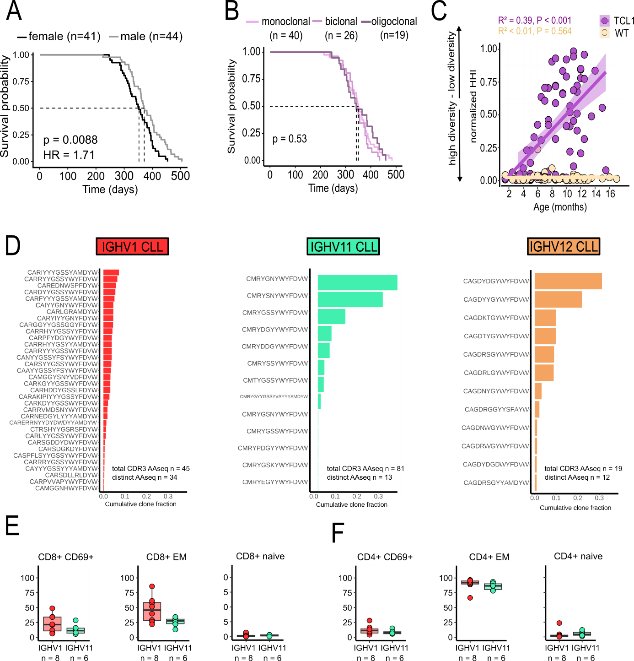
Supplement Figure 1. (A) Kaplan-Meier survival curves, grouped by sex (female mice: n =41; male mice: n = 44). (B) Kaplan-Meier survival curves based on clonality, including monoclonal (n=40), biclonal (n=26) and oligoclonal (n=19) TCL1 mice. (C) Scatter plot comparing changes of BCR-repertoire diversity in WT (n=73 samples) and TCL1 (n= 69 samples) mice over time. (D) Bar graph showing cohort specific cumulative clone fraction of distinct aaCDR3 sequences of IGHV groups (IGHV1 n = 45, IGHV11 n = 81, IGHV12 = 19). (E + F) Flow cytometric results for CD8⁺ and CD4⁺ T-cell subsets (CD69+, EM and naive) grouped by IGHV gene usage of the dominant CLL clone (IGHV11: n = 6; IGHV1: n = 8). Wilcoxon test was used to compare IGHV11 and IGHV1 data.

