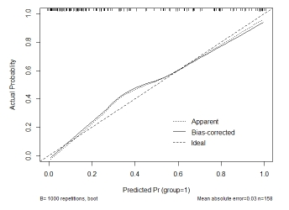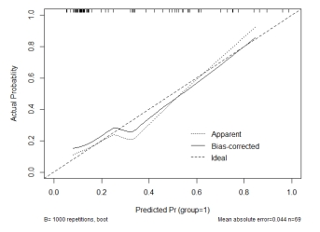
- (b)
Fig. S1 Calibration curve of DCE combined IVIM radiomic model for predicting HER2 positive breast cancer. (a) Training cohort. (b) Validation cohort. The horizontal and vertical axes represent the prediction probability and actual probability of the model respectively, and the diagonal dashed line and curve respectively represent the prediction of the ideal model and the constructed
model. The closer the two lines are, the better the calibration efficiency of the model is.

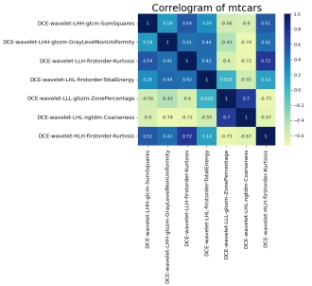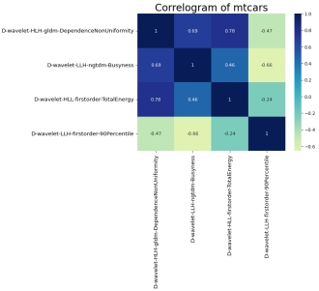
- (b)
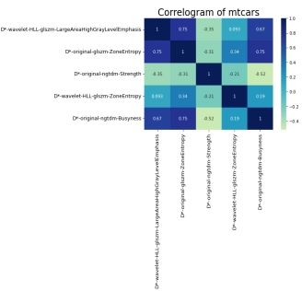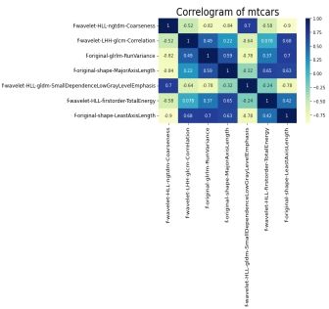
(c) (d)
Fig. S2 Correlation heatmaps of radiomic features. (a-d) It represents the correlation heat map of the final remaining 7, 4, 5 and 7 radiomic features of each model of DCE, D, D* and f.

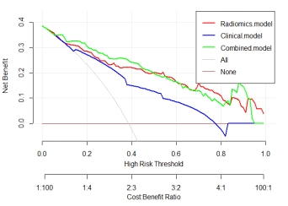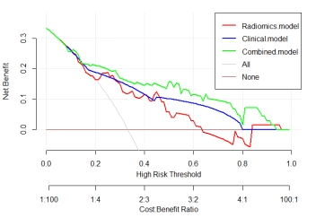
- (b)
Fig. S3 DCA diagrams for predicting clinical model, radiomic model and clinic combined radiomic model of HER2 positive breast cancer. (a) Training cohort. (b) Validation cohort. "All" means All intervention, and "None" means no intervention. Under the threshold probability (0.0-1.0), its net income is higher than all line and None line, which means that the model has practical value.

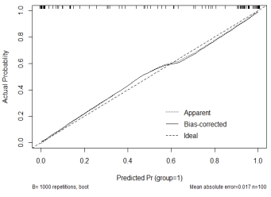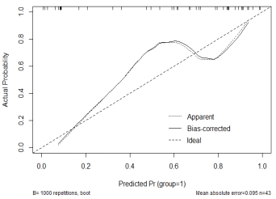
- (b)
Fig. S4 Calibration curve of DCE combined IVIM radiomic model for predicting HER2 low breast cancer. (a) Training cohort. (b) Validation cohort. The horizontal and vertical axes represent the prediction probability and actual probability of the model respectively, and the diagonal dashed line and curve respectively represent the prediction of the ideal model and the constructed
model. The closer the two lines are, the better the calibration efficiency of the model is.

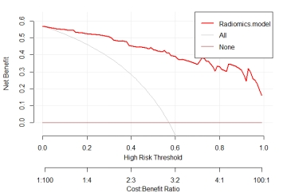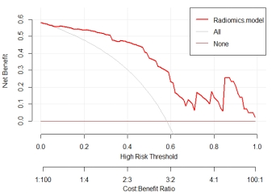

Fig. S5 Prediction of DCA diagram of HER2 low breast cancer based on DCE combined IVIM radiomic model. (a) Training cohort. (b) Validation cohort. "All" means All intervention, and "None" means no intervention. Under the threshold probability (0.0-1.0), its net income is higher than all line and None line, which means that the model has practical value.

