Table A1 Associations of Covariates with Semen volume outcomes(N=896)
 |  | Basic model | Complete model
Covariant | +/- term | X88=1 | X88=1 | - Election
 | Initial regression coefficient | -0.3044 | -0.1541
Time spent using electronics | factor(X251) | -0.2713 * | -0.1907 * | Yes
Sedentary time (days) | factor(X261) | -0.3186 | -0.1357 * | Yes
The exercise time | factor(X46) | -0.3024 | -0.1565
Sleep hours per night | factor(X49) | -0.2985 | -0.1642
The degree of education | factor(X581) | -0.2895 | -0.1612
Professional | factor(X59) | -0.2164 * | -0.2299 * | Yes
Marriage | factor(X63) | -0.2914 | -0.1648
Whether there is repayment pressure | factor(X71) | -0.2601 * | -0.2119 * | Yes
Frequency of physical exercise | factor(X47) | -0.3485 * | -0.1212 * | Yes
* Represents a change of more than 10% from the initial regression coefficient
The filtered covariates
Note：
1.Covariates are introduced into the basic model or the influence of covariates on the regression coefficient of X is eliminated in the complete model
2. Variable fixed to be adjusted is adjusted in Y model, basic model and complete model by individual covariates: BMI,smoking,Age,Drinking
Created by EmpowerStats (www.empowerstats.com) and R on 2021-01-04

Table A 2 Associations of Covariates with sperm concentration outcomes(N=896)
 |  | Basic model | Complete model
Covariant | +/- term | X88=1 | X88=1 | - Election
 | Initial regression coefficient | 4.0640 | 10.7759
Time spent using electronics | factor(X251) | 4.1440 | 10.6830
Sedentary time (days) | factor(X261) | 4.0516 | 10.6279
The exercise time | factor(X46) | 4.0584 | 10.8539
Sleep hours per night | factor(X49) | 5.7707 * | 9.3395 * | Yes
The degree of education | factor(X581) | 4.7933 * | 10.2535 | Yes
Professional | factor(X59) | 5.2626 * | 10.4813 | Yes
Marriage | factor(X63) | 3.8428 | 11.0470
Whether there is repayment pressure | factor(X71) | 6.6789 * | 7.9418 * | Yes
Frequency of physical exercise | factor(X47) | 4.8777 * | 9.9633 | Yes
*Represents a change of more than 10% from the initial regression coefficient
The filtered covariates
Note：
1.Covariates are introduced into the basic model or the influence of covariates on the regression coefficient of X is eliminated in the complete model
2. Variable fixed to be adjusted is adjusted in Y model, basic model and complete model by individual covariates: BMI smoking Age Drinking
Created by EmpowerStats (www.empowerstats.com) and R on 2021-01-04

Table A 3 Associations of Covariates with total sperm count outcomes(N=896)
 |  | Basic model | Complete model
- Covariant | +/- term | X88=1 | X88=1 | - Election
 | Initial regression coefficient | -4.9460 | 28.9727
Time spent using electronics | factor(X251) | -2.2465 * | 26.4120 | Yes
Sedentary time (days) | factor(X261) | -5.4841 * | 29.2229 | Yes
The exercise time | factor(X46) | -4.9238 | 29.3959
Sleep hours per night | factor(X49) | 1.6545 * | 23.5014 * | Yes
The degree of education | factor(X581) | -1.6568 * | 26.5397 | Yes
Professional | factor(X59) | 4.0782 * | 23.5892 * | Yes
Marriage | factor(X63) | -5.0308 | 29.1368
Whether there is repayment pressure | factor(X71) | 7.1333 * | 14.8834 * | Yes
Frequency of physical exercise | factor(X47) | -3.7969 * | 27.4653 | Yes
*Represents a change of more than 10% from the initial regression coefficient
The filtered covariates
Note：
1.Covariates are introduced into the basic model or the influence of covariates on the regression coefficient of X is eliminated in the complete model
2. Variable fixed to be adjusted is adjusted in Y model, basic model and complete model by individual covariates: BMI smoking Age Drinking
Created by EmpowerStats (www.empowerstats.com) and R on 2021-01-04

Table A 4 Associations of Covariates with progressive motility outcomes(N=896)
 |  | Basic model | Complete model
Covariant | +/- term | X88=1 | X88=1 | - Election
 | Initial regression coefficient | -11.0221 | -10.4808
Time spent using electronics | factor(X251) | -11.0460 | -10.4010
Sedentary time (days) | factor(X261) | -10.8275 | -10.6321
The exercise time | factor(X46) | -10.9863 | -10.3748
Sleep hours per night | factor(X49) | -10.3540 | -11.0307
The degree of education | factor(X581) | -11.0482 | -10.4870
Professional | factor(X59) | -11.2119 | -10.0839
Marriage | factor(X63) | -11.1325 | -10.3201
Whether there is repayment pressure | factor(X71) | -10.7450 | -10.7360
Frequency of physical exercise | factor(X47) | -11.0205 | -10.3204
*Represents a change of more than 10% from the initial regression coefficient
The filtered covariates
Note：
1.Covariates are introduced into the basic model or the influence of covariates on the regression coefficient of X is eliminated in the complete model
2. Variable fixed to be adjusted is adjusted in Y model, basic model and complete model by individual covariates: BMI smoking Age Drinking
Created by EmpowerStats (www.empowerstats.com) and R on 2021-01-04

[1] BUKOWSKI R, SMITH G C, MALONE F D, et al. Fetal growth in early pregnancy and risk of delivering low birth weight infant: prospective cohort study [J]. BMJ (Clinical research ed), 2007, 334(7598): 836.

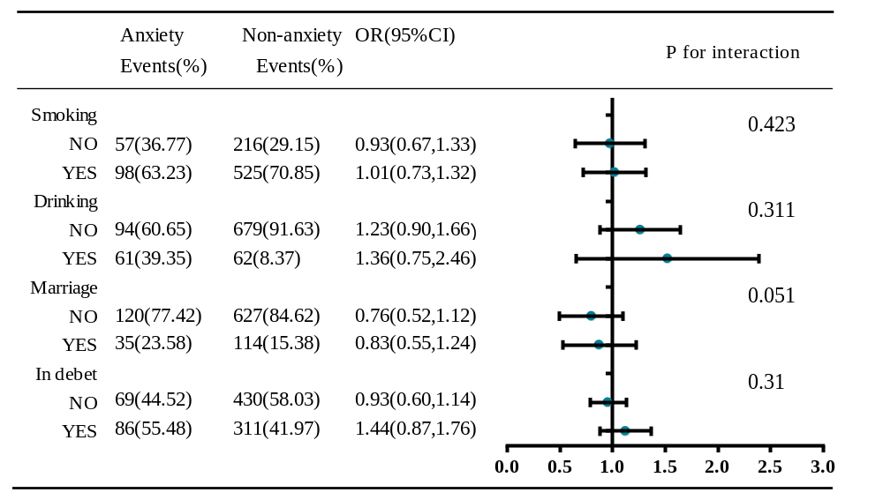
Figure A 1. The results of subgroup analyses on the association of progressive motility with the risk of anxiety levels.
Abbreviations: OR, odds ratio; CI, confidence interval.

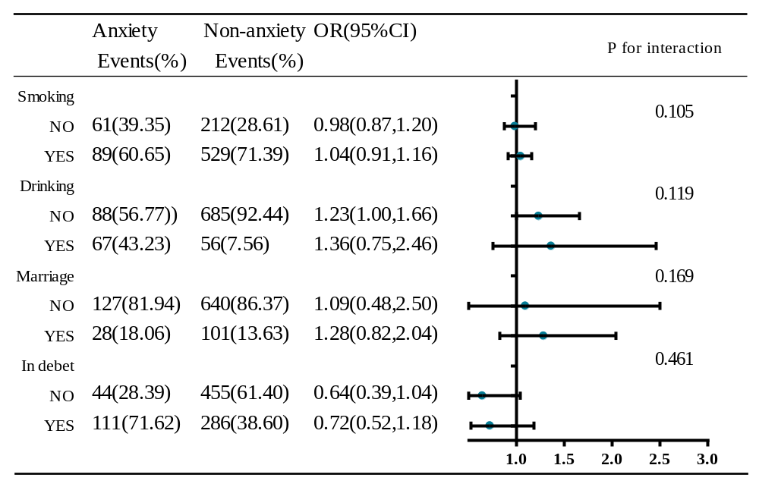
Figure A 2. The results of subgroup analyses on the association of semen volume with the risk of anxiety levels.
Abbreviations: OR, odds ratio; CI, confidence interval.

