Supplementary Table 1. Characteristics of RDT products recognized by the HealthPulse application in the MaCRA evaluation.
RDT product (manufacturer) | Referred to as: | Line color | RDT cassette format
RDT cassettes with a single test line to detect Plasmodium falciparum-specific histidine-rich protein 2 (HRP2)
AdvDx Malaria Pf Rapid Malaria Ag Detection Test  (Advy Chemical, Mumbai, India) [27] | AdvDx Malaria Pf | Red/pink | 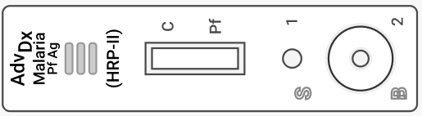
Bioline MALARIA Ag P.f  (Abbott, IL USA) [28]  Note: The same cassette previously was manufactured as SD Bioline. | Bioline Malaria Pf | Red/pink | 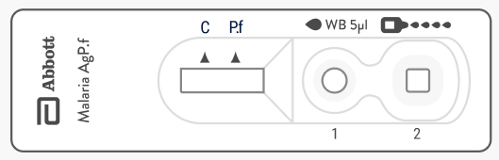  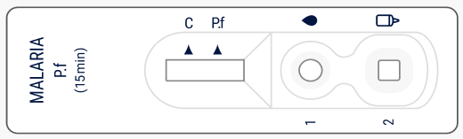
CareStart Malaria Pf (HRP2) Ag RDT  (Access Bio Inc, NJ USA)  Note: This product has been de-listed by WHO prequalification. | CareStart Malaria Pf | Test lines are blue/purple  Control lines are red/pink | 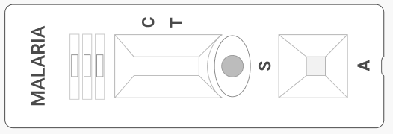
First Response Malaria Antigen P. falciparum (HRP2) Card Test (Premier Medical Corporation Ltd, Gujarat, India) [29] | First Response Malaria Pf | Blue/purple | 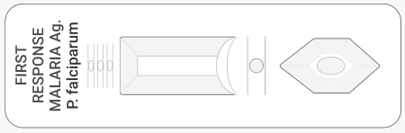
ParaHIT f Ver. 1.0 Rapid Test for P. falciparum Malaria Device  (Arkray Healthcare Prvt Ltd, Mumbai, India) [30] | ParaHIT Malaria Pf | Red/pink | 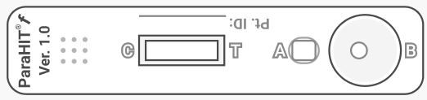
STANDARD Q Malaria P.f Ag Test (SD Biosensor, Gyeonggi-do, Republic of Korea) [31] | Standard Q Malaria Pf | Pink | 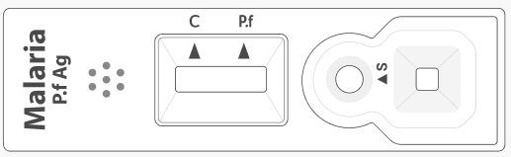
RDT cassettes with two test lines to detect P. falciparum HRP2 and P. falciparum-specific lactate dehydrogenase (pLDH)
Bioline Malaria Ag P.f (HRP2/pLDH)  (Abbott, IL USA) [32] | Bioline Malaria Pf (HRP2/pLDH) | Red/pink | 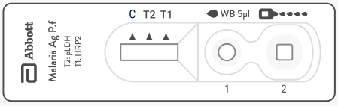
RDT cassettes with two test lines to detect P. falciparum HRP2 and pan-pLDH
Bioline Malaria Ag P.f/Pan  (Abbott, IL USA) [33] | Bioline Malaria Pf/Pan | Red/pink | 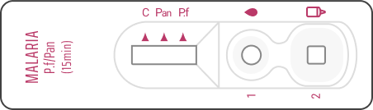
First Response Malaria Ag. pLDH/HRP2 Combo Card Test (Premier Medical Corporation Ltd, Gujarat, India)[34] | First Response Malaria Pf Ag (pLDH/HRP2) | Blue/purple | 