Production and characterization of transportation fuels from domestic plastic wastes and mixed virgin plastics by low- cost catalytic pyrolysis
Praveen Kumar Ghodkeª Krishna Moorthy^{b} Amit Kumar Sharma^{c}, Wei-Hsin Chen^{,d,e,f}
ªDepartment of Chemical Engineering, National Institute of Technology Calicut, Kozhikode, Kerala, India.
^{b}Department of Mechanical Engineering, University of Petroleum and Energy Studies (UPES), Dehradun, Uttarakhand, 248007, India.
^{c}Centre for Alternate Energy Research (CAER) and Department of Chemistry, University of Petroleum and Energy Studies (UPES), Dehradun, Uttarakhand, 248007, India.
^{d}Department of Aeronautics and Astronautics, National Cheng Kung University, Tainan 701, Taiwan
^{e} Research Center for Smart Sustainable Circular Economy, Tunghai University, Taichung 407, Taiwan
^{f} Department of Mechanical Engineering, National Chin-Yi University of Technology, Taichung 411, Taiwan

Corresponding author: Dr Amit Kumar Sharma, amit.orgchemistry@gmail.com, Mob. +91-9634800400

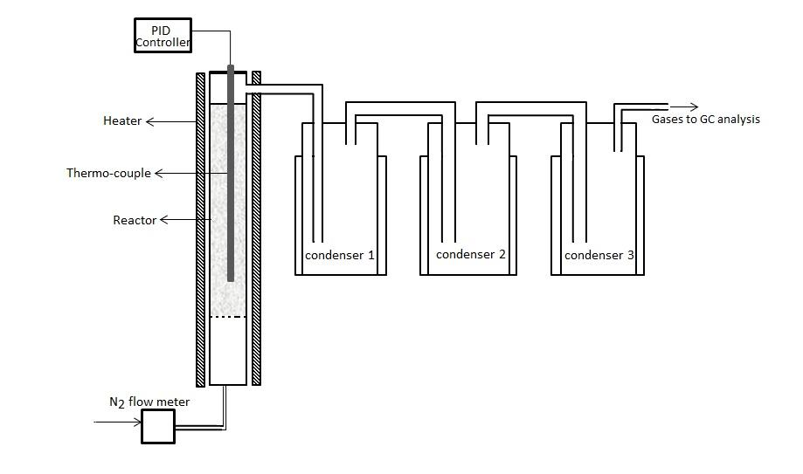
S1: Three-stage condensing system for liquid hydrocarbons production through pyrolysis

Mineral Composition | SiO₂ | Al₂O₃ | Fe₂O₃ | MgO | CaO | Na₂O | K₂O | MnO | TiO₂ | P₂O₅
Wt % | 0.3 | 0.48 | 0.04 | 0.03 | 0.02 | 0.07 | 0.01 | 0.02 | 0.01 | 0.02

S2: XRF analysis of catalysts

S3: FTIR of catalyst

S4: XRD pattern of catalyst

