Supplementary materials for Antonie van Leeuwenhoek

Kangiella shandongensis sp. nov., a novel species isolated from saltern in Yantai, China
Li-Yang Peng · Rui Yin · Shu-Kun Gao · Hui-Ning Jiang · Xiao-Xiao Liu · Yu Ma · Yan-Xia Zhou*
Marine College, Shandong University, Weihai, 264209, China

*Authors for correspondence: Yan-Xia Zhou
E-mail: zhouyx@sdu.edu.cn
Table S1. General features of strain PI^{T} genome.
Size (bp) | 2809662
G+C content | 45.8%
Gene number | 2653
Average Gene length (bp) | 951
tRNAs | 39
rRNAs | 3
sRNAs | 2
Type III secretion system | 103
Secondary metabolite | 2
Siderophore gene number | 12
Arylpolyene gene number | 49

Table S2. ANI, dDDH and AAI values between strain PI^{T} and neighbour type strains.
Genome | Accession | ANI (%) | dDDH (%) | AAI (%)
Kangiella shandongensis PI^{T} | JACNML000000000 | 100 | 100 | 100
Kangiella aquimarina SW-154^{T} | ARFE00000000 | 71.0 | 19.1 | 69.82
Kangiella sediminilitoris BB-Mw22^{T} | CP012418 | 76.9 | 19.8 | 83.86
Kangiella geojedonensis YCS-5^{T} | CP010975 | 74.6 | 18.5 | 79.76
Kangiella koreensis DSM 16069^{T} | CP001707 | 70.6 | 18.4 | 69.33
Kangiella profundi FT102^{T} | CP025120 | 71.1 | 19.1 | 69.61
Kangiella spongicola A79^{T} | QICH00000000 | 74.0 | 18.7 | 78.40
Kangiella taiwanensis KT1^{T} | JAHCLT000000000 | 74.6 | 18.7 | 79.68
Marinimicrobium agarilyticum M18^{T} | AUHU00000000 | 65.9 | 29.8 | 46.53
Saccharophagus degradans 2-40^{T} | CP000282 | 65.8 | 21.5 | 45.85
Motiliproteus coralliicola C34^{T} | QQOH00000000 | 66.3 | 34.4 | 47.37

Table S3. Types of antibiotics tolerated by strain PI^{T} and their related resistance gene clusters.
Antibiotic | Resistance Gene
glycopeptide | arlR, mtrA, vanRE, vanRF, vanHB, vanHA, vanHF, vanHD, vanHO, vanHM, vanRM, baeR, smeR, vanA, vanC, vanB, vanE, vanD, vanG, vanF, vanM, vanL, vanO, vanN, mtrA, adeR, vanRA, arlR, Escherichia coli CpxR, smeR, vanRI, vanRB, vanRC, vanRD, vanRG, CpxR, vanRL, vanRN, vanTN, vanTG, vanTE, vanTC, vanTrL
fluoroquinolone | Mfd, gyrA, parC
beta-lactam | mecC, mecB, NmcR, PBP2
isoniazid | katG
tetracycline | tetB(P), tetQ, tet44, tetT, tetW, tetS, tetM, otr(A), tet36, tet32
diaminopyrimidine | dfrE, dfrC, dfrD, dfrA26, dfrK, dfrA3, dfrG
sulfonamide | sul1, sul2, sul3
rifamycin | rphB, rphA
fosfomycin | murA
aminocoumarin | parY
mupirocin | ileS
aminoglycoside,glycopeptide | mtrA, baeR, vanRL, smeR, arlR, CpxR, vanRI, vanRA, vanRB, vanRC, vanRD, vanRE, vanRF, vanRG, kdpE, vanRM, vanRN
aminocoumarin,fluoroquinolone | gyrB, parY
lincosamide, linezolid, macrolide, phenicol, streptogramin | clbC, clbB, clbA, cipA, cfrA, cfrC
phenicol,streptogramin | catB7, catB6, catB3, catB2, catB9, catB8, vatC, vatB, vatA, vatF, vatE, vatD, vatI, vatH, catB

Kangiella spongicola A79^{T} (GU339304)
Kangiella taiwanensis KT1^{T} (JN559389)
Kangiella marina KM1^{T} (JN559388)
Kangiella geojedonensis YCS-5^{T} (HQ340606)
Kangiella japonica KMM 3899^{T} (AB505051)
Kangiella sediminilitoris BB-Mw22^{T} (JQ317935)
Kangiella shandongensis PI^{T} (MW407073)
Kangiella chungangensis CAU 1040^{T} (KP064189)
Kangiella koreensis SW-125^{T} (AY520560)
Kangiella aquimarina SW-154^{T} (AY520561)
Kangiella profundi FT102^{T} (KM209197)
Thiolapillus brandeum Hiromi 1^{T} (AP012273)
Aestuariirhabdus litorea GTF13^{T} (MH742310)
Saccharospirillum alexandrii LZ-5^{T} (MH197114)
Reinekea aestuarii IMCC 4489^{T} (AB682357)
Reinekea marina HME 8277^{T} (MT760288)
Marinobacterium lutimaris AN9^{T} (FJ230839)
Pseudohongiella spirulinae Ma-20^{T} (JX981925)
Motiliproteus sediminis HS6^{T} (KF953945)
Motiliproteus coralliicola C34^{T} (MH071780)
Neptunomonas antarctica S3-22^{T} (FJ713802)
Neptunomonas acidivorans MEBiC06243^{T} (JQ672629)
Neptuniibacter caesariensis MED92^{T} (AY136116)
Neptunomonas concharum LHW37^{T} (JF748732)
Neptunomonas qingdaonensis P10-2-4^{T} (JF747202)
Marinimicrobium agarilyticum M18^{T} (AY839870)
Marinimicrobium locisalis ISL-43^{T} (EU874388)
Teredinibacter waterburyi Bs02^{T} (MK938300)
Marinibactrum halimedae Q-192^{T} (AB900126)
Simiduia agarivorans SA1^{T} (EF617350)
Sinobacterium caligoides SCSWE24^{T} (HQ686140)
Saccharophagus degradans 2-40^{T} (AF063028)
Nitriliruptor alkaliphilus ANL-iso2^{T} (EF422408)
87
63
99
78
90
55
96
50
81
50
72
50
0.05

Fig. S1. Maximum-likelihood phylogenetic tree based on 16S rRNA gene sequences of strain PI^{T} and high similarity of genus. Bootstrap support values (1000 replications) above 50% are shown at nodes. The filled circles indicate that the corresponding node is also restored in the maximum likelihood tree. Nitriliruptor alkaliphilus ANL-iso2^{T} was used as an outgroup. Bar, 0.05 substitutions per nucleotide position.
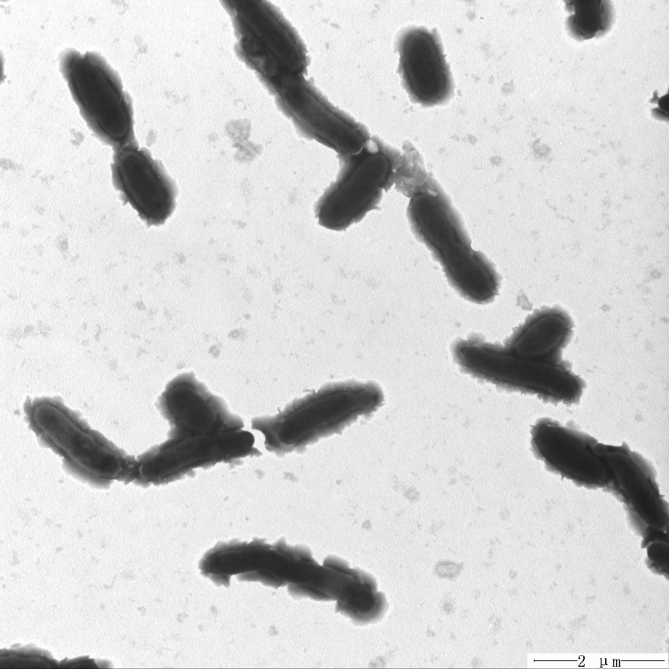
Fig. S2. After incubating the bacterium on MA at 30 ℃ for 3 days, cell morphology of strain PI^{T} was observed by an electron microscope. Bar, 2 μm.
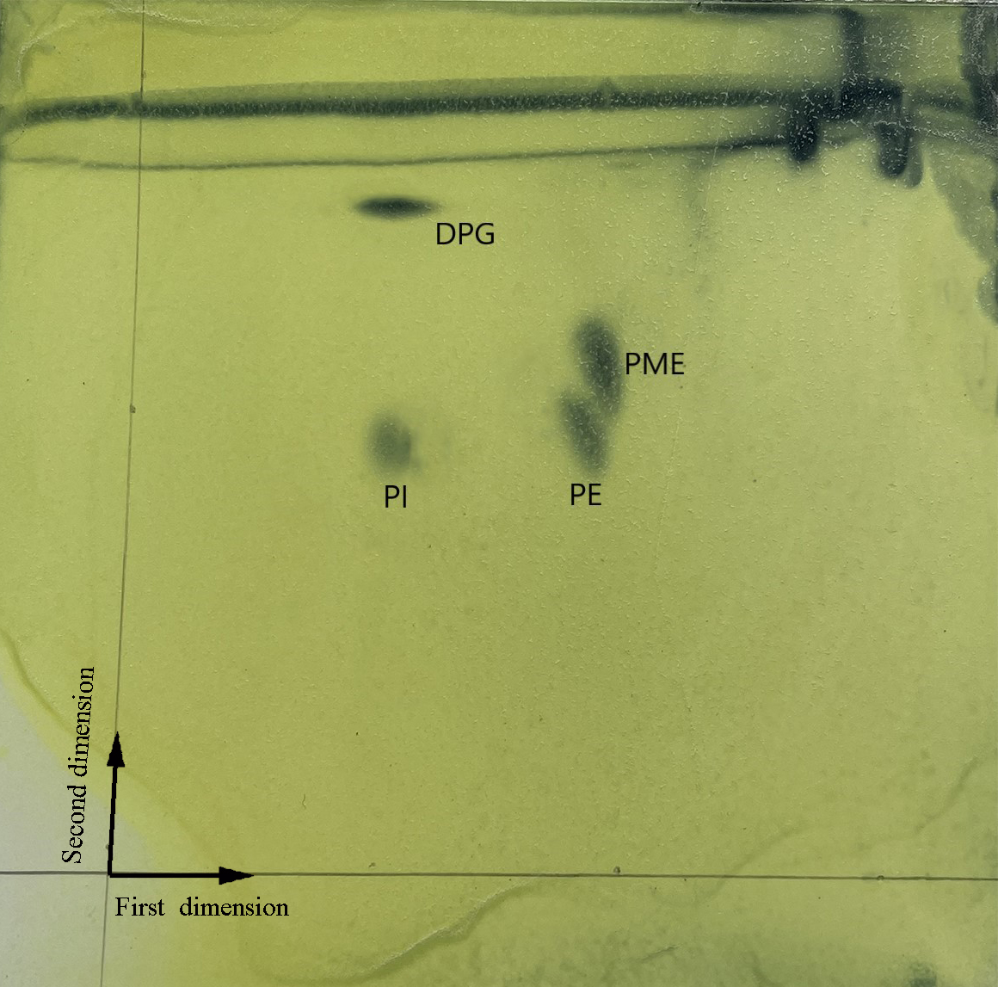

Fig. S3. Two-dimensional Thin Layer Chromatography (TLC) pattern of the total polar lipids from strain PI^{T}. Abbreviations: DPG, Diphosphatidylglycerol; PE, phosphatidylethanolamine; PME, pectin methylesterase; PI, phosphatidylinositol.

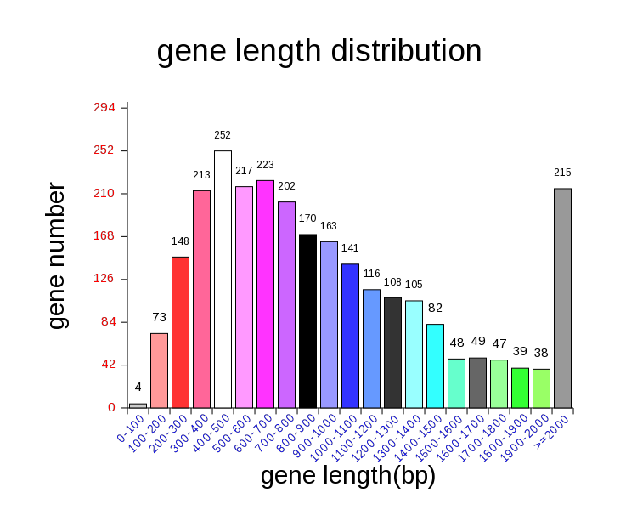
Fig. S4. The gene length distribution of strain PI^{T}, the abscissa is the window of different gene length distribution, and the ordinate is the number of genes whose length falls in the window interval.
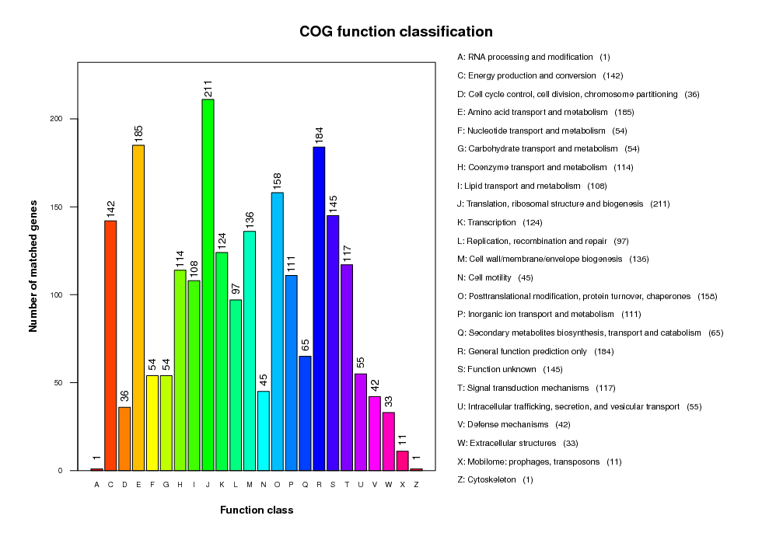
Fig. S5. The Cluster of Orthologous Groups of proteins (COG) of strain PI^{T}. The statistics of the number of genes in different COG classifications were presented.
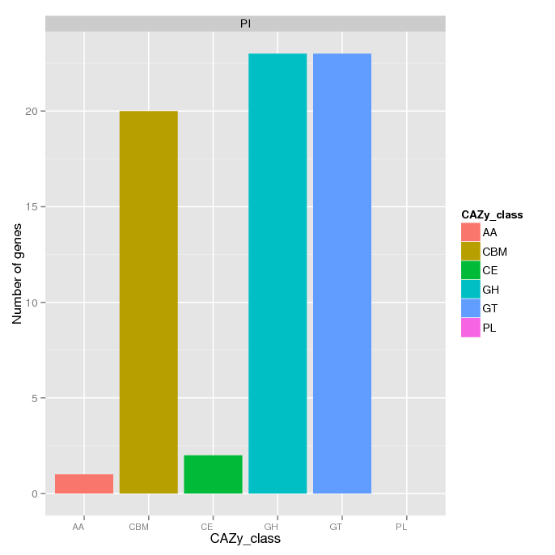
Fig. S6. Statistical diagram of the number of carbohydrate-active enzymes related genes of strain PI^{T}. Abbreviations: AA, Auxiliary Activitie; CBM, Carbohydrate-Binding Module; CE, Carbohydrate Esterase; GH, Glycoside Hydrolase; GT, GlycosylTransferase; PL, Polysaccharide Lyase.

