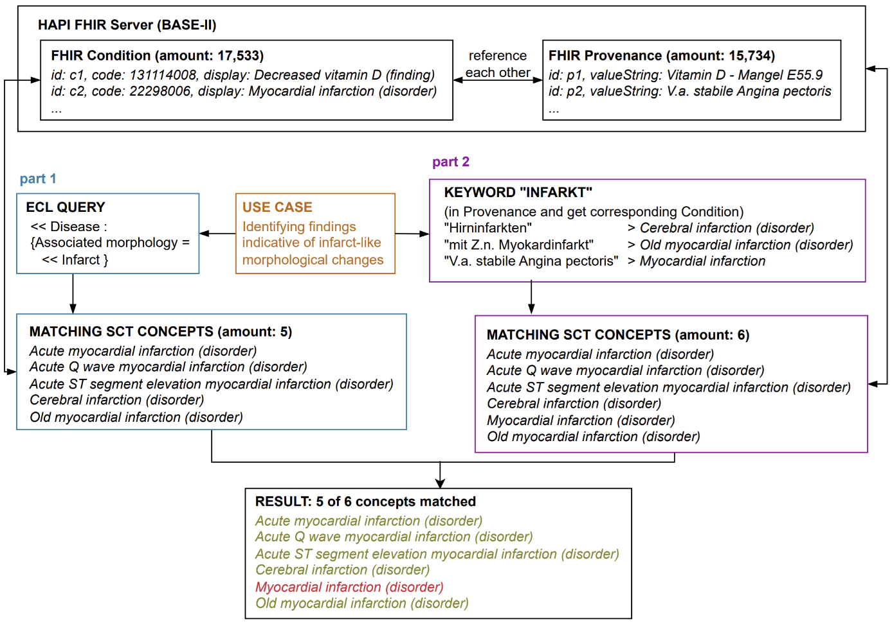
Figure 1. Comparison of Semantic and Keyword-Based Methods for Identifying Infarct-Associated Clinical Concepts in FHIR Data
Real-World Validation Using SNOMED CT-Coded FHIR Data

This figure illustrates two different approaches for identifying clinically relevant, infarct-associated conditions within a FHIR dataset (BASE-II) using SNOMED CT:
- Part 1 – Semantic Query (left):
A precisely formulated Expression Constraint Language (ECL) query leverages SNOMED CT relationships to extract disorders characterized by infarct-type morphological changes. This query yields five matching concepts.
- Part 2 – Keyword Search (right):
The keyword “Infarkt” (German for infarction) is searched within the textual content of Provenance entries. This method identifies six concepts in total.
- Conclusion:
Both methods identify five overlapping SNOMED CT concepts, including cerebral infarction. While the semantic ECL query ensures high precision, keyword-based extraction from narrative provenance text can uncover additional relevant conditions. Combining both approaches can improve completeness and accuracy in the identification of infarct-related clinical concepts from structured and unstructured healthcare data.

