SUPPLEMNTARY DESCRIPTION

Table S1. Serum IgG1, IgG2, IgG3, IgG4 concentrations and proportions of total IgG in pregnant women at different pregnancy stages
ID | Age | IgG_{total}(mg/mL) | IgG1(mg/mL) | IgG1/ IgG_{total} % | IgG2(mg/mL) | IgG2/ IgG_{total} % | IgG3(mg/mL) | IgG3/ IgG_{total} % | IgG4(mg/mL) | IgG4/ IgG_{total} %
NP | 32 | 14.3 | 6.97 | 48.74% | 5.94 | 41.54% | 0.56 | 3.92% | 0.83 | 5.80%
NP | 31 | 13.45 | 6.71 | 49.89% | 5.38 | 40.00% | 0.49 | 3.64% | 0.87 | 6.47%
NP | 29 | 15.73 | 8.72 | 55.44% | 5.61 | 35.66% | 0.63 | 4.01% | 0.77 | 4.90%
2W | 30 | 14 | 6.84 | 48.86% | 5.01 | 35.79% | 0.51 | 3.64% | 1.64 | 11.71%
2W | 29 | 14.92 | 6.37 | 42.69% | 6.58 | 44.10% | 0.73 | 4.89% | 1.24 | 8.31%
2W | 39 | 14.69 | 8.65 | 58.88% | 4.83 | 32.88% | 0.51 | 3.47% | 0.7 | 4.77%
2W | 37 | 11.46 | 5.71 | 49.83% | 4.69 | 40.92% | 0.55 | 4.80% | 0.51 | 4.45%
2W | 35 | 15.33 | 7.21 | 47.03% | 6.46 | 42.14% | 0.95 | 6.20% | 0.71 | 4.63%
2W | 30 | 13.23 | 7.12 | 53.82% | 5.07 | 38.32% | 0.3 | 2.27% | 0.74 | 5.59%
12W | 23 | 6.99 | 4.1 | 58.66% | 1.96 | 28.04% | 0.36 | 5.15% | 0.57 | 8.15%
12W | 28 | 8.89 | 4.61 | 51.86% | 2.93 | 32.96% | 0.21 | 2.36% | 1.14 | 12.82%
12W | 25 | 10.9 | 5.23 | 47.98% | 4.48 | 41.10% | 0.56 | 5.14% | 0.63 | 5.78%
12W | 24 | 9.92 | 5.11 | 51.51% | 3.74 | 37.70% | 0.44 | 4.44% | 0.63 | 6.35%
12W | 25 | 9.39 | 5.56 | 59.21% | 2.67 | 28.43% | 0.36 | 3.83% | 0.8 | 8.52%
12W | 28 | 10.64 | 6.26 | 58.83% | 2.77 | 26.03% | 0.52 | 4.89% | 1.09 | 10.24%
12W | 29 | 8.22 | 4.74 | 57.66% | 2.44 | 29.68% | 0.43 | 5.23% | 0.61 | 7.42%
24W | 27 | 11.15 | 6.2 | 55.61% | 3.99 | 35.78% | 0.48 | 4.30% | 0.48 | 4.30%
24W | 25 | 11.22 | 6.71 | 59.80% | 3.67 | 32.71% | 0.53 | 4.72% | 0.31 | 2.76%
24W | 26 | 11.79 | 6.39 | 54.20% | 4.64 | 39.36% | 0.45 | 3.82% | 0.31 | 2.63%
24W | 22 | 9.94 | 6.13 | 61.67% | 3.19 | 32.09% | 0.4 | 4.02% | 0.22 | 2.21%
24W | 27 | 11.08 | 5.77 | 52.08% | 4.44 | 40.07% | 0.64 | 5.78% | 0.23 | 2.08%
24W | 25 | 8.36 | 4.92 | 58.85% | 2.76 | 33.01% | 0.32 | 3.83% | 0.36 | 4.31%
24W | 26 | 13.06 | 7.34 | 56.20% | 4.7 | 35.99% | 0.73 | 5.59% | 0.29 | 2.22%
37W | 34 | 9.8 | 4.79 | 48.88% | 4.24 | 43.27% | 0.43 | 4.39% | 0.34 | 3.47%
37W | 37 | 12.33 | 7.62 | 61.80% | 3.66 | 29.68% | 0.49 | 3.97% | 0.56 | 4.54%
37W | 28 | 9.93 | 5.72 | 57.60% | 2.99 | 30.11% | 0.23 | 2.32% | 0.99 | 9.97%
37W | 30 | 11.86 | 6.9 | 58.18% | 3.79 | 31.96% | 0.52 | 4.38% | 0.65 | 5.48%
37W | 29 | 14.49 | 7.51 | 51.83% | 5.85 | 40.37% | 0.58 | 4.00% | 0.55 | 3.80%
37W | 25 | 11 | 6.38 | 58.00% | 4.01 | 36.45% | 0.24 | 2.18% | 0.37 | 3.36%
37W | 25 | 11.67 | 6.53 | 55.96% | 3.48 | 29.82% | 0.99 | 8.48% | 0.67 | 5.74%
Caption：IgG1, IgG2, IgG3, IgG4, and their ratio to total IgG (IgG_{total}) were measured in the serum of 30 pregnant women at different time during pregnancy（the raw data of Fig3）. Divided into five groups in total， Group 1 (n=3). NP: Non-pregnancy (healthy non-pregnant women). Group 2 (n=6). 2W: (naturally pregnant women at 2 weeks of gestation). Group 3 (n=7). 12W: (naturally pregnant women at 12 weeks of gestation). Group 4 (n=7). 24W: (naturally pregnant women at 24 weeks of gestation). Group 5 (n=7). 37W: (naturally pregnant women at 37weeks of gestation).

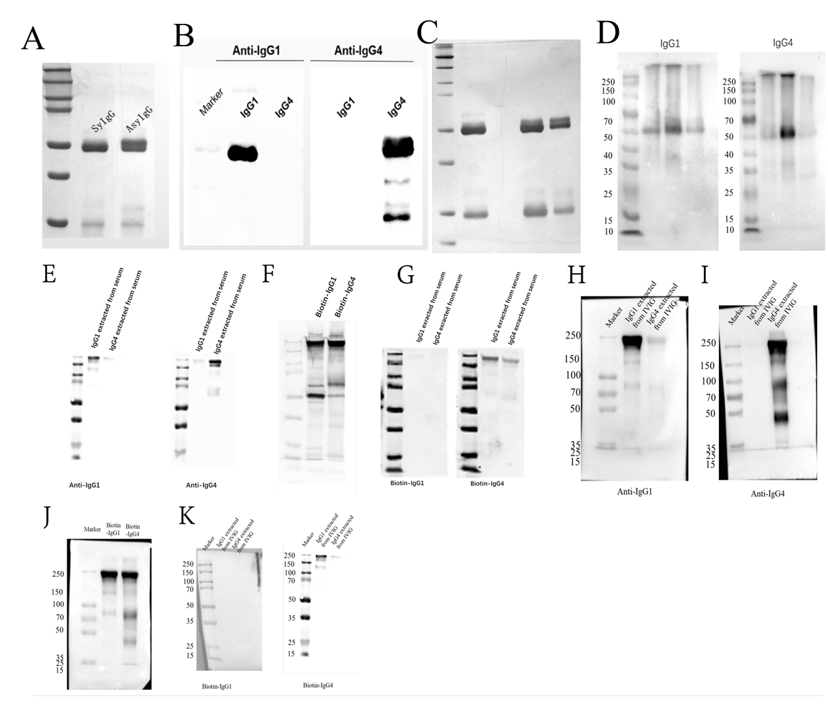
FIGURE S1. Western blot and silver staining original image data
A, Original image data for Fig 1D. B, Original image data for Fig 1D. C, Original image data for Fig 1C. D, Original image data for Fig 4A and 4B. E, Original image data for Fig 5A and 5B. F, Original image data for Fig 5C. G, Original image data for Fig5D and E. H, Original image data for Fig 6A. 1, Original image data for Fig 6B. 1. Original image data for Fig 6C. K. Original image data for Fig 6D and 6E.

