FGFR gene amplification and response to HER2-targeted therapy in patients with HER2-expressing metastatic breast cancer

Diana Jaber,^{1*} Yangruijue Ma,² Sarah Marini,¹ Natalie K. Heater,¹ Surbhi Warrior,^{1,3} Regina Stein,^{1,3} Lisa Flaum,^{1,3} Patricia Robinson,^{1,3} Huiping Liu,^{1,3} Claudia Tellez,^{1,3} Ami Shah,^{1,3} Massimo Cristofanilli,⁴ Youbin Zhang,^{1,3} Leonidas C. Platanias,^{1,3} Qiang Zhang,^{1,3} Zequn Sun,² William Gradishar,^{1,3} Janice Lu^{1,3}

¹ Department of Medicine, McGaw Medical Center of Northwestern University, Chicago, Illinois, USA
² Department of Preventive Medicine, Biostatistics and Informative Division, Northwestern University, Chicago, Illinois, USA
³ Division of Hematology/Oncology, Robert H. Lurie Comprehensive Cancer Center of Northwestern University, Chicago, Illinois, USA
⁴ Division of Hematology/Oncology, Weill Cornell Medicine, New York, New York, USA

*Corresponding Author:
Diana Jaber, MD
Department of Medicine
McGaw Medical Center of Northwestern University
676 North Saint Clair Street
Suite #2330
Chicago, IL
60611
Phone: 312-926-2000
Email: diana.jaber@northwestern.edu (email)
ORCID: 0009-0008-7288-6820

This document contains supplementary material for the above manuscript.

Supplementary Fig. S1 Overall survival swimmer plot by FGFR status
Swimmer plot illustrating overall survival from the time of metastatic breast cancer diagnosis, stratified by FGFR amplification status. Each horizontal bar represents an individual patient, with FGFR wild-type (WT) shown in red and FGFR-amplified (FGFR+) in blue. FGFR+ patients demonstrated shorter survival durations and earlier mortality events compared to WT patients
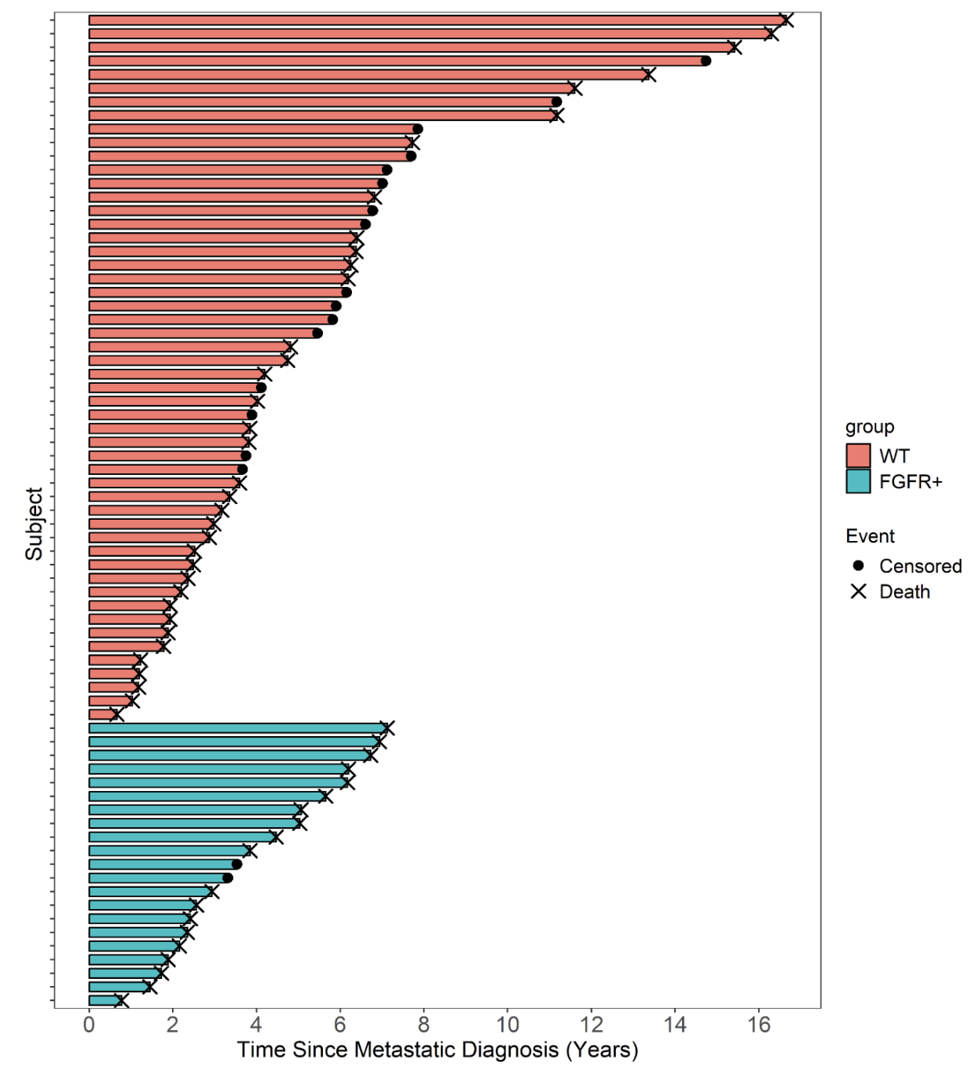

Supplementary Fig. S2 Multivariate analysis of progression-free survival on 1st–2nd line HER2-targeted therapy following FGFR detection
Multivariate Cox proportional hazards model evaluating the association of FGFR amplification and clinical covariates with progression-free survival on 1st–2nd line HER2-targeted therapy (low treatment burden) following FGFR detection. Hazard ratios (HRs) and 95% confidence intervals (CIs) are shown. FGFR-amplified (FGFR+) patients had significantly higher risk of progression compared to FGFR wild-type (WT) (HR = 6.27, p = 0.005). Global model p = 0.03. ER, estrogen receptor; PR, progesterone receptor

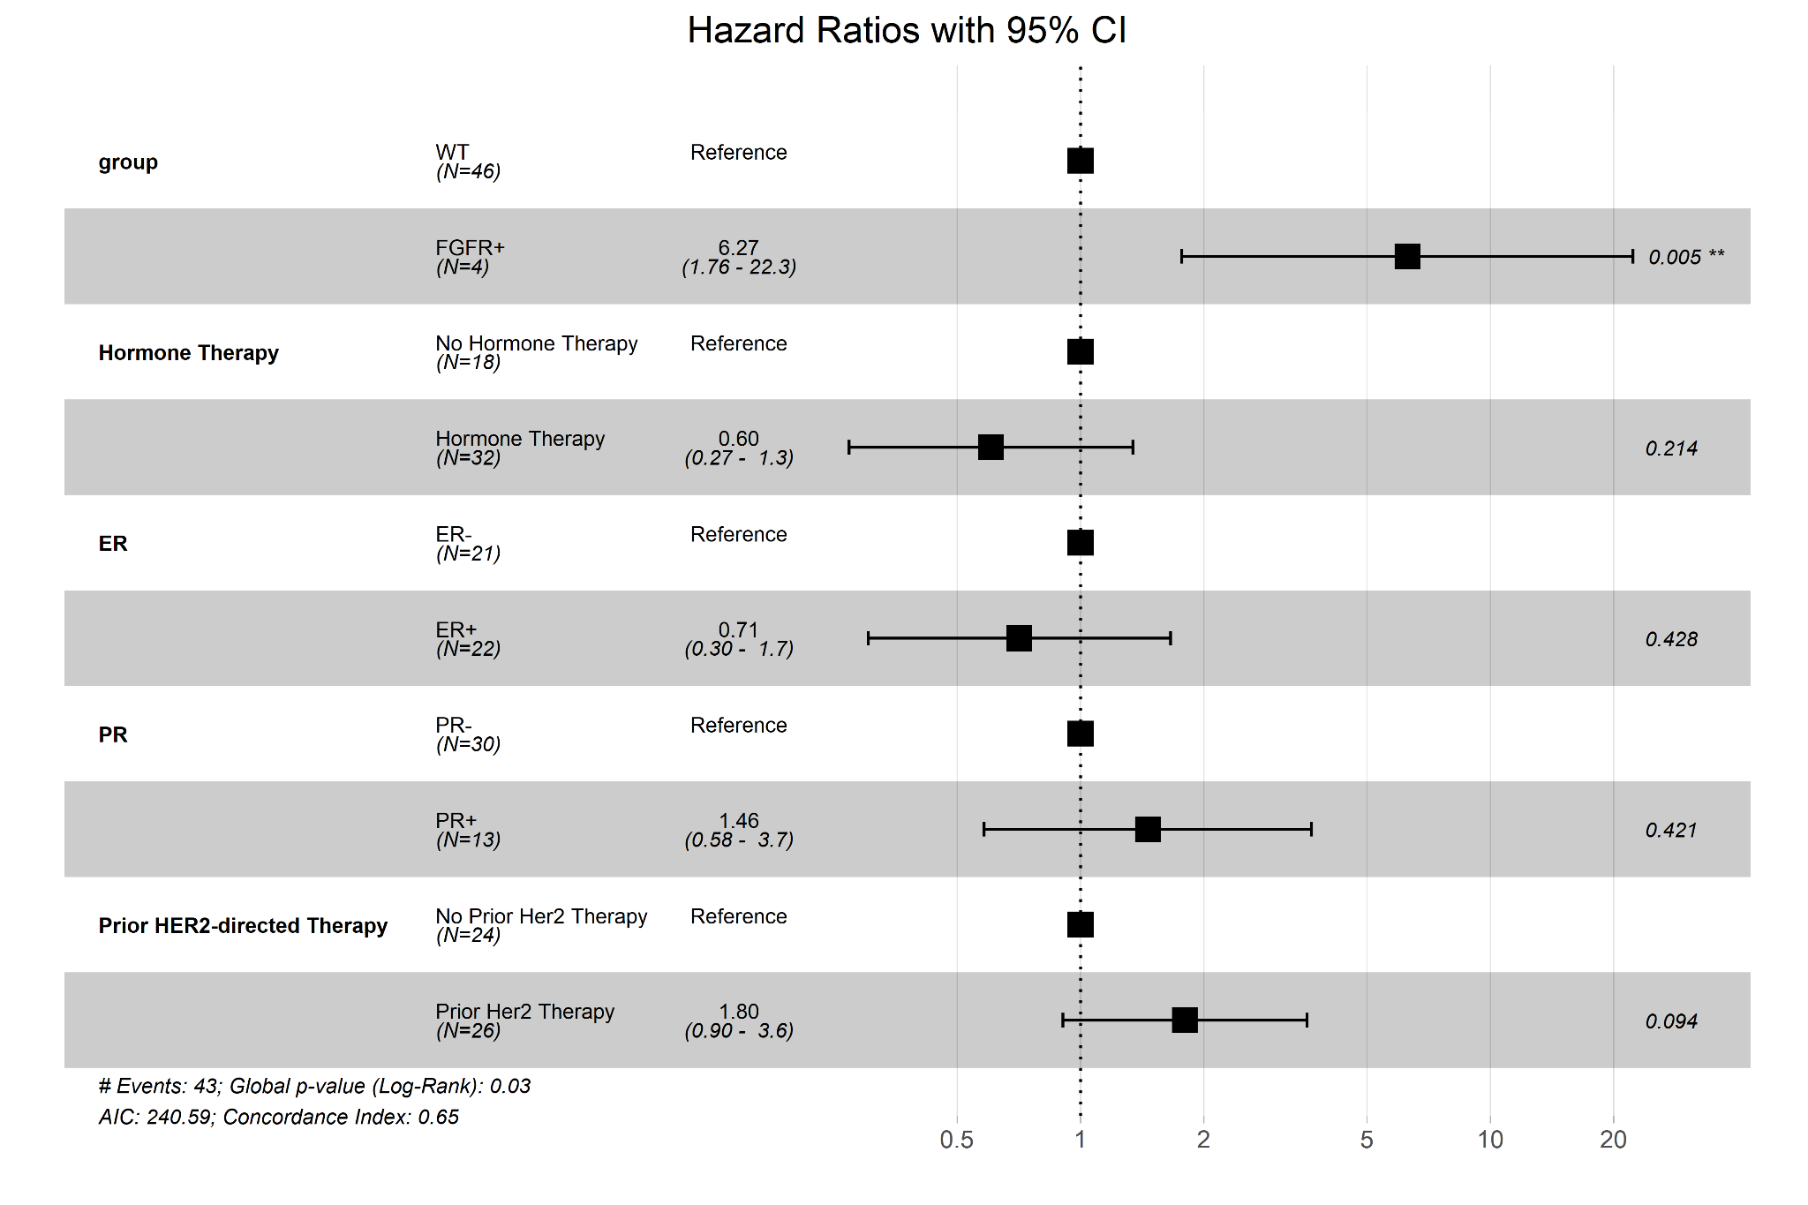

Supplementary Fig. S3 Multivariate analysis of progression-free survival on 3rd–4th line HER2-targeted therapy following FGFR detection
Multivariate Cox proportional hazards model evaluating the association of FGFR amplification and clinical covariates with progression-free survival on 3rd–4th line HER2-targeted therapy (moderate treatment burden) following FGFR detection. Hazard ratios (HRs) and 95% confidence intervals (CIs) are shown. FGFR-amplified (FGFR+) patients had significantly higher risk of progression compared to FGFR wild-type (WT) (HR = 3.41, p = 0.008). Global model p = 0.05. ER, estrogen receptor; PR, progesterone receptor

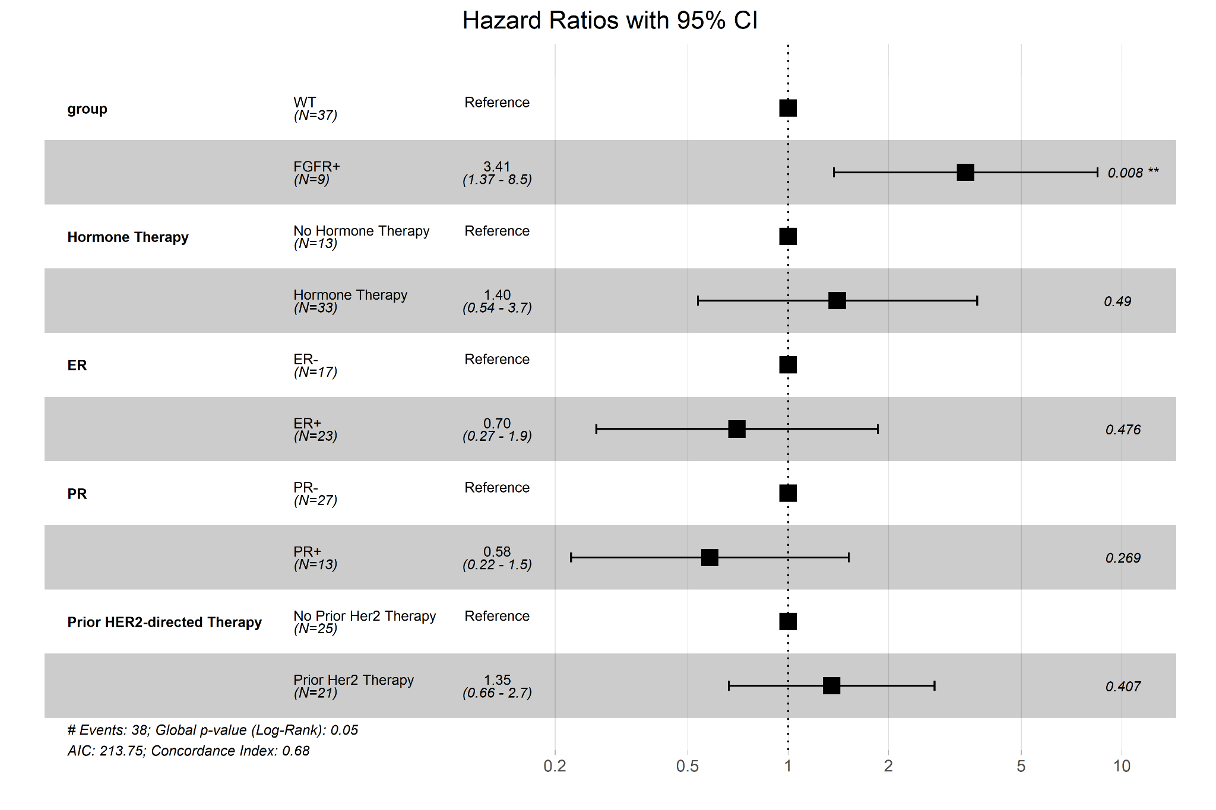

Supplementary Fig. S4 Multivariate analysis of progression-free survival on ≥5th line HER2-targeted therapy following FGFR detection
Multivariate Cox proportional hazards model evaluating the association of FGFR amplification and clinical covariates with progression-free survival on 5th line or later HER2-targeted therapy (high treatment burden) following FGFR detection. Hazard ratios (HRs) and 95% confidence intervals (CIs) are shown. FGFR-amplified (FGFR+) patients had significantly higher risk of progression compared to FGFR wild-type (WT) (HR = 13.38, p < 0.001). Global model p < 0.001. ER, estrogen receptor; PR, progesterone receptor

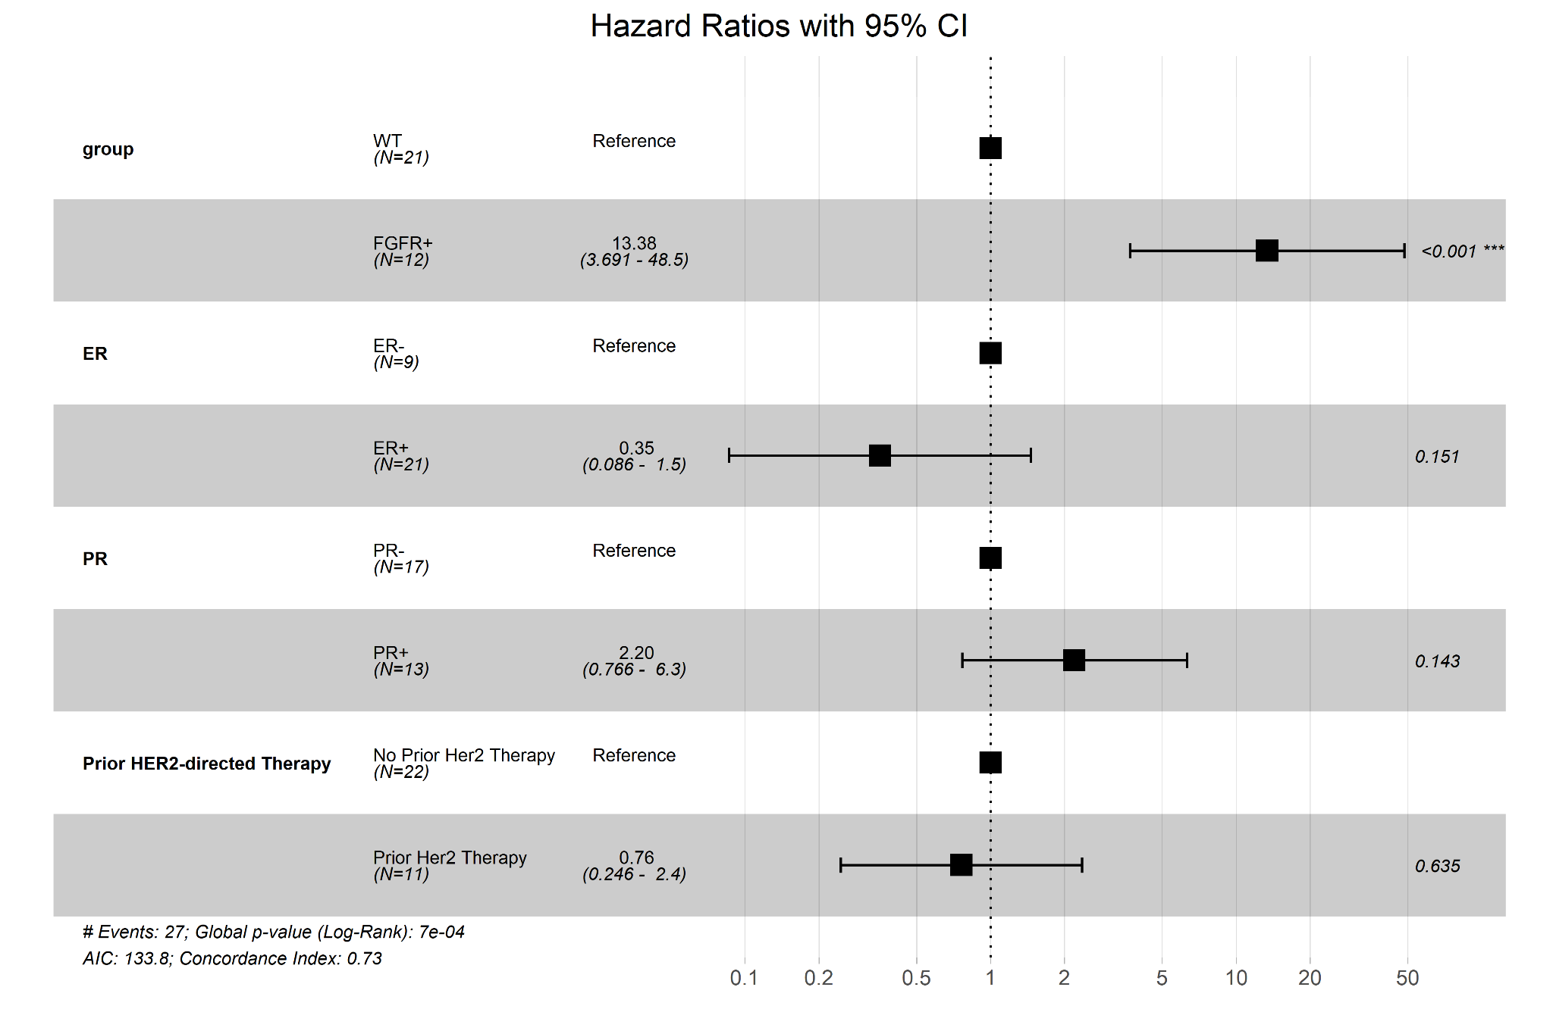

Supplementary Fig. S5 Multivariate analysis of progression-free survival on 1st–2nd line HER2-targeted therapy prior to FGFR detection
Multivariate Cox proportional hazards model evaluating the association of FGFR amplification and clinical covariates with progression-free survival on 1st–2nd line HER2-targeted therapy (low treatment burden) prior to FGFR detection. Hazard ratios (HRs) and 95% confidence intervals (CIs) are shown. FGFR-amplified (FGFR+) patients had significantly higher risk of progression compared to FGFR wild-type (WT) (HR = 4.03, p = 0.025). Global model p = 0.06. ER, estrogen receptor; PR, progesterone receptor

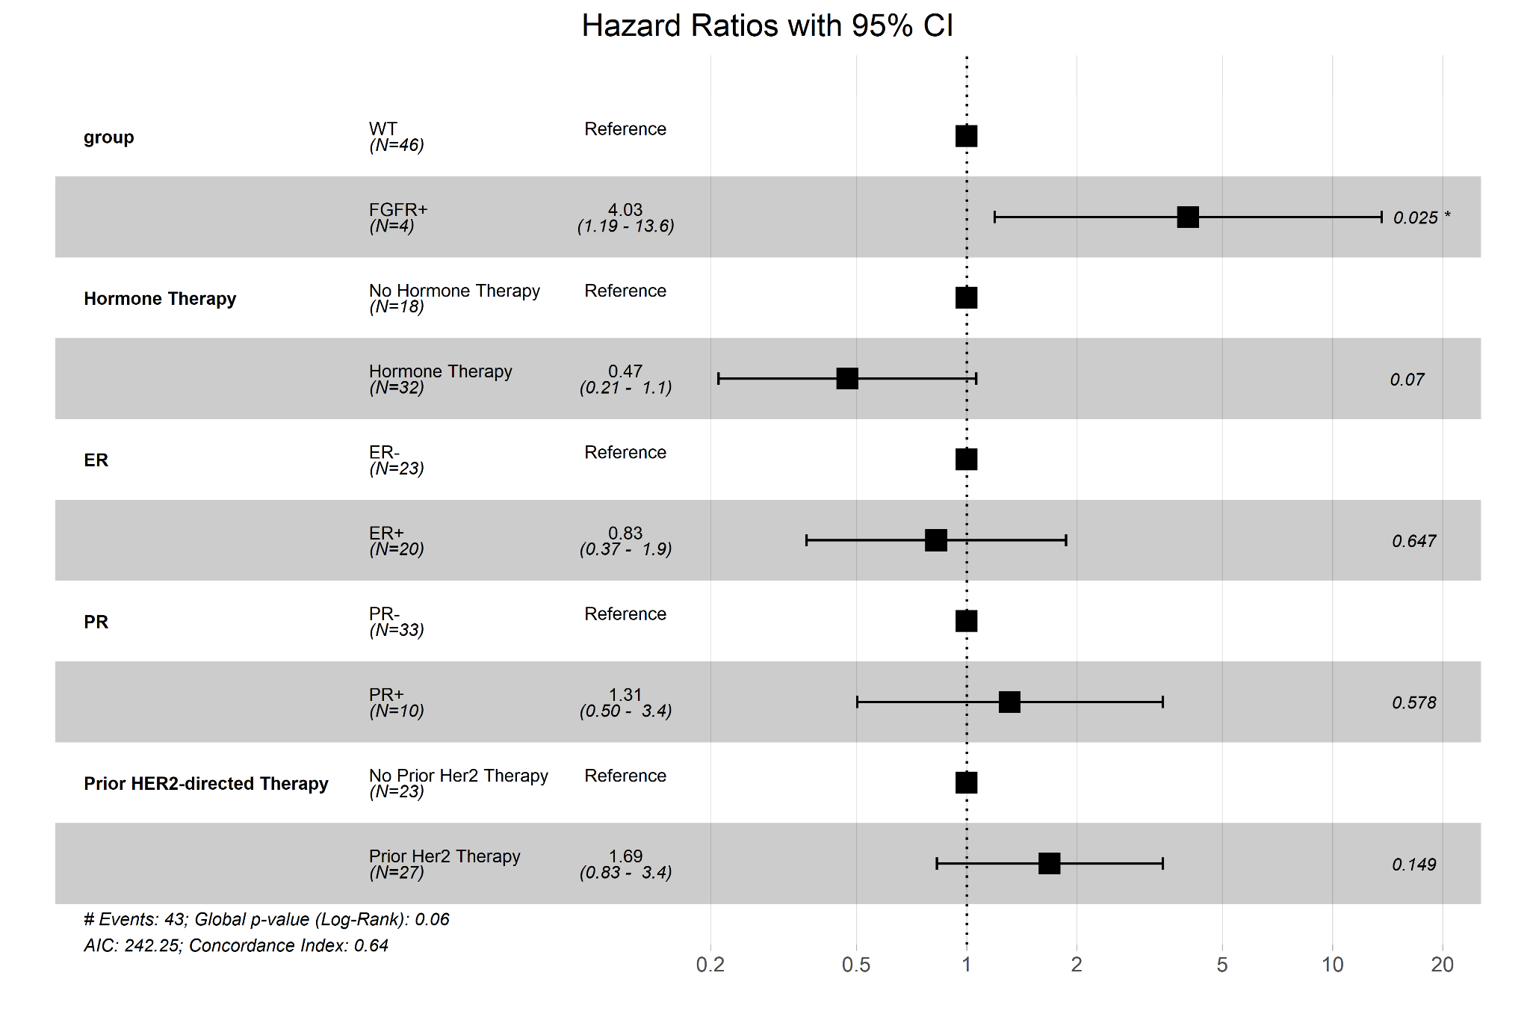

Supplementary Fig. S6 Multivariate analysis of progression-free survival on ≥3rd line HER2-targeted therapy prior to FGFR detection
Multivariate Cox proportional hazards model evaluating the association of FGFR amplification and clinical covariates with progression-free survival on 3rd line or later HER2-targeted therapy (moderate-to-high treatment burden) prior to FGFR detection. Hazard ratios (HRs) and 95% confidence intervals (CIs) are shown. FGFR-amplified (FGFR+) patients had significantly higher risk of progression compared to FGFR wild-type (WT) (HR = 2.95, p = 0.046). Global model p = 0.09. ER, estrogen receptor; PR, progesterone receptor
