Kinematics and Kinetics
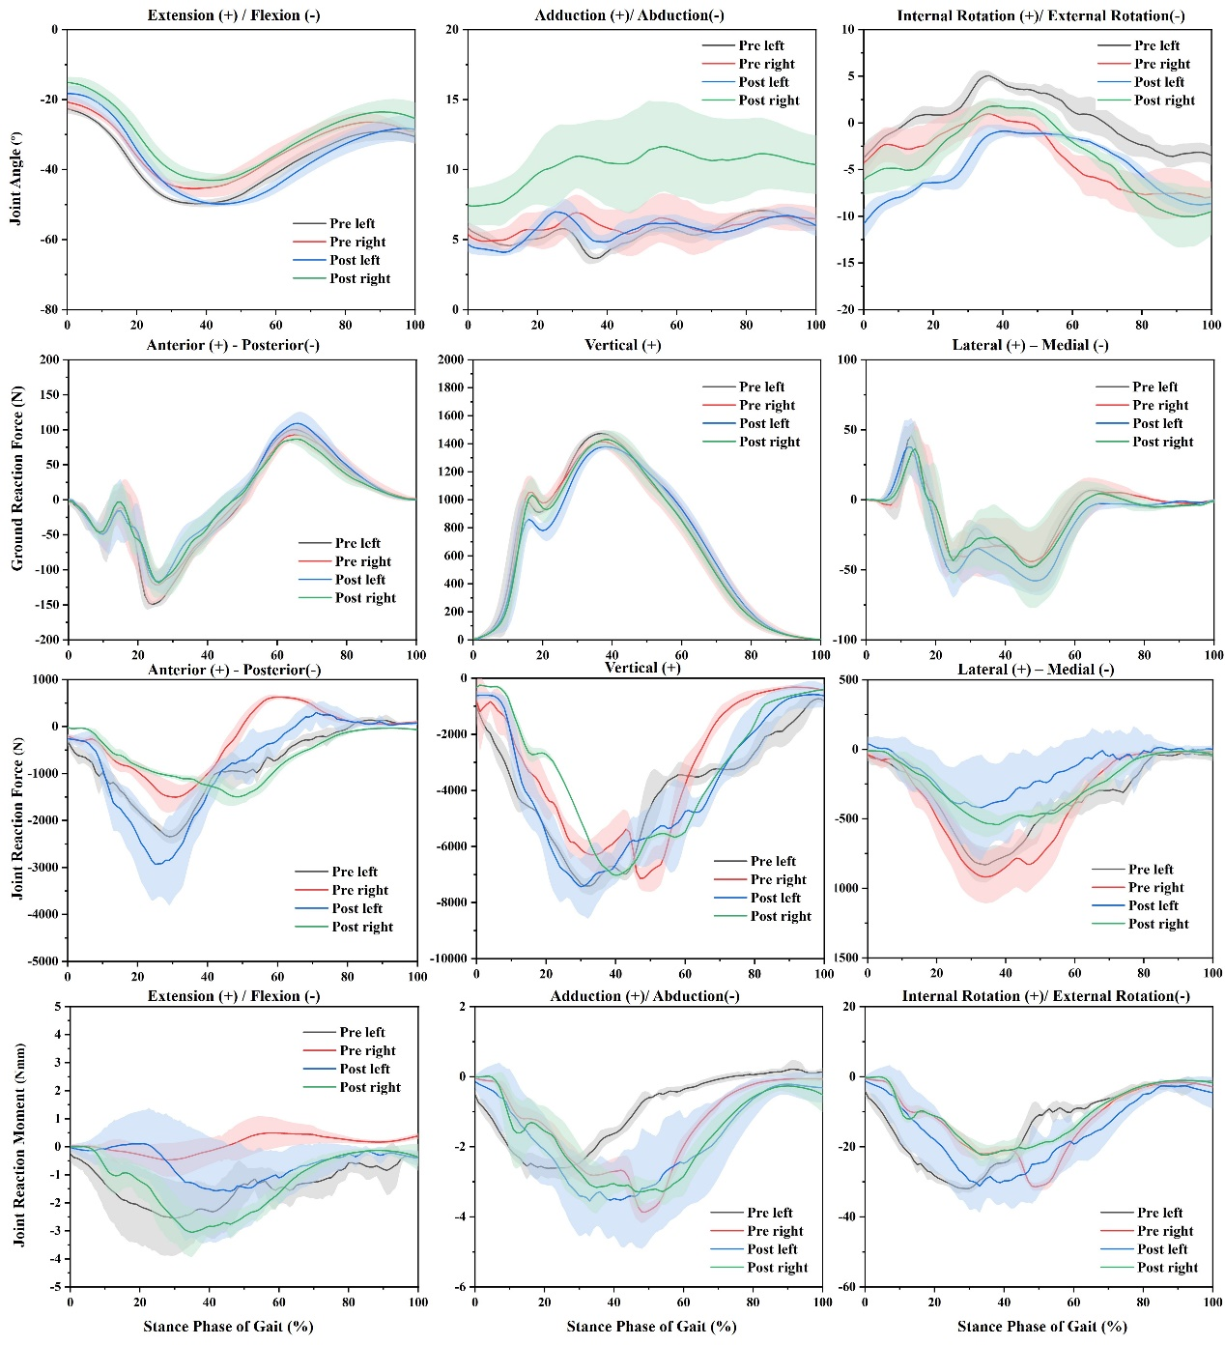
Figure A1. Knee joint angles, ground reaction forces, joint reaction forces and joint reaction moments calculated from experimental and musculoskeletal models during running gait. Note: Pre left: Non-dominant leg before 10km running. Pre right: Dominant leg before 10km running. Post left: Non-dominant leg after 10km running, Post right: Dominant leg after 10km running.

Statistical analysis of Kinematics and Kinetics
Statistical scrutiny of the null hypothesis, which posited no variance in one-dimensional biomechanical data between different limbs, was conducted on the entire time series. Statistical Parametric Mapping (SPM1d) was utilized for this analysis in Python 3.8. The residuals' normality and homogeneity were assessed, adhering to the analytical variance (ANOVA) principles. A two-way repeated-measures ANOVA (limb × fatigue) probed for differences between groups (dominant limb versus non-dominant limb) and investigated potential interactions between the group and the 10 km run. Subsequent post-hoc paired t-tests were performed for individual condition comparisons. The significance level for all statistical tests was set a priori to 0.05.

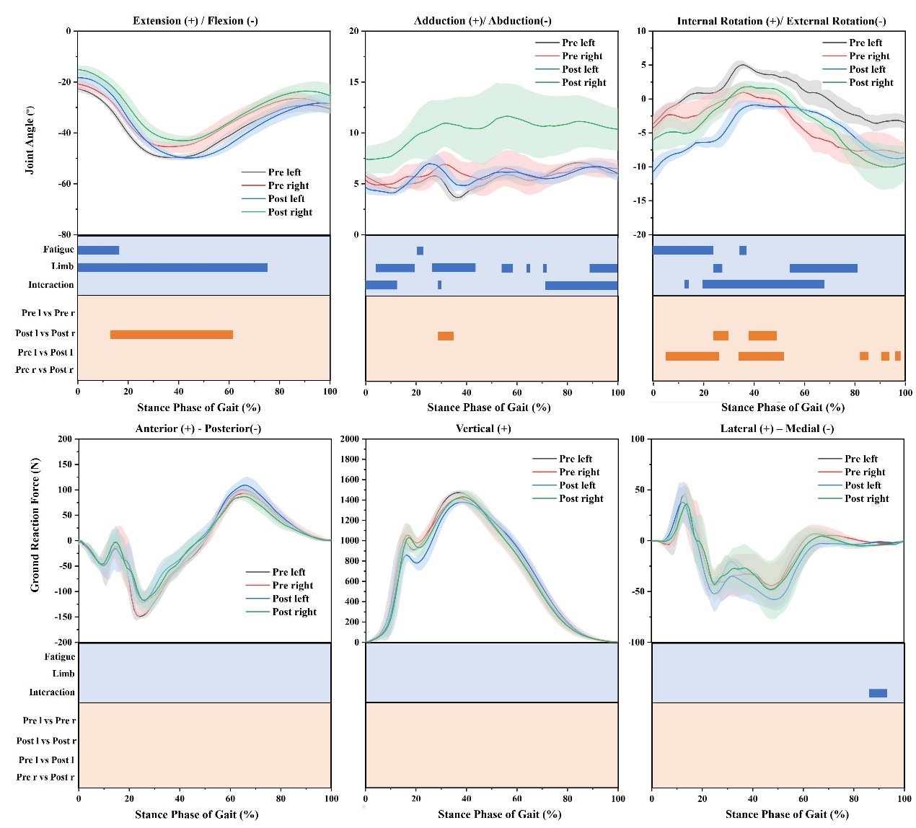

Figure A2. Repeated-measures ANOVA and post hoc test analysis for one-dimensional joint angles and ground reaction forces. Note: Pre left: left leg before 10km running. Pre right: right leg before 10km running. Post left: left leg after 10km running. Post right: right leg after 10km running. The blue padding is the corresponding area of repeated measures of ANOVA significance. The orange fill is the corresponding area of post-test significance.

Figure A2 shows no fatigue-limb interaction effects were observed for the knee joint angle in the sagittal plane during the stance phase of the gait cycle. However, interaction effects were noted in the coronal (from initial contact to 13% of the stance phase, 28-30%, and terminal 72-100%) and horizontal planes (13-15% and mid-stance 20-68%). The main effects for fatigue and limb were apparent at the knee, where increases in extension were seen from initial contact to 16% and throughout the entire stance phase up to 75%, respectively. Post hoc analyses revealed that the right limb demonstrated a more significant extension than the left during 13-62% of the stance phase. In addition, main effects for fatigue were observed at the knee, with adduction increasing between 20-22% of the stance phase, and for the limb, an increase in adduction was noted at 4-20%, 26-44%, 53-58%, 62-66%, 70-72%, and 88-100% of the stance phase. Post hoc analyses indicated that the right limb experienced significantly more adduction than the left during 28-36% of the stance phase. Moreover, the main effects for fatigue at the knee showed an increase in external rotation from the start of the stance phase to 25% and again at 33-36%, and for the limb, an increase in external rotation was observed at 24-28% and 55-82% of the stance phase. Post hoc results showed that the right limb exhibited a significantly greater internal rotation after running-induced fatigue than the left during 24-30% and 54-81% of the stance phase. Significant increases in external rotation of the left knee were recorded post-fatigue (p< 0.05). Additionally, ground reaction force (GRF) interaction effects due to fatigue and limb were present in the horizontal planes during 86-94% of the stance phase.

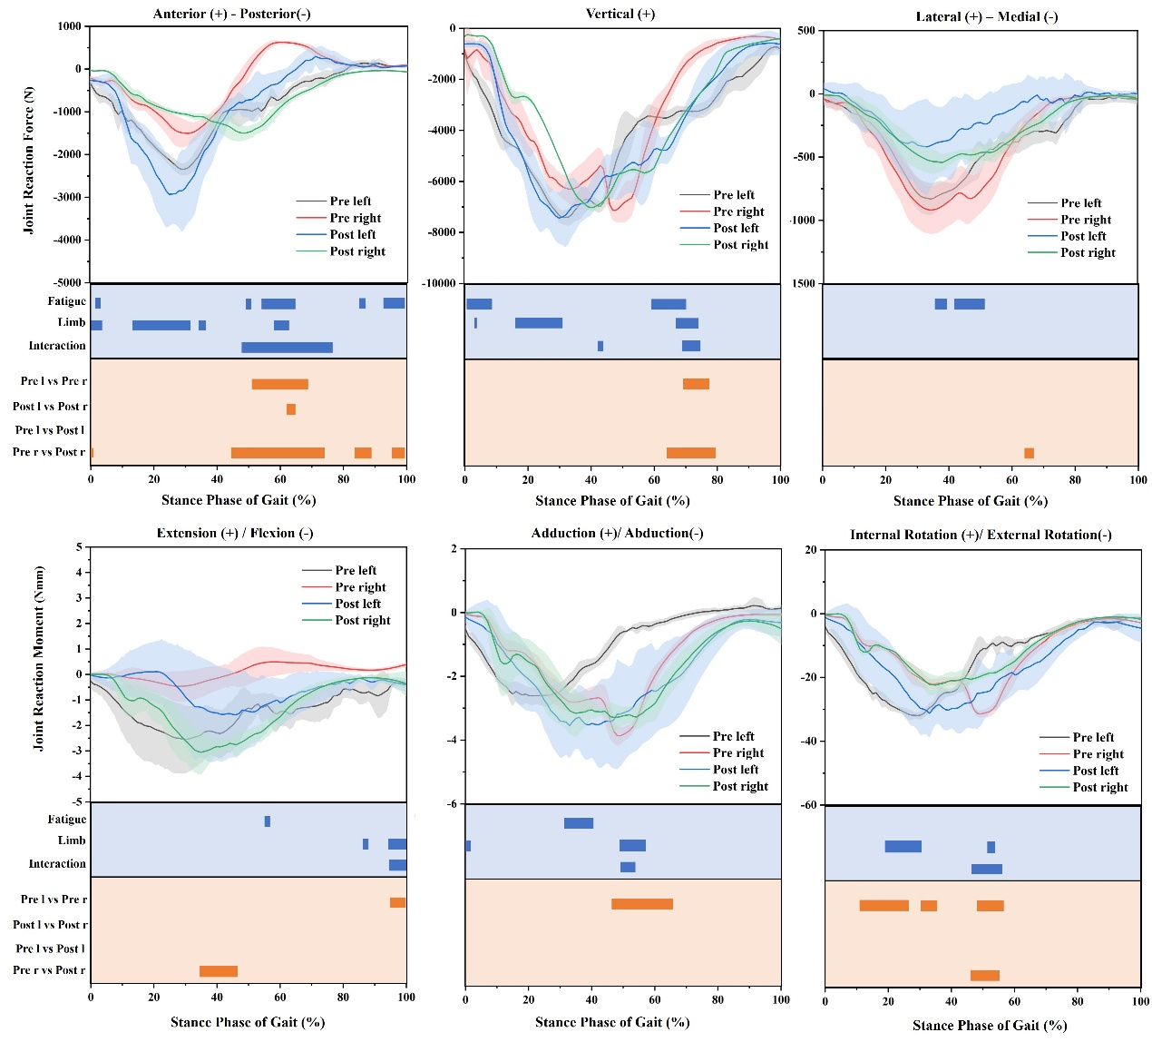
Figure A3. The Spm results of Repeated-measures ANOVA and post hoc tests of knee joint reaction force and joint reaction moment. Note: Pre left: Left leg before 10km running. Pre right: Right leg before 10km running. Post left: Left leg after 10km running. Post right: Right leg after 10km running. The blue padding is the corresponding area of repeated measure of ANOVA significance. The orange fill is the corresponding area of post-test significance.

As depicted in A2, fatigue and limb interaction effects were observed for the knee joint reaction force in the sagittal (48-77%) and coronal planes (41-43% and 68-75%). A main effect of fatigue was noted where the knee joint reaction force increased at 1-2% and decreased at 49-51%, 54-65%, 86-87%, and 93-100% in the anterior direction. An increase in knee joint reaction force was recorded for limb effects at 0-4%, 14-32%, 34-36%, and 58-63% in the anterior direction. Post hoc analysis revealed that, before the 10 km run, the right limb's anterior direction reaction force increased significantly more than the left within the 13-62% range. After the 10 km run, the right limb's posterior direction reaction force was higher than the left's at 62-65%. Additionally, a decrease in the right joint reaction force at 0-1% and a significant increase at 44-47%, 84-89%, and 96-100% in the posterior direction were observed after the 10 km run. Fatigue effects were evident in the vertical knee joint reaction force, which decreased at 1-9% and increased at 59-70%. Limb effects caused an increase in the vertical knee joint reaction force at 2-3%, 16-31%, and 66-73%. Before fatigue, the vertical reaction force of the right knee joint was significantly lower than that of the left, at 69-78%. Post fatigue, the right knee joint's vertical reaction force significantly increased. In the lateral direction, fatigue increased the knee joint reaction force at 35-39% and 41-46%. Post fatigue, the medial direction reaction force of the right knee joint significantly increased.
Furthermore, interaction effects between fatigue and limb were observed for the knee joint reaction force in the sagittal (95-100%), coronal (50-54%), and horizontal planes (57-67%). A main effect of fatigue at the knee was noted, where flexion and abduction increased within the 55-57% and 31-41% ranges, respectively. A main effect for the limb at the knee was observed, with increases in flexion during the 86-88% and 94-100% ranges and in abduction at 0-2%. A significant increase in abduction for limb at the knee was also noted within the 49-57% range. Moreover, a main effect for the limb at the knee was seen with an increase in internal rotation within the 19-31% and 51-54% ranges. Prior to the 10km run, the left knee joint's reaction to flexion moment was significantly higher than that of the right, within the 95-100% range. Post-10km run, a significant increase in the right knee's joint reaction to flexion moment was detected. Additionally, a higher abduction knee joint reaction moment was observed on the right side within the 46-66% range. Significant external rotation joint reaction moments for the left knee were observed in the 11-27% and 30-36% ranges compared to the right knee before the 10km run, while significant internal rotation was observed in the left knee compared to the right within the 49-58% range. Furthermore, after the 10km run, the reaction of the right knee joint to the external rotation moment decreased.

knee joint loads
Table A1. Summary of loads applied to the knee joint at five typical moments in a stance phase of gait.
Gait (%) | Angle (°) | Force(N) |  |  | Moment (Nmm)
Gait (%) | Angle (°) | Fx | Fy | Fz | Mx | My | Mz
Pre left
Initial contact | -22.63 | -307.01 | -1000.21 | -41.05 | -0.27 | -0.52 | -4.14
First Peak | -33.17 | -1367.24 | -4674.43 | -228.66 | -1.89 | -2.55 | -25.10
Mid-stance | -37.44 | -1628.87 | -5498.92 | -315.23 | -2.03 | -2.58 | -26.96
Second Peak | -49.71 | -1673.34 | -6575.96 | -798.51 | -2.22 | -1.76 | -25.23
Toe off | -30.63 | 94.03 | -1106.56 | -48.22 | -0.4 | 0.14 | -1.40
Pre right
Initial contact | -20.71 | -208.69 | -814.29 | -39.31 | 0.22 | -0.05 | -0.51
First Peak | -30.77 | -827.09 | -3424.58 | -327.90 | -0.18 | -2.00 | -10.13
Mid-stance | -36.13 | -960.45 | -4231.98 | -490.15 | -0.28 | -1.40 | -11.49
Second Peak | -45.41 | -1233.75 | -6091.67 | -898.97 | -0.24 | -2.77 | -21.64
Toe off | -29.10 | 100.07 | -430.28 | -17.98 | 0.39 | -0.07 | -2.91
Post left
Initial contact | -18.31 | -255.96 | -620.13 | 40.21 | -0.02 | -0.14 | -1.20
First Peak | -28.15 | -1847.02 | -4833.12 | -161.08 | 0.07 | -1.72 | -14.63
Mid-stance | -34.26 | -2317.48 | -6301.40 | -252.31 | 0.10 | -2.08 | -17.96
Second Peak | -49.07 | -1735.97 | -6916.34 | -376.52 | -1.47 | -3.50 | -30.10
Toe off | -28.50 | 75.88 | -670.86 | -0.10 | -0.41 | -0.32 | -4.61
Post right
Initial contact | -15.10 | -20.17 | -321.62 | -10.93 | 0.01 | 0.01 | 0.19
First Peak | -25.50 | -697.02 | -2709.89 | -205.22 | -0.96 | -1.32 | -9.90
Mid-stance | -29.47 | -833.77 | -2710.82 | -281.44 | -1.22 | -1.55 | -11.20
Second Peak | -42.79 | -1212.97 | -6868.54 | -541.09 | -2.94 | -3.11 | -21.66
Toe off | -25.42 | -68.59 | -397.60 | -37.15 | -0.37 | -0.51 | -1.79
Note: Pre left: Non-dominant leg before 10km running. Pre right: Dominant leg before 10km running. Post left: Non-dominant leg after 10km running, Post right: Dominant leg after 10km running.

