Supporting Information for

A systems perspective on rare diseases: integrating human phenotype ontology with the Anukta framework of Ayurveda

Deepika Jangir, Aditi Joshi, Saketh Ram Thrigulla, Abhimanyu Kumar, Mitali Mukerji

Corresponding Authors

Mitali Mukerji

E-mail: mitali@iitj.ac.in

This file includes:

- Textual description in Ayurveda from original references


वायु: पित्तं कफश्चोक्तः शारीरो दोषसंग्रहः ।
मानसः पुनरुद्दिष्टो रजश्च तम एव च ॥ - च. सू. 1/57
Vata, Pitta and Kapha are Sharira (bodily) Dosha and Rajas and Tamas are the mental ones.
Tridosha (Type of Body Humor)

This verse describes about Tridosha (Type of body Humours).

These disorders are of two types: Samnyaja (diseases due to multiple Dosha) and Nanatamja (diseases due to single Dosha). Samnyaja Vikara discussed earlier in the section, and Nanatamja will be detailed here—namely, the eighty Vata disorders, forty Pitta disorders, and twenty Kapha disorders.
तत्र विकाराः सामान्यजाः, नानात्मजाश्च ।
तत्र सामान्यजाः पूर्वमष्टोदरीयेव्याख्याताः, नानात्मजांस्त्विहाध्यायेऽनुव्याख्यास्यामः,
तद्यथा - अशीतिर्वात विकाराः, चत्वारिंशपित्तविकाराः, विंशतिः श्लेष्मविकारः ॥
- च. सू. 20/10
Types of Vikara & Nanatamja Vikara

This verse describes about types of disease (Vikara) & single Dosha diseases (Nanatamja Vikara) with total number count.

त एवापरिसङ्ख्येया भिद्यमाना भवन्ति हि|
रुजावर्णसमुत्थानस्थानसंस्थाननामभिः ॥ - च. सू. 18/42
विकाराः पुनरपरिसंख्येयाःप्रकृत्यधिष्ठान
लिङ्गायतन विकल्पविशेषापरिसंख्येयत्वात् ॥ - च. सू. 20/3
Innumerable Diseases
These (diseases) are originating from the same basic causes, become innumerable due to their variations in pain, color, site of origin, location in the body, configuration, and names.

This verse describes about the opinion about the count of diseases.

विकारनामाकुशलो न जिह्रीयात् कदाचन |
न हि सर्वविकाराणां नामतोऽस्ति ध्रुवा स्थितिः || - च. सू. 18/44
In context to Anukta Vyadhi, this is mentioned that Vaidya need not to be ashamed when he is unable to name the Vyadhi while diagnosing the Vyadhi. It is not necessary to know the exact name of the particular Vyadhi, as it is not possible all the time.
Anukta Vyadhi (unexplained or unsaid diseases)

This verse describes about the diseases which are not described in Ayurveda.

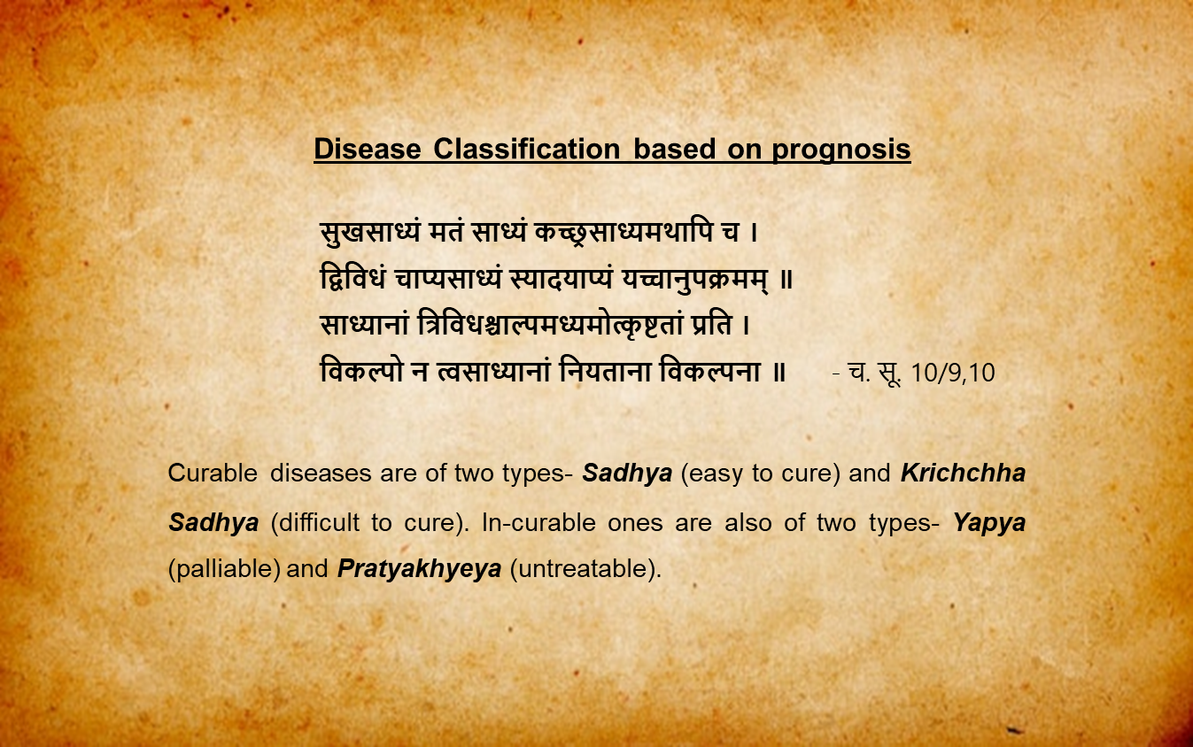
This verse describe about the classification of diseases.

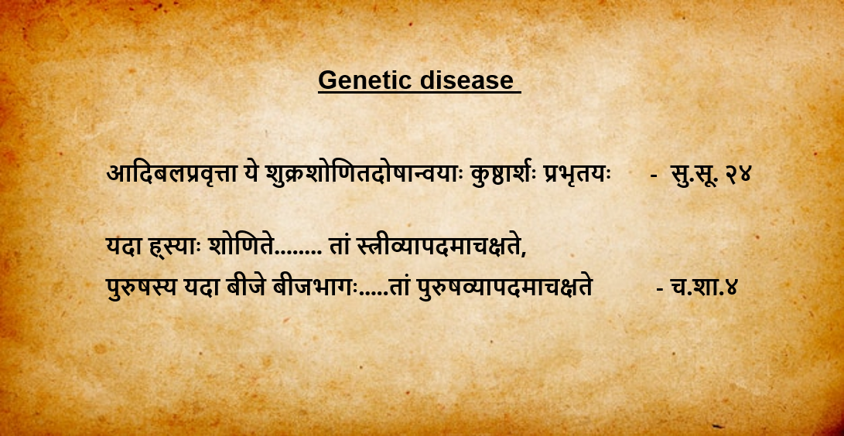
This verse describes about the description of genetic and hereditary disease.
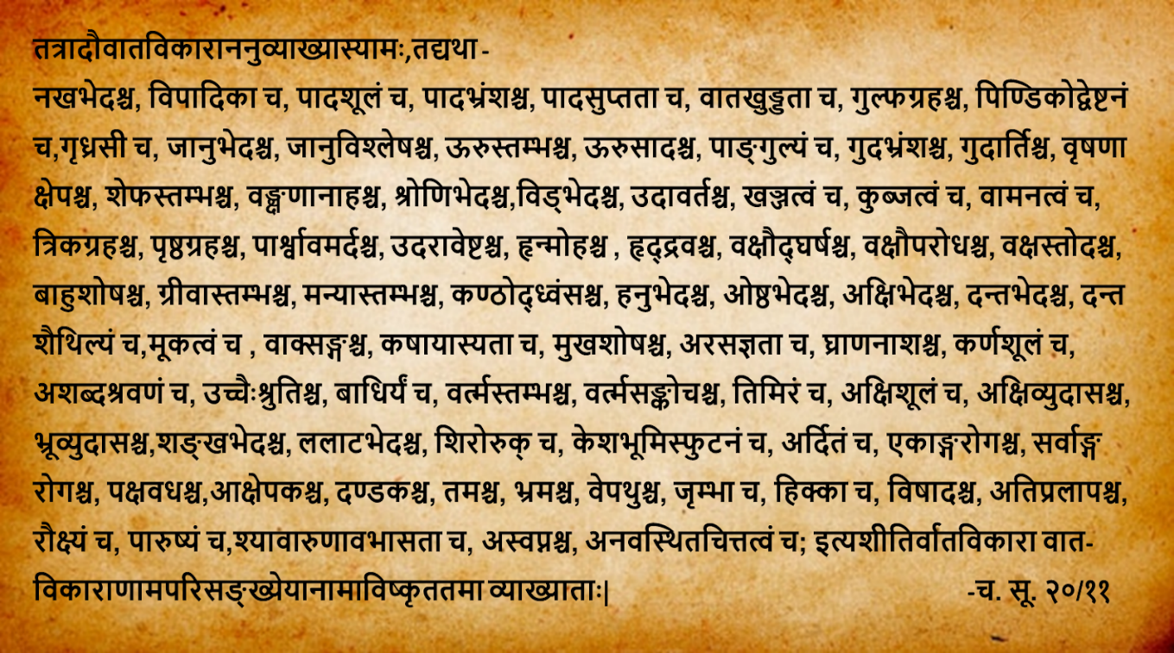
This verse describes about 80 Vata Nanatamja Vikara. Here is the translation of these Vikara in English - cracking of soles, pain in foot, foot drop, numbness in feet, pain in ankles, stiffness in ankles, cramps in calf, sciatica, tearing pain in knees, dislocation of knees, stiffness in thighs, loss of movement in thighs, lameness, prolapse of rectum, pain in anus, twitching in scrotum, stiffness in penis, pain in groins, pain in pelvis, pain in defecation, upward movement of Vayu (gases), limping, hunch back, dwarfism, stiffness in sacral region, stiffness in back, compression in sides, twisting pain in abdomen, cardiac dysfunction, tachycardia, shivering in chest, constriction in chest, chest pain, wasting of arms, stiffness of neck, stiffness of sternomastoid, hoarseness of voice, pain in jaw, cracking of lips, pain in eyes, pain in teeth, loose teeth, dumbness, stammering, astringent taste in mouth, dryness of mouth, loss of taste sensation, loss of smelling sensation, ear-ache, dizziness in ears, hardness in hearing, deafness, stiffness in eyelids, contraction in eyelids, loss of vision, pain in eyes, squint, twisting of eyebrows, pain in the temporal region, pain in forehead, headache, cracking of scalp, facial paralysis, monoplegia, polyplegia, hemiplegia, convulsions, tetanic convulsions, feeling of darkness before eyes, giddiness, tremors, yawning, hiccup, depression, excessive delirium, roughness, coarseness, blackish and reddish luster, insomnia, instability of mind-these are the eighty most prominent ones among the innumerable disorders of Vata.

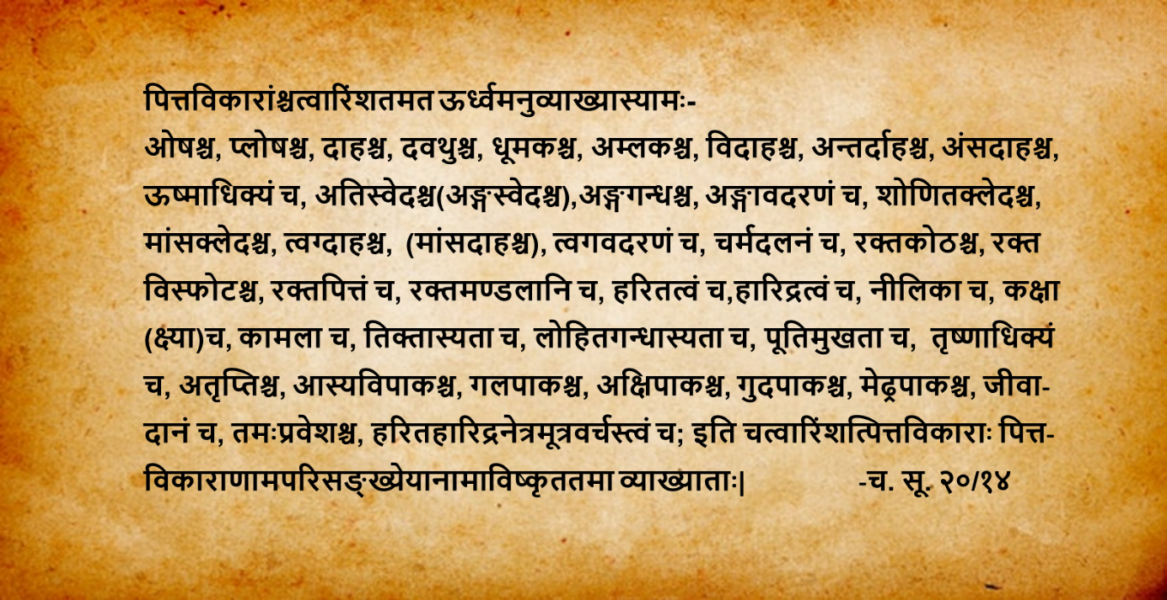

This verse describes about 80 Pitta Nanatamja Vikara. Here is the translation of these Vikara in English- heating, scorching, burning, intense burning, fuming, hyperacidity, burning in stomach and esophagus, internal burning, burning in scapular region, Pyrexia, over perspiration, foul smell in body, tearing of body parts, excessive moisture in blood(ureamic condition of blood), moistening of muscles, burning io skin, tearing of skin, thickening of skin, urticarial patches, pustules, internal hemorrhage, hemorrhagic patches, greenishness, yellowness bluishness, herpes, jaundice, bitterness in mouth, bloody smell from mouth, fetid smell from mouth, excessive thirst, loss of, contentment, stomatitis, inflammation in throat, inflammation in eyes, inflammation in anus, inflammation in penis, discharge of pure blood, fainting, green or yellow color in eyes, urine and feces- these are the prominent ones among the innumerable disorders of Pitta.

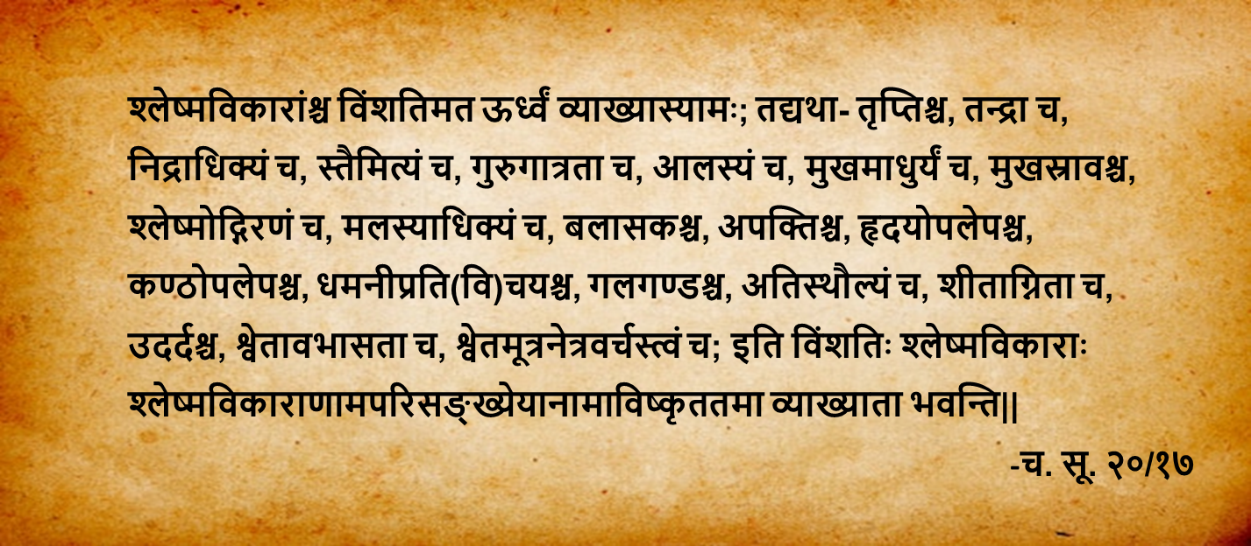

This verse describes about 20 Kapha Nanatamja Vikara. Here is the translation of these Vikara in English- saturation, drowsiness, excessive sleep, cold sensation, heaviness in body, lassitude, sweetness in mouth, salivation, mucous expectoration, excess of dirt, excess of mucus, indigestion, plastering of heart, plastering of throat, accumulation in vessels, goiter, over plumpness, urticarial eruptions, urticarial patches, white luster, whiteness in urine, eyes and feces-these twenty are the prominent ones among the innumerable disorders of Kapha.

