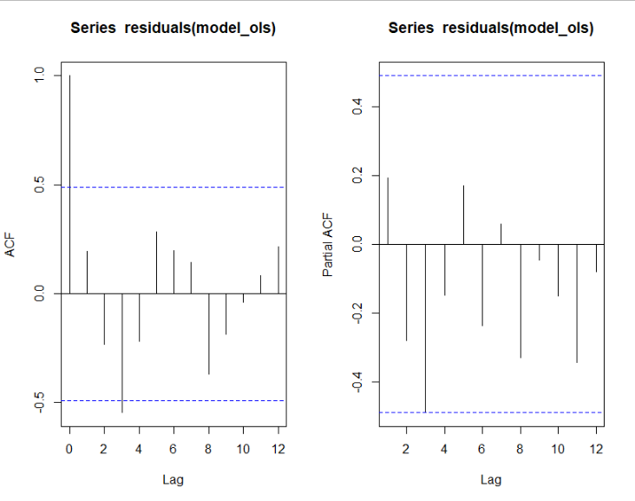
Supplementary Figure 1: ACF and PACF plots for the years of education time trend.

Crude primary outcome
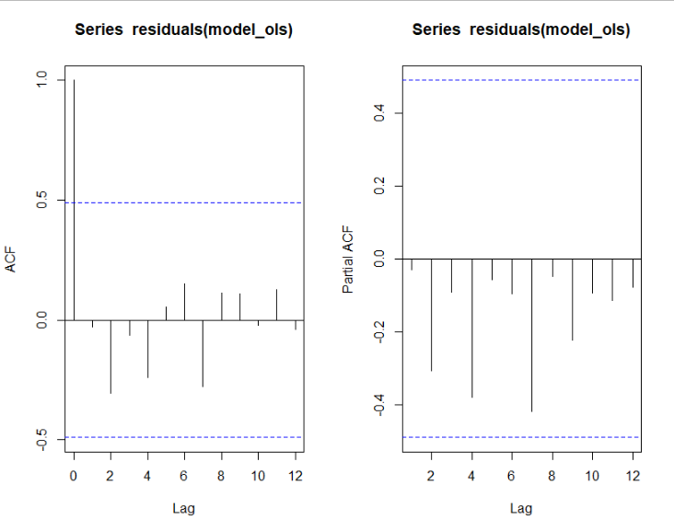
Supplementary Figure 2: ACF and PACF plots for the years of mean refractive error.

Coefficient* | Beta (95% CI) | Standard error | p-value
Intercept | 26555.801 (1.157692e+04 to 4.153468e+04) | 6722.598 | 0.0027
Year of birth | -27.157 (-4.250012e+01 to -1.181353e+01) | 6.886 | 0.0028
Year of birth squared** | 0.007 (3.013555e-03 to 1.087184e-02) | 0.002 | 0.0028
Pre/post intervention | -0.099 (-1.972702e-01 to -7.202288e-04) | 0.044 | 0.0486
YoB Trend post intervention | 7.191 (1.772049e+00 to 1.260935e+01) | 2.432 | 0.0144
YoB^2 Trend post intervention** | -1.881718e-06 (-3.296522e-06 to 4.669135e-07) | 0.000 | 0.0142
Supplementary Table 2: Final segmented regression model for the discontinuity in mean refractive error.
*P-value auto regression lag of 1: 0.2783, moving average lag of 2: 0.074
** Departure from linearity for time variable: 5e-04

Change in genetic risk score (sensitivity for bias)
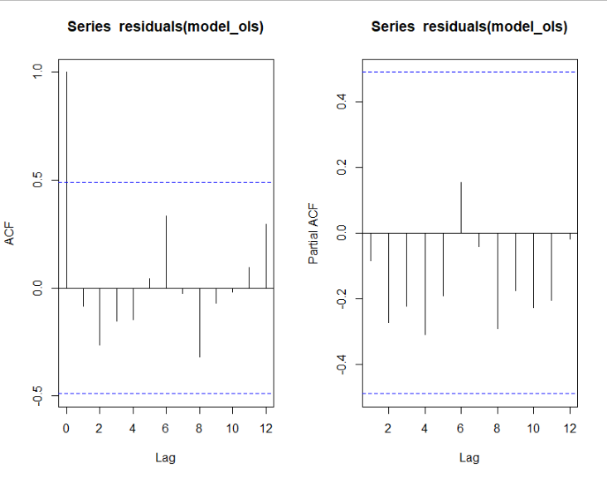
Supplementary Figure 3: ACF and PACF plots for the years of mean myopia genetic risk score.

Coefficient* | Beta (95% CI) | Standard error | p-value
Intercept | 1.0496284 (-2.022514930 to 4.121771633) | 1.5674488 | 0.5158
Year of birth | -0.0003288 (-0.001902248 to 0.001244633) | 0.0008028 | 0.6893
Pre/post intervention | -0.0009639 (-0.011289589 to 0.009361881) | 0.0052683 | 0.8579
YoB Trend post intervention | -0.0005403 (-0.002765438 to 0.001684924) | 0.0011353 | 0.6427
Supplementary Table 3: Final segmented regression model for the discontinuity in mean myopia genetic risk score
* P-value for moving average period 2: 0.073, P-value autorepression period 1: 0.1868

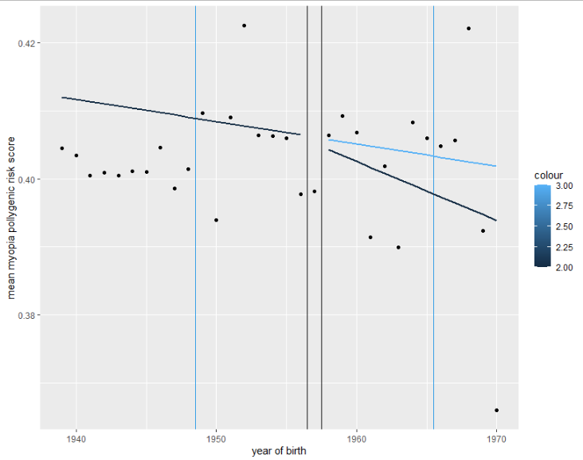
Supplementary Figure 4: Discontinuity in mean myopia genetic risk score. Black vertical lines indicate the year of intervention, blue vertical lines indicate the data analysed. The black trend lines represent the observed data, while the blue trend line represents the counterfactual trend.

Number of people in the UKB – bias sensitivity
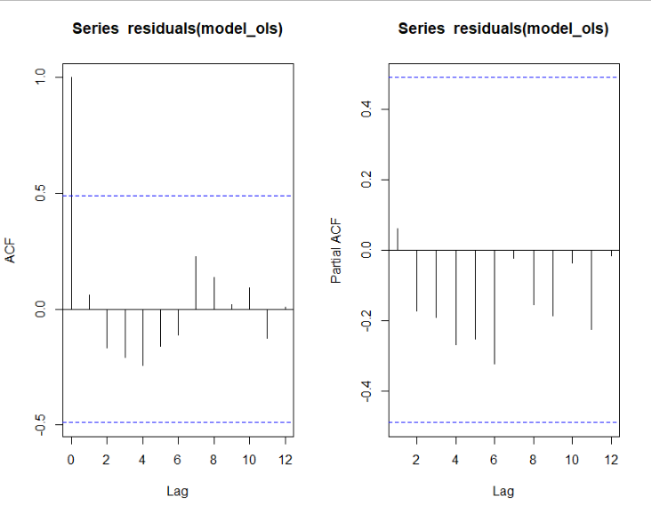
Supplementary Figure 5: ACF and PACF plots for the years of number of people recruited to the UKB per birth year.

Coefficient* | Beta (95% CI) | Standard error | p-value
Intercept | 63602268 (3.009349e+07 to 9.711105e+07) | 15038910 | 0.0017
Year of birth | -64519 (-9.883451e+04 -to -3.020412e+04) | 15401 | 0.0019
Year of birth squared | 16 (7.579722 to 2.515022e+01) | 4 | 0.0020
Pre/post intervention | 64 (-4.923077e+01 to 1.765641e+02) | 51 | 0.2375
YoB Trend post intervention | -21 ( -1.727752e+02 -to 1.301604e+02) | 68 | 0.7604
Wild point | 1584 ( 1.315731e+03 to 1.852546e+03) | 120 | 0.000
Supplementary Table 4: Final segmented regression model for the discontinuity in number of UKB participants
* P-value for moving average period 2: 0.9412, P-value autorepression period 1: 0.0797. P-value adding a wild point at 1949: <.0001, p-value square term for YoB: 0.9838

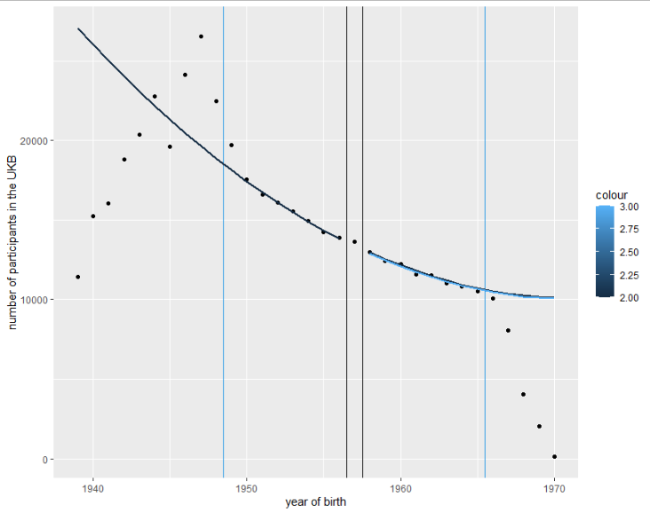

Supplementary Figure 6: Discontinuity in number of participants recruited into the UKB. Black vertical lines indicate the year of intervention, blue vertical lines indicate the data analysed. The black trend lines represent the observed data, while the blue trend line represents the counterfactual trend.

Sex as a bias check
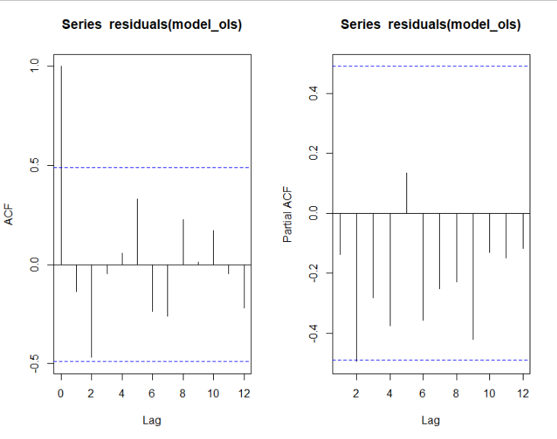
Supplementary Figure 7: ACF and PACF plots for the years log odds of being male.

Coefficient* | Beta (95% CI) | Standard error | p-value
Intercept | 21.293619 (13.228831403 to to 29.35840672) | 4.114763 | 0.0002
Year of birth | -0.011029 (-0.015159534 to -0.00689855) | 0.002107 | 0.0002
Pre/post intervention | 0.044332 (0.017225249 to 0.07143812) | 0.013830 | 0.0076
YoB Trend post intervention | 0.014292 (0.008450309 to 0.02013311) | 0.002980 | 0.0004
Supplementary Table 5: Final segmented regression model for the discontinuity in mean log odds of being male
* P-value for moving average period 2: 0.2024, P-value autorepression period 1: 0.4796

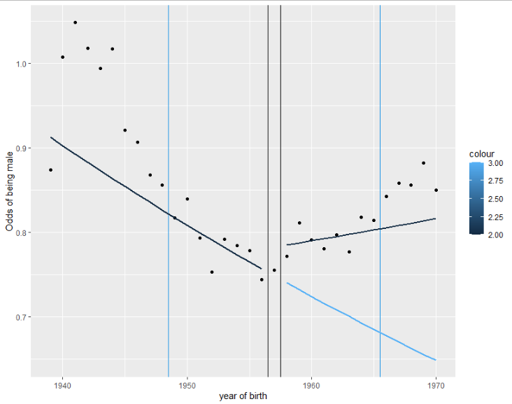
Supplementary Figure 8: Discontinuity in mean odds of being male. Black vertical lines indicate the year of intervention, blue vertical lines indicate the data analysed. The black trend lines represent the observed data, while the blue trend line represents the counterfactual trend.

Myopia missingness as a sensitivity
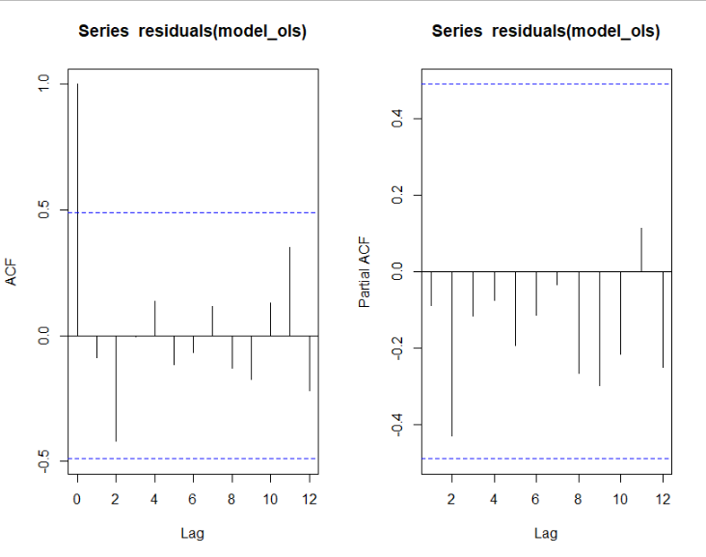
Supplementary Figure 9: ACF and PACF plots for the years log odds of having missing refractive error data.

Coefficient* | Beta (95% CI) | Standard error | p-value
Intercept | 31.159055 (19.115822197 to 43.20228851) | 5.527429 | 0.0001
Year of birth | -0.016615 (-0.022782791 to -0.01044657) | 0.002831 | 0.0001
Pre/post intervention | 0.072199 (0.031720436 to 0.11267710) | 0.018578 | 0.0022
YoB Trend post intervention | 0.006111 (-0.002612486 to 0.01483356) | 0.004004 | 0.1529
Supplementary Table 6: Final segmented regression model for the discontinuity in log odds of missing myopia data
* P-value for moving average period 2: 0.549, P-value autorepression period 1: 0.1498

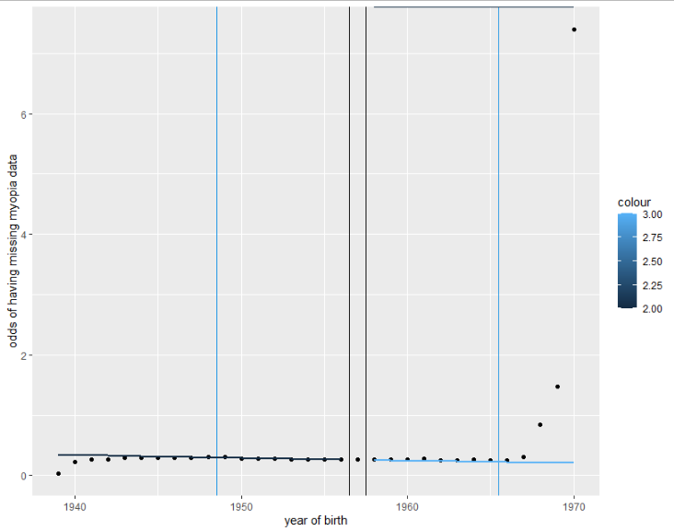
Supplementary Figure 10: Discontinuity in mean odds of having missing myopia data. Black vertical lines indicate the year of intervention, blue vertical lines indicate the data analysed. The black trend lines represent the observed data, while the blue trend line represents the counterfactual trend.

