Supplemental Materials:

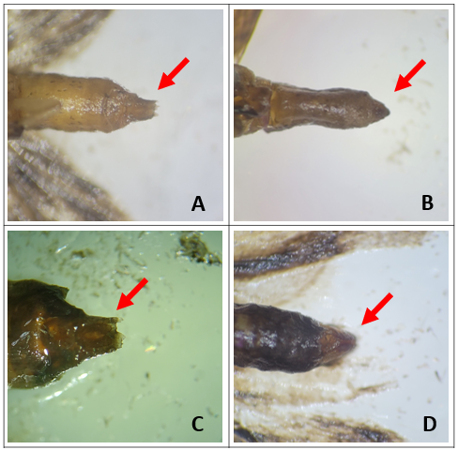
S1 Figure. Male genitalia (right) and female genitalia (left) of G. molesta (A, B) and C. pomonella (C, D).

S1 Table: Average number of C. pomonella captured according to trapping period in 2021 and 2022.
Lures | Total C. pomonella male captures
Lures | 2021 (n=4) |  | 2022 (n=5)
Lures | Mid | Late | Early | Mid
BEN-VL | - | - | 0.2 | 1.6
BEN-L | 0.25 | 0 | 0.6 | 0.8
BEN-M | 0.75 | 0.75 | 0.6 | 1.8
BEN-H | 0 | 0.75 | - | -
MEG | 0.25 | 0.75 | 1 | 2.6
MEG + BEN-VL | - | - | 1 | 2.2
MEG + BEN-L | 1.25 | 0.25 | 0.8 | 2
MEG + BEN-M | 0.5 | 0.5 | 0.2 | 1.8
MEG + BEN-H | 0.5 | 0.25 | - | -
Unbaited (Control) | 0 | 0 | 0 | 0

