Supplementary Fig 1. SHAP Feature Importance Ranking Plot in CTZ
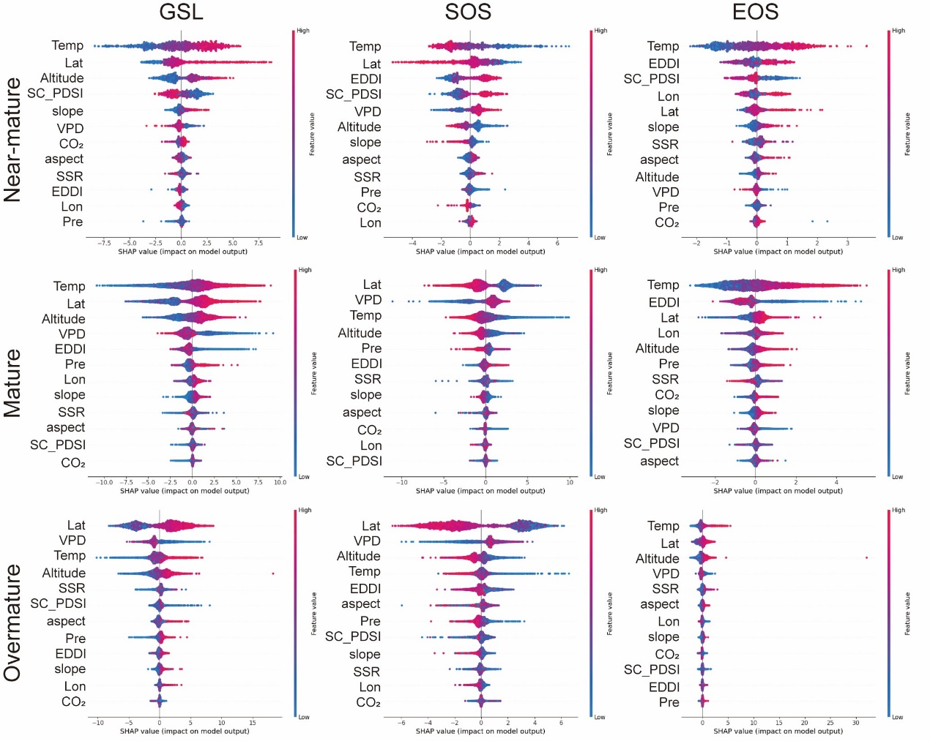

Supplementary Fig 2. SHAP Feature Importance Ranking Plot in PZ
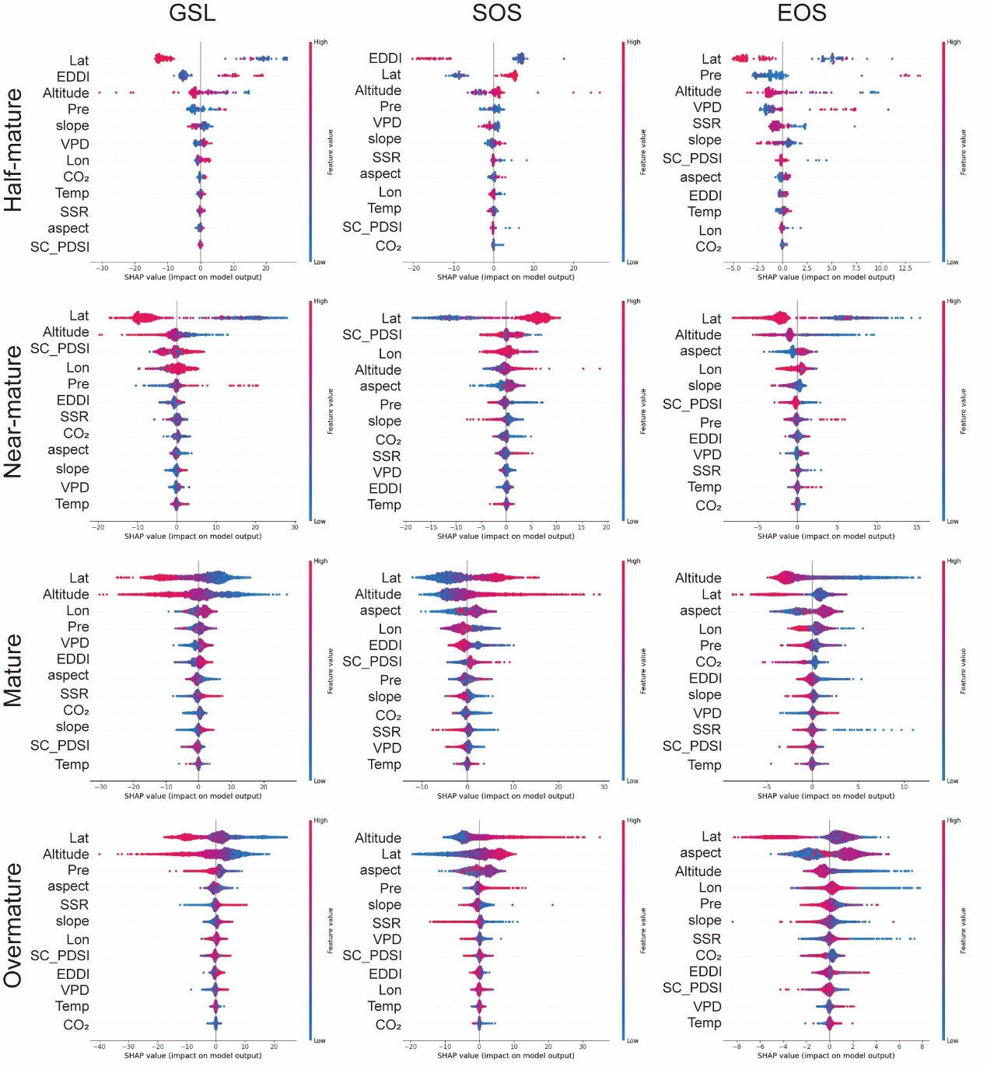

Supplementary Fig 3. SHAP Feature Importance Ranking Plot in MTZ
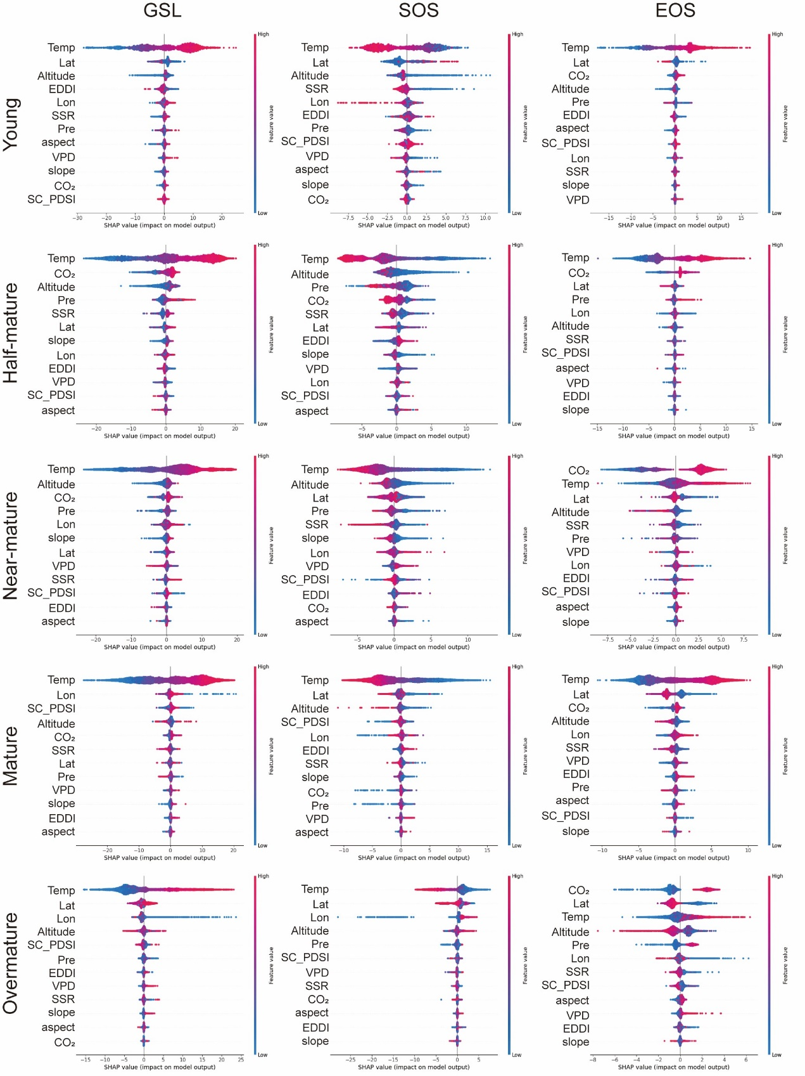

Supplementary Fig 4. SHAP Feature Importance Ranking Plot in WTZ
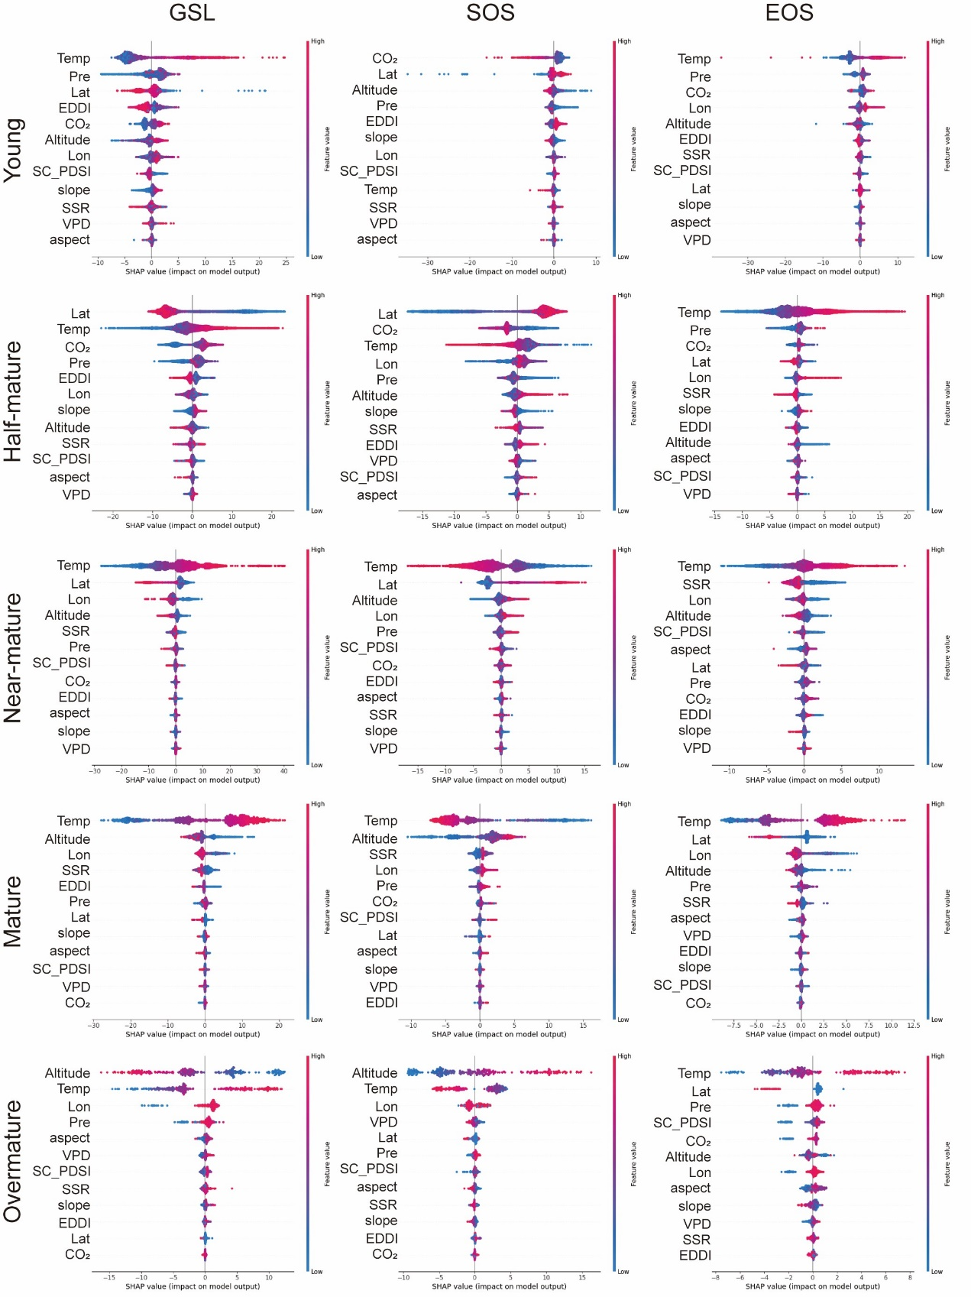

Supplementary Fig 5. SHAP Feature Importance Ranking Plot in STZ
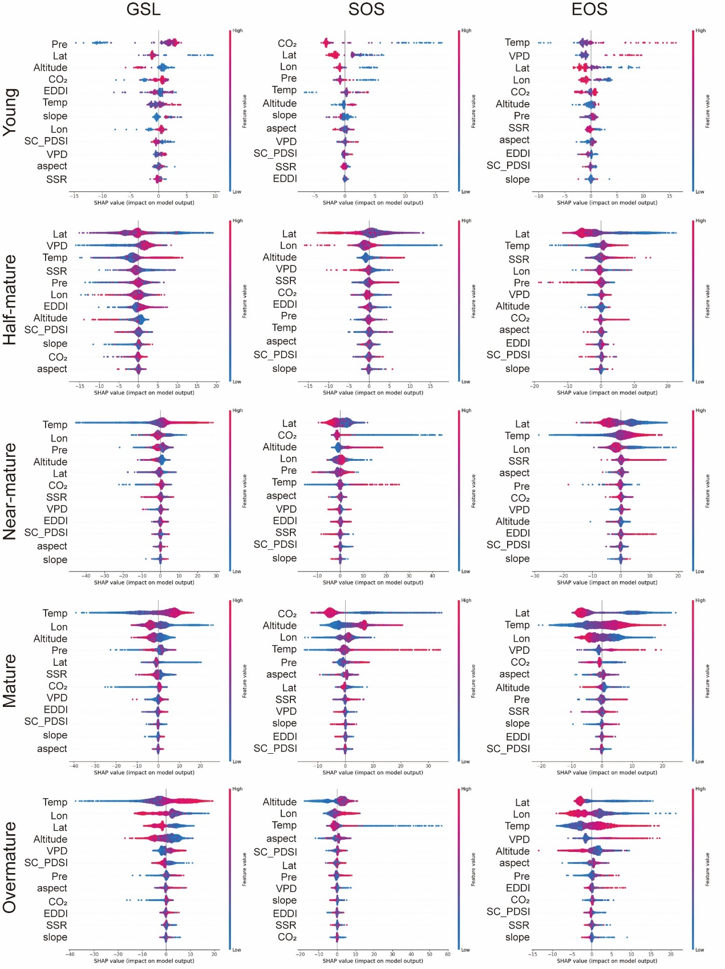

Supplementary Fig 6. SHAP Feature Importance Ranking Plot in TZ
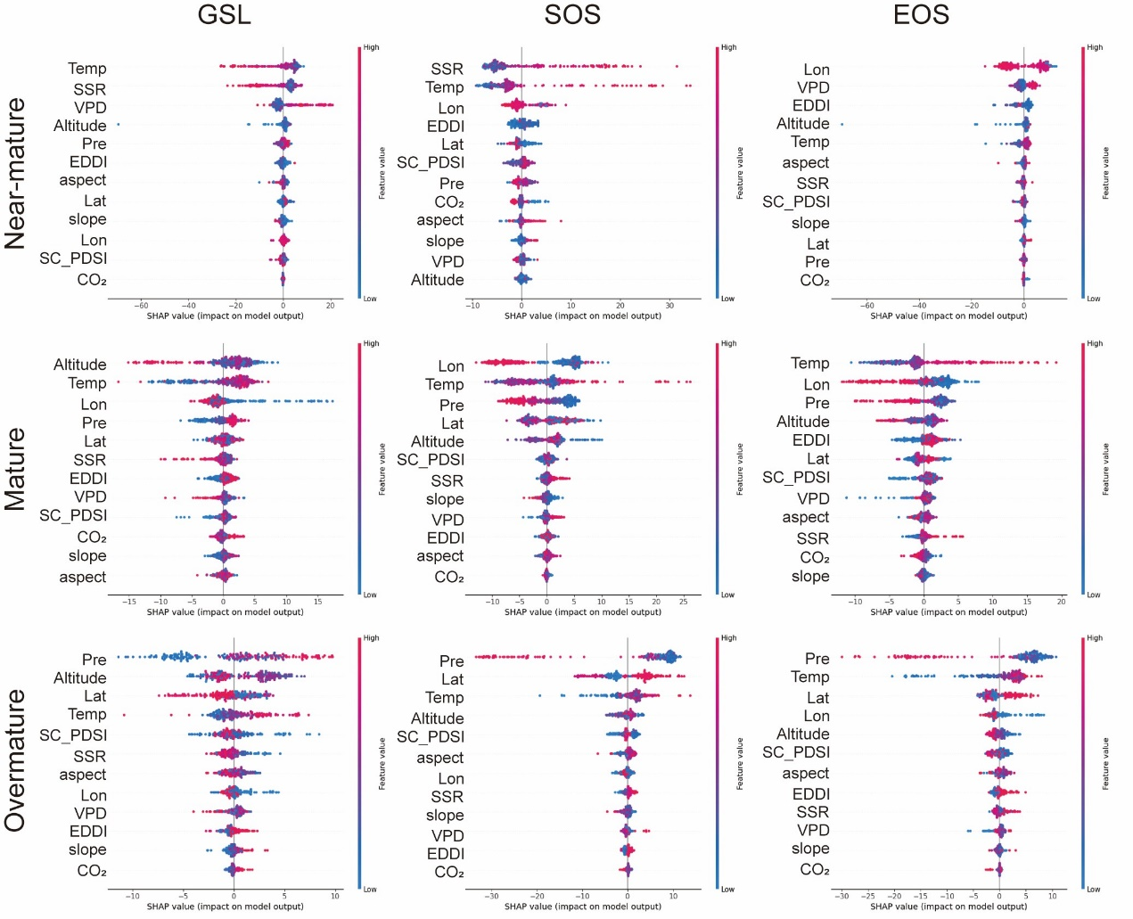

Supplementary Table 1 Description and origin of the variables used in this study.
Type | Variables | Units | Description | Database | Reference
Vegetation Variables | Forest age | year | A framework for estimating China’s forest age by combining remote sensing time series analysis and machine learning algorithms based on over 50 000 field measurements and a remote sensing dataset. | 2020 forest age map for China with 30 m resolution | 1
Vegetation Variables | NPP | kgC/m²/year | Net Primary Productivity | MOD17A3HGF Version 6.1 | 2
Climate Variables | Tempreture (Tem) | K | a dataset based on enhanced Reanalysis and Thermal infrared remote sensing Merging (E-RTM) method. | Daily 1-km all-weather land surface temperature dataset for the China's landmass and its surrounding areas (TRIMS LST; 2000-2022) | 3
Climate Variables | CO₂ | % | the Gridded Monthly OCO-2 Carbon Dioxide assimilated dataset | OCO2_GEOS_L3CO2_MONTH | 4
Climate Variables | Precipitation (Pre) | mm | This dataset is generated in China through the Delta spatial downscaling scheme based on the global 0.5 ° climate dataset released by CRU and the global high-resolution climate dataset released by WorldClim. | 1-km monthly precipitation dataset for China (1901-2023) | 5
Climate Variables | Surface Solar Radiation (SSR) | W m⁻² | the surface net radiation (SSR) from the ERA5 data set | China's net solar radiation data set based on era5 from 1982 to 2020 | 6
Climate Variables | EDDI |  | an innovative and comprehensive long-term meteorological drought dataset with a spatial resolution of 0.1° and data collected from 1961 to 2022 in mainland China. | A New High-Resolution Multi-Drought Indices Dataset for Mainland China; CHM_Drought | 7
Climate Variables | VPD |  | an innovative and comprehensive long-term meteorological drought dataset with a spatial resolution of 0.1° and data collected from 1961 to 2022 in mainland China. | A New High-Resolution Multi-Drought Indices Dataset for Mainland China; CHM_Drought | 7
Climate Variables | SC_PDSI |  | an innovative and comprehensive long-term meteorological drought dataset with a spatial resolution of 0.1° and data collected from 1961 to 2022 in mainland China. | A New High-Resolution Multi-Drought Indices Dataset for Mainland China; CHM_Drought | 7
Geography Variables | Altitude | m | the latest global bathymetric product released by the General Bathymetric Chart of the Oceans (GEBCO) and the land data in the GEBCO Grid are taken directly from SRTM15+ for all areas outside the Polar regions. | GEBCO_2020 Grid | 8
Geography Variables | Aspect | ° | calculated from Altitude
Geography Variables | Slope | ° | calculated from Altitude
Soil Variables | Aboveground Biomass Carbon (AGBC) | t ha⁻¹ | Based on the forest litter carbon density data observed at a large number of stations, the dataset was simulated and evaluated by using a random forest model driven by long-term remote sensing observation NDVI data to simulate and evaluate the temporal and spatial variation characteristics of forest litter carbon density in China from 1982 to 2020. | Forest litter carbon density dataset in China from 1982 to 2020 | 9
Soil Variables | Belowground Biomass Carbon (BGBC) | t ha⁻¹ | Based on the forest litter carbon density data observed at a large number of stations, the dataset was simulated and evaluated by using a random forest model driven by long-term remote sensing observation NDVI data to simulate and evaluate the temporal and spatial variation characteristics of forest litter carbon density in China from 1982 to 2020. | Forest litter carbon density dataset in China from 1982 to 2021 | 9
Soil Variables | SOCc | g kg⁻¹ | global digital soil mapping that makes use of global soil profile information and covariate data to model the spatial distribution of soil properties across the globe. | ISRIC—World Soil Information (2023). SoilGrids . | 10
Soil Variables | Surface soil moisture (SSM) | m³ m⁻³ | an accurate microwave remote sensing-based SSM data | Spatially seamless, daily SMAP (SSD_SMAP) surface soil moisture dataset from 2015 to 2021 | 11
Phenology data | Start of season (SOS)/Greenup | day | Date when EVI2 first crossed 15% of the segment EVI2 amplitude | MCD12Q2 Version 6.1 | 12
Phenology data | End of season (EOS)/Dormancy | day | Date when EVI2 last crossed 15% of the segment EVI2 amplitude | MCD12Q2 Version 6.1 | 12

Supplementary Table 2 Random Forest Accuracy of Forest Stages Classification Across Thermal Zones
 | Phenological indicators | Cold temperature zone(CTZ) |  |  | Plateau climate zone(PZ) |  |  | Mid-temperature zone(MTZ) |  |  | Warm temperature zone(WTZ) |  |  | Sub-tropical zone(STZ) |  |  | Tropical zone(TZ)
 | Phenological indicators | R2 | MAE | RMSE | R2 | MAE | RMSE | R2 | MAE | RMSE | R2 | MAE | RMSE | R2 | MAE | RMSE | R2 | MAE | RMSE
Forest Stage: 1  young forest | GSL | - | - | - | - | - | - | 0.77 | 4.09 | 5.85 | 0.82 | 3.44 | 5.07 | 0.53 | 7.55 | 12.44 | - | - | -
Forest Stage: 1  young forest | SOS | - | - | - | - | - | - | 0.65 | 2.94 | 4.28 | 0.73 | 2.23 | 3.20 | 0.68 | 5.49 | 9.85 | - | - | -
Forest Stage: 1  young forest | EOS | - | - | - | - | - | - | 0.82 | 1.87 | 2.64 | 0.83 | 2.02 | 2.93 | 0.75 | 4.83 | 7.46 | - | - | -
Forest Stage: 2  half-mature forest | GSL | - | - | - | 0.91 | 7.07 | 9.23 | 0.87 | 3.52 | 5.26 | 0.93 | 3.12 | 4.42 | 0.58 | 6.69 | 9.32 | - | - | -
Forest Stage: 2  half-mature forest | SOS | - | - | - | 0.69 | 6.87 | 10.69 | 0.76 | 2.89 | 4.44 | 0.94 | 2.04 | 2.91 | 0.57 | 4.77 | 6.82 | - | - | -
Forest Stage: 2  half-mature forest | EOS | - | - | - | 0.86 | 3.90 | 5.90 | 0.88 | 1.50 | 2.37 | 0.86 | 1.89 | 2.66 | 0.73 | 4.43 | 6.05 | - | - | -
Forest Stage: 3  near-mature forest | GSL | 0.74 | 2.31 | 2.99 | 0.75 | 6.85 | 9.76 | 0.85 | 3.00 | 4.28 | 0.92 | 2.98 | 3.88 | 0.69 | 5.89 | 8.19 | 0.54 | 10.84 | 13.99
Forest Stage: 3  near-mature forest | SOS | 0.75 | 1.94 | 2.48 | 0.58 | 6.15 | 8.78 | 0.71 | 2.45 | 3.64 | 0.93 | 1.85 | 2.40 | 0.73 | 4.40 | 6.23 | 0.69 | 10.54 | 13.44
Forest Stage: 3  near-mature forest | EOS | 0.60 | 1.16 | 1.46 | 0.75 | 3.19 | 4.28 | 0.89 | 1.34 | 1.87 | 0.84 | 1.71 | 2.25 | 0.75 | 4.46 | 6.27 | 0.25 | 9.07 | 15.16
Forest Stage: 4  mature forest | GSL | 0.68 | 2.69 | 3.64 | 0.62 | 8.68 | 11.71 | 0.92 | 2.31 | 3.13 | 0.92 | 2.79 | 3.76 | 0.76 | 5.95 | 8.52 | 0.49 | 10.17 | 13.26
Forest Stage: 4  mature forest | SOS | 0.67 | 1.97 | 2.77 | 0.52 | 8.10 | 11.41 | 0.86 | 1.58 | 2.27 | 0.92 | 1.79 | 2.41 | 0.80 | 4.65 | 7.03 | 0.53 | 8.01 | 11.00
Forest Stage: 4  mature forest | EOS | 0.67 | 1.26 | 1.65 | 0.57 | 3.89 | 5.15 | 0.91 | 1.35 | 1.82 | 0.87 | 1.67 | 2.26 | 0.86 | 4.62 | 6.63 | 0.53 | 8.39 | 11.02
Forest Stage: 5  overmature forest | GSL | 0.57 | 3.35 | 4.78 | 0.61 | 7.61 | 10.06 | 0.84 | 2.45 | 3.62 | 0.72 | 4.74 | 8.65 | 0.77 | 6.00 | 8.63 | 0.50 | 10.82 | 13.64
Forest Stage: 5  overmature forest | SOS | 0.60 | 2.43 | 3.49 | 0.54 | 7.83 | 10.13 | 0.86 | 1.46 | 2.03 | 0.69 | 3.31 | 5.64 | 0.57 | 5.62 | 8.86 | 0.66 | 9.46 | 13.55
Forest Stage: 5  overmature forest | EOS | 0.40 | 1.51 | 2.27 | 0.54 | 3.41 | 4.44 | 0.83 | 1.43 | 2.18 | 0.59 | 2.96 | 5.14 | 0.78 | 4.21 | 6.25 | 0.53 | 10.49 | 12.91

References
- Cheng, K. et al. 2020 forest age map for China with 30 m resolution. Zenodo https://doi.org/10.5281/ZENODO.8354262 (2023).
- Running, S. & Zhao, M. MODIS/Terra Net Primary Production Gap-Filled Yearly L4 Global 500 m SIN Grid V061. NASA Land Processes Distributed Active Archive Center https://doi.org/10.5067/MODIS/MOD17A3HGF.061 (2021).
- Tang, W. et al. TRIMS LST: a daily 1 km all-weather land surface temperature dataset for China’s landmass and surrounding areas (2000–2022). Earth Syst. Sci. Data 16, 387–419 (2024).
- NASA/GSFC/GMAO Carbon Group. OCO-2 GEOS Level 3 monthly, 0.5x0.625 assimilated CO2 V10r (OCO2_GEOS_L3CO2_MONTH) at GES DISC. NASA Goddard Earth Sciences Data and Information Services Center https://doi.org/10.5067/BGFIODET3HZ8 (2021).
- Shouzhang Peng. High-spatial-resolution monthly precipitation dataset over China during 1901–2017. Zenodo https://doi.org/10.5281/ZENODO.3114194 (2019).
- Wu, J. et al. Constructing High-Resolution (10 km) Daily Diffuse Solar Radiation Dataset across China during 1982–2020 through Ensemble Model. Remote Sensing 14, 3695 (2022).
- Zhang, Q. & Miao, C. A New High-Resolution Multi-Drought Indices Dataset for Mainland China; CHM_Drought. 8229834359 Bytes figshare https://doi.org/10.6084/M9.FIGSHARE.25656951.V2 (2024).
- GEBCO Bathymetric Compilation Group 2019. The GEBCO_2019 Grid - a continuous terrain model of the global oceans and land. British Oceanographic Data Centre, National Oceanography Centre, NERC, UK https://doi.org/10.5285/836F016A-33BE-6DDC-E053-6C86ABC0788E (2019).
- Wang, Zhaosheng. NDVI-driven model of random forest to simulate forest litter carbon density over China during 1982~2020.Remote Sensing Technology and Application，38（6）：1381-1389.(2023)
- Hengl, T. et al. SoilGrids250m: Global gridded soil information based on machine learning. PLoS ONE 12, e0169748 (2017).
- Yang, H. Spatially Seamless, Daily SMAP (SSD_SMAP) Surface Soil Moisture Dataset from 2015 to 2021. 2905526145 Bytes (figshare, 2022). doi:10.6084/M9.FIGSHARE.20279514.V3.
- Friedl, M., Gray, J. & Sulla-Menashe, D. MODIS/Terra+Aqua Land Cover Dynamics Yearly L3 Global 500m SIN Grid V061. NASA Land Processes Distributed Active Archive Center https://doi.org/10.5067/MODIS/MCD12Q2.061 (2022).

