SUPPLEMENTARY MATERIALS

Addendum 1
1a: Patient characteristics across the three participating hospitals
Characteristics | Hospital 1 | Hospital 2 | Hospital 3 | All hospitals
Hospital beds (n) | 431 | 310 | 981
Acute geriatric care beds (n) | 100 | 72 | 149
patients included (n) | 274 | 157 | 80 | 511
All clinical events (n) | 225 | 84 | 39 | 348
Age (years) (median, IQR) | 85 [8] | 86 [8] | 86 [8] | 85 [8]
Sex (female) (n, %) | 164 (59.8%) | 88 (56.1%) | 55 (68.8%) | 307 (60.1%)
Length of hospital stay (days) (median, IQR) | 11[8] | 9 [8] | 10[8] | 11 [8]
DNR coding present (n,%)  - DNR 0  - DNR 1  - DNR 2 | 274 (100%)  131 (47.8%)  42 (15.3%)  101 (36.9%) | 157 (100%)  66 (42.0%)  35 (22.3%)  56 (35.7%) | 80 (100%)  33 (41.2%)  10 (12.5%)  37 (46.3%) | 511 (100%)  230 (45.0%)  87 (17.0%)  194 (38.0%)
CFS code present (n, %)  - CFS 3-5  - CFS 6  - CFS 7-9 | 212 (77.3%)  74 (27.0%)  64 (23.3%)  74 (27.0%) | 157 (100%)  45 (28.7%)  57 (36.3%)  55 (35.0%) | 80 (100%)  19 (23.8%)  36 (45.0%)  25 (31.2%) | 449 (87.8%)  138 (27.0%)  157 (30.7%)  154 (30.1%)
Delirium diagnosis (n, %) | 28 (10.2%) | 4 (2.5%) | 10 (12.5%) | 42 (8.2%)
All events (n)  - Event type 1 (n)  - Event type 2 (n)  - Event type 3 (n)  - Event type 1-3(n)  - Event type 4 (n)  - Surgical  - Medical  intervention | 225  2  9  10  21  204  3  201 | 84  3  2  2  7  77  3  74 | 39  2  1  0  3  36  2  34 | 348  7  12  12  31  317  8  309
n: number; IQR: interquartile range; %: percentage; DNR: Do-Not-Resuscitate code (ranging from code 0 (no restrictions regarding resuscitation or ICU admission) – code 1 (refrain from resuscitation, but ICU admission for invasive ventilation) to code 2 (no resuscitation, nor ICU admission); CFS: Clinical Frailty Scale (ranging from 3-9, 62 missing values ).

1b : Details on administered medical interventions for Type 4 clinical events
Medical interventions |  | Phase 1 | Phase 2 | Total period
Consciousness related interventions:
Intravenous (IV) glucose (> 6 g) for acute hypoglycemic coma |  | 3 | 0 | 3
Cardiovascular interventions:
IV diuretics (for acute pulmonary oedema) |  | 41 | 11 | 52
IV or oral anti-arrhythmics (for life-threatening arrhythmias) |  | 8 | 3 | 11
IV nitrates (for unstable angina pectoris) |  | 3 | 0 | 3
Bleeding or hemostasis interventions:
Transfusion of packed red blood cells, platelets (for massive hemorrhage) |  | 15 | 4 | 19
Synthetic plasma factors (for massive hemorrhage) |  | 3 | 0 | 3
Anticoagulants (e.g. low-molecular-weight heparin (LMWH)), heparin,  thrombolytics (for embolism, stroke or myocardial infarction) |  | 13 | 0 | 13
Sepsis and dehydration related intervention:
Volume resuscitation with fluid challenge (crystalloids/electrolytes/albumin) |  | 133 | 13 | 146
IV or oral antibiotics (oral quinolones) |  | 156 | 20 | 176
IV corticosteroids (for acute Addison’s disease)² |  | 26 | 3 | 29
Respiratory interventions:
Oxygen supplementation : Augmentation by ≥ 100 % |  | 53 | 10 | 63
IV corticosteroids (for COPD exacerbation)² |  | 26 | 3 | 29
Total medical interventions type 4 events |  | 454 | 64 | 518
The hospitalization period was divided into two phases. Phase 1 started upon admission to the emergency department or the acute geriatric ward. Phase 2 began either 72 hours after admission – if no clinical event occurred during the first phase – or 72 hours after the last clinical event recorded within phase 1.
²No differentiation between purpose for iv corticoids was documented, therefore both possibilities are mentioned.

Addendum 2
The receiver operating curve (ROC) and precision-recall curve (PR) for GEWS and NEWS, severe clinical events (Type 1 – 3).
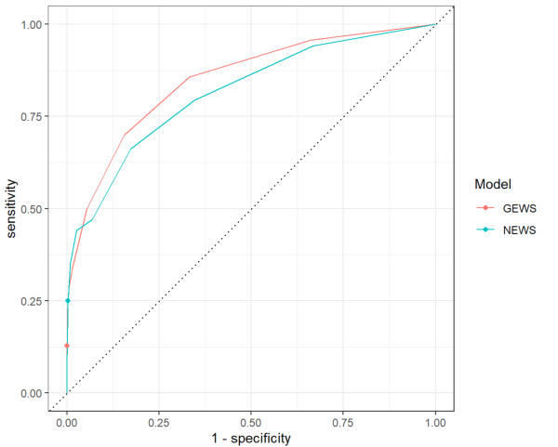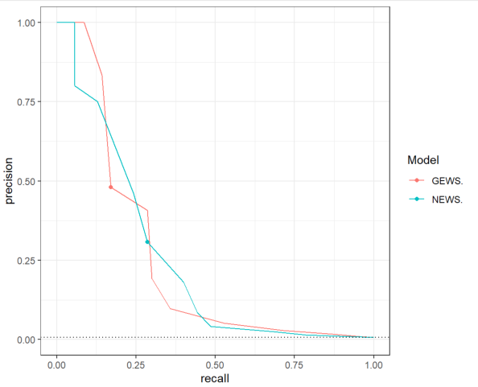
Left panel: ROC-curve for GEWS (red line) versus NEWS (blue line); Right panel: PR-curve for GEWS (red line) and NEWS (blue line); dotted lines represent performance levels expected by chance alone.

Addendum 3
Performance metrics comparison of GEWS ≥5 S3 vs. NEWS ≥5 S3 for clinical events Type 1 – 3
Clinical events Type 1 – 3 (n=31)
Metrics | NEWS ≥5 S3 | GEWS ≥5 S3 | p-value
Alerts (n) | 691 | 553
Accuracy | 0.932 | 0.944 | <0.0001
NPV | 0.996 | 0.996 | 0.0893
PPV | 0.054 | 0.054 | 0.9107
Sensitivity | 0.529 | 0.429 | 0.0893
Specificity | 0.934 | 0.948 | <0.0001
ROA | 14.321 | 11.461 | <0.0001
NNE | 18.676 | 18.433 | 0.9107
AOER | 0.767 | 0.622 | 0.0640
n: number; NPV: negative predictive value; PPV: positive predictive value; ROA: rate of alarms; NNE: number-needed-to-evaluate; AOER: alerted outcome event rate; NEWS: national early warning score; GEWS: geriatric early warning score; (S3): single score of 3 of any vital parameter; p-value in bold favors GEWS.

Addendum 4
Performance metrics of GEWS ≥7 and ≥8 vs. NEWS ≥7, respectively, for clinical events Type 1 – 3
 | Clinical events Type 1 – 3 (n=31)
Metrics | NEWS ≥7 | GEWS ≥7 | p-value | GEWS ≥8 | p-value
Alerts (n) | 65 | 49 |  | 25
Accuracy | 0.991 | 0.992 | 0.0701 | 0.993 | 0.0042
NPV | 0.995 | 0.995 | 0.7081 | 0.994 | 0.0226
PPV | 0.308 | 0.408 | 0.075 | 0.480 | 0.0222
Sensitivity | 0.286 | 0.286 | 1 | 0.171 | 0.0226
Specificity | 0.995 | 0.997 | 0.0563 | 0.999 | <0.0001
ROA | 1.347 | 1.016 | 0.0699 | 0.518 | <0.0001
NNE | 3.250 | 2.51 | 0.075 | 2.083 | 0.0222
AOER | 0.415 | 0.415 | 0.8944 | 0.249 | 0.0226
n: number; NPV: negative predictive value; PPV: positive predictive value; ROA: rate of alarms; NNE: number needed to evaluate; AOER: alarmed outcome event rate; NEWS: national early warning score; GEWS: geriatric early warning score; (S3): single score of 3 of any vital parameter; p -value in bold favors GEWS.

