SUPPLEMENTARY MATERIAL

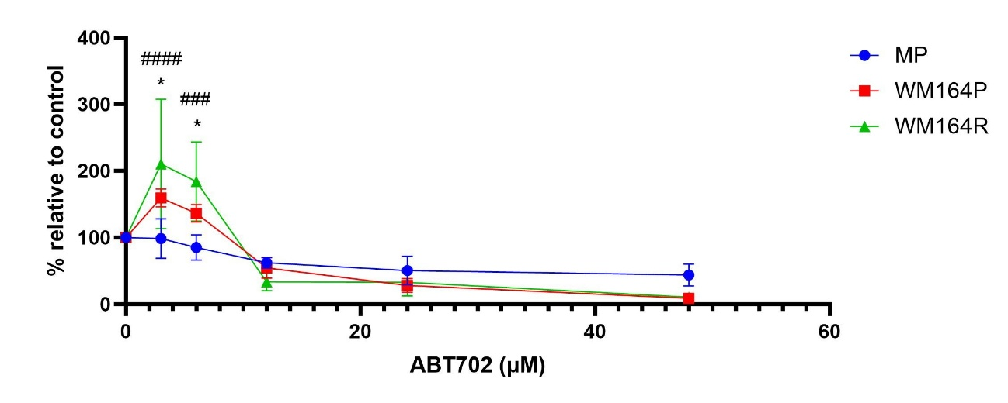
Supplementary Figure 1 – Cytotoxicity analysis using the trypan blue exclusion assay in primary melanocytes and WM164 parental and resistant cell lines treated with ABT702 for 48 hours. The graph displays cell viability expressed as a percentage relative to untreated control. MP: primary melanocyte; P: parental; R: resistant. Data are presented as a mean percentage relative to the untreated control. p<0.05 for WM164P vs. MP; ####p<0.0001 for WM164R vs. MP.

