Supplementary materials
Table S1. Univariate Cox regression analysis
Variable | HR (95%CI) | P value
Age, years | 1.018 (1.011,1.025) | <0.001
Sex (males) | 0.912 (0.743,1.119) | 0.379
Admission type (emergency) | 0.709 (0.525,0.958) | 0.025
Race (white) | 1.381 (1.127,1.692) | 0.002
Marital status (Married) | 1.404 (1.213,1.625) | <0.001
Hypertension | 1.151 (0.920,1.440) | 0.219
Diabetes | 1.478 (1.208,1.809) | <0.001
Cerebral infarction | 0.813 (0.635,1.040) | 0.100
Cerebral cysts | 2.358 (1.913,2.907) | <0.001
Dementia | 1.431 (1.110,1.846) | 0.006
Paralysis | 1.269 (1.002,1.606) | 0.048
Peripheral vascular disease | 0.961 (0.763,1.211) | 0.739
Myocardial infarction | 0.906 (0.730,1.124) | 0.369
Heart failure | 1.015 (0.770,1.337) | 0.918
Other heart disease | 1.047 (0.832,1.316) | 0.696
Respiratory failure | 1.148 (0.926,1.424) | 0.208
Kidney failure | 1.640 (1.320,2.038) | <0.001
Metabolic disorders | 2.119 (1.710,2.626) | <0.001
Anemia | 0.763 (0.618,0.942) | 0.012
Cancer | 1.105 (0.885,1.380) | 0.379
Chronic obstructive pulmonary disease | 1.430 (1.122,1.823) | 0.004
Hemoglobin-to-red blood cell distribution width ratio | 0.346 (0.226,0.528) | <0.001
Red blood cell distribution width, % | 1.120 (1.078,1.164) | <0.001
Hemoglobin, g/dL | 0.936 (0.897,0.977) | 0.002
Red blood cells, m/uL | 0.811 (0.712,0.923) | 0.002
White blood cells, K/uL | 1.002 (0.998,1.005) | 0.290
Hematocrit, % | 0.983 (0.968,0.998) | 0.030
Platelet, K/uL | 0.998 (0.997,0.999) | 0.001
Neutrophils, % | 1.003 (0.995,1.011) | 0.479
Monocytes, % | 0.998 (0.968,1.029) | 0.893
Basophils, % | 0.514 (0.345,0.766) | 0.001
Eosinophils, % | 0.919 (0.845,1.000) | 0.051
Lymphocytes, % | 0.989 (0.978,1.000) | 0.053
Glucose, mg/dL | 1.003 (1.002,1.004) | <0.001
Creatinine, mg/dL | 1.042 (1.011,1.074) | 0.008
Blood urea nitrogen, mg/dL | 1.009 (1.006,1.012) | <0.001
Bicarbonate, mEq/L | 0.956 (0.932,0.981) | <0.001
Phosphate, mg/dL | 1.191 (1.096,1.294) | <0.001
Total calcium, mg/dL | 0.779 (0.680,0.893) | <0.001
Chloride, mEq/L | 0.974 (0.956,0.992) | 0.005
Serum sodium, mEq/L | 0.998 (0.988,1.008) | 0.731
Serum potassium, mEq/L | 1.073 (0.949,1.214) | 0.262
Serum magnesium, mg/dL | 1.077 (0.762,1.521) | 0.674
Anion gap, mEq/L | 1.057 (1.033,1.081) | <0.001
Prothrombin time, sec | 1.009 (1.001,1.016) | 0.019
Activated partial thromboplastin time, sec | 1.005 (0.999,1.011) | 0.086
International normalized ratio | 1.076 (1.002,1.155) | 0.045

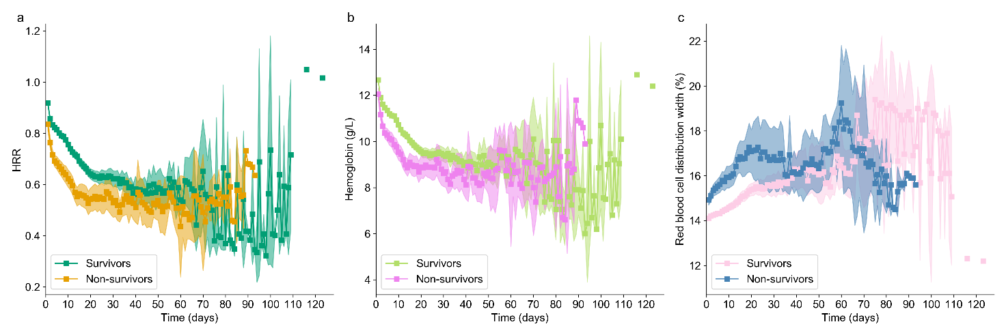
Fig.S1. Dynamic changes of hemoglobin-to-red blood cell distribution width ratio (HRR) (a), hemoglobin (Hb) (b) and red blood cell distribution width (RDW) (c) in intracerebral hemorrhage (ICH) patients during the hospitalization.

