Supplementary Material

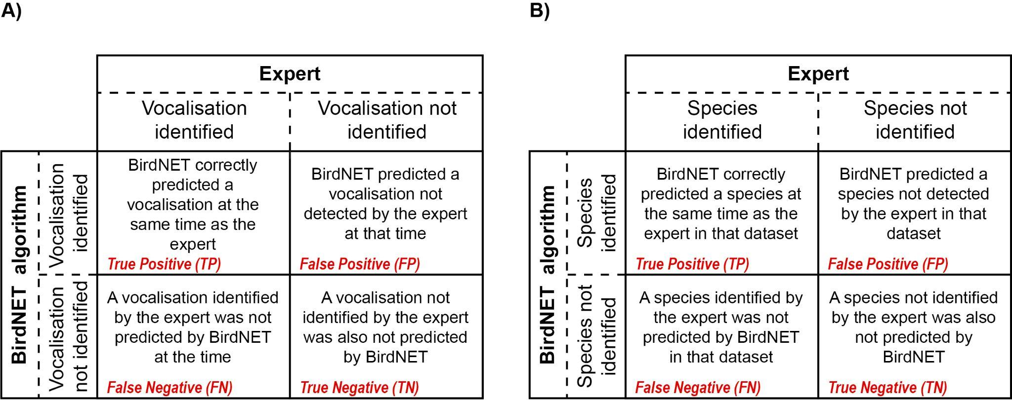
Figure S1. Definitions of True Positives, False Positives, True Negatives, and False Negatives are used to evaluate BirdNET performance at the A) vocalisation, and B) dataset levels.

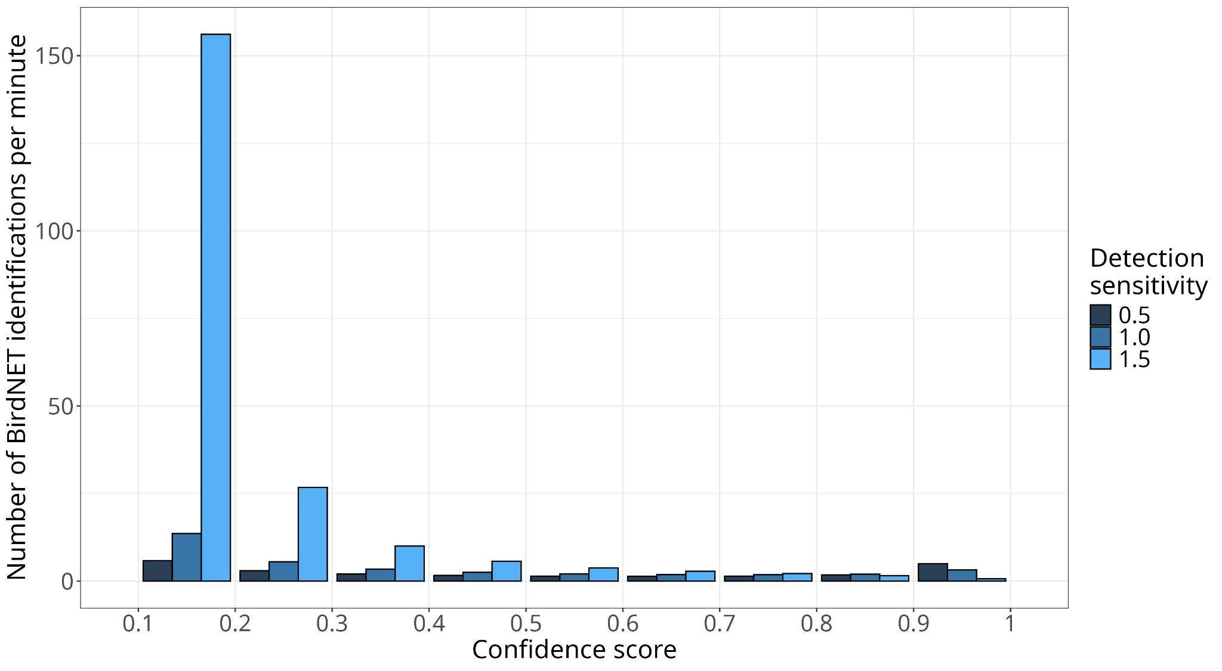
Figure S2: Average number of BirdNET predictions made per minute for different ranges of confidence scores and for each of the Sensitivity values tested, having used an Overlap of 2 s.

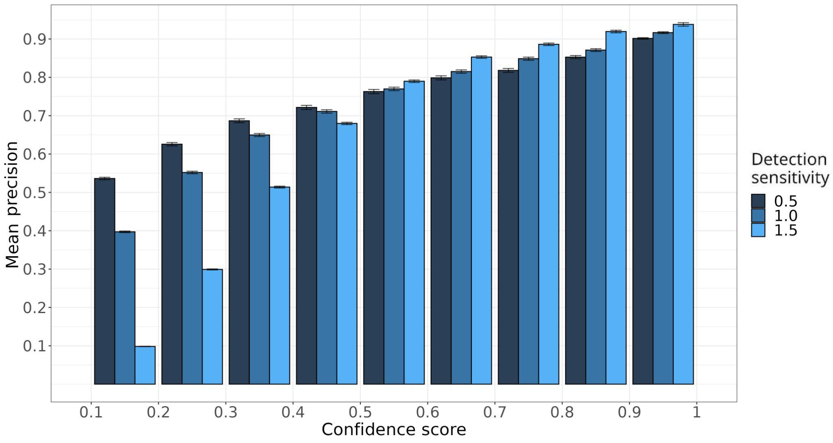
Figure S3: Mean precision, along with the standard error bar, of BirdNET vocalisations predicted for different ranges of confidence scores and each of the Sensitivity values tested, having used an Overlap of 2 s.

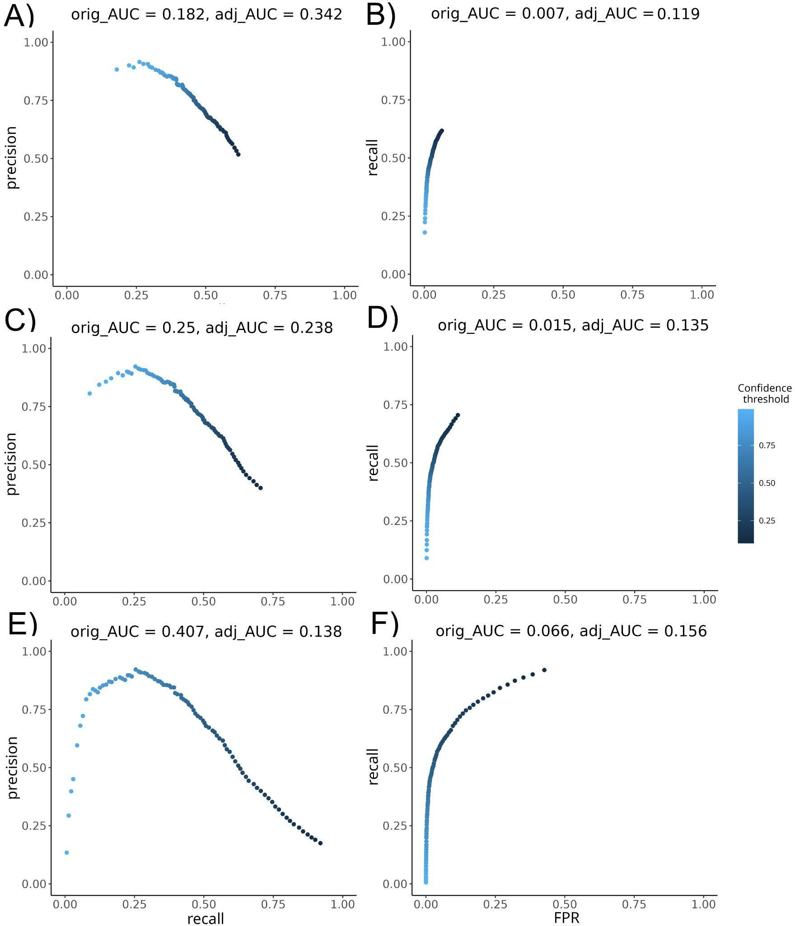
Figure S4: BirdNET-analyser Precision-Recall (PR) and Receiver Operating Characteristic (ROC) curves at the dataset level for Overlap = 0 and different Sensitivity values. The three panels on the left (A, C and E) display PR curves, while the three panels on the right (B, D and F) display ROC curves. The panels are organised by DS settings, the top panels (A and B) corresponding to DS = 0.5, the middle panels (C and D) to DS = 1.0, and the bottom panels (E and F) to DS = 1.5. Original Area Under the Curve (AUC) scores (orig_AUC) and AUC scores divided by the recall range in the PR curve and by the FPR range in the ROC curve (adj_AUC) are shown on top of each curve.

