Ambient particulate Matter Exposure Increases the Risk of Suboptimal Outcomes of
Conjunctival Incision Glaucoma Surgery

Tianhao Chen, Yi Tian, Yixiang Zhu, Haidong Kan, Xinghuai Sun*, Yuan Lei*

* Corresponding authors

Contents
Online-only figures...............................................................................2
Online-only tables................................................................................10

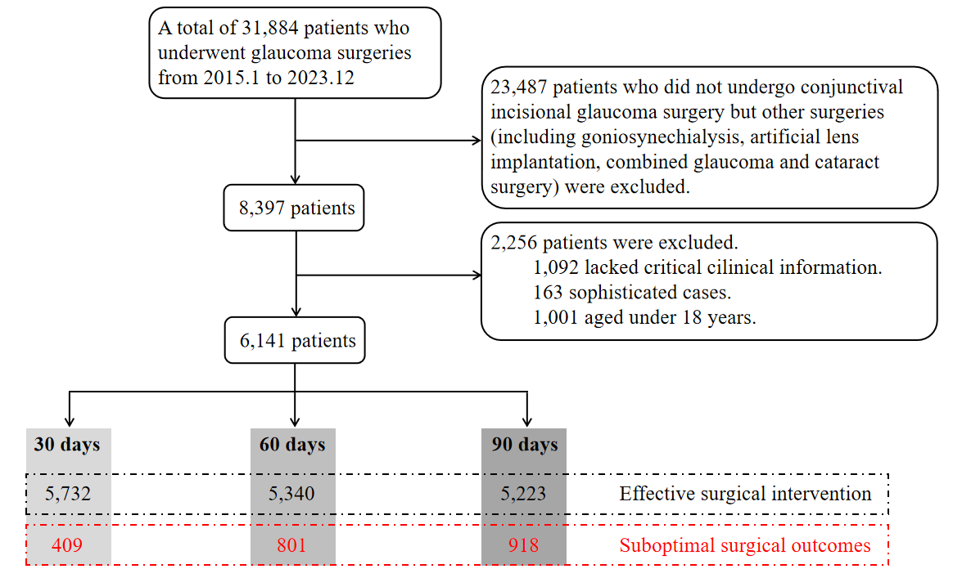
eFigure 1. The flow chart of the enrolled participants.

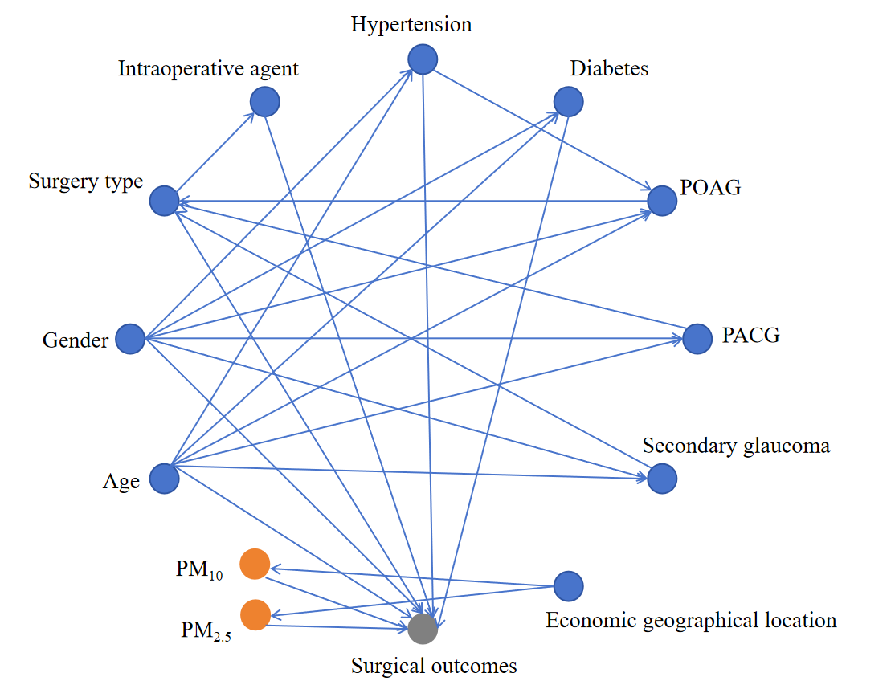
eFigure 2. Directed acyclic graph between exposure to ambient PM and surgical outcomes of patients undergoing conjunctival incision glaucoma surgery. This figure illustrates the associations of various factors found in previous studies with surgical outcomes.

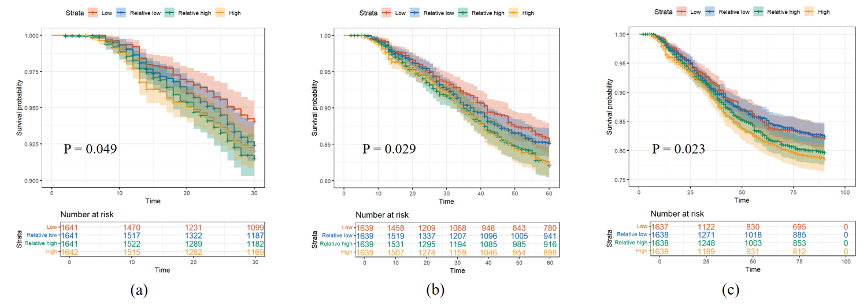
eFigure 3. Kaplan-Meier survival analysis curves for (a) 30-day, (b) 60-day, (c) 90-day subpotimal surgical outcomes, stratified by PM_{2.5} exposure levels. PM_{2.5}, particulate matter with an aerodynamic diameter less than 2.5μm.

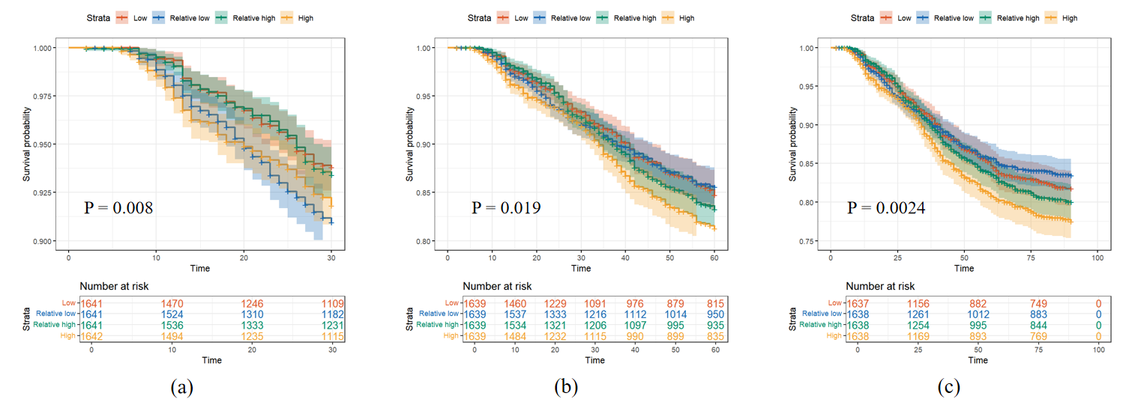
eFigure 4. Kaplan-Meier survival analysis curves for (a) 30-day, (b) 60-day, (c) 90-day suboptimal surgical outcomes, stratified by PM₁₀ exposure levels. PM₁₀, particulate matter with an aerodynamic diameter less than 10μm.

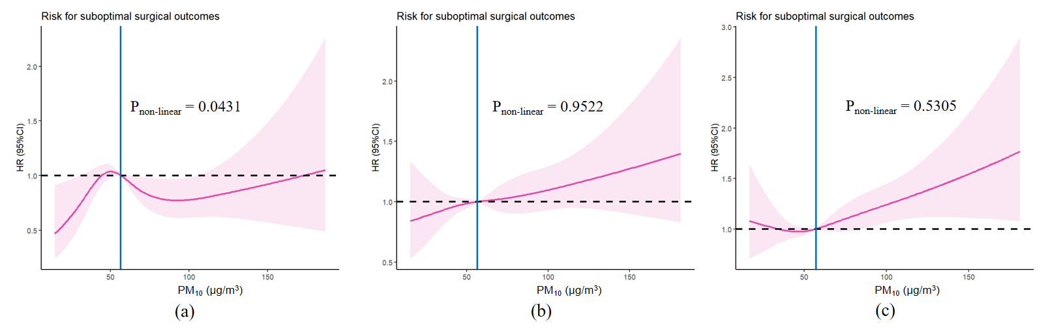
eFigure 5. Restricted cubic spline (RCS) curves of PM₁₀ for (a) 30-day, (b) 60-day, (c) 90-day suboptimal surgical outcomes. RCS regression model was adjusted for age, sex, intraoperative agent, surgery type, economic geographical location, hypertension, diabetes, POAG, PACG and secondary glaucoma. PM₁₀, particulate matter with an aerodynamic diameter less than 10μm; POAG, primary open-angle glaucoma; PACG, primary angle-closure glaucoma; HR: hazard ratio; CI: confidence interval.

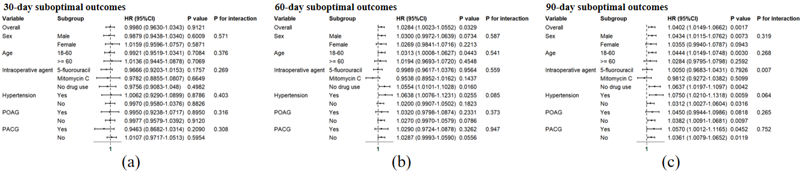
eFigure 6. Stratification and interaction analyses for the association between (a) 30-day, (b) 60-day, (c) 90-day suboptimal surgical outcomes and PM₁₀ exposure. PM₁₀, particulate matter with an aerodynamic diameter less than 10μm; POAG, primary open-angle glaucoma; PACG, primary angle-closure glaucoma; HR: hazard ratio; CI: confidence interval.

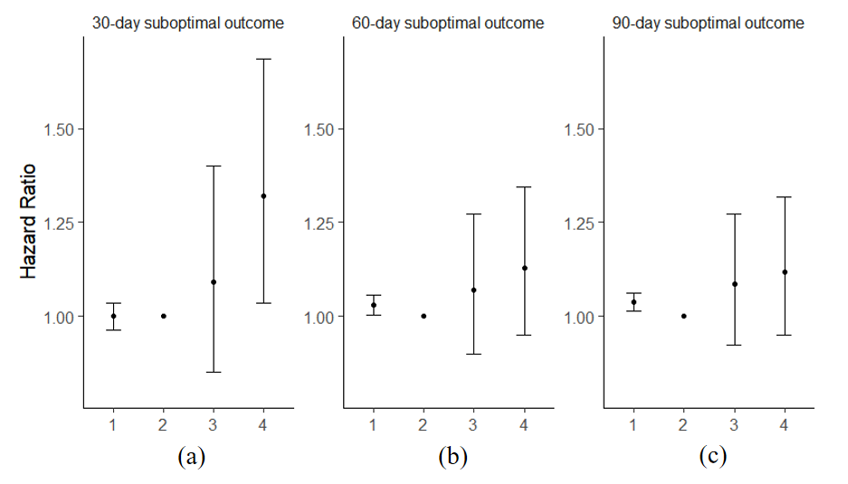
eFigure 7. Associations between constituent proportion of PMs and (a) 30-, (b) 60- and (c) 90-day suboptimal surgical outcomes. Cox regression model was adjusted for age, sex, intraoperative agent, surgery type, economic geographical location, hypertension, diabetes, POAG, PACG and secondary glaucoma. In the abscissa of the three graphs, 1 represents HR of suboptimal surgical outcomes for PM₁₀, 2, 3 and 4 represent HR of suboptimal surgical outcomes for the interaction terms PM₁₀ × low PM_{2.5}/PM₁₀, PM₁₀ × medium PM_{2.5}/PM₁₀ and PM₁₀ × high PM_{2.5}/PM₁₀, on the basis of reference group of PM₁₀ × low PM_{2.5}/PM₁₀, respectively. PM_{2.5}, particulate matter with an aerodynamic diameter less than 2.5μm; PM₁₀, particulate matter with an aerodynamic diameter less than 10μm; POAG, primary open-angle glaucoma; PACG, primary angle-closure glaucoma; HR: hazard ratio.

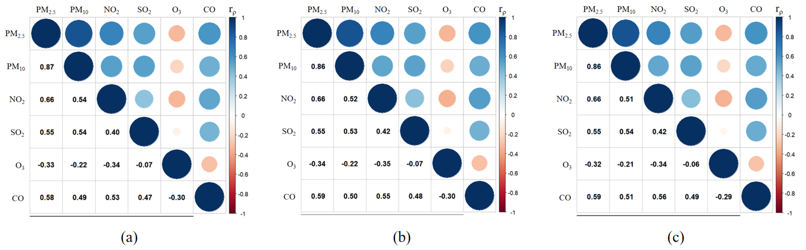
eFigure 8. Spearman rank correlation analyses between PM_{2.5}, PM₁₀, NO₂, SO₂, O₃ and CO for (a) 30-, (b) 60- and (c) 90-day suboptimal surgical outcomes. PM_{2.5}, particulate matter with an aerodynamic diameter less than 2.5μm; PM₁₀, particulate matter with an aerodynamic diameter less than 10μm; NO₂, nitrogen dioxide; SO₂, sulfur dioxide; O₃, ozone; CO, carbon monoxide.

eTable 1. Characteristics of participants with and without suboptimal surgical outcomes 30 days after operation.
Characteristic | Total  (N = 6,141) | Suboptimal surgical outcomes (n = 409) | No suboptimal surgical outcomes (n = 5,732) | P value
Sex |  |  |  | < 0.0001*
Male | 3,378 (55.01%) | 263 (64.30%) | 3,115 (54.34%)
Female | 2,763 (44.49%) | 146 (35.70%) | 2,617 (45.66%)
Age (y) |  |  |  | < 0.0001*
Mean ± SD | 56.72 ± 14.39 | 50.88 ± 14.10 | 57.10 ± 14.32
Median (IQR) | 59 (48-67) | 52 (40-62) | 59 (49-68)
Range | 18-93 | 18-79 | 18-93
PM_{2.5} |  |  |  | 0.0349*
Mean ± SD | 38.38 ± 18.74 | 40.21 ± 18.75 | 38.26 ± 18.73
Median (IQR) | 34.5 (24.81-47.39) | 36.47 (27.19-48.25) | 34.35 (24.61-47.33)
Range | 5.78-185.42 | 6.36-127.48 | 5.78-185.42
PM₁₀ |  |  |  | 0.3597
Mean ± SD | 62.10 ± 28.20 | 63.30 ± 27.31 | 62.02 ± 28.26
Median (IQR) | 56.74 (41.52-76.10) | 56.43 (43.90-77.76) | 56.77 (41.23-75.92)
Range | 8.96-332.83 | 18.29-196.55 | 8.96-332.83
Intraoperative agent |  |  |  | < 0.0001*
5-fluorouracil | 1,245 (20.27%) | 245 (59.90%) | 1,000 (17.45%)
Mitomycin C | 2,361 (38.45%) | 59 (14.43%) | 2,302 (40.16%)
No drug use | 2,535 (41.28%) | 105 (25.67%) | 2,430 (42.39%)
Surgery type |  |  |  | < 0.0001*
Trabeculectomy | 3,130 (50.97%) | 170 (41.56%) | 2,960 (51.64%)
Ex-PRESS shunt | 871 (14.18%) | 45 (11.00%) | 826 (14.41%)
Ahmed glaucoma valve | 2,140 (34.85%) | 194 (47.43%) | 1,946 (33.95%)
(Continued)
Characteristic | Total  (N = 6,141) | Suboptimal surgical outcomes (n = 409) | No suboptimal surgical outcomes (n = 5,732) | P value
Economic geographical location |  |  |  | 0.2693
East | 4,608 (75.04%) | 322 (78.73%) | 4,286 (74.77%)
East-north | 126 (2.05%) | 7 (1.71%) | 119 (2.08%)
Middle | 1,238 (20.16%) | 73 (17.85%) | 1,165 (20.32%)
West | 169 (2.75%) | 7 (1.71%) | 162 (2.83%)
Hypertension |  |  |  | 0.0070*
Yes | 1,778 (28.95%) | 94 (22.98%) | 1,684 (29.38%)
No | 4,363 (71.05%) | 315 (77.02%) | 4,048 (70.62%)
Diabetes |  |  |  | 0.9753
Yes | 1,077 (17.54%) | 71 (17.36%) | 1,006 (17.55%)
No | 5,064 (82.46%) | 338 (82.64%) | 4,726 (82.45%)
POAG |  |  |  | < 0.0001*
Yes | 1,034 (16.84%) | 103 (25.18%) | 931 (16.24%)
No | 5,107 (83.16%) | 306 (74.82%) | 4,801 (83.76%)
PACG |  |  |  | < 0.0001*
Yes | 2,637 (42.94%) | 88 (21.52%) | 2,549 (44.47%)
No | 3,504 (57.06%) | 321 (78.48%) | 3,183 (55.53%)
Secondary glaucoma |  |  |  | < 0.0001*
Yes | 1,282 (20.88%) | 122 (29.83%) | 1,160 (20.24%)
No | 4,859 (79.12%) | 287 (70.17%) | 4,572 (79.76%)
PM_{2.5}, particulate matter with an aerodynamic diameter less than 2.5μm; PM₁₀, particulate matter with an aerodynamic diameter less than 10μm;
POAG, primary open-angle glaucoma; PACG, primary angle-closure glaucoma; SD: standard deviance; IQR: interquartile range. Bold values highlight the P value of <0.05.

eTable 2. Characteristics of participants with and without suboptimal surgical outcomes 60 days after operation.
Characteristic | Total  (N = 6,141) | Suboptimal surgical outcomes (n = 801) | No suboptimal surgical outcomes (n = 5,340) | P value
Sex |  |  |  | < 0.0001*
Male | 3,378 (55.01%) | 517 (64.54%) | 2,861 (53.58%)
Female | 2,763 (44.49%) | 284 (35.46%) | 2,479 (44.42%)
Age (y) |  |  |  | < 0.0001*
Mean ± SD | 56.71 ± 14.40 | 51.65 ± 14.16 | 57.43 ± 14.29
Median (IQR) | 59 (48-67) | 53 (42-63) | 59 (50-68)
Range | 18-93 | 18-82 | 18-93
PM_{2.5} |  |  |  | 0.0004*
Mean ± SD | 38.26 ± 17.87 | 40.39 ± 18.43 | 37.96 ± 17.77
Median (IQR) | 34.59 (25.13-47.52) | 36.93 (26.63-49.35) | 34.25 (24.93-47.32)
Range | 5.78-185.42 | 6.36-129.91 | 5.78-185.42
PM₁₀ |  |  |  | 0.0027*
Mean ± SD | 62.01 ± 27.56 | 64.73 ± 27.56 | 61.63 ± 27.54
Median (IQR) | 56.74 (42.30-76.52) | 59.45 (44.39-80.46) | 56.46 (41.97-76.07)
Range | 8.96-332.83 | 18.29-196.55 | 8.96-332.83
Intraoperative agent |  |  |  | < 0.0001*
5-fluorouracil | 1,245 (20.27%) | 373 (46.57%) | 872 (16.33%)
Mitomycin C | 2,361 (38.45%) | 176 (21.97%) | 2,185 (40.92%)
No drug use | 2,535 (41.28%) | 252 (31.46%) | 2,283 (42.75%)
Surgery type |  |  |  | < 0.0001*
Trabeculectomy | 3,130 (50.97%) | 332 (41.45%) | 2,798 (52.40%)
Ex-PRESS shunt | 871 (14.18%) | 129 (16.10%) | 742 (13.90%)
Ahmed glaucoma valve | 2,140 (34.85%) | 340 (42.45%) | 1,800 (33.71%)
(Continued)
Characteristic | Total  (N = 6,141) | Suboptimal surgical outcomes (n = 409) | No suboptimal surgical outcomes (n = 5,732) | P value
Economic geographical location |  |  |  | 0.0022*
East | 4,608 (75.04%) | 638 (79.65%) | 3,970 (74.34%)
East-north | 126 (2.05%) | 8 (1.00%) | 118 (2.21%)
Middle | 1,238 (20.16%) | 142 (17.73%) | 1,096 (20.52%)
West | 169 (2.75%) | 13 (1.62%) | 156 (2.92%)
Hypertension |  |  |  | 0.0007*
Yes | 1,778 (28.95%) | 191 (23.85%) | 1,587 (29.72%)
No | 4,363 (71.05%) | 610 (76.15%) | 3,753 (70.28%)
Diabetes |  |  |  | 0.3201
Yes | 1,077 (17.54%) | 130 (16.23%) | 947 (17.73%)
No | 5,064 (82.46%) | 671 (83.77%) | 4,393 (82.27%)
POAG |  |  |  | < 0.0001*
Yes | 1,034 (16.84%) | 200 (24.97%) | 834 (15.62%)
No | 5,107 (83.16%) | 601 (75.03%) | 4,506 (84.38%)
PACG |  |  |  | < 0.0001*
Yes | 2,637 (42.94%) | 174 (21.72%) | 2,463 (46.12%)
No | 3,504 (57.06%) | 627 (78.28%) | 2,877 (53.88%)
Secondary glaucoma |  |  |  | < 0.0001*
Yes | 1,282 (20.88%) | 224 (27.97%) | 1,058 (19.81%)
No | 4,859 (79.12%) | 577 (72.03%) | 4,282 (80.19%)
PM_{2.5}, particulate matter with an aerodynamic diameter less than 2.5μm; PM₁₀, particulate matter with an aerodynamic diameter less than 10μm;
POAG, primary open-angle glaucoma; PACG, primary angle-closure glaucoma; SD: standard deviance; IQR: interquartile range. Bold values highlight the P value of <0.05.

eTable 3. Characteristics of participants with and without suboptimal surgical outcomes 90 days after operation.
Characteristic | Total  (N = 6,141) | Suboptimal surgical outcomes (n = 918) | No suboptimal surgical outcomes (n = 5,223) | P value
Sex |  |  |  | < 0.0001*
Male | 3,378 (55.01%) | 598 (65.14%) | 2,780 (53.23%)
Female | 2,763 (44.49%) | 320 (34.86%) | 2,443 (46.77%)
Age (y) |  |  |  | < 0.0001*
Mean ± SD | 56.70 ± 14.40 | 51.56 ± 14.10 | 57.56 ± 14.27
Median (IQR) | 59 (48-67) | 53 (42-62.5) | 60 (50-68)
Range | 18-93 | 18-82 | 18-93
PM_{2.5} |  |  |  | < 0.0001*
Mean ± SD | 38.05 ± 17.40 | 40.28 ± 18.27 | 37.68 ± 17.22
Median (IQR) | 34.62 (25.31-46.96) | 36.93 (26.66-49.18) | 34.28 (25.06-46.56)
Range | 5.78-185.42 | 6.36-129.91 | 5.78-185.42
PM₁₀ |  |  |  | 0.0003*
Mean ± SD | 61.72 ± 26.92 | 64.76 ± 27.44 | 61.21 ± 26.80
Median (IQR) | 56.59 (42.38-75.72) | 59.72 (44.51-79.93) | 56.12 (41.94-74.86)
Range | 8.96-332.83 | 14.41-196.55 | 8.96-332.83
Intraoperative agent |  |  |  | < 0.0001*
5-fluorouracil | 1,245 (20.27%) | 401 (43.68%) | 844 (16.16%)
Mitomycin C | 2,361 (38.45%) | 219 (23.86%) | 2,142 (41.01%)
No drug use | 2,535 (41.28%) | 298 (32.46%) | 2,237 (42.83%)
Surgery type |  |  |  | < 0.0001*
Trabeculectomy | 3,130 (50.97%) | 367 (39.98%) | 2,763 (52.90%)
Ex-PRESS shunt | 871 (14.18%) | 150 (16.34%) | 721 (13.80%)
Ahmed glaucoma valve | 2,140 (34.85%) | 401 (43.68%) | 1,739 (33.30%)
(Continued)
Characteristic | Total  (N = 6,141) | Suboptimal surgical outcomes (n = 409) | No suboptimal surgical outcomes (n = 5,732) | P value
Economic geographical location |  |  |  | 0.5580
East | 4,608 (75.04%) | 677 (73.75%) | 3,931 (75.26%)
East-north | 126 (2.05%) | 23 (2.51%) | 103 (1.97%)
Middle | 1,238 (20.16%) | 189 (20.59%) | 1,049 (20.08%)
West | 169 (2.75%) | 29 (3.16%) | 140 (2.68%)
Hypertension |  |  |  | 0.0002*
Yes | 1,778 (28.95%) | 218 (23.75%) | 1,560 (29.87%)
No | 4,363 (71.05%) | 700 (76.25%) | 3,663 (70.13%)
Diabetes |  |  |  | 0.3714
Yes | 1,077 (17.54%) | 151 (16.45%) | 926 (17.73%)
No | 5,064 (82.46%) | 767 (83.55%) | 4,297 (82.27%)
POAG |  |  |  | < 0.0001*
Yes | 1,034 (16.84%) | 230 (25.05%) | 804 (15.39%)
No | 5,107 (83.16%) | 688 (74.95%) | 4,419 (84.61%)
PACG |  |  |  | < 0.0001*
Yes | 2,637 (42.94%) | 188 (20.48%) | 2,449 (46.89%)
No | 3,504 (57.06%) | 730 (79.52%) | 2,774 (53.11%)
Secondary glaucoma |  |  |  | < 0.0001*
Yes | 1,282 (20.88%) | 248 (27.02%) | 1,034 (19.80%)
No | 4,859 (79.12%) | 670 (72.98%) | 4,189 (80.20%)
PM_{2.5}, particulate matter with an aerodynamic diameter less than 2.5μm; PM₁₀, particulate matter with an aerodynamic diameter less than 10μm;
POAG, primary open-angle glaucoma; PACG, primary angle-closure glaucoma; SD: standard deviance; IQR: interquartile range. Bold values highlight the P value of <0.05.

eTable 4. Cox proportional hazard ratios for PM₁₀.
PM₁₀ (μg/m³) | Model 1 |  |  | Model 2 |  |  | Model 3 |  |  | Model 4
PM₁₀ (μg/m³) | HR (95%CI) | P value |  | HR (95%CI) | P value |  | HR (95%CI) | P value |  | HR (95%CI) | P value
30-day suboptimal outcome
Continuous variable per 10 μg/m³ | 1.013 (0.9792-1.049) | 0.445 |  | 1.0027 (0.9687-1.0378) | 0.8794 |  | 1.0016 (0.9671-1.0372) | 0.9302 |  | 0.9975 (0.9629-1.0334) | 0.8896
Quartile
Q1 (8.96-41.52) | Reference |  |  | Reference |  |  | Reference |  |  | Reference
Q2 (41.52-56.74) | 1.498 (1.1340-1.980) | 0.0045* |  | 1.4961 (1.1321-1.977) | 0.0046* |  | 1.4569 (1.1006-1.9286) | 0.0086* |  | 1.4279 (1.0785-1.8905) | 0.0129*
Q3 (56.74-76.10) | 1.064 (0.7892-1.434) | 0.6845 |  | 1.0200 (0.7565-1.375) | 0.8968 |  | 1.0116 (0.7488-1.3667) | 0.9401 |  | 0.9893 (0.7319-1.3373) | 0.9443
Q4 (76.10-332.83) | 1.380 (1.0371-1.837) | 0.0271* |  | 1.2221 (0.9164-1.630) | 0.1721 |  | 1.1928 (0.8908-1.5971) | 0.2365 |  | 1.1658 (0.8698-1.5626) | 0.3046
P for trend |  | 0.196 |  |  | 0.7491 |  |  | 0.8453 |  |  | 0.9491
60-day suboptimal outcome
Continuous variable per 10 μg/m³ | 1.044 (1.018-1.07) | 0.0007* |  | 1.0345 (1.0089-1.0607) | 0.0079* |  | 1.0328 (1.0069-1.0593) | 0.0127* |  | 1.0297 (1.0036-1.0564) | 0.0253*
Quartile
Q1 (8.96-42.30) | Reference |  |  | Reference |  |  | Reference |  |  | Reference
Q2 (42.30-56.74) | 0.9698 (0.7907-1.189) | 0.7684 |  | 0.9546 (0.7782-1.1710) | 0.656 |  | 0.9450 (0.7696-1.1604) | 0.589 |  | 0.9177 (0.7471-1.1272) | 0.4130
Q3 (56.74-76.52) | 1.1021 (0.9036-1.344) | 0.3375 |  | 1.0701 (0.8770-1.3056) | 0.505 |  | 1.0578 (0.8652-1.2932) | 0.584 |  | 1.0393 (0.8499-1.2709) | 0.7075
Q4 (76.52-332.83) | 1.2796 (1.0524-1.556) | 0.0134* |  | 1.1643 (0.9558-1.4182) | 0.131 |  | 1.1432 (0.9356-1.3968) | 0.191 |  | 1.1301 (0.9242-1.3819) | 0.2333
P for trend |  | 0.0031* |  |  | 0.0541 |  |  | 0.0843 |  |  | 0.0896
90-day suboptimal outcome
Continuous variable per 10 μg/m³ | 1.054 (1.029-1.08) | < 0.0001* |  | 1.0440 (1.0192-1.0694) | 0.0004* |  | 1.0438 (1.0188-1.0695) | 0.0005* |  | 1.0412 (1.0160-1.0671) | 0.0013*
Quartile
Q1 (8.96-42.38) | Reference |  |  | Reference |  |  | Reference |  |  | Reference
Q2 (42.38-56.59) | 0.9317 (0.7693-1.128) | 0.4690 |  | 0.9358 (0.7727-1.1334) | 0.4973 |  | 0.9294 (0.7665-1.1270) | 0.4568 |  | 0.9059 (0.7469-1.0987) | 0.3153
Q3 (56.59-75.72) | 1.0968 (0.9118-1.319) | 0.3270 |  | 1.0770 (0.8950-1.2960) | 0.4322 |  | 1.0784 (0.8940-1.3010) | 0.4302 |  | 1.0730 (0.8892-1.2948) | 0.4625
Q4 (75.72-332.83) | 1.2889 (1.0749-1.546) | 0.0062* |  | 1.1854 (0.9870-1.4237) | 0.0688 |  | 1.1787 (0.9781-1.4205) | 0.0840 |  | 1.1689 (0.9692-1.4098) | 0.1026
P for trend |  | 0.0006* |  |  | 0.0183* |  |  | 0.0222* |  |  | 0.0225*
Model 1: Crude; Model 2: Adjusted for age and sex; Model 3: Adjusted for age, sex, intraoperative agent, surgery type and economic geographical location; Model 4: Adjusted for age, sex, intraoperative agent, surgery type, economic geographical location, hypertension,
diabetes, POAG, PACG and secondary glaucoma. PM₁₀, particulate matter with an aerodynamic diameter less than 10μm; POAG, primary open-angle glaucoma; PACG, primary angle-closure glaucoma;HR: hazard ratio; CI: confidence interval. Bold values highlight the P value of <0.05.

eTable 5. Sensitivity analysis for associations between PM_{2.5} and 30-, 60-, and 90-day suboptimal surgical outcomes, using model 4ª adjusted for another air pollutant (namely two-pollutant models).
PM_{2.5} (μg/m³) | NO₂ |  |  | SO₂ |  |  | O₃ |  |  | CO
PM_{2.5} (μg/m³) | HR (95%CI) | P value |  | HR (95%CI) | P value |  | HR (95%CI) | P value |  | HR (95%CI) | P value
30-day suboptimal outcome
Continuous variable per 10 μg/m³ | 0.9976 (0.9610-1.0342) | 0.6677 |  | 1.0678 (1.0050-1.1346) | 0.0340* |  | 1.0664 (1.0065-1.1298) | 0.0293* |  | 1.0244 (0.9593-1.0940) | 0.4716
Quartile
Q1 (5.78-24.81) | Reference |  |  | Reference |  |  | Reference |  |  | Reference
Q2 (24.81-34.5) | 1.1993 (0.8827-1.6293) | 0.2452 |  | 1.3547 (1.0070-1.8225) | 0.0449* |  | 1.3150 (0.9786-1.7671) | 0.0693 |  | 1.3091 (0.9723-1.7625) | 0.0759
Q3 (34.5-47.39) | 1.1578 (0.8363-1.6029) | 0.3773 |  | 1.4563 (1.0836-1.9571) | 0.0127* |  | 1.4097 (1.0532-1.8868) | 0.0210* |  | 1.3528 (1.0041-1.8227) | 0.0470*
Q4 (47.39-185.42) | 1.0037 (0.6959-1.4475) | 0.9844 |  | 1.4822 (1.0732-2.0470) | 0.0169* |  | 1.4326 (1.0487-1.9569) | 0.0239* |  | 1.2463 (0.8916-1.7422) | 0.1976
P for trend |  | 0.6176 |  |  | 0.0306* |  |  | 0.0367* |  |  | 0.3314
60-day suboptimal outcome
Continuous variable per 10 μg/m³ | 1.0024 (0.9535-1.0537) | 0.9254 |  | 1.0831 (1.0342-1.1344) | 0.0007* |  | 1.0908 (1.0439-1.1398) | 0.0001* |  | 1.0345 (0.9844-1.0872) | 0.1808
Quartile
Q1 (5.78-25.13) | Reference |  |  | Reference |  |  | Reference |  |  | Reference
Q2 (25.13-34.59) | 0.9338 (0.7514-1.1606) | 0.5369 |  | 1.0699 (0.8674-1.3197) | 0.5277 |  | 1.0528 (0.8544-1.2971) | 0.6293 |  | 1.0268 (0.8320-1.2671) | 0.8056
Q3 (34.59-47.52) | 0.9879 (0.7844-1.2444) | 0.9179 |  | 1.2650 (1.0296-1.5542) | 0.0252* |  | 1.2690 (1.0354-1.5554) | 0.0217* |  | 1.1744 (0.9545-1.4448) | 0.1286
Q4 (47.52-185.42) | 0.8676 (0.6686-1.1258) | 0.2852 |  | 1.2737 (1.0148-1.5987) | 0.0369* |  | 1.3190 (1.0603-1.6407) | 0.0129* |  | 1.0622 (0.8393-1.3445) | 0.6155
P for trend |  | 0.2971 |  |  | 0.0202* |  |  | 0.0052* |  |  | 0.5098
90-day suboptimal outcome
Continuous variable per 10 μg/m³ | 1.0250 (1.0089-1.0601) | 0.0401* |  | 1.0923 (1.0445-1.1423) | 0.0001* |  | 1.1055 (1.0595-1.1534) | < 0.0001* |  | 1.0497 (1.0008-1.1010) | 0.0488*
Quartile
Q1 (5.78-25.31) | Reference |  |  | Reference |  |  | Reference |  |  | Reference
Q2 (25.31-34.62) | 0.8775 (0.7168-1.0743) | 0.2056 |  | 1.0170 (0.8372-1.2355) | 0.8651 |  | 1.0115 (0.8333-1.2278) | 0.9078 |  | 0.9795 (0.8057-1.1908) | 0.8355
Q3 (34.62-46.96) | 0.9047 (0.7280-1.1243) | 0.3664 |  | 1.1855 (0.9772-1.4383) | 0.0844 |  | 1.1965 (0.9892-1.4472) | 0.0646 |  | 1.1054 (0.9102-1.3426) | 0.3121
Q4 (46.96-185.42) | 0.9439 (0.7621-1.1756) | 0.4305 |  | 1.2494 (1.0119-1.5426) | 0.0384* |  | 1.3142 (1.0739-1.6082) | 0.0080* |  | 1.0944 (0.8962-1.3332) | 0.3741
P for trend |  | 0.0702 |  |  | 0.0166* |  |  | 0.0023* |  |  | 0.1074
ª The model 4 was adjusted for age, sex, intraoperative agent, surgery type, economic geographical location, hypertension, diabetes, POAG, PACG and secondary glaucoma. PM_{2.5}, particulate matter with an aerodynamic diameter less than 2.5μm;
NO₂, nitrogen dioxide; SO₂, sulfur dioxide; O₃, ozone; CO, carbon monoxide; POAG, primary open-angle glaucoma; PACG, primary angle-closure glaucoma; HR: hazard ratio; CI: confidence interval. Bold values highlight the P value of <0.05.

eTable 6. Sensitivity analysis for associations between PM₁₀ and 30-, 60-, and 90-day suboptimal surgical outcomes, using model 4ª adjusted for another air pollutant (namely two-pollutant models).
PM₁₀ (μg/m³) | NO₂ |  |  | SO₂ |  |  | O₃ |  |  | CO
PM₁₀ (μg/m³) | HR (95%CI) | P value |  | HR (95%CI) | P value |  | HR (95%CI) | P value |  | HR (95%CI) | P value
30-day suboptimal outcome
Continuous variable per 10 μg/m³ | 0.9976 (0.9887-1.0081) | 0.1406 |  | 1.0120 (0.9712-1.0544) | 0.5709 |  | 1.0077 (0.9712-1.0455) | 0.6840 |  | 0.9842 (0.9436-1.0265) | 0.4588
Quartile
Q1 (8.96-41.52) | Reference |  |  | Reference |  |  | Reference |  |  | Reference
Q2 (41.52-56.74) | 1.1195 (0.8375-1.4964) | 0.4459 |  | 1.2938 (0.9753-1.7164) | 0.0740 |  | 1.2630 (0.9538-1.6724) | 0.1031 |  | 1.2387 (0.9337-1.6434) | 0.1377
Q3 (56.74-76.10) | 0.8497 (0.6176-1.1692) | 0.3174 |  | 1.1056 (0.8214-1.4881) | 0.5077 |  | 1.0827 (0.8088-1.4494) | 0.5932 |  | 1.0142 (0.7528-1.3666) | 0.9259
Q4 (76.10-332.83) | 0.7931 (0.5660-1.1114) | 0.1781 |  | 1.1468 (0.8331-1.5784) | 0.4009 |  | 1.0984 (0.8150-1.4804) | 0.5377 |  | 0.9639 (0.6981-1.3309) | 0.8234
P for trend |  | 0.0530 |  |  | 0.7465 |  |  | 0.9123 |  |  | 0.4216
60-day suboptimal outcome
Continuous variable per 10 μg/m³ | 1.0017 (0.9724-1.0319) | 0.9088 |  | 1.0415 (1.0108-1.0731) | 0.0077* |  | 1.0380 (1.0106-1.0660) | 0.0062* |  | 1.0129 (0.9822-1.0446) | 0.4141
Quartile
Q1 (8.96-42.30) | Reference |  |  | Reference |  |  | Reference |  |  | Reference
Q2 (42.30-56.74) | 0.8128 (0.6556-1.0077) | 0.0588 |  | 0.9425 (0.7664-1.1590) | 0.5743 |  | 0.9382 (0.7637-1.1527) | 0.5438 |  | 0.9030 (0.7338-1.1112) | 0.3350
Q3 (56.74-76.52) | 0.8523 (0.6816-1.0657) | 0.1610 |  | 1.0819 (0.8798-1.3306) | 0.4556 |  | 1.0780 (0.8800-1.3205) | 0.4681 |  | 0.9955 (0.8090-1.2250) | 0.9663
Q4 (76.52-332.83) | 0.8871 (0.7028-1.1198) | 0.3135 |  | 1.2195 (0.9765-1.5230) | 0.0801 |  | 1.2083 (0.9826-1.4858) | 0.0729 |  | 1.0326 (0.8249-1.2927) | 0.7796
P for trend |  | 0.7539 |  |  | 0.0288* |  |  | 0.0222* |  |  | 0.9775
90-day suboptimal outcome
Continuous variable per 10 μg/m³ | 1.0125 (0.9843-1.0414) | 0.3894 |  | 1.0491 (1.0192-1.0798) | 0.0011* |  | 1.0483 (1.0218-1.0754) | 0.0003* |  | 1.0285 (1.0093-1.0542) | 0.0384*
Quartile
Q1 (8.96-42.38) | Reference |  |  | Reference |  |  | Reference |  |  | Reference
Q2 (42.38-56.59) | 0.8026 (0.7396-1.0002) | 0.0983 |  | 0.9124 (0.7517-1.1075) | 0.3538 |  | 0.9157 (0.7548-1.1109) | 0.3718 |  | 0.8794 (0.7240-1.0682) | 0.1953
Q3 (56.59-75.72) | 0.8751 (0.7127-1.0746) | 0.2030 |  | 1.0919 (0.9004-1.3241) | 0.3714 |  | 1.0949 (0.9065-1.3226) | 0.3467 |  | 1.0179 (0.8394-1.2343) | 0.8570
Q4 (75.72-332.83) | 0.8970 (0.7228-1.1131) | 0.3234 |  | 1.2120 (0.9851-1.4913) | 0.0691 |  | 1.2253 (1.0108-1.4853) | 0.0385* |  | 1.0447 (0.8471-1.2884) | 0.6827
P for trend |  | 0.0901 |  |  | 0.0177* |  |  | 0.0066* |  |  | 0.2460
ª The model 4 was adjusted for age, sex, intraoperative agent, surgery type, economic geographical location, hypertension, diabetes, POAG, PACG and secondary glaucoma. PM₁₀, particulate matter with an aerodynamic diameter less than 2.5μm;
NO₂, nitrogen dioxide; SO₂, sulfur dioxide; O₃, ozone; CO, carbon monoxide; POAG, primary open-angle glaucoma; PACG, primary angle-closure glaucoma; HR: hazard ratio; CI: confidence interval. Bold values highlight the P value of <0.05.

eTable 7. Sensitivity analysis for associations between PM_{2.5} and 30-, 60-, and 90-day suboptimal surgical outcomes, using model 4ª adjusted for ambient temperature.
PM_{2.5} (μg/m³) | Ambient temperature (℃)
PM_{2.5} (μg/m³) | HR (95%CI) | P value
30-day suboptimal outcome
Continuous variable per 10 μg/m³ | 1.0400 (0.9840-1.0992) | 0.1646
Quartile
Q1 (5.78-24.81) | Reference
Q2 (24.81-34.5) | 1.3290 (0.9543-1.8509) | 0.0924
Q3 (34.5-47.39) | 1.5904 (1.1383-2.2222) | 0.0066*
Q4 (47.39-185.42) | 1.5224 (1.0361-2.2369) | 0.0323*
P for trend |  | 0.0530
60-day suboptimal outcome
Continuous variable per 10 μg/m³ | 1.0584 (1.0156-1.1030) | 0.0071*
Quartile
Q1 (5.78-25.13) | Reference
Q2 (25.13-34.59) | 1.1166 (0.8879-1.4041) | 0.3456
Q3 (34.59-47.52) | 1.2997 (1.0330-1.6352) | 0.0253*
Q4 (47.52-185.42) | 1.3182 (1.0221-1.7001) | 0.0333*
P for trend |  | 0.0298*
90-day suboptimal outcome
Continuous variable per 10 μg/m³ | 1.0713 (1.0288-1.1157) | 0.0009*
Quartile
Q1 (5.78-25.31) | Reference
Q2 (25.31-34.62) | 1.0277 (0.8319-1.2696) | 0.8000
Q3 (34.62-46.96) | 1.1445 (0.9274-1.4124) | 0.2085
Q4 (46.96-185.42) | 1.2006 (0.9596-1.5021) | 0.1097
P for trend |  | 0.0457*
ª The model 4 was adjusted for age, sex, intraoperative agent, surgery type, economic geographical location, hypertension, diabetes, POAG, PACG and secondary glaucoma. PM_{2.5}, particulate matter with an aerodynamic diameter less than 2.5μm; POAG, primary open-angle glaucoma; PACG, primary angle-closure glaucoma; HR: hazard ratio; CI: confidence interval. Bold values highlight the P value of <0.05.

eTable 8. Sensitivity analysis for associations between PM₁₀ and 30-, 60-, and 90-day suboptimal surgical outcomes, using model 4ª adjusted for ambient temperature.
PM₁₀ (μg/m³) | Ambient temperature (℃)
PM₁₀ (μg/m³) | HR (95%CI) | P value
30-day suboptimal outcome
Continuous variable per 10 μg/m³ | 1.0045 (0.9672-1.0433) | 0.8153
Quartile
Q1 (8.96-41.52) | Reference
Q2 (41.52-56.74) | 1.3439 (0.9821-1.8390) | 0.0648
Q3 (56.74-76.10) | 1.1161 (0.7968-1.5635) | 0.5230
Q4 (76.10-332.83) | 1.1211 (0.7840-1.6031) | 0.5310
P for trend |  | 0.9858
60-day suboptimal outcome
Continuous variable per 10 μg/m³ | 1.0322 (1.0046-1.0605) | 0.0220*
Quartile
Q1 (8.96-42.30) | Reference
Q2 (42.30-56.74) | 0.9662 (0.7688-1.2144) | 0.7682
Q3 (56.74-76.52) | 1.0532 (0.8370-1.3254) | 0.6582
Q4 (76.52-332.83) | 1.2161 (0.9585-1.5430) | 0.1071
P for trend |  | 0.0444*
90-day suboptimal outcome
Continuous variable per 10 μg/m³ | 1.0437 (1.0166-1.0716) | 0.0015*
Quartile
Q1 (8.96-42.38) | Reference
Q2 (42.38-56.59) | 0.8948 (0.7223-1.1084) | 0.3088
Q3 (56.59-75.72) | 1.0318 (0.8375-1.2712) | 0.7685
Q4 (75.72-332.83) | 1.1555 (0.9328-1.4313) | 0.1859
P for trend |  | 0.0497*
ª The model 4 was adjusted for age, sex, intraoperative agent, surgery type, economic geographical location, hypertension, diabetes, POAG, PACG and secondary glaucoma. PM₁₀, particulate matter with an aerodynamic diameter less than 10μm; POAG, primary open-angle glaucoma; PACG, primary angle-closure glaucoma; HR: hazard ratio; CI: confidence interval. Bold values highlight the P value of <0.05.

eTable 9. Sensitivity analysis for associations between PM_{2.5} and 30-, 60-, and 90-day suboptimal surgical outcomes, using model 4ª adjusted for surgery season or visit season or both.
PM_{2.5} (μg/m³) | Surgery season |  |  | Visit season |  |  | Surgery season + visit season
PM_{2.5} (μg/m³) | HR (95%CI) | P value |  | HR (95%CI) | P value |  | HR (95%CI) | P value
30-day suboptimal outcome
Continuous variable per 10 μg/m³ | 1.0634 (1.0043-1.1259) | 0.0351* |  | 1.0452 (0.9896-1.1039) | 0.1130 |  | 1.0634 (1.0043-1.1261) | 0.0351*
Quartile
Q1 (5.78-24.81) | Reference |  |  | Reference |  |  | Reference
Q2 (24.81-34.5) | 1.3582 (1.0081-1.8298) | 0.0441* |  | 1.3967 (1.0342-1.8862) | 0.0293* |  | 1.4008 (1.0371-1.8922) | 0.0280*
Q3 (34.5-47.39) | 1.4446 (1.0720-1.9468) | 0.0157* |  | 1.5416 (1.1290-2.1050) | 0.0065* |  | 1.5464 (1.1324-2.1118) | 0.0061*
Q4 (47.39-185.42) | 1.3955 (1.0180-1.9132) | 0.0384* |  | 1.5445 (1.0929-2.1826) | 0.0138* |  | 1.5525 (1.0981-2.1949) | 0.0128*
P for trend |  | 0.0874 |  |  | 0.0349* |  |  | 0.0329*
60-day suboptimal outcome
Continuous variable per 10 μg/m³ | 1.0904 (1.0439-1.1390) | 0.0001* |  | 1.0550 (1.0140-1.0975) | 0.0081* |  | 1.0897 (1.0433-1.1381) | 0.0001*
Quartile
Q1 (5.78-25.13) | Reference |  |  | Reference |  |  | Reference
Q2 (25.13-34.59) | 1.0894 (0.8825-1.3449) | 0.4254 |  | 1.0954 (0.8841-1.3571) | 0.4048 |  | 1.1221 (0.9048-1.3915) | 0.2943
Q3 (34.59-47.52) | 1.2835 (1.0452-1.5760) | 0.0172* |  | 1.3233 (1.0594-1.6529) | 0.0136* |  | 1.3605 (1.0880-1.7012) | 0.0069*
Q4 (47.52-185.42) | 1.2603 (1.0198-1.5576) | 0.0322* |  | 1.3285 (1.0344-1.7063) | 0.0261* |  | 1.3787 (1.0715-1.7742) | 0.0125*
P for trend |  | 0.0211* |  |  | 0.0210* |  |  | 0.0108*
90-day suboptimal outcome
Continuous variable per 10 μg/m³ | 1.1133 (1.0670-1.1615) | < 0.0001* |  | 1.0727 (1.0329-1.1141) | 0.0003* |  | 1.1128 (1.0666-1.1610) | < 0.0001*
Quartile
Q1 (5.78-25.31) | Reference |  |  | Reference |  |  | Reference
Q2 (25.31-34.62) | 1.0276 (0.8456-1.2488) | 0.7841 |  | 0.9952 (0.8142-1.2165) | 0.9626 |  | 1.0180 (0.8310-1.2470) | 0.8633
Q3 (34.62-46.96) | 1.1933 (0.9858-1.4444) | 0.0697 |  | 1.1405 (0.9272-1.4027) | 0.2133 |  | 1.1756 (0.9522-1.4514) | 0.1324
Q4 (46.96-185.42) | 1.2376 (1.0207-1.5006) | 0.0302* |  | 1.1657 (0.9280-1.4643) | 0.1877 |  | 1.2105 (0.9584-1.5289) | 0.1088
P for trend |  | 0.0123* |  |  | 0.0465* |  |  | 0.0415*
ª The model 4 was adjusted for age, sex, intraoperative agent, surgery type, economic geographical location, hypertension, diabetes, POAG, PACG and secondary glaucoma. PM_{2.5}, particulate matter with an aerodynamic diameter less than 2.5μm; POAG, primary open-angle glaucoma; PACG, primary angle-closure glaucoma; HR: hazard ratio; CI: confidence interval. Bold values highlight the P value of <0.05.

eTable 10. Sensitivity analysis for associations between PM₁₀ and 30-, 60-, and 90-day suboptimal surgical outcomes, using model 4ª adjusted for surgery season or visit season or both.
PM₁₀ (μg/m³) | Surgery season |  |  | Visit season |  |  | Surgery season + visit season
PM₁₀ (μg/m³) | HR (95%CI) | P value |  | HR (95%CI) | P value |  | HR (95%CI) | P value
30-day suboptimal outcome
Continuous variable per 10 μg/m³ | 1.0060 (0.9699-1.0435) | 0.7479 |  | 1.0002 (0.9649-1.0369) | 0.9897 |  | 1.0059 (0.9697-1.0435) | 0.7523
Quartile
Q1 (8.96-41.52) | Reference |  |  | Reference |  |  | Reference
Q2 (41.52-56.74) | 1.2816 (0.9656-1.7011) | 0.0859 |  | 1.2915 (0.9708-1.7183) | 0.0790 |  | 1.2937 (0.9722-1.7215) | 0.5259
Q3 (56.74-76.10) | 1.0824 (0.8040-1.4571) | 0.6018 |  | 1.1037 (0.8103-1.5034) | 0.5314 |  | 1.1052 (0.8113-1.5055) | 0.5236
Q4 (76.10-332.83) | 1.0824 (0.7956-1.4725) | 0.6141 |  | 1.1086 (0.7997-1.5368) | 0.5363 |  | 1.1123 (0.8020-1.5428) | 0.6313
P for trend |  | 0.9295 |  |  | 0.9527 |  |  | 0.9391
60-day suboptimal outcome
Continuous variable per 10 μg/m³ | 1.0390 (1.0115-1.0672) | 0.0052* |  | 1.0282 (1.0021-1.0550) | 0.0340* |  | 1.0402 (1.0127-1.0684) | 0.0040*
Quartile
Q1 (8.96-42.30) | Reference |  |  | Reference |  |  | Reference
Q2 (42.30-56.74) | 0.9460 (0.7695-1.1630) | 0.5982 |  | 0.9514 (0.7693-1.1766) | 0.6456 |  | 0.9617 (0.7774-1.1897) | 0.3450
Q3 (56.74-76.52) | 1.0833 (0.8831-1.3290) | 0.4427 |  | 1.0878 (0.8744-1.3533) | 0.4502 |  | 1.1115 (0.8925-1.3841) | 0.0833
Q4 (76.52-332.83) | 1.1865 (0.9662-1.4570) | 0.1027 |  | 1.2017 (0.9513-1.5180) | 0.1234 |  | 1.2306 (0.9730-1.5562) | 0.5304
P for trend |  | 0.0351* |  |  | 0.0440* |  |  | 0.0278*
90-day suboptimal outcome
Continuous variable per 10 μg/m³ | 1.0542 (1.0271-1.0820) | < 0.0001* |  | 1.0407 (1.0154-1.0667) | 0.0015* |  | 1.0547 (1.0276-1.0825) | < 0.0001*
Quartile
Q1 (8.96-42.38) | Reference |  |  | Reference |  |  | Reference
Q2 (42.38-56.59) | 0.9136 (0.7531-1.1084) | 0.3596 |  | 0.8786 (0.7182-1.0747) | 0.2078 |  | 0.8902 (0.7272-1.0898) | 0.5801
Q3 (56.59-75.72) | 1.0963 (0.9067-1.3254) | 0.3426 |  | 1.0317 (0.8430-1.2626) | 0.7620 |  | 1.0596 (0.8631-1.3010) | 0.2463
Q4 (75.72-332.83) | 1.1939 (0.9883-1.4423) | 0.0661 |  | 1.1053 (0.8916-1.3703) | 0.3610 |  | 1.1380 (0.9146-1.4160) | 0.3928
P for trend |  | 0.0130* |  |  | 0.0446* |  |  | 0.0466*
ª The model 4 was adjusted for age, sex, intraoperative agent, surgery type, economic geographical location, hypertension, diabetes, POAG, PACG and secondary glaucoma. PM₁₀, particulate matter with an aerodynamic diameter less than 10μm; POAG, primary open-angle glaucoma; PACG, primary angle-closure glaucoma; HR: hazard ratio; CI: confidence interval. Bold values highlight the P value of <0.05.

eTable 11. Sensitivity analysis for associations between PM_{2.5} and 30-, 60-, and 90-day suboptimal surgical outcomes, excluding patients undergoing simultaneous glaucoma surgeries on both eyes (n = 576).
PM_{2.5} (μg/m³) | HR (95%CI) | P value
30-day suboptimal outcome
Continuous variable per 10 μg/m³ | 1.0414 (0.9940-1.0976) | 0.1146
Quartile
Q1 (5.78-24.61) | Reference
Q2 (24.61-34.32) | 1.3517 (0.9939-1.8385) | 0.0548
Q3 (34.32-47.26) | 1.3468 (0.9927-1.8272) | 0.0558
Q4 (47.26-185.42) | 1.3928 (1.0251-1.8925) | 0.0342*
P for trend |  | 0.0766
60-day suboptimal outcome
Continuous variable per 10 μg/m³ | 1.0627 (1.0201-1.1004) | 0.0034*
Quartile
Q1 (5.78-24.98) | Reference
Q2 (24.98-34.31) | 1.0412 (0.8361-1.2967) | 0.7183
Q3 (34.31-47.29) | 1.1999 (0.9690-1.4857) | 0.0947
Q4 (47.29-185.42) | 1.2519 (1.0088-1.5537) | 0.0414*
P for trend |  | 0.0214*
90-day suboptimal outcome
Continuous variable per 10 μg/m³ | 1.0807 (1.0381-1.1120) | 0.0001*
Quartile
Q1 (5.78-25.14) | Reference
Q2 (25.14-34.34) | 1.0158 (0.8282-1.2461) | 0.8801
Q3 (34.34-46.78) | 1.1804 (0.9662-1.4422) | 0.1045
Q4 (46.78-185.42) | 1.2586 (1.0287-1.5398) | 0.0254*
P for trend |  | 0.0093*
The model was adjusted for age, sex, intraoperative agent, surgery type, economic geographical location, hypertension, diabetes, POAG, PACG and secondary glaucoma. PM_{2.5}, particulate matter with an aerodynamic diameter less than 2.5μm; POAG, primary open-angle glaucoma; PACG, primary angle-closure glaucoma; HR: hazard ratio; CI: confidence interval. Bold values highlight the P value of <0.05.

eTable 12. Sensitivity analysis for associations between PM₁₀ and 30-, 60-, and 90-day suboptimal surgical outcomes, excluding patients undergoing simultaneous glaucoma surgeries on both eyes (n = 576).
PM₁₀ (μg/m³) | HR (95%CI) | P value
30-day suboptimal outcome
Continuous variable per 10 μg/m³ | 1.0010 (0.9944-1.0138) | 0.9579
Quartile
Q1 (8.96-40.96) | Reference
Q2 (40.96-56.52) | 1.3192 (0.9836-1.7694) | 0.0644
Q3 (56.52-75.45) | 1.0682 (0.7866-1.4505) | 0.6727
Q4 (75.45-332.83) | 1.1483 (0.8469-1.5568) | 0.3734
P for trend |  | 0.7907
60-day suboptimal outcome
Continuous variable per 10 μg/m³ | 1.0298 (1.0087-1.0634) | 0.0106*
Quartile
Q1 (8.96-41.79) | Reference
Q2 (41.79-56.44) | 0.9396 (0.7567-1.1667) | 0.5725
Q3 (56.44-76.07) | 1.0040 (0.8096-1.2449) | 0.9712
Q4 (76.07-332.83) | 1.2390 (1.0035-1.5299) | 0.0463*
P for trend |  | 0.0146*
90-day suboptimal outcome
Continuous variable per 10 μg/m³ | 1.0476 (1.0219-1.0733) | 0.0004*
Quartile
Q1 (8.96-41.98) | Reference
Q2 (41.98-56.27) | 0.9212 (0.7517-1.1288) | 0.4286
Q3 (56.27-75.17) | 1.0472 (0.8564-1.2804) | 0.6532
Q4 (75.17-332.83) | 1.2561 (1.0311-1.5303) | 0.0236*
P for trend |  | 0.0042*
The model was adjusted for age, sex, intraoperative agent, surgery type, economic geographical location, hypertension, diabetes, POAG, PACG and secondary glaucoma. PM₁₀, particulate matter with an aerodynamic diameter less than 10μm; POAG, primary open-angle glaucoma; PACG, primary angle-closure glaucoma; HR: hazard ratio; CI: confidence interval. Bold values highlight the P value of <0.05.

eTable 13. Sensitivity analysis for associations between PM_{2.5} and 30-, 60-, and 90-day suboptimal surgical outcomes, excluding patients whose exposure level was < P_{2.5}ª or >P_{97.5}^{b}.
PM_{2.5} (μg/m³) | HR (95%CI) | P value
30-day suboptimal outcome
Continuous variable per 10 μg/m³ | 1.0324 (0.9823-1.0876) | 0.3619
Quartile
Q1 (13.58-25.52) | Reference
Q2 (25.52-34.52) | 1.2979 (0.9578-1.7588) | 0.0926
Q3 (34.52-46.10) | 1.3228 (0.9802-1.7853) | 0.0674
Q4 (46.10-84.71) | 1.3027 (0.9629-1.7625) | 0.0864
P for trend |  | 0.1526
60-day suboptimal outcome
Continuous variable per 10 μg/m³ | 1.0374 (0.9886-1.0712) | 0.1578
Quartile
Q1 (14.49-25.69) | Reference
Q2 (25.69-34.5) | 0.9864 (0.7976-1.2199) | 0.8996
Q3 (34.5-46.33) | 1.1830 (0.9639-1.4519) | 0.1077
Q4 (46.33-83.03) | 1.0923 (0.8859-1.3468) | 0.4085
P for trend |  | 0.2448
90-day suboptimal outcome
Continuous variable per 10 μg/m³ | 1.0494 (1.0024-1.0889) | 0.0448*
Quartile
Q1 (14.79-25.86) | Reference
Q2 (25.86-34.56) | 0.9489 (0.7792-1.1555) | 0.6017
Q3 (34.56-45.96) | 1.1437 (0.9454-1.3837) | 0.1669
Q4 (45.96-81.88) | 1.0823 (0.8911-1.3146) | 0.4252
P for trend |  | 0.2049
The model was adjusted for age, sex, intraoperative agent, surgery type, economic geographical location, hypertension, diabetes, POAG, PACG and secondary glaucoma. PM_{2.5}, particulate matter with an aerodynamic diameter less than 2.5μm; POAG, primary open-angle glaucoma; PACG, primary angle-closure glaucoma; HR: hazard ratio; CI: confidence interval. Bold values highlight the P value of <0.05.
ª P_{2.5} is the 2.5th percentile of the exposure distribution.
^{b} P_{97.5} is the 97.5th percentile of the exposure distribution.

eTable 14. Sensitivity analysis for associations between PM₁₀ and 30-, 60-, and 90-day suboptimal surgical outcomes, excluding patients whose exposure level was < P_{2.5}ª or >P_{97.5}^{b}.
PM₁₀ (μg/m³) | HR (95%CI) | P value
30-day suboptimal outcome
Continuous variable per 10 μg/m³ | 0.9945 (0.9838-1.0231) | 0.5237
Quartile
Q1 (24.93-42.02) | Reference
Q2 (42.02-56.06) | 1.2883 (0.9671-1.7161) | 0.0834
Q3 (56.06-73.48) | 1.0437 (0.7751-1.4054) | 0.7782
Q4 (73.48-131.87) | 1.0400 (0.7722-1.4006) | 0.7964
P for trend |  | 0.7068
60-day suboptimal outcome
Continuous variable per 10 μg/m³ | 1.0237 (0.9889-1.0569) | 0.1828
Quartile
Q1 (25.51-42.66) | Reference
Q2 (42.66-56.26) | 0.9414 (0.7630-1.1615) | 0.5733
Q3 (56.26-74.11) | 1.0636 (0.8660-1.3063) | 0.5564
Q4 (74.11-130.23) | 1.0709 (0.8707-1.3171) | 0.5168
P for trend |  | 0.3195
90-day suboptimal outcome
Continuous variable per 10 μg/m³ | 1.0328 (1.0001-1.0643) | 0.0496*
Quartile
Q1 (25.99-42.71) | Reference
Q2 (42.71-56.14) | 0.9343 (0.7669-1.1383) | 0.5000
Q3 (56.14-73.30) | 1.1063 (0.9131-1.3405) | 0.3024
Q4 (73.30-128.14) | 1.1176 (0.9215-1.3554) | 0.2589
P for trend |  | 0.1074
The model was adjusted for age, sex, intraoperative agent, surgery type, economic geographical location, hypertension, diabetes, POAG, PACG and secondary glaucoma. PM₁₀, particulate matter with an aerodynamic diameter less than 10μm; POAG, primary open-angle glaucoma; PACG, primary angle-closure glaucoma; HR: hazard ratio; CI: confidence interval. Bold values highlight the P value of <0.05.
ª P_{2.5} is the 2.5th percentile of the exposure distribution.
^{b} P_{97.5} is the 97.5th percentile of the exposure distribution.

