Supplementary Appendix A. Image acquisition
The 3D time-of-flight magnetic resonance angiography (TOF-MRA) images were acquired using a 3.0T MAGNETOM Trio scanner (Siemens, Germany). DT tractography and T1-weighted MRI were implemented in the intraoperative MRI suite using a MAGNETOM Verio scanner (Siemens AG, Germany). This study utilized Neuro 3D Analysis, a workstation software for MR imaging. Anatomical images were acquired using a 3D magnetization-prepared rapid acquisition gradient echo (3D MPRAGE) sequence. Specifically, whole-brain axial T1-weighted images were obtained with a section thickness of 1 mm, a TR of 1900 ms, a TE of 2.98 ms, a flip angle of 90°, and a voxel size of 1.0 × 1.0 × 1.0 mm. The field of view was 256 mm with a matrix of 256 × 256. Diffusion tensor imaging (DTI) was performed using a single-shot multi-slice 2D spin-echo diffusion-sensitized and fat-suppressed echo planar imaging sequence. The parameters for DTI included axial acquisition with 42 slices, section thickness of 2 mm without a gap, TR of 9900 ms, TE of 90 ms, voxel size of 1.5 × 1.5 × 3 mm, and a flip angle of 90°. The field of view was 240 mm with a matrix of 128 × 128, covering the entire brain.

Supplementary Appendix B. Network architecture
To better realize the precise and efficient segmentation of bAVM nidus, we introduced CMUNeXt Block and attention mechanism module to U-shaped network architecture, as shown in Figure S1.
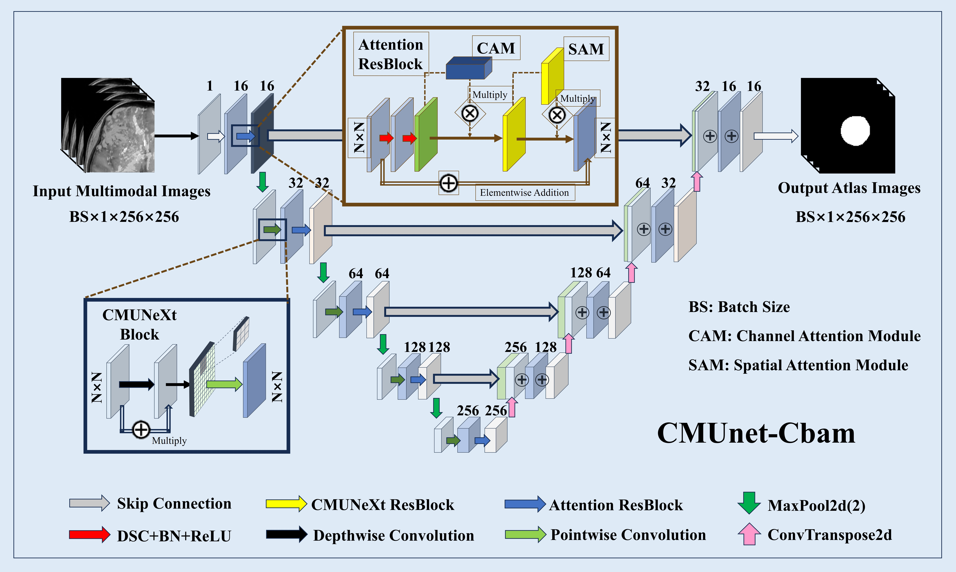
Supplemental Fig. 1. The proposed architecture of 3D CMUnet-Cbam.
B1. CMUNeXt Block [1]
The core component of the CMUNeXt Block is the depthwise separable convolution, which employs a combination of depthwise convolution (i.e., the number of groups was equal to the channels) and pointwise convolution with a 1 × 1 kernel size to substitute a traditional full convolution operation. In the CMUNeXt Block, a depthwise convolution with a large kernel size is utilized to extract global context from each channel, followed by a residual connection to preserve original feature integrity. To achieve a thorough integration of spatial and channel information, two pointwise convolutions are subsequently applied, adopting an inverted bottleneck design. This design expands the hidden dimension between the two pointwise convolutional layers to four times the input dimension, which facilitates efficient feature transformation and strengthens the model's capacity to capture complex representations. Unlike ordinary convolution, depthwise convolution significantly reduce the number of network parameters and computational cost. Subsequent pointwise convolutions integrate spatial and channel information more comprehensively. The structure of the CMUNeXt block is defined as follows:
 | $$f_{l}^{'}=BN\left(σ_{1}\left\{ \text{DepthwiseConv} \left(f_{l-1}\right)\right\}\right)+f_{l-1}$$ | (S1)

 | $$f_{l}^{''}=BN\left(σ_{1}\left\{ \text{PointwiseConv} \left(f_{l}^{'}\right)\right\}\right)$$ | (S2)

 | $$f_{l}=BN\left(σ_{1}\left\{ \text{PointwiseConv} \left(f_{l}^{''}\right)\right\}\right)$$ | (S3)
Where $f_{l}$ represent the output feature map of layer l in the ConvMixer block, $σ_{1}$ represent the GELU activation, and $BN$ represent Batch Normalization layer.
B2. Attentional Block
The attention mechanism is a crucial component integrated into neural network architectures, enabling the model to autonomously learn and evaluate the relative importance of input features in relation to the output. Attention weights are computed as a weighted average of the encoder's hidden states across all time steps, allowing the model to determine which parts of the input sequence are most relevant. At each time step, the decoder dynamically adjusts these attention weights, thereby focusing selectively on different segments of the input. This dynamic focusing capability significantly enhances the network's ability to capture essential information across temporal contexts, improving overall model performance and interpretability. Inspired by CBAM [2], channel attention mechanism (CAM) and spatial attention mechanism (SAM) module are incorporated into the U-shaped network architecture, collectively termed as the "Attentional Block" to enhance the precision of bAVM nidus edge prediction. The CAM leverages both global average pooling and maximum pooling to assimilate information across both high and low levels, enriching the feature representation. Concurrently, the SAM facilitates the network's ability to discern more meaningful spatial features critical for accurate segmentation. The full stages of CAM and SAM are shown in follows:
 | $$V_{c}(F)=σ(MLP⁡(MeanPool⁡(F))+MLP⁡(MaxPool⁡(F)))$$ | (S4)

 | $$V_{s}(F)=σ(f([MeanPool⁡(F), \text{MaxPool} (F)]))$$ | (S5)
Where $MLP$ represent the multilayer perceptron, $F$ represent the original feature, $V_{c}$ and $V_{s}$ represent weight coefficient for CAM and SAM, respectively.
B3. Loss functions
Recent studies have predominantly employed either the Intersection over Union (IoU) or Dice loss functions within their neural network architectures [3,4]. In this work, we introduce a novel compound loss function designed to supervise the training of our network. This function integrates both IoU and Dice losses, strategically penalizing discrepancies while simultaneously promoting congruence between the predicted segmentations and the ground truth data.
IoU Loss: The IoU metric serves as an effective measure for assessing the alignment between the segmented regions and their corresponding ground truth counterparts. It is defined in terms of the true positive (TP), false positive (FP), and false negative (FN) counts derived from pixel classification, with the loss expressed as 1 - IoU.
 | $$L_{IoU}=1-IoU=1-\frac{TP}{TP+FP+FN}$$ | (S6)
Dice Loss: The Dice loss, or more precisely, the Dice similarity coefficient (DSC), represents a metric that is inherently connected to IoU and can be directly computed from it. The loss formulation for the Dice metric is:
 | $$L_{\text{Dice }}=1-\frac{2×TP}{2×TP+FP+FN}$$ | (S7)
By combining these two distinct loss functions, we establish the composite loss function for deep supervision as follows:
 | $$L_{\text{final }}=\frac{L_{IoU}+L_{\text{Dice }}}{2}$$ | (S8)
Supplementary Table 1. Numerical comparison between proposed method with Res-Net, U-net and the results in previous studies.
 | DSC |  | HD
Backbone | Mean | Std | Mean | Std
Res-Net | 0.75 | 0.12 | 3.51 | 0.26
U-Net | 0.77 | 0.09 | 4.14 | 0.99
TBASE (ours) | 0.87 | 0.03 | 3.94 | 0.82
Previous studies
V-Net  Wang, 2019⁵ | 0.85 | 0.04 | - | -
U-Net  Jiao, 2022⁶ | 0.80 | [0.72-0.84] | - | -

Reference
1. Tang F, Ding J, Quan Q, Wang L, Ning C, Zhou SK, editors. Cmunext: An efficient medical image segmentation network based on large kernel and skip fusion. 2024 IEEE International Symposium on Biomedical Imaging (ISBI); 2024;pp1-5. https://doi.org/10.48550/arXiv.2308.01239
2. Woo S, Park J, Lee J-Y, Kweon IS, editors. Cbam: Convolutional block attention module. Proceedings of the European conference on computer vision (ECCV); 2018;pp.3-19. https://doi.org/10.48550/arXiv.1807.06521
3. Jadon S, editor. A survey of loss functions for semantic segmentation. 2020 IEEE conference on computational intelligence in bioinformatics and computational biology (CIBCB); 2020;pp.1-7. https://doi.org/10.48550/arXiv.2006.14822
4. Bokhovkin A, Burnaev E, editors. Boundary loss for remote sensing imagery semantic segmentation. International Symposium on Neural Networks; Springer. 2019;pp.388-401. https://doi.org/10.48550/arXiv.1905.07852.
5. Wang T, Lei Y, Tian S, Jiang X, Zhou J, Liu T, et al. Learning‐based automatic segmentation of arteriovenous malformations on contrast CT images in brain stereotactic radiosurgery. Medical physics 2019;46:3133-3141. https://doi.org/10.1002/mp.13560.
6. Jiao Y, Zhang J-Z, Zhao Q, Liu J-Q, Wu Z-Z, Li Y, et al. Machine learning-enabled determination of diffuseness of brain arteriovenous malformations from magnetic resonance angiography. Translational stroke research 2022;13:939-948. https://doi.org/10.1007/s12975-021-00933-1.

