Table S1. Mixed-effects regression† results for ACT in the non-extended LFT group‡.
Variables | Univariable |  |  |  | Multivariable
Variables | Coefficient β | SE | P |  | Coefficient β | SE | P
NM infusion rate, mg/kg/h | -6.062 | 5.205 | 0.244
Age, years | -0.999 | 1.005 | 0.320
Sex
Female | Reference
Male | -8.328 | 12.649 | 0.510
Body weight, kg | -0.115 | 0.241 | 0.634
Liver function test
AST, unit/L | -0.007 | 0.013 | 0.586
ALT, unit/L | -0.017 | 0.023 | 0.454
ALP, unit/L | -0.002 | 0.037 | 0.957
Total bilirubin, mg/dL | 8.060 | 1.378 | <0.001 |  | 7.147 | 1.528 | <0.001
GGT, unit/L | 0.009 | 0.016 | 0.584
Transfusion§
Fresh frozen plasma | 46.946 | 15.069 | 0.002 |  | 27.464 | 14.378 | 0.056
Red blood cells | 6.191 | 8.099 | 0.445
Platelets | -2.082 | 10.337 | 0.840
†The patient identifier served as the random effect in the mixed-effects regression model.
‡The non-extended LFT group includes cases in which both direct bilirubin and GGT were not measured.
§This refers to the transfusion status from 12 hours prior to the commencement of NM administration until the time of its administration.
ACT = activated clotting time, LFT = liver function test, SE = standard error, NM = nafamostat mesylate, AST = aspartate aminotransferase, ALT = alanine aminotransferase, ALP = alkaline phosphatase, GGT = gamma-glutamyl transferase

Table S2. Mixed-effects regression† results for aPTT in the non-extended LFT group‡.
Variables | Univariable |  |  |  | Multivariable
Variables | Coefficient β | SE | P |  | Coefficient β | SE | P
NM infusion rate, mg/kg/h | 5.356 | 2.529 | 0.034 |  | 5.208 | 2.529 | 0.039
Age, years | -0.736 | 0.464 | 0.113
Sex
Female | Reference
Male | -2.753 | 5.963 | 0.644
Body weight, kg | -0.205 | 0.119 | 0.084
Liver function test
AST, unit/L | -0.003 | 0.004 | 0.504
ALT, unit/L | -0.008 | 0.008 | 0.316
ALP, unit/L | -9.503×10⁻⁵ | 0.022 | 0.997
Total bilirubin, mg/dL | 1.078 | 0.545 | 0.048 |  | 1.031 | 0.524 | 0.049
GGT, unit/L | 0.011 | 0.017 | 0.505
Transfusion§
Fresh frozen plasma | 4.263 | 8.009 | 0.594
Red blood cells | -0.311 | 4.035 | 0.938
Platelets | 4.881 | 4.433 | 0.271
†The patient identifier served as the random effect in the mixed-effects regression model.
‡The extended LFT group includes cases in which both direct bilirubin and GGT were measured in addition to routine liver function tests.
§This refers to the transfusion status from 12 hours prior to the commencement of NM administration until the time of its administration.
aPTT = activated partial thromboplastin time, SE = standard error, NM = nafamostat mesylate, AST = aspartate aminotransferase, ALT = alanine aminotransferase, ALP = alkaline phosphatase, GGT = gamma-glutamyl transferase

Table S3. Mixed-effects regression† results for ACT in the extended LFT group‡.
Variables | Univariable
Variables | Coefficient β | SE | P
NM infusion rate, mg/kg/h | -2.476 | 3.463 | 0.475
Age, years | -1.140 | 0.934 | 0.222
Sex
Female | Reference
Male | -18.373 | 12.831 | 0.152
Body weight, kg | -0.194 | 0.276 | 0.482
Liver function test
AST, unit/L | 0.006 | 0.009 | 0.527
ALT, unit/L | 0.005 | 0.011 | 0.622
ALP, unit/L | -0.012 | 0.039 | 0.753
Total bilirubin, mg/dL | 0.628 | 0.671 | 0.349
Direct bilirubin, mg/dL | 0.726 | 0.926 | 0.433
GGT, unit/L | -0.043 | 0.025 | 0.079
Transfusion§
Fresh frozen plasma | 2.807 | 15.373 | 0.855
Red blood cells | -1.960 | 7.865 | 0.803
Platelets | -10.876 | 7.611 | 0.153
†The patient identifier served as the random effect in the mixed-effects regression model.
‡The non-extended LFT group includes cases in which both direct bilirubin and GGT were not measured.
§This refers to the transfusion status from 12 hours prior to the commencement of NM administration until the time of its administration.
ACT = activated clotting time, LFT = liver function test, SE = standard error, NM = nafamostat mesylate, AST = aspartate aminotransferase, ALT = alanine aminotransferase, ALP = alkaline phosphatase, GGT = gamma-glutamyl transferase

Table S4. Mixed-effects regression† results for aPTT in the extended LFT group‡.
Variables | Univariable |  |  |  | Multivariable
Variables | Coefficient β | SE | P |  | Coefficient β | SE | P
NM infusion rate, mg/kg/h | 12.714 | 1.508 | <0.001 |  | 12.373 | 1.568 | <0.001
Age, years | -1.256 | 0.871 | 0.149
Sex
Female | Reference
Male | 5.998 | 10.557 | 0.570
Body weight, kg | -0.406 | 0.238 | 0.089
Liver function test
AST, unit/L | 0.004 | 0.005 | 0.406
ALT, unit/L | 0.003 | 0.008 | 0.667
ALP, unit/L | -0.056 | 0.019 | 0.004 |  | -0.018 | 0.017 | 0.286
Total bilirubin, mg/dL | 0.556 | 0.364 | 0.120
Direct bilirubin, mg/dL | -0.067 | 0.571 | 0.907
GGT, unit/L | -0.021 | 0.020 | 0.298
Transfusion§
Fresh frozen plasma | 6.460 | 8.211 | 0.431
Red blood cells | -3.212 | 3.729 | 0.389
Platelets | -4.951 | 3.880 | 0.202
†The patient identifier served as the random effect in the mixed-effects regression model.
‡The extended LFT group includes cases in which both direct bilirubin and GGT were measured in addition to routine liver function tests.
§This refers to the transfusion status from 12 hours prior to the commencement of NM administration until the time of its administration.
aPTT = activated partial thromboplastin time, SE = standard error, NM = nafamostat mesylate, AST = aspartate aminotransferase, ALT = alanine aminotransferase, ALP = alkaline phosphatase, GGT = gamma-glutamyl transferase

Figure S1. Scatter plots of NM infusion rate versus coagulation times in the non-extended LFT group.
In the non-extended LFT group, ACT showed a non-significant decreasing trend, while aPTT increased with higher NM infusion rates. Mixed-effects linear regression with a pseudonymized subject identifier as a random effect was used.
ACT = activated clotting time, aPTT = activated partial thromboplastin time, NM = nafamostat mesylate

Figure S2. Scatter plots of NM infusion rate vs. coagulation times in the extended LFT group.
In the extended LFT group, ACT remained uncorrelated with NM infusion rate, whereas aPTT consistently increased. Analysis was performed using mixed-effects linear regression with a pseudonymized subject identifier as a random effect.
ACT = activated clotting time, aPTT = activated partial thromboplastin time, NM = nafamostat mesylate

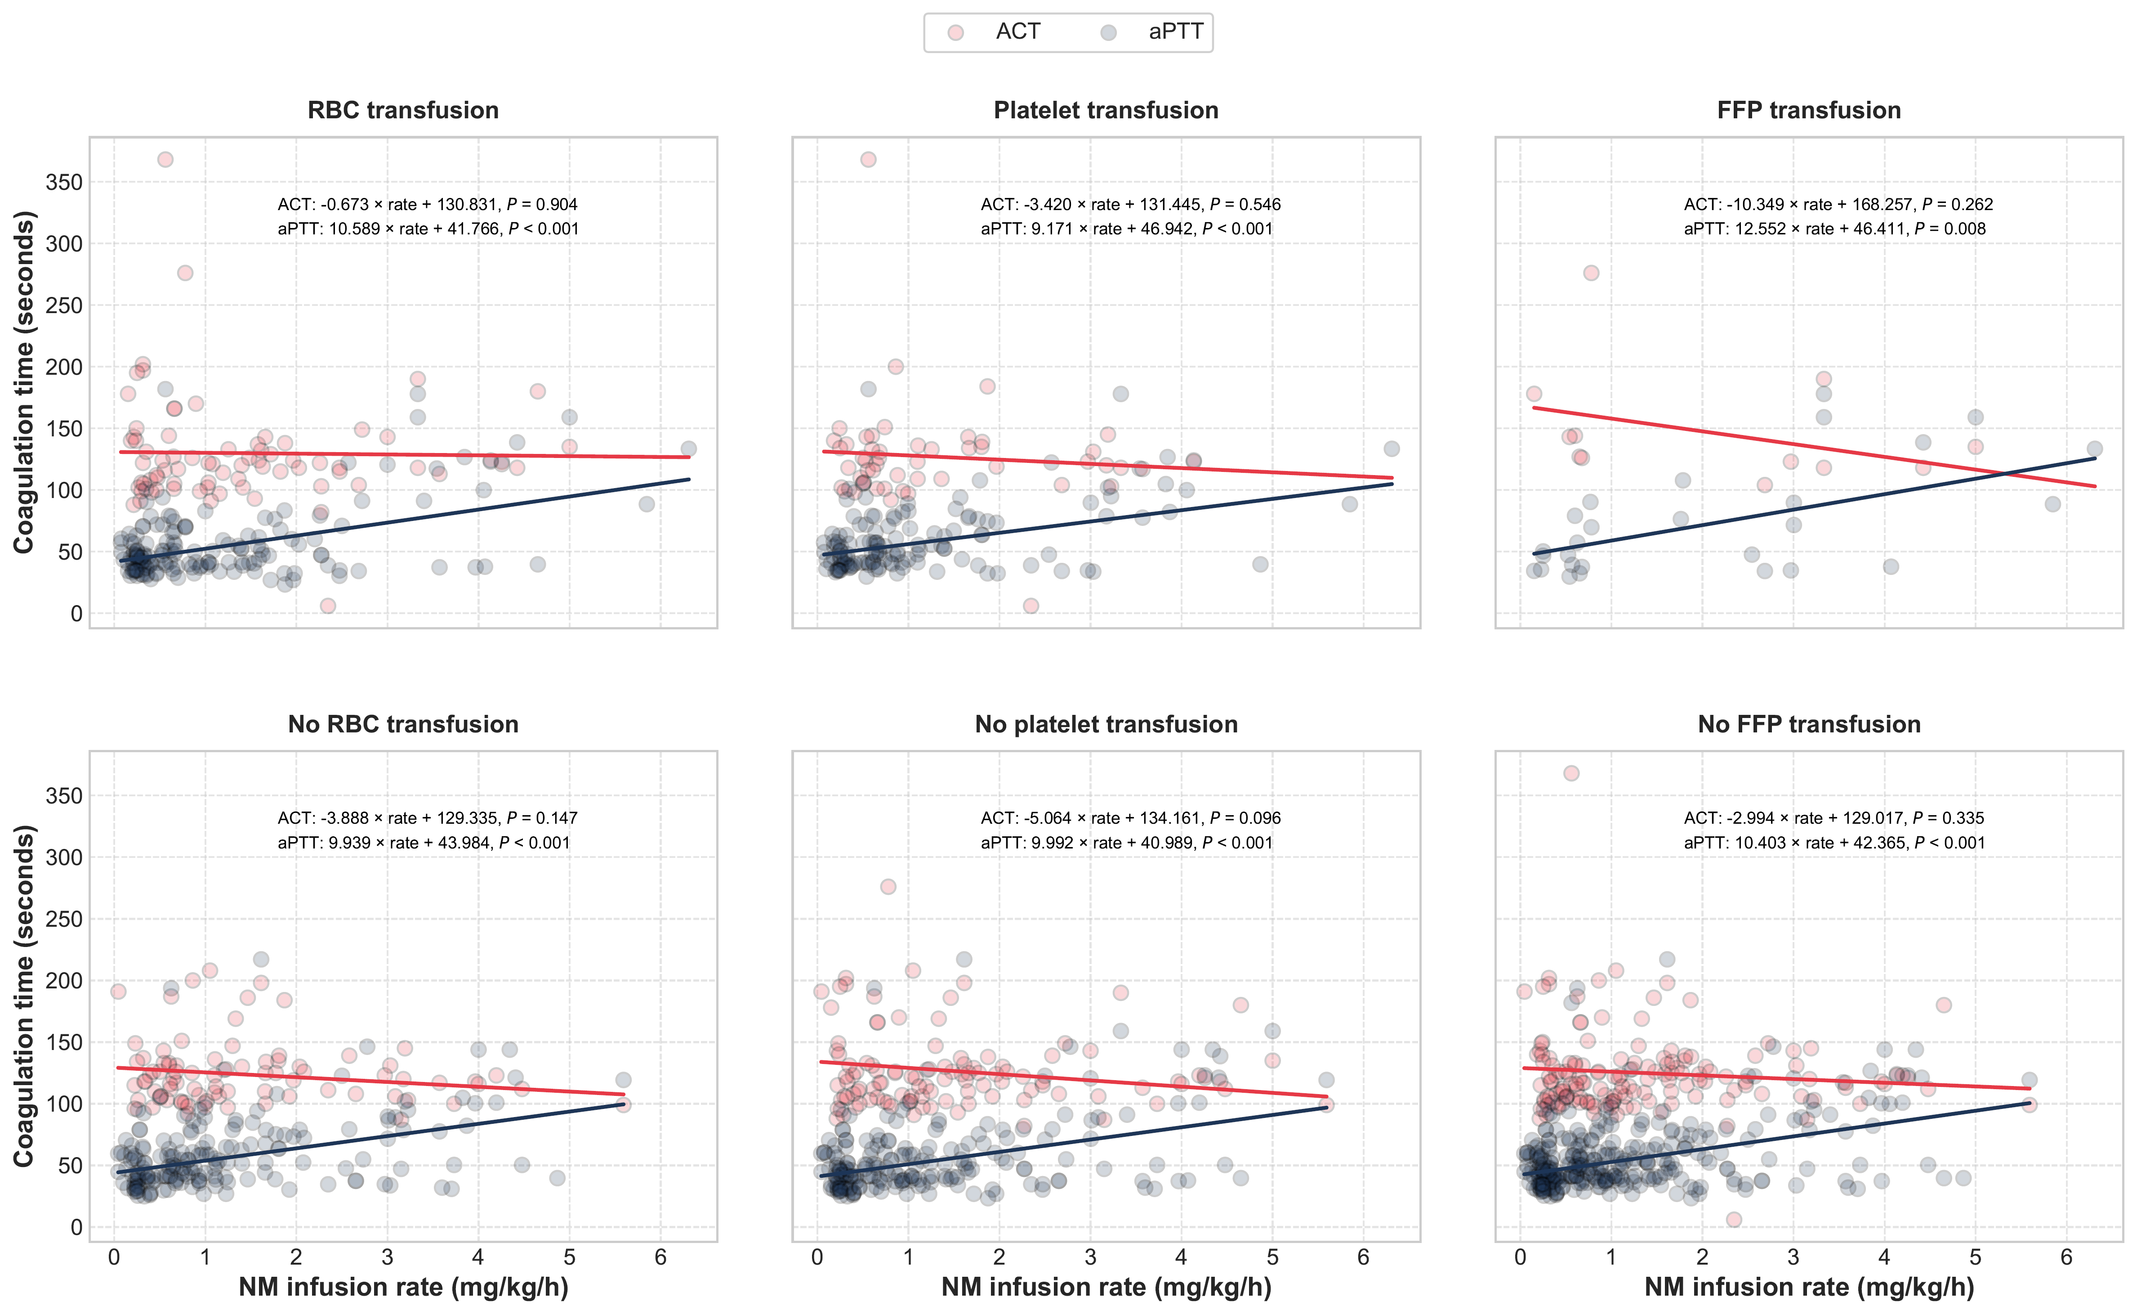

Figure S3. Subgroup analysis by transfusion status: mixed-effects regression of NM infusion rate and coagulation times.
Patients were stratified by transfusion history (RBCs, platelets, and FFP within 12 hours prior to NM order). Across all subgroups, NM infusion rate was significantly associated with aPTT but not with ACT. Mixed-effects regression with pseudonymized subject-level random effects was applied.
NM = nafamostat mesylate , ACT = activated clotting time, aPTT = activated partial thromboplastin time, RBC = red blood cell, FFP = fresh frozen plasma

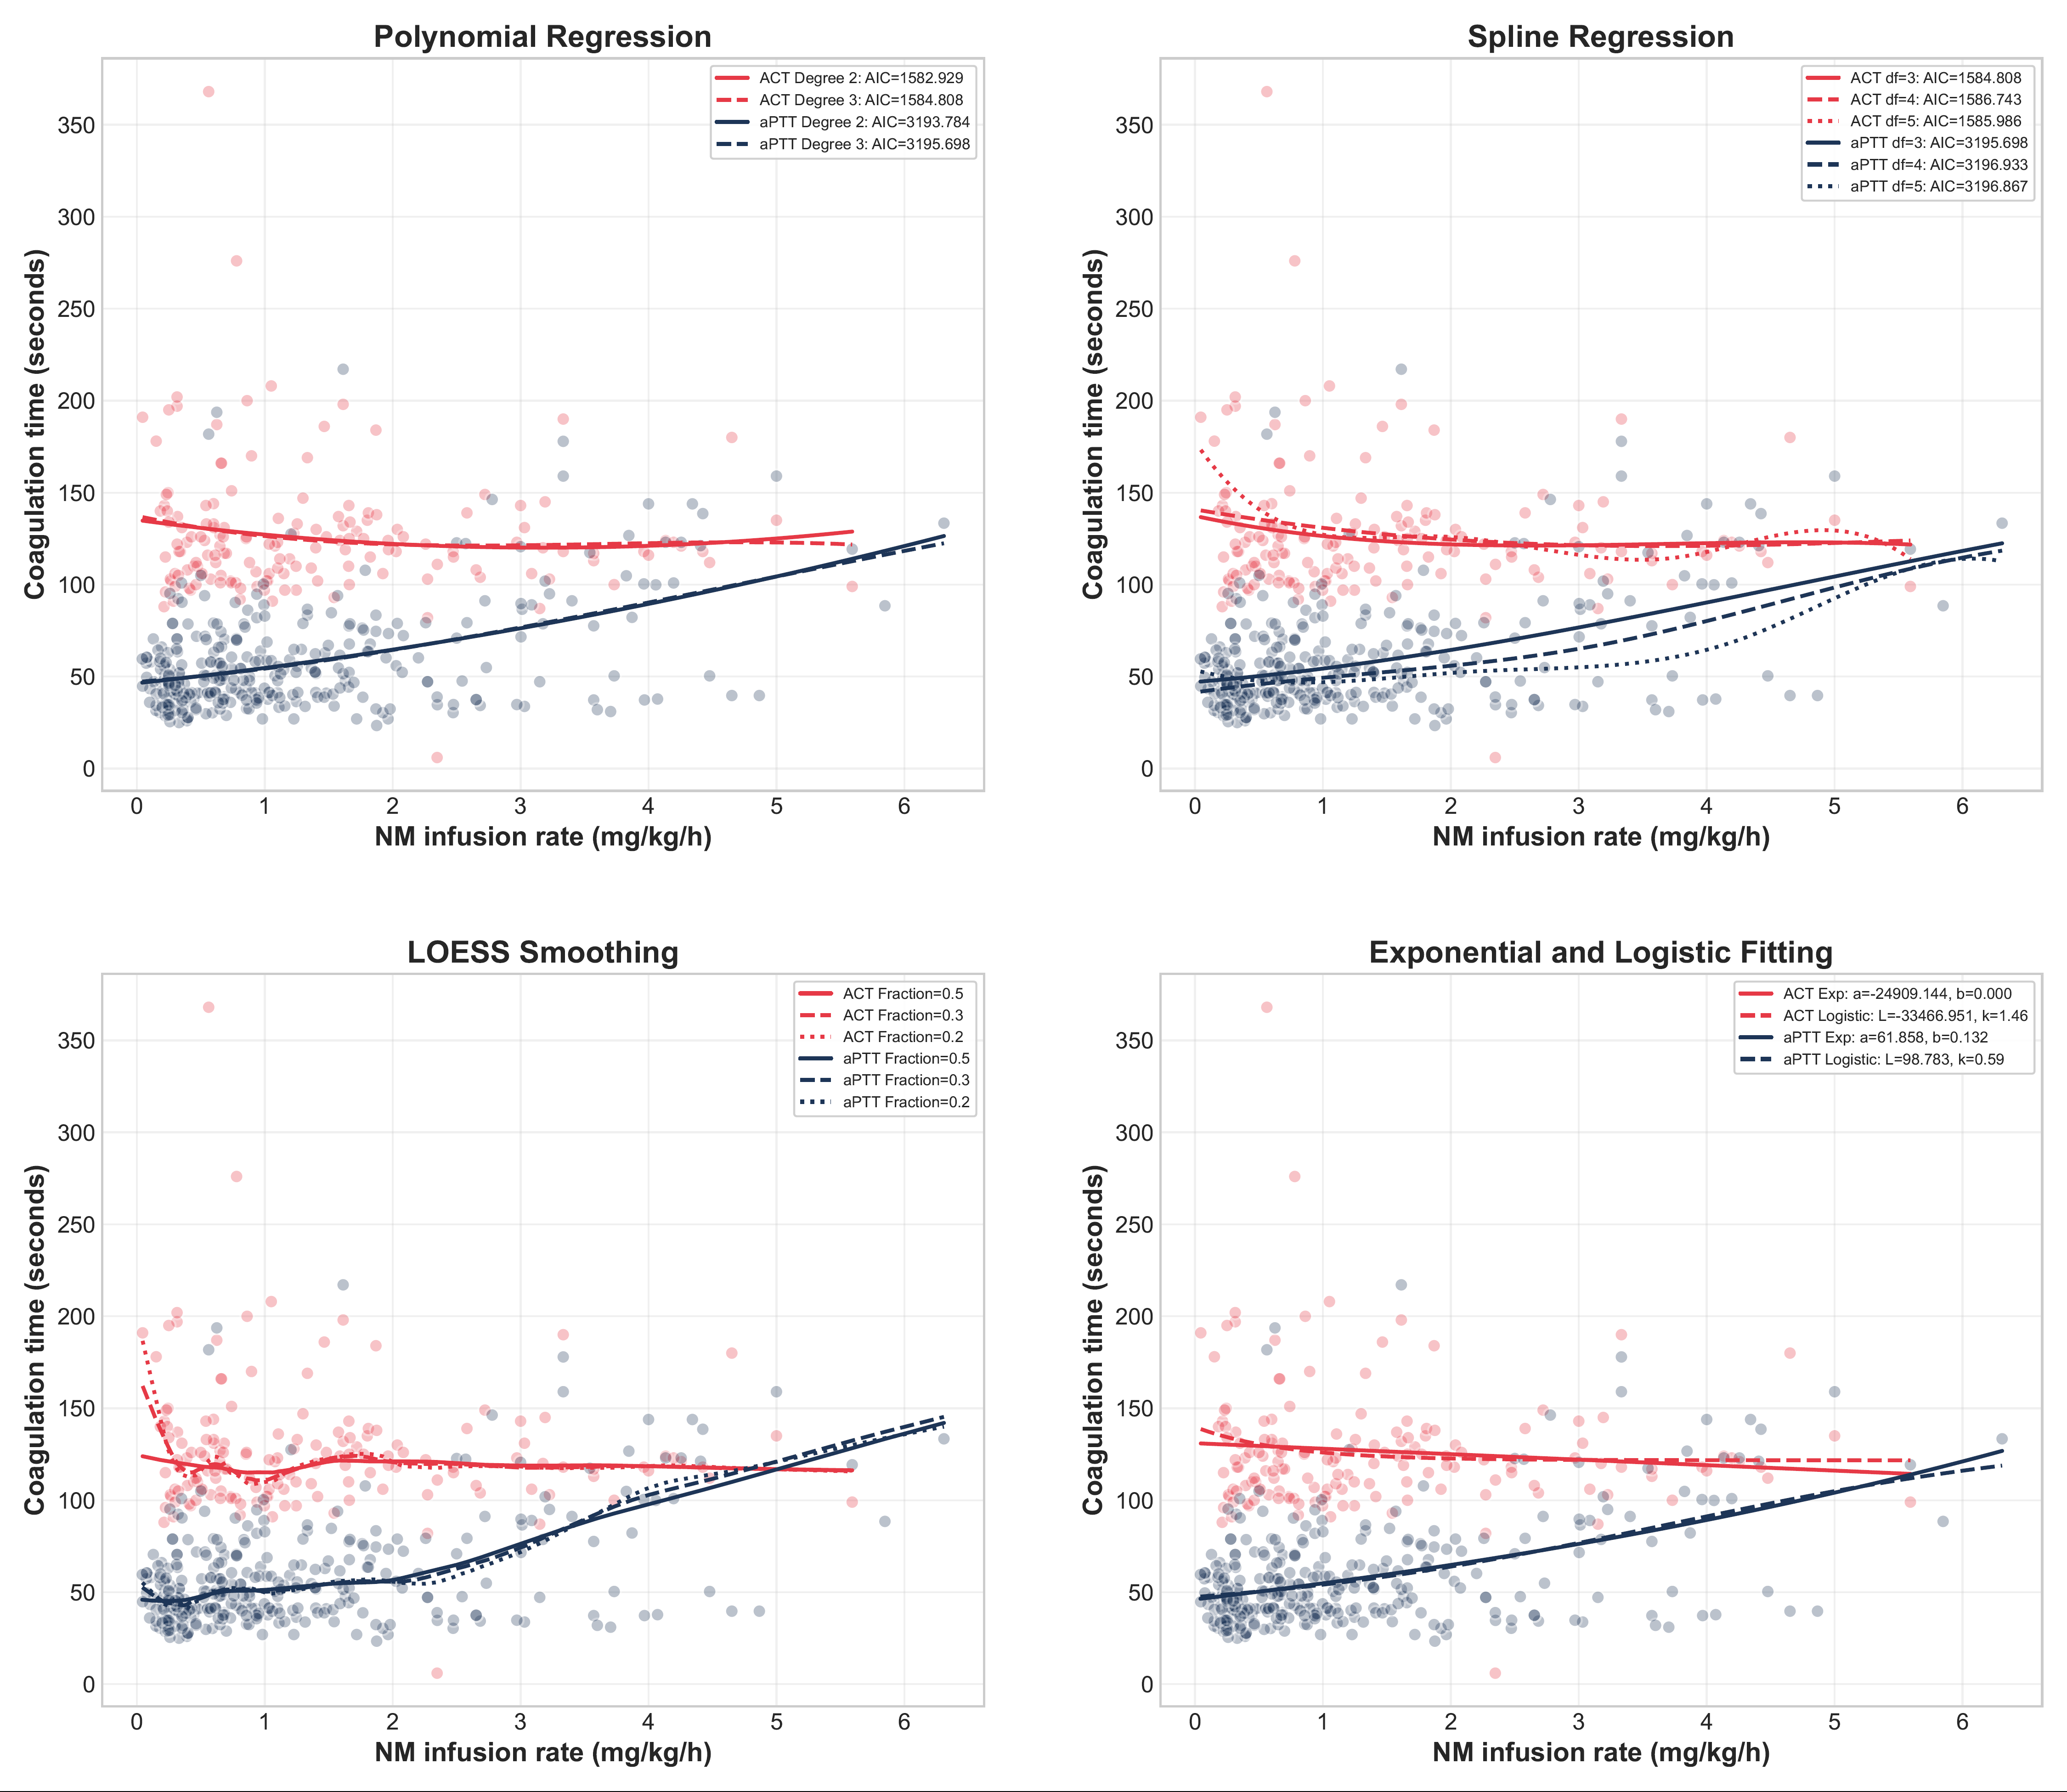

Figure S4. Non-linear regression analysis of NM infusion rate and coagulation times (total cohort).
Non-linear models (polynomial, spline, LOESS, exponential/logistic) were used to explore trends in ACT and aPTT across NM infusion rates in the overall cohort. aPTT consistently showed dose-dependent increases, while ACT displayed irregular or flat trends.
NM = nafamostat mesylate , LFT = liver function test, ACT = activated clotting time, aPTT = activated partial thromboplastin time, AIC = akaike information criterion, LOESS = locally estimated scatterplot smoothing

Figure S5. Non-linear regression in the non-extended LFT group.
aPTT in the non-extended LFT group increased with higher NM infusion rates, while ACT remained variable. Various non-linear regression methods were applied.
NM = nafamostat mesylate, LFT = liver function test, ACT = activated clotting time, aPTT = activated partial thromboplastin time, AIC = akaike information criterion, LOESS = locally estimated scatterplot smoothing

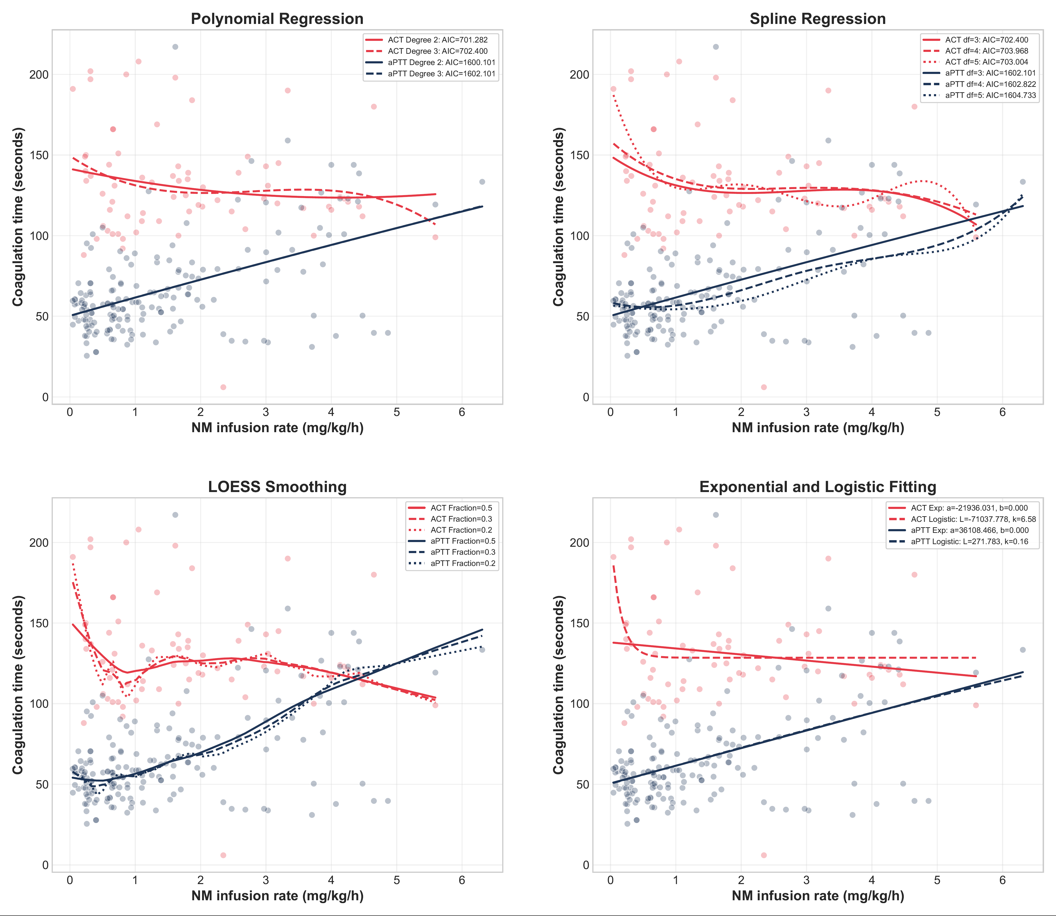

Figure S6. Non-linear regression in the extended LFT group.
In the extended LFT group, aPTT showed a clear dose-responsive increase across all models. ACT remained inconsistent.
NM = nafamostat mesylate, LFT = liver function test, ACT = activated clotting time, aPTT = activated partial thromboplastin time, AIC = akaike information criterion, LOESS = locally estimated scatterplot smoothing

