CarbaDetector: A Machine Learning Model for Detecting Carbapenemase-Producing Enterobacterales from Disk Diffusion Tests

Linea Katharina Muhsal, Cansu Cimen, Janko Sattler, Lisa Theis, Oliver Nolte, Laurent Dortet, Rémy A. Bonnin, Adrian Egli, Axel Hamprecht

Supplementary information

Methods

Statistical analysis, classification, and development of an app for carbapenemase detection
Analysis was performed using R Statistical Software [1]. The packages tidyverse, tidyr, caret, tree, rpart, and randomForest were used for model creation [2-7]. Data was centered and scaled prior to analysis. Isolates that were present in the internal dataset less than 10 times were denoted as “Other”. Isolates in the external datasets that had no corresponding species in the internal dataset were denoted as “Other”.
Furthermore, we developed CarbaDetector, an easy to use web-app employing up to eight inhibition zone diameters provided by the user to predict the presence or absence of carbapenemase production based on a random forest model. The web-app was built using shiny [8].

Results

Strain collections

Internal dataset (n=385)
Six species constituted 88.8 % of the isolates, namely Klebsiella pneumoniae (29.6 %), E. coli (17.9 %), Citrobacter freundii (16.9 %), Enterobacter cloacae (16.6%), P. mirabilis (4.2%), and Serratia marcescens (3.6 %). Of all 385 isolates, 238 (61.8 %) were carbapenemase producers, 147 (38.2 %) were carbapenemase-negative. The most frequent carbapenemase group present was bla_{OXA-48-like} (n = 111, 46.6 %), followed by bla_{VIM} (n=72, 30.3 %), bla_{NDM} (n = 26, 10.9 %), bla_{IMP} (n = 12, 5.0 %), bla_{KPC} (n = 8, 3.4 %), bla_{IMI} (n = 7, 2.9 %), and others (n = 7, 2.9 %). The most represented Ambler-class was class D (n = 111, 46.6 %), followed by class B (n = 110, 46.2 %), and class A (n = 17, 7.1 %).

External dataset A (n=282)
Five species constituted 95.4 % of the isolates, namely K. pneumoniae (47.2 %), E. coli (26.2 %, Enterobacter cloacae complex (16.3 %), C. freundii (2.8 %), and M. morganii (2.8 %). Of 282 isolates, 80 (28.4 %) were carbapenemase producers. The most represented Ambler class was Class D (n = 40, 50.0 %), with 6/40 isolates harboring an additional Class B and 1/40 an additional Class A carbapenemase, followed by Class B (n = 22, 27.5 %) and Class A (n = 18, 22.5 %). Isolates were characterized by whole genome sequencing and/or PCR for carbapenemase genes, followed by Sanger sequencing.

External dataset B (n=518)
External dataset 2 was previously published by Duque et al. [9].

Models

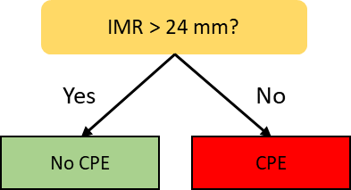
Figure S1: Decision tree constructed from the internal dataset.
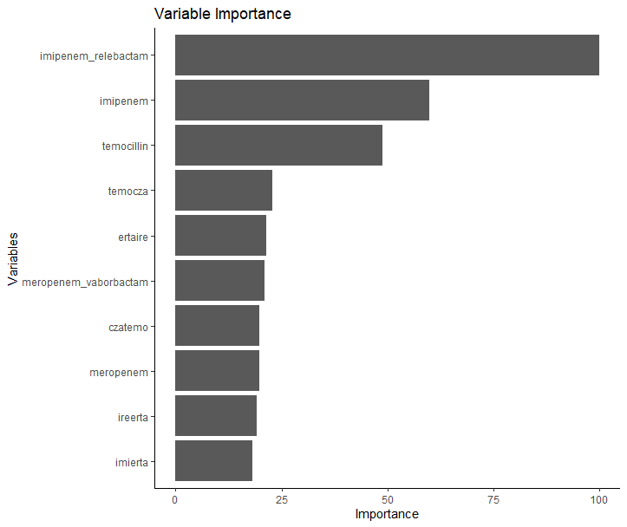
Figure S2: Importance parameters for the final decision tree expanded model “CarbaDetector”. temocza: difference between temocillin inhibition zone diameter and ceftazidime-avibactam inhibition zone diameter, ertaire: difference between ertapenem inhibition zone diameter and imipenem-relebactam inhibition zone diameter, czatemo: difference between ceftazidime-avibactam inhibition zone diameter and temocillin inhibition zone diameter, ireerta: difference between imipenem-relebactam inhibition zone diameter and ertapenem inhibition zone diameter, imierta: difference between imipenem inhibition zone diameter and ertapenem inhibition zone diameter

Hyperparameters of the CarbaDetector model
mtry = 4, chosen from 4, 8, 16, and 22. ntree = 500.

Comparison of species-specific performance
Species-specific performance was determined for K. pneumoniae and E. coli isolates. When assessing CarbaDetector results for K. pneumoniae isolates, a sensitivity of 96.8 % and a specificity of 94.2 % was achieved. Training of a species-specific model results in 98.4 % sensitivity and 86.5 specificity. CarbaDetector results for E. coli yielded a sensitivity of 95.6 % and a specificity of 79.2 %. The training of a E. coli-specific model resulted in 97.8 % sensitivity and 70.8 % specificity.

False negative isolates predicted on original dataset by CarbaDetector

Table S1: Disk diffusion diameters (mm) and broth microdilution MICs (mg/L) for the six false negative isolates predicted by CarbaDetector.
Isolate |  | B7-26 | B6-77 | B5-37 | B1-74 | Z-01393 | B2-3
Species |  | K. pneumoniae | E. hormaechei | E. coli | K. pneumoniae | S. marcescens | E. coli
Meropenem | Disk diffusion (DDT) | 20 | 17 | 26 | 13 | 28 | 27
Meropenem | Broth Microdilution (BMD) | 2 | 4 | 0.25 | 64 | 0.5 | 0.5
Imipenem | DDT | 25 | 17 | 26 | 11 | 27 | 28
Imipenem | BMD | 0.5 | 2 | 0.25 | 16 | 2 | 0.25
Ertapenem | DDT | 9 | 8 | 19 | 6 | 23 | 19
Ertapenem | BMD | 8 | 16 | 1 | 16 | 0.5 | 2
Meropenem-vaborbactam | DDT | 21 | 19 | 26 | 20 | 32 | 30
Meropenem-vaborbactam | BMD | 2 | 1 | 0.125 | 0.03 | 0.5 | 0.5
Imipenem-relebactam | DDT | 26 | 24 | 26 | 24 | 27 | 29
Imipenem-relebactam | BMD | 0.5 | 1 | 0.125 | 0.25 | 2 | 0.25
Ceftazidime-avibactam | DDT | 20 | 21 | 24 | 15 | 17 | 25
Ceftazidime-avibactam | BMD | 2 | 1 | 0.25 | 2 | 8 | 0.25
Ceftolozan-tazobactam | DDT | 9 | 22 | 19 | 7 | 18 | 28
Ceftolozan-tazobactam | BMD | >128 | 1 | 16 | 128 | 32 | 0.5
temocillin | DDT | 10 | 20 | 11 | 8 | 15 | 21
temocillin | BMD | 64 | 8 | 64 | 64 | 32 | 16
Carbapenemase |  | OXA-244 | VIM-1 | OXA-244 | KPC-3 | IMP-13 | VIM-1

References
1. R Core Team, R: A Language and Environment for Statistical Computing. 2024, R Foundation for Statistical Computing: Vienna, Austria.
2. Wickham, H., et al., Welcome to the Tidyverse. Journal of open source software, 2019. 4(43): p. 1686.
3. Wickham, H. and M.H. Wickham, Package ‘tidyr’. Easily Tidy Data with’spread’and’gather ()’Functions, 2017.
4. Kuhn, M., et al., Package ‘caret’. The R Journal, 2020. 223(7): p. 48.
5. Therneau, T., et al., Package ‘rpart’. Available online: cran. ma. ic. ac. uk/web/packages/rpart/rpart. pdf (accessed on 20 April 2016), 2015.
6. Ripley, B. and M.B. Ripley, Package ‘tree’. 2023.
7. Breiman, L., Random Forests. Machine Learning, 2001. 45(1): p. 5-32.
8. Chang W, C.J., Allaire J, Sievert C, Schloerke B, Xie Y, Allen J, McPherson J, Dipert A, Borges B, shiny: Web Application Framework for R. 2024.
9. Duque, M., R.A. Bonnin, and L. Dortet, Evaluation of the French novel disc diffusion-based algorithm for the phenotypic screening of carbapenemase-producing Enterobacterales. Clinical Microbiology and Infection, 2024. 30(3): p. 397.e1-397.e4.

