Supplemental Table 1. Instruments collected across visits to assess psychosocial stress during early life.
ASSESSMENTS | Georgia Stress and Heart (GSH)
ASSESSMENTS | V7 | V8 | V9 | V10 | V11 | V12 | V13 | V14 | V15 | V16
Year of Visit | 1997-1998 | 1998-1999 | 1999-2000 | 2000-2001 | 2001-2002 | 2002-2003 | 2003-2005 | 2005-2007 | 2008-2010 | 2010-2012
ARCS (Adolescent Resources Challenges Scale) | x | x | x |  |  | x | x
PDS (Perceived Discrimination Scale) |  |  | x | x | x | x | x | x
UNF (Unfairness Scale) |  |  | x | x | x | x | x | x | x
FES (Family Environment Scale) |  |  |  |  | x | x | x |  | x | x
HOLLINGSHEAD (Hollingshead Four Factor Index) | x | x | x | x | x | x | x | x | x | x
ACE (Adverse Childhood Experiences) |  |  |  |  |  |  |  |  | x

Supplemental Table 2. Measures of ELS in the first 20 years of life.
Assessments | Description
Family SES
Parental Hollingshead | Measure of family social status calculated on the basis of the educational attainment and occupational level of the parents.
Stressful Life Events
ARCS-Peer | ARCS is designed specifically for use with adolescent populations and it assesses the accumulation of life events experienced during the past 12 months. ARCS-Peer subscale assesses the stressful life experiences from peer environment.
ACE | The assessment of participants’ exposure to ACEs covered the first 18 years of their lives, including childhood abuse, neglect and household dysfunction.
PDS | Measures how often people feel that others treat them badly or unfairly.
UNF | Self-report questionnaire evaluating aspects of unfair treatment that the participant has experienced in multiple facets of life such as ethnicity, race, gender, age, sex, or appearance
Family Environment
ARCS-Family | ARCS-Family subscale assesses the stressful life experiences from family environment.
FES-Coh  FES-Exp  FES-Cnf | Assessment of family functioning in three subscales:  (1) cohesion, which is the extent to which family members support one another  (2) emotional expression, which is the degree to which family members express their feelings  (3) conflict, which is the extent to which the family experiences disagreement.
Neighborhood Environment
ARCS-Neighbor | ARCS-Neighborhood subscale assesses the stressful life experiences from neighborhood environment.

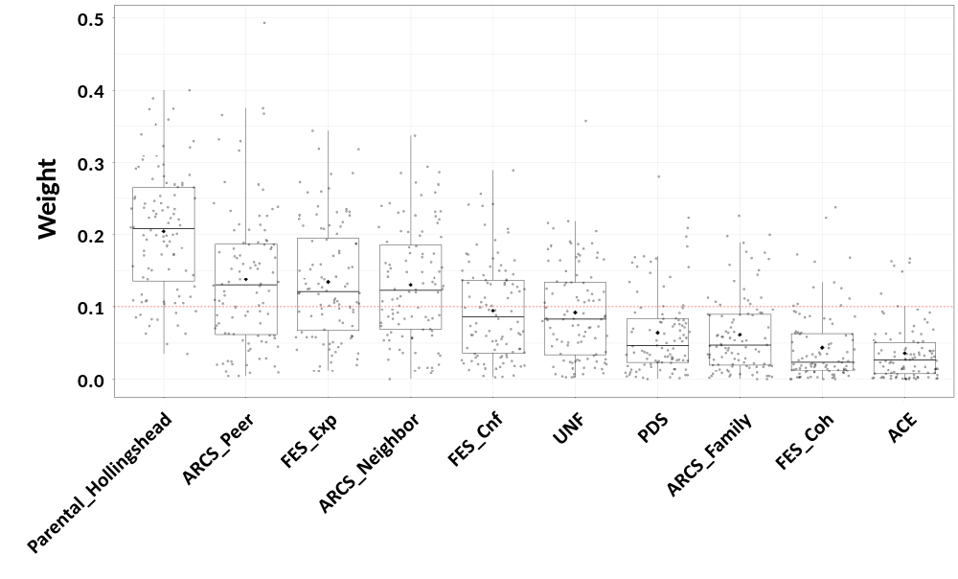
Supplemental Figure 1. Box-plot of the weights contributing to the WQS index estimate through 100 repeated holdout WQS regressions. The red dashed line represents the prespecified cut-off established to identify the most important elements of the mixture and set equal to the inverse of the number of the mixture components (1/10=0.10).

