Supplementary Information Text
Subhead. The SI contains the SIR simulation methods, supplemental figures and tables.

Methods
Before analyzing these countries' pandemic data, we build a tool to measure control policies' strength based on the simple Susceptible-Infected-Recovered (SIR) model (1-3). In the SIR model, the total population N can be divided into three compartments: Susceptible compartment (S), Infected compartment (I), and Recovered compartment (R). A susceptible individual will become infected at a spreading rate $λ$ if he is contacted with an infected individual. Since an infected individual can contact susceptible ones at rate $\frac{S}{N}$, this process can be described as $\frac{dS}{dt}=-λ\frac{S}{N}I$. Besides, an infected person can be recovered at a recovery rate $μ$, which can be described as $\frac{dR}{dt}=μI$. Therefore, a well-established SIR model can be described in the differential equations (1).
$\frac{dS}{dt}=-λ\frac{S}{N}I$ (1a)
$\frac{dI}{dt}=λ\frac{S}{N}I-μI$ (1b)
$\frac{dR}{dt}=μI$ (1c)
The differential equations can be solved at each discrete time step $\left({dI}/{dt}≈∆I/∆t\right)$, as formula (2) shows below.
$\frac{dS}{dt}=S_{t}-S_{t-1}=-λΔt\frac{S_{t-1}}{N}I_{t-1}$ (2a)
${\frac{dI}{dt}=I}_{t}-I_{t-1}=λ\frac{S_{t-1}}{N}ΔtI_{t-1}-μΔtI_{t-1}$ (2b)
$\frac{dR}{dt}=R_{t}-R_{t-1}=μΔtI_{t-1}$ (2c)
During the transmission process of COVID-19 worldwide, every country had issued control policies such as travel restriction, isolation of susceptible people, "stay at home", etc. Therefore, we assume that spreading rate $λ$ and recovery rate $μ$ vary day by day. Also, we found that, until Dec 12, 2020, which is the final date of our pandemic data, in all these three countries, ${S_{t}}/N≈1$ (China: $S_{t}=$1,404,582,002, N=1,404,676,330
and $\frac{S_{t}}{N}=99.99\text{\%}$; the US: $S_{t}=$313,121,874, N=329,466,283 and $\frac{S_{t}}{N}=95.04\text{\%}$; Sweden: $S_{t}=$9,779,172, N=10,099,270 and $\frac{S_{t}}{N}=96.83\text{\%}$), so we set $\frac{S_{t}}{N}$ =1 in the modified SIR model. Under such condition, the time-discrete SIR model is revised as below.

$S_{t}-S_{t-1}=-λΔt\frac{S_{t-1}}{N}I_{t-1}=-λ_{t}ΔtI_{t-1}$ (3a)
$I_{t}-I_{t-1}=λ\frac{S_{t-1}}{N}ΔtI_{t-1}-μΔtI_{t-1}$
$=λ_{t}ΔtI_{t-1}-μ_{t}ΔtI_{t-1}=\left(λ_{t}-μ_{t}\right)ΔtI_{t-1}$ (3b)
$R_{t}-R_{t-1}=μΔtI_{t-1}=μ_{t}ΔtI_{t-1}$ (3c)
$λ_{t}=\frac{-S_{t}-S_{t-1}}{ΔtI_{t-1}}$ (3d)
$μ_{t}=\frac{R_{t}-R_{t-1}}{ΔtI_{t-1}}$ (3e)
According to Equation (3b), $I_{t}-I_{t-1}=\left(λ_{t}-μ_{t}\right)ΔtI_{t-1}$. This equation denotes that one infected individual infect $\left(λ_{t}-μ_{t}\right)$ persons on day t. Thus, we define variable $Φ_{t}$ as below.
$Φ_{t}=λ_{t}-μ_{t}$ (4)
This variable is defined as the effective spreading rate on day t, which represents the intensity of infection and the strength of control policy, i.e., the smaller $Φ_{t}$ is, the stricter control policy is. According to Equations (3) and (4).
With the help of the time-discrete SIR model mentioned above, we simulate the spreading process of COVID-19 in China, the USA, and Sweden. Our data is obtained from the program "COVID-19 Data Repository by the Center for System Science and Engineering (CSSE) at Johns Hopkins University (4)" from Jan 22, 2020, to Dec 12, 2020, and the National Health Commission of the People's Republic of China. We find that in the spreading process of COVID-19, all these three countries have an response period and a recovery period. In the response period (Period 1), some travel restriction policies are taken. Human mobility is limited, but social contact can still be frequent, and little self-protect behavior is taken. The effective spreading rate is kept at a high level. Moreover, in the recovery period (Period 2), the government issued self-isolation policies or recommendations. People are aware of the severity of COVID-19 and will take some self-protect behavior to avoid being infected; the effective spreading rate dropped, which means that the self-isolation control policies began to affect. After period 2, the effective spreading rate will keep at a low level until a second spreading process if it exists. Actually, at the end of Period 2, the effective spreading rate is small, and the first outbreak of pandemic is over, no matter if the pandemic is controlled. Since the active infected population will disturb our analysis on the second outbreak, we will concentrate on the spreading process of the first outbreak, i.e., Period 1 and 2, to find the main factors affecting the control effect.

Materials
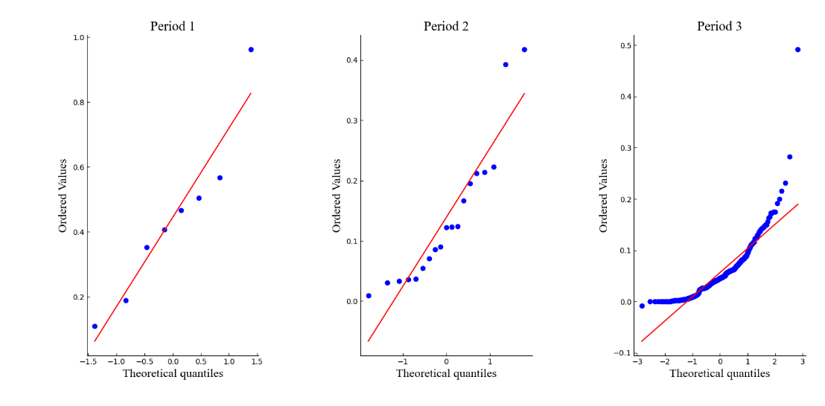
A
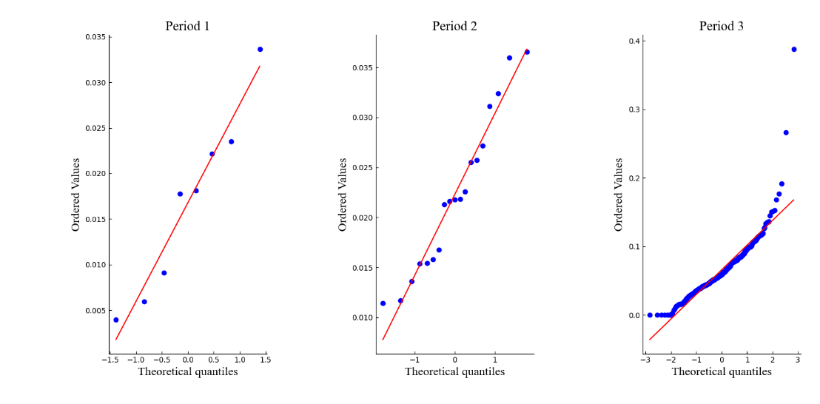
B
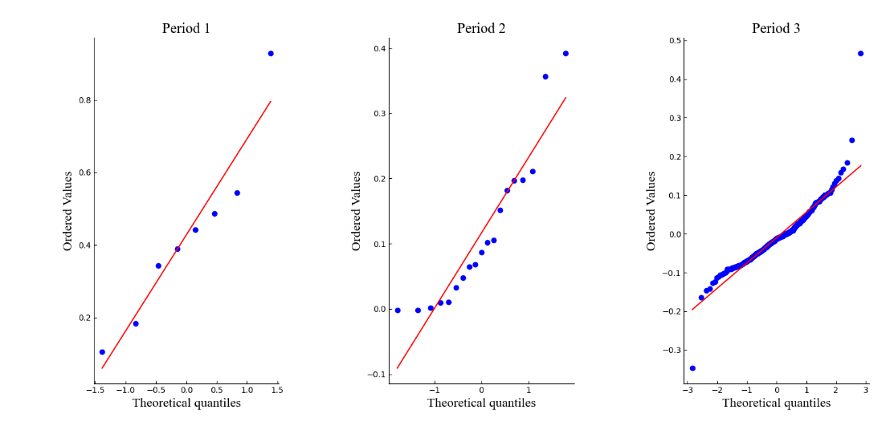
C
Fig. S1. QQ-plot of the main epidemiological parameters in China (A: spreading rate; B: recovery rate; C: effective spreading rate; the red line shows that the main epidemiological parameters in China in each period can almost fit normal distribution except some outliers.)

. 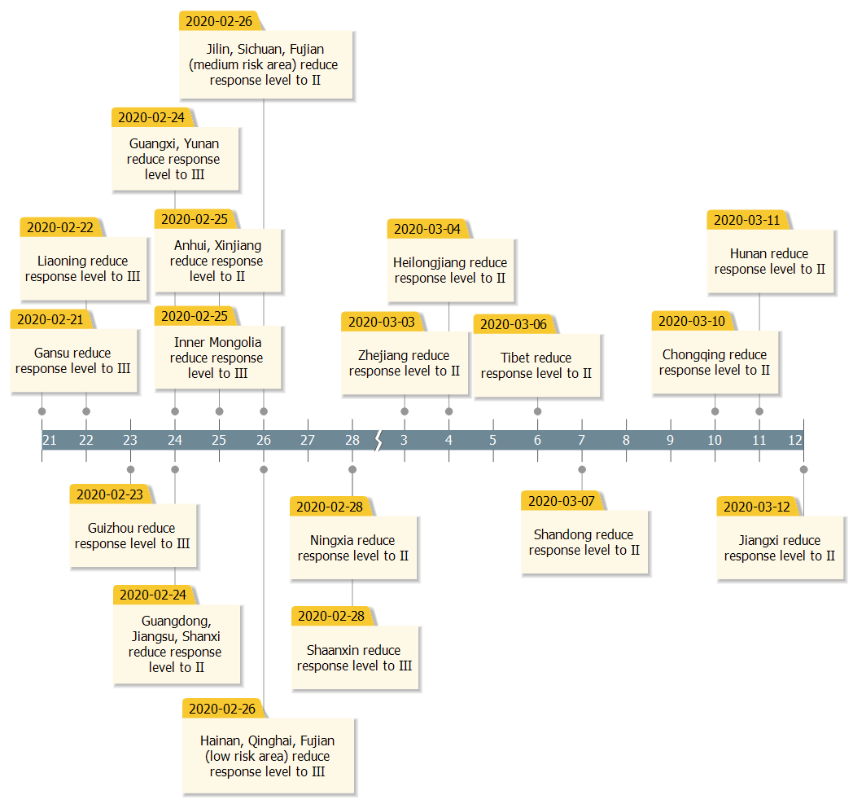
Fig. S2. exact time of the response time of each province of China
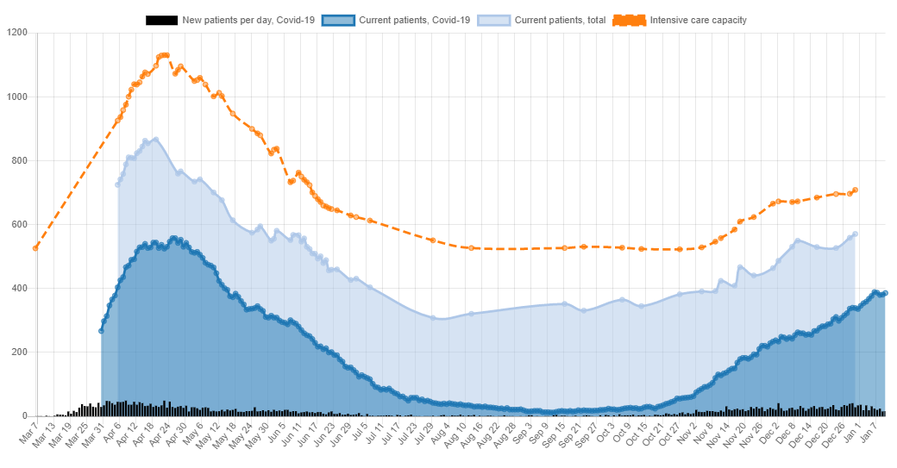
Fig. S3. Patients in intensive care of Sweden (5)

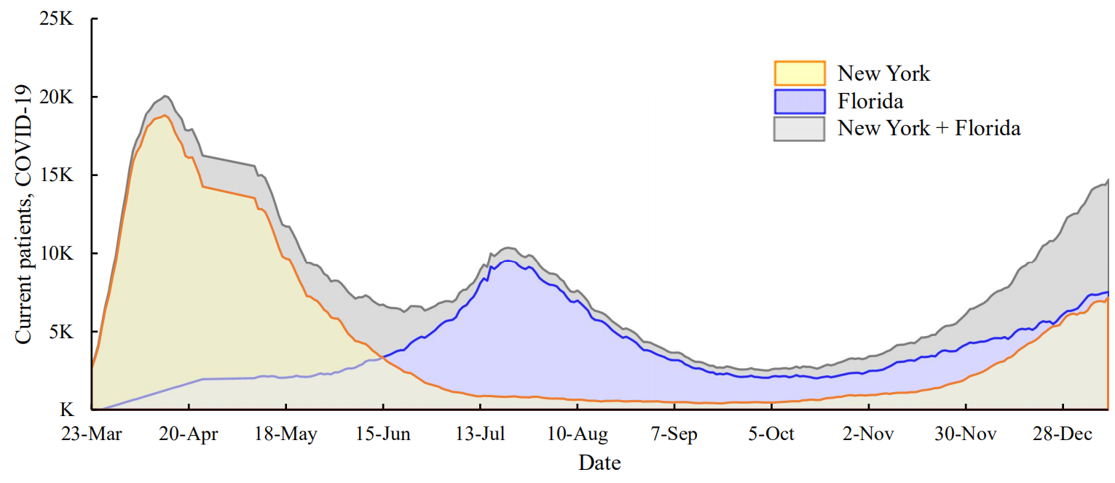
Fig. S4. Current patients in New York and Florida

Table S1. Daily increased active infections before and after the second outbreak
Country | Date | Ten days average before the second outbreak | Daily average after the second outbreak
China | Jul 19, 2020 | 51 infections/day | 185 infections/day
USA | Oct 20, 2020 | 37,751 infections/day | 128,030 infections/day
Sweden | Oct 27, 2020 | 1,399 infections/day | 3,424 infections/day

SI References

- Hethcote, H. W. . (1989). Three Basic Epidemiological Models. Springer Berlin Heidelberg.
- H. Hethcote, The mathematics of infectious diseases. SIAM Rev. 42, 599-653 (2020). doi:10.1137/S0036144500371907
- Anderson, J. S. , Lampl, I. , Reichova, I. , Carandini, M. , & Ferster, D. . (2000). Stimulus dependence of two-state fluctuations of membrane potential in cat visual cortex. Nature Neuroscience, 3(6), 617-621.
- Johns Hopkins University, COVID-19 Data Repository by the Center for Systems Science and Engineering (CSSE) (2020); https://github.com/CSSEGISandData/COVID-19
- Irrational Software AB, (2020), “Covid-19 in Sweden: patients in intensive care”, from: https://www.covid19insweden.com/en/healthcare.html#intensivecare

