Supporting information
5-Phosponohydantoins: synthesis and investigation of their biological activities
Ivan A. Klimchuk,ª Dmitry O. Shkil,ª Yury V. Timchenko,ª Arsenii A. Timichev,ª Igor A. Rodin,ª Vitaliy A. Ioutsi,^{b} Garegin A. Petrosyan,^{c} Dmitrii A. Lukianov,^{ad} Tingxuan Yan,^{e} Jinlei Bian,^{f} Natalya A. Pavlova,^{g} Elizaveta G. Lukina,^{g} Alexander O. Berestetskiy,^{g} Elena K. Beloglazkinaª and Alexander V. Finko^{*a}

ªDepartment of Chemistry, Lomonosov Moscow State University (MSU) 119991, Moscow, Russia. E-mail: finko.alexander@gmail.com
^{b}The National Medical Research Centre for Endocrinology, 117292 Moscow, Russia
^{c}Department of Soil Science, Lomonosov Moscow State University (MSU), 119991 Moscow, Russia
^{d}Center for Molecular and Cellular Biology, 121205, Skolkovo, Moscow, Russia
^{e}Department of Chemical Biology and Pharmaceutical Engineering, School of Chemistry and Chemical Engineering, Anhui University of Technology, Ma'anshan, 243032, China
^{f}Department of Medicinal Chemistry, School of Pharmacy, China Pharmaceutical University, 210009, Nanjing, China
^{g}Laboratory of Phytotoxicology and Biotechnology, All-Russian Institute of Plant Protection 196608, Pushkin, Saint Petersburg, Russia

Contents
1. ¹H NMR, ¹³C NMR and ³¹P spectra S2
2. HRMS spectra S42
3. FTIR spectra S53
4. HPLC spectra S64
5. Assays of antibacterial activity S74
6. Control effect of target compounds by leaf prick method S75

1. ¹H NMR, ¹³C NMR and ³¹P spectra
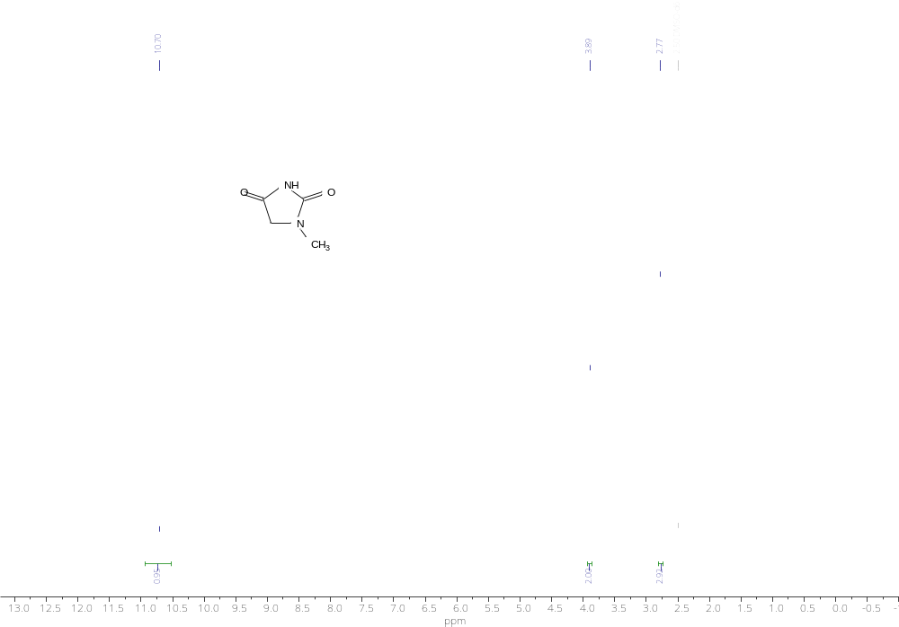
¹H NMR spectrum of compound 5a
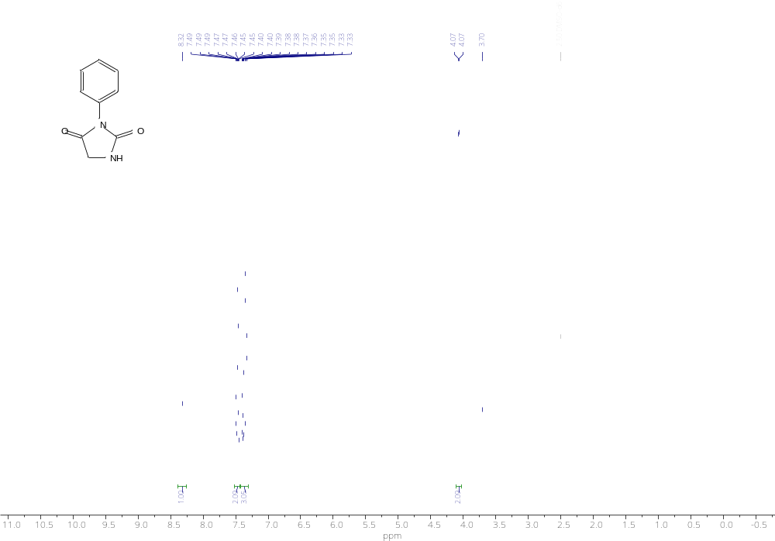
¹H NMR spectrum of compound 5b

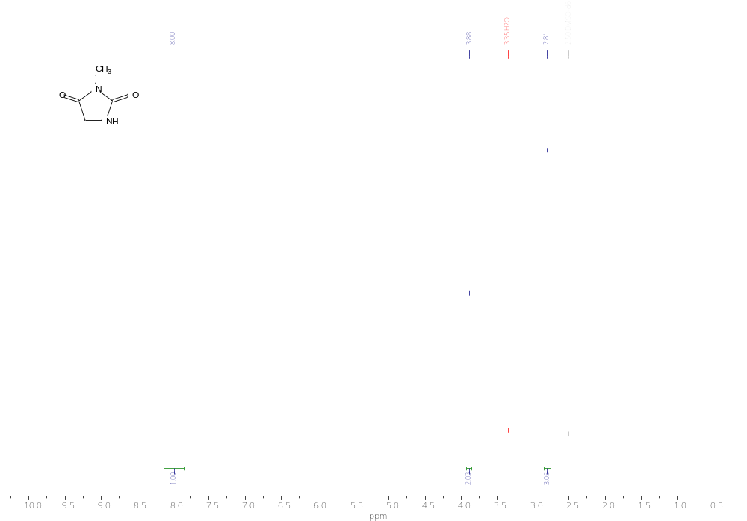
¹H NMR spectrum of compound 5d

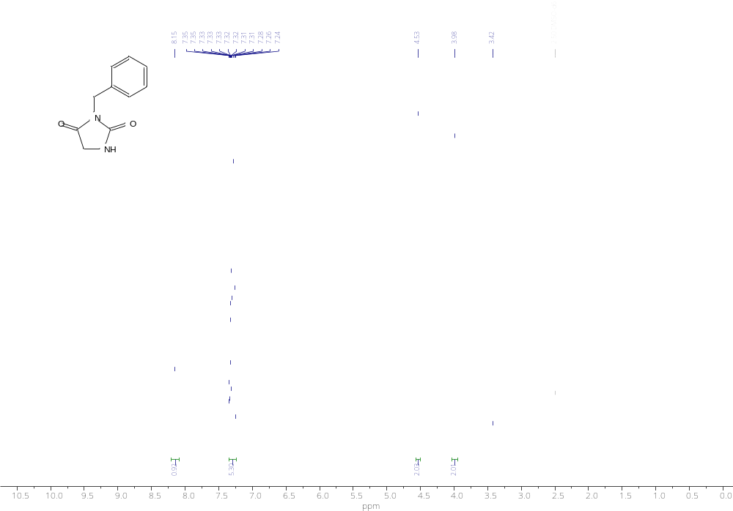
¹H NMR spectrum of compound 5e

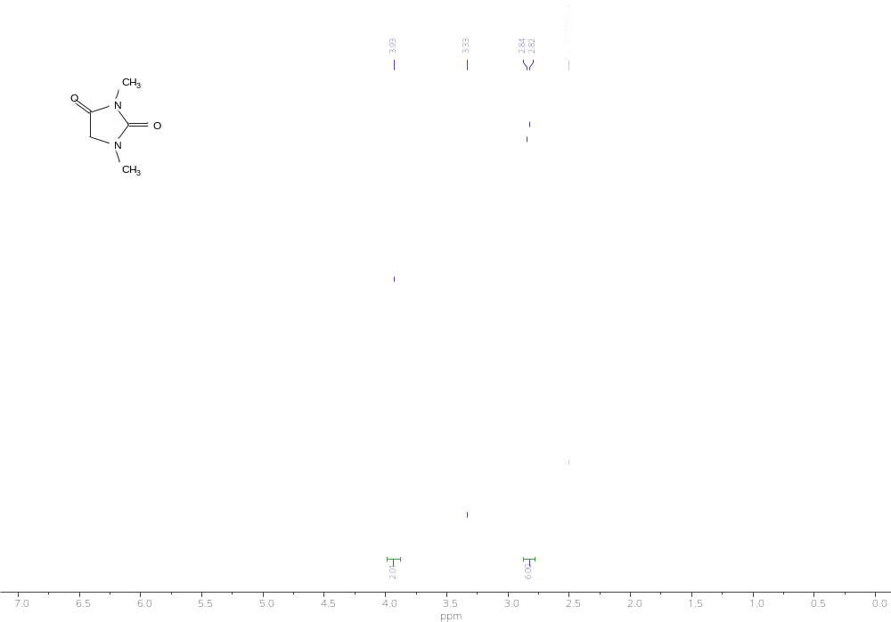
¹H NMR spectrum of compound 5f

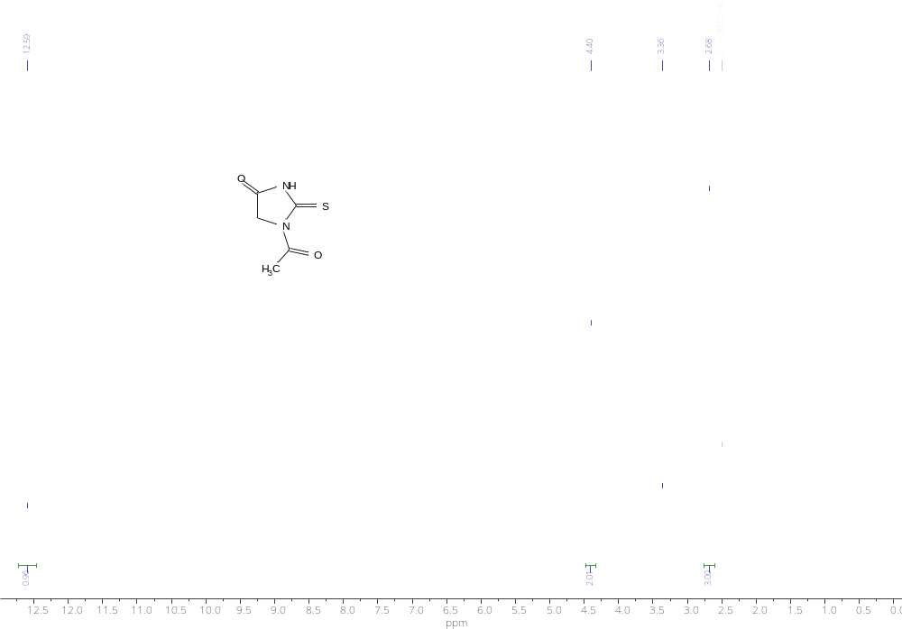
¹H NMR spectrum of compound 5g

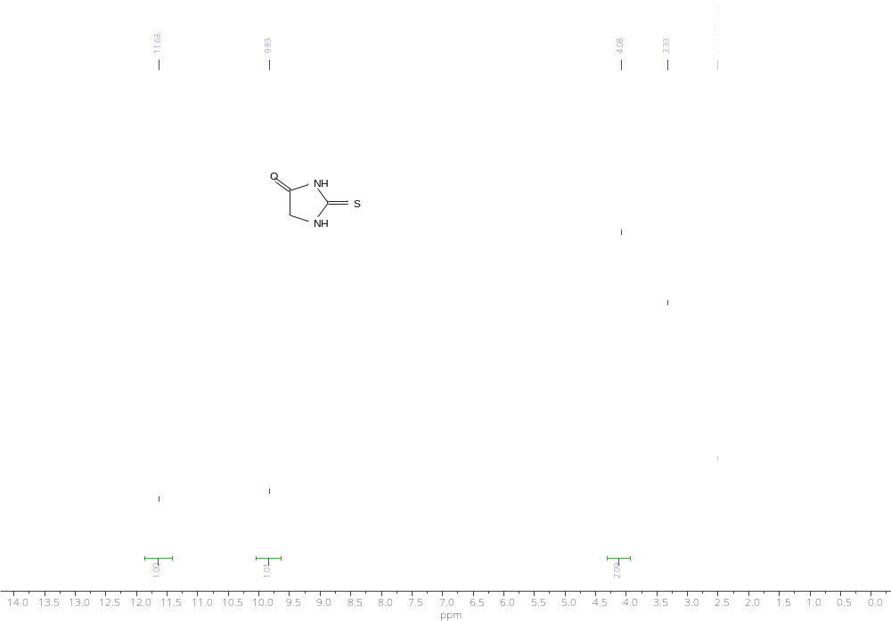
¹H NMR spectrum of compound 5h

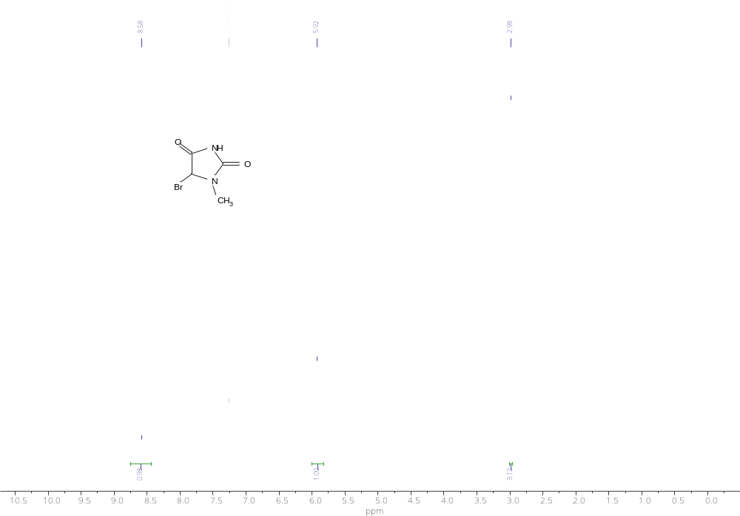
¹H NMR spectrum of compound 6a

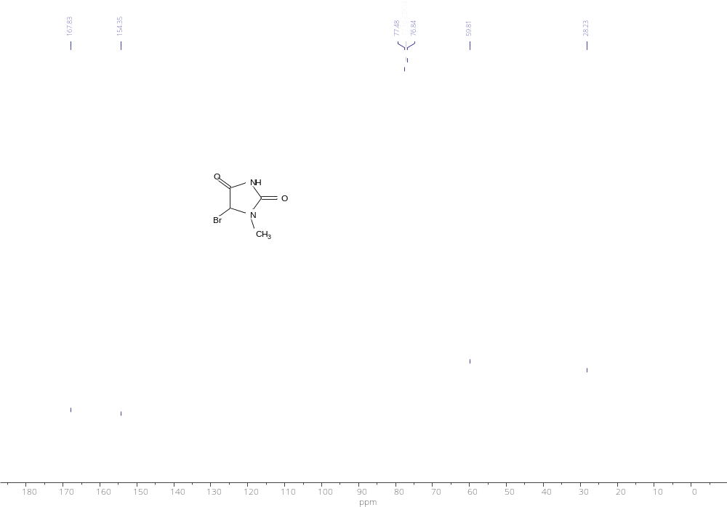
¹³C NMR spectrum of compound 6a

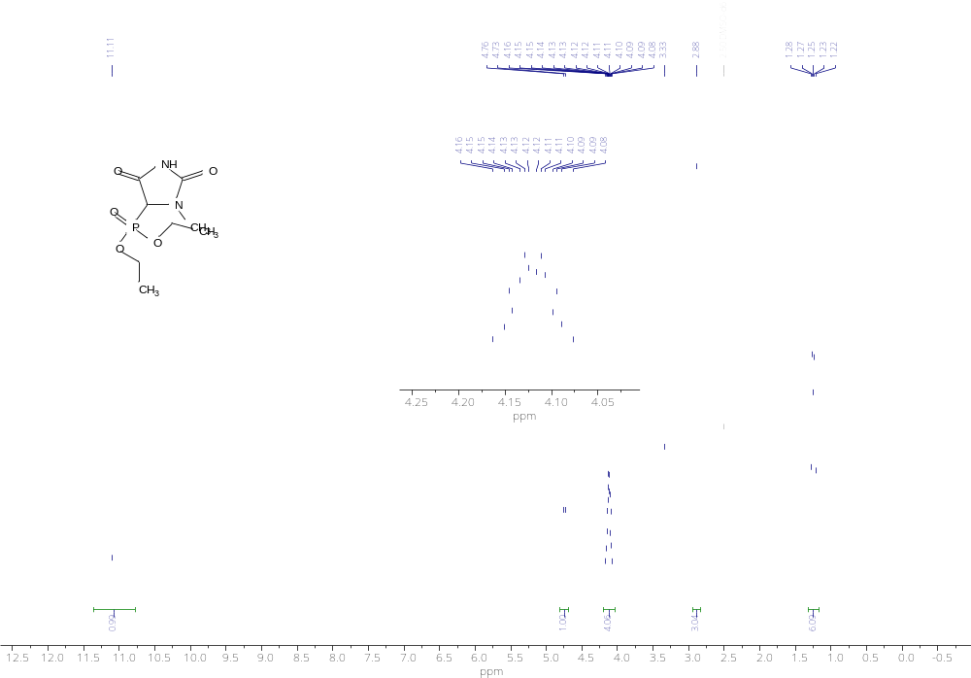
¹H NMR spectrum of compound 7a

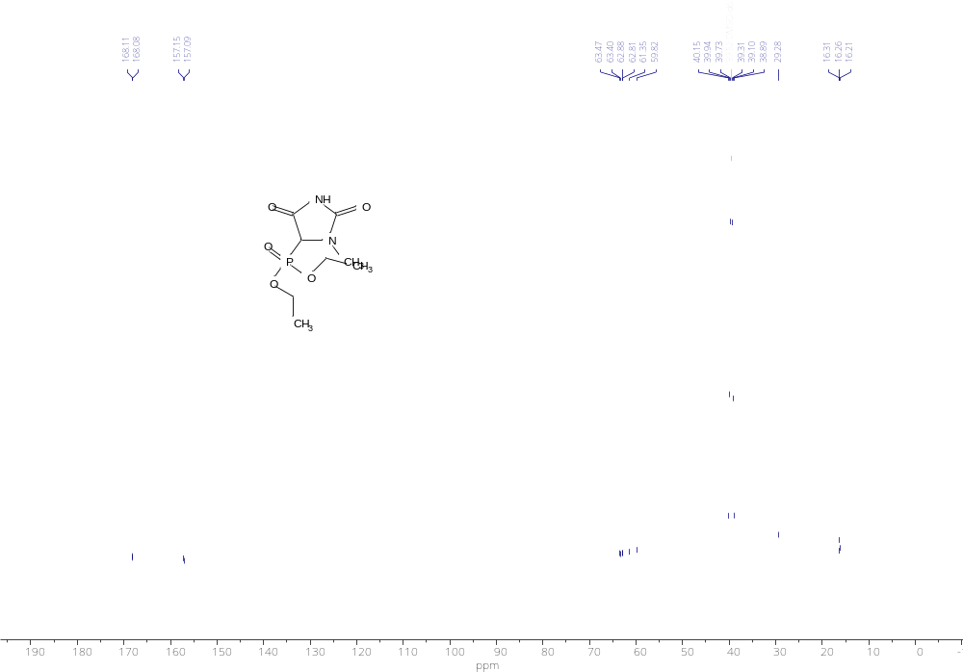
¹³C NMR spectrum of compound 7a

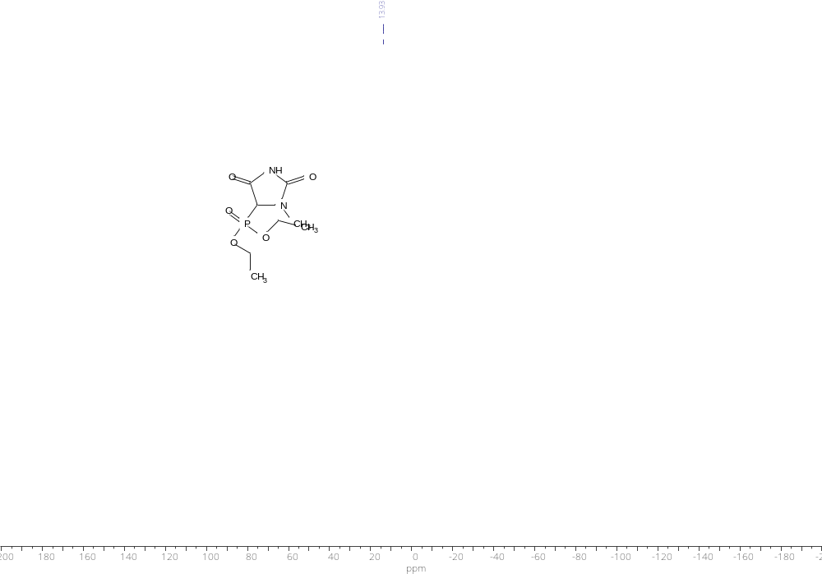
³¹P NMR spectrum of compound 7a

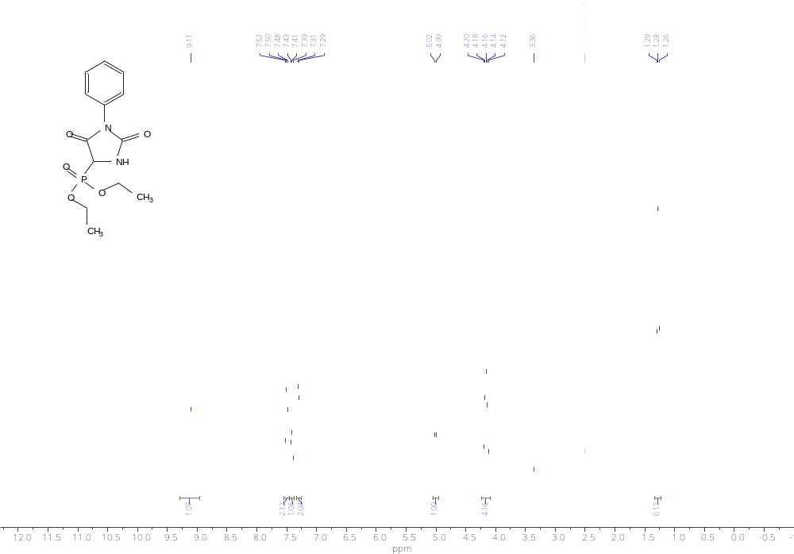
¹H NMR spectrum of compound 7b

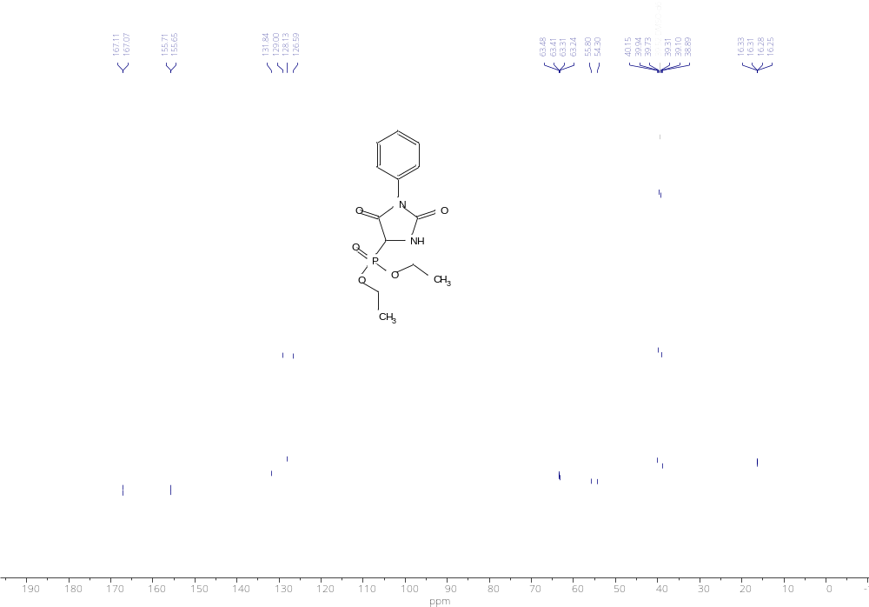
¹³C NMR spectrum of compound 7b

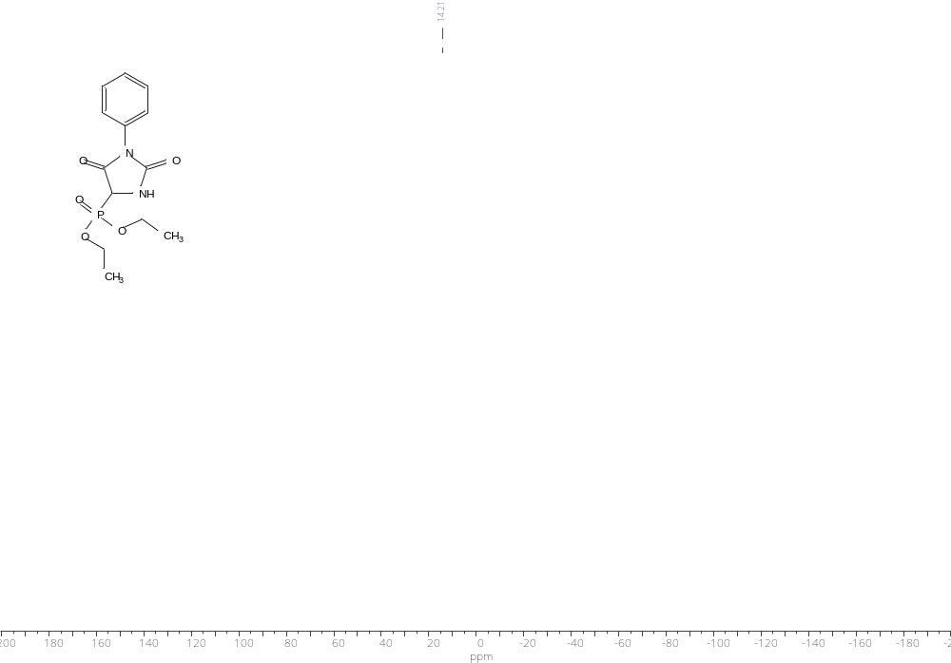
³¹P NMR spectrum of compound 7b

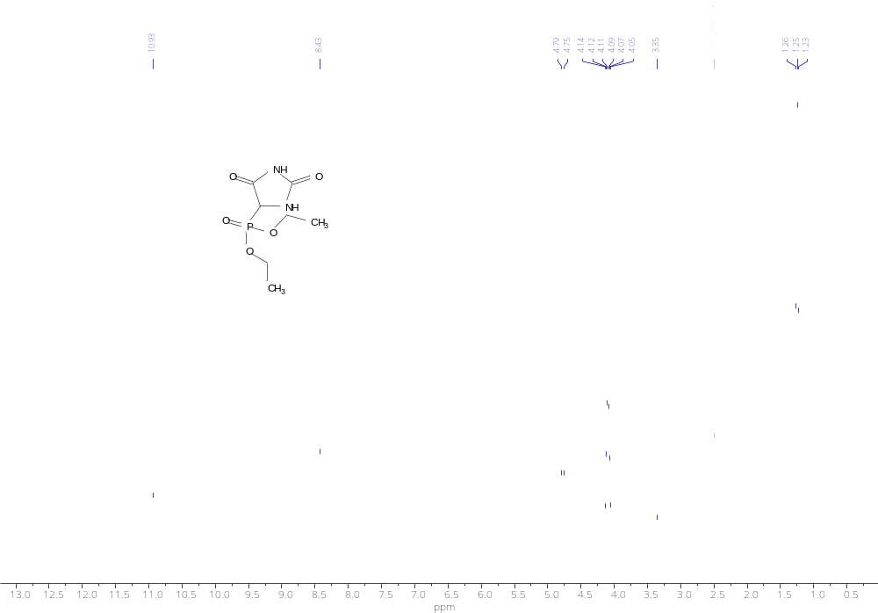
¹H NMR spectrum of compound 7c

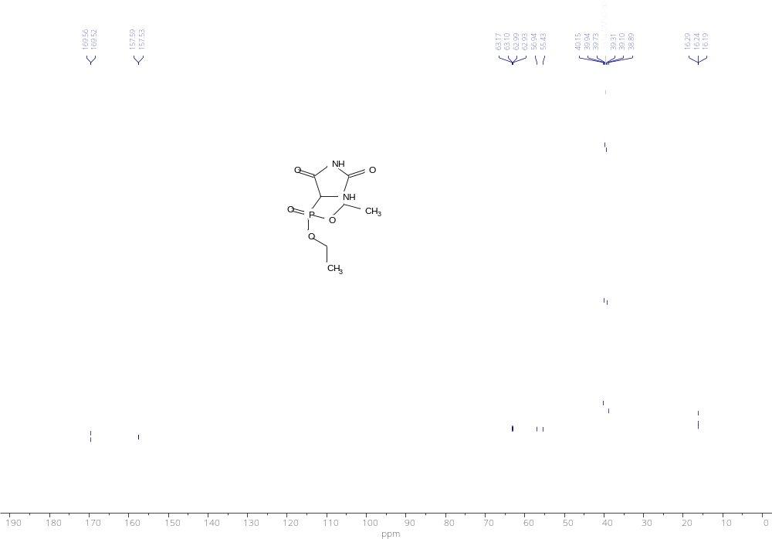
¹³C NMR spectrum of compound 7c

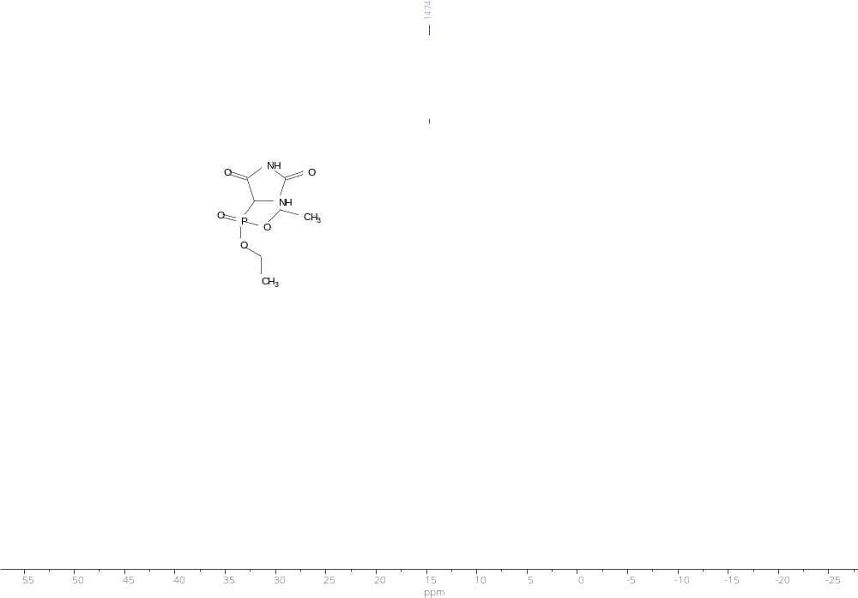
³¹P NMR spectrum of compound 7c

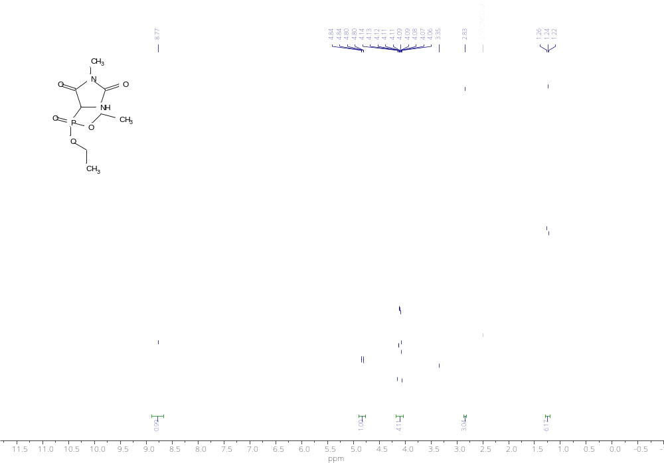
¹H NMR spectrum of compound 7d

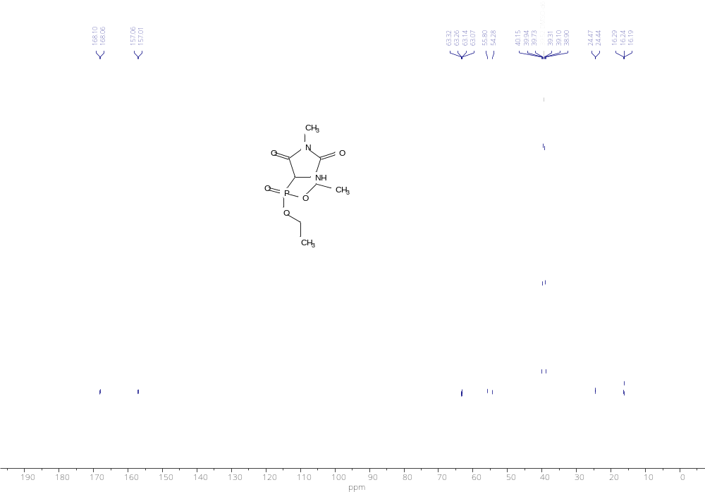
¹³C NMR spectrum of compound 7d

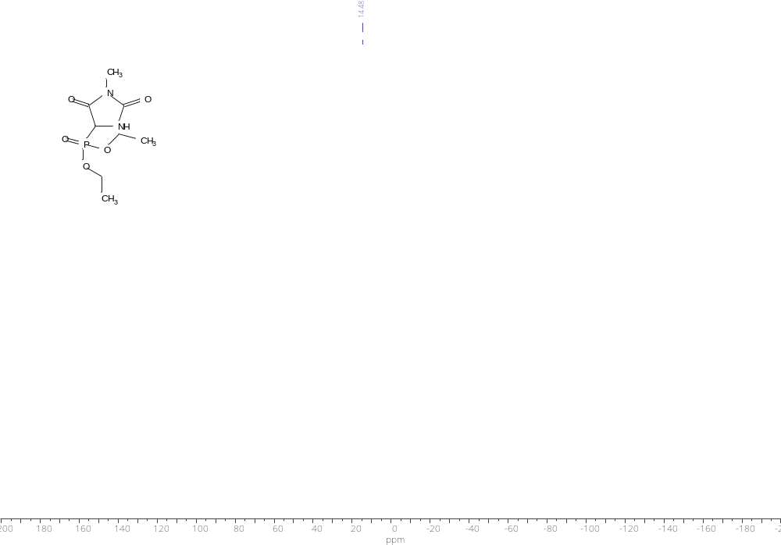
³¹P NMR spectrum of compound 7d

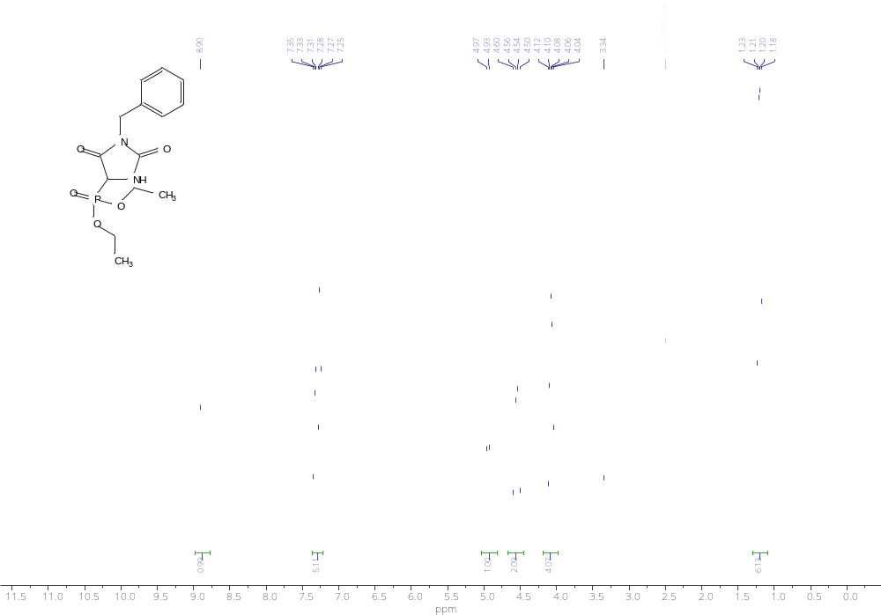
¹H NMR spectrum of compound 7e

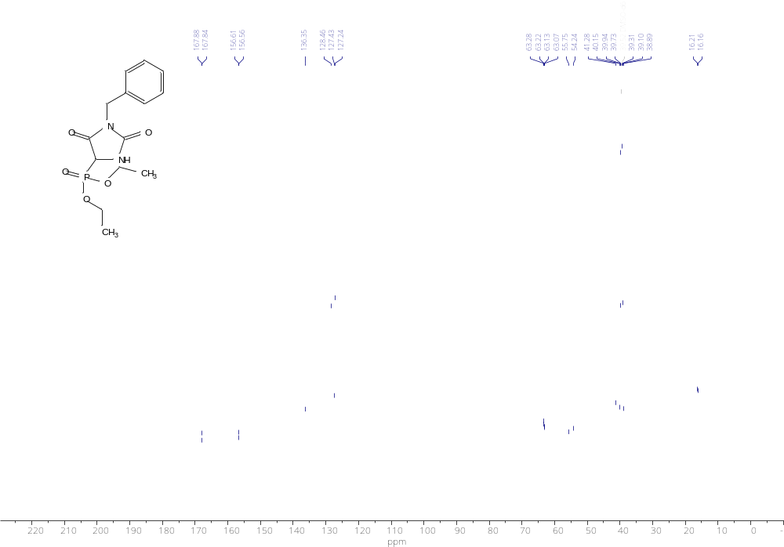
¹³C NMR spectrum of compound 7e

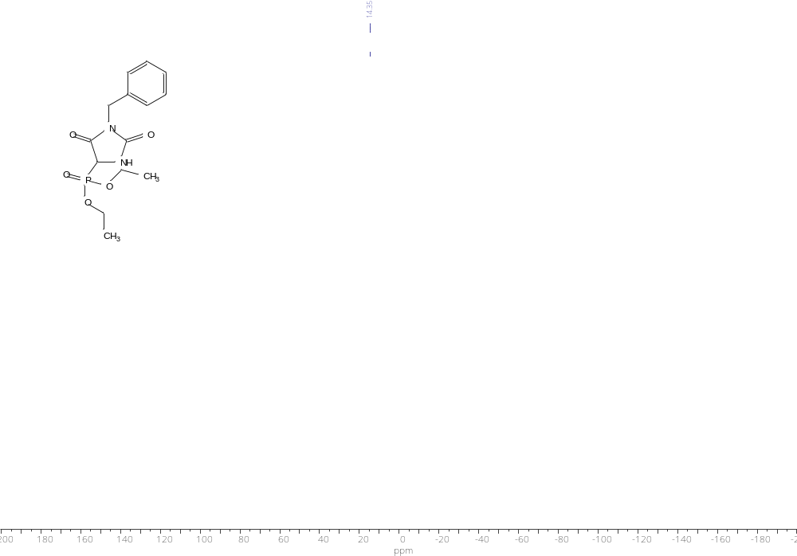
³¹P NMR spectrum of compound 7e

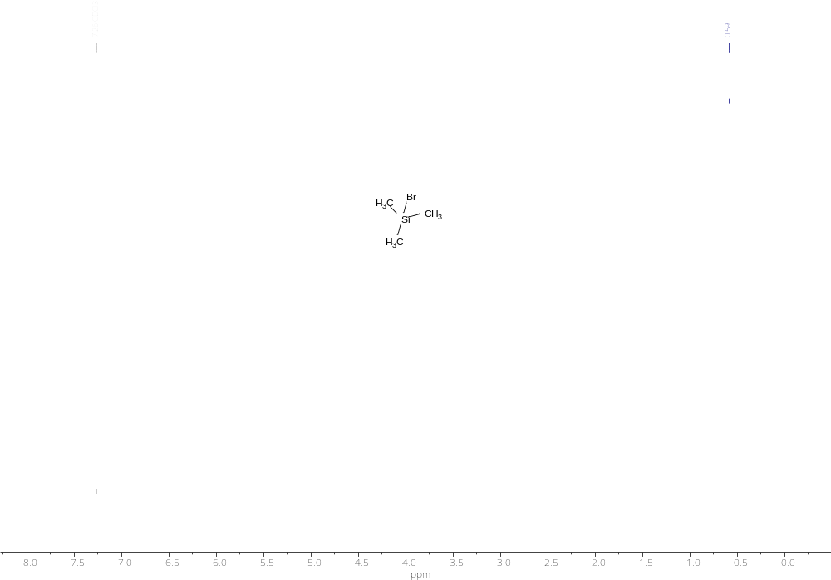
¹H NMR spectrum of compound 9

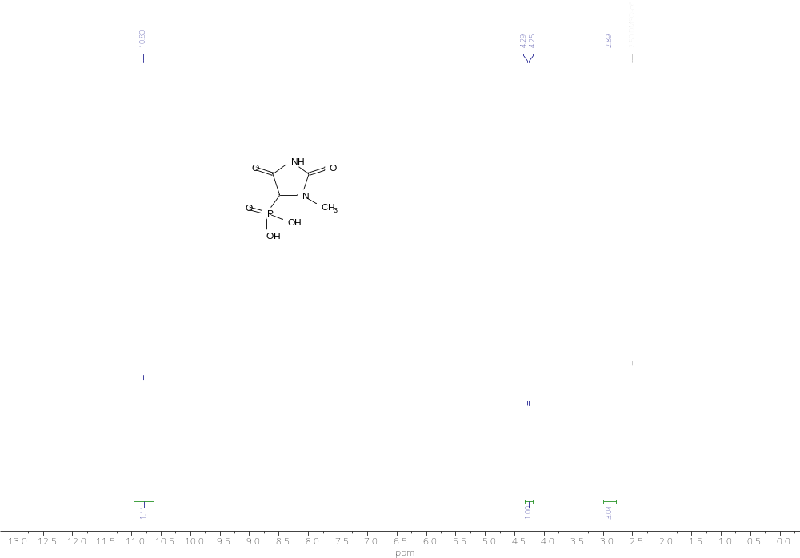
¹H NMR spectrum of compound 10a

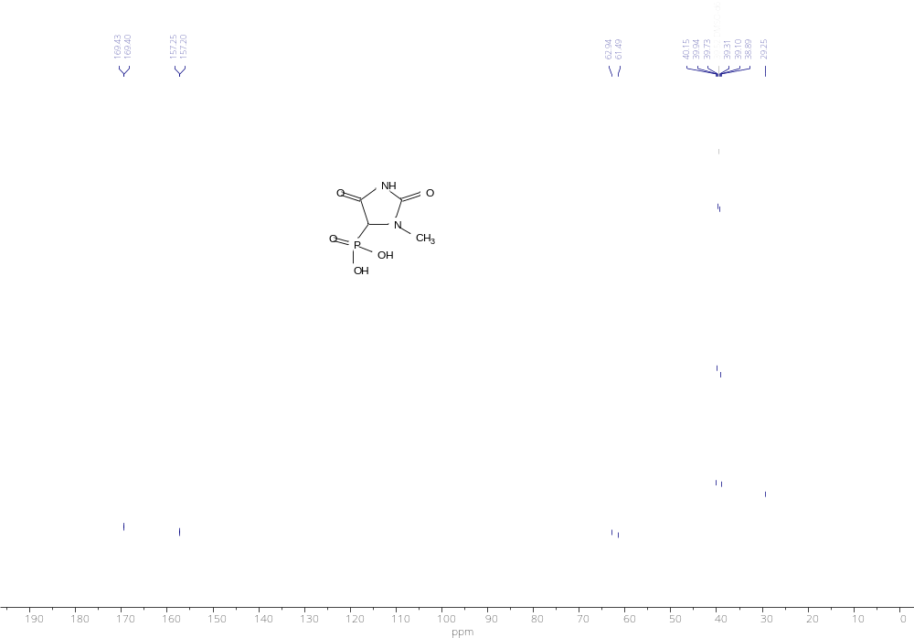
¹³C NMR spectrum of compound 10a

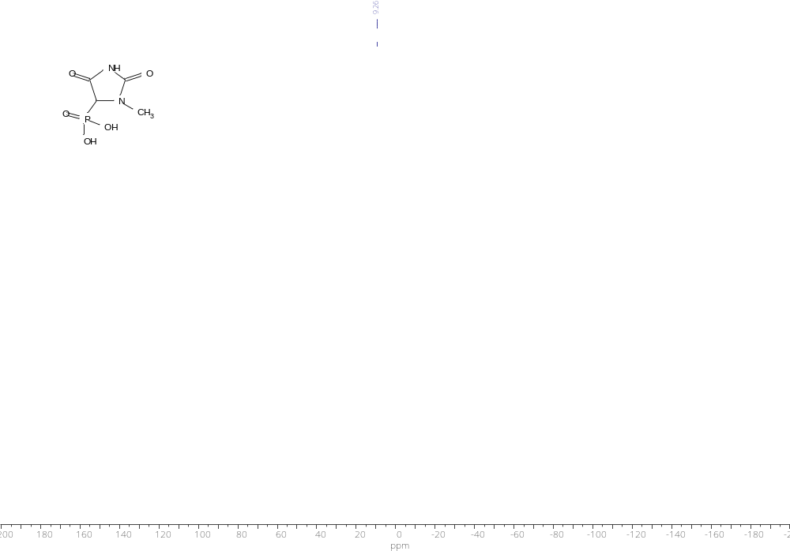
³¹P NMR spectrum of compound 10a

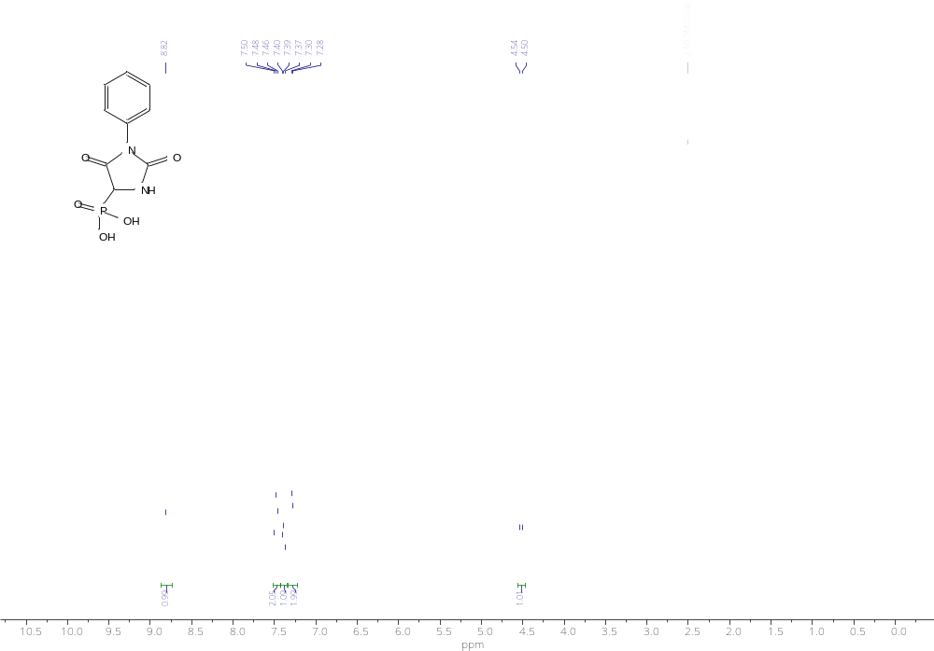
¹H NMR spectrum of compound 10b

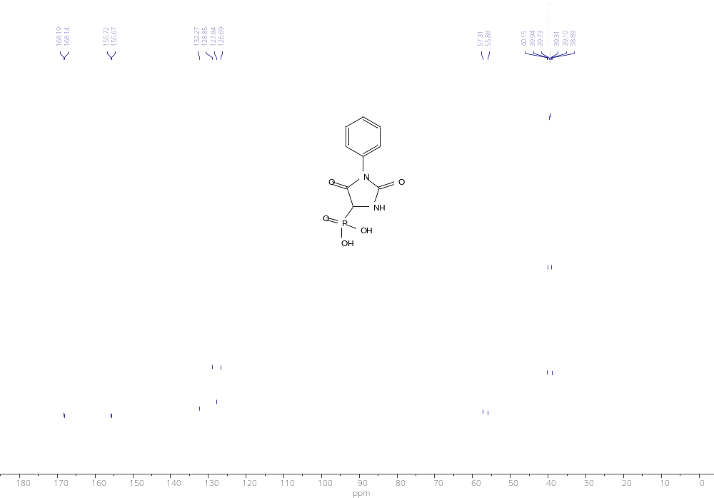
¹³C NMR spectrum of compound 10b

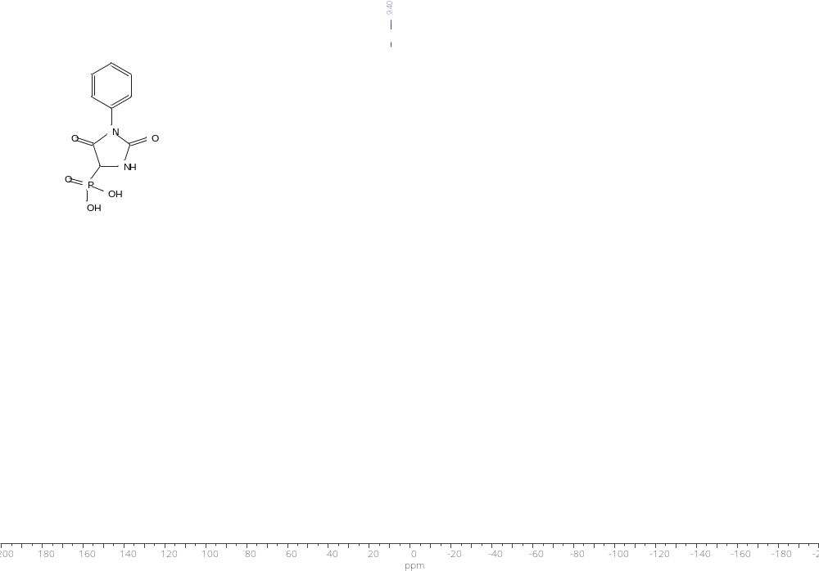
³¹P NMR spectrum of compound 10c

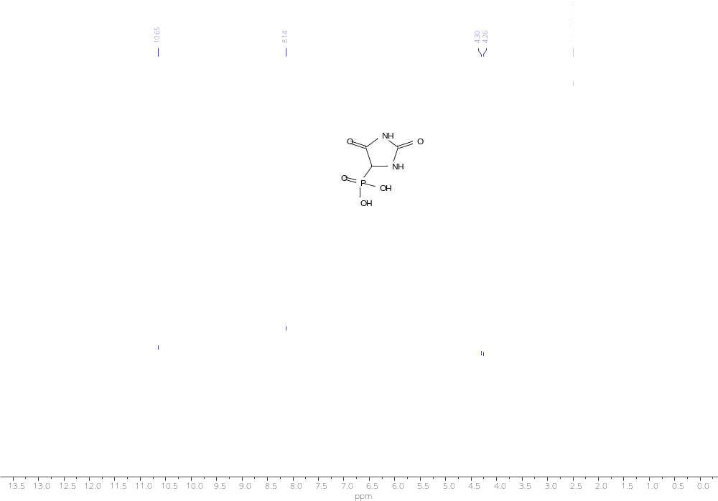
¹H NMR spectrum of compound 10c

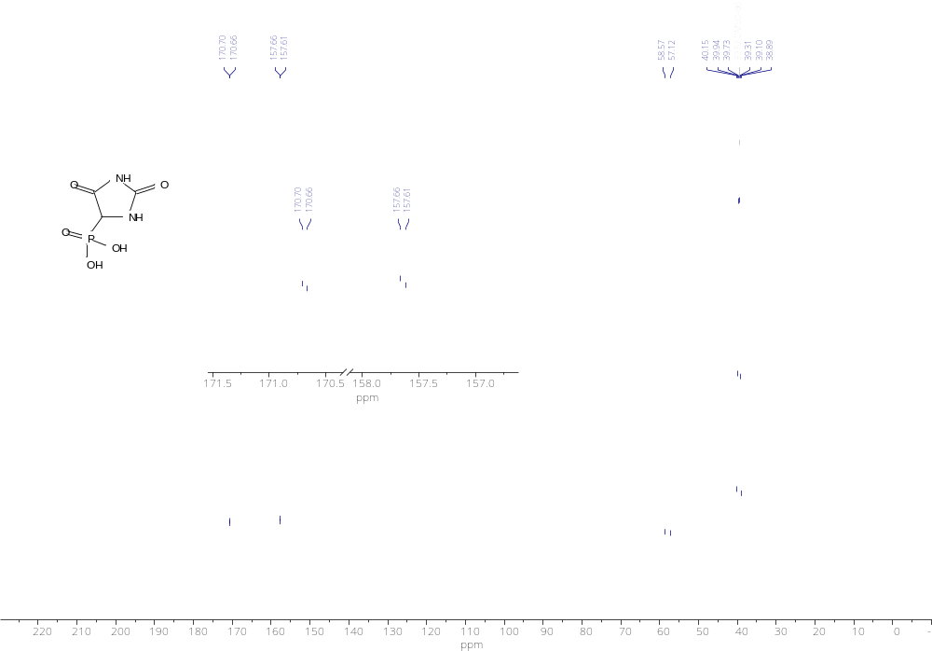
¹³C NMR spectrum of compound 10c

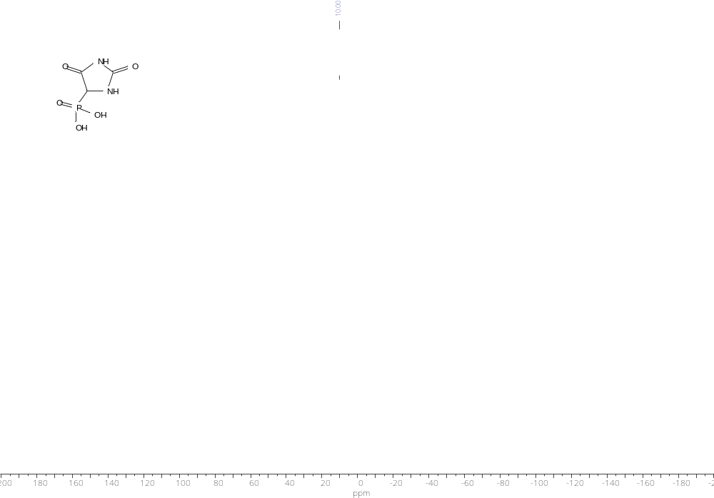
³¹P NMR spectrum of compound 10c

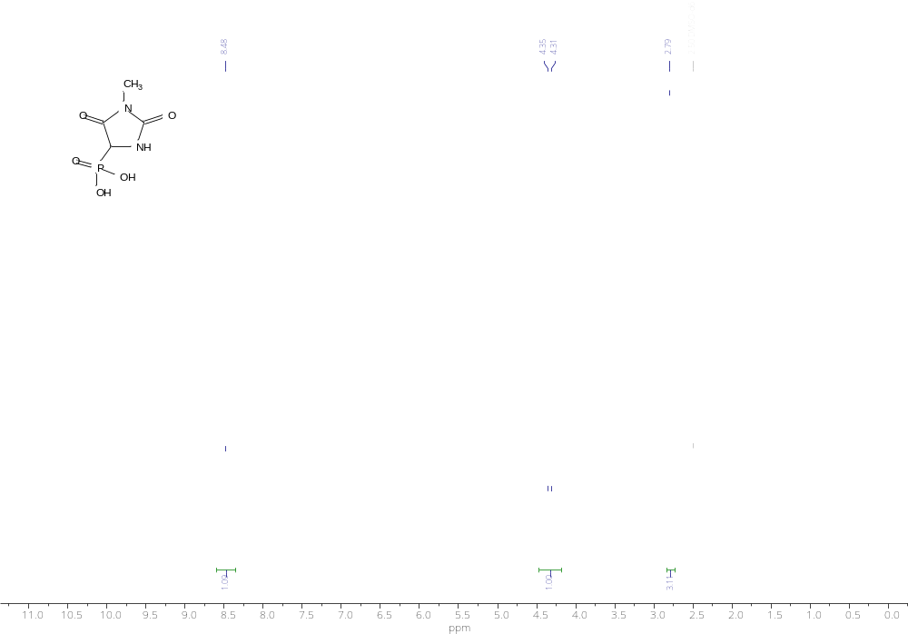
¹H NMR spectrum of compound 10d

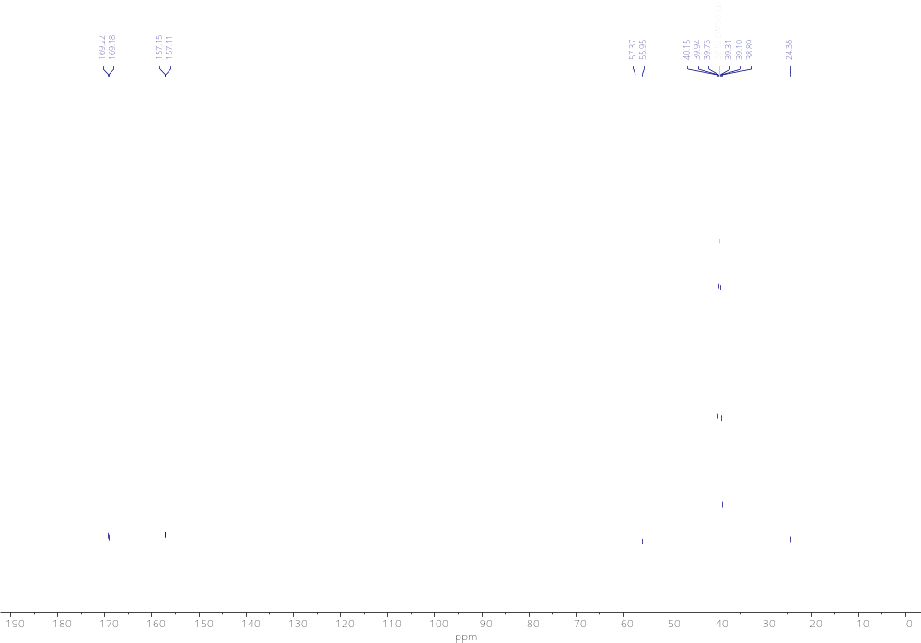
¹³C NMR spectrum of compound 10d

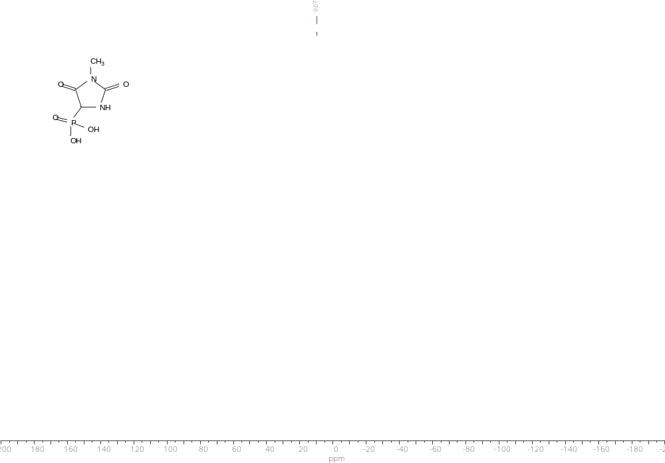
³¹P NMR spectrum of compound 10d

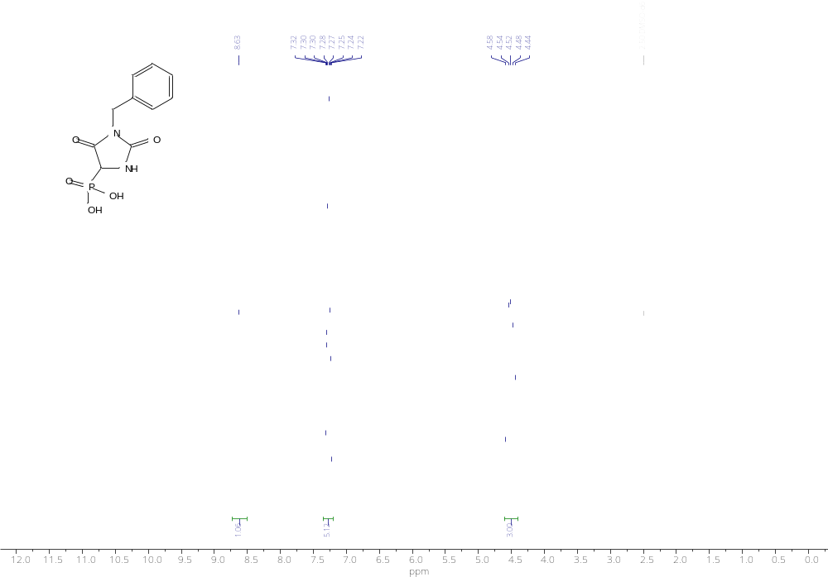
¹H NMR spectrum of compound 10e

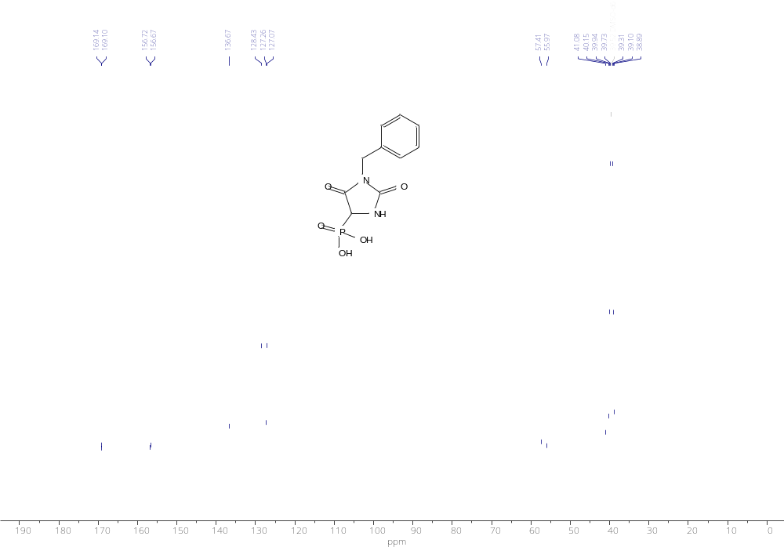
¹³C NMR spectrum of compound 10e

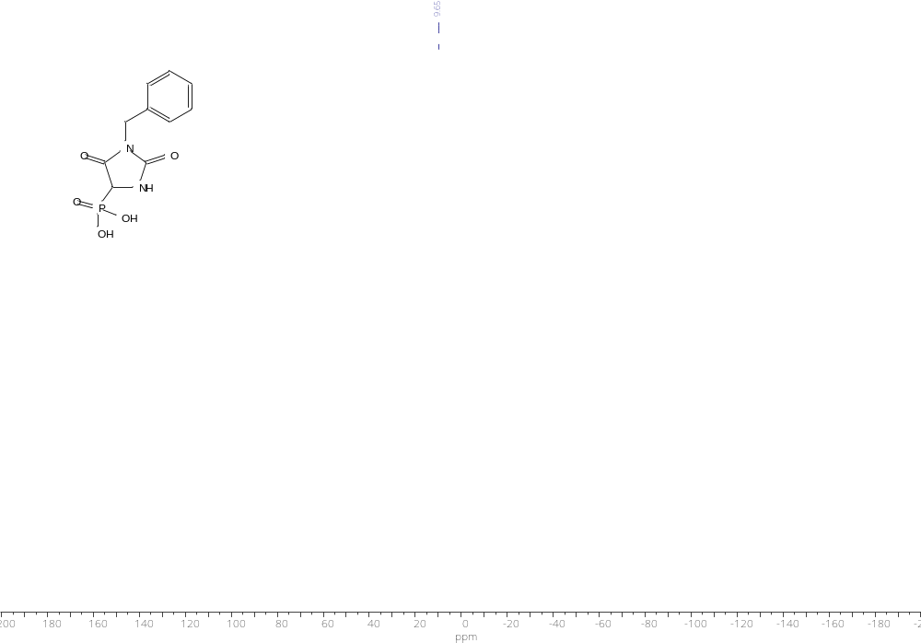
³¹P NMR spectrum of compound 10e

2. HRMS spectra
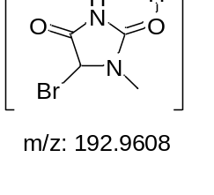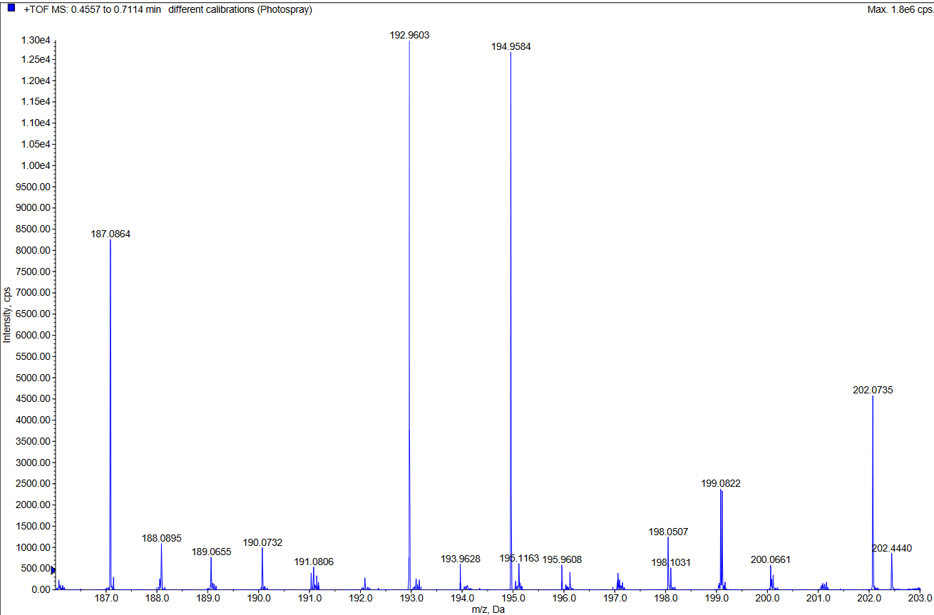
HRMS spectrum of compound 6a

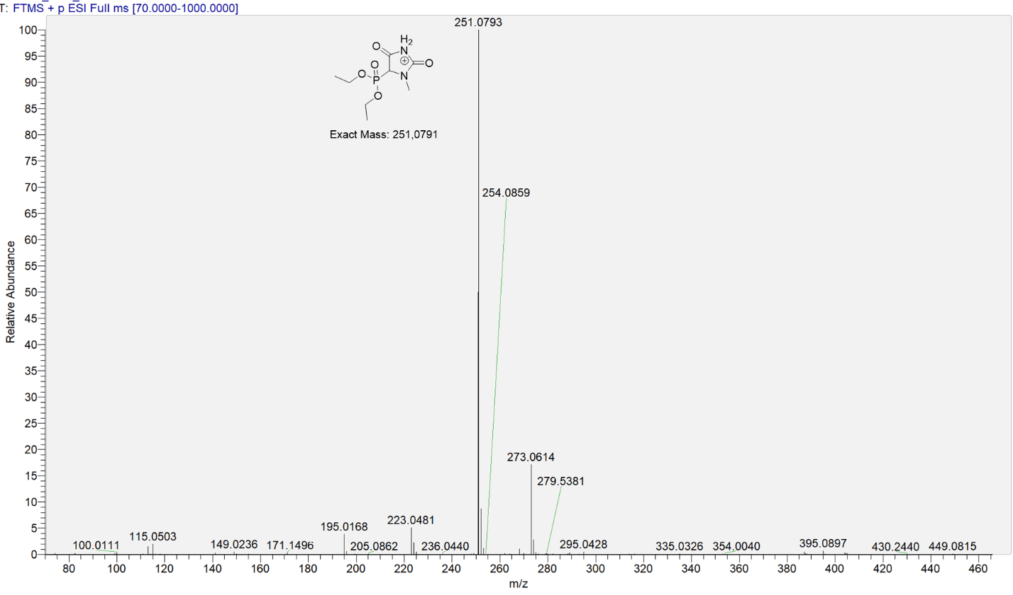
HRMS spectrum of compound 7a

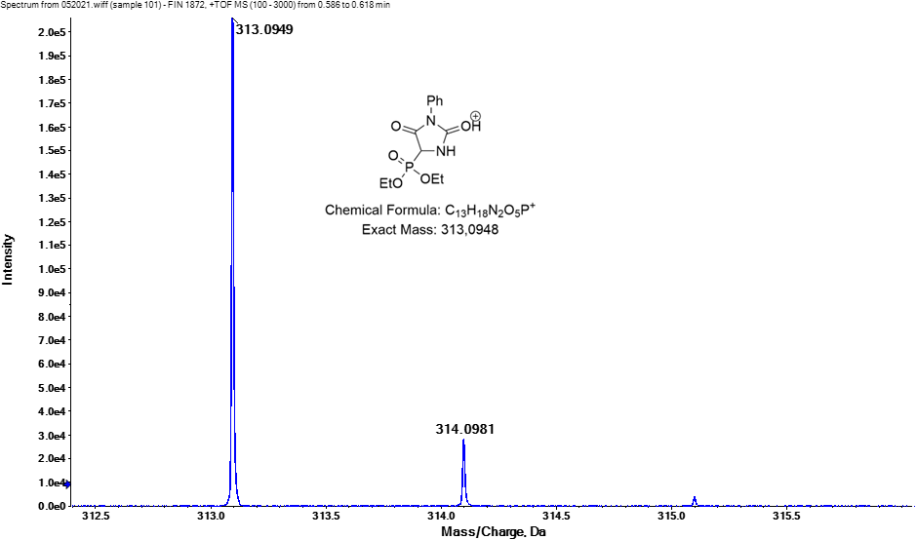
HRMS spectrum of compound 7b

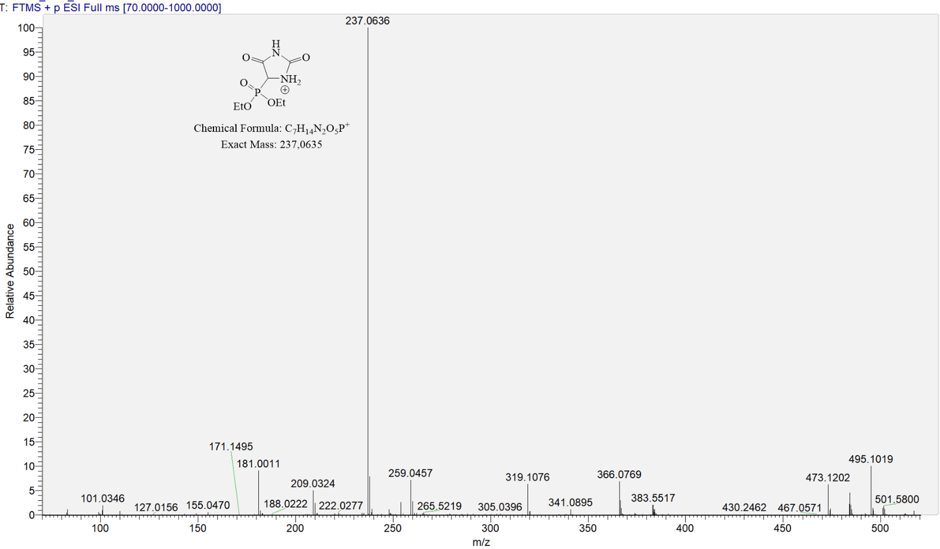
HRMS spectrum of compound 7c

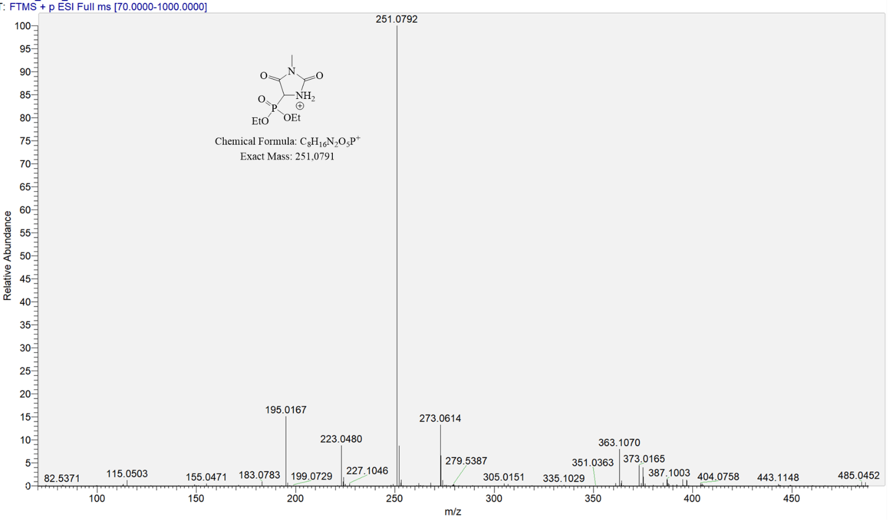
HRMS spectrum of compound 7d

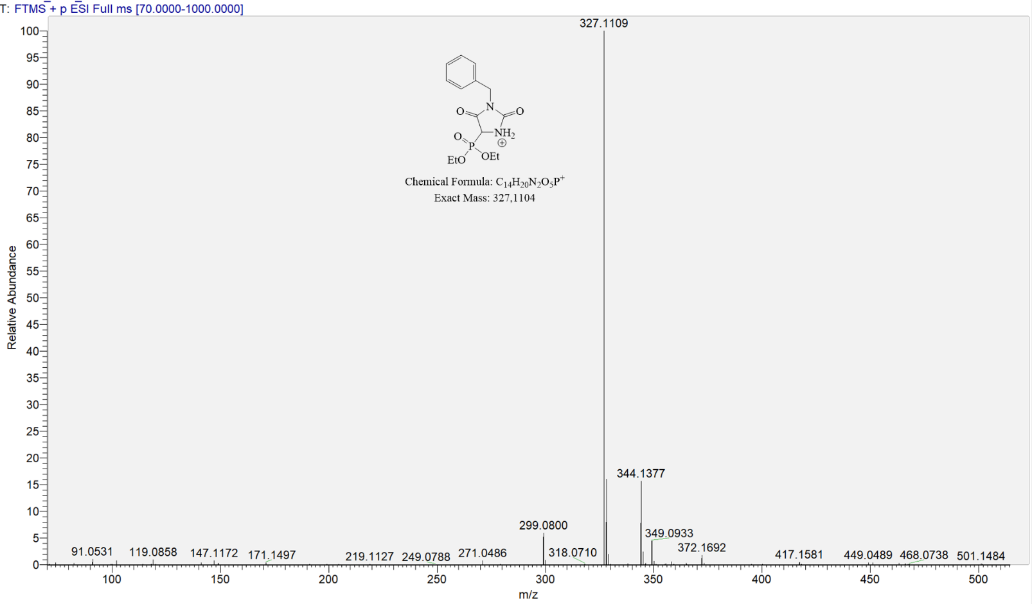
HRMS spectrum of compound 7e

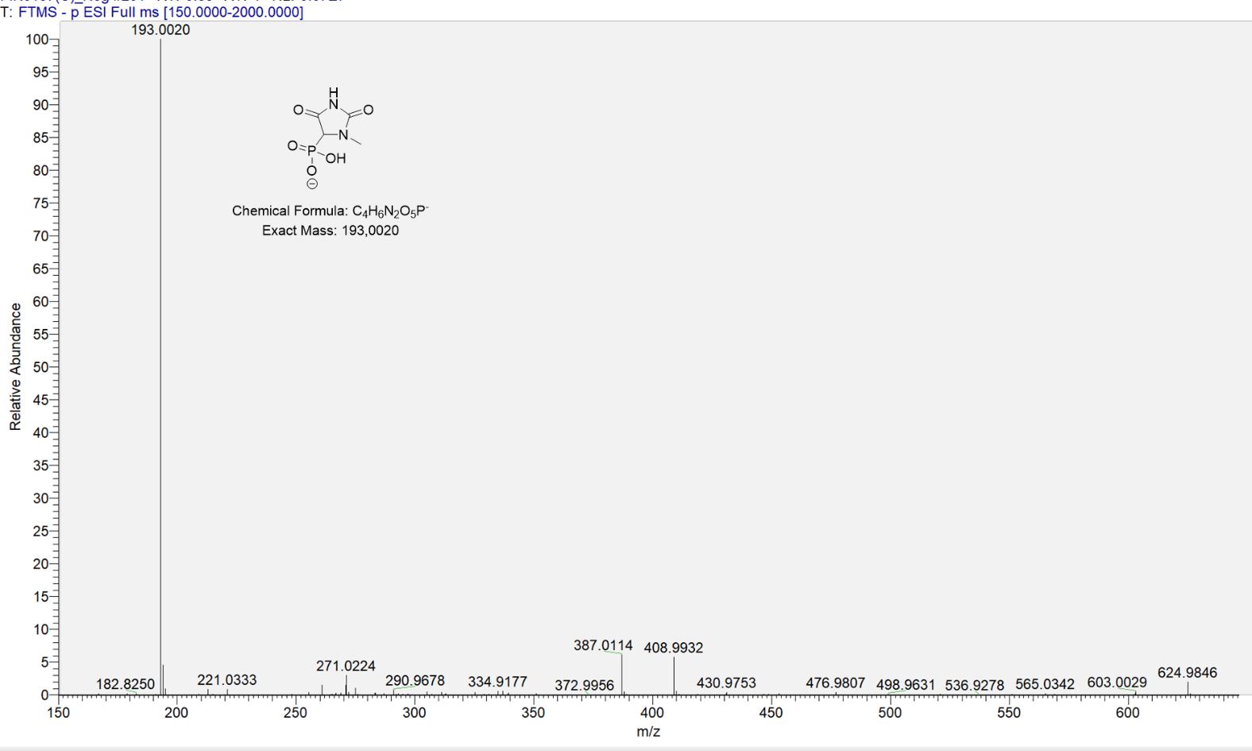
HRMS spectrum of compound 10a

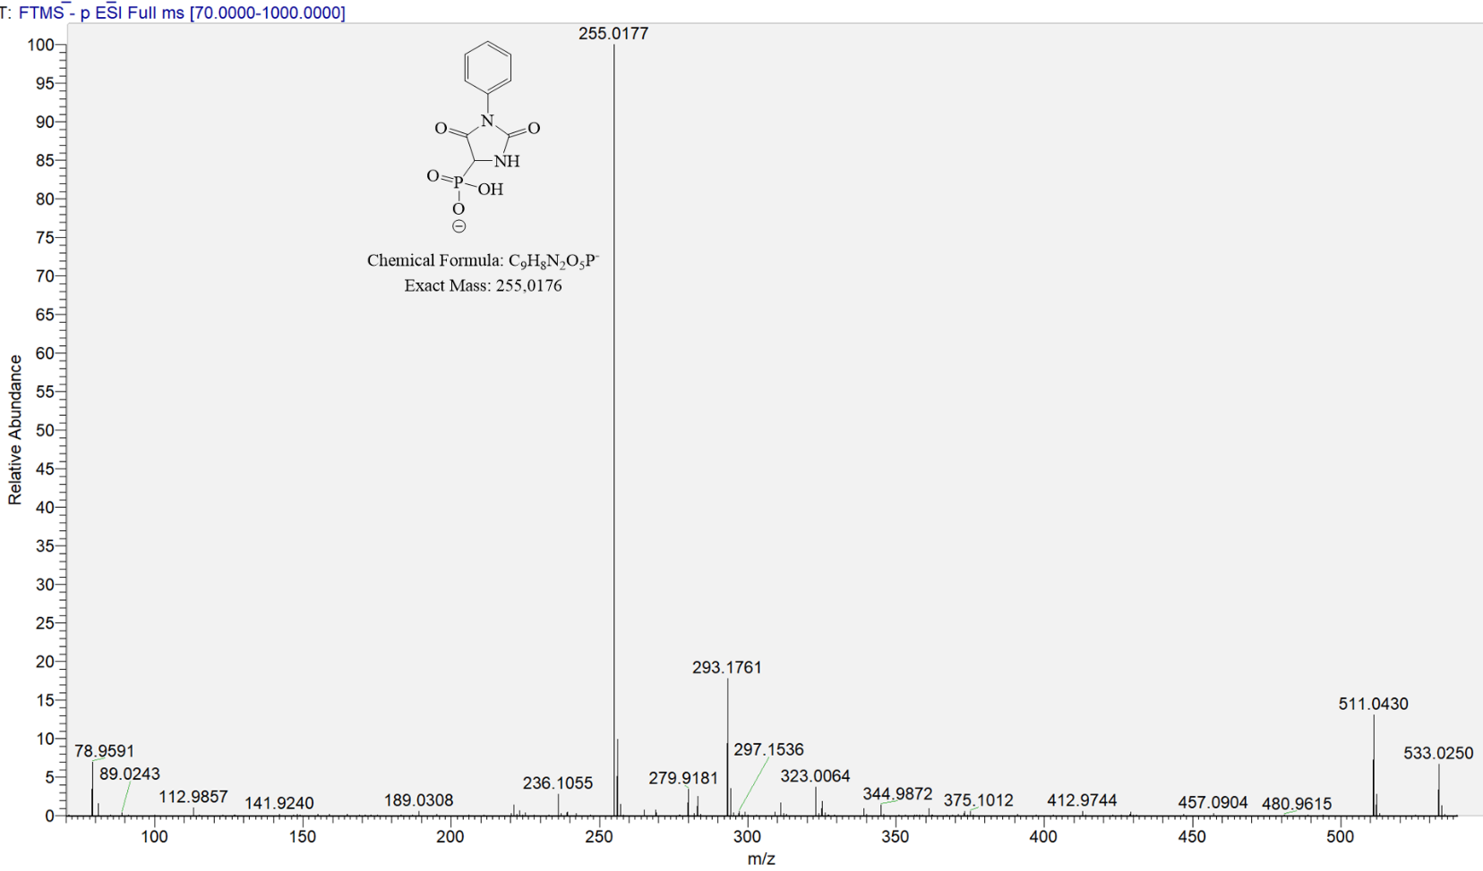
HRMS spectrum of compound 10b

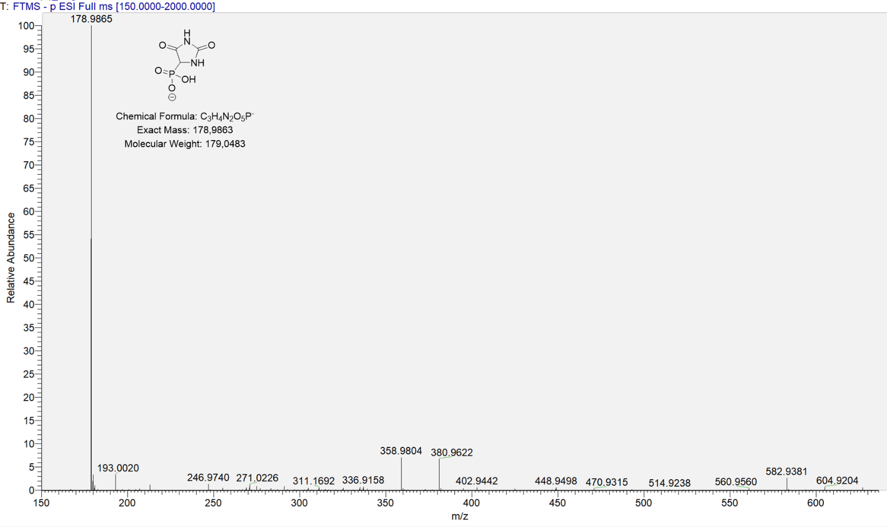
HRMS spectrum of compound 10c

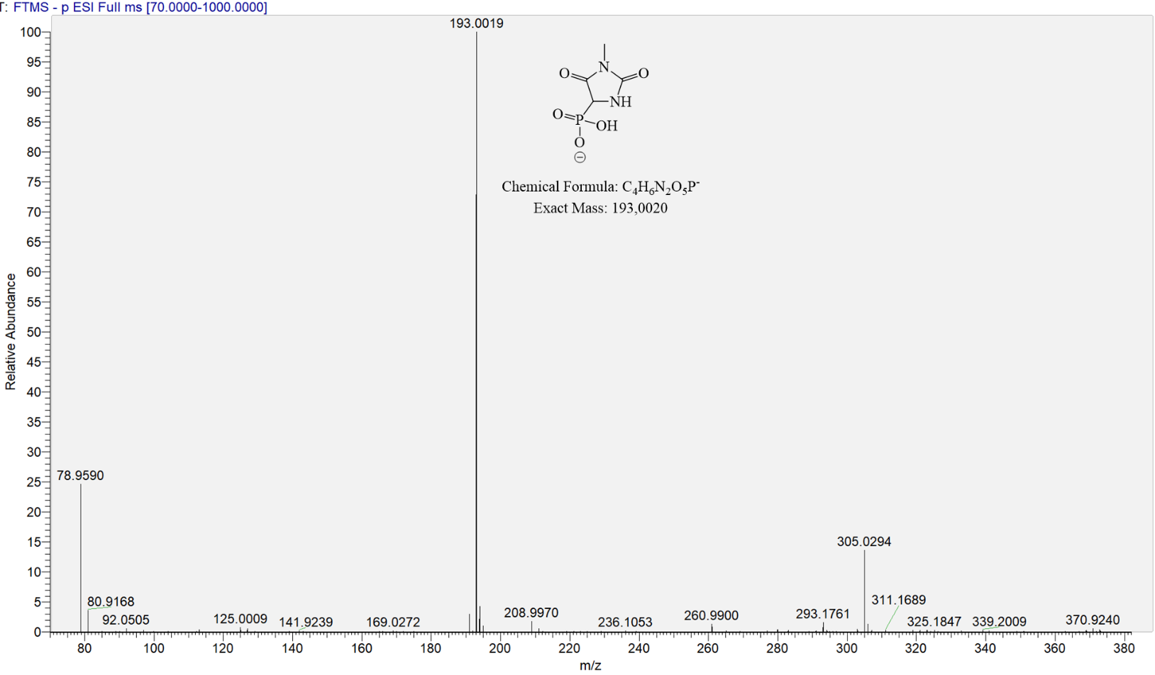
HRMS spectrum of compound 10d

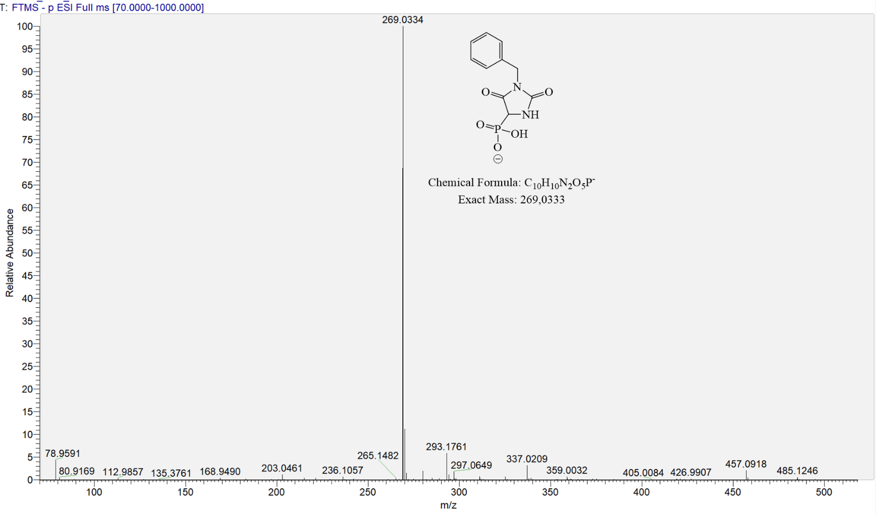
HRMS spectrum of compound 10e

3. FTIR spectra
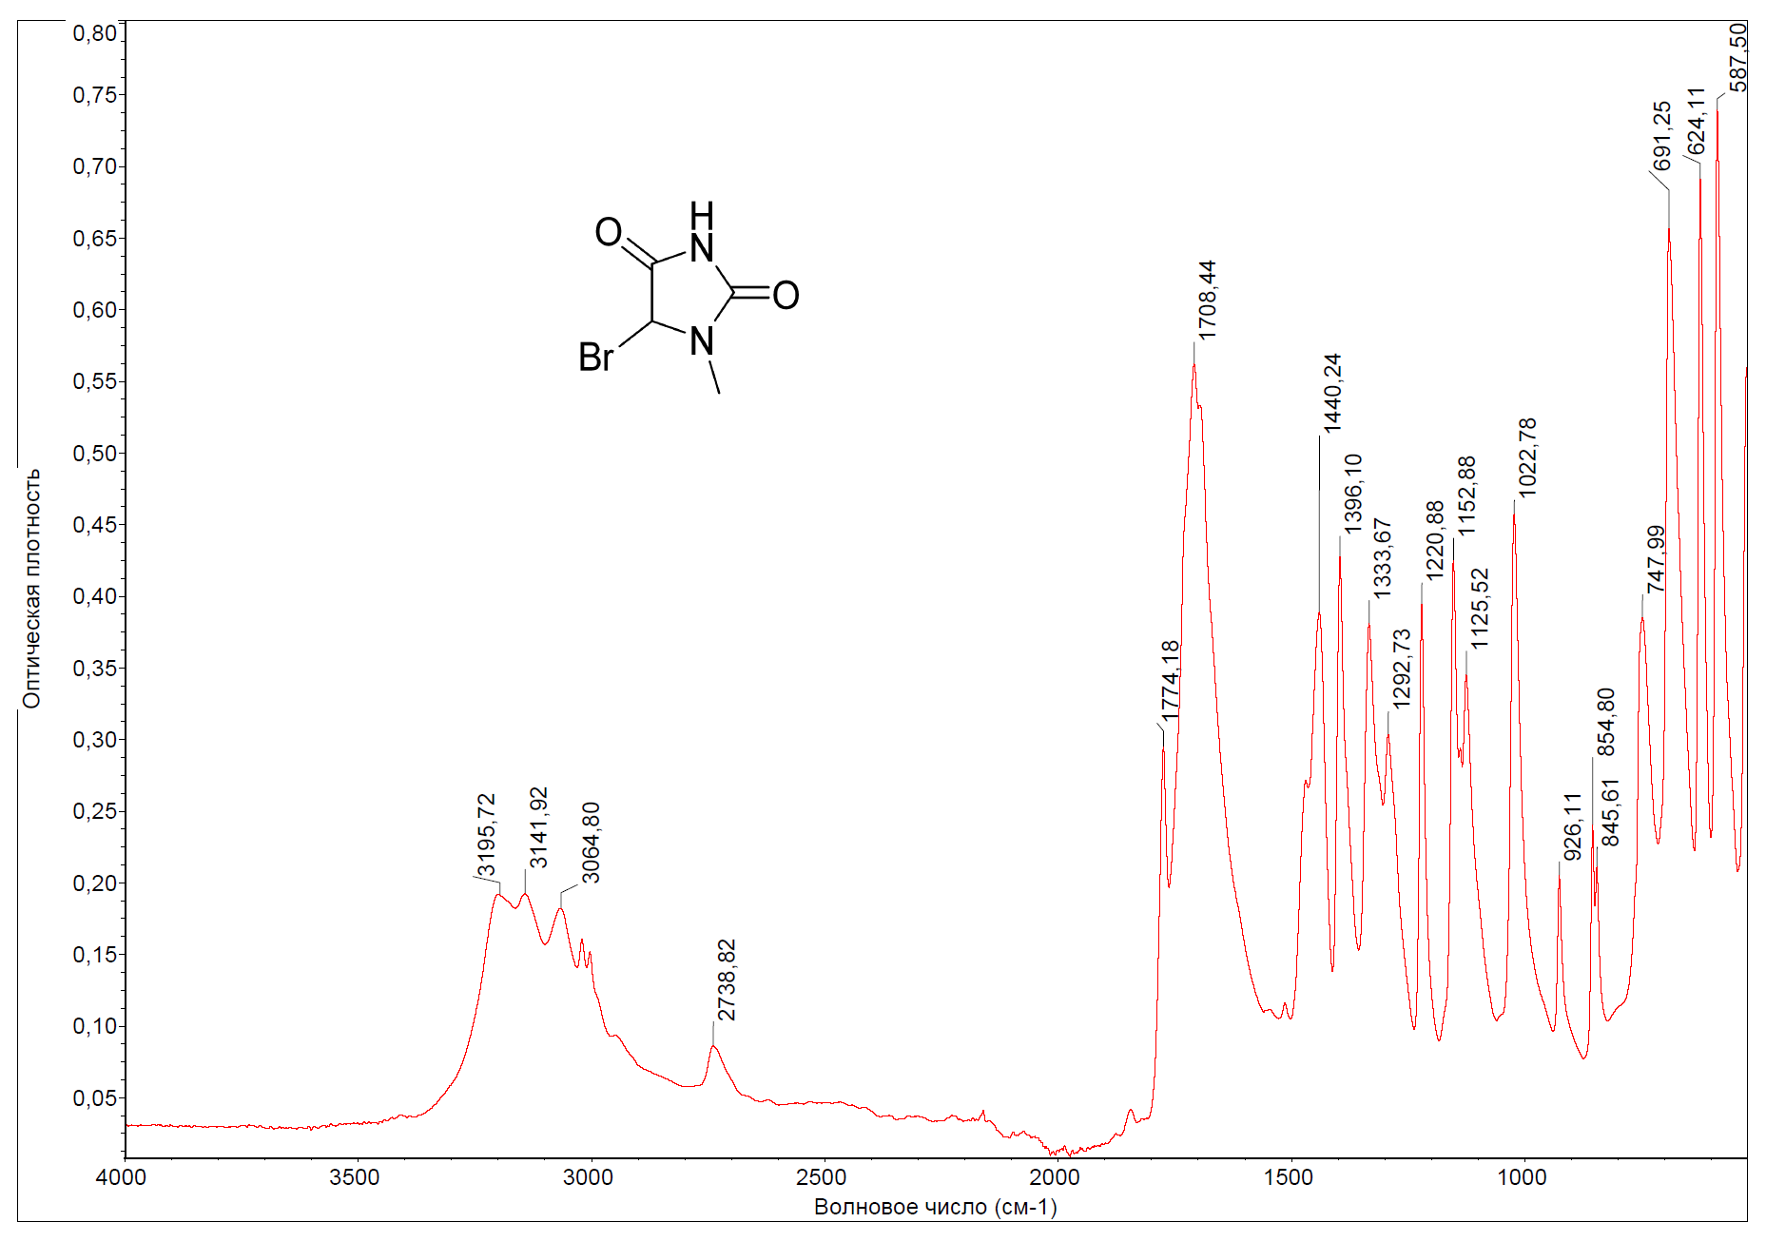
FTIR spectrum of compound 6a

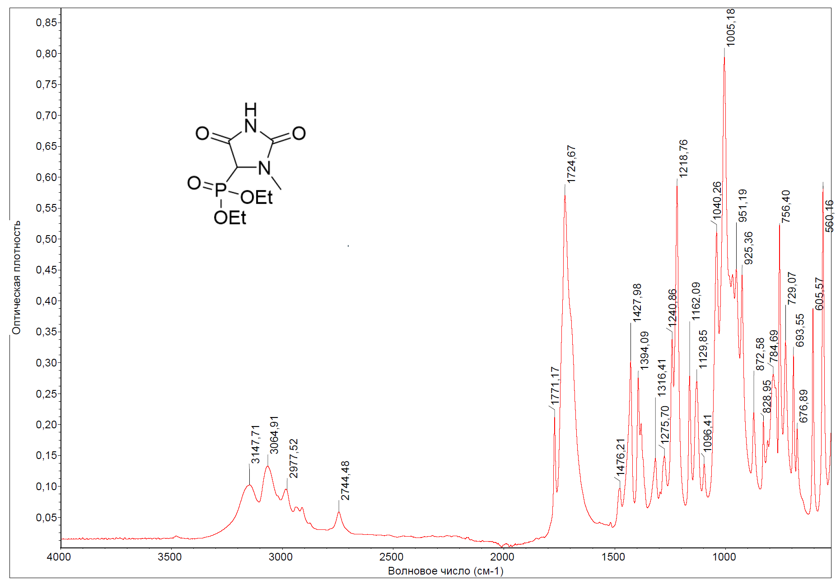
FTIR spectrum of compound 7a

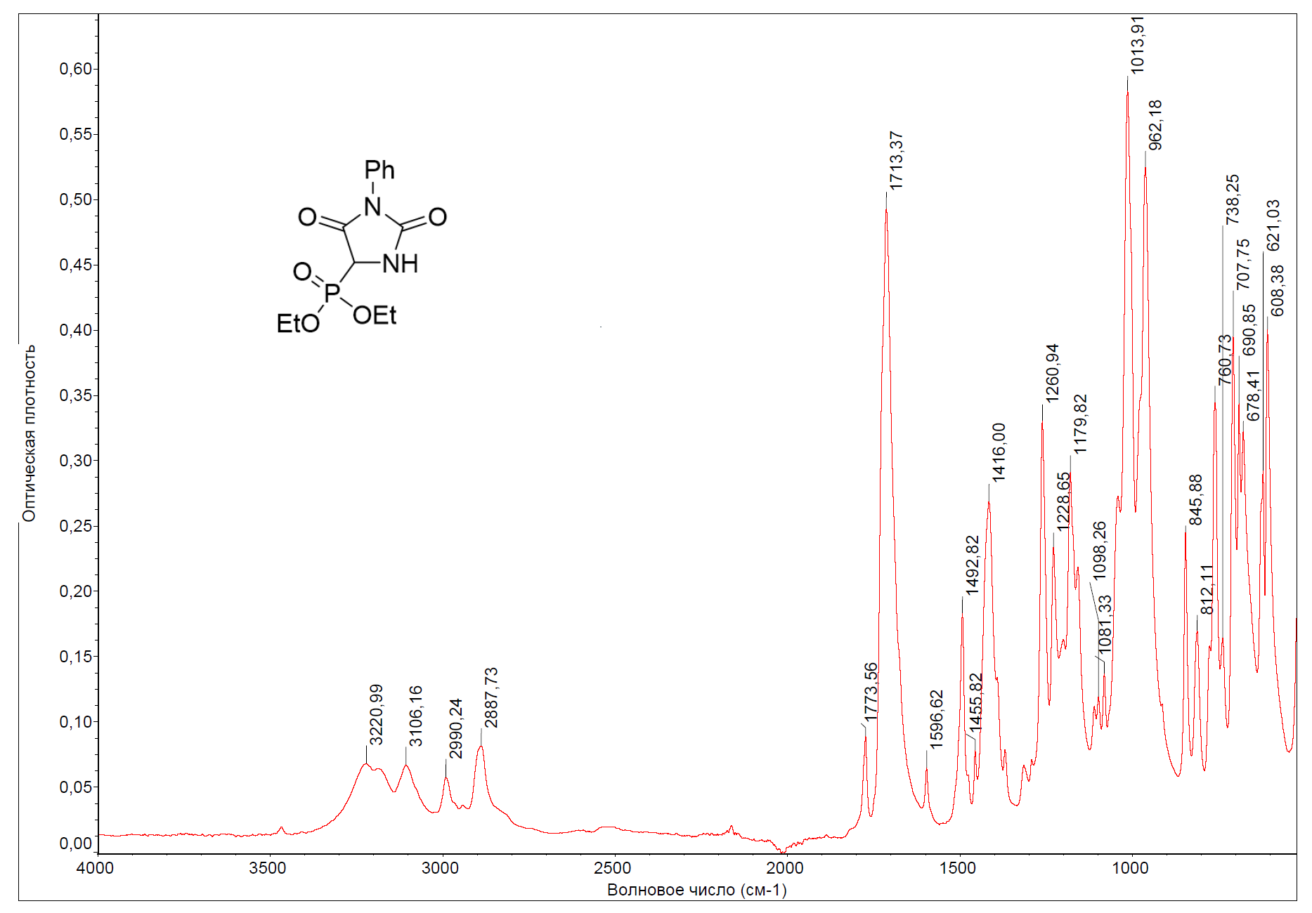
FTIR spectrum of compound 7b

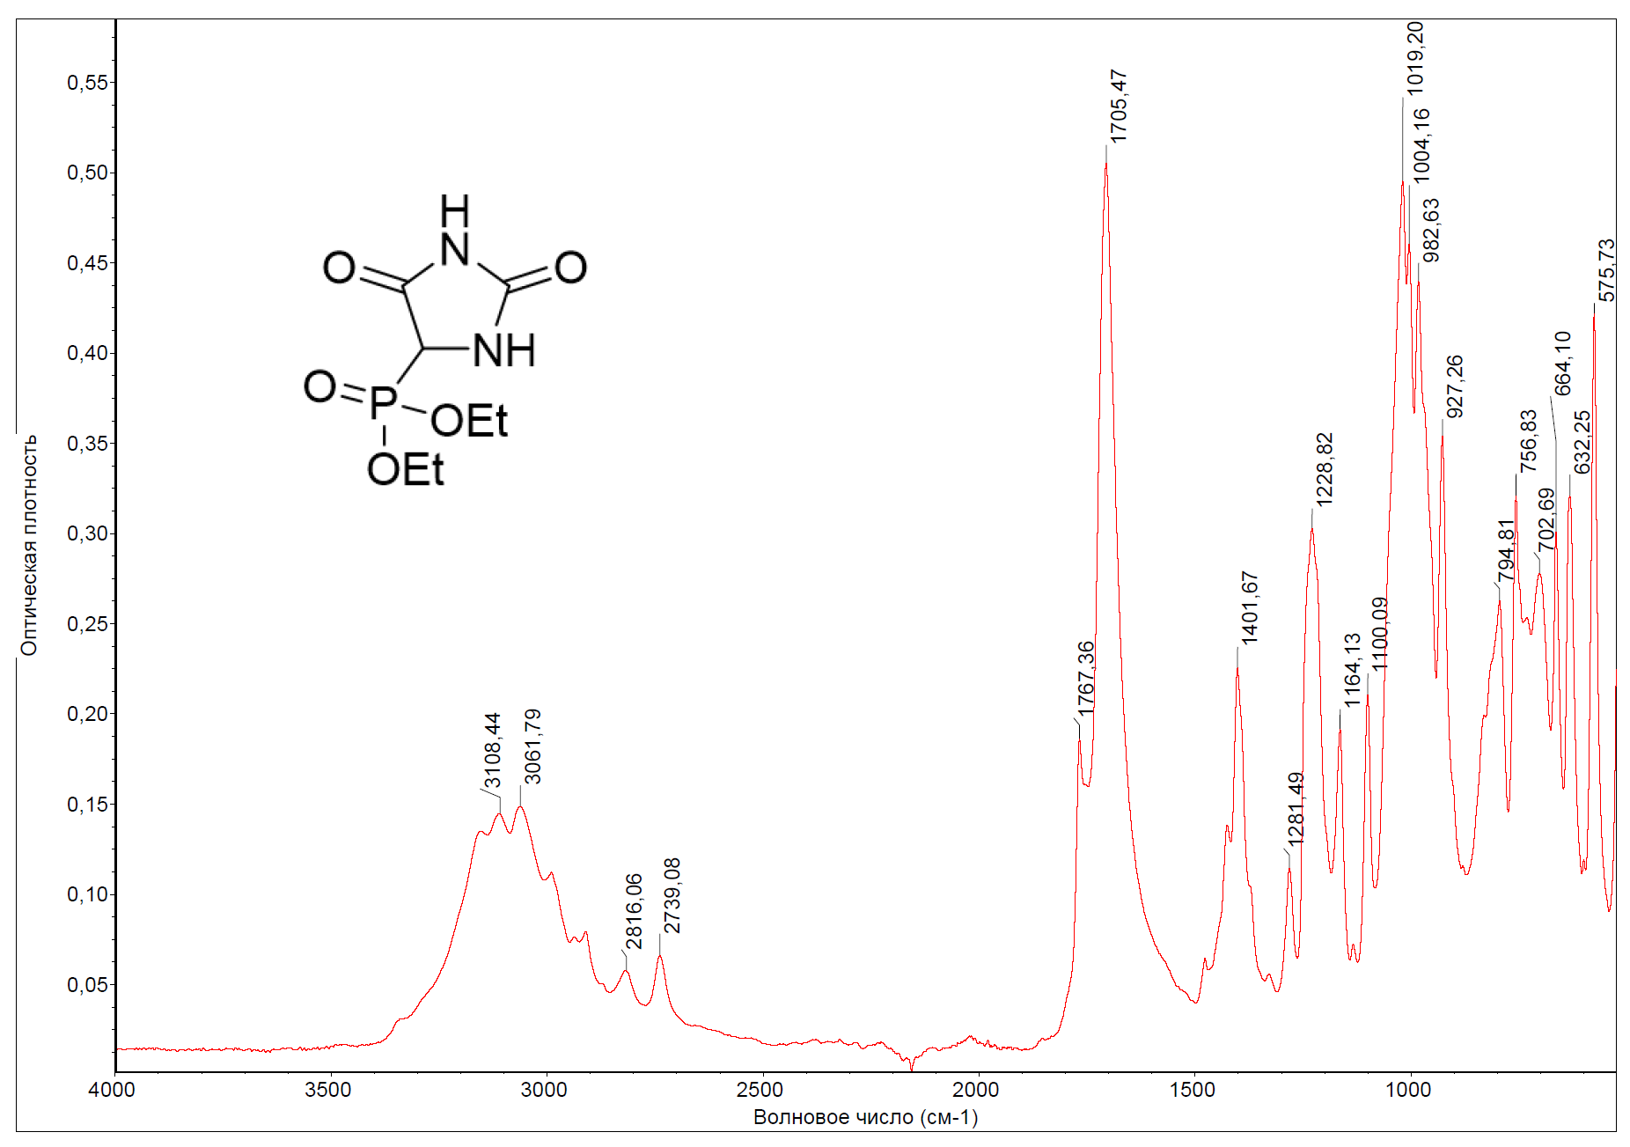
FTIR spectrum of compound 7c

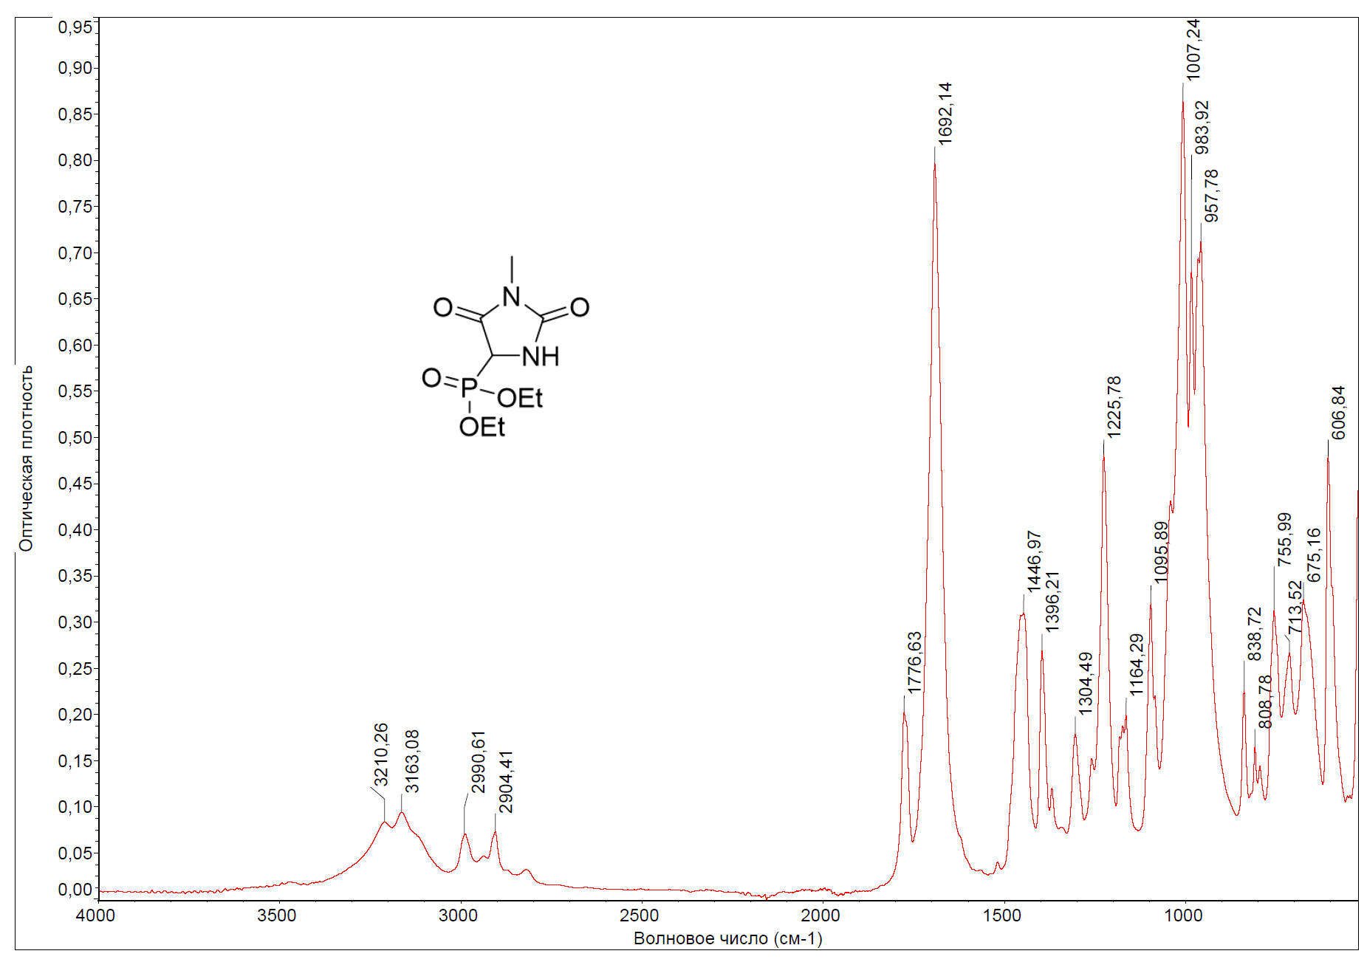
FTIR spectrum of compound 7d

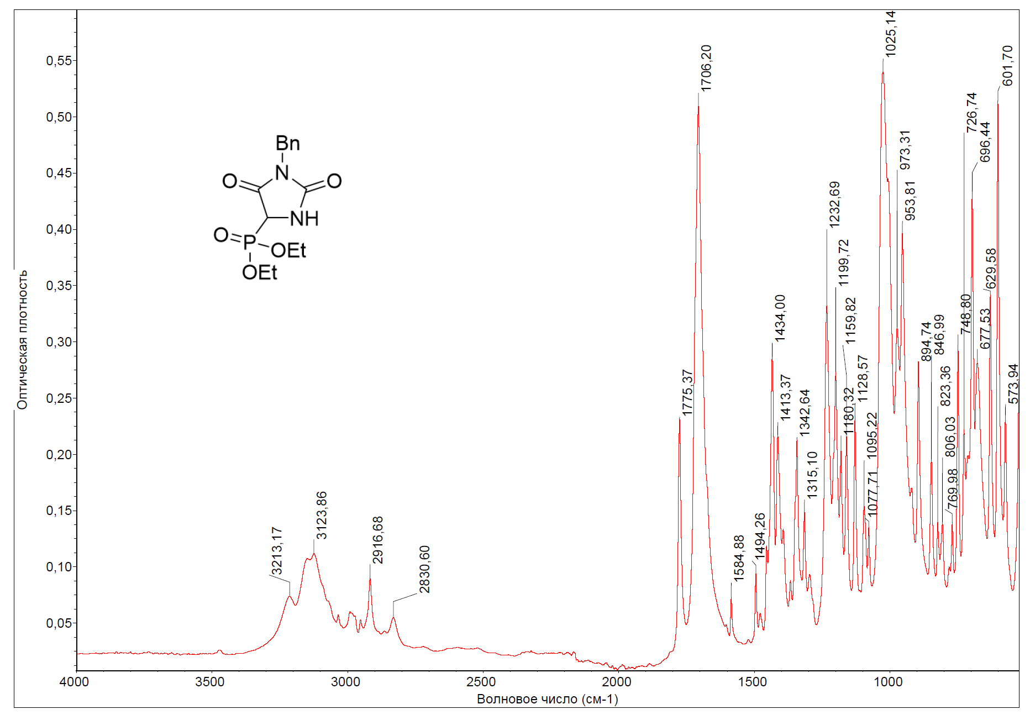
FTIR spectrum of compound 7e

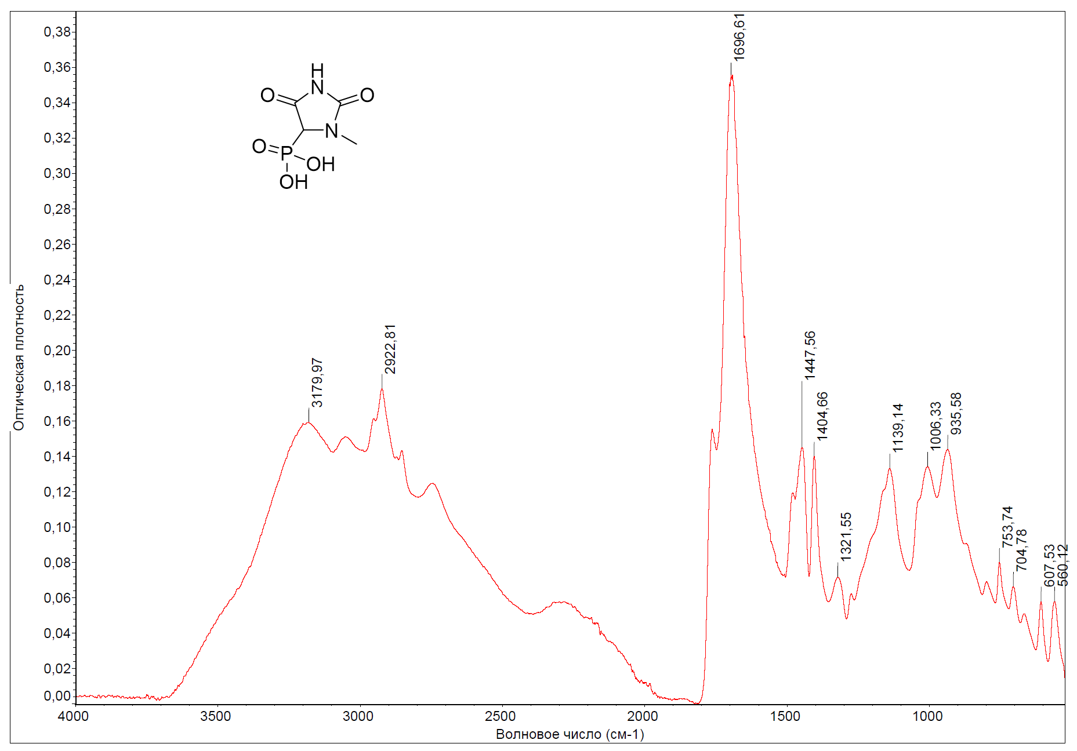
FTIR spectrum of compound 10a

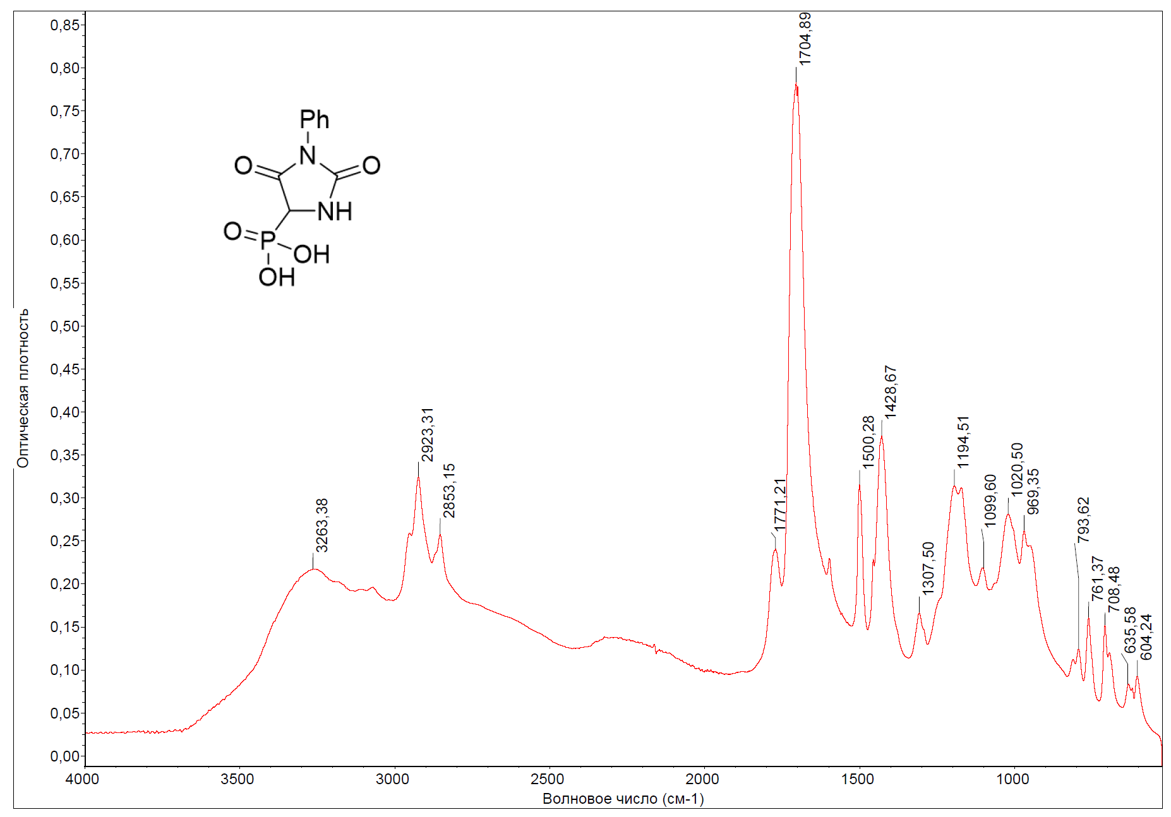
FTIR spectrum of compound 10b

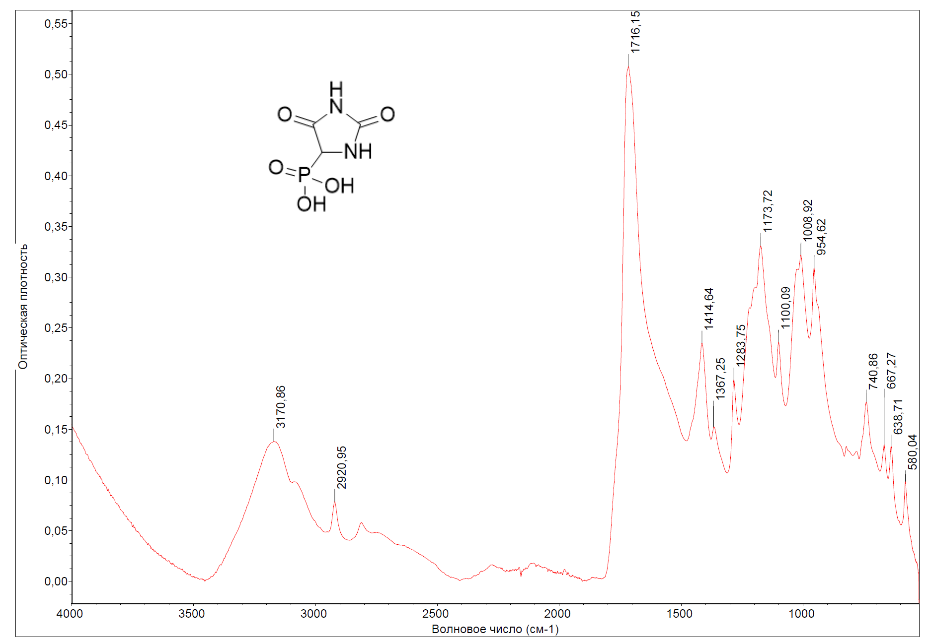
FTIR spectrum of compound 10c

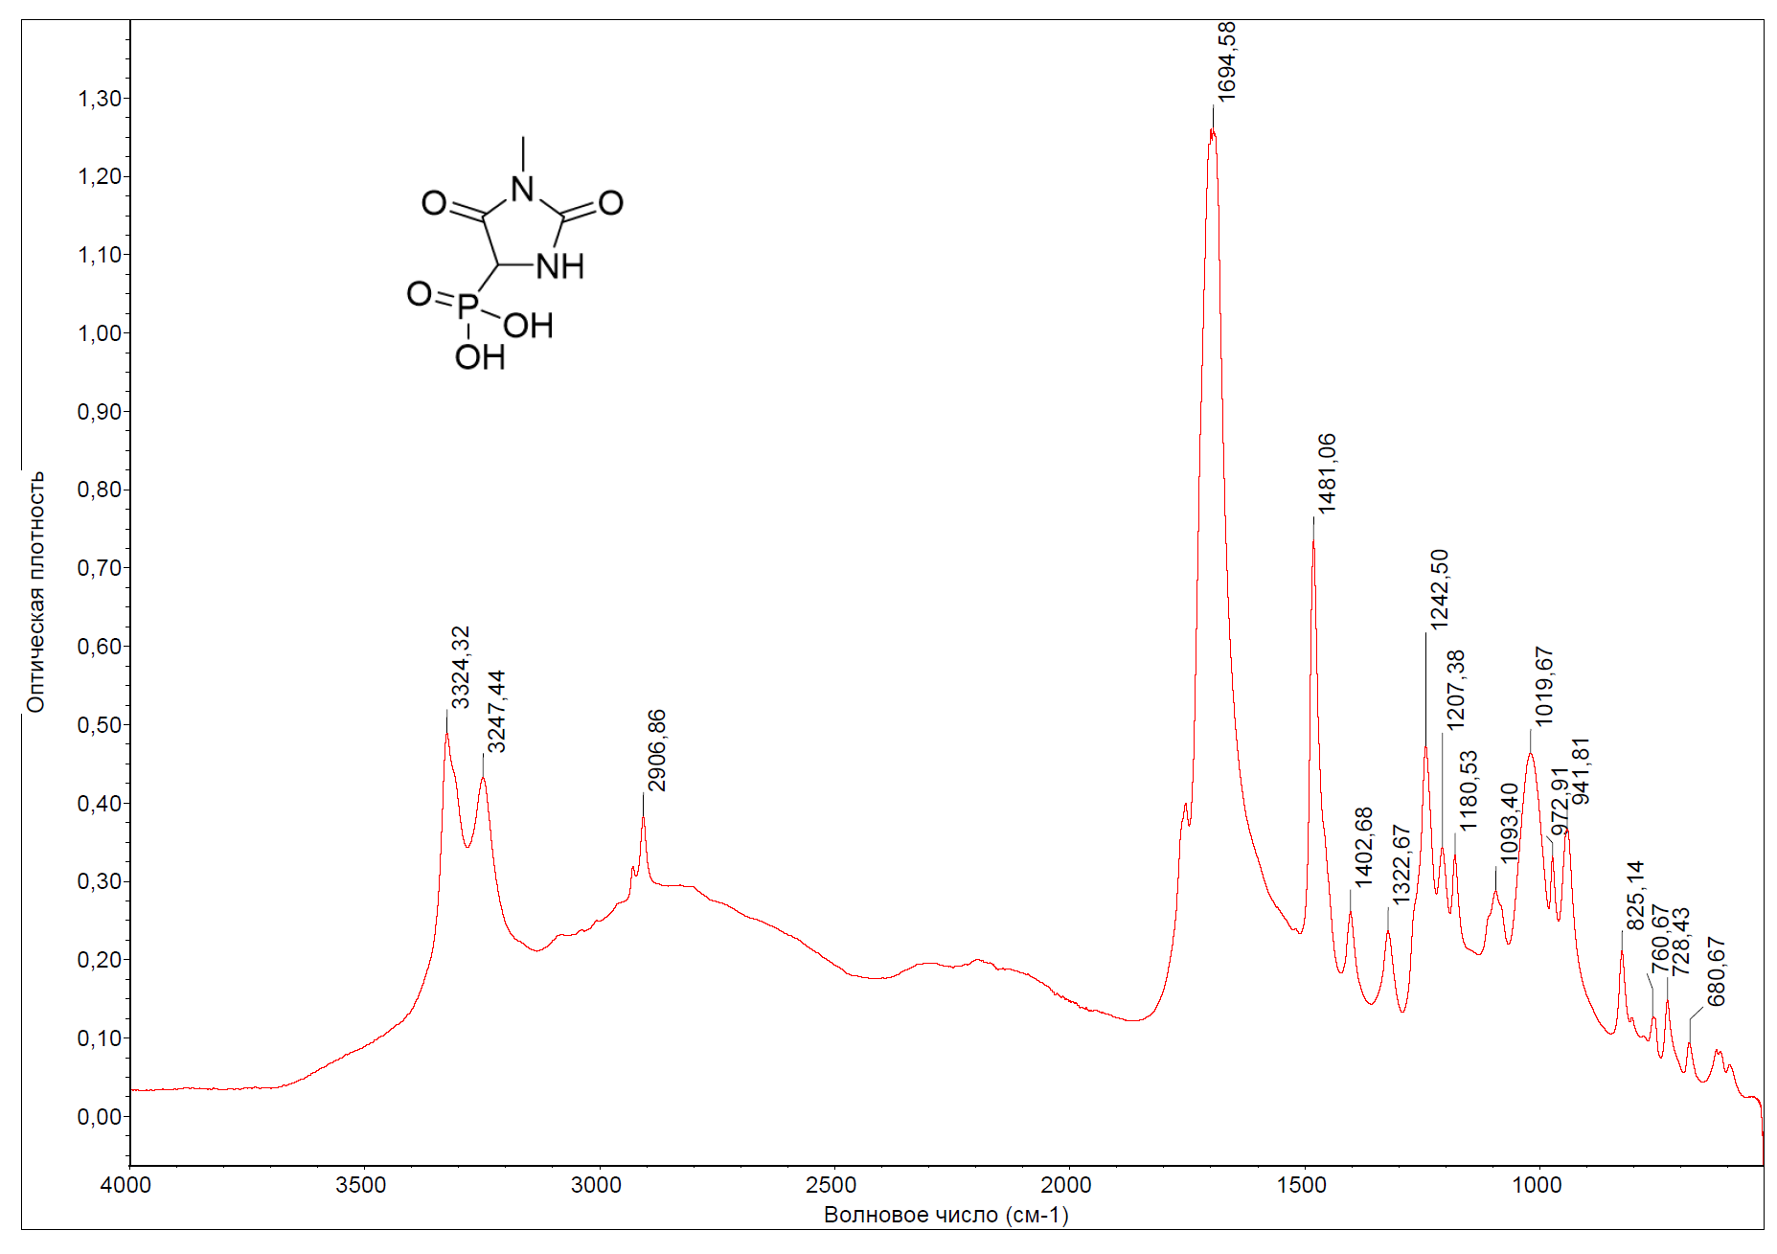
FTIR spectrum of compound 10d

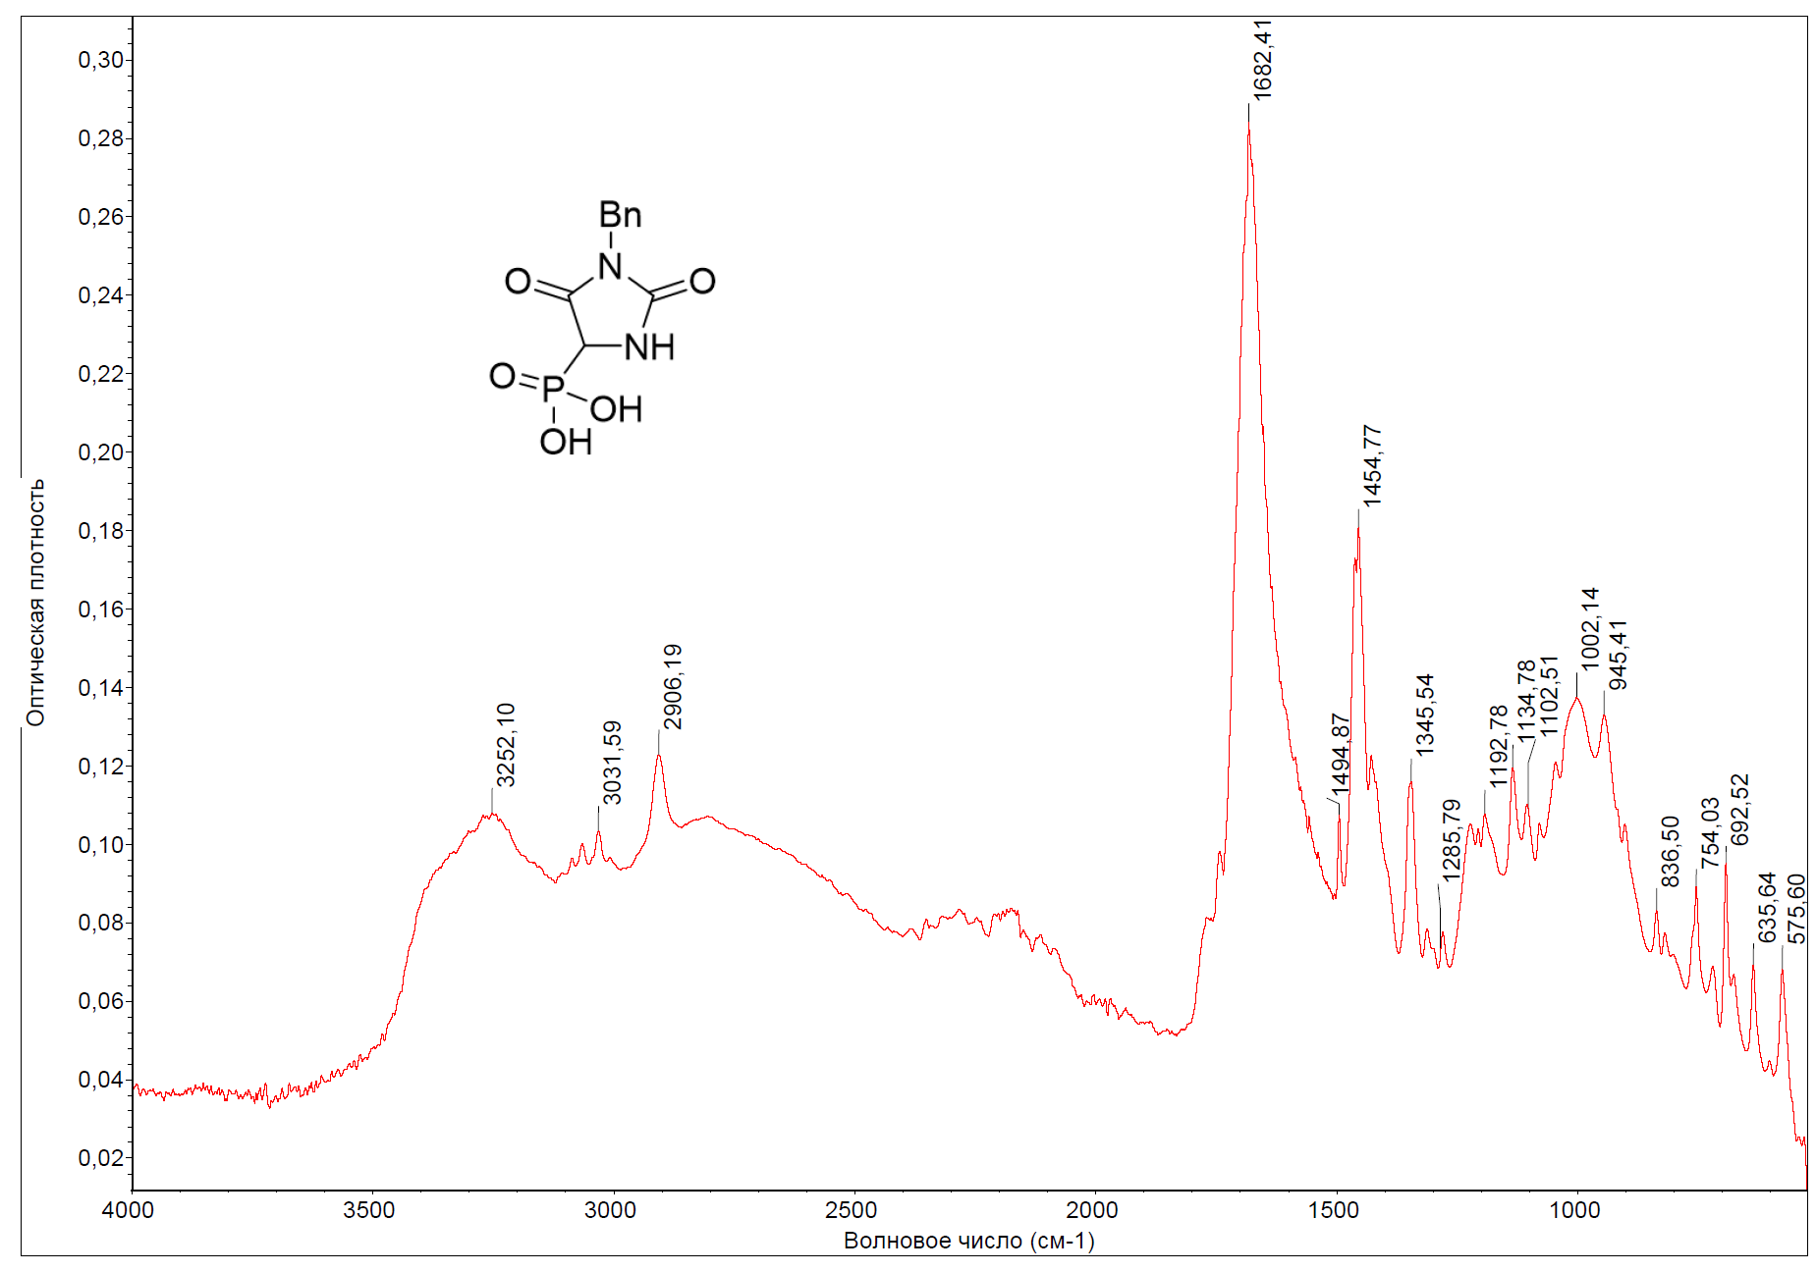
FTIR spectrum of compound 10e

4. HPLC spectra
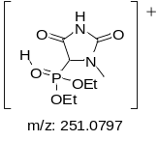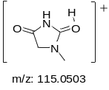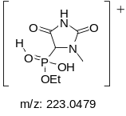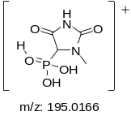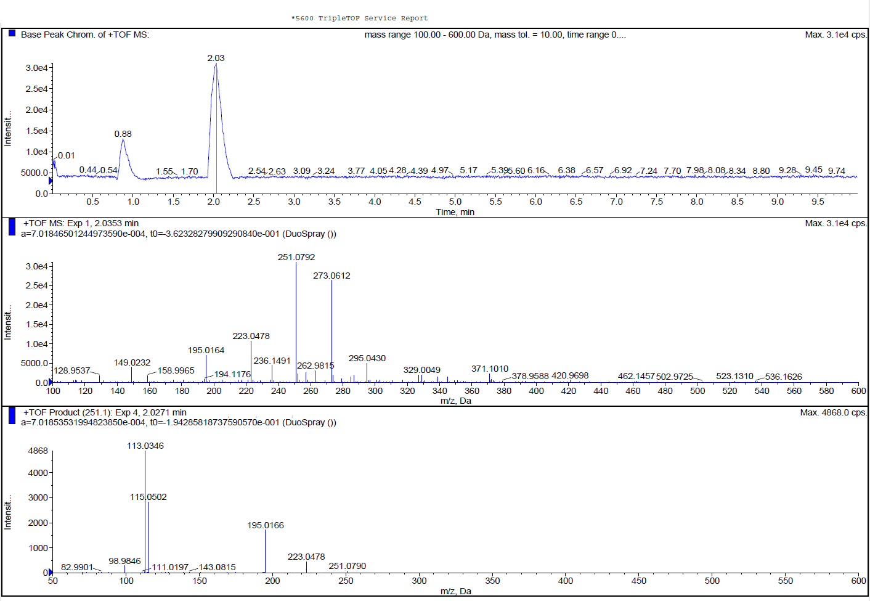
[M+Na]⁺
[M+H]⁺
response to sample introduction and/or solvent admixture

HPLC spectrum of compound 7a. HPLC was performed on ACQUITY UPLC HSS T3 1.8 µm, 2.1 x 100 mm column.
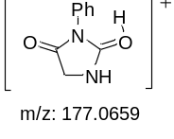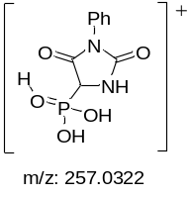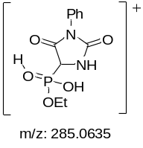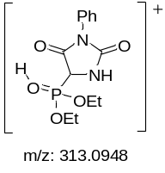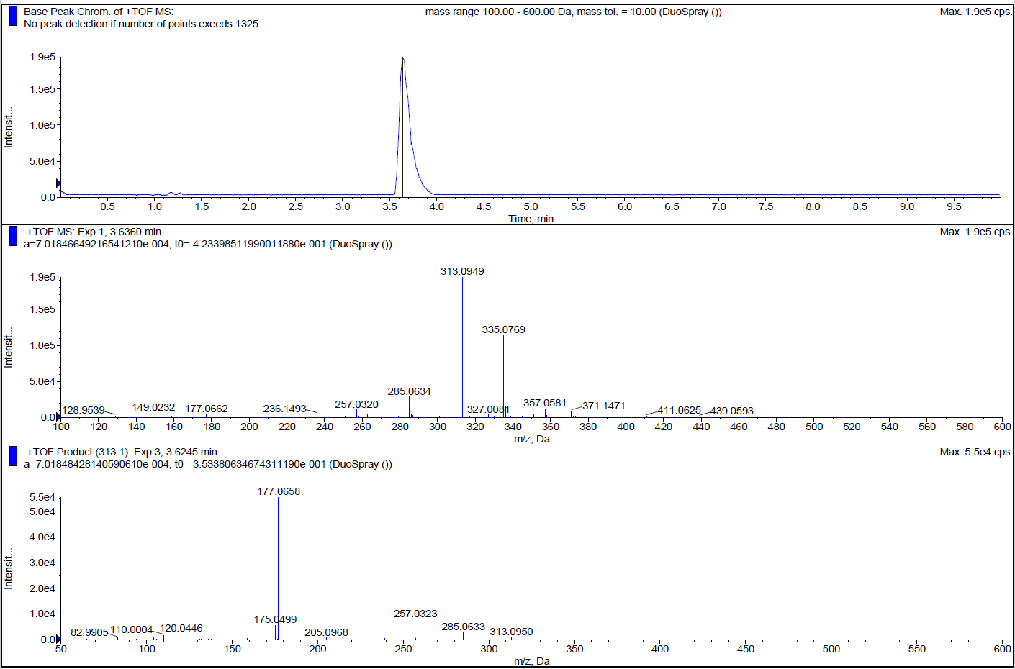
response to sample introduction and/or solvent admixture

[M+Na]⁺
[M+H]⁺
HPLC spectrum of compound 7b. HPLC was performed on ACQUITY UPLC HSS T3 1.8 µm, 2.1 x 100 mm column.
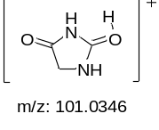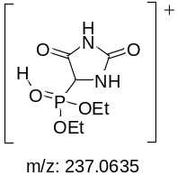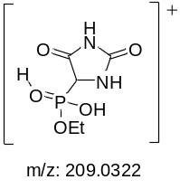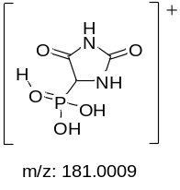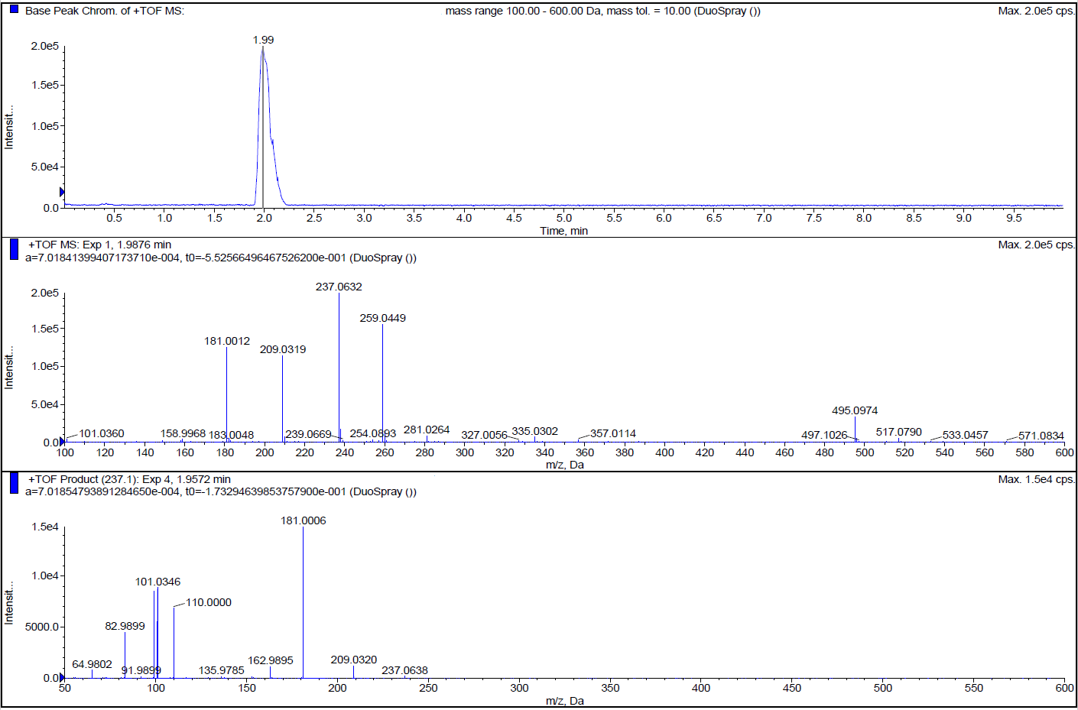
[M+Na]⁺
[M+H]⁺
HPLC spectrum of compound 7c. HPLC was performed on ACQUITY UPLC HSS PFP 1.8 µm, 2.1 x 50 mm column.
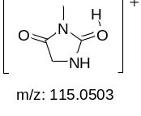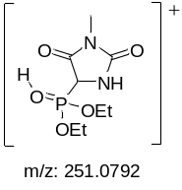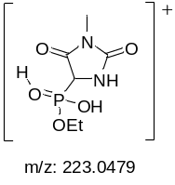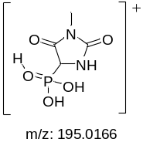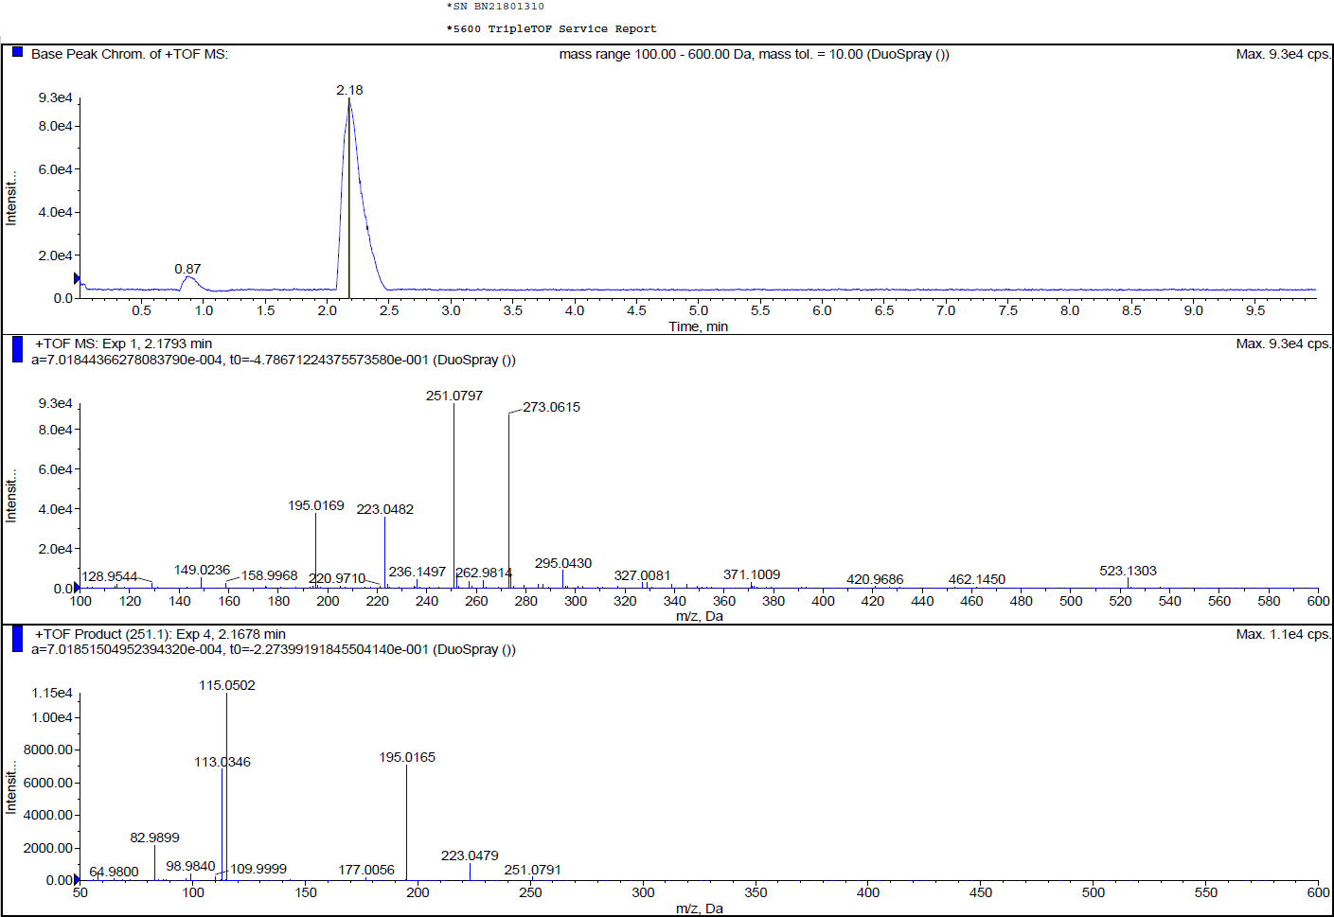
[M+Na]⁺
[M+H]⁺
response to sample introduction and/or solvent admixture

HPLC spectrum of compound 7d. HPLC was performed on ACQUITY UPLC HSS T3 1.8 µm, 2.1 x 100 mm column.
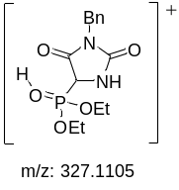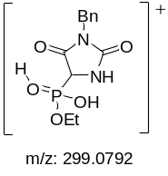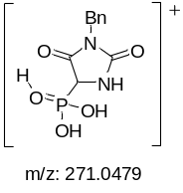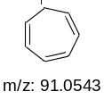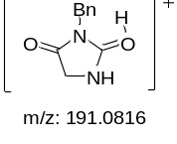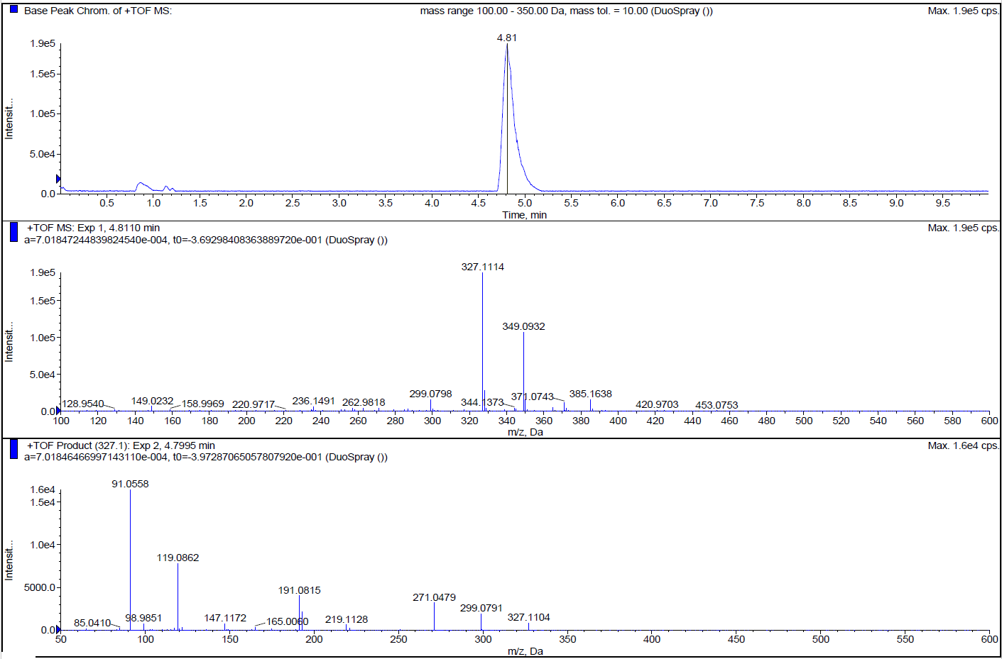
response to sample introduction and/or solvent admixture

[M+Na]⁺
[M+H]⁺
HPLC spectrum of compound 7e. HPLC was performed on ACQUITY UPLC HSS T3 1.8 µm, 2.1 x 100 mm column.
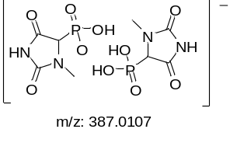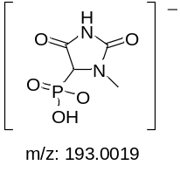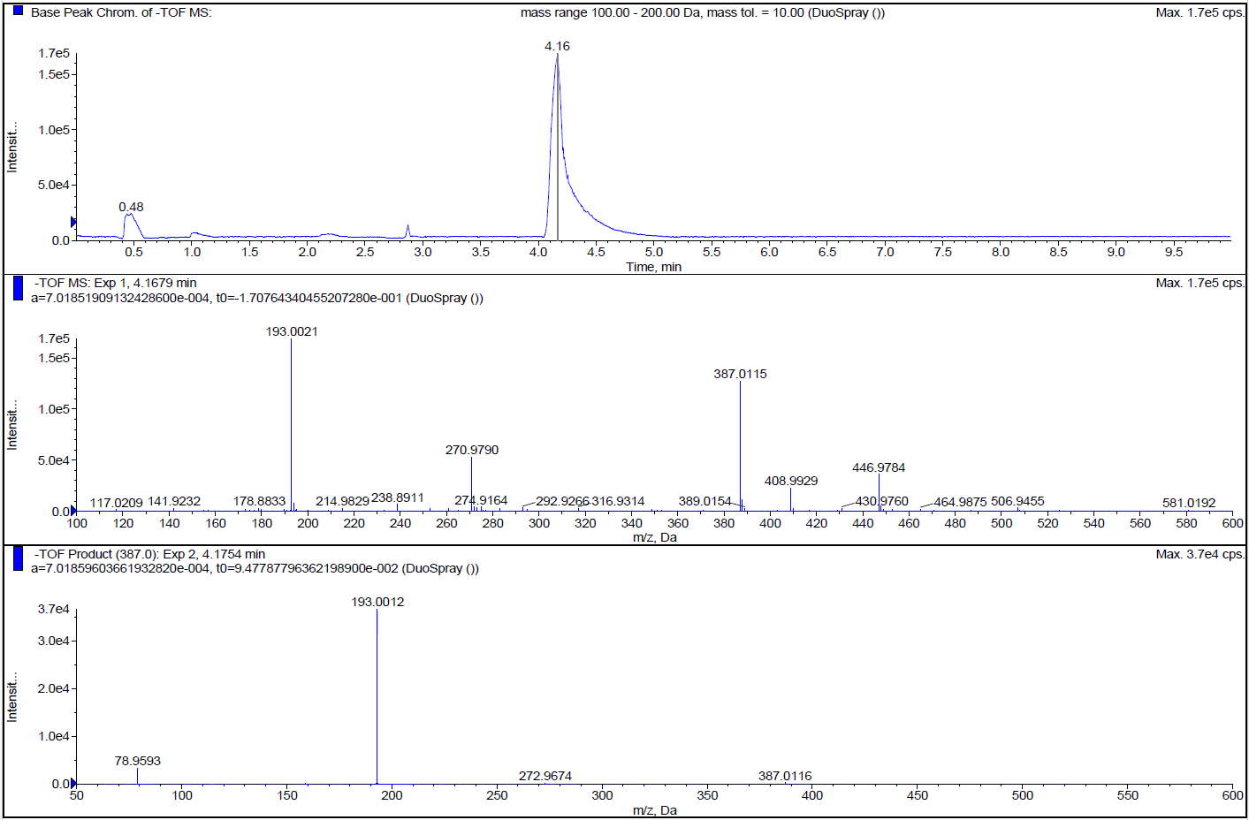
response to sample introduction and/or solvent admixture
HPLC spectrum of compound 10a. HPLC was performed on CORTECS HILIC 2.7 µm, 2.1 x 150 mm column.
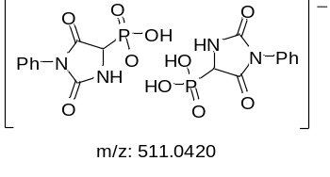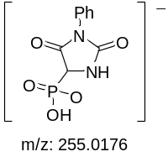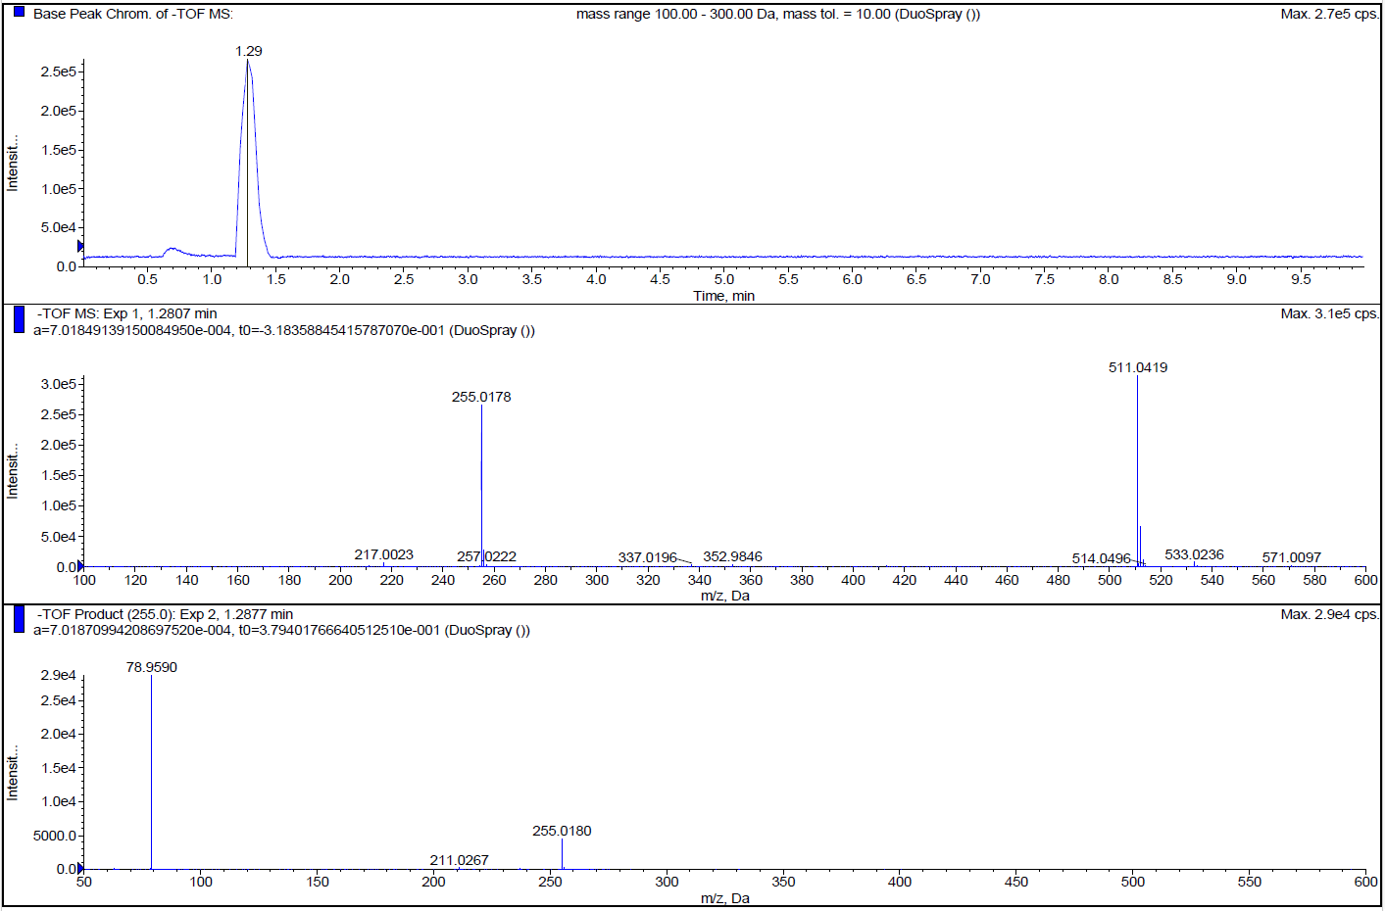
response to sample introduction and/or solvent admixture
HPLC spectrum of compound 10b. HPLC was performed on ACQUITY UPLC HSS T3 1.8 µm, 2.1 x 100 mm column.
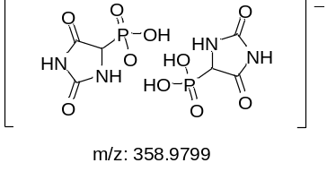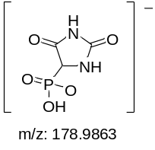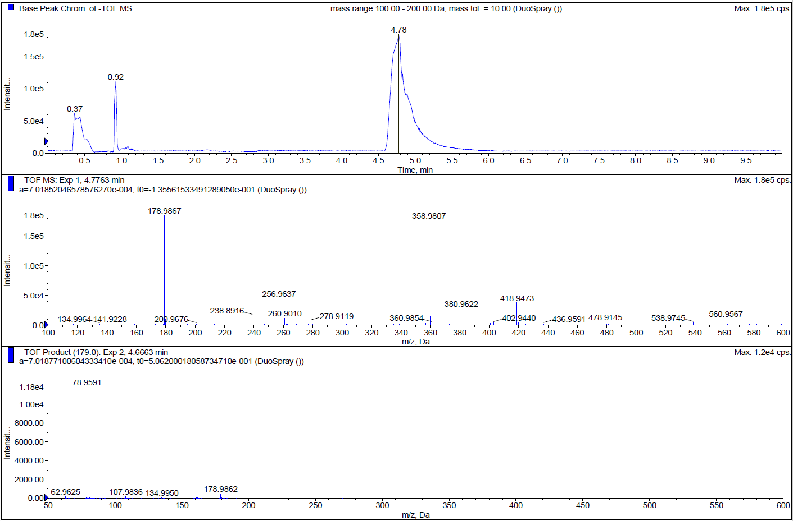
response to sample introduction and/or solvent admixture
HPLC spectrum of compound 10c. HPLC was performed on CORTECS HILIC 2.7 µm, 2.1 x 150 mm column.
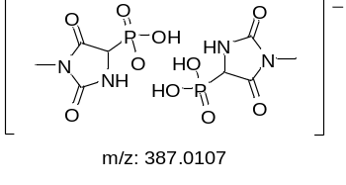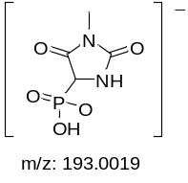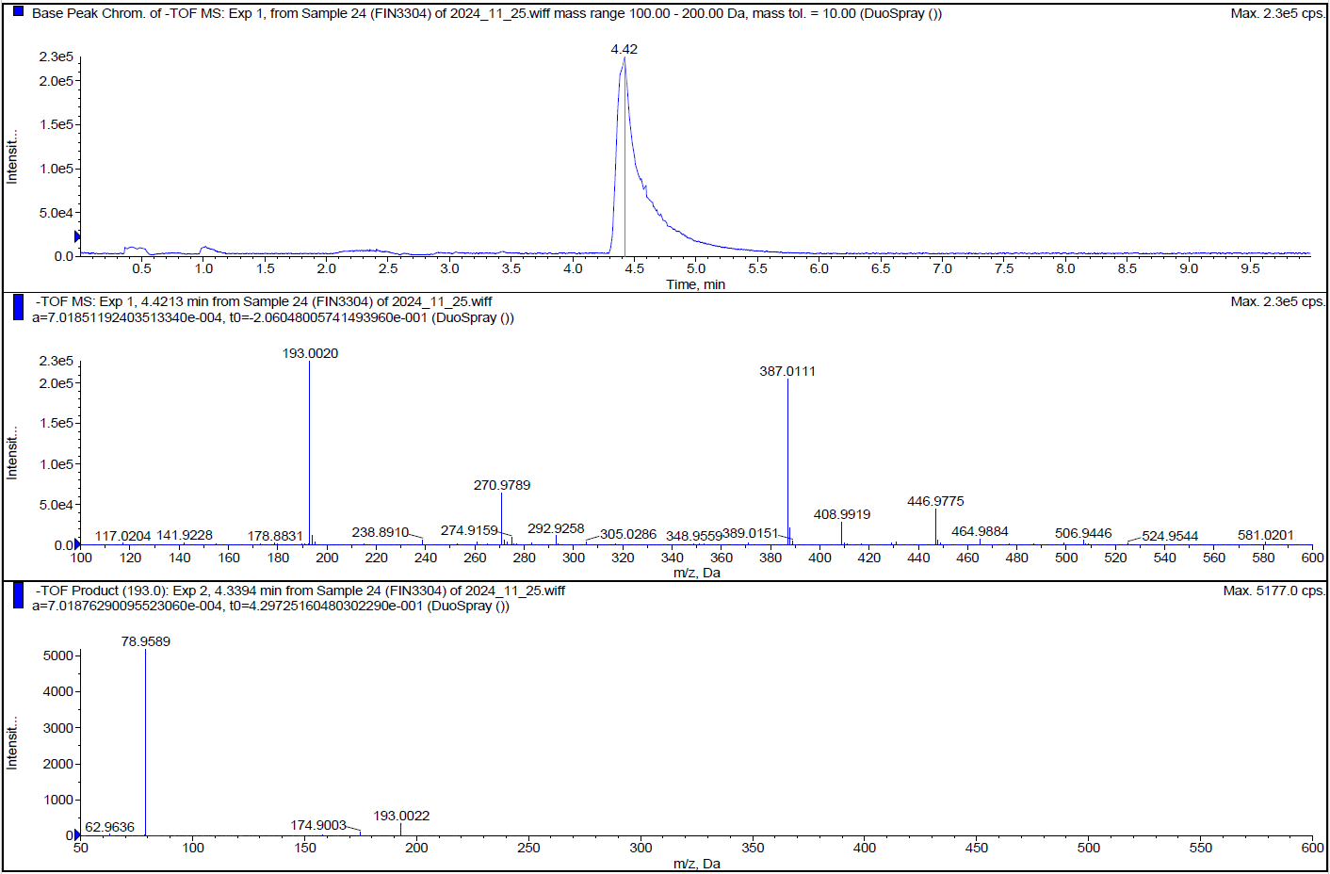
response to sample introduction and/or solvent admixture
HPLC spectrum of compound 10d. HPLC was performed on CORTECS HILIC 2.7 µm, 2.1 x 150 mm column.
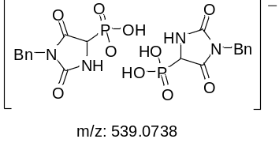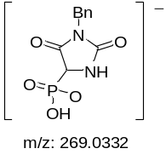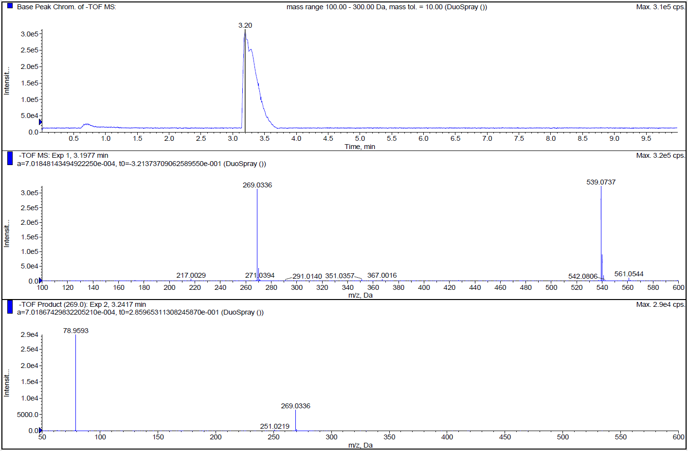
response to sample introduction and/or solvent admixture
HPLC spectrum of compound 10e. HPLC was performed on ACQUITY UPLC HSS T3 1.8 µm, 2.1 x 100 mm column.
5. Assays of antibacterial activity
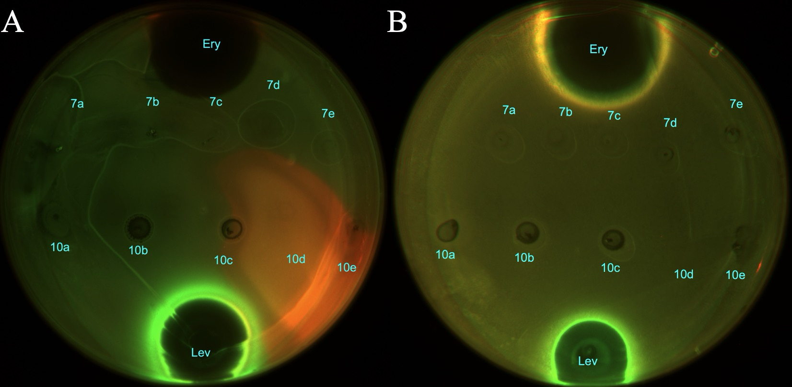
Assays of antibacterial activity for target compounds and mechanism of action. Test on E. coli ΔtolC (A) and lptD^{mut} (B)

6. Control effect of target compounds by leaf prick method
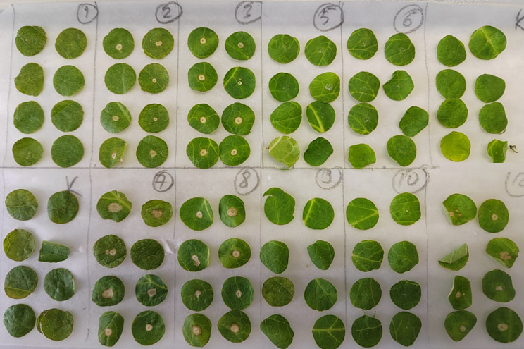
control test
7b
7e
10b
10a
7d
control test
10d
10c
7c
7a
10e

Sosnowsky's hogweed

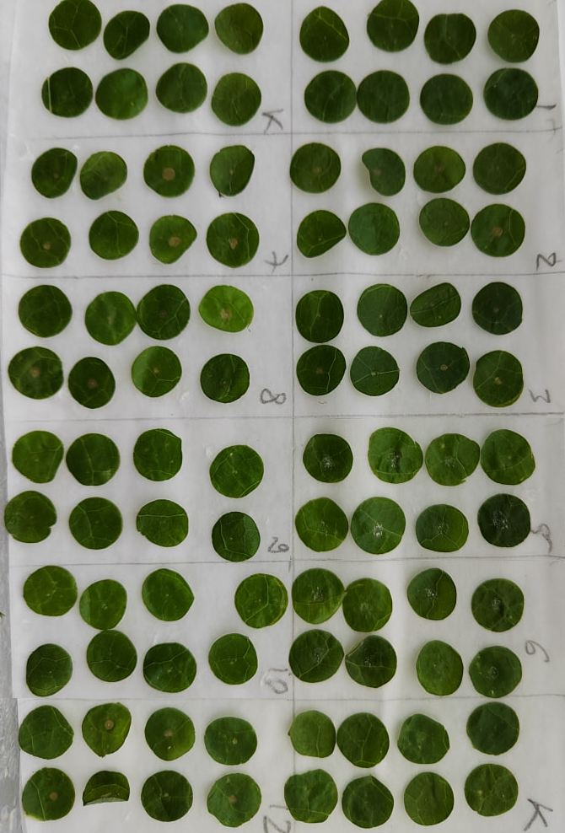
10e
7a
7c
10c
10d
control test
7b
7e
10b
10a
7d
control test
Sonchus oleraceus
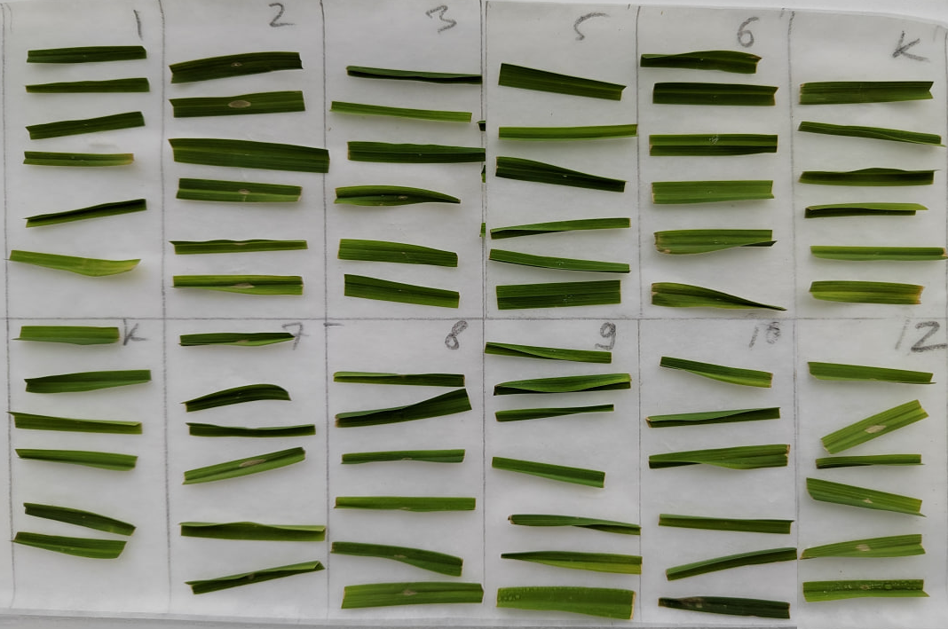
7a
10e
7c
10c
10d
control test
7b
control test
7e
10b
10a
7d
Elymus repens

