Extended data figures

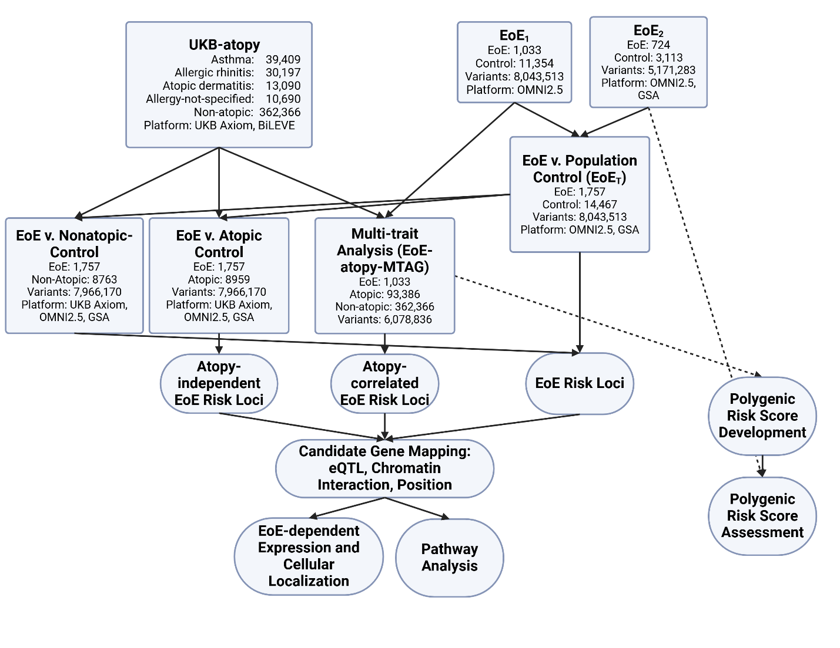
Figure S1. EoE-GWAS Study Roadmap. A flow chart summarizing the examined cohorts (rectangles) and primary analysis outputs (ovals). Cohort information provided include cohort sample size, genotyping platforms, and the total number of imputed variants. EoE, eosinophilic esophagitis; eQTL, expression quantitative trait loci; GSA, Global Screening Array; GWAS, genome-wide association study; MTAG, multi-trait analysis of genome-wide association studies; UKB, United Kingdom Biobank.

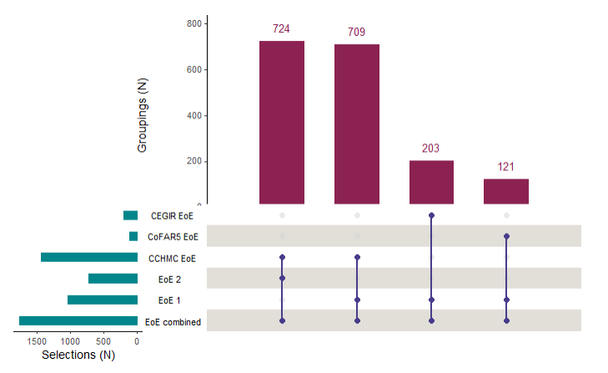
Figure S2. EoE-GWAS Cohorts. An upset plot illustrating the sources of the cases (CEGIR EoE, CoFAR5 EoE, and CCHMC EoE) for each of the EoE cohorts (EoE₁, EoE₂, and EoE_{T}). Each maroon bar quantifies a combination of sources and analysis cohorts, the dots indicate the specific cases and cohorts that contributed, and the teal bars indicate their size. CCHMC, Cincinnati Children’s Hospital Medical Center; CEGIR, Consortium of Eosinophilic Gastrointestinal Disease Researchers; CoFAR, Consortium of Food Allergy Research.

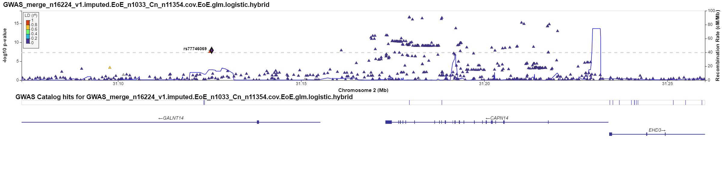
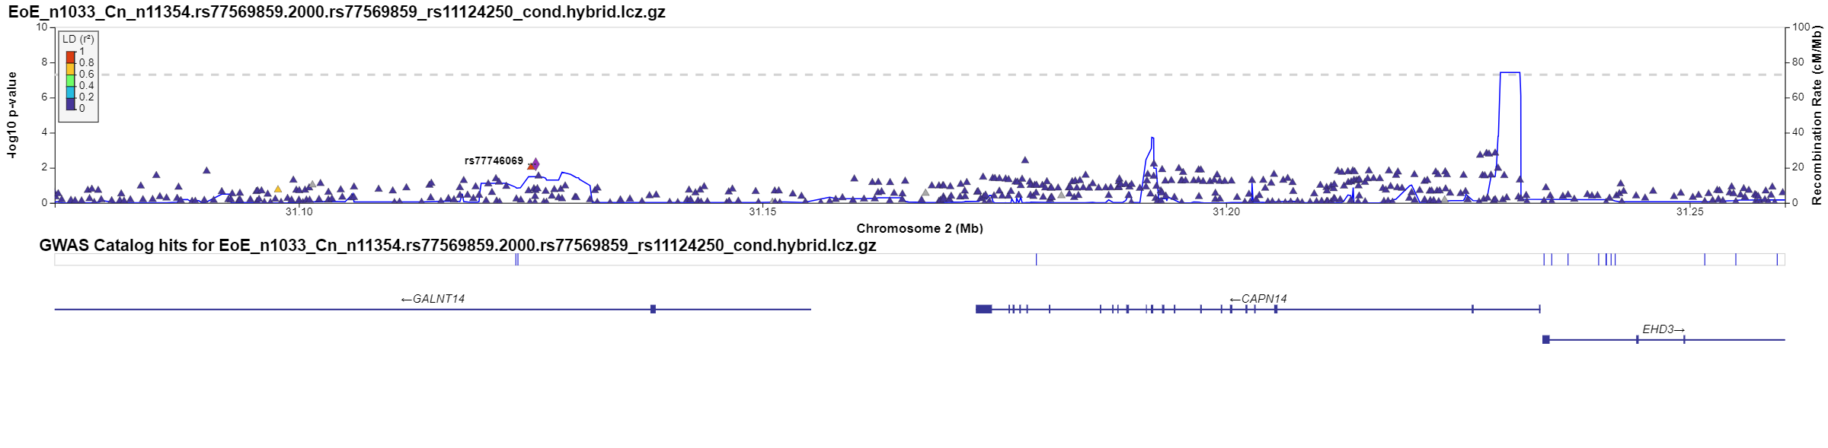
A. rs77746069 at 2p23.1, pre-conditioning
B. rs77746069 at 2p23.1, conditioned on rs77569859 and rs11124250
Figure S3. Conditional analyses of EoE risk loci with putative independent associations. Zoom plots were generated using LocusZoom for EoE risk loci with putative independent associations using imputed data from the EoE₁ association study (EoE n = 1,033 and population controls n = 11,354). For each putative independent association, a pair of plots are shown illustrating the association pre- and post-conditioning. Triangles represent association p values for individual variants plotted by genomic position. The color indicates the degree of genetic linkage with the selected variant (purple diamond) as assessed using the 1000 Genomes European reference panel; grey indicates no linkage data. Recombination rate is plotted in blue as indicated on the right y axis. CAPN14, calpain 14; GALNT14, polypeptide N-acetylgalactosaminyltransferase 14; LD, linkage disequilibrium.

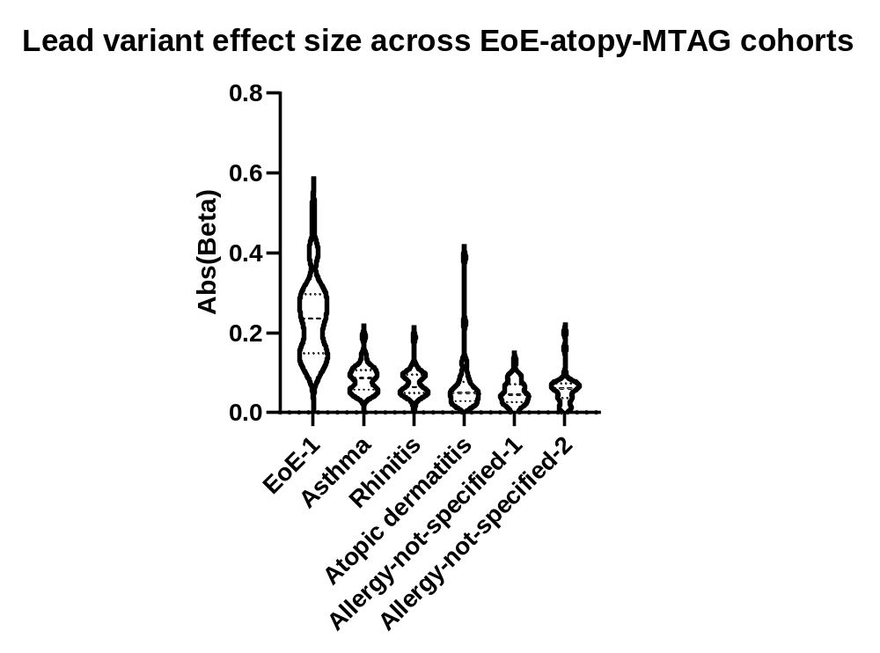
*
Disease
EoE
Asthma
Allergic rhinitis
Atopic dermatitis
Allergy 1
Allergy 2
Figure S4. MTAG lead variant effect size across the EoE-atopy-MTAG cohorts. Effect size for the 33 lead variants (MTAG p < 5e-8, EoE₁ p < 0.05, LD r² < 0.1) was plotted across each cohort in the EoE-atopy-MTAG analysis by violin plot. Within each violin, the upper and lower dashed lines represent the interquartile range, and the middle dashed line represents the median. The dashed line extending across the full graph indicates median beta in EoE. *p < 0.001 Repeated Measures ANOVA on Ranks; all EoE comparisons were p < 0.05 by Tukey Test. Abs, absolute value; Allergy 1, Allergy-not-specified-1; Allergy 2, Allergy-not-specified-2; EoE, eosinophilic esophagitis.

A. Males
B. Females
12q24
(SCARB1)
10p14
5q22.1
(TSLP/WDR36)
2p23.1
(CAPN14)
2p23.1
(CAPN14)
5q22.1
(TSLP/WDR36)
Chromosome
2
4
6
8
10
12
14
16
18
20
22
0
2
4
6
8
10
12
-log₁₀(p-value)
Chromosome
2
4
6
8
10
12
14
16
18
20
22
0
2
4
6
8
10
12
-log₁₀(p-value)
Figure S5. EoE GWAS association by sex. An EoE GWAS (EoE_{T}) was conducted comprising EoE (n = 1,757) and population controls (n = 14,467) genotyped and imputed genome-wide and subset into sex-specific cohorts. The p values of each variant are plotted by chromosomal position. The dotted red line indicates genome-wide significance (p < 5e-8). Parentheses indicate representative mapped genes at each risk locus. EoE, eosinophilic esophagitis.

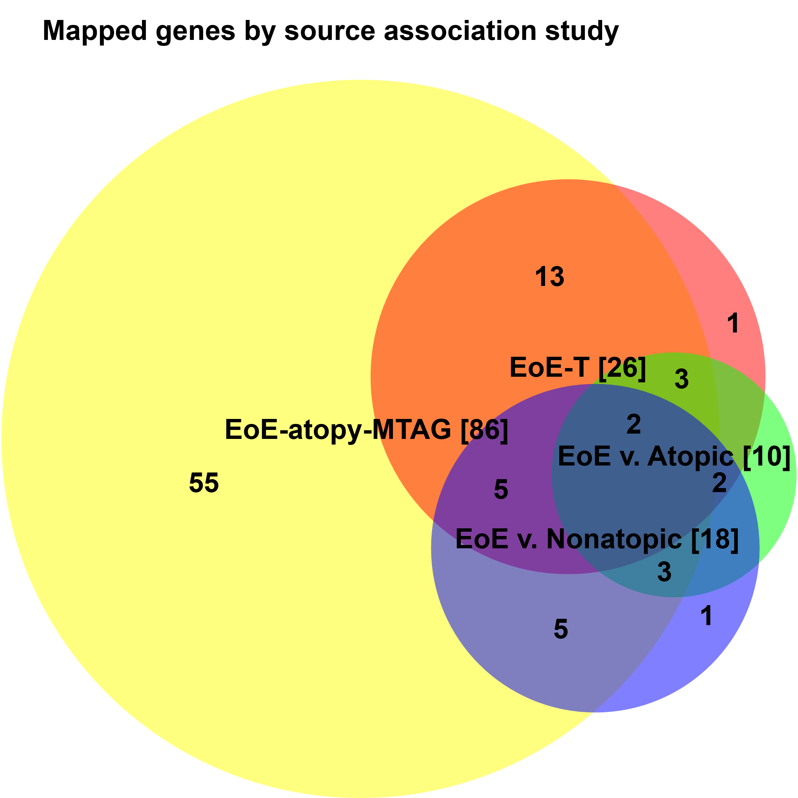
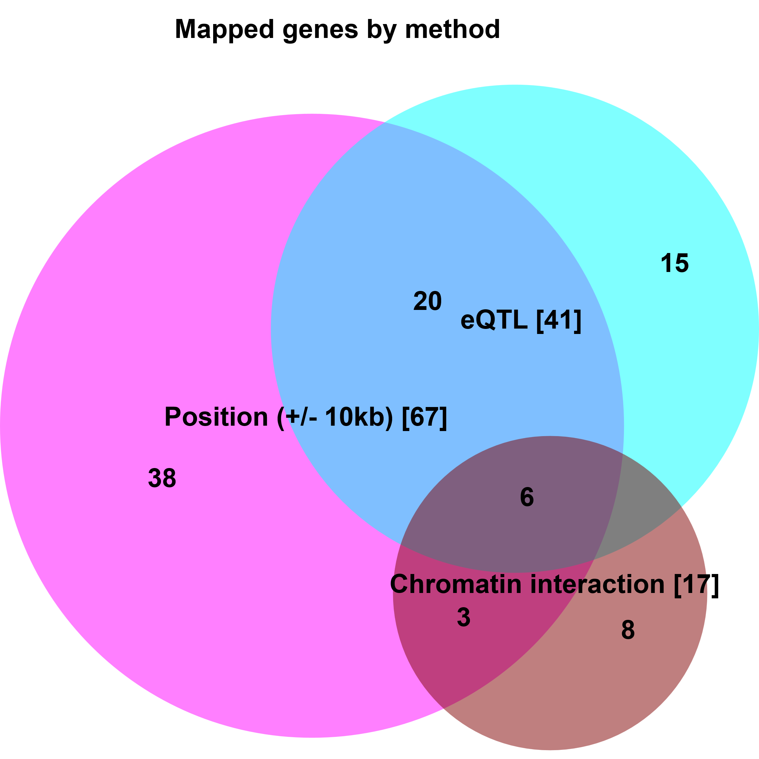
A.
B.
Figure S6. Mapped genes by association study and method. A total of 90 genes were mapped from four association studies (A) using three methods (B). The proportional Venn diagrams illustrate the number of overlapping genes. Bracketed numbers indicate the total number of genes in the category (circle). EoE, eosinophilic esophagitis; eQTL, expression quantitative trait loci; MTAG, multi-trait analysis of genome-wide association studies.

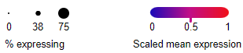
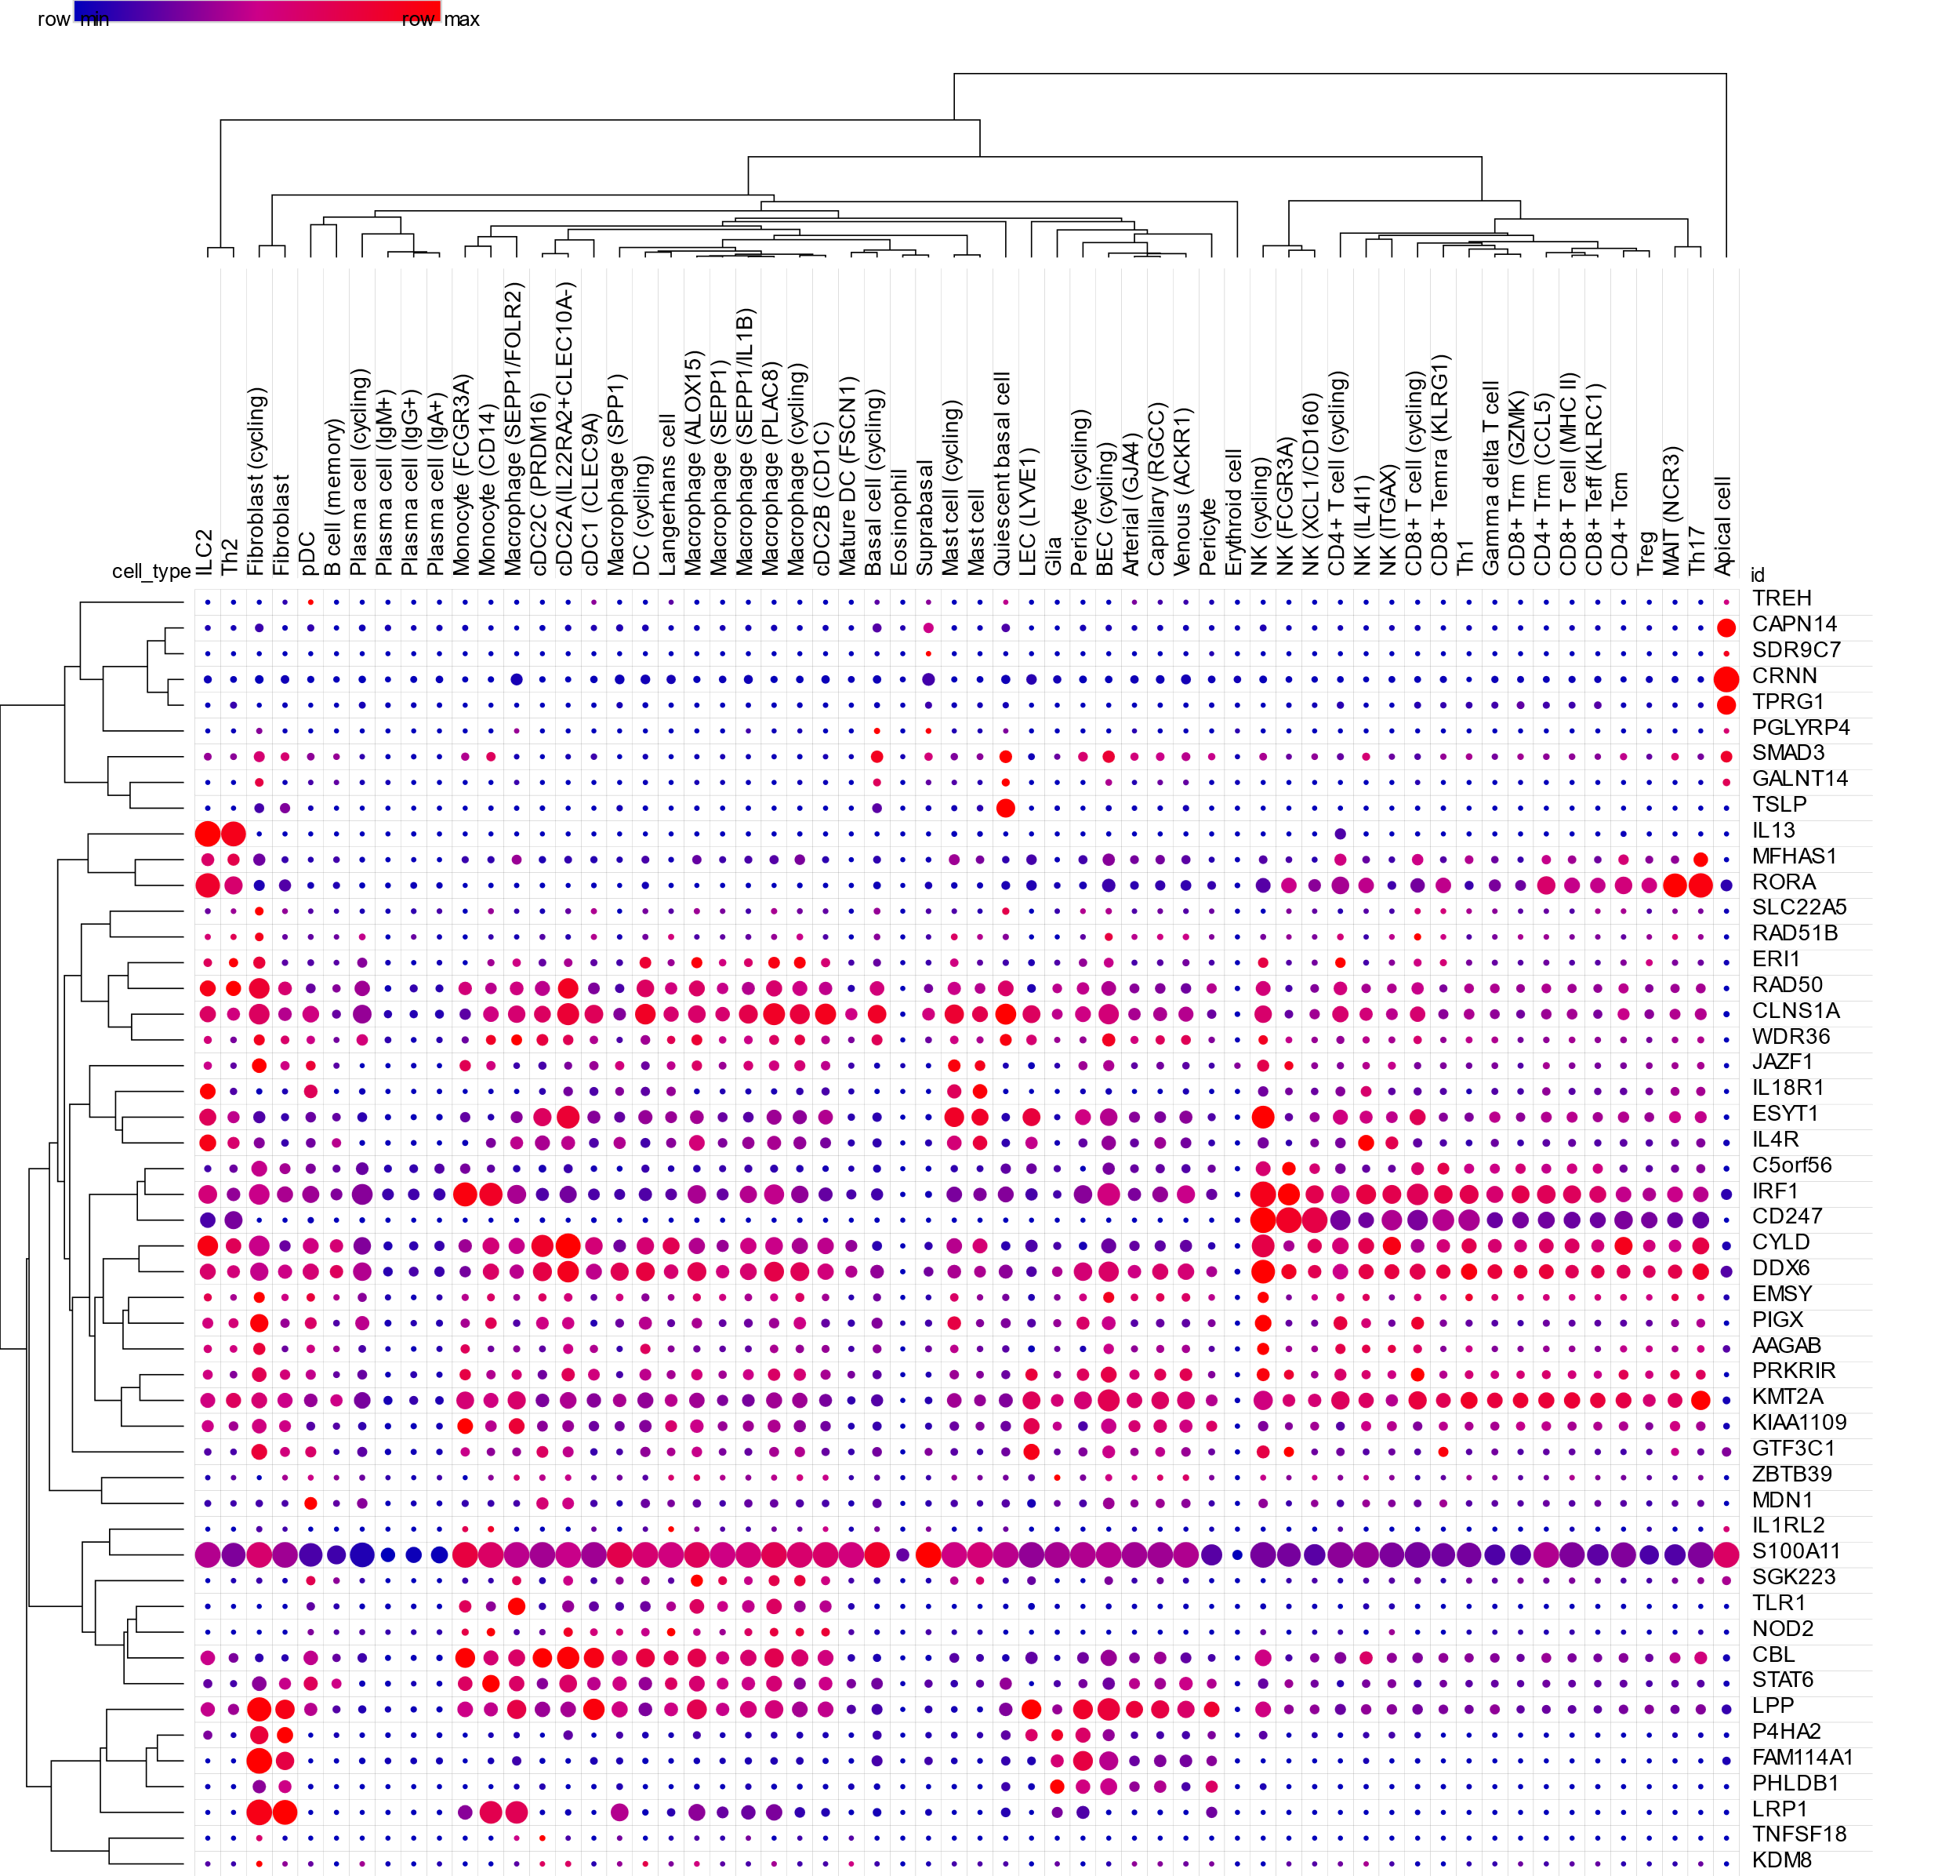
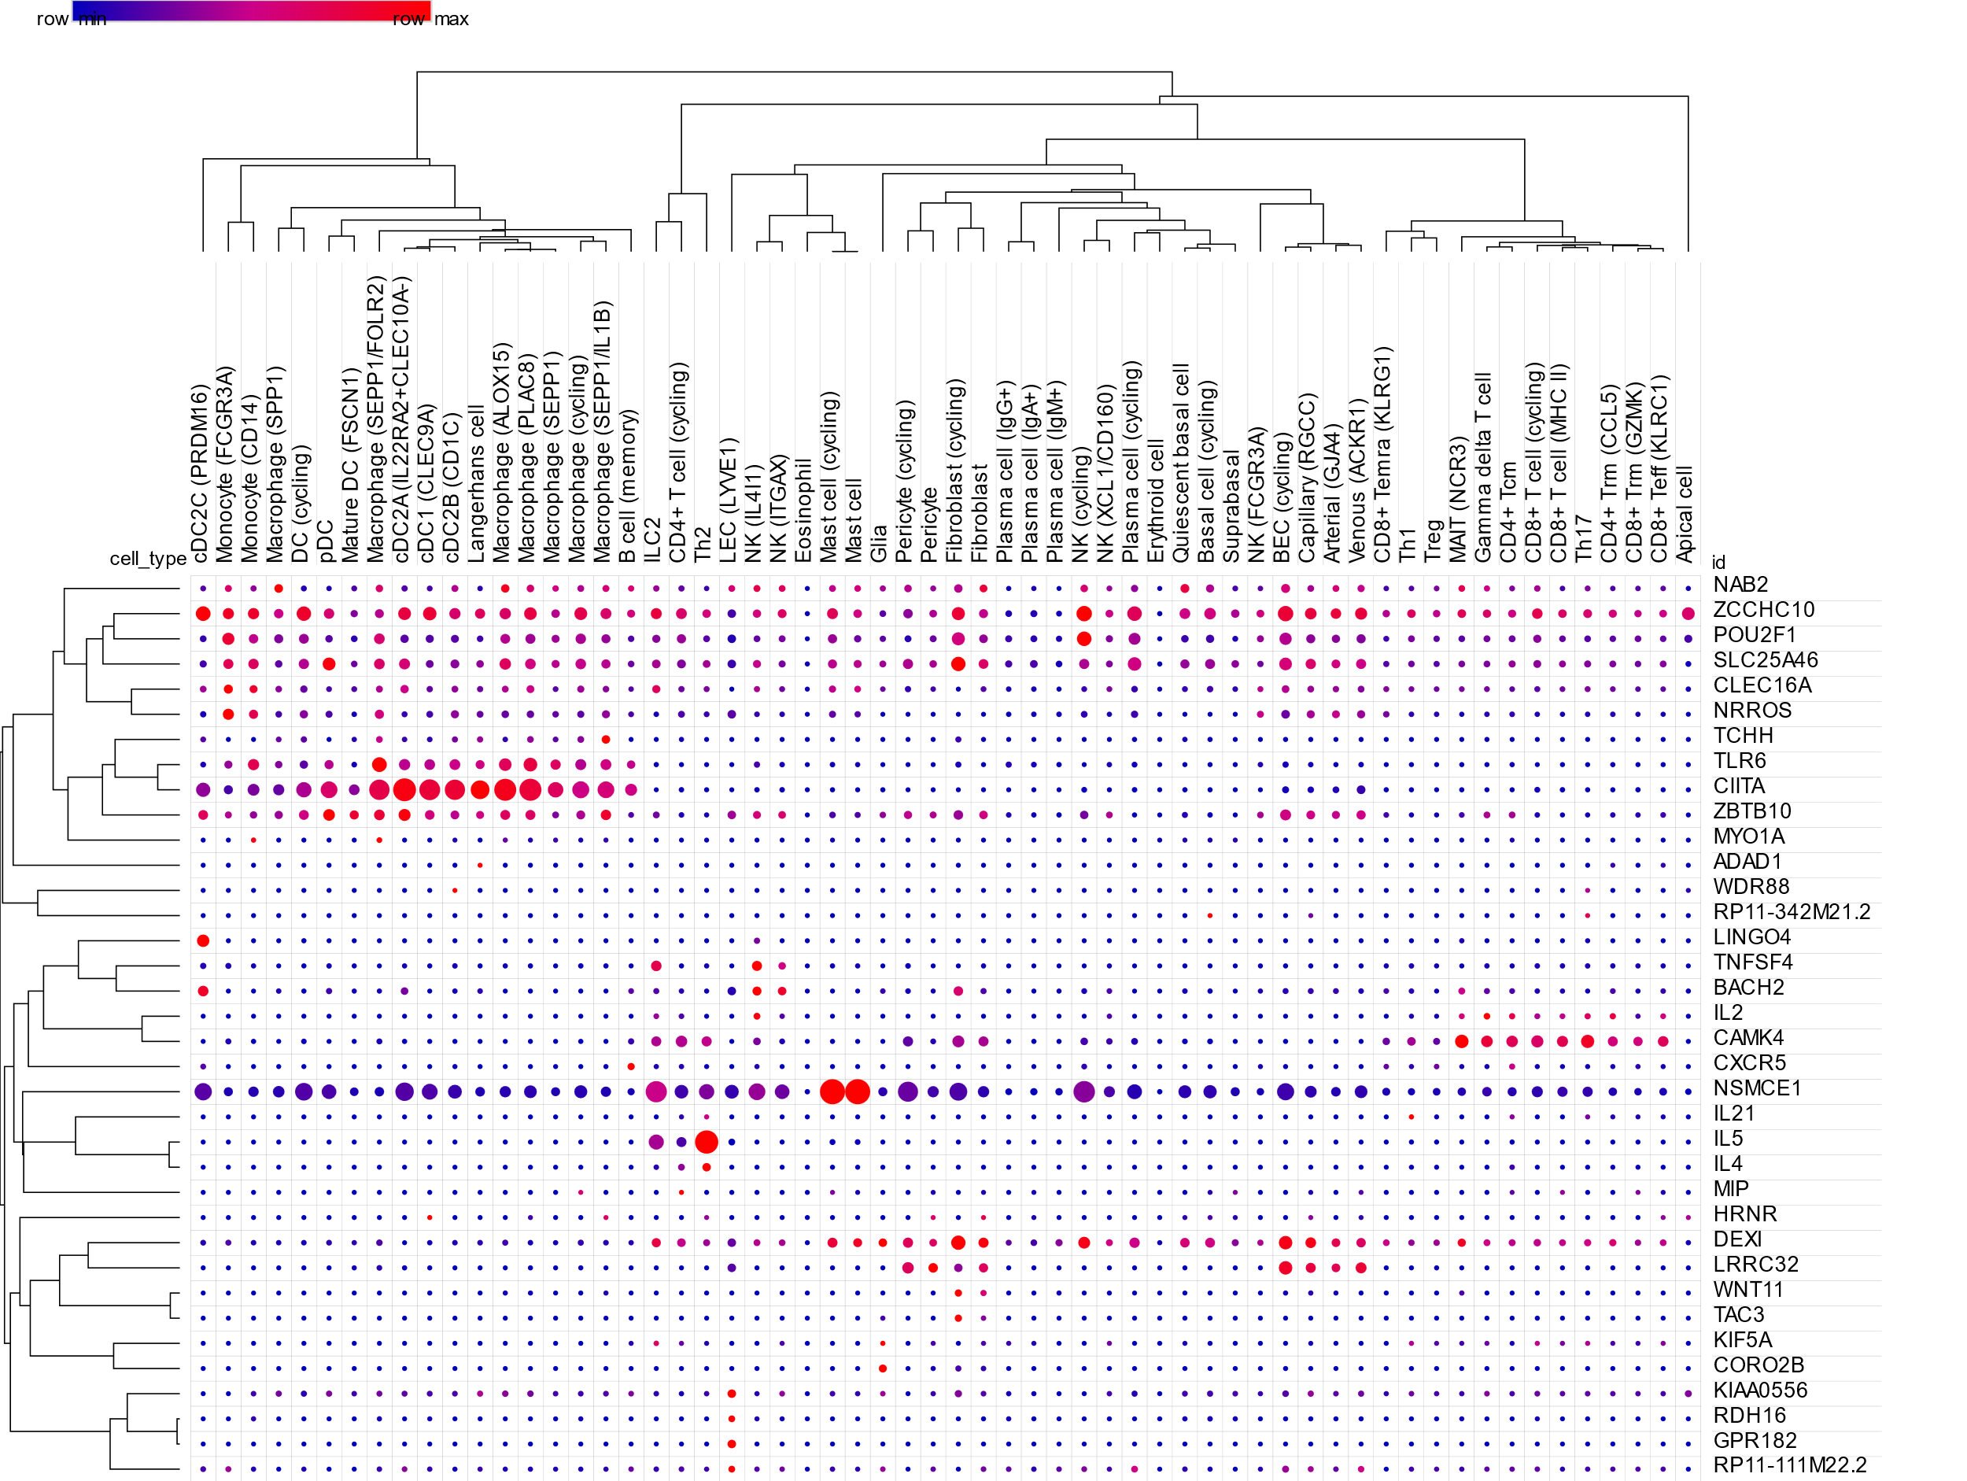
Figure S7. Cellular localization of EoE risk candidates (unfiltered). Dot plot showing cellular localization, as assessed by single-cell RNA sequencing of 86/90 candidate genes expressed in esophageal biopsies (EoE n = 15, control n = 7; no % expression threshold) and classified into 60 cell subsets. The dot size indicates the percent of cells in the cell type expressing each gene, and the dot color is proportional to the mean of the per-cell expression (Broad Single-cell Portal, EoE: Part 1, Part 2). BEC, blood vascular endothelial cell; DC, dendritic cell; EoE, eosinophilic esophagitis; ILC, innate lymphoid cell; LEC, lymphatic endothelial cell; MAIT, mucosal-associated invariant T cells; NK, natural killer cell; pDC, plasmacytoid dendritic cells; Teff, effector T cell; Th, T helper cell; Treg, regulatory T cell; Trm, resident memory T cell; Tcm, central memory T cell.

