Supplementary files

Table S1. Study Inclusion and Exclusion Criteria

Inclusion Criteria
- Confirmed diagnosis of heart failure
- Aged 18 years or older
- Able to use a mobile application (either independently or with the assistance of a caregiver)
- New York Heart Association (NYHA) class ≥ 2
- Actively followed in a heart failure clinic (or equivalent) in Quebec, with no anticipated discharge within 3 months
- At least one of the following contexts:
- New diagnosis of HF (<3 months)
- An emergency room visit or hospitalization for heart failure (primary or secondary diagnosis) within the last 6 months
- Two visits related to heart failure less than 3 months apart
- A >50% increase in diuretic dosage within the past 3 months
- Another diuretic added within the past 3 months (excluding spironolactone and eplerenone)
- Use of an intravenous diuretic within the past 3 months.

Exclusion Criteria
- Active hospitalization (except on the discharge day) OR expected hospitalization within two weeks of study initiation
- Legally incompetent adult
- History of non-adherence to medication or refusal of treatment
- Active alcohol or drug abuse
- Severe major depression without a caregiver
- Life expectancy of less than three months
- Under dialysis or awaiting a kidney transplant
- History of heart transplantation or mechanical heart implant
- Severe pulmonary disease requiring home oxygen therapy, or awaiting lung transplant, or recurrent pleural drainage (more than one episode in the last 6 months).
- Severe liver cirrhosis, or awaiting liver transplant, or recurrent ascitic drainage (more than one episode in the last 6 months).
- Scheduled surgical or percutaneous intervention (e.g., valve procedure, revascularization) within the past 30 days or within 3 months of study initiation.
- Current pregnancy
- Participating to other remote monitoring programs (mobile applications or implanted devices)
- Active participation in another clinical trial, excluding registry studies.

Figure S1. Study design
This shows the main inclusion criteria as well as the time flow of the two groups.
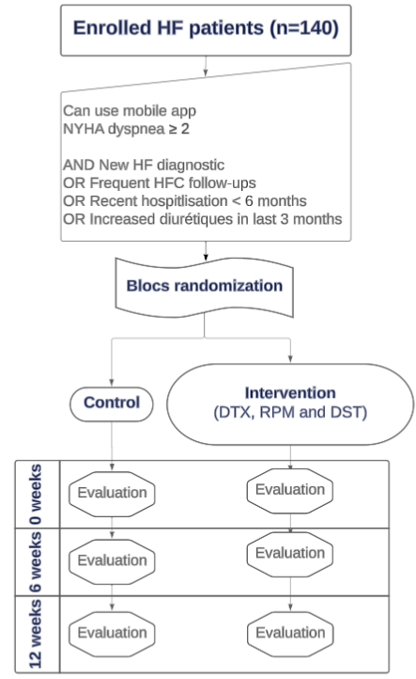

DST: decision support tool, HFC: Heart failure clinic, DTX: digital therapeutics, RPM: remote patient monitoring, NYHA: New York Heart Association dyspnea classification

Figure S2. Mobile and professional interfaces of the application

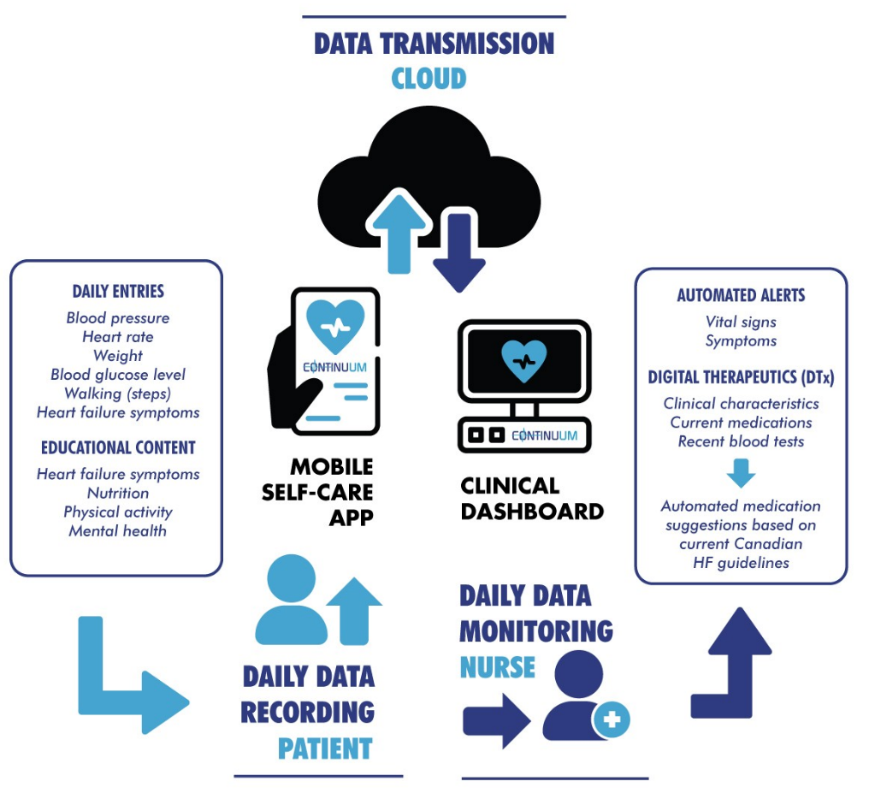
This figure represents the main components of the Continuum program, mainly the remote patient monitoring, the digitals therapeutics and the decision support tools module.

Figure S3. Mobile app images of Greybox Takecare adapted for the Continuum project
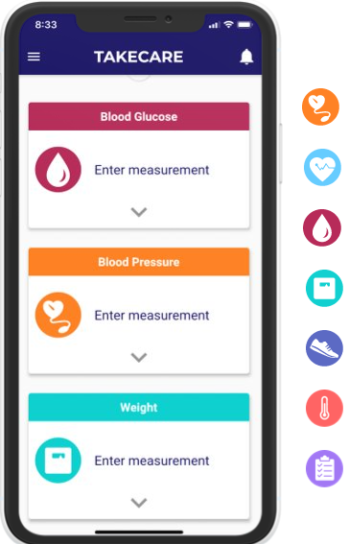
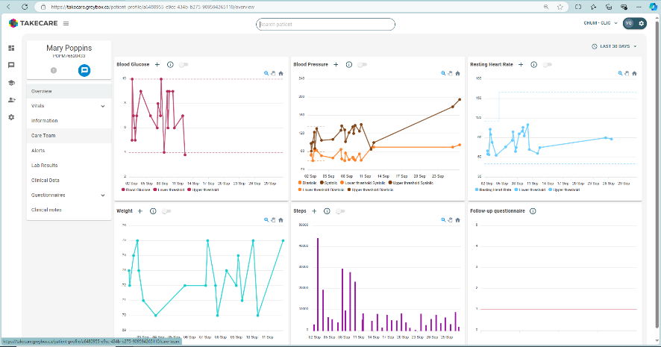

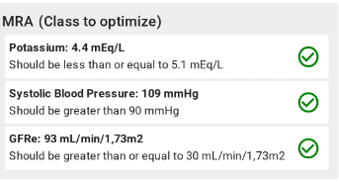

Daily recordings could be made manually or automatically via Bluetooth. Patients could archive their data, get a summary of their vital signs and view graphical trends over time. Data visualization tools were designed to help the interpretation of the data by clinicians. The software was not connected to an electronic medical record (EMR). Manual report corrections could be made based on this revision committee. Further software developments for the algorithm could be undertaken to reflect the revision committee recommendations.

Table S2. Definitions and data processing
Costs | Emergency and hospitalization costs exclude physicians’ compensation.(30, 31) Four-hour formation time was included in the intervention total costs for 2 clinicians and 2 clerks. Clinicians’ salary costs don’t include time in recruitment, as it is considered part of the routine visit. Software costs exclude initial app development and focus solely on updating and maintaining it, since the initial development cost was covered by a part of the fund.
Event days | First day of hospitalization counted as an emergency day and its associated cost, if the hospitalization started at the emergency. Events days count started at index date, meaning the first date of event counted as an events day, even if the patient was at the hospital just a few hours on this day.
Secondary Outcome definitions | Major cardiovascular events (MACE)’ definition used was an adaptation of the five-point MACE definition previously reported that includes HF events (52). We also added arrhythmic problems as well as we believe ventricular arrhythmias and defibrillator shocks are major events. MACE definitions and reporting is known to be heterogenous.(52) Only MACE related hospitalizations are reported (not emergency visits). Index emergency or hospitalization event for 30 days all-cause readmissions were during the study or in the 3 weeks prior to randomization.

Table S3. Other costs calculations (CAD $)
 | Intervention (n=52) |  |  | Control (n=54)
Intention to treat | Sum | Mean | SD | Sum | Mean | SD | Difference in means | p value
Intervention costs | 8,952 | 172 | 18 | - | - | - | - | -
Main condition during hospitalization method
Heart failure events | 61,211 | 1,177 | 4,986 | 96,974 | 1,796 | 5,958 | 619 | 0.367
Hospitalizations | 133,365 | 2,565 | 7,057 | 206,969 | 3,833 | 9,245 | 1,268 | 0.482
Major adverse cardiovascular events | 67,422 | 1,297 | 4,942 | 113,446 | 2,101 | 6,274 | 8,034 | 0.39
Standard hospital stay cost method
All-cause events | 73,680 | 1,417 | 3,747 | 137,184 | 2,540 | 5,724 | 1,123 | 0.605
Cardiac events | 36,840 | 708 | 3,010 | 98,410 | 1,822 | 4,006 | 1,114 | 0.119
Heart failure events | 36,067 | 694 | 3,012 | 53,327 | 988 | 2,820 | 294 | 0.36
Hospitalizations | 69,040 | 1,328 | 3,579 | 129,450 | 2,397 | 5,411 | 1,069 | 0.408
Major adverse cardiovascular events | 43,150 | 830 | 3,085 | 69,040 | 1,279 | 3,519 | 449 | 0.386
Unplanned cardiac consultations | 1024 | 20 | 34 | 1194 | 22 | 56 | 2 | 0.403
Emergency room visits costs | 4640 | 89 | 197 | 7734 | 143 | 392 | 54 | 0.834
Per protocol | Intervention (n=47) |  |  | Control (n=49)
Main condition during hospitalization method
Heart failure events | 61,211 | 1,302 | 5,237 | 96,974 | 1,979 | 6231 | 677 | 0.373
Hospitalizations costs | 104,430 | 2,222 | 6,278 | 206,969 | 4,224 | 9,628 | 2,002 | 0.304
Major adverse cardiovascular events | 67,422 | 1,435 | 5,184 | 113,446 | 2,315 | 6,554 | 880 | 0.393
Standard hospital stay method
All-cause events | 63,890 | 1,359 | 3,745 | 137,184 | 2,800 | 5,952 | 1,441 | 0.311
Cardiac events | 36,067 | 767 | 3,163 | 98,410 | 2,008 | 4,164 | 1,241 | 0.034
Heart failure events | 36,067 | 767 | 3,163 | 53,327 | 1,088 | 2,944 | 321 | 0.365
Hospitalizations | 60,410 | 1,285 | 3,589 | 129,450 | 2,642 | 5,627 | 1,357 | 0.268
Major adverse cardiovascular events | 43,150 | 918 | 3,236 | 69,040 | 1,409 | 3,673 | 491 | 0.388
Unplanned cardiac consultations | 910 | 19 | 32 | 1137 | 23 | 58 | 4 | 0.404
Emergency room visits costs | 3480 | 74 | 174 | 7734 | 158 | 410 | 84 | 0.456

Table S4. Other events count
 | Intervention (n=52) |  |  |  | Control (n=54)
Intention to treat | Events |  | Mean | SD | Sum | Mean | SD | p value | 95% CI
HF events | 4 |  | 0 | 0 | 6 | 0 | 0 | X | X
Patients with HF events | 3 |  | 0 | 0 | 6 | 0 | 0 | 0.489 | 0.589-3.898
HF events days | 65 |  | 1 | 6 | 77 | 1 | 5 | 0.360 | -
Patients with MACE | 4 |  | 0 | 0 | 7 | 0 | 0 | 0.527 | 0.620-3.113
MACE hospitalizations days | 69 |  | 1 | 6 | 92 | 2 | 5 | 0.400 | -
 | Intervention (n=47) |  |  |  | Control (n=49)
Per protocol | Sum |  | Mean | SD | Sum | Mean | SD | p value | 95% CI
HF events | 4 |  | 0 | 0 | 6 | 0 | 0 | X | X
Patients with HF events | 3 |  | 0 | 0 | 6 | 0 | 0 | 0.487 | 0.589-3.911
HF events days | 65 |  | 1 | 6 | 77 | 2 | 5 | 0.365 | -
Patients with MACE | 4 |  | 0 | 0 | 7 | 0 | 0 | 0.525 | 0.619-3.126
MACE hospitalizations days |  | 69 | 1 | 6 | 92 | 2 | 6 | 0.404 | -
*No statistical analysis for events only, due to low number per group.

Figure S4. Kaplan-Meier curves of the time to the first all-cause event.
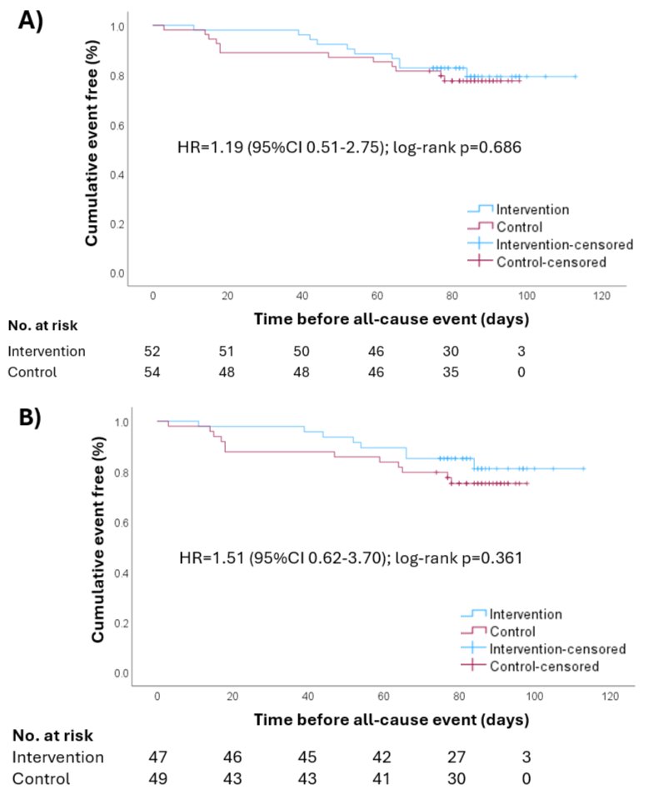
S4A). Intention to treat analysis for all-cause events. S4B) Per protocol analysis for all-cause events.

Table S5. Time to event results. Kaplan Meir analysis
 | Total N | N of all-cause events | N of cardiac events | N of heart failure events
ITT Intervention | 52 | 10 | 5 | 3
ITT Control | 54 | 12 | 11 | 6
Log Rank | - | 0.686 | 0.128 | 0.346
PP Intervention | 47 | 8 | 3 | 3
PP Control | 49 | 12 | 11 | 6
Log Rank | - | 0.361 | 0.028 | 0.35

Table S6. Compliance events and costs
 | Low |  |  | Medium |  |  | High |  |  | P value
 | Sum | Mean | SD | Sum | Mean | SD | Sum | Mean | SD
Events costs based on case mix group | 80,894 | 4,758 | 10,619 | 48,580 | 2,858 | 6,309 | 8,531 | 502 | 1,972 | 0.526
Cardiac events costs based on case mix group | 29,007 | 1,706 | 6,837 | 32,977 | 1,940 | 5,478 | 0 | 0 | 0 | 0.225
Heart failure events costs based on case mix group | 28,233 | 1,661 | 6,848 | 32,977 | 1,940 | 5,478 | 0 | 0 | 0 | 0.367
Patients with at least one unplanned event | 4 | 0 | 0 | 4 | 0 | 0 | 2 | 0 | 0 | 0.742
Patients with cardiac unplanned events | 3 | 0 | 0 | 2 | 0 | 0 | 0 | 0 | 0 | 0.347
Patients with HF unplanned events | 1 | 0 | 0 | 2 | 0 | 0 | 0 | 0 | 0 | 0.764

Figure S5. Percentage of reduced heart failure patients with recommended medication classes before and after the study follow-up.*
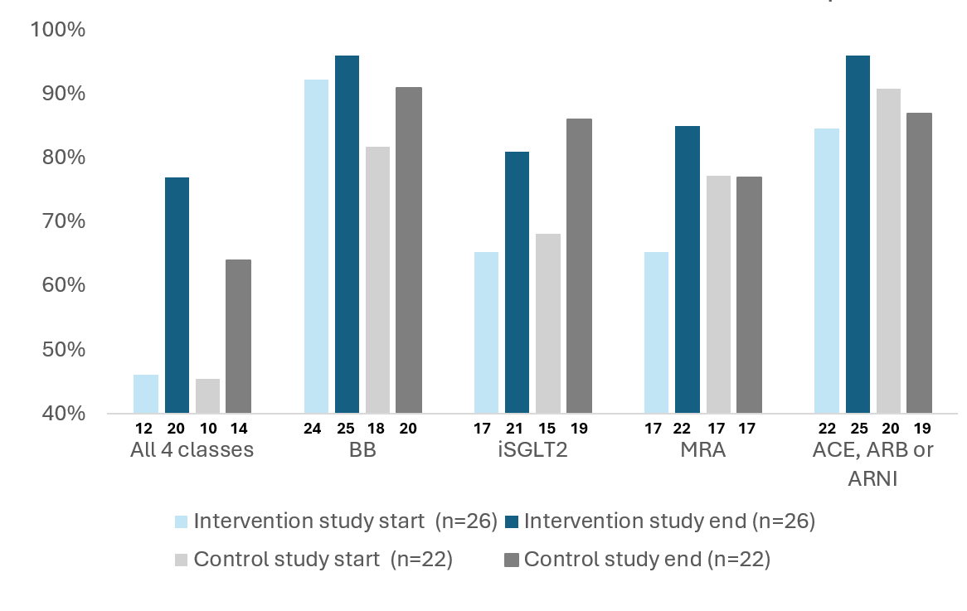
BB: b-blockers;
ACEi: angiotensin-converting enzyme inhibitors
ARB: angiotensin receptor blockers
ARNI: angiotensin receptor–neprilysin inhibitors
MRA: mineralocorticoid receptor antagonists
SGLT2i: sodium-glucose cotransporter-2 inhibitors
*Data available for baseline and end of study (n= 26/27 INT and 22/27 CTRL)

