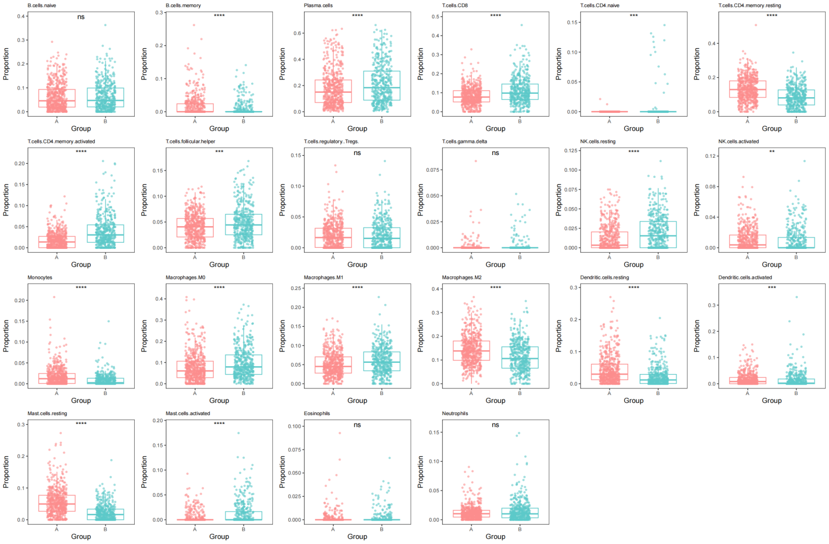
Figure S1. Immune cell infiltration analysis of hot and cold tumor subtypes. Immune infiltration levels of LUAD subtypes were estimated using the CIBERSORT algorithm. Cluster 1 (hot tumors) showed significantly higher infiltration of immune-active cells, including CD8⁺ T cells, activated NK cells, and M1 macrophages. In contrast, Cluster 2 (cold tumors) exhibited higher proportions of M0 macrophages, M2 macrophages, and resting NK cells. No significant differences were observed in the abundance of certain cell types such as Tregs and B cells between the two subtypes.

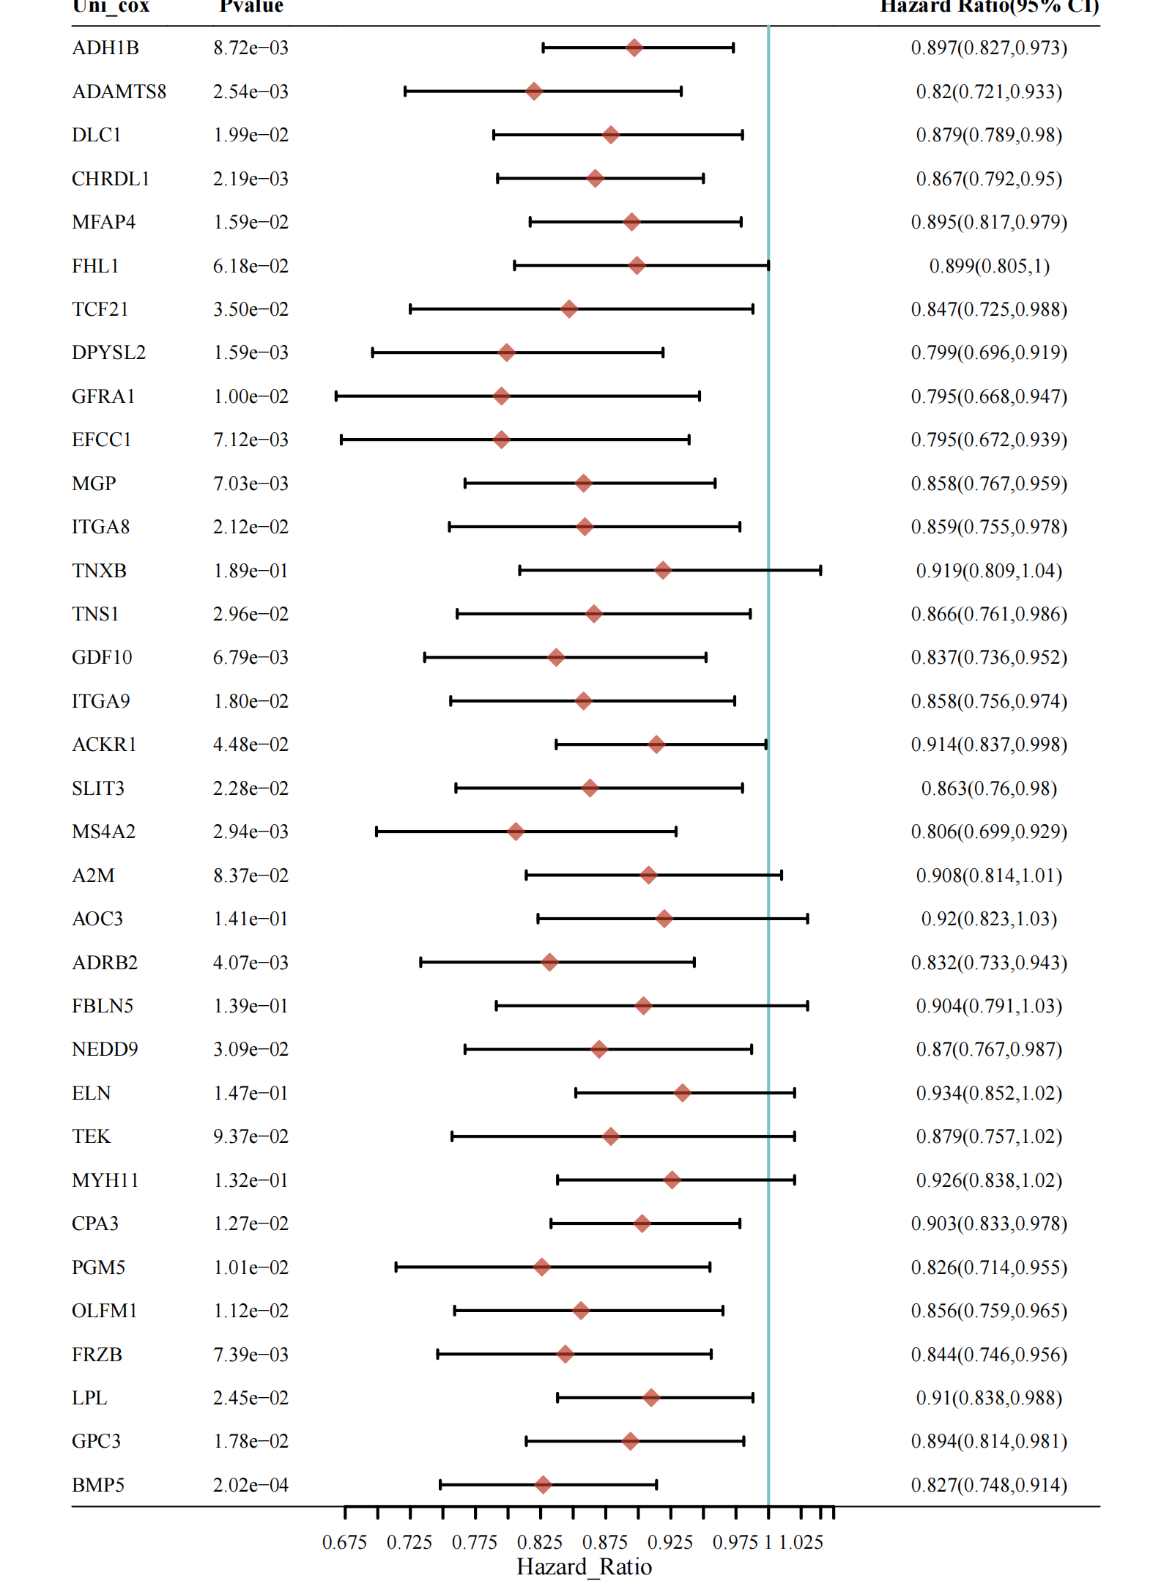
Figure.S2 Cox regression analysis of upregulated genes associated with the hot tumor subtype.

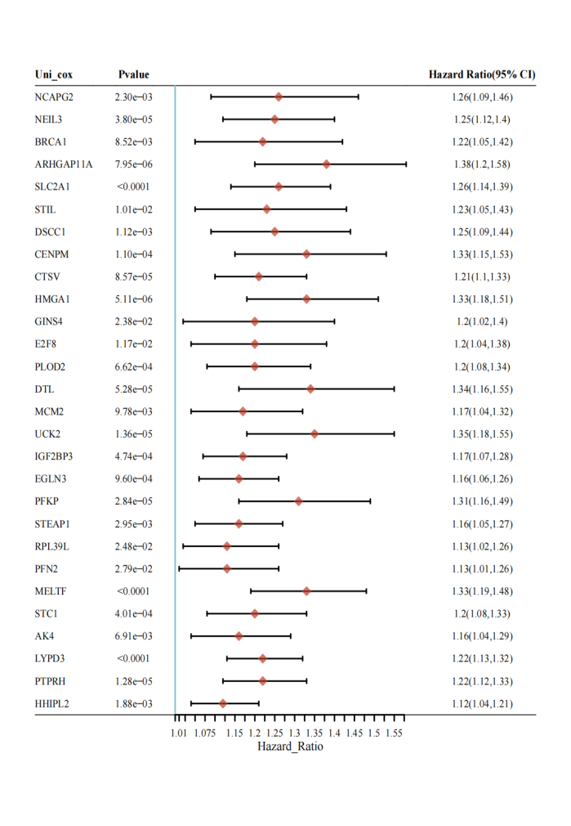
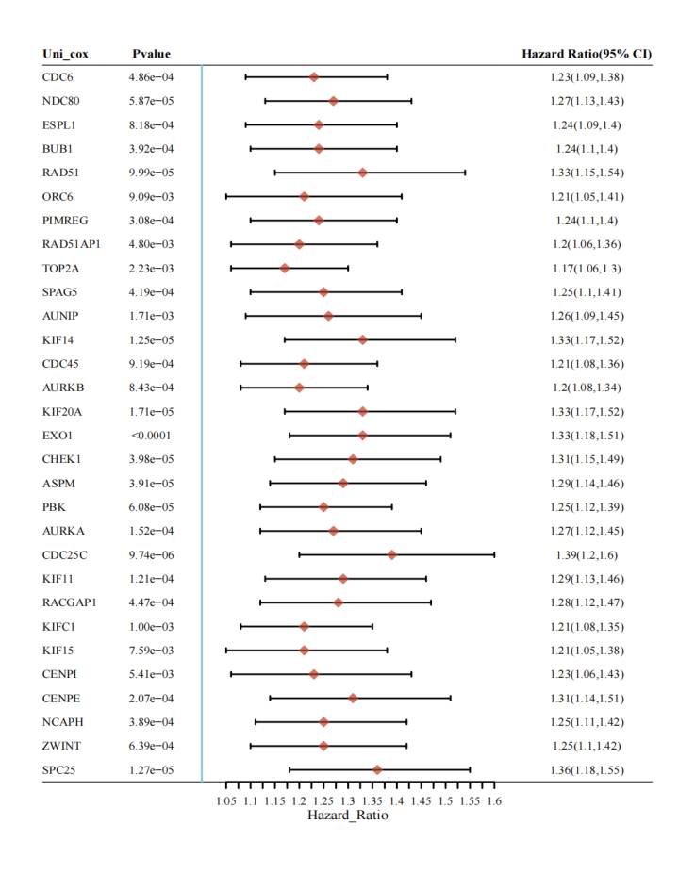
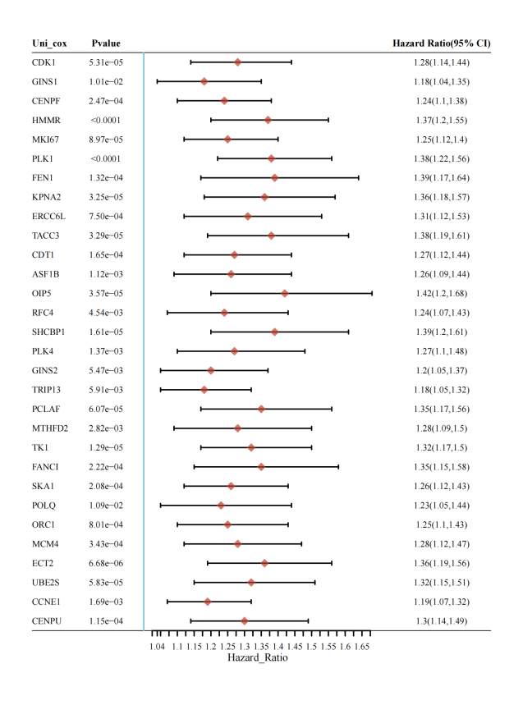
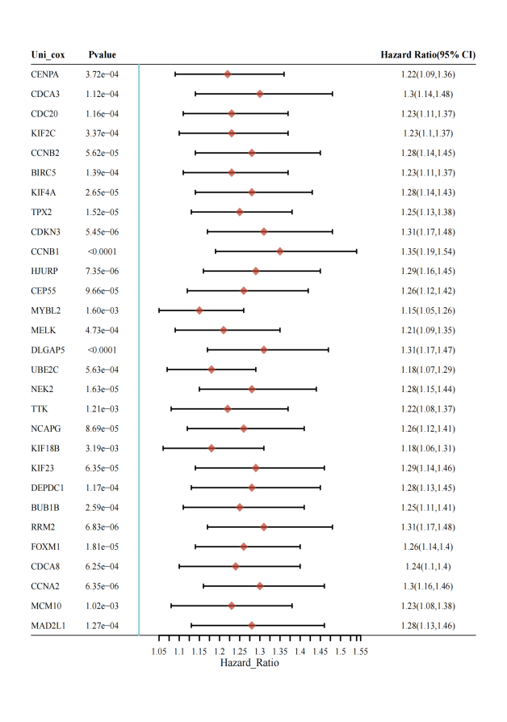
Figure S3. Cox regression analysis of downregulated genes associated with the cold tumor subtype.

Figure S4. Differences in immune-related features between high and low CMLS groups. (A) Distribution of immune cell infiltration between high and low CMLS groups. High CMLS scores were associated with significantly increased infiltration of anti-tumor immune cells such as CD8⁺ T cells and M1 macrophages. (B) Analysis of immunosuppressive features showed elevated levels of regulatory T cells (Tregs) and myeloid-derived suppressor cells (MDSCs) in the high CMLS group. (C) Immune exclusion characteristics, including cancer-associated fibroblasts (CAFs) and TGF-β signaling, were more prominent in the high CMLS group. (D) Expression of immunotherapy-related biomarkers showed no significant differences between the two groups, although immune checkpoints such as PD-L1 were slightly elevated in the high CMLS group.

Figure S5. Quality control and batch effect correction of single-cell RNA sequencing data. (A) Violin plots showing the distribution of nFeature_RNA, nCount_RNA, percent.mt, and percent.HB across different samples, used to assess overall cell quality. (B) Scatter plots illustrating the correlation between nCount_RNA and percent.mt (left) as well as nCount_RNA and nFeature_RNA (right); a strong positive correlation was observed between RNA count and feature number. (C) Highly variable gene (HVG) selection plot, with red dots indicating HVGs selected for downstream dimensionality reduction and clustering. (D–E) Dimensionality reduction results from PCA (D) and Harmony (E); Harmony correction effectively minimized batch effects, yielding more uniform distributions across samples.

Figure S6. Association between SHCBP1 expression and functional pathway activity. (A) GSVA analysis revealed that high SHCBP1 expression is associated with the activation of proliferation-related pathways, including cell cycle, DNA repair, and mitosis, whereas low SHCBP1 expression is enriched in immune and developmental pathways. (B) GSEA results showed that the high SHCBP1 expression group is significantly enriched in proliferative pathways such as the cell cycle and G2M checkpoint. (C) In contrast, the low SHCBP1 expression group is enriched in immune-related pathways, including T cell receptor signaling and inflammatory response pathways.

