SUPPLEMENTARY APPENDIX

Supplementary Figure 1. Treatment and parasitological history of the patient infected by the strain 9097.

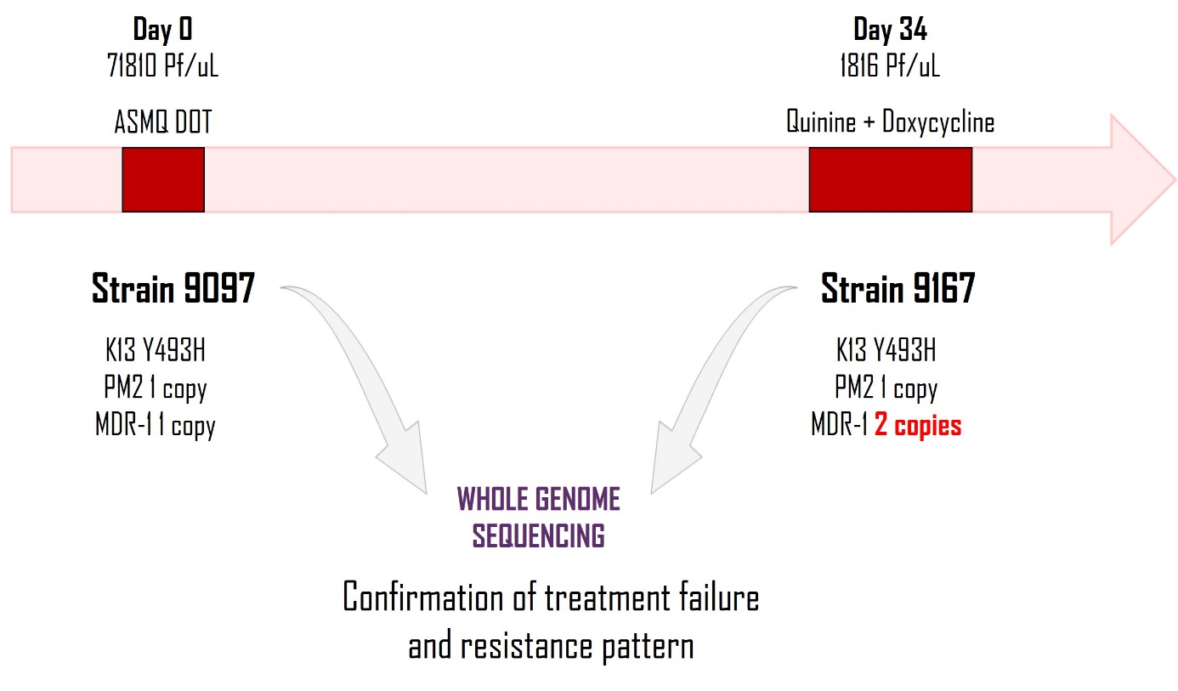

Supplementary Figure 2. Summary of pressure experiment. 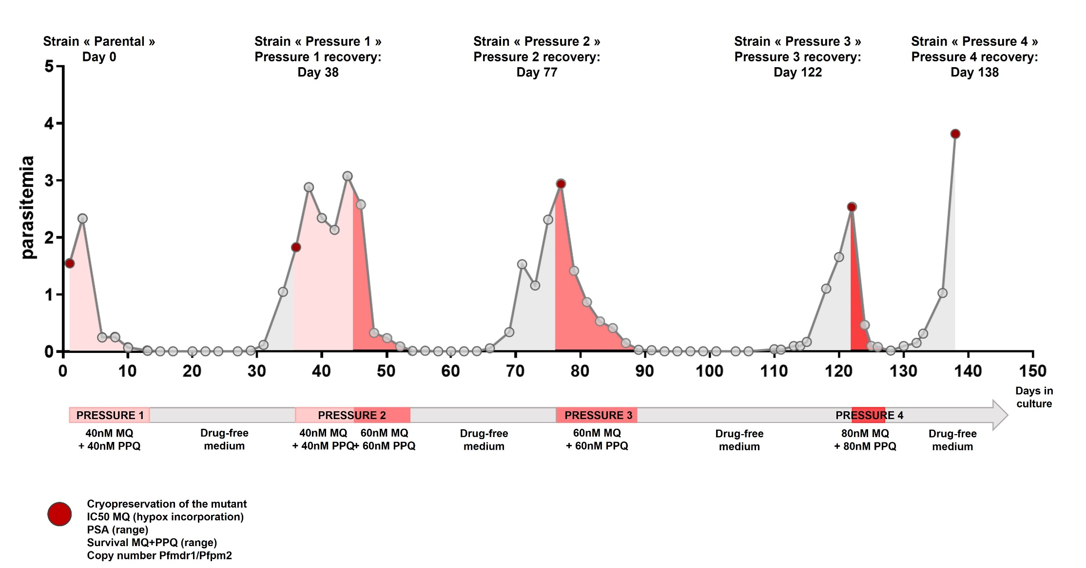

Supplementary Figure 3. Evolution of the in vitro susceptibility of the parent strain and the selected strain after continuous pressure of MQ+PPQ, measured by conventional methods. Mean and standard deviation are represented on the graphs and each dot represents one independent replicate. Mann-Whitney U test was used as statistical test.
A. Mefloquine susceptibility evolution. The susceptibility to mefloquine was measured using incorporation of 3H-hypoxanthine and IC_{50s} were calculated (** p = 0.0040). B. Piperaquine susceptibility evolution. The susceptibility to piperaquine was determined using PSA. A significant increase was observed between the two strains, but PSA remains below the threshold of resistance (** p = 0.0068).

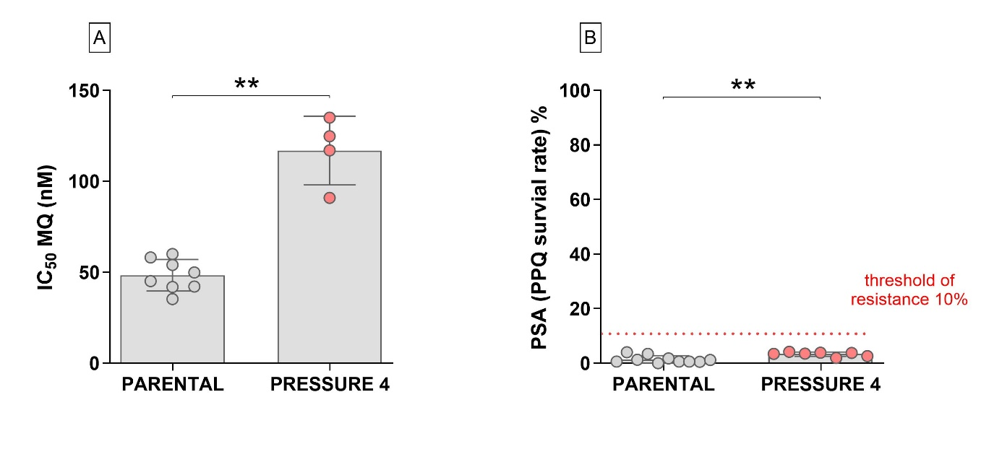
Supplementary Figure 4. Number of (A) SNPs and (B) indels detected between the two studied strains (Parental and Pressure 4 strains). The plots report the number of genomic positions retained after each filtering step.

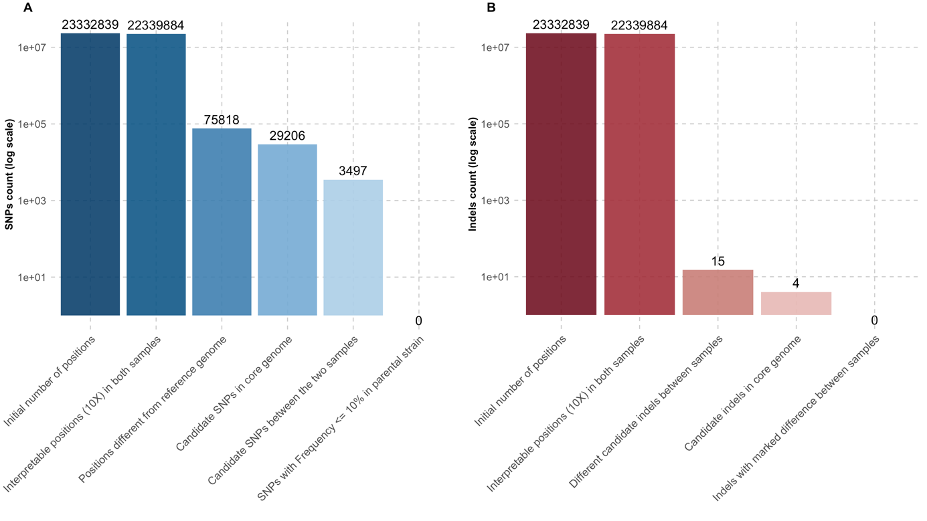

Supplementary Table 1. Characteristics and in vitro results of samples selected.
Strain | Category | Year | Province | K13 | PfPm2 copy number | Pfmdr-1 copy number | CRT 88 | CRT 93 | CRT 97 | CRT 145 | CRT 218 | CRT 343 | CRT 353 | IC₅₀ MQ (nM) | PSA (%) | IC₅₀ MQ+PPQ coexposure (nM)
7742 | KEL1/PLA1 | 2016 | Mondulkiri | C580Y | > 1,5 | < 1,5 | N | T | H | F | I | M | G | 8,55 | 80,55 | 25,73
8197 | KEL1/PLA1 | 2017 | Mondulkiri | C580Y | > 1,5 | < 1,5 | N | T | H | I | I | M | G | 24,37 | 66,37 | 23,94
8286 | KEL1/PLA1 | 2017 | Pursat | C580Y | > 1,5 | < 1,5 | N | S | H | F | I | M | G | 9,82 | 64,64 | 10,98
8315 | KEL1/PLA1 | 2017 | Rattanakiri | C580Y | > 1,5 | < 1,5 | K | T | H | F | I | M | G | 24,87 | 42,85 | 30,74
8546 | KEL1/PLA1 | 2018 | Kampong Speu | C580Y | > 1,5 | < 1,5 | N | T | Y | F | I | M | G | 50,82 | 27,50 | 31,84
9025 | KEL1/PLA1 | 2019 | Kampong Speu | C580Y | > 1,5 | < 1,5 | N | T | Y | F | I | M | G | 40,65 | 57,40 | 14,88
9028 | KEL1/PLA1 | 2019 | Pursat | C580Y | > 1,5 | < 1,5 | N | T | Y | F | I | M | G | 30,55 | 46,16 | 17,97
9034 | KEL1/PLA1 | 2019 | Pursat | C580Y | > 1,5 | < 1,5 | N | T | Y | F | I | M | G | 34,8 | 64,18 | 33,59
9074 | KEL1/PLA1 | 2019 | Kampong Speu | C580Y | > 1,5 | < 1,5 | N | T | Y | F | I | M | G | 48,32 | 50,56 | 28,90
8916 | MQ-R | 2018 | Rattanakiri | R539T | < 1,5 | > 1,5 | N | T | H | F | I | M | G | 107,49 | 0,01 | 63,70
9042 | MQ-R | 2019 | Rattanakiri | C580Y | < 1,5 | > 1,5 | N | T | H | F | I | M | G | 100,40 | 0,39 | 34,72
9061 | MQ-R | 2019 | Rattanakiri | C580Y | < 1,5 | > 1,5 | N | T | H | F | I | M | G | 85,96 | 0,00 | 47,20
9062 | MQ-R | 2019 | Rattanakiri | C580Y | < 1,5 | > 1,5 | N | T | H | F | I | M | G | 72,57 | 0,00 | 47,42
9065 | MQ-R | 2019 | Rattanakiri | C580Y | < 1,5 | > 1,5 | N | T | H | F | I | M | G | 105,15 | 0,00 | 28,25
9067 | MQ-R | 2019 | Rattanakiri | C580Y | < 1,5 | > 1,5 | N | T | H | F | I | M | G | 69,56 | 0,00 | 63,21
9069 | MQ-R | 2019 | Rattanakiri | C580Y | < 1,5 | > 1,5 | N | T | H | F | I | M | G | 71,20 | 0,00 | 29,06
9071 | MQ-R | 2019 | Rattanakiri | C580Y | < 1,5 | > 1,5 | N | T | H | F | I | M | G | 93,69 | 0,00 | 52,52
9077 | MQ-R | 2019 | Rattanakiri | C580Y | < 1,5 | > 1,5 | N | T | H | F | I | M | G | 125,58 | 0,00 | 37,62
9078 | MQ-R | 2019 | Rattanakiri | C580Y | < 1,5 | > 1,5 | N | T | H | F | I | M | G | 72,81 | 0,00 | 26,38
9080 | MQ-R | 2019 | Rattanakiri | C580Y | < 1,5 | > 1,5 | N | T | H | F | I | M | G | 77,26 | 0,00 | 63,69
9081 | MQ-R | 2019 | Rattanakiri | C580Y | < 1,5 | > 1,5 | N | T | H | F | I | M | G | 89,05 | 0,18 | 57,64
9093 | MQ-R | 2019 | Kampong Speu | Y493H | < 1,5 | > 1,5 | N | T | H | F | I | M | G | 118,95 | 1,41 | 67,58
9099 | MQ-R | 2019 | Rattanakiri | C580Y | < 1,5 | > 1,5 | N | T | H | F | I | M | G | 147,89 | 0,00 | 54,92
9128 | MQ-R | 2019 | Kampong Speu | Y493H | < 1,5 | > 1,5 | N | T | H | F | I | M | G | 126,47 | 0,00 | 83,84
9167 | MQ-R | 2019 | Pursat | Y493H | < 1,5 | > 1,5 | N | T | H | F | I | M | G | 90,36 | 0,00 | 46,51
9175 | MQ-R | 2019 | Pursat | Y493H | < 1,5 | > 1,5 | N | T | H | F | I | M | G | 83,61 | 0,70 | 67,23
8944 | Sensitive | 2018 | Rattanakiri | WT | < 1,5 | < 1,5 | N | T | H | F | I | M | G | 20,77 | 0,00 | 23,70
9032 | Sensitive | 2019 | Rattanakiri | WT | < 1,5 | < 1,5 | N | T | H | F | I | M | G | 51,95 | 0,00 | 23,60
9037 | Sensitive | 2019 | Rattanakiri | WT | < 1,5 | < 1,5 | N | T | H | F | I | M | G | 54,68 | 0,00 | 20,26
9046 | Sensitive | 2019 | Rattanakiri | WT | < 1,5 | < 1,5 | N | T | H | F | I | M | G | 35,39 | 0,00 | 21,11
9049 | Sensitive | 2019 | Rattanakiri | WT | < 1,5 | < 1,5 | N | T | H | F | I | M | G | 52,15 | 0,00 | 27,32
9097 | PARENTAL | 2019 | Pursat | Y493H | < 1,5 | < 1,5 | N | T | H | F | I | M | G | 49,05 | 2,49 | 21,70

Supplementary Table 2. List of amplified and deleted genes in Pressure 4 strain.

Gene_ID | F75  strain | F78  strain | Differential | Gene description | Chromosome | Result
PF3D7_0522000 | 0,51 | 1,18 | 0,67 | Uncharacterized protein | PF3D7_05 | Amplified
PF3D7_0519500 | 1,06 | 1,76 | 0,7 | poly(A)-specific ribonuclease | PF3D7_05 | Amplified
PF3D7_0522300 | 0,69 | 1,45 | 0,76 | 18S rRNA (Guanine-N(7))-methyltransferase, putative | PF3D7_05 | Amplified
PF3D7_0522200 | 0,78 | 1,55 | 0,77 | Transcription initiation factor TFIID subunit 10, putative | PF3D7_05 | Amplified
PF3D7_0522700 | 0,71 | 1,5 | 0,79 | Iron-sulfur cluster assembly protein SufA | PF3D7_05 | Amplified
PF3D7_0522500 | 0,68 | 1,48 | 0,8 | 50S ribosomal protein L17, apicoplast, putative | PF3D7_05 | Amplified
PF3D7_0520600 | 0,91 | 1,72 | 0,81 | Bis(5'-nucleosyl)-tetraphosphatase [asymmetrical] | PF3D7_05 | Amplified
PF3D7_0520000 | 0,56 | 1,38 | 0,82 | 40S ribosomal protein S9, putative | PF3D7_05 | Amplified
PF3D7_0523100 | 1,06 | 1,88 | 0,82 | Alpha-MPP | PF3D7_05 | Amplified
PF3D7_0522800 | 0,91 | 1,77 | 0,86 | Pre-mRNA-splicing factor BUD31, putative | PF3D7_05 | Amplified
PF3D7_0522900 | 1,19 | 2,09 | 0,9 | Zinc finger protein, putative | PF3D7_05 | Amplified
PF3D7_0521500 | 1,06 | 2,02 | 0,96 | Ribosomal large subunit pseudouridylate synthase, putative | PF3D7_05 | Amplified
PF3D7_0523200 | 1,03 | 2,02 | 0,99 | Heptatricopeptide repeat-containing protein, putative | PF3D7_05 | Amplified
PF3D7_0520700 | 1,15 | 2,14 | 0,99 | CDC73 domain-containing protein, putative | PF3D7_05 | Amplified
PF3D7_0519900 | 1,11 | 2,11 | 1 | Uncharacterized protein | PF3D7_05 | Amplified
PF3D7_0522100 | 1,07 | 2,07 | 1 | RRM domain-containing protein | PF3D7_05 | Amplified
PF3D7_0520100 | 0,92 | 1,92 | 1 | Protein phosphatase PPM9, putative | PF3D7_05 | Amplified
PF3D7_0521100 | 1,06 | 2,06 | 1 | Uncharacterized protein | PF3D7_05 | Amplified
PF3D7_0520500 | 0,92 | 1,93 | 1,01 | Phosphomethylpyrimidine kinase, putative | PF3D7_05 | Amplified
PF3D7_0521800 | 1,07 | 2,08 | 1,01 | AFG1-like ATPase, putative | PF3D7_05 | Amplified
PF3D7_0519700 | 0,82 | 1,83 | 1,01 | FoP domain-containing protein, putative | PF3D7_05 | Amplified
PF3D7_0522600 | 1,15 | 2,16 | 1,01 | Inner membrane complex protein | PF3D7_05 | Amplified
PF3D7_0520900 | 1,1 | 2,12 | 1,02 | Adenosylhomocysteinase | PF3D7_05 | Amplified
PF3D7_0521200 | 1,02 | 2,06 | 1,04 | Uncharacterized protein | PF3D7_05 | Amplified
PF3D7_0521300 | 1,07 | 2,12 | 1,05 | Zinc finger protein, putative | PF3D7_05 | Amplified
PF3D7_0519600 | 1,2 | 2,26 | 1,06 | Zinc finger protein, putative | PF3D7_05 | Amplified
PF3D7_0521900 | 1,16 | 2,22 | 1,06 | Uncharacterized protein | PF3D7_05 | Amplified
PF3D7_0522400 | 1,17 | 2,24 | 1,07 | Chorein N-terminal domain-containing protein | PF3D7_05 | Amplified
PF3D7_0519800 | 1,22 | 2,3 | 1,08 | EELM2 domain-containing protein, putative | PF3D7_05 | Amplified
PF3D7_0520400 | 1,13 | 2,21 | 1,08 | Single-stranded DNA-binding protein, putative | PF3D7_05 | Amplified
PF3D7_0523000 | 1,17 | 2,25 | 1,08 | Multidrug resistance protein 1 | PF3D7_05 | Amplified
PF3D7_0520800 | 1,16 | 2,24 | 1,08 | Uncharacterized protein | PF3D7_05 | Amplified
PF3D7_0521700 | 1,11 | 2,23 | 1,12 | ATP-dependent RNA helicase | PF3D7_05 | Amplified
PF3D7_0520200 | 1,25 | 2,4 | 1,15 | Mediator of RNA polymerase II transcription subunit 17, putative | PF3D7_05 | Amplified
PF3D7_0521000 | 1,13 | 2,31 | 1,18 | Uncharacterized protein | PF3D7_05 | Amplified
PF3D7_0521400 | 1,1 | 2,42 | 1,32 | SUN domain-containing protein | PF3D7_05 | Amplified
PF3D7_0936000 | 0,57 | 0 | 0,57 | Ring-exported protein 2 | PF3D7_09 | Deleted
PF3D7_0935500 | 0,67 | 0 | 0,67 | Plasmodium RESA N-terminal domain-containing protein | PF3D7_09 | Deleted
PF3D7_0936600 | 0,74 | 0 | 0,74 | Plasmodium RESA N-terminal domain-containing protein | PF3D7_09 | Deleted
PF3D7_0936200 | 0,75 | 0 | 0,75 | Plasmodium RESA N-terminal domain-containing protein | PF3D7_09 | Deleted
PF3D7_0935400 | 1,04 | 0,25 | 0,79 | Gametocyte development protein 1 | PF3D7_09 | Deleted
PF3D7_0935700 | 0,86 | 0 | 0,86 | Plasmodium RESA N-terminal domain-containing protein | PF3D7_09 | Deleted
PF3D7_0935600 | 0,88 | 0 | 0,88 | Gametocytogenesis-implicated protein | PF3D7_09 | Deleted
PF3D7_0935900 | 0,88 | 0 | 0,88 | Ring-exported protein 1 | PF3D7_09 | Deleted
PF3D7_0936400 | 0,89 | 0 | 0,89 | Ring-exported protein 4 | PF3D7_09 | Deleted
PF3D7_0936800 | 0,91 | 0 | 0,91 | Plasmodium RESA N-terminal domain-containing protein | PF3D7_09 | Deleted
PF3D7_0935800 | 0,92 | 0 | 0,92 | Cytoadherence linked asexual protein 9 | PF3D7_09 | Deleted
PF3D7_0936300 | 0,93 | 0 | 0,93 | Ring-exported protein 3 | PF3D7_09 | Deleted
PF3D7_0936700 | 0,95 | 0 | 0,95 | Lysophospholipase, putative | PF3D7_09 | Deleted
PF3D7_0937000 | 0,97 | 0 | 0,97 | Plasmodium RESA N-terminal domain-containing protein | PF3D7_09 | Deleted
PF3D7_0937100 | 0,97 | 0 | 0,97 | Uncharacterized protein | PF3D7_09 | Deleted
PF3D7_0937200 | 1 | 0 | 1 | Lysophospholipase, putative | PF3D7_09 | Deleted
PF3D7_0936100 | 1,01 | 0 | 1,01 | Early transcribed membrane protein | PF3D7_09 | Deleted
PF3D7_0936500 | 1,05 | 0 | 1,05 | Virulence-associated protein 1 | PF3D7_09 | Deleted

