Supplementary information for
Atorvastatin calcium selectively kills thyroid cancer cells by inhibiting the prenylation of HRAS proteins

Rong Wang ^{1,2,3,*}, Hexiang Li^{1,*}, Yan Zhang¹, Nana Liu², Shengxiang Li², Daxu Li⁴，Meiju Ji⁵, Qi Yang¹, and Peng Hou¹

Running Title: Atorvastatin calcium selectively kills thyroid cancer cells

* Corresponding authors:
Qi Yang, Ph.D
Department of Endocrinology and International Joint Research Center for Tumor Precision Medicine of Shaanxi Province, The First Affiliated Hospital of Xi’an Jiaotong University, Xi’an 710061, P.R. China
E-mail (Qi Yang): yangqi2015@xjtu.edu.cn
Peng Hou, Ph.D
Department of Endocrinology and International Joint Research Center for Tumor Precision Medicine of Shaanxi Province, The First Affiliated Hospital of Xi’an Jiaotong University, Xi’an 710061, P.R. China
E-mail (Peng Hou): phou@xjtu.edu.cn.

Supplementary Table 1. Tissue origins and genetic alterations of different thyroid cancer cell lines [1]

Cell lines | Origins | Genetic alteration  of BRAF | Genetic alteration  of RAS | Genetic alteration  of PIK3CA
8305C | ATC | BRAF^{V600E}  (Heterozygous) | NRAS truncating (Heterozygous) | -
8505C | ATC | BRAF^{V600E}  (Homozygous) | - | -
IHH4 | ATC | BRAF^{V600E}  (Heterozygous) | - | -
K1 | PTC | BRAF^{V600E}  (Heterozygous) | - | PIK3CA^{E542K}  (Heterozygous)
C643 | ATC | - | HRAS^{G13R}  (Heterozygous) | -
HTori3 | - | Wild- type | Wild- type | Wild- type

Supplementary Table 2 Antibodies used in this study
Antibodies | Catalog# | Source
anti-p-AKT^{S473} | #4060 | Cell Signaling Technology
anti-p-AKT^{T308} | #13038 | Cell Signaling Technology
anti-t-AKT | BS1810 | Bioworld Technology
anti-p-ERK | #4695 | Cell Signaling Technology
anti-t-ERK | #9102 | Cell Signaling Technology
anti-HRAS | 18295-1-AP | Proteintech Group
anti-KRAS | 12063-1-AP | Proteintech Group
anti-NRAS | 10724-1-AP | Proteintech Group
anti-p110a | #4255 | Cell Signaling Technology
anti-β-Actin | M20011 | Abmart
anti-GAPDH | M20006 | Abmart

Supplementary Table 3 The primers used in this study
Genes |  | Oligonucleotides (5’- 3’) | Application
HMGCR | Forward | GCAATAGGTCTTGGTGGAGG | qRT-PCR
HMGCR | Reverse | TGGACTGGAAACGGATATAAAGG | qRT-PCR
FDPS | Forward | AGCCCTATTACCTGAACCTG | qRT-PCR
FDPS | Reverse | GTCAAGGTAATCATCCTGAATCTG | qRT-PCR
FNTA | Forward | CCAATTATACAGTGTGGCATTTCC | qRT-PCR
FNTA | Reverse | ACATACTGCAGCTCATTATCCC | qRT-PCR
FNTB | Forward | CTTCTCCGAGTTCTTTCACC | qRT-PCR
FNTB | Reverse | CATCCAGACACTCATAGGCA | qRT-PCR
RCE1 | Forward | ACTCCCTTCCTCACTTTGGAC | qRT-PCR
RCE1 | Reverse | GCCATGTTACCCAAGTTAAATCTC | qRT-PCR
ICMT | Forward | TCGCTACCAGATAGCCATCC | qRT-PCR
ICMT | Reverse | CATGTACCAGCCAAAGTGACTC | qRT-PCR
ZDHHC9 | Forward | CCCTTGTCAGGAGGAGACAG | qRT-PCR
ZDHHC9 | Reverse | CAATTGCTAGCCCTGGAAGAC | qRT-PCR
ZDHHC17 | Forward | CAGAATATCAAGGGCGAATCAG | qRT-PCR
ZDHHC17 | Reverse | CCAACCAGCCAAATAACTAGGA | qRT-PCR
ZDHHC18 | Forward | GGTCGCAATCGCTTCTACTG | qRT-PCR
ZDHHC18 | Reverse | GGTAGGGACAGTCAAAGACGA | qRT-PCR
GOGA7 | Forward | AGTCATATCTCGAAGGTTGTTTGG | qRT-PCR
GOGA7 | Reverse | GGTAATTTCAATAACTCGCAGTCC | qRT-PCR
ACTB | Forward | CACCATTGGCAATGAGCGGTTC | qRT-PCR
ACTB | Reverse | CACCATTGGCAATGAGCGGTTC | qRT-PCR

Supplementary figures
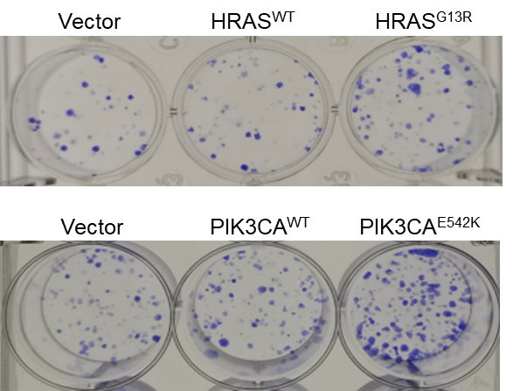
Supplementary Fig. S1 The representative pictures of colony formation of 8505C cells exogenously expressing the indicated genes.
Supplementary Fig. S2 The effects of ATO on murine liver and kidney in vivo. (A) The mice in Fig. 7 were sacrificed at the end of the experiment, and the liver and kidney tissues were paraffin embedded and sectioned for Hematoxylin and eosin (H&E) staining. Scale bar, 200 μm. (B) The serum of the mice underwent different treatments was collected before sacrifice and subjected to ALT and AST tests. Data were presented as mean ± SD.

References
- Landa I, Pozdeyev N, Korch C, Marlow LA, Smallridge RC, Copland JA, et al. Comprehensive genetic characterization of human thyroid cancer cell lines: a validated panel for preclinical studies. Clin Cancer Res. 2019;25:3141-51.

