Method
Factor Analysis
Exploratory factor analysis (EFA)
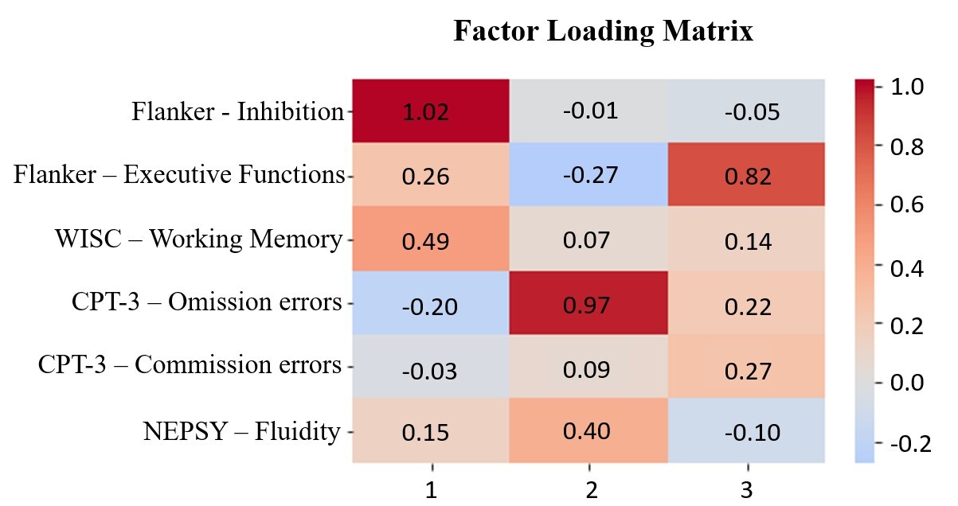
Fig.1 Factor Loadings for the solution with 3 factors. The fraction of variance explained by Factor 1 was 0.228, by Factor 2 was 0.190 and by Factor 3 was 0.134. The total fraction of variance explained was 0.552.

Data Analysis
Effect of Gender on the Three Factors and Cortical Thickness
While the simple linear regressions showed a significant effect of gender on factor 1 (β = 0.19, p = 0.041) and factor 2 (β = 0.28, p = 0.011), no significant effect was found for factor 3 (β = 0.04, p = 0.786) and for thickness (β = 0.05, p = 0.43).
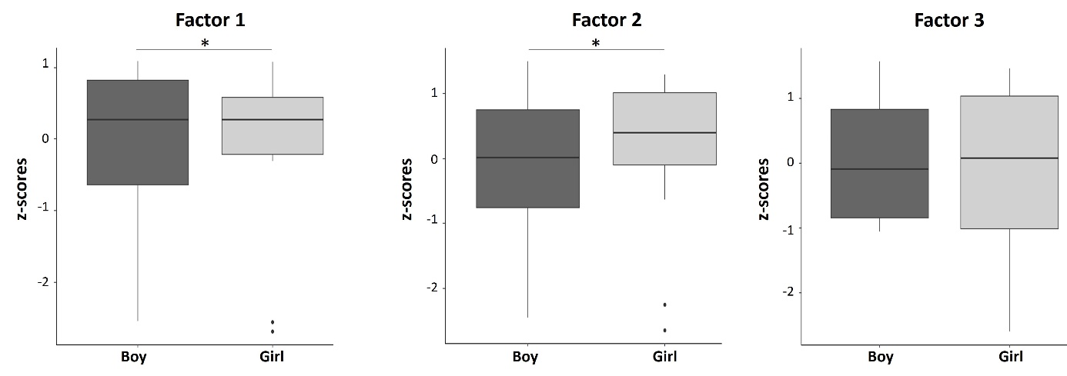
Fig.2 Differences between boys and girls for the three factors. Note *p<.05
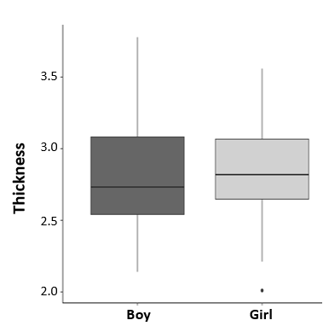
Fig.3 Difference in cortical thickness between boys and girls

Effect of Age on the Three Factors and Cortical Thickness
The simple linear regressions showed no effect of Age on the different factors (i.e., factor 1(β = -0.11, p = 0.25), factor 2 (β = -0.04, p = 0.707), factor 3 (β = 0.23, p = 0.154)) and on thickness (β = 0.03, p = 0.47).

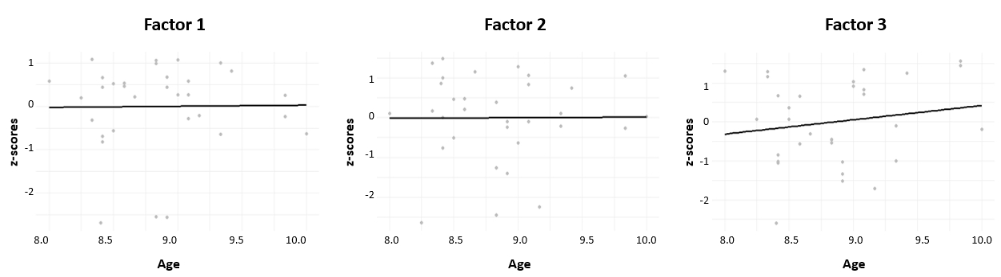
Fig.4 Relations between age and the three factors
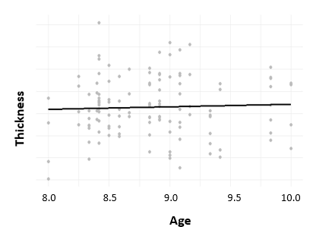
Fig.5. Relation between age and cortical thickness

Results
Associations Between Executive and Attentional Functions and Brain Structures
Theses correlations were adjusted for sex and age and corrected for multiple comparisons.
Cortical Thickness
 | Factor 1 | Factor 2 | Factor 3
Right DLPFC | -0.362, p = .137 | -0.251, p = 0.241 | -0.481, p =.04*
Left DLPFC | -0.272, p = 0.225 | -0.158, p = 0.486 | -0.313, p = 0.184
Right ACC | -0.352, p = 0.137 | -0.101, p = 0.650 | -0.269, p = 0.225
Left ACC | -0.526. p = .036* | -0.465, p = .04* | -0.003, p = 0.987
Table 1. Correlation coefficients and adjusted p-values for cortical thickness

Fractional Anisotropy
 | Factor 1 | Factor 2 | Factor 3
Right DLPFC | 0.035, p = 0.879 | -0.066, p = 0.879 | 0.063, p = 0.879
Left DLPFC | 0.110, p = 0.879 | 0.100, p = 0.879 | 0.070, p = 0.879
Right ACC | 0.058, p = p = 0.879 | -0.197, p = 0.879 | -0.195, p = 0.879
Left ACC | 0.029, p = 0.879 | -0.447, 0.156 | -0.038, p = 0.879
Table 2. Correlation coefficients and adjusted p-values for fractional anisotropy

Between Centrality
 | Factor 1 | Factor 2 | Factor 3
Right DLPFC | -0.227, p = 0.545 | 0.162, p = 0.672 | -0.065, p = 0.880
Left DLPFC | -0.269, p = 0.545 | -0.364, p = 0.545 | -0.076, p=0.880
Right ACC | -0.191, p = 0.622 | 0.003, p = 0.987 | -0.299, p =0.545
Left ACC | 0.023, p = 0.986 | -0.246, p = 0.545 | -0.068, p = 0.880
Table 3. Correlation coefficients and adjusted p-values for between centrality

Volume
 | Factor 1 | Factor 2 | Factor 3
Right DLPFC | -0.198, p = 0.711 | -0.041, p = 0.893 | -0.298, p = 0.711
Left DLPFC | -0.026, p = 0.893 | -0.044, p = 0.893 | -0.179, p = 0.711
Right ACC | -0.168, p = 0.711 | -0.138, p=0.711 | -0.052, p = 0.893
Left ACC | -0.251, p = 0.711 | -0.136, p = 0.711 | -0.153, p = 0.711
Table 4. Correlation coefficients and adjusted p-values for volume

Cortical Surface Area
 | Factor 1 | Factor 2 | Factor 3
Right DLPFC | -0.067, p = 0.888 | 0.076, p = 0. 888 | -0.098, p = 0. 888
Left DLPFC | 0.103, p = 0.888 | -0.072, p = 0. 888 | -0.027, p = 0.888
Right ACC | -0.079, p = 0. 888 | -0.127, p = 0. 888 | -0.061, p = 0. 888
Left ACC | -0.092, p = 0. 888 | -0.036, p = 0. 888 | -0.149, p = 0. 888
Table 5. Correlation coefficients and adjusted p-values for cortical surface area

