Anomalies in effective connectivity explain different hallucination subtypes in Parkinson’s disease psychosis
. . .
Supplementary Information

SI1. Study design details, hallucinations questionnaires and patients' clinical information and screening procedures ………………………………………………………………………………………………………………1
SI2. EEG task and preprocessing details …………………………………………………………………………... 2
SI3. Analysis in sensor space ………………………………………………………………………………………... 6
SI4. Additional details on source reconstruction ………………………………………………………………..... 7
SI5. Individual DCMs specification details ………………………………………………………………............ 11
SI6. PEB analysis specification and recursive PEB details ……………………………………………………. 14
SI7. Individual regression analyses ………………………………………………………………....................... 17
SI8. Details on multiple regression LOOCV models ………………………………………….......................... 18
SI9. Additional details on neural sources analyses …………………………………………........................... 20
SI10. Simulations details ………………………………………………………………....................................... 22
SI11. Dorsal model analyses and details ………………………………………………………………................ 24
SI12. EEG source reconstructed signal and PET binding atlases analysis ……………………………………27
Supplementary References …………………………………………………………………………………………. 31

SI1. Study design details, hallucinations questionnaires and patients' clinical information and screening procedures.
The study was pre-registered (Open Science Framework registration: https://osf.io/q9x7v). At the time of the pre-registration, we envisioned only ERP analyses of vMMN and DCM was not included in the original analysis plan. All the procedures here described are detailed in Vignando et al., 2024.
Recruitment. Participants were recruited through the Parkinson’s centre of excellence at King’s College Hospital, Imperial College Charing Cross Hospital and Cambridge University Hospitals NHS Trust. We also recruited from a previous PD-VH study carried out at KCL (Renouf et al., 2018). We enrolled 19 PD-noVH and 21 PD-VH. Two participants were excluded due to noise affecting the quality of the data. The final sample comprises 18 PD-noVH and 20 PD-VH.
Screening. We pre-screened participants by phone to check for main inclusion and exclusion criteria; eligible participants underwent a study day at the clinical research facility (CRF) of King’s College Hospital. After taking consent, first we collected participants’ medical history, information medication, cognitive testing and psychiatric questionnaires. The study physician conducted the physical and non-motor symptoms examinations. Finally, participants completed the EEG procedure. 13 participants had a phone screening during the pandemic rather than the standard in-person screening; in these cases we administered the blind MoCA and converted the score to the full MoCA (Melikyan et al., 2021) in order to confirm eligibility (MoCA >22). One of the participants did not undergo the SCOPA-motor scale, which was the motor symptom scale chosen for this study; however for this patient we had a recent full UPDRS (< 2 weeks), and we converted the score as recommended (Verbaan et al., 2011).
 |  | Group |  | N |  | Mean |  | SD |  | SE
Age |  | PD |  | 18 |  | 65.96 |  | 10.24 |  | 2.41
 |  | PDP |  | 20 |  | 68.75 |  | 8.52 |  | 1.91
PD duration |  | PD |  | 18 |  | 4.49 |  | 2.89 |  | 0.68
 |  | PDP |  | 19 |  | 6.24 |  | 3.82 |  | 0.88
CISI-motor |  | PD |  | 17 |  | 2.59 |  | 0.87 |  | 0.21
 |  | PDP |  | 20 |  | 2.40 |  | 0.82 |  | 0.18
SCOPA-motor |  | PD |  | 17 |  | 19.35 |  | 7.74 |  | 1.88
 |  | PDP |  | 20 |  | 20.02 |  | 8.84 |  | 1.98
MoCA |  | PD |  | 18 |  | 27.39 |  | 2.12 |  | 0.50
 |  | PDP |  | 20 |  | 27.15 |  | 2.76 |  | 0.62
LEDD |  | PD |  | 18 |  | 302.28 |  | 226.36 |  | 53.35
 |  | PDP |  | 20 |  | 475.63 |  | 320.27 |  | 71.62

Supplementary Table 1. We report participants’ demographics and relevant clinical information; disease duration is reported in years, we also report CISI-PD (Clinical Impression of Severity Index for PD) for motor severity, SCOPA-motor* total score, Montreal Cognitive assessment (MoCA) scores (participants were not eligibile for the study if they presented a score lower to 22) LEDD (levodopa equivalent dose*), CISI-PD was completed by a Parkinson’s neurologist.
*One PD-noVH participant did not undergo the SCOPA-motor and was excluded from this comparison.
**LEDD: this information was not available for one PD-noVH participant, but we verified they were on both Sinemet and Madopar and thus not drug naive– based on this we used the group average of PD-noVH for this analysis.

 |  | F |  | df |  | p
Age |  | 0.822 |  | 1,33 |  | 0.371
PD duration |  | 2.476 |  | 1,33 |  | 0.125
CISI-motor |  | 0.453 |  | 1,33 |  | 0.506
SCOPA-motor |  | 0.059 |  | 1,35 |  | 0.809
MoCA |  | 0.091 |  | 1,35 |  | 0.765
LEDD |  | 3.768 |  | 1,34 |  | 0.061

Supplementary Table 2. One-way ANOVA results (Welch’s) comparing PD and PDP patients on the relevant clinical variables. The df column reflects the presence/absence of the participants who did not have SCOPA-motor or LEDD scores as mentioned in the description of Supplementary Table 1.
We ran a Pearson’s product moment correlational analysis between the clinical variables, finding that age correlated with motor severity (SCOPA) scores in the whole sample (r = .33, p=.044), and that LEDD correlated with disease duration (r=.38, p=.02) consistently with the literature. LEDD correlates also with SCOPA-motor score (r=.50, p=.002) and total non-motor symptom score (r=.43, p=.01).
We repeated the analysis in the PDP sample only to ascertain whether any of the psychiatric measures correlated with any clinical measures, finding that this was not the case (see Supplementary Figure 1 below). In the PDP sample, LEDD correlated with motor severity (r=.58, p=.01) as in the main sample, and motor severity with disease duration (r=.59, p=.01).
Supplementary Figure 1. Correlation plot presenting the results described in SI; NEVHI and SAPS-PD scores were correlated with each other but not with any other clinical variable. The pink * indicates correlations that were significant with p <.05. All significant correlations were p<.01.

To assess whether participants had visual hallucinations we used the Neuropsychiatric Inventory (Cummings et al., 1994) at the screening visit. However, to assess the presence and the extent of hallucinations we used the SAPS-PD and the NEVHI. The Scale for the Assessment of Positive Symptoms-PD (SAPS-PD) was first adapted for PD from schizophrenia (Voss et al., 2013) and is composed of 9 questions on the symptoms that are the most frequently reported in PDP, including: auditory hallucinations, voices conversing, visual hallucinations, somatic/tactile hallucinations, global rating of hallucinations. The SAPS-PD also investigates the presence of delusions. Only one patient presented delusions in our sample, and they retained insight about it. The maximum score for each item is five, for a maximum total score of 25. Participants with >10 had also auditory or somatic hallucinations. Thus, we also computed a multimodal hallucinations score by summing together all the items that were not related to visual hallucinations and delusions, in order to explore also this aspect.
We also used an adaptation of the NEVHI to assess the phenomenology of visual hallucinations (D’Antonio et al., 2022). The NEVHI is composed of 6 main items assessing different types of VH: complex hallucinations, pareidolia (a specific type of visual illusion), presence, passage, simple hallucinations and any other visual experience of note that the researcher can classify under the relevant section. For each item, there are questions regarding the frequency and duration of the experience, questions on distress, insight and delusions specific to each type of VH. Participants’ scores at the different VH types are also reported in Vignando et al., 2024 in detail.
Since this adapted version of the NEVHI has no scoring rules, we decided to compute temporal severity by multiplying duration and the frequency of the VH. In order to make the results as comparable as possible with those from other studies using the same scale, we used an ordinal scale following what D’Antonio et al., 2022 have done. We multiply the number of minutes spent hallucinating by the number of visual experiences in a month, thus obtaining temporal severity as a continuous measure. The full procedure used to create this score is reported in detail in Vignando et al., 2024, together with the % of patients experiencing the different VH subtypes.
We found a difference in the MNSQ as expected, with mood, attention and perception (including hallucinations) being more affected in PD-VH (discussed in Vignando et al. 2024).

SI2. EEG task and pre-processing details.

The task consisted of 1000 trials, with 640 standard trials, 240 frequent deviant trials and 120 rare deviant trials. Based on results of exploratory analyses conducted during our previous ERP study we decided to focus on the standard and rare deviant difference, as the frequent deviant was perceived as not significantly different from the standard. The ERP analysis for the mismatch negativity in this sample, together with the pilot study for the task, has been reported in a previous publication where we show that PD-VH have a reduced or absent vMMN if compared to PD without hallucinations (Vignando et al., 2024).
An automated script was created for batch preprocessing participants using spm12 and following the procedure recommended in spm12 user manual for EEG data preprocessing for dynamic causal modelling and in particular mismatch negativity data (see also Garrido et al., 2009). In brief, upon converting the .cnt data with spm’s spm.meeg.convert function, we created a custom montage file to exclude eye channels and a trial definition file was created for the interval –100 to 500 (the duration of the task) and for the two conditions of interest (standard, rare deviant), with shift triggers = 0. We used a high-pass filter with cutoff = 0.3, then we down sampled to 500 Hz and lowpass filter with cutoff = 30. We chose a high-pass filter with cutoff =0.1 rather than 0.1 as the data contained some noise and upon inspecting the data after testing the 0.1 filter we decided to use 0.3 in order to have a cleaner dataset. The trial definition file was used for epoching and baseline correction was applied pre-stimulus. After epoching, bad trials and channels were visually inspected and marked using the Fieldtriep toolbox (Oostenveld et al., 2011) and then artefacts were removed with threshold set at 80 as recommended (Garrido et al., 2009). ERPs were then averaged for standard and rare deviant conditions.
Data was pre-processed with spm12, whereas the ERP analyses reported in the Vignando et al., 2024 publication has been preprocessed with a conceptually similar pipeline but with a different toolbox (EEGlab, Delorme et al., 2004; Lopez-Calderon, J., & Luck, S. J. (2014)).

SI3. Analysis in sensor space.

Based on a previous ERP study conducted on this set of data, we had strong hypotheses regarding the regions involved (Vignando et al. 2024), as we found differences in vMMN amplitude between PDP and PD patients at parieto-occipital and frontal electrodes (POZ, PZ, P2 and F2, F4, F6 corrected for multiple comparisons) at 100-180ms. Nevertheless, We decided to perform an analysis in the sensor space to further support the decision of which regions to select for the DCM and to replicate our results with a different technique.
First the preprocessed files were converted to images using the scalp x time mode, in order to obtain .nii files to input in this second-level analysis. Sensor space analysis is used to create a 2D space that represents the data from the scalp; this is done by flattening the locations of the electrodes that are then interpolated to create an image where locations where the ERP amplitude between two conditions differed significantly. The use of random filed theory to correct for multiple comparisons across participants and electrodes, the results indicating the source identified for the ERP component at any timepoint is reliable, as this type of correction considers also the spatial correlation across pixels.
We computed a one-sample t-test and defined the F contrast as 0 1 since the purpose of the analysis is to investigate the locations involved in the generation of the signal and not investigate the standard-deviant contrast or a group contrast, as the standard and deviant difference or PD-PDP difference (something that was explored in the previous ERP study). We found that parieto-occipital locations, in particular, POZ, were involved in the generation of the signal, which accords well with what found in the ERP analysis. Results are reported in Supplementary Figure 2.

SI4. Additional details on the source reconstruction analysis and coordinate tables. We used the SPM template, as we did not have T1-weighted MRI scans for all participants to co-register the EEG to. The normal cortical mesh option was selected, and we specified the forward model using a boundary element method (BEM), then the inversion was completed. We obtained individual MIPs (maiximum intensity projection) of the activity in the source space and a time series of the activity for each condition. We used this data to generate .nii images for the 60-400ms interval of interest to be investigated with the DCM analyses.
The images were used for second level analyses: we specified a one-samples t-test model to investigate the neural correlates of standard and rare deviant images, to further investigate the regions associated to the vMMN task and inform our decision as to the coordinates of the DCM dipoles (coordinates are reported in the Supplementary Table 2 below). For this analysis, we used all participants’ scans to identify all possible sources, but we also repeated the source reconstruction for PD only as a sanity check, finding consistent results (results significant for rare (ITG region), no suprathreshold for standard which is expected given the smaller sample size of N=18). We also conducted paired t-tests in PD and PDP separately (rare-standard) to investigate if and where there are specific locations related to standard and deviant differences in each group that needed taking into account (Supplementary Figure 2). We explored possible differences between the frequent deviant and the standard with the same method finding no difference (no suprathreshold clusters p >.05), supporting what we found in our ERP study where no difference between the two was observed in any of the groups.

Region | p(FWE-corr) | p(unc) | F | Z | x | y | z
Left ITG | 0.003 | <.001 | 30.28 | 4.89 | -48 | -18 | -32
Right ITG | 0.005 | <.001 | 28.17 | 4.73 | 54 | -18 | -34
Calcarine | 0.047 | <.001 | 21.44 | 4.17 | 2 | -86 | 14
Left PFC | 0.085 | <.001 | 19.69 | 4 | -40 | 44 | -8
Supplementary Table 2. Peak coordinates for significant clusters found in the source reconstruction analysis. The coordinates here identified helped us determine the dipole coordinates for the DCMs. We also identified a small cluster in the right precuneus (not shown) but once corrected the p value was >.1. Nevertheless, this was taken into account when building the dorsal model.

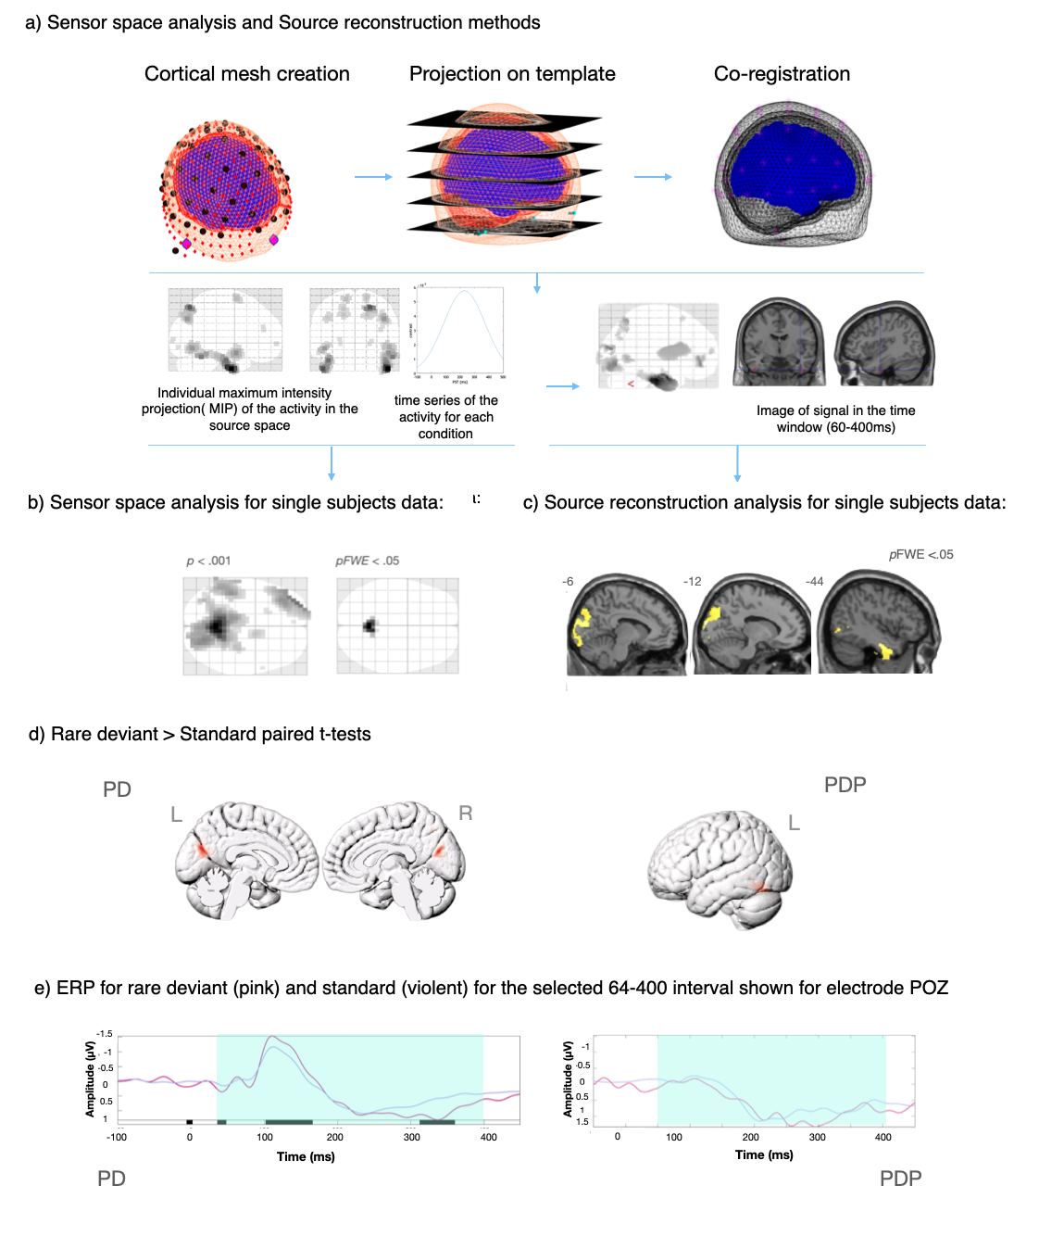
Supplementary Figure 2. Sensor space analysis and source reconstruction analysis summary and results. a) Source reconstruction procedure. The top row shows the registration to the template and the model inversion using BEM; the * on the mesh represent the electrodes co-registered on the template. The second row shows the MIP of the activity in the source space and the image generated for the signal in the time window of interest (actual data from a participant shown). b) Sensor space analysis results for the task are shown at p<.001 uncorrected and pFWE corrected <.05. c) Main results of the source reconstruction (entire sample) for the rare deviant trials are shown (pFWE corrected <.05). The p<.001 MIP and the MIP with the channel locations and FWE <.05.

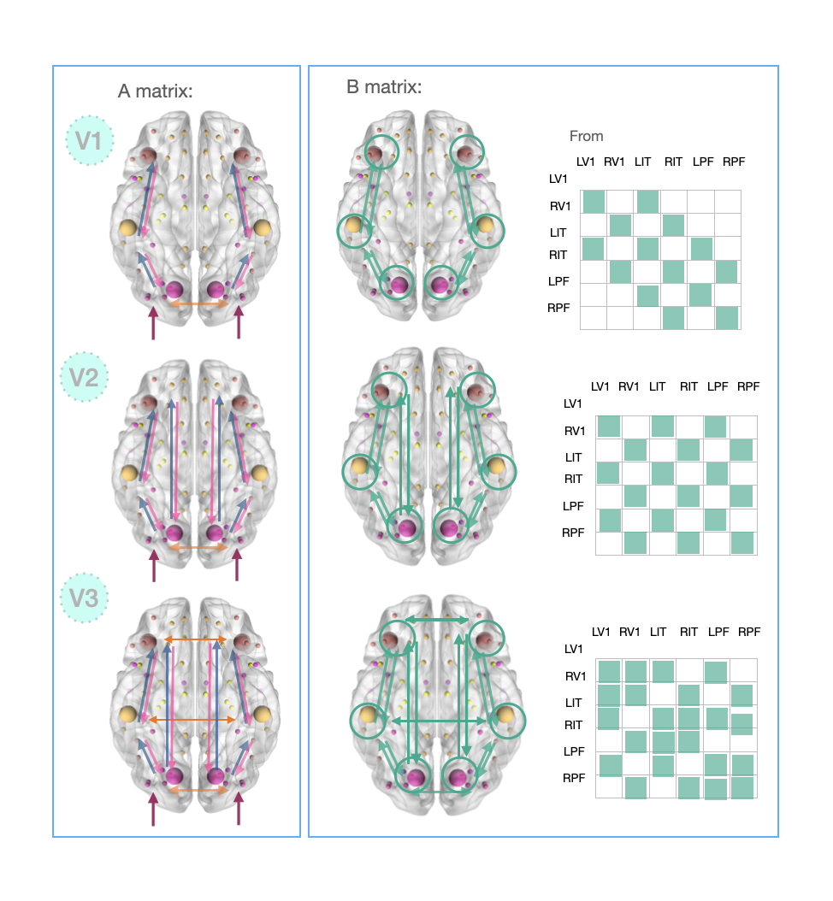
Supplementary Figure 3. Ventral models specification. Model v1: Forward connections from V1 to ITG, V1 to PFC, ITG to PFC; backward connections from ITG to V1, PFC to ATL were specified. Lateral (intra-hemispheric) connections between regions were also specified between L and R V1 only. The differential connectivity effects matrix (B) was specified with connections from V1 to ITG, V1 to PFC, ITG to PFC, PFC to ITG, ITG to V1, and for each region as well. Model v2: Forward connections from V1 to ITG, V1 to PFC, ITG to PFC; backward connections from ITG to V, PFC to ATL, PFC to V were specified. Lateral (intra-hemispheric) connections between regions were also specified between L and R V only. The differential connectivity effects matrix (B) was specified with connections from V1 to ITG, V1 to PFC, ITG to PFC, PFC to ITG, ITG to V1, PFC to V, and for each region as well. model v3: forward connections from V1 to ITG, V1 to PFC, ITG to PFC; backward connections from ITG to V1, PFC to ITG, PFC-V1 were specified. Lateral (intra-hemispheric) connections between regions were also specified between left and right V1, ITG and PFC. Green circles represent connectivity on the same region, testing for self-inhibition or self-excitation during task condition.

Supplementary Information 5. Individual DCMs specification details. We used an ERP neuronal mass model, focussing on the 0 to 400ms interval, rare deviant vs. standard. An equivalent current dipole (ECD) was used for each source, with anterior occipital, inferior temporal and dorsolateral prefrontal regions, bilaterally (Figure 2c). All model specification details are provided in SI5, Supplementary Figure 3 and SI9. For onset parameter we kept the standard 64ms onset as the propagation of the stimulus impulse through the input nodes causes a delay and large responses are usually not observed before 100ms. Modes was set at 8. Receiving areas (input) were V (L and R) specified. Details about all the models are presented in Supplementary Figure 3. Model v3 (fully connected ventral model) was used in the second-level analyses after Bayesian model selection and comprises: forward connections from V1 to ITG, V1 to PFC, ITG to PFC; backward connections from ITG to V1, PFC to ITG, PFC-V1 were specified. Lateral (intra-hemispheric) connections between regions were also specified between left and right V1, ITG and PFC. The differential connectivity effects matrix (B) was specified with connections from V1 to ITG, V1 to PFC, ITG to PFC, PFC to ITG, ITG to V1, and for each region as well. The dorsal model has the same visual and prefrontal dipoles, but with IPL replacing the ITG and no direct V1 to PFC connections. This choice was determined by results in the source reconstruction analysis (Figure 2 and Supplementary Figure 2) and by the neural correlates typically associated to this task.

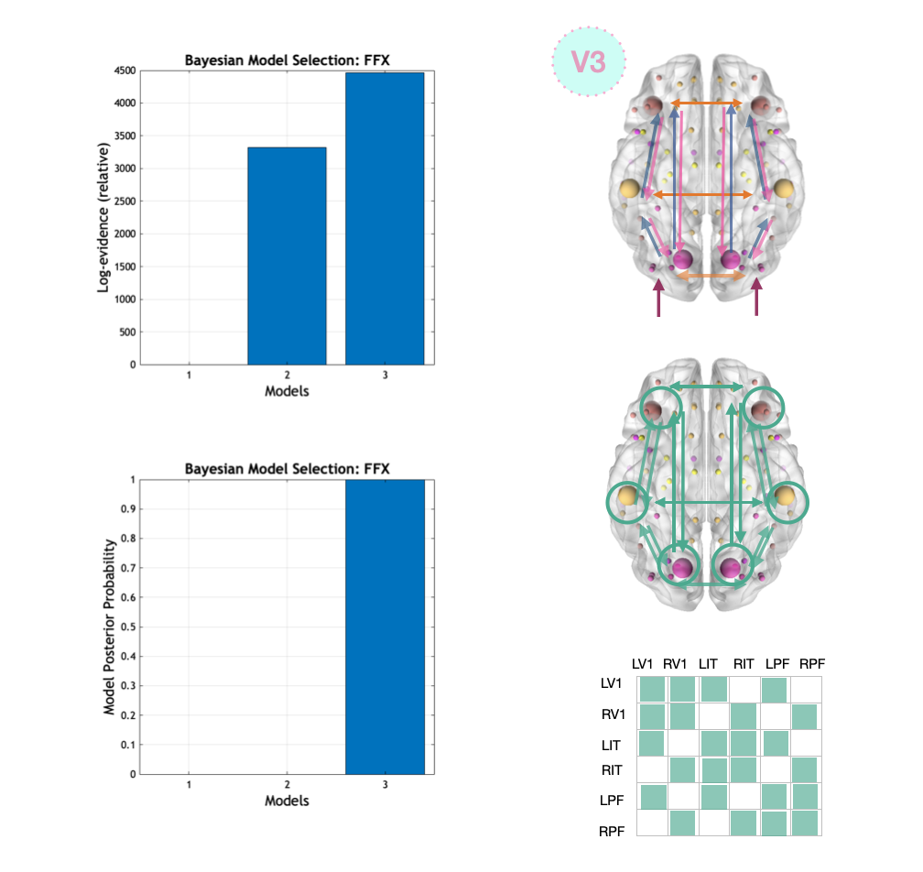

Supplementary Figure 4. BMS for ventral models. We used Bayesian model selection to decide which of the three ventral models we specified was the winning one to the scope of focussing second-level analyses on a specific DCM. Within each pathway model, the models were compared using Bayesian model selection. BMS allows to compare different models of the same data, provided that the electromagnetic model is the same. We used a Fixed Effects (FFX) design as inference method. Model 3 was the winning model, thus we proceeded with second-level analyses with model 3, featuring also cross-hemispheric connections.

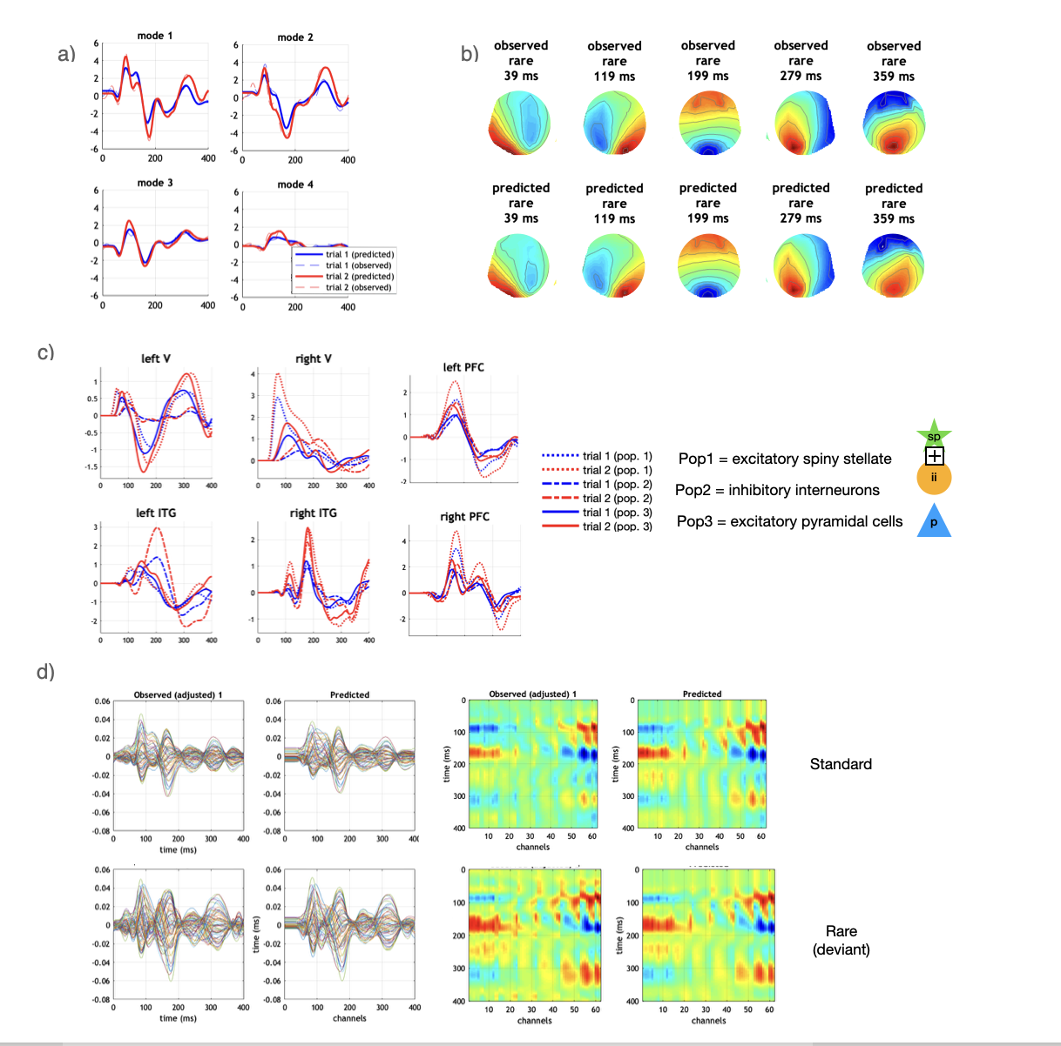
Supplementary Figure 5. Individual DCM model fits. a) modes: example of our visual MMN model fits of the first four modes, which are the ones that captured most of the variance (out a total of eight); modes represent the predicted covariance (prior) in the sensor space. Blue = standard; red = deviant; dotted line = original data; full line = model fits. b)Scalp maps: example model fits from a participant (c_005) in sensor space. The top row represents scalp maps the EEG data in the rare (deviant) condition; the bottom row represents the EEG data at the same latencies, generated by the model parameters. c)Sources: Dotted line (population 1) = excitatory spiny stellates; dashed lined (population 2) = inhibitory interneurons; soldi line (population 3) = excitatory pyramidal cells. Blue = standard; red = deviant. d) Response: left: representation of the data selected by the spatial modes back-projected into sensor space. Each line represents the activity of a single channel. First column = observed data; second column = model predictions. Right: The same data plotted as time as a function of channels; top= standard; bottom = rare (deviant).

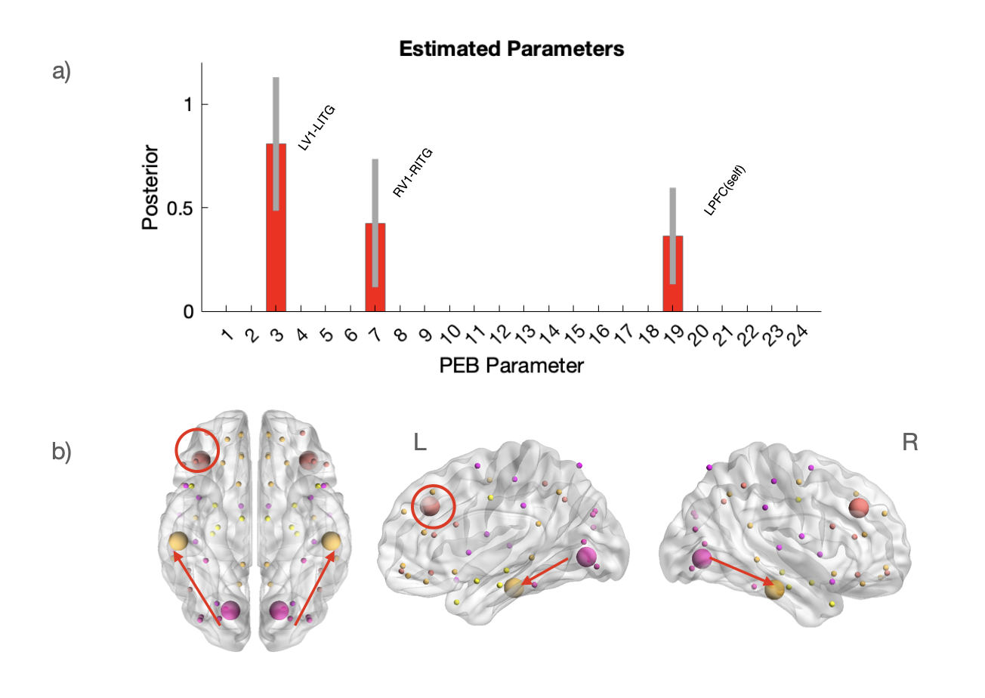Supplementary Figure 6. Ventral model – task connectivity in PD-noVH only. We decided to explore the effect of the task itself without including patients with hallucinations since our ERP study has shown that PD patients with VH did not have a MMN or had a very reduced one. When focussing on the difference between the standard and the deviant in PD, we found that the task was associated increased connectivity (self) in left PFC and increased V1 to ITG bilateral activity.

Supplementary Information 6. PEB analysis specification and recursive PEB additional details.
PEB was carried out (Friston et al., 2016; Zeidman et al, 2019) at this stage. We took the modulatory parameters of the individual DCMs to the group level and used them to fit a PEB model (a type of Bayesian linear regression.) We fitted a general linear model (GLM) to the connection strengths estimated with the first level analyses and with covariates: mean, group (PD-VH (-1) or PD (1)) and age. The GLM has one regression parameter per covariate per connection. Model inversion was carried out with spm_dcm_fit; and spm_dcm_bmr and spm_dcm_peb were used to perform Bayesian model reduction and to generate model posteriors, respectively. Finally, we used Bayesian model averaging spm_dcm_bma to investigate group-level differences between patients with and without psychosis. We analysed the different B “task modulatory” matrix separately and A “baseline” matrix (forward, backward, inter-hemispheric connectivity). To understand which of the parameters contributed best to explaining variance between DCMs, we also created a model space to carry out PEB analyses recursively with specific parameters specified. By switching on and off some specific parameters and then comparing the models we can explore the effect of given connectivity features in a more direct manner. The model specified were both extrinsic (fully connected, forward, backward, forward and self-connections, backward and self), intrinsic (coupling parameter G, timing parameter T, modulatory parameter M, gain S) and a combination of extrinsic and intrinsic (full, forward, backward together with G or T). Bayesian model comparison at second level was then explored and the paratamised winning 2nd level model was further examined with Bayesian model reduction (RMA). This allowed us to identify parameter changes associated with the main effect of vMMN in the two groups. We also explored task connectivity in PD-noVH (without psychosis only) to isolate the effect of task, as we previously showed that this group had an MMN (Supplementary Figure 6).
Supplementary Figure 7. Recursive PEB results. a) Connectivity task matrix for the recursive PEB result for the effect of VH. b) visual representation of the recursive PEB winning model (brains created using BrainNet viewer); c) top row: free energy ranking and posterior probability for the different models specified (task connectivity matrix); bottom row: same information but specifically when taking into account connection strength (Ep) for VH. d) parameters coefficients for the connections with pp>.99 to differ in VH vs noVH patients for task connectivity; e) sina and box and whisker plots showing the distribution of Ep in PD with and without VH for each connection found differing in the model (the plots are colour coded with the colour of the node from which the connection starts; noVH patients = black dots; VH patients = white dots; the boxplots indicate the mean and the quantiles).

Supplementary Information 7. Individual regression analyses: hallucination subtype severity and effective connectivity additional details and statistics.
Matrix B (task). For the task matrix (Figure4B; SI7), decreased top-down connectivity (rPFC r ITG) negatively correlates with the NEVHI score for complex visual hallucinations (CVH) [F(1,18) = 4.63, t = -2.15, R² = .2, CI (-4, -.04), p =.04, pFDR =.06 ; Pearson’s r= -.45]; a similar pattern is observed for lV1lITG [F(1,17) = 5.07, t = -2.52, R² = .23, CI (-3.47, -.11), p =.037, pFDR =.06; Pearson’s r= -.48] the more severe the CVH, the more reduced the connectivity. The severity of CVH is positively predicted by bottom-up connectivity (rV1 rPFC) [F(1,17)=10.27, t = 3.2, R² =.38 , CI(0.53, 2.57), p =.005, pFDR = .015; Pearson’s r= .61] and rV1 rITG [F(1,17)=11.38, t = 3.37, R² =.4 , CI(0.44, 1.91), p =.003, pFDR = .015; Pearson’s r= .44] (all analyses underwent outlier detection with Cook’s distance).MH severity correlates negatively with connectivity (decreased in PD-VH) from left PFC to left V1 [F(1,17)=8.15, t = -2.85, R² = .32, CI(-17.29, -2.57) p=.011, Pearson’s r= -.31, pFDR <.1]. Baseline matrix results are in part reported in Figure 4D and in detail in SI7, together with details on MH subtypes.

Matrix A (baseline). When exploring this relationship for the baseline (A) matrix, we found that connectivity (increased in PD-VH) from to right V left V1 positively correlates with complex VH [F(1,16)= 6.525 , t = 2.55, p =.02, CI (0.089, 0.96), Pearson’s r= .53, pFDR = .1] and a trend from leftV1 to right V1 [F(1,16)= 6.525 , t = 2.05, p =.05, CI (-0.04, 2.85; note the CI crosses the zero thus we do not consider this a robust result), Pearson’s r= .45, pFDR = .2].
No significant results are found for minor VH upon outlier removal.
We also computed an exploratory multimodal hallucination score using the data provided by the SAPS-PD questionnaire. Multimodality correlates with increased connectivity from left V1 to PFC [F(1,17)=15.37, t = 3.920, p =.001, pFDR = .01, CI (1.23, 4.11), Pearson’s r= .69]. When visually inspecting hallucinations modality, we see that all patients have VH, and most of the patients who hallucinate in other sensory domains have auditory ones (only one patient, who had tactile hallucinations, also had olfactory) (Figure 6b, c and d).
For all models one (and the same) outlier was removed using Cook’s distance (correlations were significant before outlier removal and remained significant after).
To explore minor VH subtypes (passage, presence and pareidolia), we ran the same type of models. For what concerns the MMN task (matrix B), we only found presence VH being predicted by LPFC to LV1 (decreased in PD-VH) [F(1,18)=5.04, R² = .22, p=.037, pFDR > .05] so the lower the connectivity the higher the severity scores, however upon outlier removal the model is no longer significant. For pareidolia we find a positive relationship with increased connectivity from RV1 to RITG [F(1,18)=5.57, R² = .24, p=.03, pFDR > .05], however after removing one outlier this is no longer the case. For the baseline matrix we find a positive relationship with increased cross-hemispheric connectivity from left ot right V1 [F(1,18)=20.16, R² = .53, p=.0002, pFDR<.05] and pareidolia, but as in the previous case, upon outlier removal this is no longer true.

Supplementary Information 8. Details on ML Multiple regression models with LOOCV

Complex VH. For task connectivity (B), we found that complex VH were best predicted by connections rV1-rPFC (increased), rPFC-rITG (decreased), which were related to complex VH severity (Figure 6), plus increased rV1 to rITG connectivity (not found in the individual correlations) [multiple R² = 0.58, adjusted R² 0.49, F(3,15) = 6.86, p-value: 0.0039 RMSE =1.89, MAE = 1.77, R² =.36 ; note: one outlier was removed with Cook’s distance in a multiple regression model before running the LOOCV based on the analysis presented in the previous section]. The BIC was 84.29, with a better fit than the model including all connections had BIC = 94.82. MH were best predicted by both lV1-rV1and left PFC-V1together [multiple R² = 0.40, adjusted R² = .32, F(2,16) = 5.28, p= 0.01, RMSE = 5.64, MAE = 4.3, R² =.11, BIC = 120.56].
For the baseline connectivity (A), we found that complex VH were best predicted by 4 (LPFC – LITG, RPFC- RV1, LV1-RV1, RV1-LV1) of the 10 connections that were related to complex VH severity [R² = 0.57, adjusted R² = .45, F(4,15) = 4.914, p= 0.009, RMSE = 2.79, MAE = 1.87, BIC = 92.75]. The best contributors of the model are the increased connectivity between V1 (in both directions) and rPFC to rV1, and the decrease in connectivity from left PFC to IT).
Minor VH, were predicted by left PFC-V1 and increased connectivity from left V1 to rV1 proved also fitting [R² = 0.42, adjusted R² = .35, p =.008, RMSE = 7.39, MAE = 4.83]). We repeated the models including MoCA to see if global cognitive status affected the models; results did not vary (Supplementary Information6). We repeated the procedure including LEDD as a covariate, and the results were unchanged (SI6).
Multimodal hallucinations had as most significant predictor the left V1-PFC connectivity [R² = 0.37, F(1,18) = 10.64, p= 0.004, RMSE = 2.55, MAE = 2.15], the connection that we found uniquely associated to this measure. However, when 7 out of the 10 connections (LV.LPFC+ RV.RIT+ RV.RPFC+ LITG.LV1+LPFC.LV+ LPFC.LIT+ LV1.RV1) found differing between PD-VH and PD-noVH patients were entered as predictors of multimodality of hallucinations, the overall model was significant [R² = 0.68, adjustedr2=.5, F(7,12) = 2.54, p = 0.023, RMSE = 3.6, MAE = 2.9], BIC=104.76]. When investigating whether this result could be related to a global cognitive impairment, we found that global cognition as measured by MoCA did not correlate with temporal severity of complex VH, SAPS-PD, minor VH or multimodality of hallucinations (Supplementary Figure 1). When running the model with MoCA as covariate the results changed [R² = 0.69, F(9,10) = 2.54, p = 0.05, RMSE = 3.5, MAE = 2.84]. When further investigating this strong reduction in significance, by splitting in bottom-up and top-down connections to better understand the contribution of global cognition, a model with top-down connections only was not significant [R² = .14, adjusted R² = -.08, F(4,15), = 0.63, p=.64, RMSE = 3.69, MAE = 3.02], whereas a model with bottom-up (left V1-PFC, right V1 to PFC and RIT) was significant [R² = .47, adjusted R² = 0.33, F(4,15) = 3.302, p =.039, RMSE = 3.25, MAE = 2.58] .

LOOCV models with multiple connections and MoCA as a covariate.
Task connectivity (B), Complex VH. Ee found that complex VH were best predicted by connections (rV1-rPFC (increased), rPFC-rITG (decreased), increased rV1 to rITG connectivity (not found in the individual correlations) with MoCA as a covariate [R² = 0.6, adjusted R² = 0.48, F= (4,14) = 5.22, p-value: 0.009, RMSE =1.91, MAE = 1.65; MoCA coefficient =.42], confirming the results reported in the main text. Minor VH were best predicted by both lV1-rV1and left PFC-V1together with MoCA as a covariate [R² = 0.49, adjusted R² = .4, F(3,15) = 4.96, p= 0.014, RMSE = 6.47, MAE = 4.88; MoCA coefficient was =.1] confirming the results reported in the main text.
Baseline matrix (A). Complex VH were best predicted by LPFC – LITG, RPFC- RV1, LV1-RV1, RV1-LV1 connectivity also when adding MoCA as a covariate [R² = 0.58, adjusted R²r2 = .44, F(4,15) = 4.02, p= 0.017, RMSE = 2.75, MAE = 1.9] confirming the results reported in the main text.
Minor VH, were best predicted by PFC-V1 and increased connectivity from left V1 to rV1 proved also fitting [F(3,15) =5.26, R² = 0.51, adjusted R² = .41, p =.01, RMSE = 5.19, MAE = 4.12]) confirming the results reported in the main text.

LOOCV models with multiple connections and LEDD as a covariate.
Task connectivity (B), Complex VH. Ee found that complex VH were best predicted by connections (rV1-rPFC (increased), rPFC-rITG (decreased), increased rV1 to rITG connectivity (not found in the individual correlations) also when adding LEDD as a covariate [R² = 0.58, adjusted R² = 0.46, F= (4,14) = .58, p-value: 0.012; LEDD coefficient =.93]. Minor VH were predicted by both lV1-rV1and left PFC-V1 as reported in the main text, which holds when adding LEDD as a covariate [R² = 0.42, adjusted R² = 0.3, F= (3,15) = 3.6, p-value: 0.039, RMSE =5.98, MAE = 4.66; LEDD coefficient was .47].

Baseline matrix (A). Complex VH were best predicted by LPFC – LITG, RPFC- RV1, LV1-RV1, RV1-LV1 connectivity also when adding LEDD as a covariate [R² = 0.57, adjusted R²r2 = .42, F(5,14) = 3.8, p= 0.022, RMSE = 2.9, MAE = 2.01]. Minor VH, were best predicted by PFC-V1 and increased connectivity from left V1 to rV1 also when including LEDD [F(3,16) =3.9, R² = 0.42, adjusted R² = .3, p =.03, RMSE = 7.65, MAE = 5.13]), confirming what reported in the main text.
Also multimodal hallucinations results were confirmed with predictors (LV.LPFC+ RV.RIT+ RV.RPFC+ LITG.LV1+LPFC.LV+ LPFC.LIT+ LV1.RV1) and LEDD [F(3,16) =3.4, R² = 0.71, adjusted R2 = .5, p =.032, RMSE = 3.68, MAE = 2.83])

Supplementary Information 9. Additional details on neural sources analyses.

Difference in activity for rare (deviant) – standard trials in the different neural populations contributing to the DCM model, based on complex VH severity. We computed the multiple regression models with total estimated activity for all 6 regions as predictors to check if results were consistent and we find the model with all regions not being significant [F(6,13) = 1.26, R² = .37, adjusted r² = .08, intercept = 0.0005, p = .3 ] but we observed a trend towards significance for the left ITG (t =2.006. p=.066). Thus, we proceeded to explore the neural population activity in this region, with the same model for estimated inhibitory interneurons, spiny and pyramidal activity using them as separate predictors. The first left ITG model, with the sum of all three populations was significant [F(3,16)=5.41, R² = .24, adjusted = 0.2, p= .03, RMSE = 2.22, MAE = 1.79]; however when using all three populations separately as predictors the model was not significant. In order to explore this result, we removed the parameters with the worst coefficients (pyramidal cells, inhibitory interneurons), finding that spiny excitatory cells estimated activity in left ITG for deviant-standard positively relates to complex VH severity [F(1,18)= 5.863, r2 = .25, adjusted = 0.2, p=.026, RMSE = 2.20, MAE = 1.74, BIC = 94.9], meaning that the more positive the activity for deviant-standard, the more the VH, similarly to what we previously found in out ERP study (Vignando et al., 2024) the model using a standard linear regression (as this method cannot be used on LOOCV removing outliers based on Cook’s distance, we find that spiny excitatory cells estimated activity positively relates to complex VH [F(1,179.088, t = 5.43, p=.008, st error =0.46, residual = 1.867 , intercept =2.52, R² = 0.35]. This result is found solely for complex VH. We tested the same model for minor VH and multimodal hallucinations score, finding no significant results. The result is in line with the finding from the recursive PEB analysis that ss for left ITG was reduced in PD-VH at task, if compared to PD.

Following the analysis of neural populations, we also explored whether there was a difference between PD and PDP for the left ITG based on the results of the regression models. When looking at the activity for each component with paired t-tests for standard vs deviant within each group, we find a difference for PD (p =.04) but not for PDP (p=.14) for inhibitory interneurons, suggesting that they might be involved in the vMMN detection, but no difference is observed for spiny activity.

Supplementary Figure8. Neural populations estimates and complex VH. A) Top row: estimated neural activity for PD and PD-VH for inhibitory interneurons (left) and spiny stellate cells (right): cyan = difference (rare – standard), pink = rare, green = standard; bottom row: interneuron and spiny stellate cells activity estimated by the DCM (pink = rare, green = standard) (representation using the activity of a PD-VH and a PD patient). The data points are the values extracted from each individual DCM after model inversion for the 0-400ms for each estimated neural population and each region; the ones plotted and used for the analyses are for the 100-250ms interval, the latencies of interest for the vMMN. x axis = time ms; y axis = estimated neural activity (DCM-derived estimates). B) Scatter plot showing CVH severity score plotted as a function of left ITG ss cells estimated activity: based on results of a multiple regression model with total estimated activity for all 6 regions as predictors (SI9) we proceeded to explore the neural population activity in the left ITG we compared differences in activity for rare (deviant) – standard trials in the different neural populations contributing to the DCM model, based on CVH severity, finding that spiny excitatory cells estimated activity in left ITG for deviant-standard positively relates to severity, suggesting that the more positive the activity for deviant-standard, the more the VH (SI9). x axis = CVH severity score; y axis = estimated neural activity (DCM-derived estimates). We confirmed our result using a standard linear regression removing outliers based on Cook’s distance; all details in full are reported in SI9, where we also describe additional exploratory analyses related differences in standard-deviant trials in PD-noVH and PD-VH in these regions where we explored neural predictors of hallucinations severity.

Supplementary Information 10. Simulations details.
To understand more clearly the role of intrinsic coupling in the results pertaining to the previous sections and on the PEB analysis where specific parameter changes were found associated to the inhibitory to excitatory coupling, we simulated model outputs for the coupling parameters to apply perturbations associated to having VH, to modulate the inhibition-to-excitation coupling parameter (G) and examine how connectivity changes with psychosis. To this aim, we start with the grand mean model inversion and modulate the coupling parameters of all regions to the values estimated in the PEB analysis, to see how much of the measured effect of VH is reproducible by modulating the parameter. To do this, we also extracted the psychosis factor from the design matrix and used it to estimate how such changes related to the psychosis/hallucinations factor. We also extracted the estimate of probability for the psychosis factor as derived from the PEB analysis, that is the magnitude and direction of the difference in connectivity between the two groups; this factor is a measure of how having VH is expected to affect the strength of connectivity parameters. We did this for all regions and examine effects in state space and time. We present model predictions for simulated increasing G parameter changes (10 steps, 0.5 range to attain to physiologically realistic changes and local changes) in time space and state space (Friston et al., 2010). To visualise how these connectivity changes disclose in time-resolved EEG activity in PDP and PD we use heatmaps and time series plots. The heatmaps show time-resolved effects of hallucinations on the neural populations of interest across the ventral visual network in our paradigm (details: x-axis = peristimulus time, y-axis = degree of change in G (ii to excitatory) scaled based on effect of psychosis). To quantify differences in excitatory and inhibitory activity for each region quantifying them with the time resolved AUC method, computing the AUC using a trapezoid function. To quantify the state space changes observed with the increasing parameter changes, we compute state spare area differences for each region for PD-VH and PD and compare them statistically with a paired t-test. All analyses were carried out in MatLAB 2023b.
When examining results from the simulations, the inhibitory simulated activity shows an initial increase and significant later dip in activity bilaterally, but especially for left V1. Inhibitory signalling may be disrupted early on in visual processing altering the E/I balance in the process. A similar pattern is observed for the ITG bilaterally, supporting the e/I balance disruption also at higher levels of visual processing. PFC show decreases after 200ms, however smaller. These differences are quantified by the AUC analysis (Figure 8B). In the MMN and P300 latencies, PD-VH show a strong decrease in both activity types in V1, with left V1 being particularly affected and the ITG also shows a similar pattern, with little disinhibition in RITG in the MMN latencies, but a particular strong disinhibition observed for left ITG; disinhibition is also observed for the PFC bilaterally. The AUC differences show a decrease in ii and excitatory activity for both these visual processing regions and are consistent with the heatmaps suggesting that PD-VH is associated to reduced activity of both types. We computed statistical differences for the time-resolved AUC in the relevant latencies, the p values are reported in the tables below:
Time resolved AUC - ii
Region | 0ms | 50ms | 100ms | 150ms | 200ms | 250ms | 300ms
LV1 | 0.15 | <.0001 | <.0001 | <.0001 | <.0001 | <.0001 | <.0001
RV1 | 0.08 | <.0001 | <.0001 | 0.02 | <.0001 | <.0001 | <.0001
LITG | 0.05 | <.0001 | <.0001 | 0.44 | 0.0001 | <.0001 | <.0001
RITG | 0.93 | <.0001 | <.0001 | <.0001 | 0.0075 | <.0001 | <.0001
LPFC | 0.1613 | 0.0001 | <.0001 | <.0001 | <.0001 | <.0001 | <.0001
RPFC | 0.0066 | <.0001 | 0.0027 | <.0001 | <.0001 | 0.044 | <.0001
Time resolved AUC - ex
Region | 0ms | 50ms | 100ms | 150ms | 200ms | 250ms | 300ms
LV1 | 0.0441 | <.0001 | <.0001 | <.0001 | <.0001 | <.0001 | <.0001
RV1 | 0.0027 | 0.0004 | <.0001 | <.0001 | <.0001 | <.0001 | <.0001
LITG | 0.0008 | <.0001 | <.0001 | 0.0001 | 0.003 | 0.0001 | <.0001
RITG | 0.9 | <.0001 | <.0001 | 0.0001 | <.0001 | 0.02 | <.0001
LPFC | 0.0014 | <.0001 | <.0001 | <.0001 | <.0001 | <.0001 | <.0001
RPFC | 0.0021 | 0.0001 | <.0001 | 0.0025 | <.0001 | <.0001 | 0.0013

The state space plots describe the difference in inhibitory and excitatory activity between PD-VH and PD. In PD the trajectories follow smooth and non-convoluted loops, with changes occurring only at higher values of the G parameter modulation, whereas PD-VH show a very complex trajectory with multiple loops. When the parameter (G) regulating the strength of the inhibitory-excitatory coupling is increased in a step-wise manner, PD-VH state space plots show a higher variability (loops), suggesting that the system is more sensitive to changes.
When computing state space area in the two groups the difference is statistically significant for all regions, confirming statistically the differences observed with the plots, that we can interpret as a reduced adaptability and stability in the network dynamics and, in particular, in the coupling between excitatory and inhibitory cells in our network.
Region | Average Area PD | Average Area PD-VH | Difference in Area | Relative Difference | p
Left V1 | -1.692 | -1.774 | -0.082 | 4.85% | 0.011
Right V1 | 1.324 | 1.277 | -0.046 | -3.51% | 0.003
Left ITG | -0.418 | -0.414 | 0.004 | -0.85% | 0.020
Right ITG | 0.356 | 0.370 | 0.014 | 4.03% | 0.007
Left PFC | -0.268 | -0.251 | 0.017 | -6.41% | 0.023
Right PFC | 0.276 | 0.253 | -0.024 | -8.56% | 0.003

Supplementary Information 11. Dorsal pathway DCM.

We tested one dorsal model with the same visual and prefrontal dipoles, but with the IPL. This choice was determined by results in the source reconstruction analysis (Figure 2 in the main text; SI4) and by the task. The dorsal model has the same visual and prefrontal dipoles, but with IPL replacing the ITG and no direct V1 to PFC connections. This choice was determined by results in the source reconstruction analysis (Figure 2 and Supplementary Figure 2) and by the neural correlates typically associated to this task. For what concerns source reconstruction, results pointed more to the visual ventral pathway; nevertheless, we observed an inferior parietal cluster and given the fact that the MMN visual stimuli are bars with different orientation, we decided to explore the dorsal pathway as well. In addition, a study on Benton line judgement task neural correlates implicated these regions as reported in the introduction (Garcia-Diez et al., 2017).
The model setup was identical to that of the ventral model.

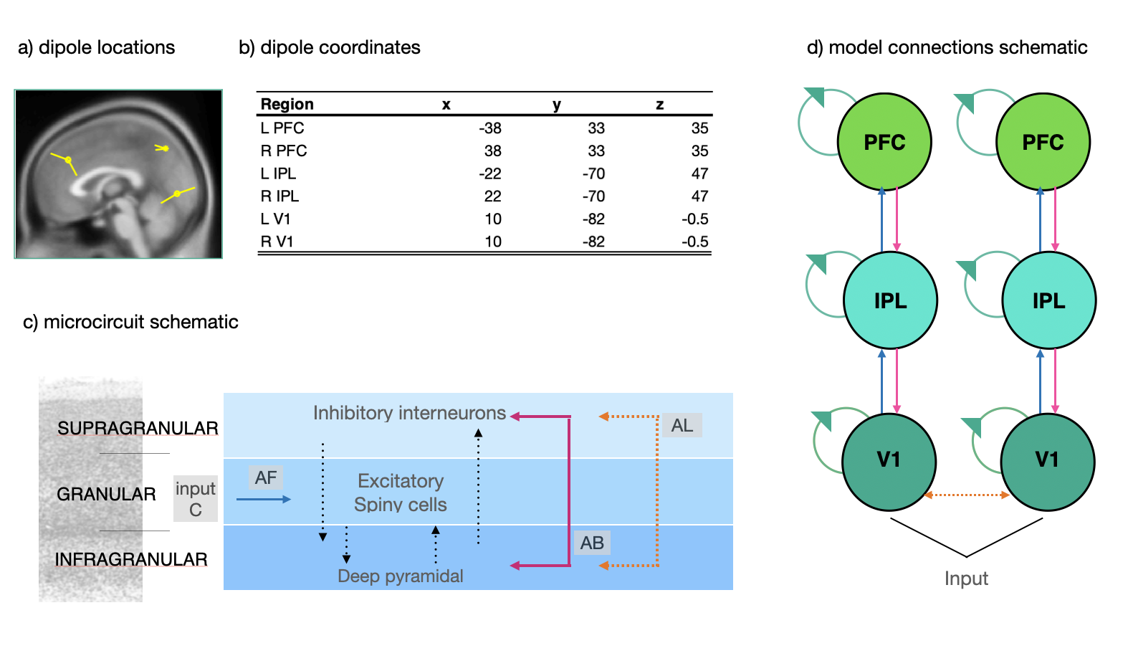
Supplementary Figure 9. Dorsal DCM specification. a) Neural mass model and electromagnetic model specifications. b) B connectivity matrix. c) Visual representation of model v1. Left: matrix A: forward connections in blue, backward connections in fuchsia, inter-hemispheric connections in orange; input (matrix C) is depicted in orange (in L and R V1). Right: B matrix connectivity representation. Circles represent connectivity on the same region, testing for self-inhibition or self-excitation during task condition.

Results for the task connectivity matrix (B matrix) are reported for Free energy (with vs without) and pp > .99. The BMA results show that task effects (rare vs standard) for PDP were mostly associated to an altered connectivity between parietal and frontal nodes, with probability 100%. Examining the model parameters, psychosis was positively related to connectivity from left V1 to left IPL, and negatively correlated with connectivity from IPL to PFC, bilaterally.
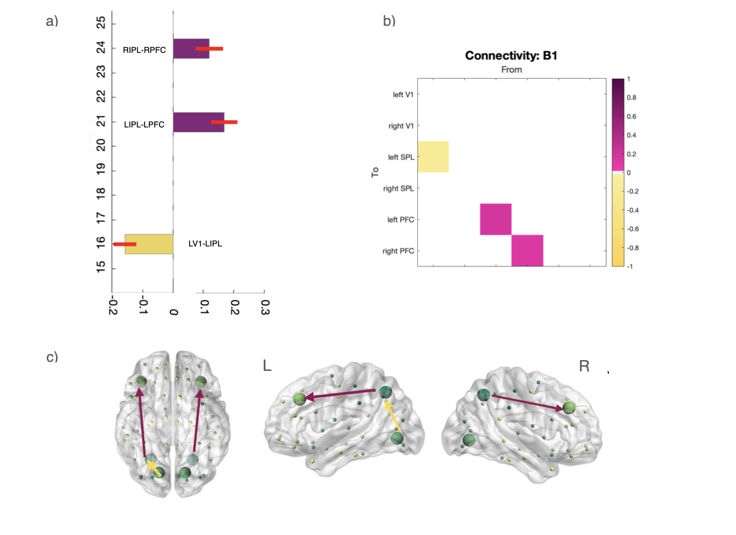Supplementary Figure 10. Dorsal model PEB results. a) Bar plots showing that connectivity is increased in PDP from letf V1 to IPL and decreased from IPL to PFC bilaterally. b) Matrix representation of the results shown in (a). C) Visual summary of the result. Brain and nodes are created with BrainNet viewer.

When looking at the task effect in PD-noVH only, connectivity is only increased. Increased self-connectivity is present for V1 bilaterally, and there is an increase in connectivity from left PFC to left IPL, opposite to the decrease in connectivity from PFC to IPL found in PDP. The involvement of V1 is in line with what found in the same analysis for the ventral model strongly supporting a role of primary visual cortex connectivity in the task, consistent with the task design as well.

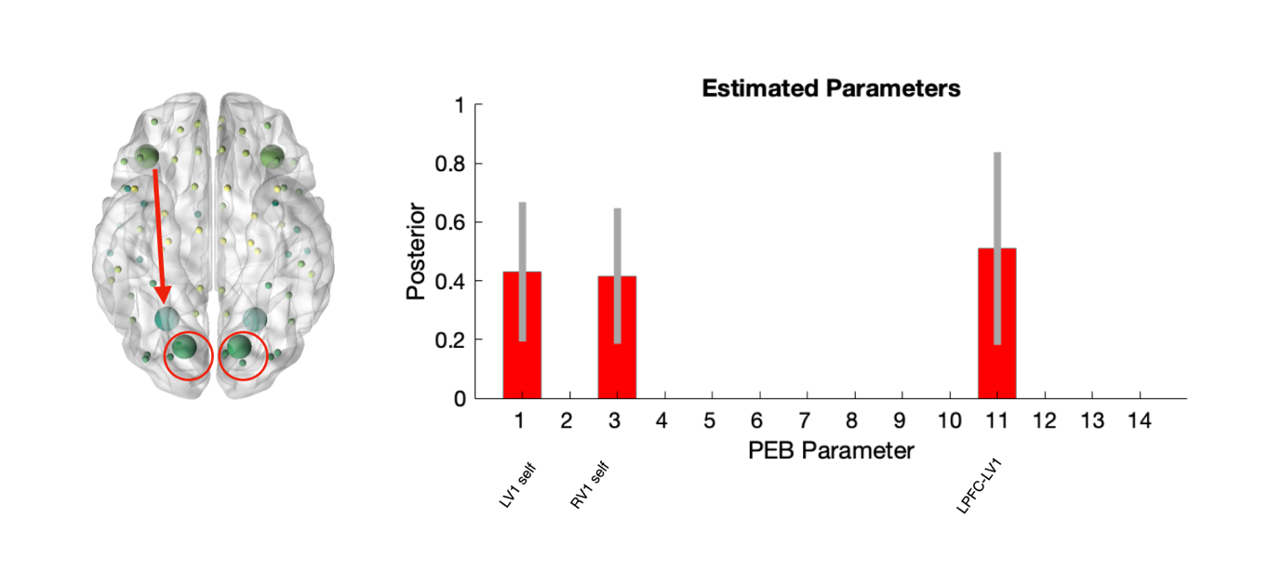Supplementary figure 11. Task effect (PD-noVH only) for the dorsal model. Pp > .99 (parameter prob; with free energy >.99 ns).

Hallucination severity, subtype and multimodality analysis.
No significant correlations were found for complex VH or minor VH or multimodality for task or baseline connectivity for the dorsal model. For this reason, we did not further explore this with the leave one out logistic regressions as done for the ventral model.

Supplementary Information 12. Exploratory receptor binding atlases and MMN source reconstructed signal analysis: additional methods and results. We used source reconstructed data, the procedure for this has been described in the main text briefly and in detail in SI4. Then difference images were created by subtracting standard from rare activity for each participant, with each image then registered to the atlas using the imcalc function using the nearest neighbour interpolation method. Then we registered the Desikan-Killiany atlas (Desikan et al., 2006) to the same space as the EEG source-reconstructed signals (reslice). Image alignment was checked using checkreg in spm. We chose this atlas as the number of cortical regions resembles that of our electrodes; an atlas with higher dimensionality would introduce too much noise.
The PET atlases were downloaded from https://github.com/juryxy/JuSpace/tree/JuSpace_v1.5/JuSpace_v1.5/PETatlas (Dukart et al., 2020) and neuromaps (Markello et al., 2022) https://github.com/netneurolab/neuromaps as described in the main text. A custom script was created to parcellate the source-reconstructed difference images and the PET maps of interest (5HT2-A, VAChT, M1, D2/D3, D1) in MNI template space. This allowed for the extraction of regional binding for each PET map and the corresponding reconstructed EEG signal within the regions defined by the atlas. Map and resliced atlas alignment was verified with checkreg and with additional code in the script comparing the image dimensions.
Supplementary Figure 12. Atlas-map alignment figures: examples from D1, VAChT, 5-HT2A.

First, we ran individual regression models using regional receptor binding as a predictor and regional MMN signal difference (VH – noVH) as dependent variable. Before proceeding to do this, we removed all the cerebellar, WM and ventricular regions as none of these had any relationship with our EEG signal. Outliers were removed with Cook’s distance and the outlier-free dataset was saved.
We found that 5-HT2_{A} binding significantly predicted MMN signal differences in VH – noVH patients [F(1,75]= 6.558, t =2.561 , p=.012], with a positive relationship. VAChT [F(1,69)=4.6, t= -2.145, p=.035] (results for the second vAChT map: [F(1,72)]=6.2, p=.015, t=-2.49] and D1 [F(1,75)=7.035, t=-2..65, p=.009] and D2/D3 [F(1m75)=4.622, t=-2.15, p=.035] showed a negative relationship. M1 showed no relationship (p =.3). P vales were corrected for multiple comparisons before proceeding to the next step – all values reported in the main text.
We proceeded to test whether these relationships were still true after accounting for spatial autocorrelation. Spatial autocorrelation needs to be taken into account when dealing with brain maps (or other spatial data) and it is a problem that arises from the fact that neighbouring locations tend to be more similar than locations that are more distant from one another (for a in depth discussion see Markello and Misic, 2021). Pearson’s correlations were computed between each PET map and the difference in the MMN signal between participants with and without visual hallucinations (VH). To account for spatial autocorrelation, we utilized the BrainSMASH toolbox (Burt, J.B. et al., 2020). This toolbox simulates surrogate maps that match the spatial autocorrelation of the target brain map, allowing for accurate correlations between brain maps while minimizing spatial effects. Using BrainSMASH, we generated the MNI coordinates for our atlas and removed the regions we removed with the regression models, in order to run the correlational analyses on the exact same regions on which we ran the regressions. By creating centroids from the .nii atlas and running multiple permutations, we obtained a correlation coefficient that is proposed, by Burt and colleagues, to reflected the relationship between the two maps free from spatial autocorrelation. For the maps surviving the actual correlational analysis, we carried out linear mixed models using individual-level data, to test the effect of age, MoCA score, LEDD and disease onset in this relationship. All results are reported below, together with tables with LMMs specific statistics.
Only the maps with pFDR <.05 were used for further analysis (corrected ps: D1 p = 0.026, 5-HT_{2A} p = .026, VAChT p = .026, D2/D3 p = .04; note: this was true also for the VAChT map with 4 healthy participants; M1 showed no relationship p=.3; models results are reported in SI13). Using BrainSMASH⁵⁶ we confirmed a positive correlation between 5-HT_{2A} binding and MMN signal (r=.284, p=.037) with higher connectivity in regions of higher binding. The opposite pattern was observed for D1 (r=-.29, p =.017) and VAChT (r=-2.73, p =.03). D2/D3 was no longer significant after correcting for spatial autocorrelation (p >.05).
When investigating these results at the individual level using LMMs (MMN_signal ~ _receptor * VH + age + LEDD + sex + disease onset +MoCA + (1 | Participant)), we found for 5-HT_{2A} a main effect of 5‐HT2A t =2.13,p =.034, of hallucination status (VH) t =2.52, p =.017 and a positive interaction between 5‐HT_{2A} and VH t =2.06, p =.040. Among people without VH, increasing 5‐HT2A by 1 SD was associated with a +0.0012 higher MMN, whereas in those with VH, 1 SD increase yielded +0.0028 higher MMN, consistent with an amplified effect of 5‐HT2A in the VH group. The same model using D1 receptor availability found a significant group effect t = 2.54, p = .015, and a negative D1 *VH interaction t = –2.13, p =.033 whereby for people with VH, higher D1 values were associated with a steeper drop in MMN amplitude, overriding the otherwise higher MMN observed at average D1 levels.

For VAChT, using the map from N=18 older participants⁵², we found a positive association with MMN (t =1.75, p =.08) and a negative VAChT * VH interaction effect (t =-1.58, p =.1), though neither reached significance; VH status was significant t =2.46, p =.019. In a sensitivity analysis with the N=4 map⁵¹, we observed the same direction of effects but with a larger effect size and formal significance (partial r ≈ –.037 for the VAChT * VH interaction; see details in SI13). These convergent patterns suggest a negative relationship between VAChT and MMN in the VH group, though not as robust as D1.

No effect of disease duration, LEDD and age was found for any of the models

Dopamine D1
Term | Estimate | Std. Error | df | t value | Pr(>|t|) | Significance
(Intercept) | -0.0021 | 0.0020 | 30 | -1.071 | 0.2929
d1_s | -0.0004 | 0.0005 | 2810 | -0.772 | 0.4399
VH1 | 0.0045 | 0.0017 | 30 | 2.587 | 0.0148 | *
age_s | 0.0002 | 0.0009 | 30 | 0.223 | 0.8249
LEDD_s | -0.0009 | 0.0010 | 30 | -0.889 | 0.381
sexmale | 0.0048 | 0.0020 | 30 | 2.461 | 0.0198 | *
onset_s | 0.0007 | 0.0009 | 30 | 0.739 | 0.4655
MoCA_s | 0.0006 | 0.0009 | 30 | 0.695 | 0.4922
d1_s:VH1 | -0.0016 | 0.0007 | 2810 | -2.132 | 0.0331 | *
Acetilcholine vAChT n = 18 Alghourian et al 2017
Term | Estimate | Std. Error | df | t value | Pr(>|t|) | Significance
(Intercept) | -0.0019 | 0.0021 | 30 | -0.936 | 0.357
vacht_s | -0.0010 | 0.0006 | 2588 | -1.745 | 0.0811 | .
VH1 | 0.0045 | 0.0018 | 30 | 2.464 | 0.0197 | *
age_s | 0.0002 | 0.0009 | 30 | 0.205 | 0.8387
LEDD_s | -0.0006 | 0.0011 | 30 | -0.564 | 0.5773
sexmale | 0.0048 | 0.0021 | 30 | 2.301 | 0.0285 | *
onset_s | 0.0004 | 0.0009 | 30 | 0.442 | 0.6616
MoCA_s | 0.0005 | 0.0009 | 30 | 0.565 | 0.576
vacht_s:VH1 | -0.0012 | 0.0008 | 2588 | -1.576 | 0.115
Acetilcholine vAChT n = 4 sensirivity analysis
Term | Estimate | Std. Error | df | t value | Pr(>|t|) | Significance
(Intercept) | -0.0019 | 0.0020 | 30 | -0.94 | 0.3549
vacht_s | -0.0008 | 0.0005 | 2810 | -1.385 | 0.1662
VH1 | 0.0045 | 0.0018 | 30 | 2.52 | 0.0173 | *
age_s | 0.0001 | 0.0009 | 30 | 0.087 | 0.9312
LEDD_s | -0.0006 | 0.0010 | 30 | -0.537 | 0.5951
sexmale | 0.0046 | 0.0020 | 30 | 2.242 | 0.0325 | *
onset_s | 0.0003 | 0.0009 | 30 | 0.375 | 0.7099
MoCA_s | 0.0005 | 0.0009 | 30 | 0.561 | 0.5787
vacht_s:VH1 | -0.0015 | 0.0007 | 2810 | -1.976 | 0.0482 | *
Serotonine 5-HT2A
Term | Estimate | Std. Error | df | t value | Pr(>|t|) | Significance
(Intercept) | -0.0019 | 0.0020 | 30 | -0.94 | 0.3549
ht2a_s | 0.0012 | 0.0005 | 2810 | 2.126 | 0.0336 | *
VH | 0.0045 | 0.0018 | 30 | 2.52 | 0.0173 | *
age_s | 0.0001 | 0.0009 | 30 | 0.087 | 0.9312
LEDD_s | -0.0006 | 0.0010 | 30 | -0.537 | 0.5951
sexmale | 0.0046 | 0.0020 | 30 | 2.242 | 0.0325 | *
onset_s | 0.0003 | 0.0009 | 30 | 0.375 | 0.7099
MoCA_s | 0.0005 | 0.0009 | 30 | 0.561 | 0.5787
ht2a_s:VH | 0.0015 | 0.0007 | 2810 | 2.058 | 0.0397 | *

Supplementary References

Vignando, M., Ffytche, D., Mazibuko, N., Palma, G., Montagnese, M., Dave, S., ... & Mehta, M. A. (2024). Visual mismatch negativity in Parkinson's psychosis and potential for testing treatment mechanisms. Brain Communications, 6(5), fcae291.

Verbaan, D., Van Rooden, S. M., Benit, C. P., van Zwet, E. W., Marinus, J., & van Hilten, J. J. (2011). SPES/SCOPA and MDS-UPDRS: formulas for converting scores of two motor scales in Parkinson’s disease. Parkinsonism & related disorders, 17(8), 632-634.

Cummings, J. L., Mega, M., Gray, K., Rosenberg-Thompson, S., Carusi, D. A., & Gornbein, J. (1994). The Neuropsychiatric Inventory: comprehensive assessment of psychopathology in dementia. Neurology, 44(12), 2308-2308.

Voss, T., Bahr, D., Cummings, J., Mills, R., Ravina, B., & Williams, H. (2013). Performance of a shortened Scale for Assessment of Positive Symptoms for Parkinson's disease psychosis. Parkinsonism & Related Disorders, 19(3), 295-299.

D’Antonio, F., Boccia, M., Di Vita, A., Suppa, A., Fabbrini, A., Canevelli, M., ... & Ffytche, D. (2022). Visual hallucinations in Lewy body disease: pathophysiological insights from phenomenology. Journal of Neurology, 269(7), 3636-3652.

Vignando, M., Ffytche, D., Mazibuko, N., Palma, G., Montagnese, M., Dave, S., ... & Mehta, M. A. (2024). Visual mismatch negativity in Parkinson’s psychosis and potential for testing treatment mechanisms. Brain Communications, fcae291.

Garrido, M. I., Kilner, J. M., Stephan, K. E., & Friston, K. J. (2009). The mismatch negativity: a review of underlying mechanisms. Clinical neurophysiology, 120(3), 453-463.

Oostenveld, R., Fries, P., Maris, E., & Schoffelen, J. M. (2011). FieldTrip: open source software for advanced analysis of MEG, EEG, and invasive electrophysiological data. Computational intelligence and neuroscience, 2011(1), 156869.

Delorme, A., & Makeig, S. (2004). EEGLAB: an open source toolbox for analysis of single-trial EEG dynamics including independent component analysis. Journal of neuroscience methods, 134(1), 9-21.

Lopez-Calderon, J., & Luck, S. J. (2014). ERPLAB: An open-source toolbox for the analysis of event-related potentials. Frontiers in human neuroscience, 8, 21

Garcia-Diaz, A. I., Segura, B., Baggio, H. C., Marti, M. J., Valldeoriola, F., Compta, Y., ... & Junque, C. (2018). Structural brain correlations of visuospatial and visuoperceptual tests in Parkinson’s disease. Journal of the International Neuropsychological Society, 24(1), 33-44.

Desikan, R. S., Ségonne, F., Fischl, B., Quinn, B. T., Dickerson, B. C., Blacker, D., ... & Killiany, R. J. (2006). An automated labeling system for subdividing the human cerebral cortex on MRI scans into gyral based regions of interest. Neuroimage, 31(3), 968-980.

Dukart J, Holiga S, Rullmann M, Lanzenberger R, Hawkins PCT, Mehta MA, Hesse S, Barthel H, Sabri O, Jech R, Eickhoff SB. JuSpace: A tool for spatial correlation analyses of magnetic resonance imaging data with nuclear imaging derived neurotransmitter maps. Hum Brain Mapp. 2021 Feb 15;42(3):555-566. doi: 10.1002/hbm.25244. Epub 2020 Oct 20.

Markello, R. D., & Misic, B. (2021). Comparing spatial null models for brain maps. NeuroImage, 236, Article 118052.
Markello, R. D., Hansen, J. Y., Liu, Z. Q., Bazinet, V., Shafiei, G., Suárez, L. E., ... & Misic, B. (2022). Neuromaps: structural and functional interpretation of brain maps. Nature Methods, 19(11), 1472-1479.

Burt, J.B., Helmer, M., Shinn, M.W., Anticevic, A., Murray, J.D. Generative modeling of brain maps with spatial autocorrelation. Neuroimage, 220 (2020).

A model LV1+ LV-RV+RV-RIT+ RV-RPFC +LPFC.LV+ RPFC-RV proved also fitting [R² = 0.572, adjusted R2 = .42, F(5,14) = 3.75, p =.023, RMSE = 5.37, MAE = 4.36] but less significant and with greater BIC = 128.26).
A model with as many as 6 predictors was also significant but had worse residual deviance: Predictors: LV.LPFC + RV.RIT + LPFC.LIT + RPFC.RV + LV1.RV1 + RV1.LV1, residual standard error = 1.88, RMSE: 4.91, MAE = 2.91. Multiple R-squared: 0.6, Adjusted R-squared: 0.414, F (6,13)=3.242, p= 0.036, BIC = 97.27.

