Supplementary file
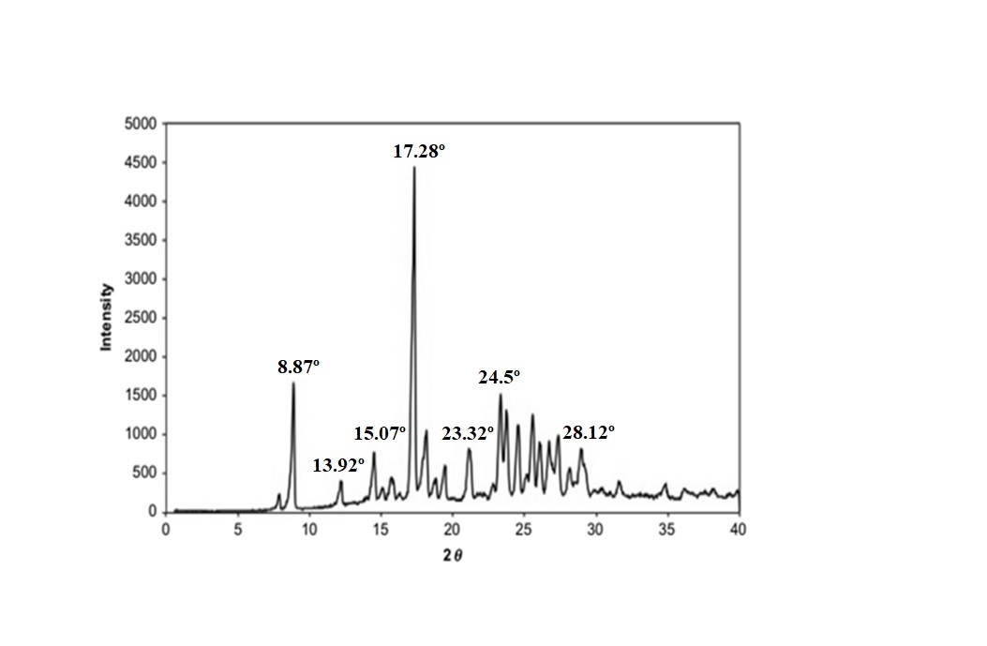
Figure S1: Diffractogram of CUR

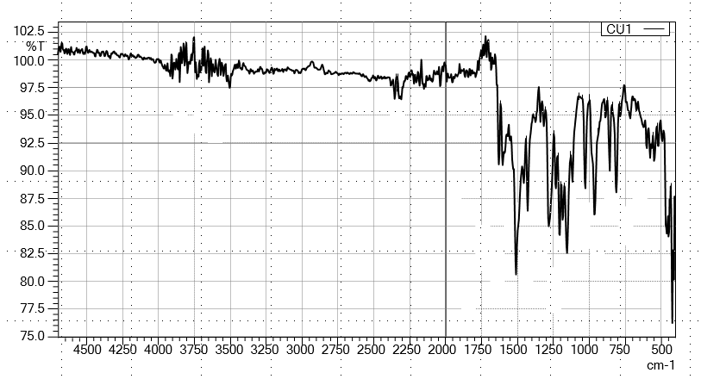
Figure S2: FTIR of CUR

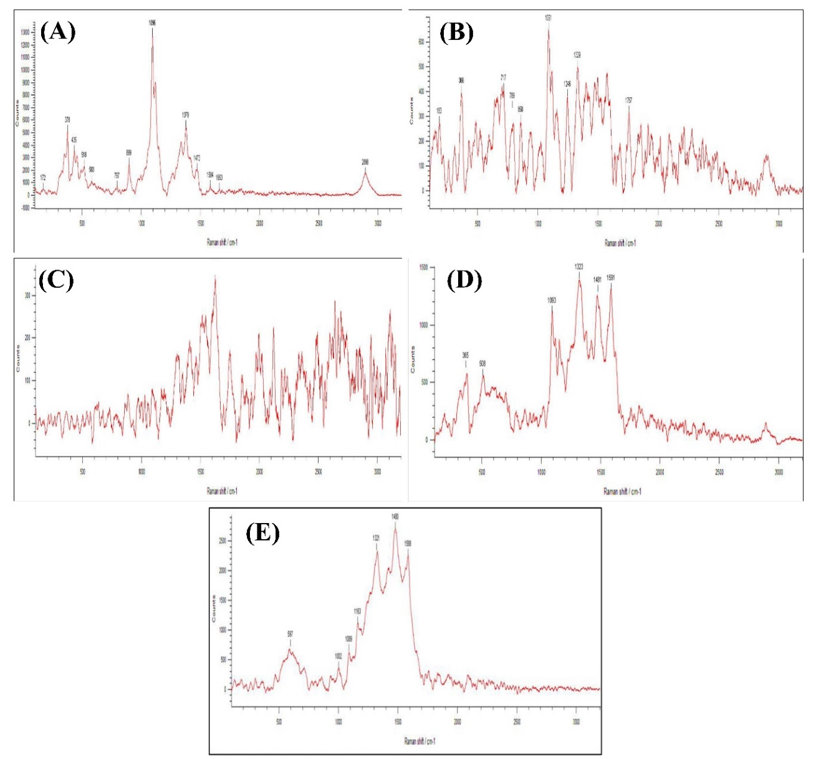
Figure S3: Raman spectra of (A) WCNFs; (B) MCNFs; (C) NH₂-MCNFs; (D) Wf-GQDs; (E) GQDs-CUR@NH₂-MCNFs

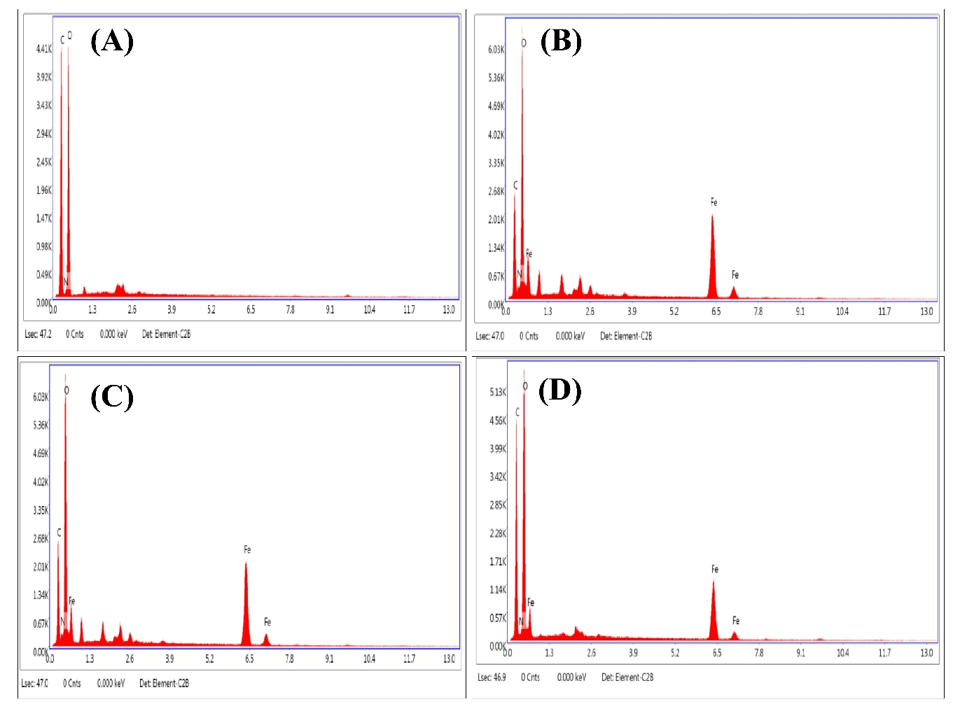
Figure S4: EDX spectrum of (A) WCNFs;(B) MCNFs; (C) CUR@NH₂-MCNFs; (D) GQDs-CUR@NH₂-MCNFs
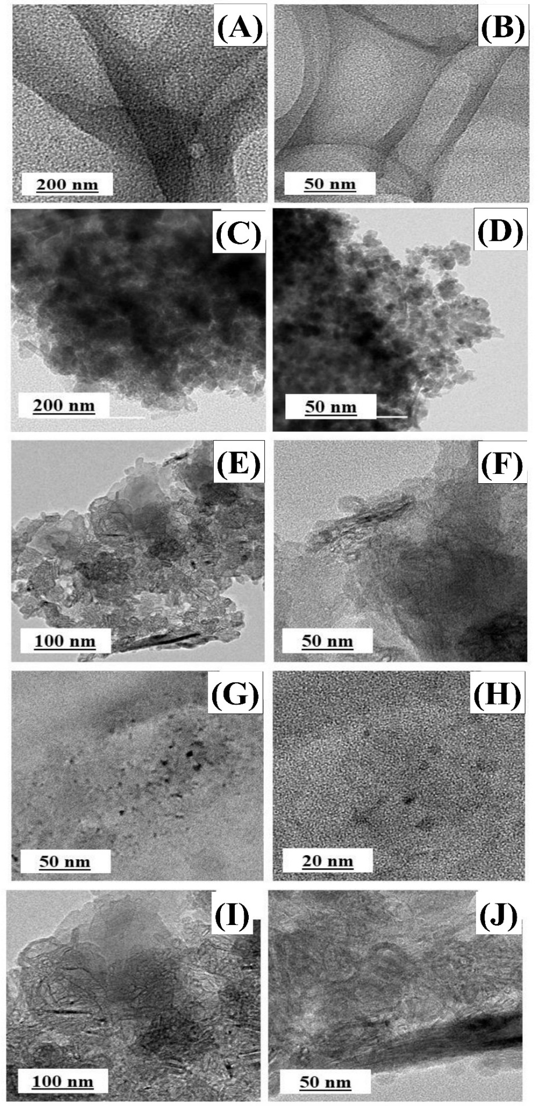
Figure S5: TEM images of WCNFs (A, B), MCNFs (C, D), CUR@NH₂-MCNFs (E, F), Wf-GQDs (G, H), and CUR@NH₂-MCNFs (I, J)
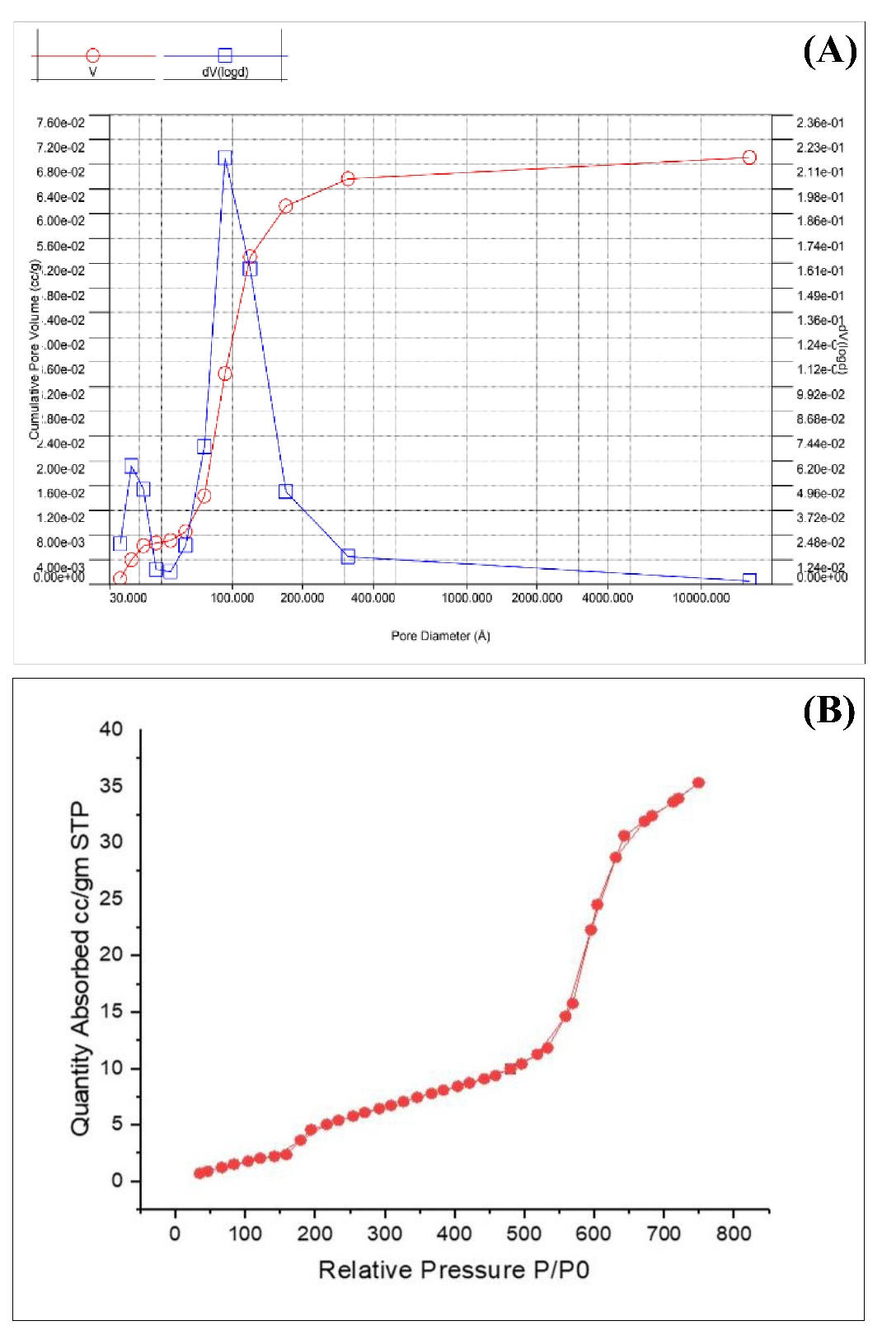
Figure S6: (A) BET surface area including relative pressure vs adsorption-desorption curve of synthesized WCNFs and (B) pore volume and pore diameter of synthesized WCNFs

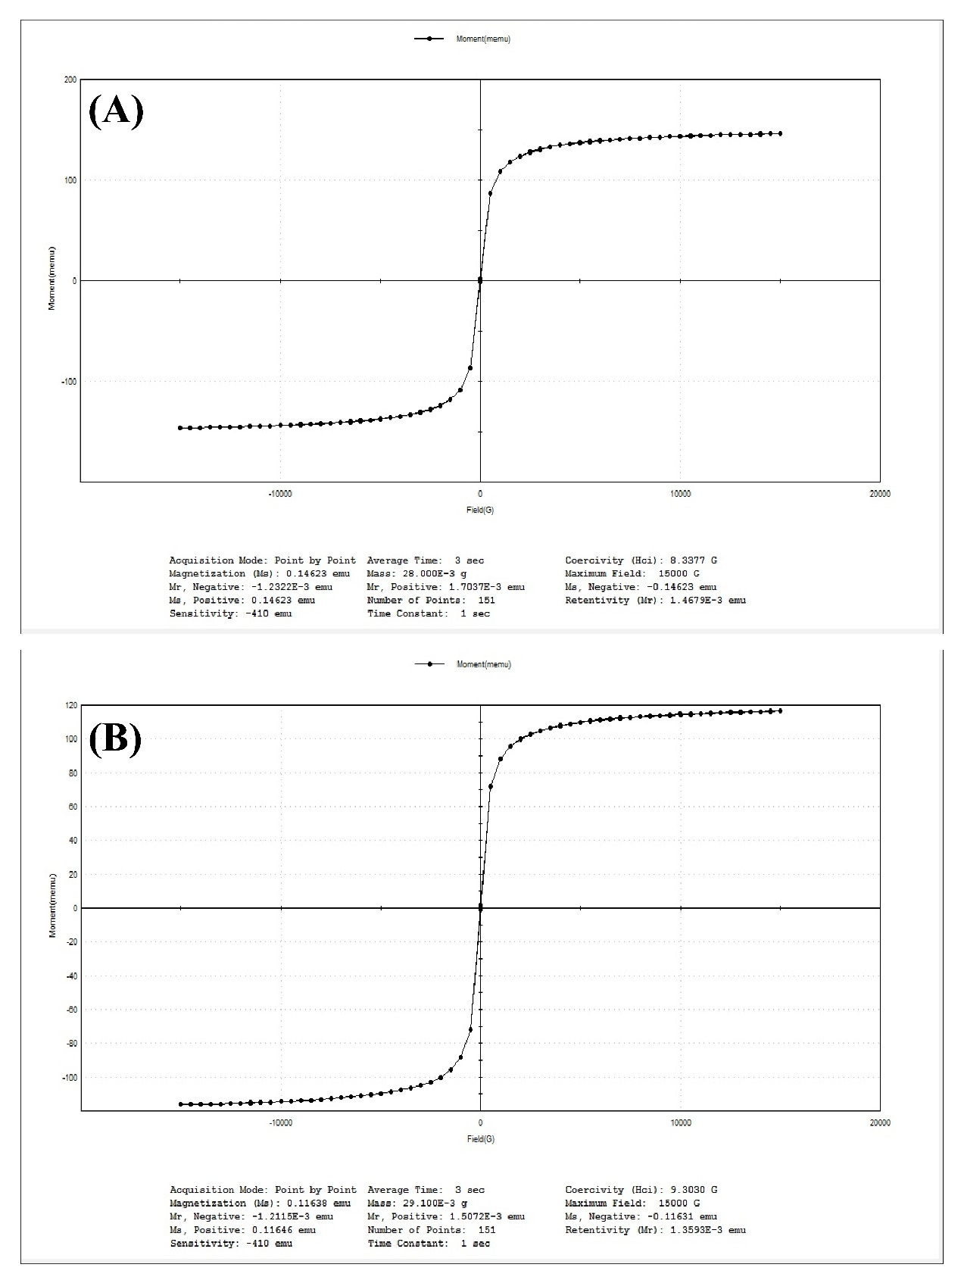
Figure S7: Magnetization curves of (A) MCNFs and (B) GQDs-CUR@NH₂-MCNFs

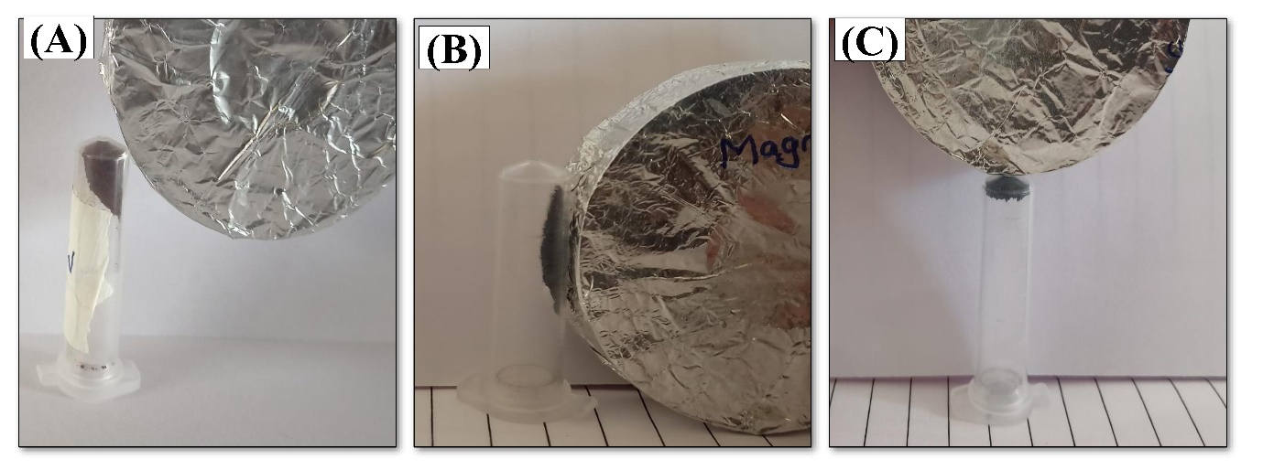
Figure S8: Magnetic responsive nature of (A) MNPs; (B) MCNFs; (C) GQDs-CUR@NH₂-MCNFs

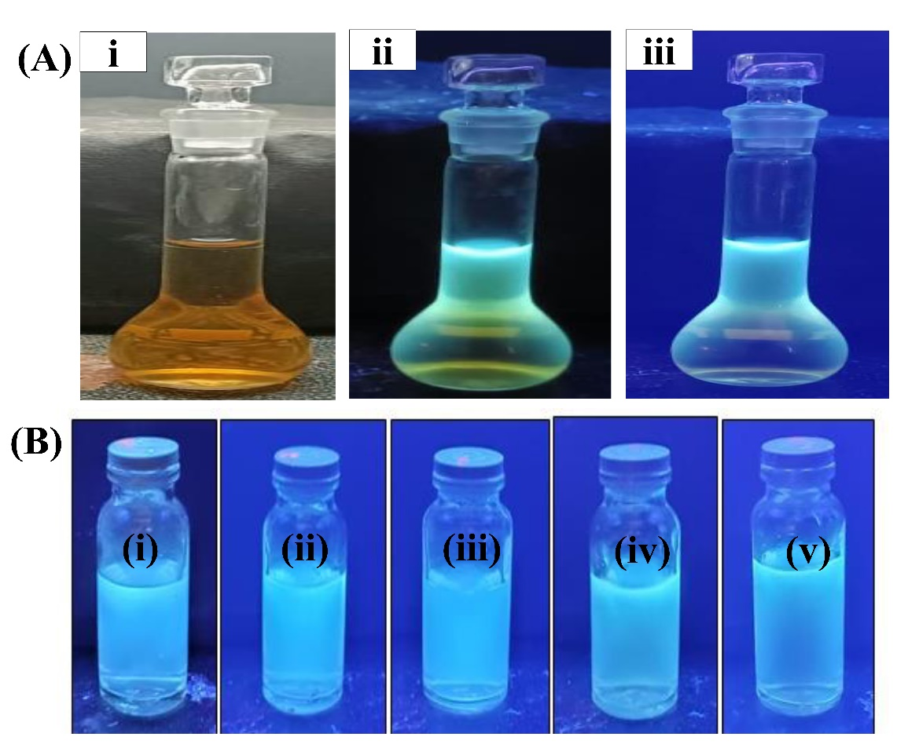
Figure S9: (A) Wf-GQDs solution in (i) visible light (ii) UV light at a short wavelength of 254 nm and (iii) UV light at a long wavelength of 365 nm. (B) Different dilutions of Wf-GQDs from 1 mL, 2 mL, 3 mL, 4 mL, and 5 mL to 10 mL in A, B, C, D, and E samples, respectively.
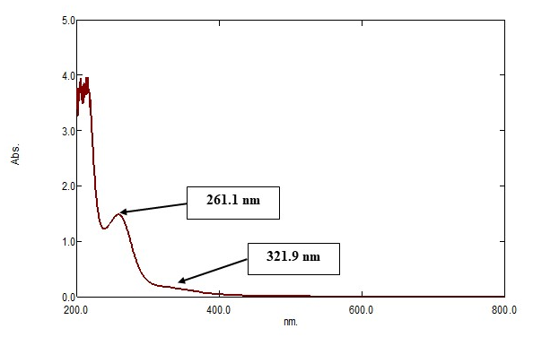
Figure S10: UV Vis spectra of Wf-GQDs

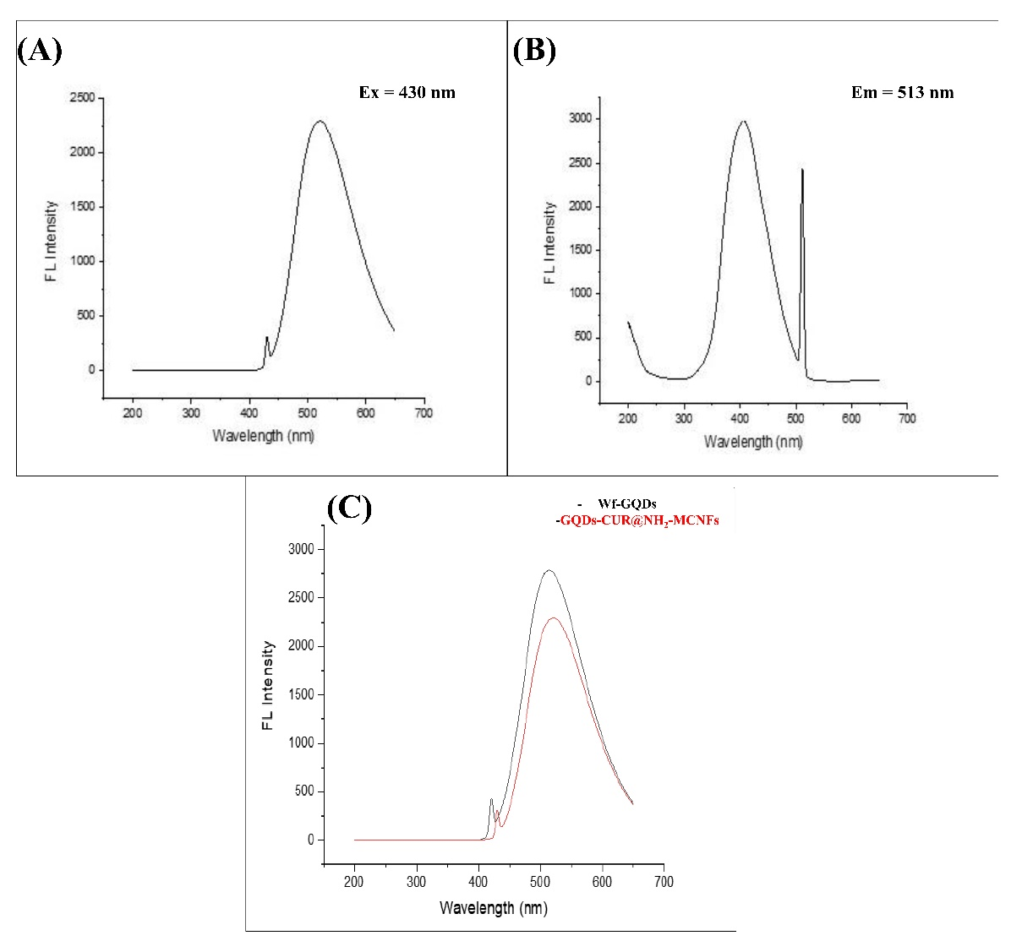
Figure S11: (A) Excitation spectra; (B) emission spectra of GQDs-CUR@NH₂-MCNFs; and (C) fluorescence spectra of Wf-GQDs and GQDs-CUR@NH₂-MCNFs

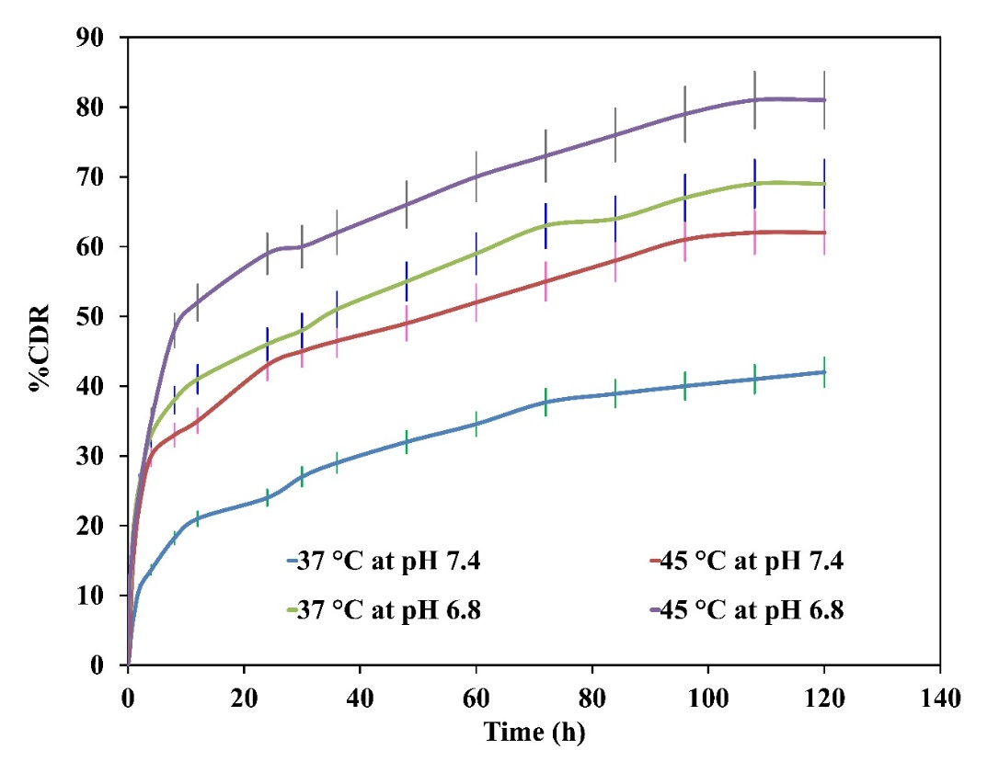
Figure S12: Cumulative ‘CUR’ release from the GQDs-CUR@NH₂-MCNFs under different pH and temperature conditions

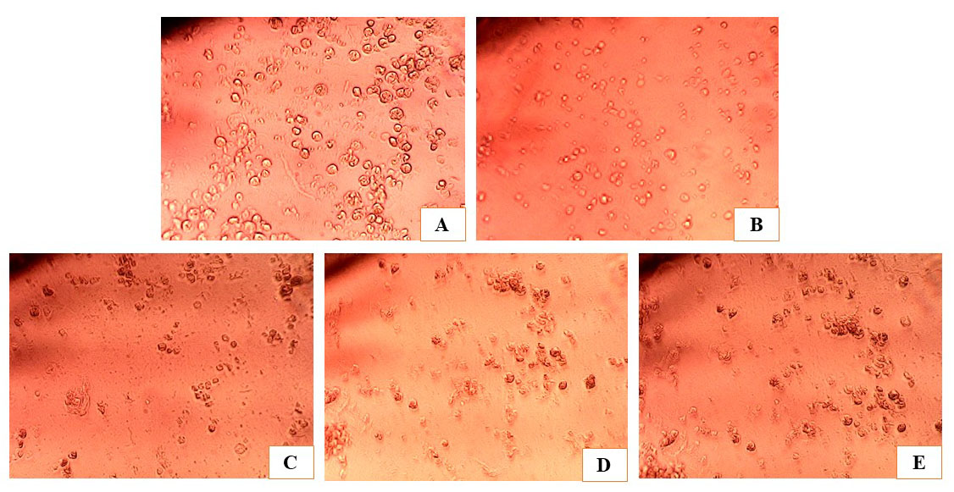
Figure S13: Effect of (A) Control; (B) Std. 5 FU; (C) CUR; (D) CUR@NH₂-MCNFs and (E) GQDs-CUR@NH₂-MCNFs measured against MCF-7 Breast cancer cell line by MTT assay

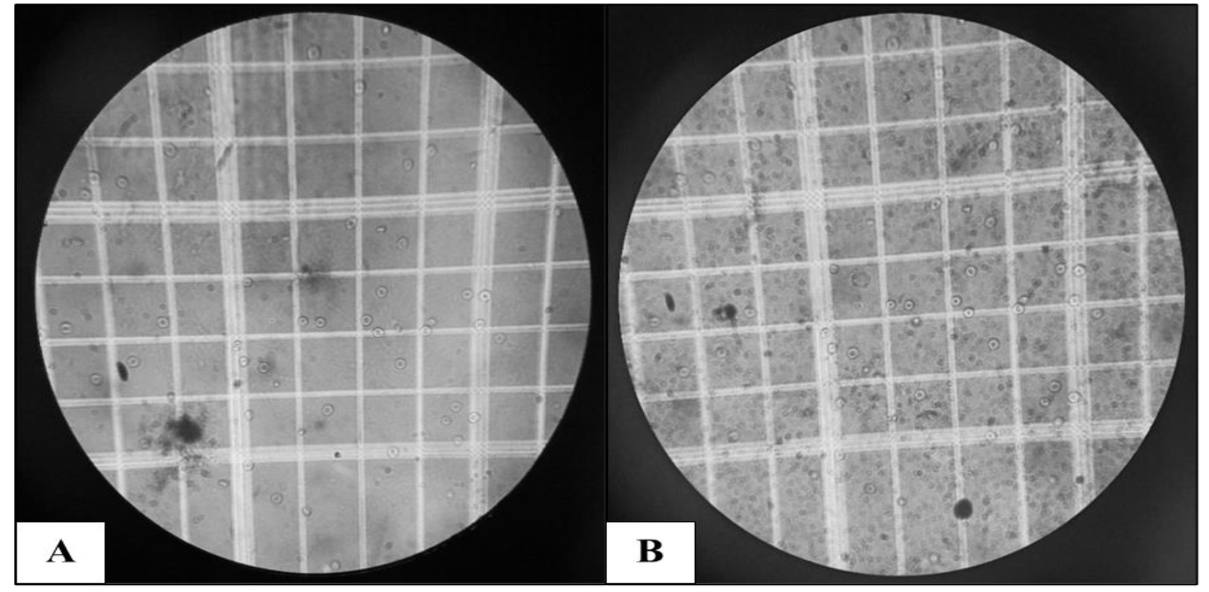
Figure S14: A) Depicts the normal structure of erythrocytes; (B) illustrates the structure of GQDs-CUR@NH₂-MCNFs-treated erythrocytes.

