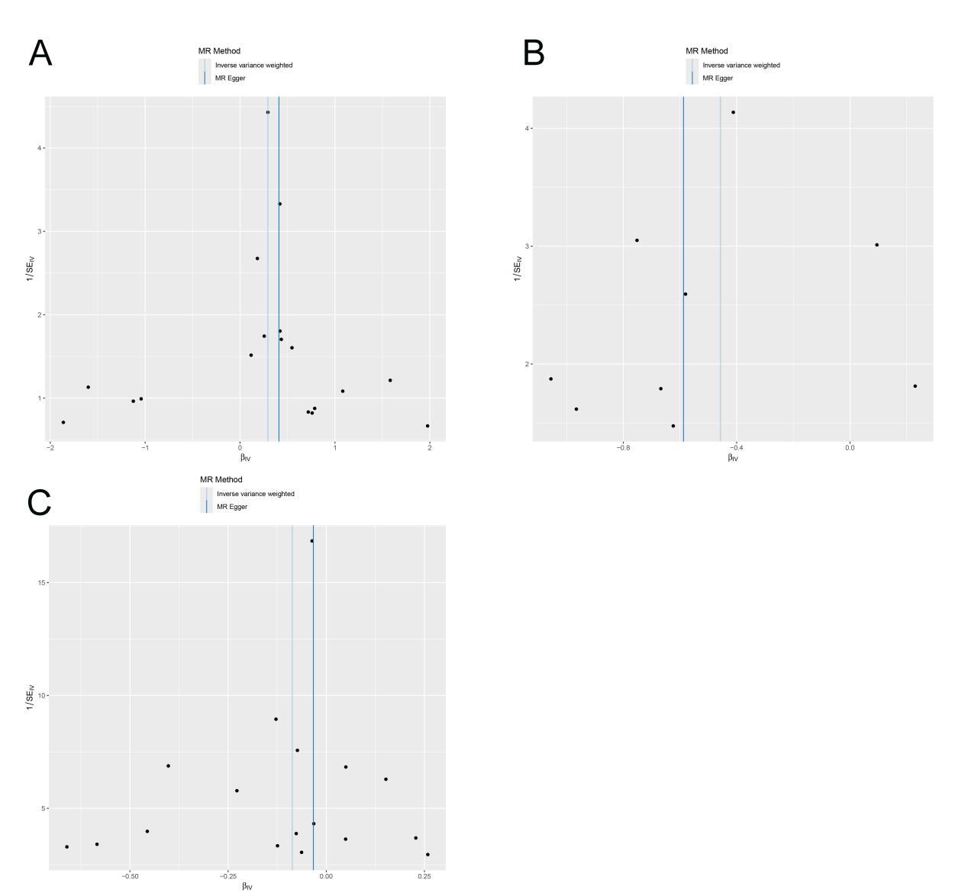
Supplementary Figure S1.Funnel plots visually display the overall heterogeneity of MR estimates for all results:(A)Heterogeneity analysis for Funnelplot for DPF2 on Finnish patients with hepatocellular carcinoma;(B)Heterogeneity analysis for Funnelplot for Glycosyl-N-behenoyl-sphingadienine (d18:2/22:0) on Finnish patients with hepatocellular carcinoma;(C)Heterogeneity analysis for DPF2 on Glycosyl-N-behenoyl-sphingadienine (d18:2/22:0) .

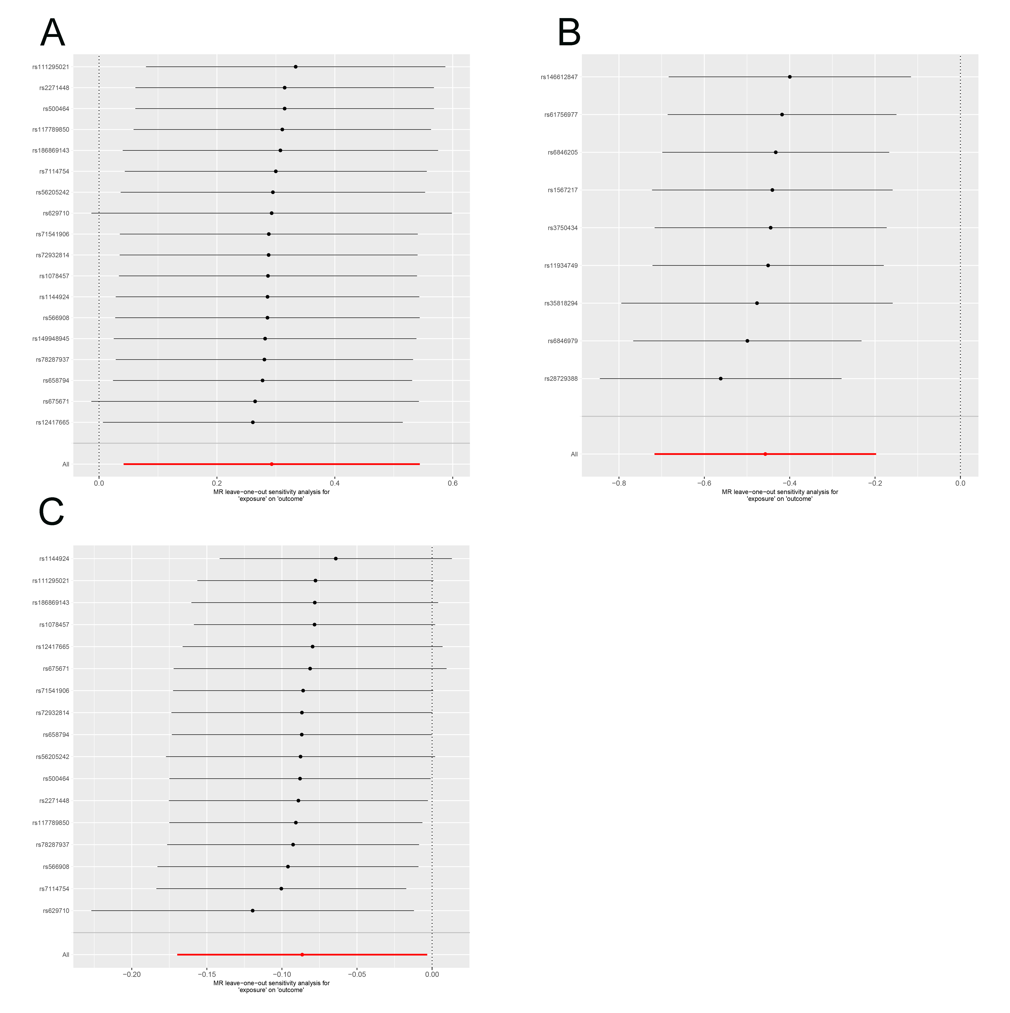
Supplementary Figure S2 Leave-one-out analysis visually displays the overall robustness of MR estimates for all results:(A)Leave-one-out analysis for DPF2 on Finnish patients with hepatocellular carcinoma;(B)Leave-one-out analysis for Glycosyl-N-behenoyl-sphingadienine (d18:2/22:0) on Finnish patients with hepatocellular carcinoma;(C)Leave-one-out analysis for DPF2 on Glycosyl-N-behenoyl-sphingadienine (d18:2/22:0).

