Full uncropped Gels and Blots image(s) for Figure1F
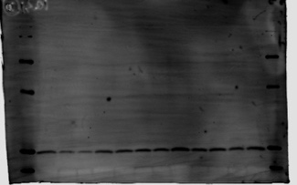
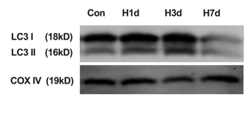
COX IV
Con H1d H3d H7d
Con H1d H3d H7d
LC3 I
LC3II
10kD
15kD
35kD
55kD
10kD
55kD
35kD
15kD

Full uncropped Gels and Blots image(s) for Figure1N
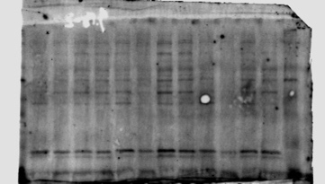
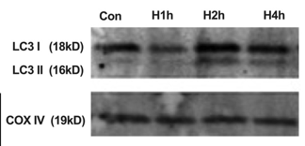
10kD
15kD
55kD
25kD
LC3 I
LC3II
Con H1h H2h H4h
55kD
15kD
10kD
35kD
25kD
35kD
COX IV
Con H1h H2h H4h

Full uncropped Gels and Blots image(s) for Figure2A
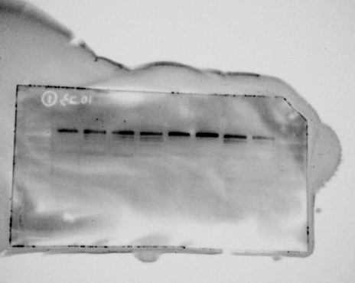
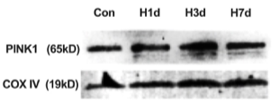
COX IV
PINK1
Con H1d H3d H7d
Con H1d H3d H7d
70kD
50kD
40kD
35kD
25kD
20kD
15kD
10kD

Full uncropped Gels and Blots image(s) for Figure2C
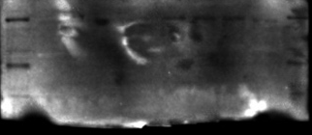
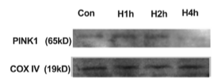
10kD
PINK1
Con H1h H2h H4h
10kD
15kD
35kD
55kD
70kD
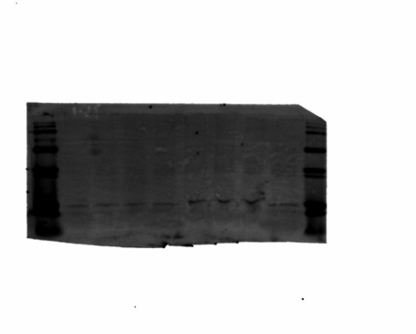
70kD
Con H1h H2h H4h
15kD
55kD
35kD
COX IV
10kD

Full uncropped Gels and Blots image(s) for Figure2K
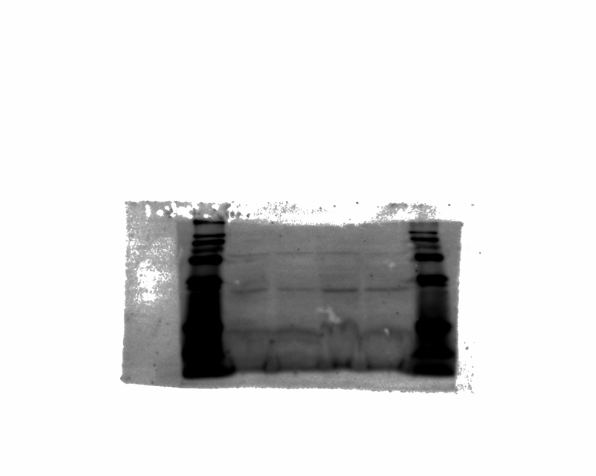
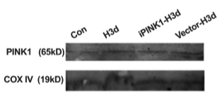
PINK1
COX IV
Con H3d iPINK1-H3d Vestor-H3d
15kD
70kD
55kD
35kD

Full uncropped Gels and Blots image(s) for Figure2M
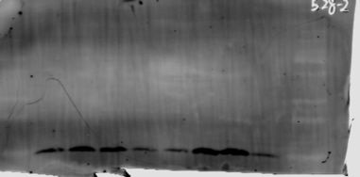
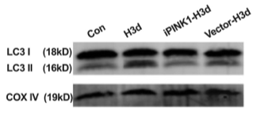
COX IV
Con
H3d
Vestor-H3d
iPINK1-H3d
35kD
25kD
15kD
10kD
35kD
Vestor-H3d
iPINK1-H3d
H3d
Con
LC3 I
LC3 II
10kD
15kD

Full uncropped Gels and Blots image(s) for Figure3A
Con H1d H3d. H7d
L-PGAM5
S-PGAM5
55kD
25kD
35kD
15kD
10kD

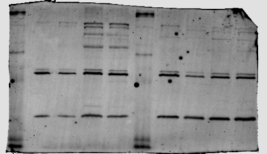
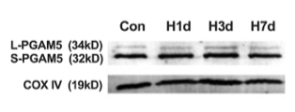
Con H1d H3d. H7d
COX IV

Full uncropped Gels and Blots image(s) for Figure3C
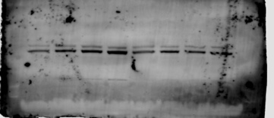
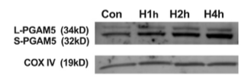
L-PGAM5
S-PGAM5
Con H1h H2h. H4h
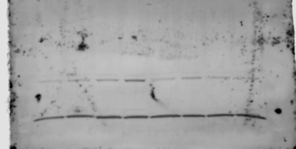

Con H1h H2h. H4h
COX IV

Full uncropped Gels and Blots image(s) for Figure3K
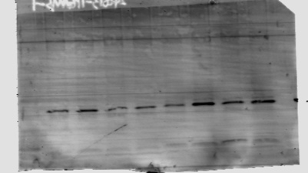
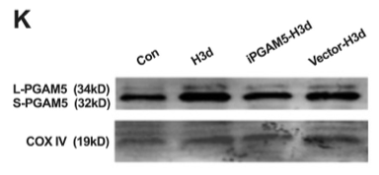
L-PGAM5
S-PGAM5
COX IV
Con H3d iPGAM5-H3d Vestor-H3d
55kD
35kD
15kD
10kD

Full uncropped Gels and Blots image(s) for Figure3M
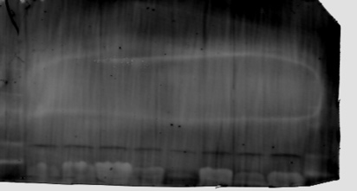
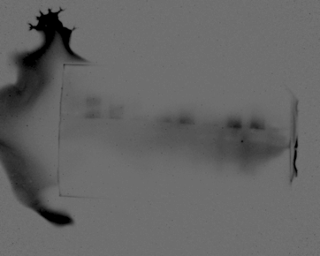
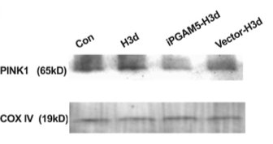
PINK1
COX IV
15kD
35kD
55kD
70kD
Con
H3d
iPGAM5-H3d
Vestor-H3d
Vestor-H3d
iPGAM5-H3d
H3d
Con
10kD

Full uncropped Gels and Blots image(s) for Figure3O
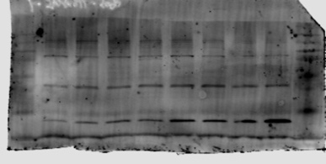
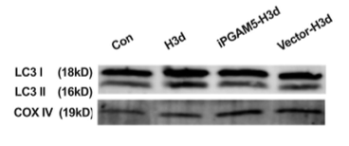
COX IV
LC3 I
LC3 II
H3d
Con
Con
H3d
Vestor-H3d
iPGAM5-H3d
iPGAM5-H3d
Vestor-H3d
15kD
55kD
70kD
35kD
10kD

Full uncropped Gels and Blots image(s) for Figure4A
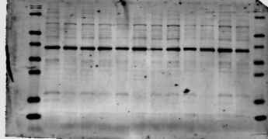
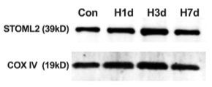
COX IV
STOML2
Con H1d H3d H7d
Con H1d H3d H7d
25kD
35kD
55kD
15kD
70kD
10kD

Full uncropped Gels and Blots image(s) for Figure4C
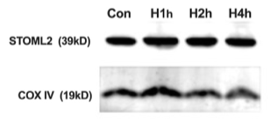
STOML2
COX IV
Con H1h H2h H4h
55kD
35kD
10kD
15kD

Full uncropped Gels and Blots image(s) for Figure4K
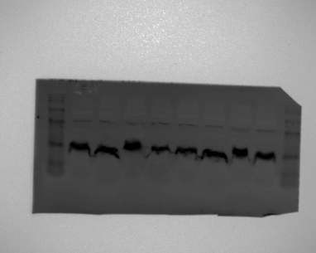
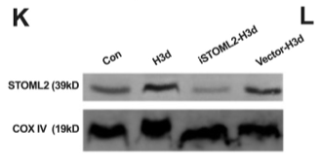
STOML2
COX IV
Con
H3d
iSTOML2-H3d
Vestor-H3d
H3d
Con
iSTOML2-H3d
Vestor-H3d
35kD
15kD
10kD
55kD

Full uncropped Gels and Blots image(s) for Figure4M
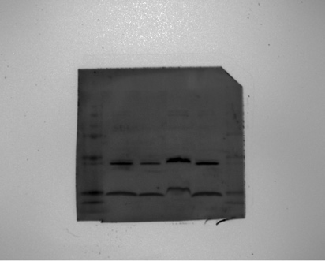
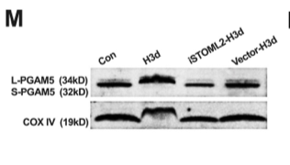
35kD
55kD
15kD
Con
H3d
Vestor-H3d
iSTOML2-H3d
L-PGAM5
S-PGAM5
COX IV
10kD

Full uncropped Gels and Blots image(s) for Figure4O
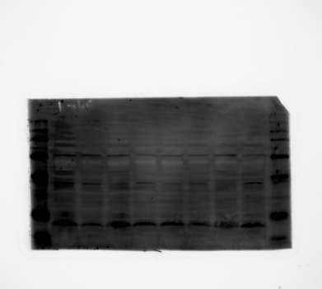
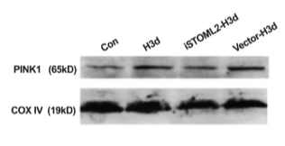
PINK1
COX IV
iSTOML2-H3d
Vestor-H3d
Con
H3d
25kD
35kD
10kD
15kD
55kD
70kD

Full uncropped Gels and Blots image(s) for Figure4Q
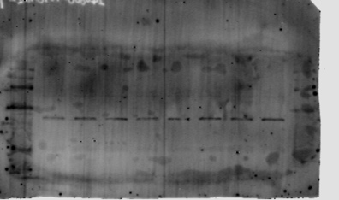
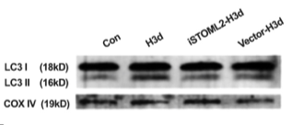
COX IV
LC3 I
LC3 II
iSTOML2-H3d
Vestor-H3d
Con
H3d
H3d
Con
Vestor-H3d
iSTOML2-H3d
35kD
15kD
10kD
55kD
15kD
10kD

Full uncropped Gels and Blots image(s) for Figure5A

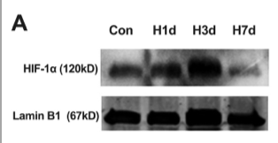
55kD
150kD
100kD
70kD
Lamin B1
HIF-1α
Con H1d H3d H7d
Con H1d H3d H7d

Full uncropped Gels and Blots image(s) for Figure5C
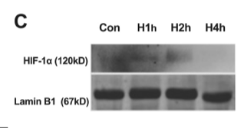
HIF-1α
Lamin B1
Con H1h H2h H4h
Con H1h H2h H4h
70kD
100kD
150kD
55kD

Full uncropped Gels and Blots image(s) for Figure6D
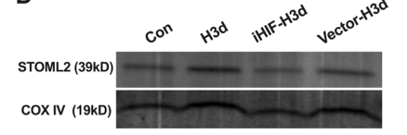
15kD
35kD
55kD
10kD
COX IV
STOML2

Full uncropped Gels and Blots image(s) for Figure6F
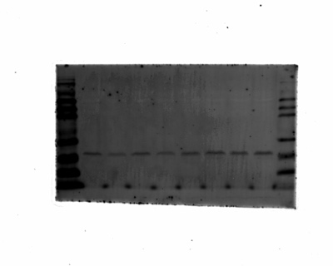
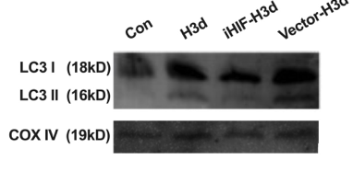
Con
H3d
Vestor-H3d
iHIF-H3d
10kD
15kD
25kD
LC3 I
LC3 II

Vestor-H3d
iHIF-H3d
Con
H3d
25kD
15kD
COX IV
10kD

Full uncropped Gels and Blots image(s) for Figure7A
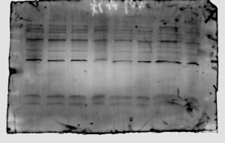
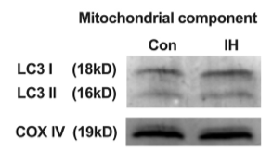
LC3 I
LC3 II
Con. IH
55kD
35kD
10kD
15kD
25kD
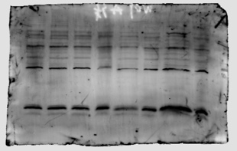

COX IV
Con. IH

Full uncropped Gels and Blots image(s) for Figure7C

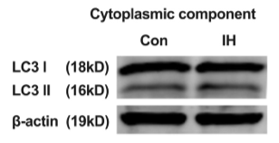
35kD
Con IH
25kD
55kD
15kD
10kD
Con IH
β-actin
COX IV

Full uncropped Gels and Blots image(s) for Figure7E

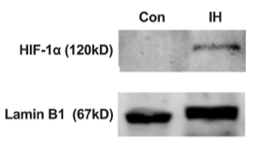
HIF-1α
Con IH
70kD
100kD
150kD
150kD
100kD
Con IH
70kD
Lamin B1
55kD

Full uncropped Gels and Blots image(s) for Figure7H

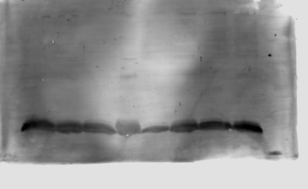
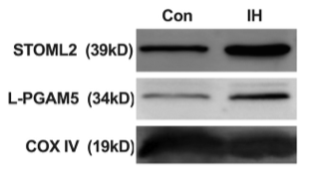
L-PGAM5
S-PGAM5
STOML2
70kD
55kD
25kD
35kD
15kD
10kD
Con IH
Con IH

COX IV
Con IH

Full uncropped Gels and Blots image(s) for Figure7K
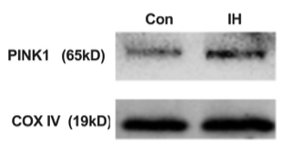
55kD
70kD
35kD
25kD
15kD
10kD
Con IH
Con IH
PINK1
COX IV

