EXTENDED DATA FIGURES

Chemically guided single-cell transcriptomics reveals sulfotransferase-mediated scaffold remodeling in securinine biosynthesis

Sungjun Choung^{1‡}, Gyumin Kang^{2‡}, Taein Kim^{1‡}, Seoyoung Kim², Hyejung Yun¹, Yeojin Hwang¹, Hyeonjin Kim¹, Hangah Lim¹, Sunkyu Han^{2*}, and Sang-Gyu Kim^{1,3*}

Affiliations:
¹Department of Biological Sciences, KAIST, Daejeon, 34141, Republic of Korea
²Department of Chemistry, KAIST, Daejeon, 34141, Republic of Korea
³Graduate School of Engineering Biology, KAIST, Daejeon 34141, Republic of Korea
*Co-corresponding authors: Sunkyu Han (sunkyu.han@kaist.ac.kr), Sang-Gyu Kim (sgkim1@kaist.ac.kr)

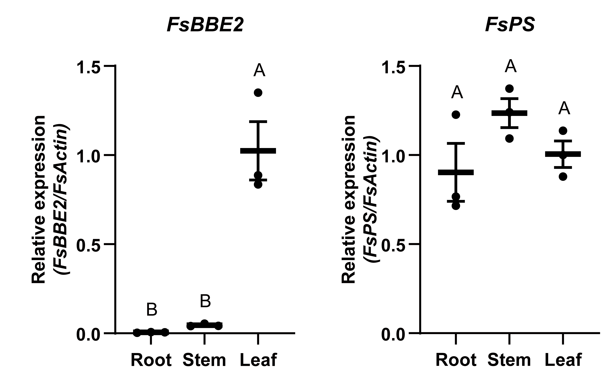
Extended Data Fig. 1. Relative expression patterns of known SeA biosynthetic genes. Transcript levels of FsBBE and FsPS were quantified by qPCR using cDNA synthesized from root, stem, and leaf. The late-stage SeA biosynthetic gene FsBBE showed a leaf-specific expression pattern, whereas the early-stage SeA biosynthetic gene FsPS was expressed uniformly across all organs (N = 3, mean ± SEM, One-way ANOVA, post-hoc Tukey’s HSD).

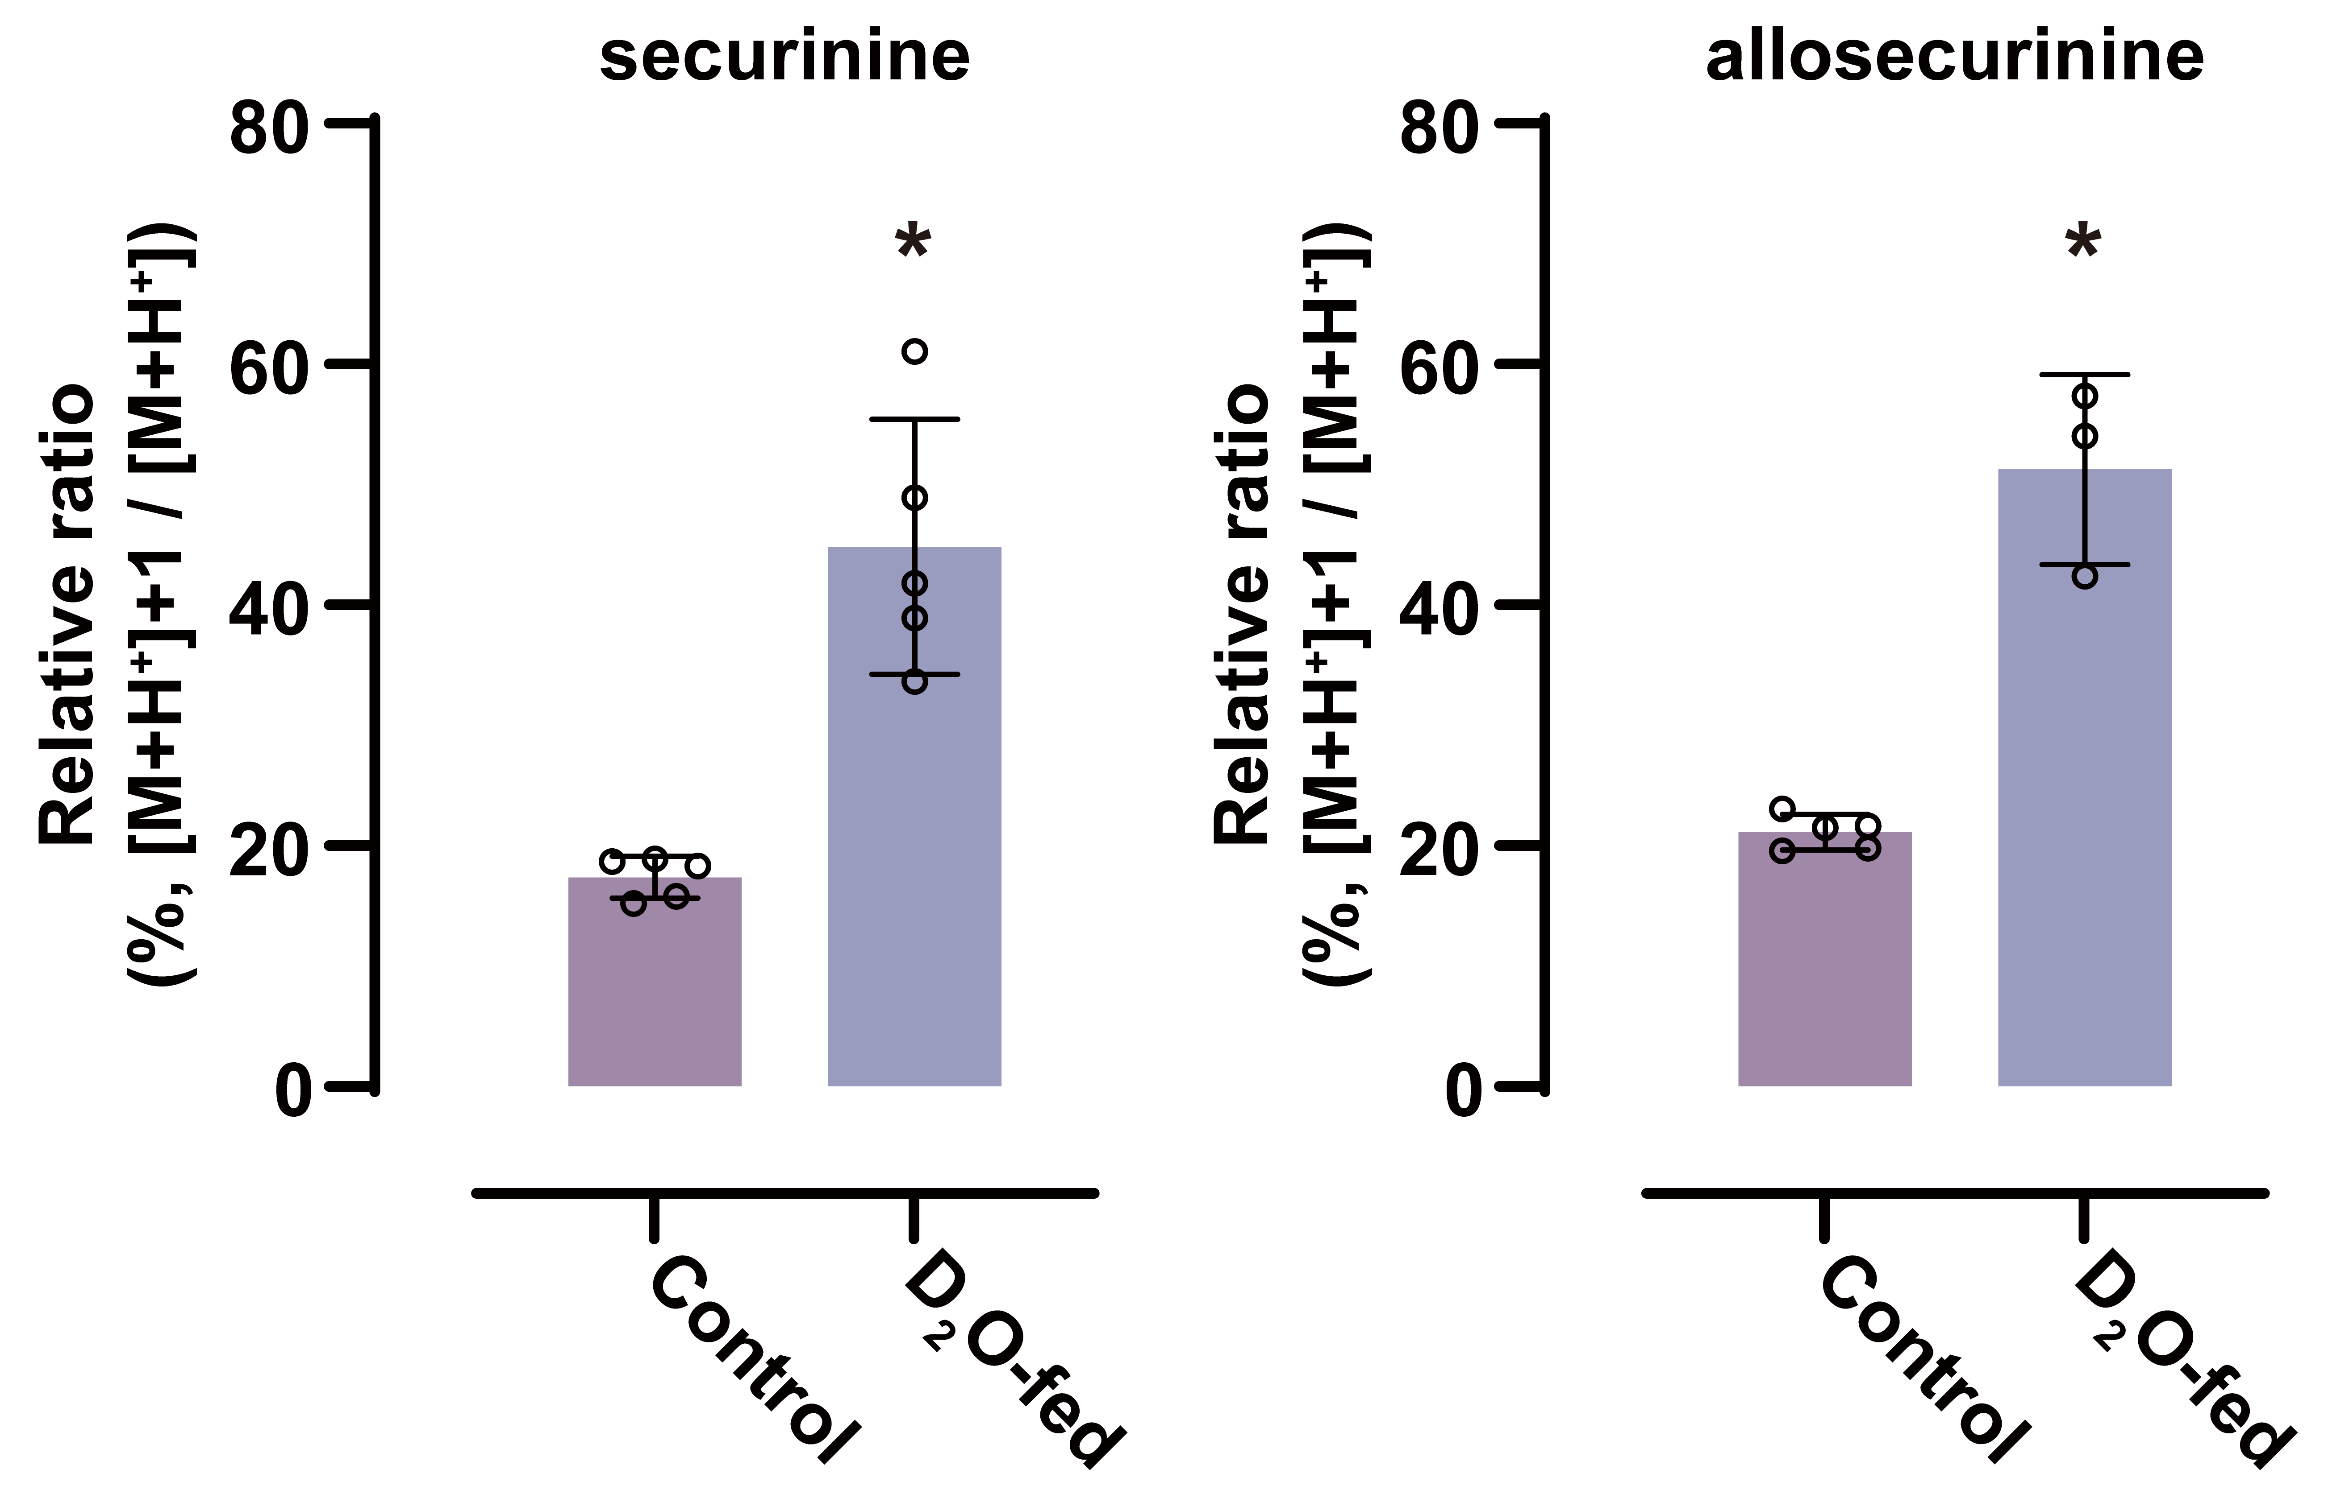
Extended Data Fig. 2. D₂O labeling assay. Leaves from five-week-old F. suffruticosa were supplemented with H₂O (control) or D₂O for 6 days. The relative ratio of [M+H⁺]+1 to [M+H⁺] for securinine and allosecurinine were calculated (N = 3-5, mean ± SEM, unpaired t-test with Welch’s correction. *, P < 0.05). In the D₂O-fed group, the isotopic enrichment of securinine increased to 44.9%, compared to 17.4% in the control group, while the isotopic enrichment of allosecurinine rose to 51.3%, compared to 21.1% in the control group. These results indicate that leaves at this developmental stage are actively synthesizing both securinine and allosecurinine.

Extended Data Fig. 3. Replicate 2 single-cell transcriptome analysis of F. suffruticosa, related to Fig. 2. a CellRanger alignment metric for scRNA-seq replicate 1 and 2 by using F. suffruticosa genome and annotation as a reference b (replicate 2) UMAP plot of processed single-cell transcriptomes showed clusters classified into five major cell types: mesophyll, epidermis, vasculature, guard cells, and unassigned cells. Cluster numbers were assigned in descending order of cell count. c (replicate 2) Dot plot showing the expression of genes involved in sulfate assimilation, L-Lys biosynthesis, L-Tyr/L-Phe biosynthesis, and SeA biosynthesis across cell clusters. Genes include: FsAPSK2 (APS kinase 2), FsATPS2 (ATP sulfurylase 2), FsStr (sulfite transferase), FsTauE/SafE (sulfite transporter), FsDAPEpi (diaminopimelate epimerase), FsDAPAT (diaminopimelate aminotransferase), FsCS (chorismate synthase), FsCM (chorismate mutase), FsPS (piperideine synthase), and FsBBE2 (berberine bridge-like enzyme 2). d (replicate 2) Co-expression analysis using FsPS as the bait gene ranks genes based on Spearman correlation with FsPS. The top-ranked genes include FsNSST1 and 2 (neosecurinane sulfotransferase 1 and 2), FsMS, and FsBBE2.

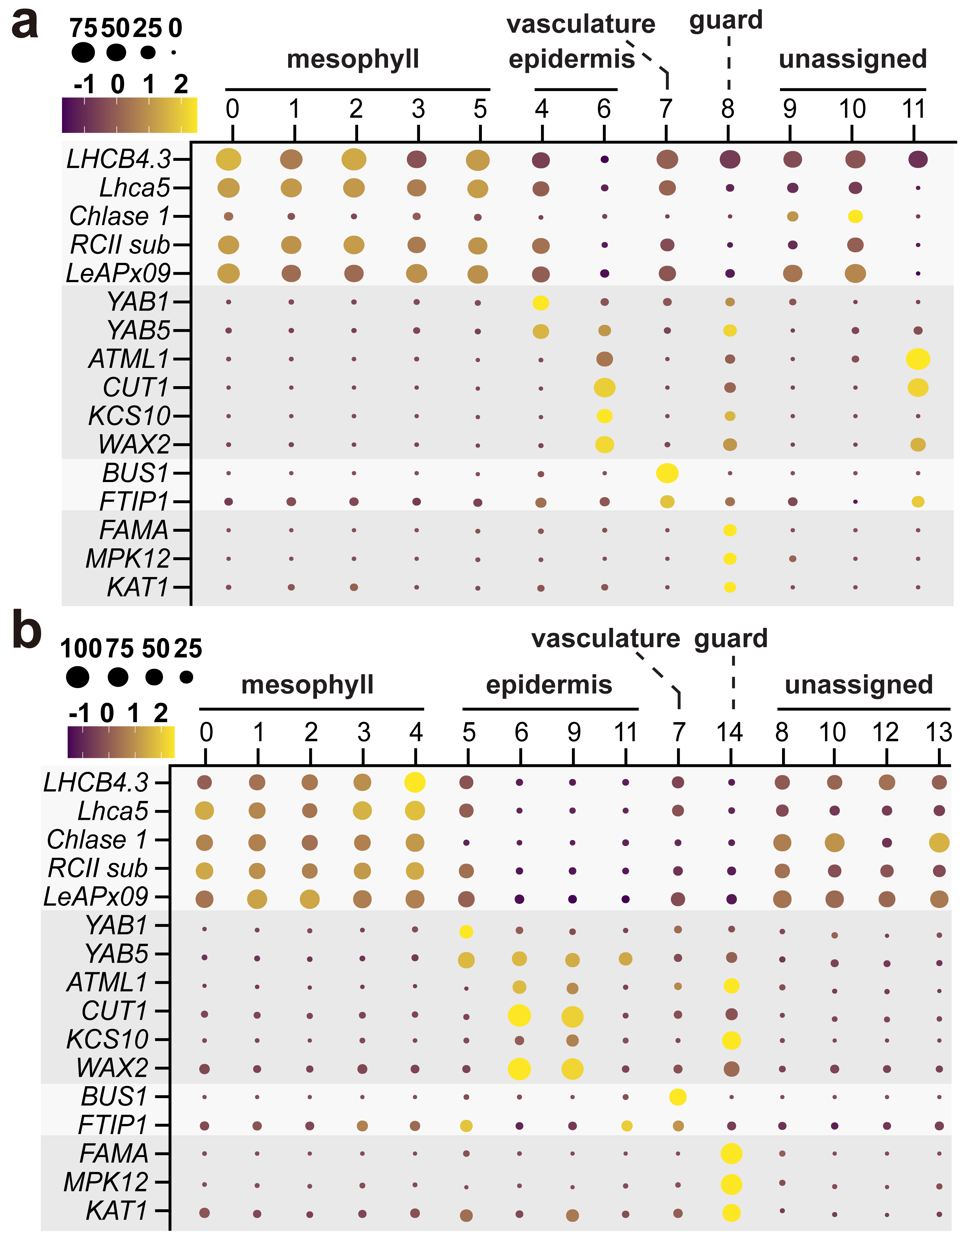
Extended Data Fig. 4. The expression pattern of leaf cell type marker genes across the cell clusters. a, b The expression pattern of leaf cell type marker genes was represented as dot plots for replicate 1 (a) and replicate 2 (b). Marker genes are as follows: 1. Mesophyll cell markers: LHCB4.3 (chlorophyll a-b binding protein CP29.3), Lhca5 (photosystem I chlorophyll a/b-binding protein 5), Chlase 1 (chlorophyllase 1), RCII sub (photosystem II reaction center subunit), and LeAPx09 (thylakoid lumenal 29 kDa protein); 2. Epidermis markers: YAB1 (YABBY 1), YAB5 (YABBY 5), ATML1 (Arabidopsis thaliana MERISTEM LAYER 1), CUT1 (CUTICLE 1), KCS10 (3-ketoacyl-CoA synthase), and WAX2 (waxy 2); 3. Vasculature markers: BUS1 (bushy 1), FTIP (flowering locus T-interacting protein 1); 4. Guard cell markers: FAMA (Guard cell fate-determining transcription factor), MPK12 (Mitogen-activated protein kinase 12), KAT1 (K+ channel in Arabidopsis thaliana 1). Dot size represents the proportion of cells within the cluster expressing the marker gene and dot color indicates the average expression level of the gene, with purple representing low expression and yellow representing high expression.

Extended Data Fig. 5. GO Enrichment analysis of marker genes for cluster 7. a, b Heatmap representing the relative abundances of different categories across a predefined dataset of replicate 1 (a) and 2 (b). The x-axis indicates the measured counts, while the y-axis lists the corresponding categories.

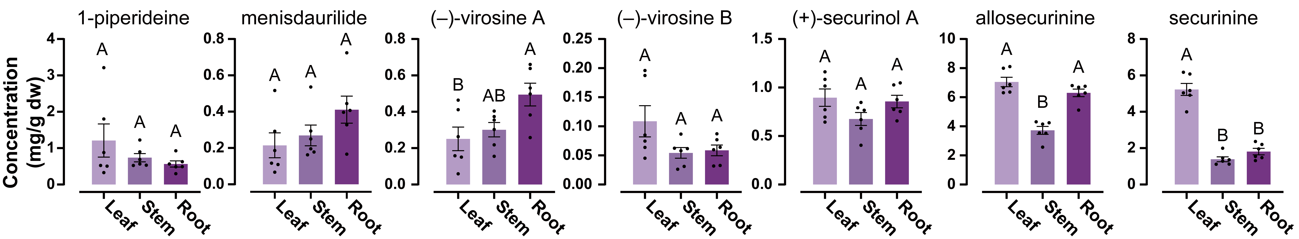
Extended Data Fig. 6. Distribution of 1-piperideine, menisdaurilide, neosecurinanes, and securinanes by tissues. Metabolite contents were measured using HPLC-MS/MS after extraction (N = 6, Mean ± SEM, One-way ANOVA, post-hoc Tukey’s HSD).

Extended Data Fig. 7. Remaining (–)-virosine A and B after assays, related to Fig. 5. a, b Remaining (–)-virosine A (a) and (–)-virosine B (b) after the in vitro sulfotransferase assay. (–)-virosine A and B was consumed only when PAPS was supplemented (N = 3, mean ± SEM, One-way ANOVA, post-hoc Tukey’s HSD). c, d Remaining (–)-virosine A (c) and (–)-virosine B (d) was also measured after the in planta assay to ensure substrate was infiltrated equally (N = 6, Mean ± SEM, One-way ANOVA, post-hoc Tukey’s HSD).

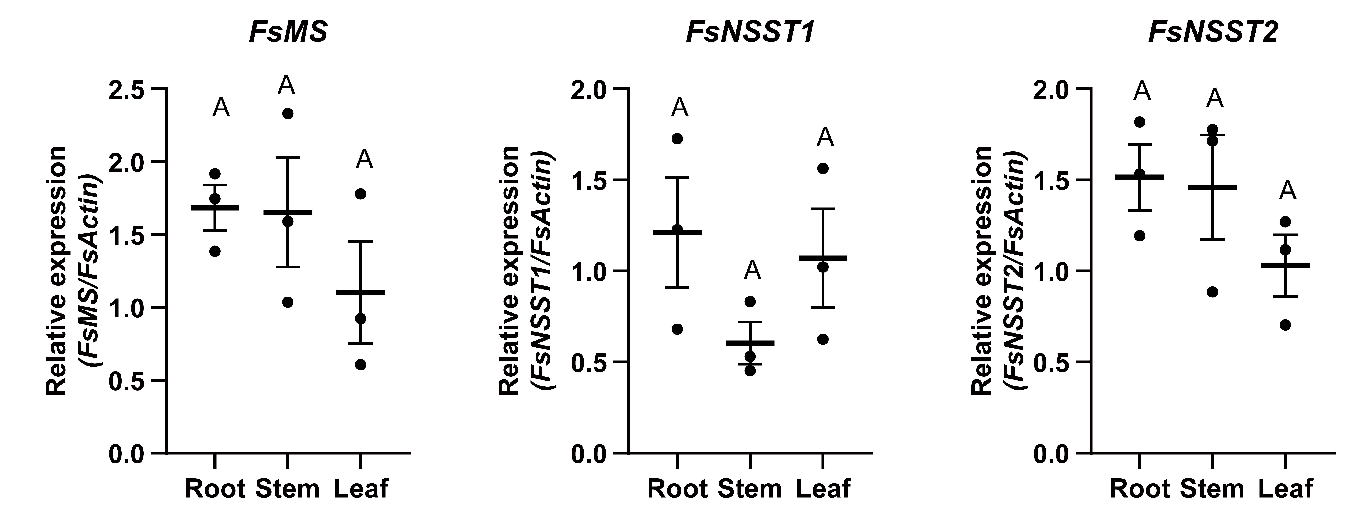
Extended Data Fig. 8. Relative expression patterns of FsMS, FsNSST1, and FsNSST2. Transcript levels of FsMS, FsNSST1 and FsNSST2 were quantified by qPCR using cDNA synthesized from root, stem, and leaf. All genes were expressed uniformly across organs (N = 3, Mean ± SEM, One-way ANOVA, post-hoc Tukey’s HSD).

Extended Data Fig. 9. [¹³C₂]-4HPP feeding experiment in leaf discs. Leaf discs of F. suffruticosa were fed with [¹³C₂]-4HPP (1 mM in 50 mM HEPES, pH 7.0) for 72 hours at 26°C. The incorporation of ¹³C into menisdaurilide, neosecurinane, and securinane was quantified (N = 6, Mean ± SEM, Student’s t-test, n.s. indicates no significant difference).

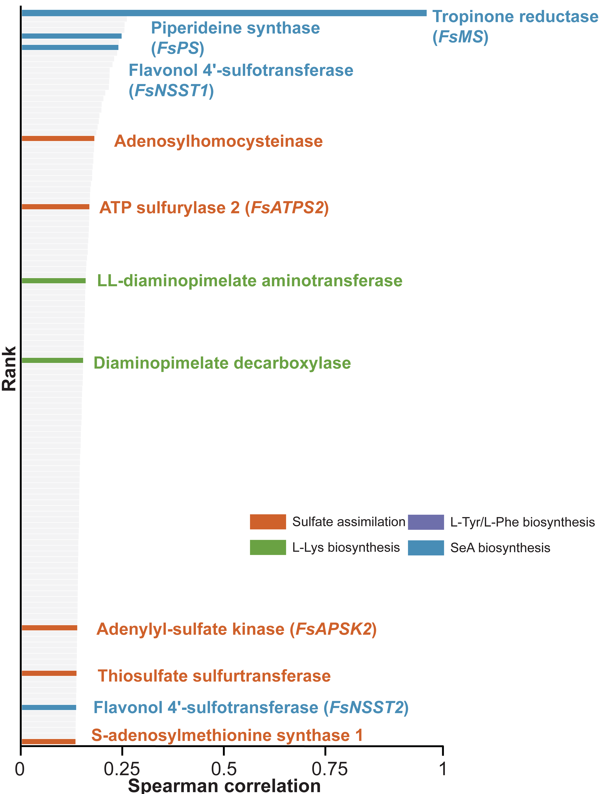
Extended Data Fig. 10. Co-expression analysis with FsMS on replicate 1. Co-expression analysis using FsMS (menisdaurilide synthase) as the bait gene ranks genes based on Spearman correlation with FsMS. The top-ranked genes include FsNSST1 and 2 (neosecurinane sulfotransferase 1 and 2), and FsPS (piperideine synthase).

