Supplementary Methods

Supplementary Table 1. Total area (in million km²) of high-value freshwater ecosystems (HVFEs) and their components under the maximum and minimum delineation scenarios.
 | Total HVFE | Surface water | Wetland | Headwater | Low-Order Stream Corridor | High-Order Stream & Lake Corridor | Geomorphic Floodplains | Wetland corridor
Maximum Scenario | 51.6 | 4.3 | 7.4 | 9.1 | 12.9 | 2.4 | 14.2 | 1.5
Minimum Scenario | 40.9 | 4.3 | 6.6 | 9.1 | 15.2 | 5.7 | 0 | 0

Supplementary Table 2: Percentage coverage of High-Value Freshwater Ecosystems (HVFEs) and associated water-related risks across 49 Freshwater Challenge countries. The table reports the national coverage (%) of three HVFE types—headwater regions, fixed-width stream corridors, and geomorphic floodplains—as well as total freshwater ecosystem area.
Water risk indicators, sourced from the World Resources Institute’s Aqueduct Country Rankings¹, include baseline water stress (0–5 scale) for the current period and for 2050 under both optimistic and pessimistic scenarios, and projected riverine flood risk. Ranges in some columns represent values under minimum and maximum HVFE extent scenarios (with and without floodplains). Columns that do not show a range have identical values across both scenarios. For water risk indicators (Baseline Water Stress and Riverine Flood Risk), cool colors (green) represent lower risk, while warm colors (red) represent higher risk. For ecosystem coverage columns, including "Total Area", green indicates higher coverage (a positive outcome), and red indicates lower coverage. This combined ecosystem and risk information helps identify countries where nature-based interventions may offer strong climate adaptation co-benefits.
Country Name | Percentage Coverage of Country |  |  |  |  | Baseline Water Stress (0-5) |  |  | Riverine Flood Risk (0-5)
Country Name | Freshwater Ecosystems | Headwater regions | Geomorphic Floodplains | Fixed-width Corridor Range | Total Area | Current | 2050 (Optimistic) | 2050 (Pessimistic) | Riverine Flood Risk (0-5)
Australia | 3.4 | 1.1 | 25.7 | 13.4-20.5 | 24.8-43.6 | 2.91 | 3.1 | 3.24 | 1.59
Botswana | 2.4 | 0.0 | 44.5 | 10.2-21.2 | 23.3-57.1 | 4.66 | 4.84 | 4.87 | 0.85
Brazil | 8.1 | 2.6 | 6.4 | 15.4-18.7 | 28.8-32.6 | 1.04 | 1.2 | 1.3 | 1.62
Burkina Faso | 1.2 | 0.1 | 15.0 | 16.8-22.1 | 23.2-33.0 | 1.65 | 2.89 | 2.76 | 2.11
Cambodia | 7.5 | 3.9 | 23.6 | 13.6-20.6 | 31.2-48.5 | 1.87 | 1.69 | 1.73 | 4.46
Canada | 22.8 | 6.6 | 4.9 | 14.0-14.8 | 41.8-48.2 | 1.23 | 1.4 | 1.43 | 2.25
Chad | 2.2 | 0.1 | 21.8 | 4.3-9.7 | 11.9-28.5 | 0.85 | 0.9 | 1.07 | 4.1
Chile | 5.4 | 14.9 | 2.1 | 10.6-11.3 | 31.2-33.0 | 4.47 | 4.47 | 4.62 | 1.04
Colombia | 9.3 | 11.0 | 9.3 | 16.7-20.5 | 39.9-46.4 | 0.50 | 0.52 | 0.55 | 1.1
Democratic Republic of the Congo | 9.1 | 2.6 | 6.1 | 17.2-19.8 | 31.2-35.0 | 0.01 | 0.24 | 0.26 | 3.11
Dominican Republic | 4.0 | 14.5 | 7.5 | 17.3-19.9 | 38.2-43.3 | 1.60 | 1.44 | 1.66 | 1.15
Ecuador | 4.1 | 18.9 | 5.8 | 16.6-19.3 | 41.9-45.4 | 0.66 | 1.11 | 1.1 | 2.09
El Salvador | 4.3 | 16.5 | 5.2 | 17.0-19.4 | 39.9-42.9 | 1.95 | 2.05 | 2.23 | 2.5
Fiji | 5.5 | 15.4 | 2.6 | 17.5-15.2 | 35.6-40.9 | Not listed | Not listed | Not listed | Not listed
Finland | 18.8 | 1.7 | 10.3 | 15.0-15.3 | 35.3-45.9 | 0.81 | 2.45 | 2.53 | 0.83
France | 1.0 | 4.0 | 2.9 | 7.8-8.9 | 13.8-15.7 | 1.92 | 1.52 | 1.33 | 2.64
Gabon | 5.3 | 4.0 | 5.9 | 17.9-20.0 | 28.8-33.1 | 0.00 | 0.12 | 0 | 3.04
Gambia | 17.5 | 0.0 | 11.3 | 15.3-22.6 | 36.1-44.1 | 0.02 | 0.12 | 0.44 | 3.16
Germany | 3.0 | 6.4 | 15.2 | 13.2-17.2 | 26.5-37.8 | 2.04 | 2.37 | 2.31 | 0.52
Guinea | 2.3 | 6.0 | 6.4 | 15.9-19.3 | 27.2-30.6 | 0.36 | 0.28 | 0.3 | 3.21
Iraq | 3.2 | 2.0 | 13.9 | 4.6-8.0 | 13.1-23.6 | 4.15 | 4.29 | 4.72 | 3.4
Kazakhstan | 5.4 | 1.9 | 28.0 | 10.8-17.6 | 24.5-46.1 | 2.51 | 2.89 | 2.82 | 1.6
Kenya | 3.0 | 3.0 | 17.8 | 14.9-20.5 | 26.4-38.7 | 0.79 | 2.2 | 1.86 | 4.03
Liberia | 2.8 | 1.6 | 7.9 | 17.0-19.8 | 24.1-29.3 | 0.00 | 0 | 0 | 4.79
Malawi | 20.8 | 4.7 | 5.5 | 13.8-16.3 | 41.7-44.8 | 0.75 | 0.86 | 0.94 | 4.05
Mali | 2.0 | 0.3 | 10.9 | 5.5-9.0 | 11.0-18.8 | 0.68 | 1.1 | 1.21 | 4.05
Mauritania | 0.3 | 0.1 | 4.9 | 2.0-3.5 | 3.8-7.2 | 2.73 | 2.64 | 2.83 | 4.84
Mexico | 4.3 | 14.1 | 10.8 | 15.4-19.2 | 37.2-44.5 | 4.00 | 3.92 | 4.03 | 2.09
Moldova | 2.1 | 4.0 | 7.8 | 13.1-16.3 | 22.2-27.0 | 1.26 | 1.33 | 1.27 | 2.85
Mozambique | 4.9 | 1.6 | 10.5 | 15.7-19.9 | 26.2-32.7 | 0.37 | 0.56 | 1.05 | 4.06
Nepal | 1.1 | 36.1 | 6.0 | 15.1-17.3 | 54.4-58.2 | 3.18 | 3.12 | 3.21 | 3.78
Netherlands | 12.4 | 0.0 | 56.9 | 5.9-15.9 | 28.1-75.2 | 1.58 | 2.01 | 1.96 | 0.16
Niger | 5.3 | 1.5 | 16.3 | 15.1-21.0 | 27.0-38.3 | 3.47 | 3.12 | 2.8 | 3.68
Norway | 8.3 | 19.2 | 1.6 | 12.6-12.4 | 39.6-41.7 | 0.19 | 0.27 | 0.28 | 2.86
Pakistan | 2.6 | 6.8 | 21.3 | 6.3-11.5 | 20.7-37.0 | 3.79 | 3.63 | 3.86 | 3.26
Panama | 13.9 | 17.8 | 4.3 | 21.1-19.9 | 50.8-57.2 | 0.75 | 0.91 | 1.14 | 3.01
Peru | 8.8 | 16.9 | 5.6 | 15.2-18.0 | 43.3-46.5 | 3.74 | 3.63 | 3.61 | 2.95
Republic of Congo | 19.5 | 2.2 | 8.1 | 16.0-19.9 | 41.2-45.9 | 0.01 | 0.03 | 0.03 | 2.6
Senegal | 4.4 | 0.1 | 24.2 | 13.8-21.0 | 24.9-42.5 | 2.22 | 3.34 | 3.44 | 3.93
Slovenia | 0.8 | 26.0 | 9.2 | 13.6-16.9 | 43.8-49.6 | 0.53 | 0.8 | 0.77 | 1.42
Spain | 1.0 | 12.5 | 5.3 | 15.6-17.8 | 31.2-34.3 | 3.94 | 4.35 | 4.56 | 0.82
Tajikistan | 2.3 | 17.9 | 2.4 | 10.9-12.1 | 32.2-33.6 | 2.34 | 2.49 | 2.54 | 4.21
Tanzania | 8.8 | 3.5 | 11.9 | 14.8-19.2 | 31.4-39.1 | 1.91 | 2.13 | 2.1 | 3.81
Uganda | 18.6 | 3.2 | 6.9 | 13.8-17.1 | 38.7-42.6 | 0.20 | 0.55 | 0.73 | 2.15
United Arab Emirates | 0.3 | 0.0 | 1.9 | 1.5-2.1 | 2.5-3.8 | 5.00 | 4.99 | 5.0 | 3.41
United Kingdom | 5.9 | 8.9 | 8.3 | 14.8-16.0 | 30.6-37.9 | 1.30 | 1.72 | 1.8 | 0.57
United States | 10.2 | 7.7 | 9.6 | 14.7-17.7 | 35.0-42.2 | 2.60 | 2.78 | 2.87 | 0.83
Zambia | 7.8 | 1.0 | 11.5 | 15.9-20.9 | 29.0-36.4 | 0.85 | 1.12 | 1.15 | 1.44
Zimbabwe | 1.3 | 2.1 | 6.8 | 16.6-19.6 | 23.0-26.7 | 2.17 | 2.57 | 2.94 | 1.8
Note: For the "Total Area" column, color coding is based on the maximum extent value (i.e., the upper bound of the reported range for each country).

Supplementary Table 2. Datasets Used for HVFE Mapping.
HVFE Class | Dataset Used | Resolution | Temporal Coverage
Surface Water | UMD Land Cover & Land Use Change² | 30m | 2000–2020
Regularly Flooded Wetlands | UMD Land Cover & Land Use Change² | 30m | 2000–2020
Headwater Catchments | MERIT Hydro Sub-catchments³ | 90m | 2019
Low-order & High-order Streams | MERIT Hydro Stream Data³ | 90m | 2019
Riparian Buffers | UMD Land Cover & MERIT Hydro^{2,3} | 30m | 2000–2020
Geomorphic Floodplains | GFPlain90⁴ | 90m | 2019

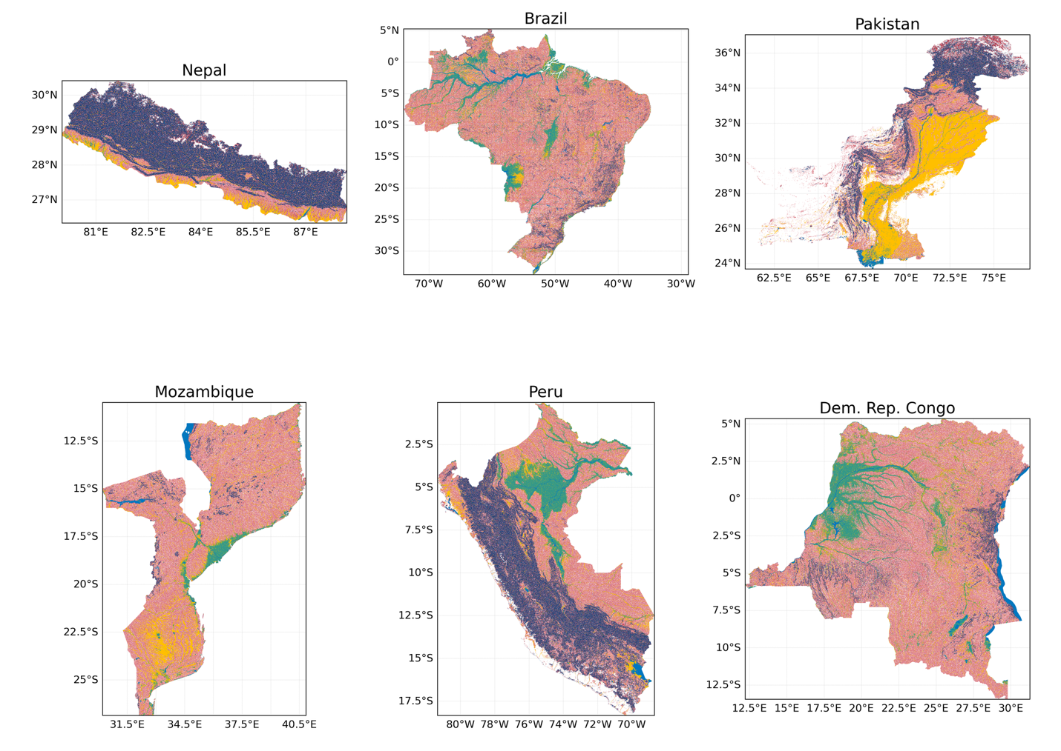
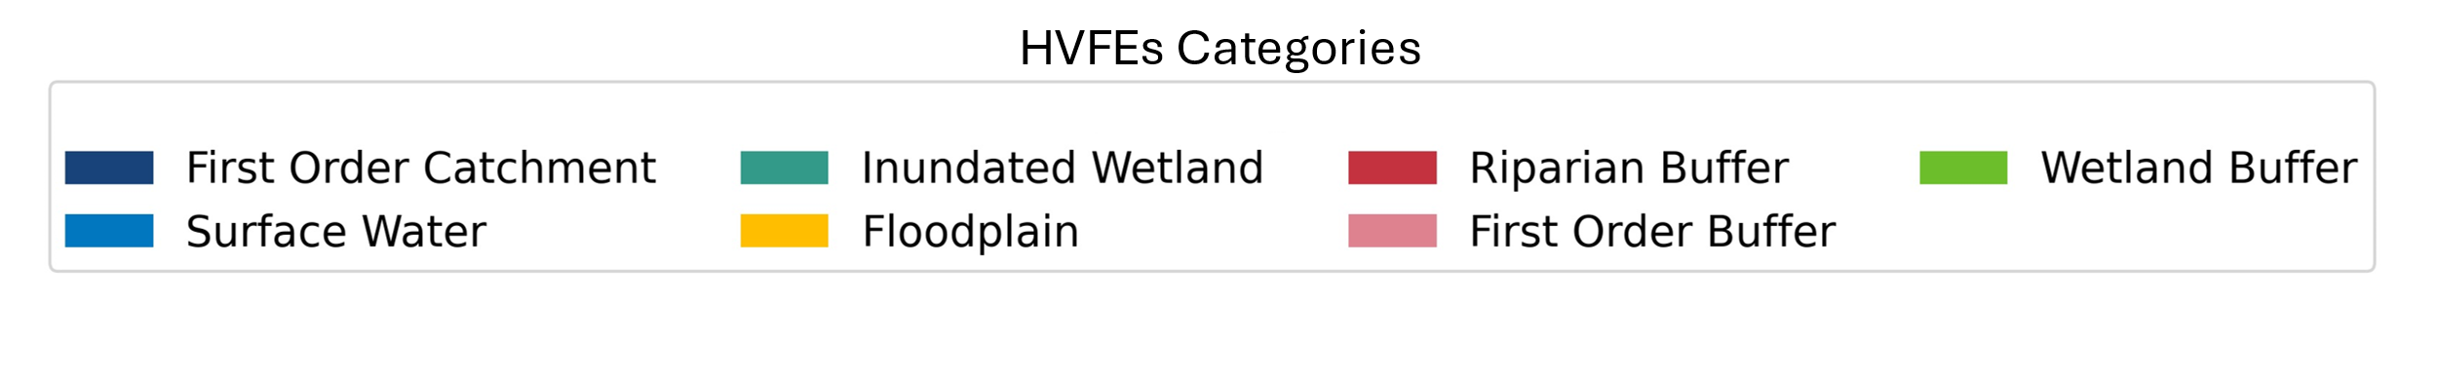
Supplementary Figure 1. Map of HVFEs under the maximum delineation scenario in six selected Freshwater Challenge countries.
Supplementary Figure 2. Comparison of climate mitigation potential (GtCO₂ Yr-1) from the minimum restoration scenario between countries committed to the FWC and those not across NDC types.

Supplementary Methods A: Schematic Representation and Definitions of HVFE Features
Our study presents a comprehensive global map highlighting HVFEs, integrating various landscape elements that offer significant benefits in freshwater and carbon storage. These elements encompass surface water bodies, regularly flooded wetlands, headwater regions, geomorphic floodplains, and corridors around low-order streams, high-order streams, lakes, and wetlands. Each component is systematically defined, using carefully chosen datasets and delineation methods to achieve high spatial accuracy and maintain ecological relevance. This approach enables a comprehensive and scalable representation of freshwater ecosystems, facilitating targeted conservation and restoration efforts worldwide.
A1. Surface Water
Surface water refers to any water present on the surface of the Earth, including permanent and seasonal water bodies such as lakes, rivers, and reservoirs. These features can be mapped and monitored using satellite imagery, capturing both static and dynamic changes over time—including fluctuations in water extent due to seasonal or climatic variations.
The University of Maryland (UMD) Land Cover and Land Use (LULC) Change dataset was used to delineate surface water bodies. This comprehensive global product is derived from Landsat imagery spanning 2000–2020 with a 30‐meter spatial resolution².
The Surface Water and Ocean Topography (SWOT) Mission River Database (SWORD)⁵ was initially evaluated to be used as the river width dataset. SWORD is a high‐resolution river dataset that provides detailed information on river widths and nodes at 200‐meter intervals, incorporating critical hydrological attributes such as water surface elevation, river width, and slope measurements. The dataset primarily focuses on rivers wider than 30-meter, leveraging the Global River Widths from Landsat (GRWL) dataset for river centerlines⁶. Although initially promising, the SWORD dataset has key limitations: it excludes rivers narrower than 30 meters, overlooks seasonal rivers by relying solely on observable water, and often misplaces centerlines in widening river sections. Due to these constraints, we selected the UMD LULC change (2000–2020) and MERIT Hydro stream dataset³ as the primary source for defining riverine buffers.

A2. Regularly Flooded Wetlands
Regularly flooded wetlands are areas that experience periodic, predictable inundation, which creates unique conditions supporting water‐adapted vegetation, specialized soils, and aquatic communities. Regular flooding—whether seasonal or triggered by natural hydrological events—is crucial for processes such as nutrient cycling and sediment deposition that shape these ecosystems⁷. The UMD LULC change dataset was used to delineate regularly flooded wetlands.
A3. Headwater Catchments
Headwater catchments refer to the uppermost portions of a river network where small tributaries and first‐order streams originate. These areas typically consist of relatively small catchments characterized by steep gradients³, limited storage capacity, and rapid hydrological responses to precipitation. As the primary source areas of a drainage system, headwater regions play a crucial role in regulating water quality, sediment transport, and nutrient cycling for downstream ecosystems⁸. Their ecological integrity is vital for maintaining overall watershed health, as disturbances in these regions can propagate and amplify impacts throughout the river network⁹. For instance, headwater streams contribute significantly to biodiversity, providing habitat for various aquatic species and serving as critical pathways for organic material transport to downstream water⁸. Additionally, these areas help define watersheds, influence water flow direction, and affect the overall health of aquatic ecosystems downstream. Therefore, preserving the ecological integrity of headwater regions is crucial for sustaining the health and function of entire river networks.
MERIT Hydro, a high-resolution global map of river networks, was used to delineate headwater sub-catchments. Developed in 2019, it integrates advanced error-corrected elevation data with multiple water body datasets, including G1WBM, Global Surface Water Occurrence, and OpenStreetMap. It provides a static, 3‐arc‐second (~90 m at the equator) representation of water flow and river morphology across nearly the entire globe (from 90°N to 60°S), capturing both major rivers and small streams with minimal manual editing³.
A4. Low-Order and High-Order Streams
Low-order streams are small, often unbranched headwater channels that originate in upland areas and form the foundational network of a river system. High-order streams are larger channels formed by the confluence of several lower-order streams, and are characterized by greater discharge, increased channel complexity, and diverse ecological processes. The MERIT Hydro stream dataset was used to delineate both low-order and high-order streams³. Fixed-width buffers were defined around first-order and high-order streams, as well as around lakes and wetlands (Supplementary Methods C).
A5. Geomorphic Floodplain
A geomorphic floodplain refers to the flat, low‐lying area adjacent to a river channel, shaped over time by flooding and sediment deposition. This dynamic environment is vital for dissipating flood energy, regulating sediment transport, and supporting diverse ecological habitats¹⁰. The global floodplain map, GFPlain90, was used to delineate geomorphic floodplains. Developed in 2019 using the GFPlain v1.0 algorithm⁴ and the MERIT Hydro terrain dataset³, GFPlain90 offers a 90‐meter resolution and a minimum contributing area of 20 km² for stream networks. This dataset provides a detailed and scalable representation of floodplain extents. The floodplain data were validated against a machine learning based floodplain dataset developed by Woznicki et al.¹¹ for the contiguous United States (CONUS). The GFPlain90 data achieved a Hit Rate of 0.77, indicating that 77% of the benchmark floodplain area was captured, and a False Alarm Ratio of 0.26, demonstrating some overestimation.
Supplementary Methods B: Rules for Combining HVFE Features
The HVFEs map was produced at a 30-meter resolution and captures freshwater-associated features under two delineation scenarios—minimum and maximum—to reflect a gradient of protection strategies based on ecosystem service potential and spatial influence.
B1. Minimum Scenario: Core Freshwater Protection Zones
The minimum scenario provides a conservative delineation focused on preserving essential ecosystem services such as water quality regulation, erosion control, and aquatic habitat protection. This scenario includes surface water bodies, regularly flooded wetlands, headwater regions, and fixed-width riparian corridors around low-order streams (orders 1–3), high-order streams (orders ≥4), and lakes and reservoirs. This scenario excludes geomorphic floodplains and wetland buffer corridors, emphasizing a more policy-aligned footprint with clearly mappable boundaries.
B2. Maximum Scenario: Broad Hydrological Influence Zones
The maximum scenario builds upon the minimum by incorporating freshwater-adjacent areas that contribute to flood mitigation, sediment retention, and long-term water storage. It includes all features from the minimum scenario, as well as geomorphic floodplains and wetland corridors. This more inclusive delineation represents the maximum restoration potential, designed to integrate biodiversity, hydrological resilience, and carbon sequestration co-benefits.
B3. Resolving Feature Overlaps
To maintain consistency and prevent double-counting, spatial overlaps between HVFE classes are resolved using a hierarchical masking logic. In cases where multiple features overlap spatially, the lower-priority feature is masked out. The Supplementary Table B outlines, for each scenario, which HVFE features are retained, and which are masked out during the final classification process. Colors correspond to feature types for visual clarity.
Supplementary Table B. Overlap resolution rules for the High-Value Freshwater Ecosystem (HVFE) map under minimum and maximum delineation scenarios. For each HVFE feature, the table lists other features that take precedence during classification when spatial overlaps occur. The minimum scenario represents a conservative, policy-aligned delineation, while the maximum scenario includes broader hydrological zones to capture full ecosystem service potential. Colors correspond to feature types for visual clarity.
Feature | Gets Masked Out By (Minimum Scenario) | Gets Masked Out By (Maximum Scenario)
Surface Water | — | —
Inundated Wetland | Surface Water, Stream Buffer | Surface Water, Stream Buffer
Floodplain | — (not included) | Surface Water, Inundated Wetland
Surface Water Buffer | Surface Water, Inundated Wetland | Surface Water, Inundated Wetland,  Floodplain
Low/High-Order  Streams & Buffers | Surface Water, Water Buffer | Surface Water, Water Buffer,  Floodplain
Headwater Catchment | Surface Water, Inundated Wetland, Stream Buffer | Surface Water, Inundated Wetland,  Stream Buffer, Floodplain
Wetland Buffer | — (not included) | Surface Water, Inundated Wetland, Stream Buffer,  Water Buffer, Headwater, Floodplain

Supplementary Methods C: Justification for Fixed-Width Buffers
To define fixed-width riparian buffers in our freshwater mapping framework, we drew on global best practices and existing regulatory standards. This approach aligns with patterns identified in McDermott et al.¹², who documented the widespread use of fixed-width, no-harvest riparian zones as a baseline regulatory measure across more than 20 countries. As detailed in Supplementary Table C, the buffer widths applied in our analysis exceed those required in many jurisdictions—such as South Africa’s 30–50 meters for plantations and the Democratic Republic of Congo’s uniform 50-meter standard—while falling within the range of more protective frameworks, including Brazil’s 200–500 meters for large rivers. By adopting a no-harvest designation, our delineation ensures full ecological protection, preserving water quality, habitat continuity, and riparian ecosystem function. These standardized, evidence-informed thresholds allow us to balance ecological integrity with implementation feasibility, ensuring both biological relevance and global consistency in the delineation of riparian zones.
Supplementary Table C1. Riparian buffer width regulations across global jurisdictions.
This table summarizes no-harvest buffer width standards for streams, rivers, and other freshwater bodies across a range of countries. The listed values represent minimum regulatory thresholds used to protect water quality, biodiversity, and ecosystem function, and were used to inform the fixed-width delineation applied in this study.

Region | Stream Type/Order | Buffer Width (m) | Ecological Function
South Africa (Natural forests) | Riparian zones | Variable | Based on environmental sensitivity
Brazil (Amazon) | Waterways >600m width | 500 | Biodiversity conservation, flood control, sediment retention
Brazil (Amazon) | Waterways 200-600m width | 200 | Biodiversity conservation, flood control, sediment retention
Western Australia | 5th and higher order | 200 | Water quality protection, habitat preservation
Russian Federation | Rivers/streams >500 km | 500 | Fisheries protection, water quality
Russian Federation | Rivers/streams 200-500 km | 400 | Fisheries protection, water quality
Indonesia | Rivers >50m wide | 100 | Erosion control, water quality protection
Indonesia | Rivers <50m wide | 50 | Erosion control, water quality protection
Mexico | Permanent water body | 20 | Temperature regulation, bank stabilization
US Forest Service | Fish-bearing | 30 | Sediment control, organic matter input
Tasmania | Classes 1-3, Type 1 | 40 | Water quality protection
Latvia | Streams >100 km | 300 | Temperature regulation, bank stabilization
Latvia | Streams 25-100 km | 100 | Temperature regulation, bank stabilization
Poland | Rivers in state forests | 40 | Habitat connectivity, water quality
New Zealand | Unspecified buffer | Var. | Water quality, habitat protection
US Southeastern states | Perennial streams | 30-Oct | Shade provision, debris contribution
Democratic Republic of Congo | All water courses | 50 | Not specified
Democratic Republic of Congo | Water sources | 100 (radius) | Not specified
South Africa (Plantations) | Rivers | 30 (from 1:50 year flood mark) | Water yield protection
South Africa (Plantations) | Wetlands | 50 | Water yield protection

B1) Low‐Order Stream Buffer
To delineate first‐order stream buffers, we selected streams of order ≤ 3 from the MERIT hydro dataset and applied a 45‐meter buffer from the centerline. The buffer width accounts for stream bank dynamics and the influence of immediate riparian vegetation. The use of MERIT hydro data ensures global consistency in stream delineation, which is critical for accurately identifying these hydrologically significant areas.
B2) Riparian Buffer Delineation
For high‐order streams (order ≥ 4.), which are not covered by UMD surface water data, we utilized MERIT Hydro 90‐meter stream data. The final fixed-width riparian buffer definitions are:
· 75‐meter fixed‐width buffer from the centerline of high‐order streams.
· 60‐meter fixed‐width buffer from the edge of rivers and lakes.
· 60‐meter fixed‐width buffer around the regularly flooded wetlands.
Challenges arose due to MERIT data and floodplain layers covering areas such as deserts, salt pans, and ice‐covered regions. To address this, we excluded areas classified as true deserts, salt pans, and ice regions based on the UMD land cover dataset.

Supplementary Methods D: Validation of Riparian Delineation
Since most HVFEs, such as wetlands and surface water, are well-represented in the UMD dataset, which has undergone validation based on its licensing requirements, our primary focus was on validating the delineated riparian corridors and geomorphic floodplains. For this purpose, we utilized the U.S. Forest Service (USFS)¹³ 10-meter Riparian Area Dataset (2019), which serves as a nationwide dataset of riparian areas with coverage over the contiguous CONUS, and is the only high-resolution dataset of its kind currently available for validation.
The USFS dataset incorporates various data sources, including USGS stream gage data, the NHDPlus v2.1 hydrologic framework for detailed stream and river networks, the National Wetland Inventory (NWI) for wetland-related ecological functions, and USGS 10-meter digital elevation models (DEMs) to capture terrain variability and delineate floodplains. Its methodology combines stream gauge measurements, 50-year flood height estimations, DEM-based hydrological modeling, and integration of wetland data to ensure accurate representation of riparian areas.
The USFS dataset employs three main riparian delineation methods: (i) fixed-width riparian buffers, where 10-meter and 50-meter buffers are applied to capture immediate and extended riparian processes; (ii) variable-width riparian buffers, which consider ecological and hydrological parameters such as stream locations, DEM-derived terrain features, and 50-year flood heights to estimate floodplain extents; and (iii) legal fixed-width buffers, a policy-driven approach with minimal buffer widths (e.g., 2-meter buffers) applied along minor rivers or streams. These methods are supported by high-resolution DEMs, hydrologic soil data, and detailed land cover datasets.
The validation methodology included:
- Comparing fixed-width riparian buffers with USFS buffer delineations.
- Assessing variable-width riparian buffers derived from ecological and hydrological factors.
- Evaluating geomorphic floodplain accuracy using GFPlain90 and USFS floodplain estimates.
- Analyzing the effectiveness of buffers in different Köppen climate zones (Fig. D1).

Köppen Climate Zones and Validation
Riparian validation was conducted across different Köppen climate zones¹⁴ within the CONUS to evaluate climate-dependent variations in classification accuracy. Figure D1 shows the climate classification used for this validation. The pixel-based validation results (Fig. D2) indicate the proportion of correctly classified riparian zones in each climate region.

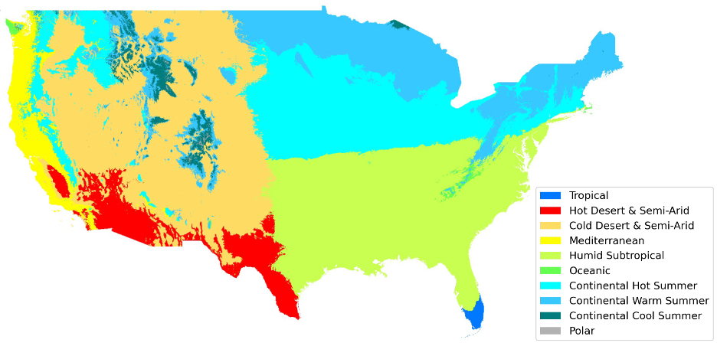
Figure D1. Köppen climate classification map of the CONUS, illustrating the spatial distribution of major climate zones. Categories include Tropical, Hot Desert & Semi-Arid, Cold Desert & Semi-Arid, Mediterranean, Humid Subtropical, Oceanic, Continental Hot Summer, Continental Warm Summer, Continental Cool Summer, and Polar zones. This classification provides a framework for analyzing validation results under different climatic conditions.
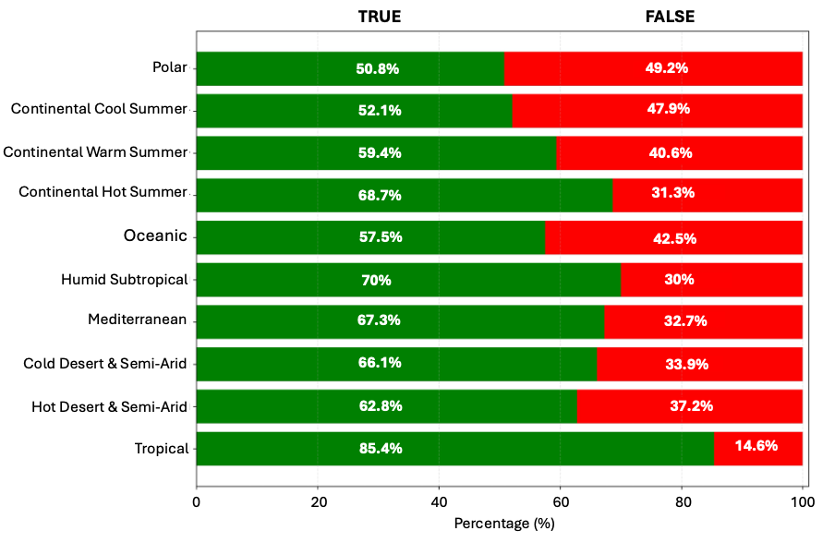Figure D2. Pixel-based validation results of riparian zones across different Köppen climate zones in the CONUS, using the USFS reference dataset. The riparian zones include geomorphic floodplains and fixed-width buffers around rivers, lakes, and wetlands. The green bars indicate correctly classified pixels, while the red bars represent mismatched pixels, highlighting validation performance across climate regions.

Reference
1. World Resources Institute. Aqueduct Country Rankings. https://www.wri.org/applications/aqueduct/country-rankings/
2. Potapov, P. et al. The Global 2000-2020 Land Cover and Land Use Change Dataset Derived From the Landsat Archive: First Results. Front. Remote Sens. 3, (2022).
3. Yamazaki, D. et al. MERIT Hydro: A high‐resolution global hydrography map based on latest topography dataset. Water Resour. Res. 55, 5053–5073 (2019).
4. Nardi, F., Annis, A., Di Baldassarre, G., Vivoni, E. R. & Grimaldi, S. GFPLAIN250m, a global high-resolution dataset of Earth’s floodplains. Sci. Data 6, 180309 (2019).
5. Altenau, E. H. et al. The Surface Water and Ocean Topography (SWOT) Mission River Database (SWORD): A Global River Network for Satellite Data Products. Water Resour. Res. 57, e2021WR030054 (2021).
6. Allen, G. H. & Pavelsky, T. M. Global extent of rivers and streams. Science 361, 585–588 (2018).
7. Cowardin, L. M. Classification of Wetlands and Deepwater Habitats of the United States. (Fish and Wildlife Service, US Department of the Interior, 1979).
8. Gomi, T., Sidle, R. C. & Richardson, J. S. Understanding processes and downstream linkages of headwater systems: headwaters differ from downstream reaches by their close coupling to hillslope processes, more temporal and spatial variation, and their need for different means of protection from land use. BioScience 52, 905–916 (2002).
9. Meyer, J. L. et al. The Contribution of Headwater Streams to Biodiversity in River Networks. JAWRA J. Am. Water Resour. Assoc. 43, 86–103 (2007).
10. Knighton, D. Fluvial Forms and Processes: A New Perspective. (Routledge, 2014).
11. Woznicki, S. A., Baynes, J., Panlasigui, S., Mehaffey, M. & Neale, A. Development of a spatially complete floodplain map of the conterminous United States using random forest. Sci. Total Environ. 647, 942–953 (2019).
12. McDermott, C., Cashore, B. & Kanowski, P. Global Environmental Forest Policies: An International Comparison. (Routledge, London, 2010). doi:10.4324/9781849774925.
13. Abood, S. A., Spencer, L. & Wieczorek, M. US Forest Service national riparian areas base map for the conterminous United States in 2019. (2022).
14. Peel, M. C., Finlayson, B. L. & McMahon, T. A. Updated world map of the Köppen-Geiger climate classification. Hydrol. Earth Syst. Sci. 11, 1633–1644 (2007).

