Table 2. Pairwise comparisons of the permutational MANOVA results on the soil animal community structure across different interactive permutation treatments.
Groups | Pairs | Treatments | Total  soil fauna | Dominant classes |  |  |  | Feeding guilds
 |  |  |  | Arachnida | Collembola | Insecta |  | Detritivores | Herbivores | Microbivores | Predators
Litter layer | a | 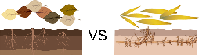 | 0.0668*** | 0.0543* | 0.0632* | 0.0806*** |  | 0.1146** | 0.0945* | 0.0358 | 0.1185***
 | b | 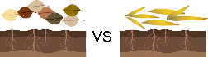 | 0.0616*** | 0.0478 | 0.1012*** | 0.0607** |  | 0.0394 | 0.0354 | 0.1180** | 0.0652*
 | c | 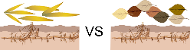 | 0.0517* | 0.0500 | 0.0473 | 0.0492 |  | 0.1013* | 0.0399 | 0.0912* | 0.0379
 | d | 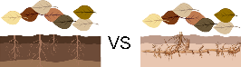 | 0.0605** | 0.0530* | 0.0492 | 0.0753*** |  | 0.0966** | 0.0767* | 0.0225 | 0.0953**
 | e | 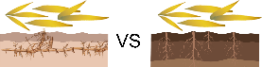 | 0.0709*** | 0.0566* | 0.0829*** | 0.0791*** |  | 0.1311** | 0.1269** | 0.1045** | 0.0767*
Soil layer | f | 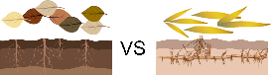 | 0.0493 | 0.0470 | 0.0753 | 0.0478 |  | 0.1277* | 0.0936 | 0.0221 | 0.0516
 | g | 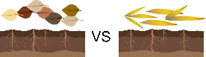 | 0.0555** | 0.0702* | 0.0892 | 0.0488 |  | 0.0643 | 0.0457 | 0.0434 | 0.0862*
 | h | 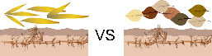 | 0.0439 | 0.0474 | 0.0751 | 0.0423 |  | 0.0507 | 0.0748 | 0.0630 | 0.0556
 | i | 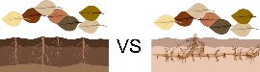 | 0.0506 | 0.0573 | 0.0879 | 0.0510* |  | 0.0803 | 0.0642 | 0.02245 | 0.1063**
 | j | 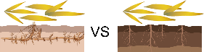 | 0.0516** | 0.0519 | 0.0703 | 0.0432 |  | 0.1205* | 0.0992 | 0.0429 | 0.0937***
 | k | 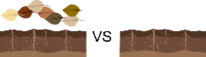 | 0.0499 | 0.0768* | 0.0760 | 0.0480 |  | 0.0590 | 0.0460 | 0.0368 | 0.0656
 | l | 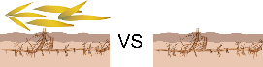 | 0.0439 | 0.0490 | 0.0574 | 0.0460 |  | 0.0556 | 0.0938 | 0.0435 | 0.0460
 | m | 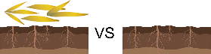 | 0.0513** | 0.0603 | 0.0736 | 0.0433 |  | 0.0293 | 0.0441 | 0.0485 | 0.0766
 | n | 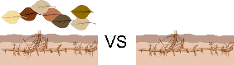 | 0.0435 | 0.0542 | 0.0806 | 0.0422 |  | 0.0143 | 0.0914 | 0.0341 | 0.0447
Note: *, P < 0.05; **, P < 0.01; ***, P < 0.001.

