Supplementary Figures
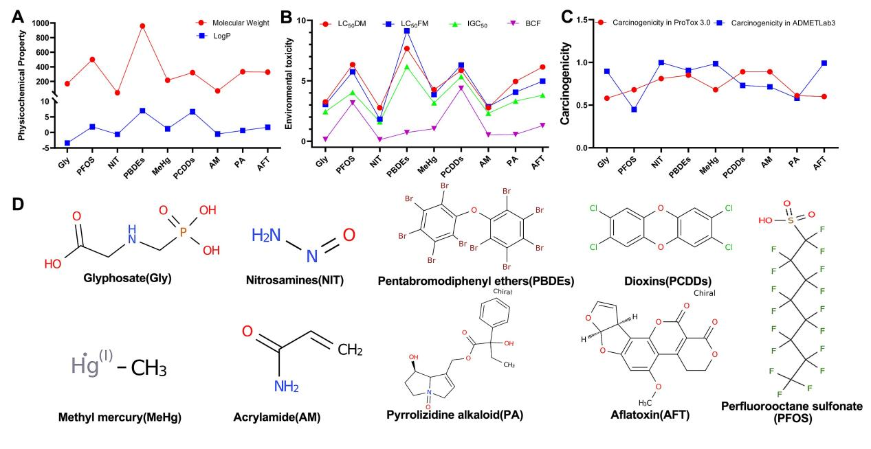
Fig. S1 Comprehensive characterization and toxicological profiling of nine food contaminants.
- Physicochemical properties of nine food contaminants, presenting calculated molecular weights (g/mol) and octanol-water partition coefficients (Log P values).
- Comparative ecotoxicological assessment including acute toxicity parameters (LC₅₀DM: 50% lethal concentration in the daphnia magna after 48 h; LC₅₀FM: 50% lethal concentration in the fathead minnow after 96 h; IGC₅₀: 50% growth inhibition concentration in the tetrahymena pyriformis; BCF: Bioconcentration factors are used for considering secondary poisoning potential and assessing risks to human health via the food chain).
- The carcinogenic potential of these contaminants was assessed in both ProTox 3.0 and ADMETlab 3 platforms.
- Chemical structure formulas of the nine amanitins.
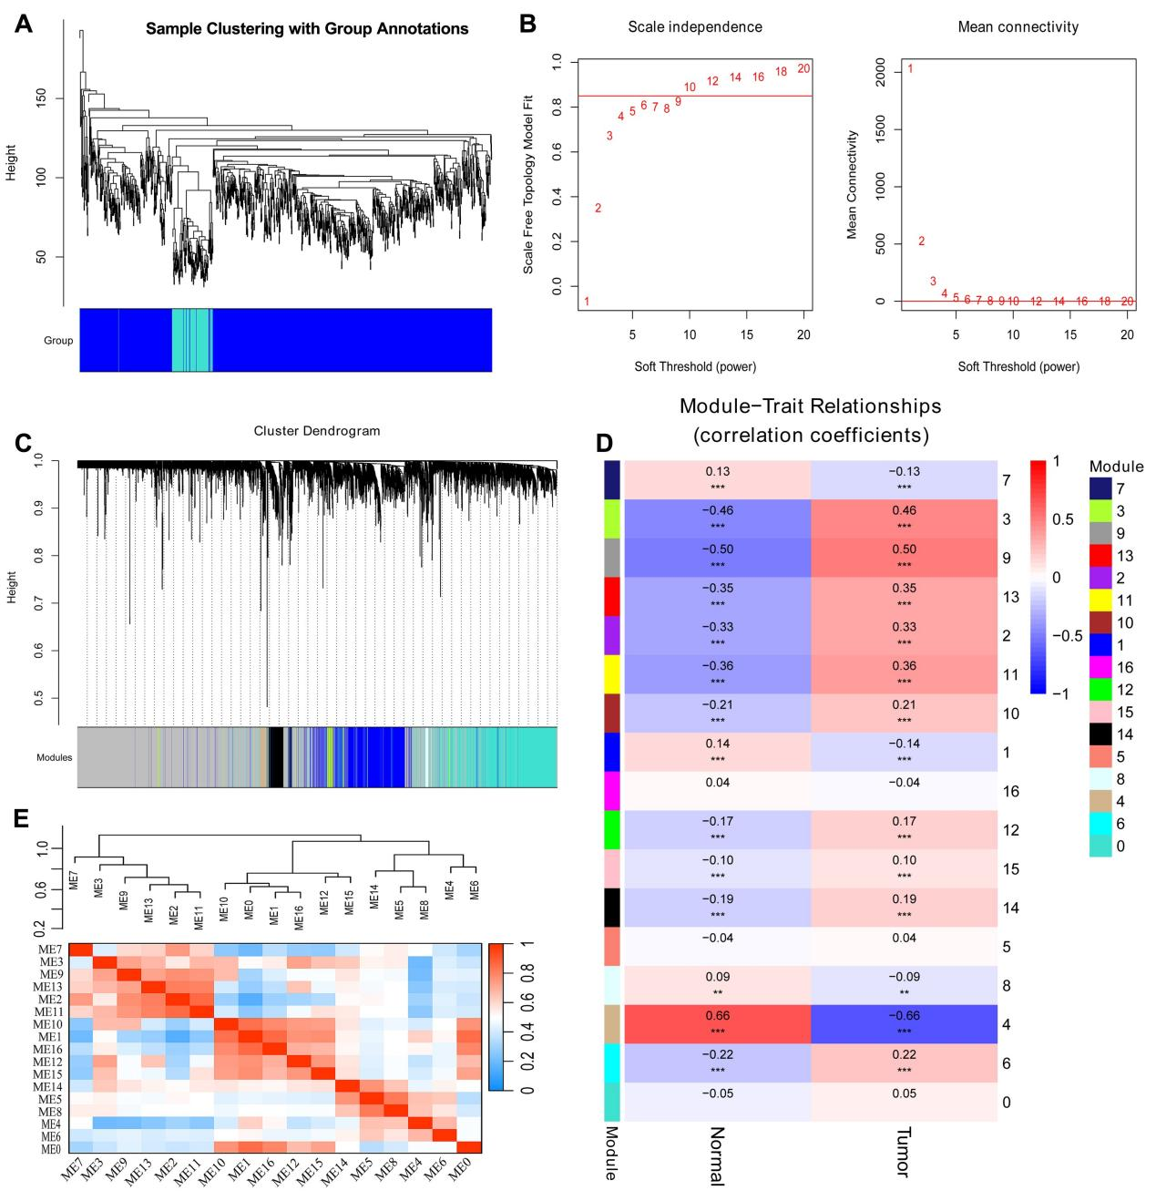
Fig. S2 Identification of the key gene modules in WGCNA.
- Sample clustering dendrograms with leaves corresponding to each sample
- Determination of the soft-thresholding power.
- Dendrogram of differentially expressed genes clustered based on a dissimilarity measure (1-TOM).
- Module-trait relationships were established to assess correlations with tumor occurrence.
- The heatmap of Eigengene adjacency.

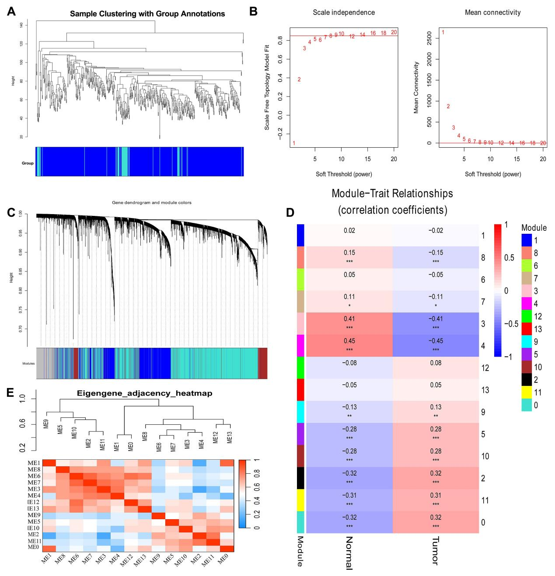
Fig. S3 Identification of the key gene modules in WGCNA.
- Sample clustering dendrograms with leaves corresponding to each sample
- Determination of the soft-thresholding power.
- Dendrogram of differentially expressed genes clustered based on a dissimilarity measure.
- Module-trait relationships were established to assess correlations with tumor occurrence.
- The heatmap of Eigengene adjacency.

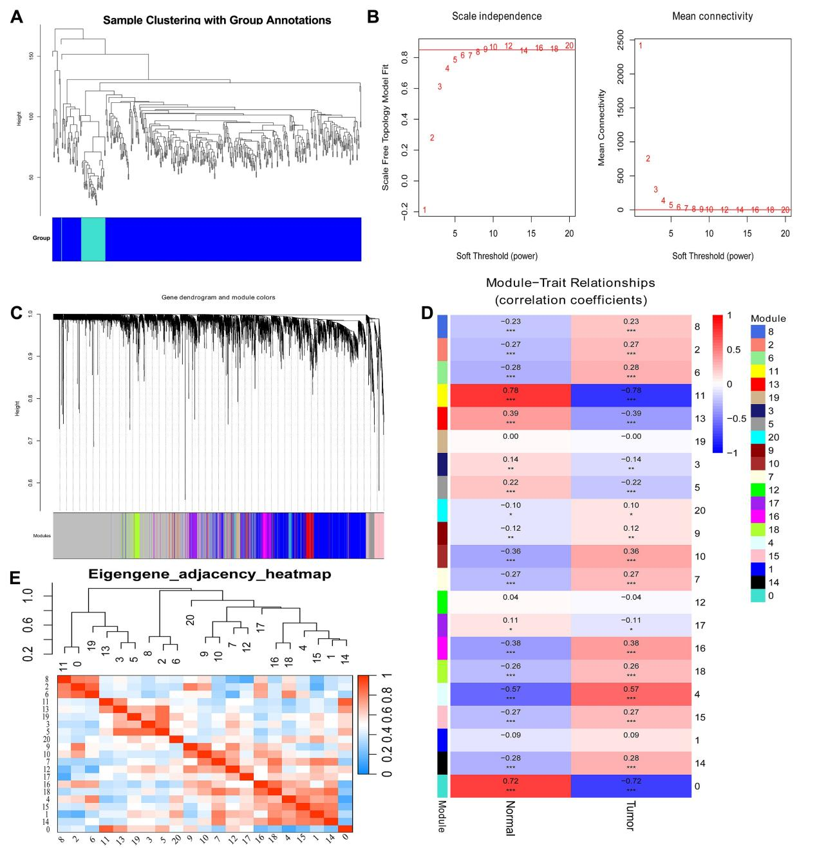
Fig. S4 Identification of the key gene modules in WGCNA.
- Sample clustering dendrograms with leaves corresponding to each sample
(B) Determination of the soft-thresholding power.
(C) Dendrogram of differentially expressed genes clustered based on a dissimilarity measure.
(D) Module-trait relationships were established to assess correlations with tumor occurrence.
(E) The heatmap of Eigengene adjacency.

